DSWD DROMIC Report #3 on Typhoon “KIKO”
as of 13 September 2021, 6PM

- Situation Overview

On 07 September 2021, “Kiko” entered the Philippine Area of Responsibility (PAR) and intensified into a Typhoon. On 11 September 2021, Typhoon “Kiko” continues to weaken while moving over the coastal waters of Itbayat, Batanes bringing heavy to intense with at times torrential rains over Batanes. Moderate to heavy with at times intense rains are also likely over Babuyan Islands, the northern portion of Cagayan, Ilocos Norte, Ilocos Sur, Abra, Apayao, Kalinga, and Benguet. Under these conditions, scattered to widespread flooding (including flash floods) and rain-induced landslides are possible especially in areas that are highly or very highly susceptible to these hazard as identified in hazard maps. Typhoon “KIKO” will continue to enhance the Southwest Monsoon, bringing monsoon rains over Metro Manila, the rest of Ilocos Region, and the western sections of Central Luzon and Southern Luzon. On 12 September 2021, “KIKO” slightly weakened and exited PAR on the same day.
Source: DOST-PAGASA Weather Advisory

- Status of Affected Areas and Population

A total of 1,907 families or 6,225 persons were affected by Typhoon “Kiko” in 118 Barangays in Regions I, II and CAR (see Table 1).

Table 1. Number of Affected Families / Persons
REGION / PROVINCE / MUNICIPALITY |  | NUMBER OF AFFECTED
 |  | Barangays | Families | Persons
GRAND TOTAL |  | 118 | 1,907 | 6,225
REGION I |  | 2 | 36 | 152
Ilocos Norte |  | 2 | 36 | 152
 | CITY OF BATAC | 1 | 19 | 89
 | Pagudpud | 1 | 17 | 63
REGION II |  | 113 | 1,839 | 5,960
Batanes |  | 10 | 30 | 106
 | Itbayat | 4 | 16 | 50
 | Ivana | 4 | 8 | 34
 | Sabtang | 2 | 6 | 22
Cagayan |  | 92 | 1,675 | 5,453
 | Abulug | 1 | 1 | 3
 | Alcala | 2 | 9 | 36
 | Allacapan | 5 | 96 | 346
 | Aparri | 8 | 57 | 252
 | Baggao | 28 | 830 | 2,340
 | Buguey | 1 | - | 19
 | Calayan | 2 | 61 | 205
 | Gattaran | 12 | 205 | 791
 | Gonzaga | 2 | 12 | 47
 | Lal-lo | 6 | 81 | 303
 | Lasam | 2 | 54 | 178
 | Pamplona | 7 | 95 | 264
 | Santa Ana | 7 | 106 | 420
 | Santa Praxedes | 2 | 9 | 30
 | Santa Teresita | 5 | 56 | 208
 | Solana | 2 | 3 | 11
Isabela |  | 11 | 134 | 401
 | Divilacan | 3 | 37 | 136
 | Maconacon | 8 | 97 | 265
CAR |  | 3 | 32 | 113
Abra |  | 1 | 1 | 8
 | Licuan-Baay (Licuan) | 1 | 1 | 8
Apayao |  | 1 | 30 | 98
 | Santa Marcela | 1 | 30 | 98
Benguet |  | 1 | 1 | 7
 | La Trinidad (capital) | 1 | 1 | 7
Note: Ongoing assessment and validation are continuously being conducted.
Source: DSWD-Field Offices (FOs)
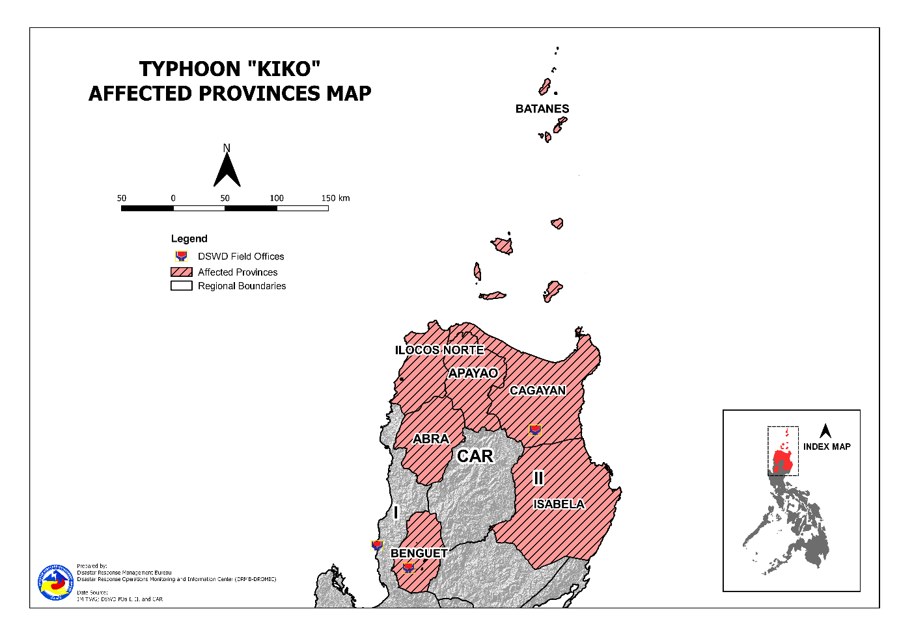
- Status of Displaced Population

- Inside Evacuation Centers
There are 36 families or 116 persons currently taking temporary shelter in three (3) evacuation centers in Region II (see Table 2).

Table 2. Number of Displaced Families / Persons Inside Evacuation Centers
REGION / PROVINCE / MUNICIPALITY |  | NUMBER OF EVACUATION CENTERS (ECs) |  | NUMBER OF DISPLACED
 |  |  |  | INSIDE ECs
 |  |  |  | Families |  | Persons
 |  | CUM | NOW | CUM | NOW | CUM | NOW
GRAND TOTAL |  | 99 | 3 | 1,061 | 36 | 3,692 | 116
REGION I |  | 1 | - | 17 | - | 63 | -
Ilocos Norte |  | 1 | - | 17 | - | 63 | -
 | Pagudpud | 1 | - | 17 | - | 63 | -
REGION II |  | 97 | 2 | 1,014 | 6 | 3,531 | 18
Batanes |  | 2 | 2 | 6 | 6 | 18 | 18
 | Itbayat | 1 | 1 | 5 | 5 | 15 | 15
 | Sabtang | 1 | 1 | 1 | 1 | 3 | 3
Cagayan |  | 86 | - | 899 | - | 3,186 | -
 | Abulug | 1 | - | 1 | - | 3 | -
 | Alcala | 2 | - | 9 | - | 36 | -
 | Allacapan | 5 | - | 92 | - | 331 | -
 | Aparri | 6 | - | 19 | - | 87 | -
 | Baggao | 25 | - | 260 | - | 871 | -
 | Buguey | 1 | - | - | - | 19 | -
 | Calayan | 2 | - | 49 | - | 159 | -
 | Gattaran | 11 | - | 131 | - | 516 | -
 | Gonzaga | 3 | - | 11 | - | 46 | -
 | Lal-lo | 8 | - | 81 | - | 303 | -
 | Lasam | 3 | - | 42 | - | 136 | -
 | Pamplona | 4 | - | 87 | - | 251 | -
 | Santa Ana | 4 | - | 69 | - | 258 | -
 | Santa Praxedes | 2 | - | 9 | - | 30 | -
 | Santa Teresita | 7 | - | 36 | - | 129 | -
 | Solana | 2 | - | 3 | - | 11 | -
Isabela |  | 9 | - | 109 | - | 327 | -
 | Divilacan | 5 | - | 37 | - | 136 | -
 | Maconacon | 4 | - | 72 | - | 191 | -
CAR |  | 1 | 1 | 30 | 30 | 98 | 98
Apayao |  | 1 | 1 | 30 | 30 | 98 | 98
 | Santa Marcela | 1 | 1 | 30 | 30 | 98 | 98
Note: Figures in Buguey, Cagayan are 19 individuals with no affected families. Hence, ongoing assessment and validation are continuously being conducted.
Source: DSWD-Field Offices (FOs)

- Outside Evacuation Centers
There are 16 families or 66 persons temporarily staying with their relatives and/or friends in Regions II and CAR (see Table 3).

Table 3. Number of Displaced Families / Persons Outside Evacuation Centers
REGION / PROVINCE / MUNICIPALITY |  | NUMBER OF DISPLACED
 |  | OUTSIDE ECs
 |  | Families |  | Persons
 |  | CUM | NOW | CUM | NOW
GRAND TOTAL |  | 825 | 16 | 2,432 | 66
REGION II |  | 824 | 15 | 2,425 | 59
Batanes |  | 24 | 15 | 88 | 59
 | Itbayat | 11 | 2 | 35 | 6
 | Ivana | 8 | 8 | 34 | 34
 | Sabtang | 5 | 5 | 19 | 19
Cagayan |  | 775 | - | 2,263 | -
 | Allacapan | 4 | - | 15 | -
 | Aparri | 38 | - | 165 | -
 | Baggao | 569 | - | 1,465 | -
 | Calayan | 12 | - | 46 | -
 | Gattaran | 75 | - | 276 | -
 | Lasam | 12 | - | 42 | -
 | Pamplona | 8 | - | 13 | -
 | Santa Ana | 37 | - | 162 | -
 | Santa Teresita | 20 | - | 79 | -
Isabela |  | 25 | - | 74 | -
 | Maconacon | 25 | - | 74 | -
CAR |  | 1 | 1 | 7 | 7
Benguet |  | 1 | 1 | 7 | 7
 | La Trinidad (capital) | 1 | 1 | 7 | 7
Note: Ongoing assessment and validation are continuously being conducted.
Source: DSWD-Field Offices (FOs)

- Total Displaced Population
There are 52 families or 182 persons still displaced in Regions II and CAR due to Typhoon “Kiko” (see Table 4).

Table 4. Total Number of Displaced Families / Persons
REGION / PROVINCE / MUNICIPALITY |  | TOTAL DISPLACED SERVED
 |  | Families |  | Persons
 |  | Total Families |  | Total Persons
 |  | CUM | NOW | CUM | NOW
GRAND TOTAL |  | 1,886 | 52 | 6,124 | 182
REGION I |  | 17 | - | 63 | -
Ilocos Norte |  | 17 | - | 63 | -
 | Pagudpud | 17 | - | 63 | -
REGION II |  | 1,838 | 21 | 5,956 | 77
Batanes |  | 30 | 21 | 106 | 77
 | Itbayat | 16 | 7 | 50 | 21
 | Ivana | 8 | 8 | 34 | 34
 | Sabtang | 6 | 6 | 22 | 22
Cagayan |  | 1,674 | - | 5,449 | -
 | Abulug | 1 | - | 3 | -
 | Alcala | 9 | - | 36 | -
 | Allacapan | 96 | - | 346 | -
 | Aparri | 57 | - | 252 | -
 | Baggao | 829 | - | 2,336 | -
 | Buguey | - | - | 19 | -
 | Calayan | 61 | - | 205 | -
 | Gattaran | 206 | - | 792 | -
 | Gonzaga | 11 | - | 46 | -
 | Lal-lo | 81 | - | 303 | -
 | Lasam | 54 | - | 178 | -
 | Pamplona | 95 | - | 264 | -
 | Santa Ana | 106 | - | 420 | -
 | Santa Praxedes | 9 | - | 30 | -
 | Santa Teresita | 56 | - | 208 | -
 | Solana | 3 | - | 11 | -
Isabela |  | 134 | - | 401 | -
 | Divilacan | 37 | - | 136 | -
 | Maconacon | 97 | - | 265 | -
CAR |  | 31 | 31 | 105 | 105
Apayao |  | 30 | 30 | 98 | 98
 | Santa Marcela | 30 | 30 | 98 | 98
Benguet |  | 1 | 1 | 7 | 7
 | La Trinidad (capital) | 1 | 1 | 7 | 7
Note: Ongoing assessment and validation are continuously being conducted.
Source: DSWD-Field Offices (FOs)

- Damaged Houses
A total of eight (8) houses were damaged; of which, two (2) were totally damaged and six (6) were partially damaged in Regions II and CAR (see Table 5).

Table 5. Number of Damaged Houses
REGION / PROVINCE / MUNICIPALITY |  | NO. OF DAMAGED HOUSES
 |  | Total | Totally | Partially
GRAND TOTAL |  | 8 | 2 | 6
REGION II |  | 6 | 2 | 4
Cagayan |  | 6 | 2 | 4
 | Calayan | 6 | 2 | 4
CAR |  | 2 | - | 2
Abra |  | 1 | - | 1
 | Licuan-Baay (Licuan) | 1 | - | 1
Benguet |  | 1 | - | 1
 | La Trinidad (capital) | 1 | - | 1
Note: Ongoing assessment and validation are continuously being conducted.
Source: DSWD-Field Offices (FOs)

- Cost of Humanitarian Assistance Provided

A total of ₱44,700.00 worth of assistance was provided by the Local Government Unit (LGU) to the affected families (see Table 6).

Table 6. Cost of Assistance Provided to Affected Families / Persons
REGION / PROVINCE / MUNICIPALITY |  | COST OF ASSISTANCE
 |  | DSWD | LGUs | NGOs | OTHERS | GRAND TOTAL
GRAND TOTAL |  | - | 44,700.00 | - | - | 44,700.00
REGION I |  | - | 44,700.00 | - | - | 44,700.00
Ilocos Norte |  | - | 44,700.00 | - | - | 44,700.00
 | Pagudpud | - | 44,700.00 | - | - | 44,700.00
Source: DSWD-Field Offices (FOs)

- Response Actions and Interventions

- Standby Funds and Prepositioned Relief Stockpile
REGIONAL / FIELD OFFICE | STANDBY FUNDS | FAMILY FOOD PACKS |  | Other Food and Non-Food Items (FNIs) | TOTAL STANDBY FUNDS & STOCKPILE
 |  | QUANTITY | TOTAL COST
TOTAL | 446,826,588.73 | 388,825 | 211,415,476.10 | 631,762,013.38 | 1,290,004,078.21
Central Office | 403,151,648.37 | - | - |  | 403,151,648.37
NRLMB - NROC | - | 43,447 | 29,884,535.60 | 165,018,668.38 | 194,903,203.98
NRLMB - VDRC | - | 12,634 | 6,001,150.00 | 28,288,615.16 | 34,289,765.16
I | 91,035.20 | 15,328 | 7,817,280.00 | 43,868,296.23 | 51,776,611.43
II | 5,031,059.68 | 20,502 | 8,590,078.00 | 19,380,886.29 | 33,002,023.97
CAR | 920,079.12 | 17,748 | 9,131,653.72 | 23,462,936.53 | 33,514,669.37
Other DSWD-Fos | 37,632,766.36 | 279,166.00 | 149,990,778.78 | 351,742,610.79 | 539,366,155.93
Note: The Inventory Summary is as of 12 September 2021, 4PM.
Source: DSWD-NRLMB

  - Standby Funds
    - ₱403.15 million Quick Response Fund (QRF) at the DSWD-Central Office.
    - ₱6.04 million available at DSWD-FOs I, II and CAR.
    - ₱37.63 million in other DSWD-FOs which may support the relief needs of the displaced families due to Severe Tropical Storm “KIKO” through inter-FO augmentation.

  - Prepositioned FFPs and Other Relief Items
    - 56,081 FFPs available in Disaster Response Centers; of which, 43,447 FFPs are at the National Resource Operations Center (NROC), Pasay City and 12,634 FFPs are at the Visayas Disaster Response Center (VDRC), Cebu City.
    - 53,578 FFPs available at DSWD-FOs I, II and CAR.
    - 279,166 FFPs in other DSWD-FOs which may support the relief needs of the displaced families due to Severe Tropical Storm “KIKO” through inter-FO augmentation.
    - ₱631.8 million worth of other food and non-food items (FNIs) at NROC, VDRC and DSWD-FO warehouses countrywide.

- Food and Non-Food Items

DSWD-FO CAR
DATE | ACTIVITIES
9 September 2021 | - DSWD FO-CAR delivered 2,500 FFPs and 135 Hygiene kits to the DSWD warehouse in the province of Abra in September 09, 2021  - Delivered 800 FFPs to the DSWD warehouse in Mt. Province on 08 September 2021  - Ensures availability of food and non-food items for resource augmentation as need arises  - Continuous production at the regional production hubs in the region  - Ensure availability of transportation service

DSWD-FO II
DATE | ACTIVITIES
12 September 2021 | - DSWD-FO II approved the request of the municipality of Baggao, Cagayan of 733 FPPs as augmentation support to the affected families.  - DSWD-FO II coordinated with NRLMB on the request of 5,000 FPPs to be airlifted to the Province of Batanes in coordination with OCD RO2 and Phil Force.

- Camp Coordination and Camp Management

DSWD-FO II
DATE | ACTIVITIES
11 September 2021 | - There are Two hundred seventy-nine (279) Families with eight hundred sixty-eight (868) individuals were pre-emptively and forcedly evacuated that are currently staying inside twenty-nine (29) Evacuation Centers;  - There are twenty-nine (29) Families with ninety-seven (97) individuals conducted pre-emptive evacuation and they are currently staying with their relatives and friends;  - There are Twenty-three (23) individuals are stranded in Claveria seaport wherein ten (10) individuals from Fuga Island are currently sheltered in the fish port while the remaining thirteen (13) individuals are sheltered in their relatives at Centro 5, Claveria.

- Other Activities

DSWD-FO I
DATE | ACTIVITIES
12 September 2021 | - DSWD Field Office 1 is closely monitoring the effects of Typhoon “KIKO” in coordination with the different Provincial/City/Municipal Disaster Risk Reduction and Management Councils (P/C/MDRRMCs) and Provincial/City/ Municipal Social Welfare and Development Offices (P/C/MSWDOs), and Social Welfare and Development Team Leaders (SWADTLs) for any significant updates.  - The DSWD FO 1 Incident Management Team (IMT) is still activated and on duty while other DSWD staff are on standby for possible augmentation. Likewise, the Field Office ensures the availability and readiness of resources.
10 September 2021 | - DSWD FO-I is closely monitoring the effects of the Typhoon “KIKO” through DOST – PAGASA and in close coordination with the RDRRMC1. Likewise,  Provincial Operations Offices (POOs) are in close coordination with the different Provincial/City/Municipal Disaster Risk Reduction and Management Councils (P/C/MDRRMCs) and Provincial/City/ Municipality Social Welfare and Development Offices (P/C/MSWDOs) to monitor the adverse effects that might be brought by the weather disturbance.  - DSWD FO-I attended the Regional Pre-Disaster Risk Assessment (PDRA) – Analyst/Core Group Meeting through VTC.  - The DSWD FO-I Incident Management Team (IMT) is still activated and on duty while other DSWD staff are on standby for possible augmentation. Likewise, the Field Office ensures the availability and readiness of resources.

DSWD-FO II
DATE | ACTIVITIES
13 September 2021 | - DSWD-FO II is continuous coordination in the province of Batanes 0n the updates and status of affected families.  - DSWD-FO II thru its DRMD is in close coordination with the RDRRMC and other concern agencies.  - DSWD-FO II is continuously repacking of FFPs to meet the required level of stockpile of the Region.
12 September 2021 | - DSWD-FO II together with the LGUs provided immediate needs to the affected families in the Evacuation Centers in Calayan.  - DSWD-FO II provided instructions to SWADTs and MATs to work with the LGUs/LSWDOs for immediate conduct of assessment for the provision of financial assistance to the affected families thru AICS.
10 September 2021 | - DSWF FO- II continuously monitoring and coordinating to LGUs/LSWDOs on affected families thru our SWADTs/MATs for any concerns the FO shall address;  - The Disaster Response Management Division and the Field Office Disaster Monitoring and Response Teams are on 24hour duty to continuously monitor the effects of Typhoon Kiko;  - DSWD FO-II thru the MAT coordinated for any concerns of the said individuals that need to be address;  - Likewise, there are three (3) field office staff from social pension program and disaster response management division who are currently stranded in the Municipality of Calayan and currently rendering DMRT duty at the said municipality;  - The Disaster Response Management Division continuously monitor the weather advisory and updates  - SWADTs/Provincial Operations Offices (POOs)/C/MATs closely coordinated with their respective Provincial/City/Municipal Disaster Risk Reduction and Management Councils (P/C/MDRRMCs) that are currently monitoring the adverse effects brought by TY KIKO;  - The DSWD FO-II DRMD continuously coordinates with RDRRMC for any concerns that the FO will address; and  - Dissemination of updates to agency operation center and to the concerned partner agencies.

DSWD-FO CAR
DATE | ACTIVITIES
12 September 2021 | - DSWD FO-CAR continuously monitor the weather updates;  - DSWD-FO CAR QRTs are on standby and ready to augment if needed.
9 September 2021 | - DSWD FO-CAR conducted Quick Response Team (QRT) via Zoom; succeeding QRT teams are ready for duty.  - DSWD FO-CAR continuously monitor the weather updates;  - Requested replenishment of standby funds and additional raw materials with an equivalent to 5,000 FFPs to NRLMB  - Provide technical assistance to LGUs on Camp Coordination and Camp Management  - Dissemination of stockpile update to AOC and partner agencies

- Photo Documentation
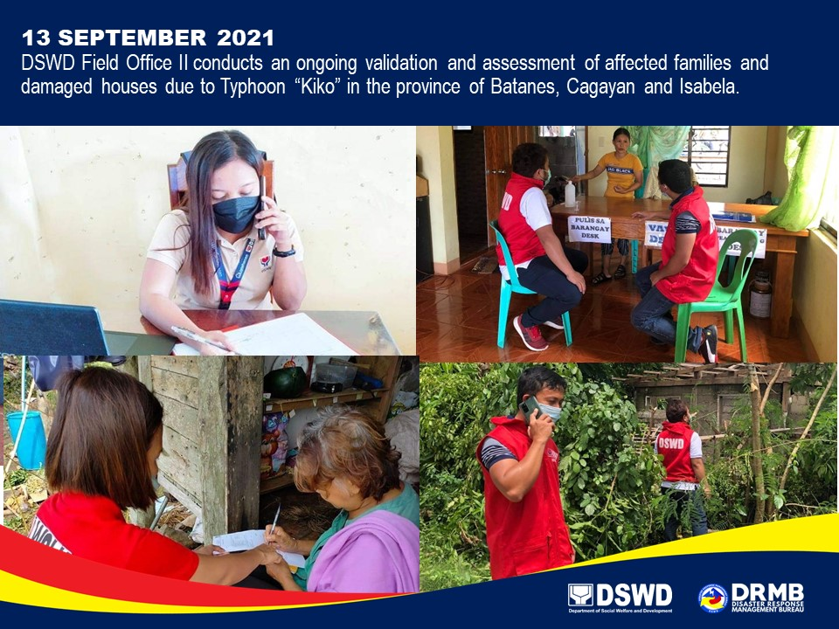

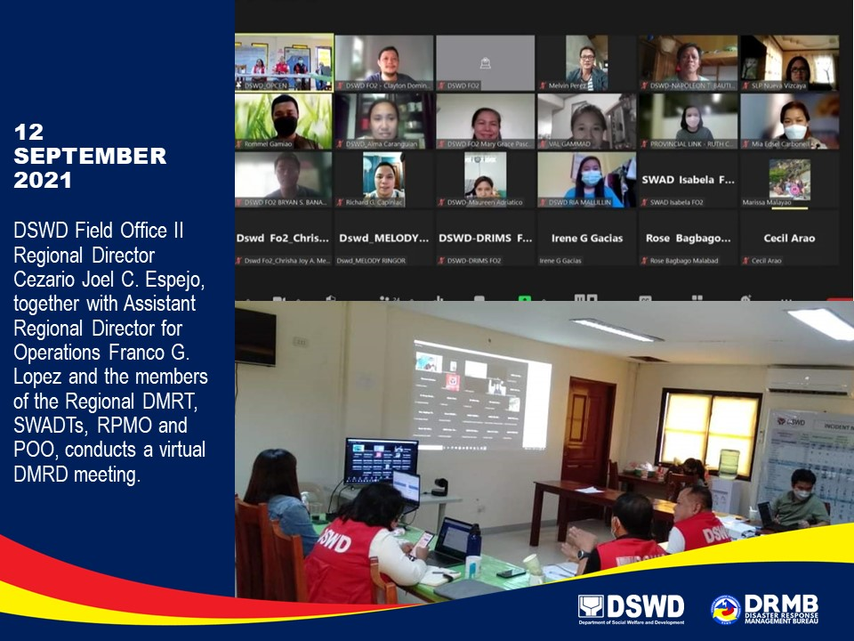

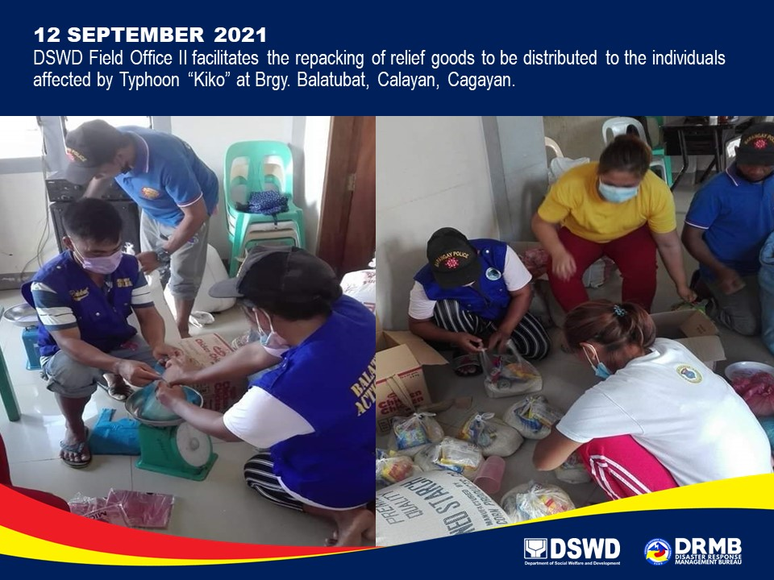

*****
The Disaster Response Operations Monitoring and Information Center (DROMIC) of DSWD-DRMB is closely coordinating with the concerned DSWD-FOs for significant disaster response updates and assistance provided.

Prepared by:  MARIEL B. FERRARIZ  MARIE JOYCE G. RAFANAN | Released by:  RODEL V. CABADDU

