DSWD DROMIC Report #7 on Typhoon “KIKO”
as of 17 September 2021, 6PM

- Situation Overview

On 07 September 2021, “Kiko” entered the Philippine Area of Responsibility (PAR) and intensified into a Typhoon. On 11 September 2021, Typhoon “Kiko” continued to weaken while moving over the coastal waters of Itbayat, Batanes bringing heavy to intense with at times torrential rains over Batanes. Moderate to heavy with at times intense rains were also likely over Babuyan Islands, the northern portion of Cagayan, Ilocos Norte, Ilocos Sur, Abra, Apayao, Kalinga, and Benguet. Under these conditions, scattered to widespread flooding (including flash floods) and rain-induced landslides were possible especially in areas that are highly or very highly susceptible to these hazard as identified in hazard maps. Typhoon “KIKO” continued to enhance the Southwest Monsoon, bringing monsoon rains over Metro Manila, the rest of Ilocos Region, and the western sections of Central Luzon and Southern Luzon. On 12 September 2021, “KIKO” slightly weakened as it exited PAR.
Source: DOST-PAGASA Weather Advisory

- Status of Affected Areas and Population

A total of 6,447 families or 22,843 persons were affected by Typhoon “Kiko” in 160 Barangays in Regions I, II and CAR (see Table 1).

Table 1. Number of Affected Families / Persons
REGION / PROVINCE / MUNICIPALITY |  | NUMBER OF AFFECTED
 |  | Barangays | Families | Persons
GRAND TOTAL |  | 160 | 6,447 | 22,843
REGION I |  | 13 | 1,194 | 4,565
Ilocos Norte |  | 6 | 429 | 1,813
 | CITY OF BATAC | 4 | 408 | 1731
 | Currimao | 1 | 4 | 19
 | Pagudpud | 1 | 17 | 63
La Union |  | 7 | 765 | 2,752
 | Bauang | 7 | 765 | 2,752
REGION II |  | 138 | 5,150 | 17,880
Batanes |  | 25 | 3,089 | 11,071
 | Basco | 5 | 476 | 1,897
 | Itbayat | 5 | 955 | 2,985
 | Ivana | 4 | 134 | 861
 | Mahatao | 1 | 517 | 1,778
 | Sabtang | 6 | 582 | 1,992
 | Uyugan | 4 | 425 | 1,558
Cagayan |  | 100 | 1,839 | 6,007
 | Abulug | 1 | 1 | 3
 | Alcala | 2 | 9 | 36
 | Allacapan | 5 | 96 | 346
 | Aparri | 8 | 57 | 248
 | Baggao | 28 | 828 | 2,363
 | Buguey | 1 | - | 19
 | Calayan | 9 | 217 | 696
 | Gattaran | 12 | 206 | 797
 | Gonzaga | 2 | 11 | 46
 | Lal-lo | 7 | 88 | 323
 | Lasam | 2 | 57 | 197
 | Pamplona | 7 | 95 | 264
 | Santa Ana | 7 | 106 | 420
 | Santa Praxedes | 2 | 9 | 30
 | Santa Teresita | 5 | 56 | 208
 | Solana | 2 | 3 | 11
Isabela |  | 13 | 222 | 802
 | Divilacan | 5 | 125 | 537
 | Maconacon | 8 | 97 | 265
CAR |  | 9 | 103 | 398
Abra |  | 4 | 53 | 220
 | Bangued (capital) | 3 | 52 | 212
 | Licuan-Baay (Licuan) | 1 | 1 | 8
Apayao |  | 3 | 48 | 168
 | Conner | 2 | 18 | 70
 | Santa Marcela | 1 | 30 | 98
Benguet |  | 2 | 2 | 10
 | Itogon | 1 | 1 | 3
 | La Trinidad (capital) | 1 | 1 | 7
Note: Ongoing assessment and validation are continuously being conducted.
Source: DSWD-Field Offices (FOs)
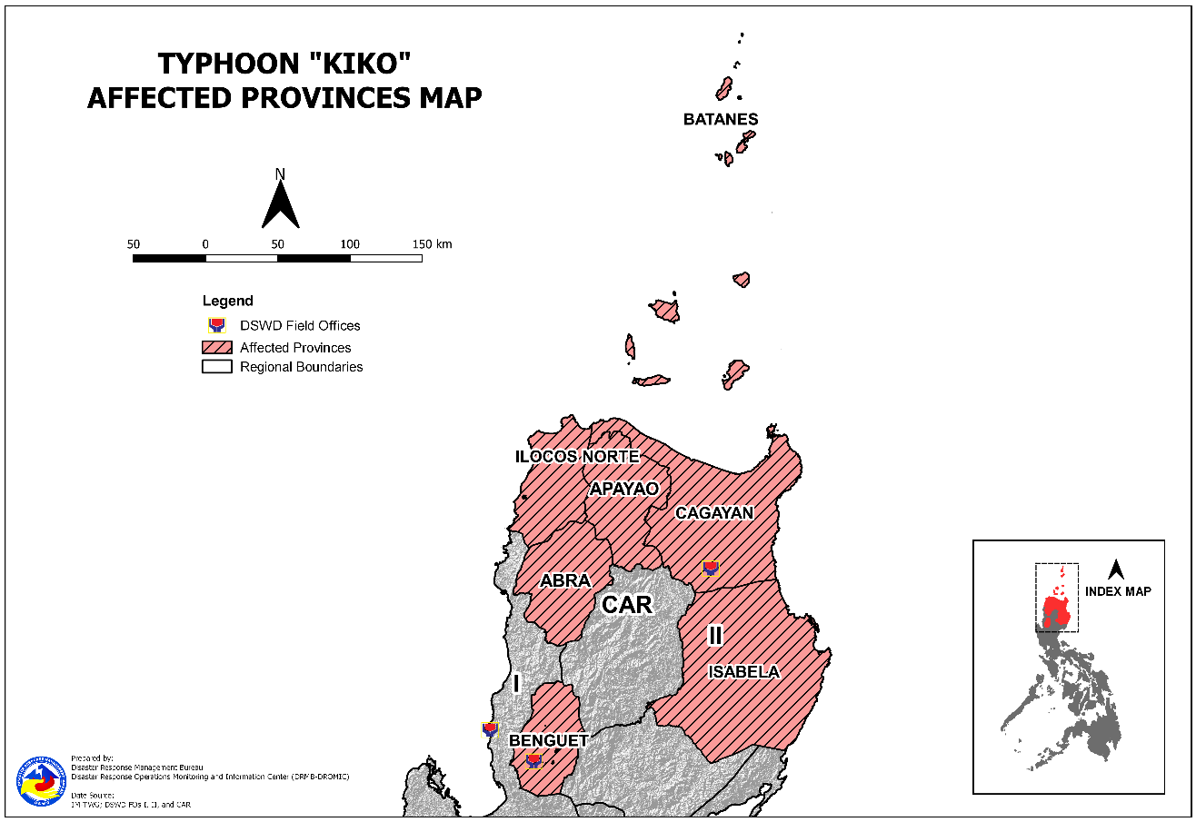

- Status of Displaced Population

- Inside Evacuation Centers
There are 10 families or 37 persons currently taking temporary shelter in one (1) evacuation center in Region II (see Table 2).

Table 2. Number of Displaced Families / Persons Inside Evacuation Centers
REGION / PROVINCE / MUNICIPALITY |  | NUMBER OF EVACUATION CENTERS (ECs) |  | NUMBER OF DISPLACED
 |  |  |  | INSIDE ECs
 |  |  |  | Families |  | Persons
 |  | CUM | NOW | CUM | NOW | CUM | NOW
GRAND TOTAL |  | 106 | 1 | 1,083 | 10 | 3,914 | 37
REGION I |  | 1 | - | 17 | - | 63 | -
Ilocos Norte |  | 1 | - | 17 | - | 63 | -
 | Pagudpud | 1 | - | 17 | - | 63 | -
REGION II |  | 104 | 1 | 1,046 | 10 | 3,787 | 37
Batanes |  | 5 | 1 | 17 | 10 | 63 | 37
 | Basco | 2 | 1 | 12 | 10 | 43 | 37
 | Itbayat | 1 | - | 3 | - | 12 | -
 | Sabtang | 2 | - | 2 | - | 8 | -
Cagayan |  | 88 | - | 842 | - | 3,039 | -
 | Abulug | 1 | - | 1 | - | 3 | -
 | Alcala | 2 | - | 9 | - | 36 | -
 | Allacapan | 5 | - | 92 | - | 331 | -
 | Aparri | 6 | - | 18 | - | 85 | -
 | Baggao | 24 | - | 213 | - | 734 | -
 | Buguey | 1 | - | - | - | 19 | -
 | Calayan | 4 | - | 34 | - | 123 | -
 | Gattaran | 11 | - | 131 | - | 521 | -
 | Gonzaga | 3 | - | 11 | - | 46 | -
 | Lal-lo | 9 | - | 88 | - | 323 | -
 | Lasam | 3 | - | 41 | - | 136 | -
 | Pamplona | 4 | - | 87 | - | 251 | -
 | Santa Ana | 4 | - | 69 | - | 258 | -
 | Santa Praxedes | 2 | - | 9 | - | 30 | -
 | Santa Teresita | 7 | - | 36 | - | 132 | -
 | Solana | 2 | - | 3 | - | 11 | -
Isabela |  | 11 | - | 187 | - | 685 | -
 | Divilacan | 7 | - | 115 | - | 494 | -
 | Maconacon | 4 | - | 72 | - | 191 | -
CAR |  | 1 | - | 20 | - | 64 | -
Apayao |  | 1 | - | 20 | - | 64 | -
 | Santa Marcela | 1 | - | 20 | - | 64 | -
Note: Figures in Buguey, Cagayan are 19 individuals with no affected families. Hence, ongoing assessment and validation are continuously being conducted.
Source: DSWD-FOs

- Outside Evacuation Centers
There are 49 families or 196 persons temporarily staying with their relatives and/or friends in Region II (see Table 3).

Table 3. Number of Displaced Families / Persons Outside Evacuation Centers
REGION / PROVINCE / MUNICIPALITY |  | NUMBER OF DISPLACED
 |  | OUTSIDE ECs
 |  | Families |  | Persons
 |  | CUM | NOW | CUM | NOW
GRAND TOTAL |  | 1,188 | 49 | 3,688 | 196
REGION II |  | 1,143 | 49 | 3,503 | 196
Batanes |  | 111 | 49 | 415 | 196
 | Itbayat | 38 | - | 129 | -
 | Ivana | 10 | 4 | 39 | 16
 | Mahatao | 34 | 34 | 136 | 136
 | Sabtang | 15 | 2 | 54 | 10
 | Uyugan | 14 | 9 | 57 | 34
Cagayan |  | 997 | - | 2,971 | -
 | Allacapan | 4 | - | 15 | -
 | Aparri | 39 | - | 163 | -
 | Baggao | 615 | - | 1,629 | -
 | Calayan | 183 | - | 573 | -
 | Gattaran | 75 | - | 276 | -
 | Lasam | 16 | - | 61 | -
 | Pamplona | 8 | - | 13 | -
 | Santa Ana | 37 | - | 162 | -
 | Santa Teresita | 20 | - | 79 | -
Isabela |  | 35 | - | 117 | -
 | Divilacan | 10 | - | 43 | -
 | Maconacon | 25 | - | 74 | -
CAR |  | 45 | - | 185 | -
Abra |  | 16 | - | 74 | -
 | Bangued (capital) | 15 | - | 66 | -
 | Licuan-Baay (Licuan) | 1 | - | 8 | -
Apayao |  | 28 | - | 104 | -
 | Conner | 18 | - | 70 | -
 | Santa Marcela | 10 | - | 34 | -
Benguet |  | 1 | - | 7 | -
 | La Trinidad (capital) | 1 | - | 7 | -
Note: Ongoing assessment and validation are continuously being conducted.
Source: DSWD-FOs

- Total Displaced Population
There are 59 families or 233 persons still displaced in Region II due to Typhoon “Kiko” (see Table 4).

Table 4. Total Number of Displaced Families / Persons
REGION / PROVINCE / MUNICIPALITY |  | TOTAL DISPLACED SERVED
 |  | Families |  | Persons
 |  | Total Families |  | Total Persons
 |  | CUM | NOW | CUM | NOW
GRAND TOTAL |  | 2,271 | 59 | 7,602 | 233
REGION I |  | 17 | - | 63 | -
Ilocos Norte |  | 17 | - | 63 | -
 | Pagudpud | 17 | - | 63 | -
REGION II |  | 2,189 | 59 | 7,290 | 233
Batanes |  | 128 | 59 | 478 | 233
 | Basco | 12 | 10 | 43 | 37
 | Itbayat | 41 | - | 141 | -
 | Ivana | 10 | 4 | 39 | 16
 | Mahatao | 34 | 34 | 136 | 136
 | Sabtang | 17 | 2 | 62 | 10
 | Uyugan | 14 | 9 | 57 | 34
Cagayan |  | 1,839 | - | 6,010 | -
 | Abulug | 1 | - | 3 | -
 | Alcala | 9 | - | 36 | -
 | Allacapan | 96 | - | 346 | -
 | Aparri | 57 | - | 248 | -
 | Baggao | 828 | - | 2,363 | -
 | Buguey | - | - | 19 | -
 | Calayan | 217 | - | 696 | -
 | Gattaran | 206 | - | 797 | -
 | Gonzaga | 11 | - | 46 | -
 | Lal-lo | 88 | - | 323 | -
 | Lasam | 57 | - | 197 | -
 | Pamplona | 95 | - | 264 | -
 | Santa Ana | 106 | - | 420 | -
 | Santa Praxedes | 9 | - | 30 | -
 | Santa Teresita | 56 | - | 211 | -
 | Solana | 3 | - | 11 | -
Isabela |  | 222 | - | 802 | -
 | Divilacan | 125 | - | 537 | -
 | Maconacon | 97 | - | 265 | -
CAR |  | 65 | - | 249 | -
Abra |  | 16 | - | 74 | -
 | Bangued (capital) | 15 | - | 66 | -
 | Licuan-Baay (Licuan) | 1 | - | 8 | -
Apayao |  | 48 | - | 168 | -
 | Conner | 18 | - | 70 | -
 | Santa Marcela | 30 | - | 98 | -
Benguet |  | 1 | - | 7 | -
 | La Trinidad (capital) | 1 | - | 7 | -
Note: Ongoing assessment and validation are continuously being conducted.
Source: DSWD-FOs

- Damaged Houses
A total of 652 houses were damaged; of which, 78 are totally damaged and 574 are partially damaged in Regions II and CAR (see Table 5).

Table 5. Number of Damaged Houses
REGION / PROVINCE / MUNICIPALITY |  | NO. OF DAMAGED HOUSES
 |  | Total | Totally | Partially
GRAND TOTAL |  | 652 | 78 | 574
REGION II |  | 649 | 78 | 571
Batanes |  | 643 | 76 | 567
 | Itbayat | 126 | 13 | 113
 | Ivana | 134 | 13 | 121
 | Mahatao | 34 | 13 | 21
 | Sabtang | 203 | 28 | 175
 | Uyugan | 146 | 9 | 137
Cagayan |  | 6 | 2 | 4
 | Calayan | 6 | 2 | 4
CAR |  | 3 | - | 3
Abra |  | 1 | - | 1
 | Licuan-Baay (Licuan) | 1 | - | 1
Benguet |  | 2 | - | 2
 | Itogon | 1 | - | 1
 | La Trinidad (capital) | 1 | - | 1
Note: Ongoing assessment and validation are continuously being conducted.
Source: DSWD-FOs

- Cost of Humanitarian Assistance Provided

A total of ₱1,051,412.00 worth of assistance was provided to the affected families; of which, ₱431,772.00 from DSWD and ₱619,640.00 from the Local Government Units (LGUs) (see Table 6).

Table 6. Cost of Assistance Provided to Affected Families / Persons
REGION / PROVINCE / MUNICIPALITY |  | COST OF ASSISTANCE
 |  | DSWD | LGUs | NGOs | OTHERS | GRAND TOTAL
GRAND TOTAL |  | 431,772.00 | 619,640.00 | - | - | 1,051,412.00
REGION I |  | - | 607,400.00 | - | - | 607,400.00
Ilocos Norte |  | - | 217,900.00 | - | - | 217,900.00
 | CITY OF BATAC | - | 172,000.00 | - | - | 172,000.00
 | Currimao | - | 1,200.00 | - | - | 1,200.00
 | Pagudpud | - | 44,700.00 | - | - | 44,700.00
La Union |  | - | 389,500.00 | - | - | 389,500.00
 | Bauang | - | 389,500.00 | - | - | 389,500.00
REGION II |  | 376,872.00 | - | - | - | 376,872.00
Cagayan |  | 376,872.00 | - | - | - | 376,872.00
 | Baggao | 376,872.00 | - | - | - | 376,872.00
CAR |  | 54,900.00 | 12,240.00 | - | - | 67,140.00
Apayao |  | 54,900.00 | 12,240.00 | - | - | 67,140.00
 | Santa Marcela | 54,900.00 | 12,240.00 | - | - | 67,140.00
Note: Cost of assistance provided by the LGU in Currimao, Ilocos Norte decreased based on the validated report submitted by DSWD-FO I.
Source: DSWD-Field Offices (FOs)

- Response Actions and Interventions

- Standby Funds and Prepositioned Relief Stockpile

OFFICE | STANDBY FUNDS | STOCKPILE |  |  | TOTAL STANDBY FUNDS & STOCKPILE
 |  | FAMILY FOOD PACKS |  | OTHER FOOD AND NON-FOOD ITEMS (FNIs)
 |  | QUANTITY | TOTAL COST
TOTAL | 462,436,491.73 | 397,709 | 223,934,024.37 | 668,249,826.58 | 1,354,620,342.68
DSWD-CO | 403,151,648.37 | - | - | - | 403,151,648.37
NRLMB-NROC | - | 74,438 | 50,281,985.60 | 175,279,016.18 | 225,561,001.78
NRLMB-VDRC | - | 2,734 | 1,298,650.00 | 30,497,307.86 | 31,795,957.86
DSWD-FO I | 5,091,035.20 | 27,066 | 13,803,660.00 | 41,172,031.23 | 60,066,726.43
DSWD-FO II | 80,962.68 | 17,705 | 7,244,934.00 | 17,827,309.92 | 25,153,206.60
DSWD-FO CAR | 5,920,079.12 | 25,918 | 13,076,873.86 | 22,769,300.16 | 41,766,253.14
Other FOs | 48,192,766.36 | 249,848 | 138,227,920.91 | 380,704,861.23 | 567,125,548.50
Note: The Inventory Summary is as of 17 September 2021, 4PM.

Source: DSWD-National Resource and Logistics Management Bureau (NRLMB)

  - Standby Funds
    - ₱403.15 million Quick Response Fund (QRF) at the DSWD-Central Office.
    - ₱11.09 million available at DSWD-FOs I, II and CAR.
    - ₱48.19 million in other DSWD-FOs which may support the relief needs of the displaced families due to Typhoon “KIKO” through inter-FO augmentation.

  - Prepositioned FFPs and Other Relief Items
    - 77,172 FFPs available in Disaster Response Centers; of which, 74,438 FFPs are at the National Resource Operations Center (NROC), Pasay City and 2,734 FFPs are at the Visayas Disaster Response Center (VDRC), Cebu City.
    - 70,689 FFPs available at DSWD-FOs I, II and CAR.
    - 249,848 FFPs in other DSWD-FOs which may support the relief needs of the displaced families due to Typhoon “KIKO” through inter-FO augmentation.
    - ₱668.25 million worth of food and non-food items (FNIs) at NROC, VDRC and DSWD-FO warehouses countrywide.

- Food and Non-Food Items

DSWD-FO CAR
DATE | ACTIVITIES
15 September 2021 | - DSWD-FO CAR facilitated request for replenishment of standby funds to DRMB as well as request for FFPs, tents to NRLMB and procurement of raw materials equivalent to 10,000 FFPs
14 September 2021 | - DSWD-FO CAR provided 30 Hygiene Kits to LGU Santa Marcela.
13 September 2021 | - Production of FFPs at the Regional Production Hubs was conducted.
9 September 2021 | - DSWD-FO CAR requested from NRLMB for replenishment of standby funds and additional raw materials equivalent to 5,000 FFPs.  - 2,500 FFPs and 135 hygiene kits were delivered to DSWD warehouse in the Province of Abra.  - Ensures availability of food and non-food items for resource augmentation as need arises
8 September 2021 | - 800 FFPs were delivered to DSWD warehouse in Mountain Province.

DSWD-FO I
DATE | ACTIVITIES
15 September 2021 | - DSWD-FO I continuously disinfection and repacking at the Regional warehouse in La Union.
13 September 2021 | - Production of FFPs and disinfestation of rice at the DSWD Regional Warehouse, Biday, City of San Fernando, La Union were conducted.

DSWD-FO II
DATE | ACTIVITIES
14 September 2021 | - DSWD-FO II in continuous coordination with the OCD on the request for airlift of 600FFPs as augmentation support to LGU Calayan.
13 September 2021 | - DSWD-FO II conducted repacking of FFPs to meet the required level of stockpile of the Region.  - LGU Baggao, Cagayan hauled 766 FFPs as augmentation support to the affected families.  - Philippine Air Force (PAF) confirmed the availability of their aircraft to ferry FFPs for Batanes Province. The aircraft can transport a maximum of 4,500 FFPs.
12 September 2021 | - DSWD-FO II coordinated with NRLMB on the request of 5,000 FPPs to be airlifted to the Province of Batanes in coordination with Office of Civil Defense (OCD) Regional Office (RO) 2 and PAF.

- Camp Coordination and Camp Management

DSWD-FO II
DATE | ACTIVITIES
11 September 2021 | - 279 Families or 868 individuals were pre-emptively and forcedly evacuated, and brought to the 29 evacuation centers.  - 29 Families or 97 individuals pre-emptive evacuated and stayed with their relatives and/or friends.  - 23 Individuals were stranded in Claveria Seaport; of which, 10 individuals from Fuga Island took shelter at the fish port, while the 13 individuals stayed with their relatives at Brgy. Centro 5, Claveria, Cagayan.
9 September 2021 | - DSWD-FO CAR provided technical assistance to LGUs on Camp Coordination and Camp Management (CCCM).

- Other Activities

DSWD-FO I
DATE | ACTIVITIES
15 September 2021 | - DSWD-FO I is closely monitoring the effects of Typhoon “Kiko” in coordination with the different Local Disaster Risk Reduction and Management Councils (DRRMCs), Local Social Welfare and Development Offices (SWDOs), and Social Welfare and Development Team (SWADT) Leaders for any significant updates.
10 September 2021 | - DSWD FO-I closely monitored the effects of the Typhoon “Kiko” through the Department of Science and Technology-Philippine Atmospheric, Geophysical, and Astronomical Services Administration (DOST-PAGASA) and in close coordination with the Regional DRRMC 1.  - The Provincial Operations Offices (POOs) of DSWD-FO I closely coordinated with the different Local DRRMCs and Local SWDOs to monitor the adverse effects that might be brought by the weather disturbance.  - DSWD-FO I attended the Regional Pre-Disaster Risk Assessment (PDRA) – Analyst/Core Group Meeting through video teleconference.  - The DSWD-FO I Incident Management Team (IMT) remained activated and on duty while other DSWD staff were on standby for possible augmentation. Likewise, FO ensured the availability and readiness of resources.

DSWD-FO II
DATE | ACTIVITIES
16 September 2021 | - DSWD-FO II thru its SWAD team in Batanes are ongoing validation of affected families as basis in providing Financial assistance thru AICS.  - DSWD-FO V DRMD-DRR chief Mr Rommel Gamiao attended the RDNA virtual meeting organized by the OCD Region II.  - DSWD-FO II thru the DRMD coordinated AFP anf Philippine Navy the airlifting/shipping of 500 FFPs bound to Batanes.
15 September 2021 | - DSWD-FO II facilitated the request for standby funds replenishment submitted to DRMG thru DRMB.
13 September 2021 | - Rapid Damage Assessment and Needs Analysis (RDANA) Team had a meeting to finalize activities to be conducted with regard to the aerial assessment in Calayan, Cagayan and Batanes Province to identify the magnitude of disaster brought by Typhoon “Kiko”.  - DSWD-FO II continuously coordinated with the Batanes Province on status of affected families and number of damaged houses.  - DSWD-FO conducted validation and assessment for the provision of immediate financial assistance through Assistance to Individuals in Crisis Situation (AICS) to families affected by Typhoon “Kiko”.  - DSWD-FO II through its Disaster Response Management Division (DRMD) closely coordinated with the Regional DRRMC and other concerned agencies for any concerns that need to be addressed.  - The SWADTs, POOs, Provincial/City/Municipal Action Teams (P/C/MATs) of DSWD-FO II coordinated with their respective Local DRRMCs for updates relative to the adverse effects brought by Typhoon “Kiko”.
12 September 2021 | - DSWD-FO II together with the LGU of Calayan, Cagayan provided immediate needs to the affected families in the evacuation centers.  - DSWD-FO II provided instructions to SWADTs and MATs to work with the LGUs/Local SWDOs for immediate conduct of assessment for the provision of financial assistance through AICS to the affected families.
10 September 2021 | - The DRMD and Disaster Monitoring and Response Teams of DSWD-FO II started rendering 24-hour duty to continuously monitor the effects of Typhoon “Kiko”.

DSWD-FO CAR
DATE | ACTIVITIES
16 September 2021 | - DSWD-FO CAR submitted their terminal report.
13 September 2021 | - The Quick Response Teams (QRTs) duty at DSWD-FO CAR and PATs of Abra, Apayao and Benguet are on standby and ready for augmentation.
9 September 2021 | - DSWD FO-CAR conducted QRT Orientation via Zoom.  - DSWD-FO CAR ensured availability of transportation service.

- Photo Documentation
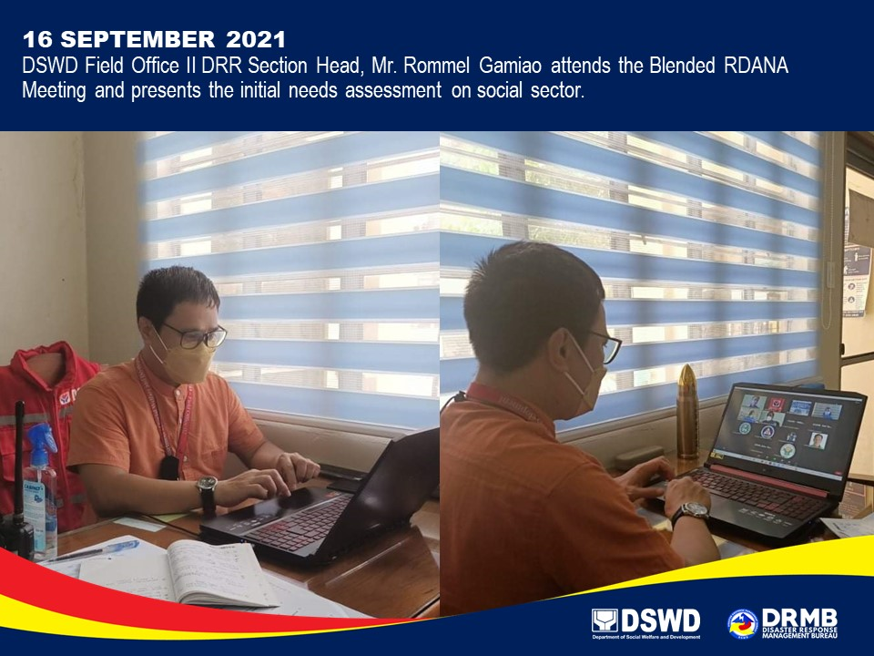

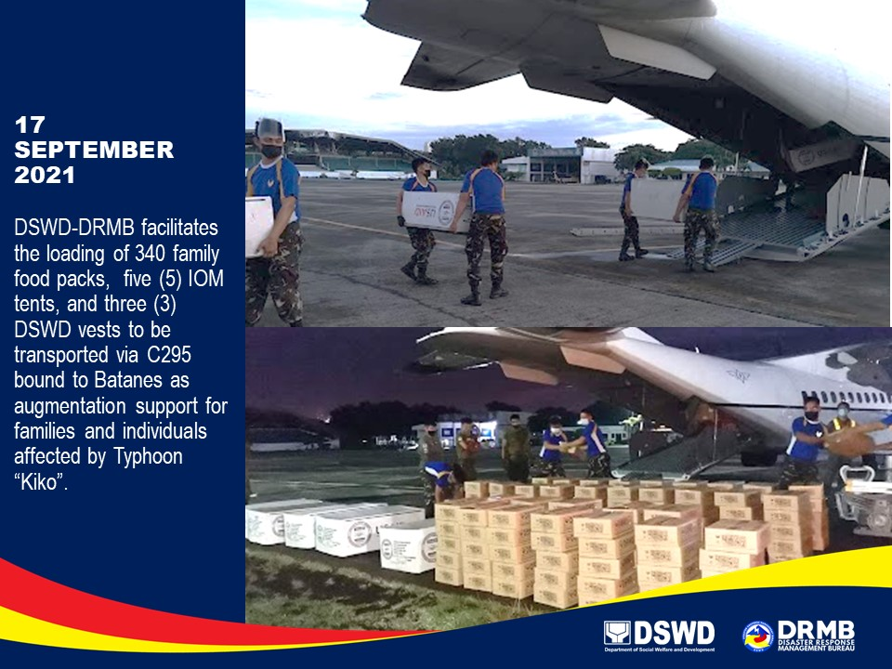

*****
The Disaster Response Operations Monitoring and Information Center (DROMIC) of DSWD-DRMB is closely coordinating with the concerned DSWD-FOs for significant disaster response updates and assistance provided.

Prepared by:  MARIEL B. FERRARIZ  MARIE JOYCE G. RAFANAN | Released by:  RODEL V. CABADDU

