DSWD DROMIC Terminal Report on Typhoon “KIKO”
13 November 2021, 6PM

SUMMARY

On 07 September 2021, “KIKO” entered the Philippine Area of Responsibility (PAR) and intensified into a Typhoon. On 11 September 2021, Typhoon “Kiko” continued to weaken while moving over the coastal waters of Itbayat, Batanes bringing heavy to intense with at times torrential rains over Batanes. Moderate to heavy with at times intense rains were also likely over Babuyan Islands, the northern portion of Cagayan, Ilocos Norte, Ilocos Sur, Abra, Apayao, Kalinga, and Benguet. Under these conditions, scattered to widespread flooding (including flashfloods) and rain-induced landslides were possible especially in areas that are highly or very highly susceptible to these hazard as identified in hazard maps. Typhoon “KIKO” continued to enhance the Southwest Monsoon, bringing monsoon rains over Metro Manila, the rest of Ilocos Region, and the western sections of Central Luzon and Southern Luzon. On 12 September 2021, “KIKO” slightly weakened as it exited PAR.
Source: DOST-PAGASA Weather Advisory

- Status of Affected Areas and Population
A total of 9,385 families or 32,387 persons were affected by Typhoon “Kiko” in 167 Barangays in Regions I, II and CAR (see Table 1).

Table 1. Number of Affected Families / Persons
REGION / PROVINCE / MUNICIPALITY |  | NUMBER OF AFFECTED
 |  | Barangays | Families | Persons
GRAND TOTAL |  | 167 | 9,385 | 32,387
REGION I |  | 16 | 1,198 | 4,581
Ilocos Norte |  | 6 | 429 | 1,813
 | CITY OF BATAC | 4 | 408 | 1731
 | Currimao | 1 | 4 | 19
 | Pagudpud | 1 | 17 | 63
La Union |  | 10 | 769 | 2,768
 | Bauang | 7 | 765 | 2,752
 | Burgos | 3 | 4 | 16
REGION II |  | 142 | 8,084 | 27,408
Batanes |  | 29 | 6,003 | 20,568
 | Basco | 6 | 3,043 | 10,656
 | Itbayat | 5 | 977 | 2,985
 | Ivana | 4 | 441 | 1,609
 | Mahatao | 4 | 517 | 1,792
 | Sabtang | 6 | 575 | 1,968
 | Uyugan | 4 | 450 | 1,558
Cagayan |  | 100 | 1,859 | 6,038
 | Abulug | 1 | 1 | 3
 | Alcala | 2 | 9 | 36
 | Allacapan | 5 | 96 | 346
 | Aparri | 8 | 57 | 248
 | Baggao | 28 | 828 | 2,363
 | Buguey | 1 | - | 19
 | Calayan | 9 | 217 | 696
 | Gattaran | 12 | 226 | 825
 | Gonzaga | 2 | 11 | 46
 | Lal-lo | 7 | 88 | 323
 | Lasam | 2 | 57 | 197
 | Pamplona | 7 | 95 | 264
 | Santa Ana | 7 | 106 | 420
 | Santa Praxedes | 2 | 9 | 30
 | Santa Teresita | 5 | 56 | 211
 | Solana | 2 | 3 | 11
Isabela |  | 13 | 222 | 802
 | Divilacan | 5 | 125 | 537
 | Maconacon | 8 | 97 | 265
CAR |  | 9 | 103 | 398
Abra |  | 4 | 53 | 220
 | Bangued (capital) | 3 | 52 | 212
 | Licuan-Baay (Licuan) | 1 | 1 | 8
Apayao |  | 3 | 48 | 168
 | Conner | 2 | 18 | 70
 | Santa Marcela | 1 | 30 | 98
Benguet |  | 2 | 2 | 10
 | Itogon | 1 | 1 | 3
 | La Trinidad (capital) | 1 | 1 | 7
Note: Changes in figures in Batanes are based on the final report submitted by DSWD-FO II.
Source: DSWD-Field Offices (FOs)

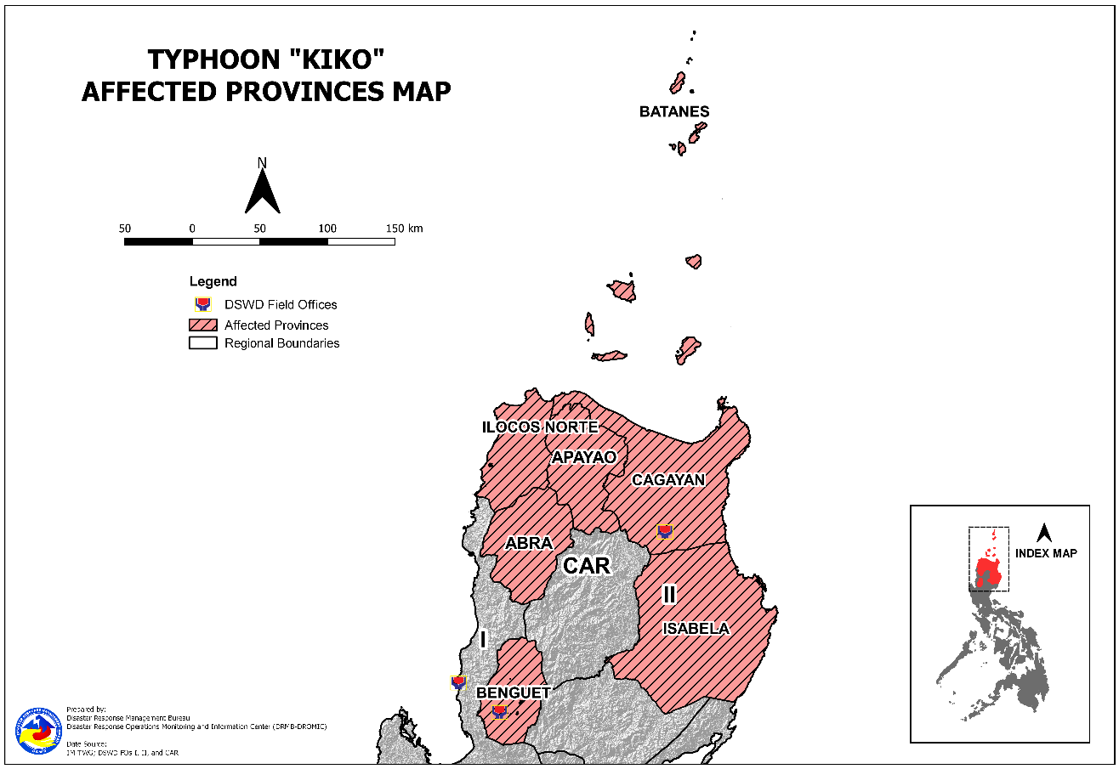

- Status of Displaced Population

- Inside Evacuation Centers
A total of 1,100 families or 3,927 persons sought temporary shelter in 110 evacuation centers in Regions I, II and CAR (see Table 2).

Table 2. Number of Displaced Families / Persons Inside Evacuation Centers
REGION / PROVINCE / MUNICIPALITY |  | NUMBER OF EVACUATION CENTERS (ECs) |  | NUMBER OF DISPLACED
 |  |  |  | INSIDE ECs
 |  |  |  | Families |  | Persons
 |  | CUM | NOW | CUM | NOW | CUM | NOW
GRAND TOTAL |  | 110 | - | 1,100 | - | 3,927 | -
REGION I |  | 1 | - | 17 | - | 63 | -
Ilocos Norte |  | 1 | - | 17 | - | 63 | -
 | Pagudpud | 1 | - | 17 | - | 63 | -
REGION II |  | 108 | - | 1,063 | - | 3,800 | -
Batanes |  | 9 | - | 34 | - | 150 | -
 | Basco | 4 | - | 22 | - | 93 | -
 | Itbayat | 1 | - | 3 | - | 12 | -
 | Mahatao | 2 | - | 7 | - | 37 | -
 | Sabtang | 2 | - | 2 | - | 8 | -
Cagayan |  | 88 | - | 842 | - | 2,965 | -
 | Abulug | 1 | - | 1 | - | 3 | -
 | Alcala | 2 | - | 9 | - | 36 | -
 | Allacapan | 5 | - | 92 | - | 331 | -
 | Aparri | 6 | - | 18 | - | 85 | -
 | Baggao | 24 | - | 213 | - | 734 | -
 | Buguey | 1 | - | - | - | 19 | -
 | Calayan | 4 | - | 34 | - | 123 | -
 | Gattaran | 11 | - | 131 | - | 447 | -
 | Gonzaga | 3 | - | 11 | - | 46 | -
 | Lal-lo | 9 | - | 88 | - | 323 | -
 | Lasam | 3 | - | 41 | - | 136 | -
 | Pamplona | 4 | - | 87 | - | 251 | -
 | Santa Ana | 4 | - | 69 | - | 258 | -
 | Santa Praxedes | 2 | - | 9 | - | 30 | -
 | Santa Teresita | 7 | - | 36 | - | 132 | -
 | Solana | 2 | - | 3 | - | 11 | -
Isabela |  | 11 | - | 187 | - | 685 | -
 | Divilacan | 7 | - | 115 | - | 494 | -
 | Maconacon | 4 | - | 72 | - | 191 | -
CAR |  | 1 | - | 20 | - | 64 | -
Apayao |  | 1 | - | 20 | - | 64 | -
 | Santa Marcela | 1 | - | 20 | - | 64 | -
Note: Figures in Buguey, Cagayan are 19 individuals with no affected families.
Source: DSWD-FOs

- Outside Evacuation Centers
There are nine (9) families or 37 persons still temporarily staying with their relatives and/or friends in Region II (see Table 3).

Table 3. Number of Displaced Families / Persons Outside Evacuation Centers
REGION / PROVINCE / MUNICIPALITY |  | NUMBER OF DISPLACED
 |  | OUTSIDE ECs
 |  | Families |  | Persons
 |  | CUM | NOW | CUM | NOW
GRAND TOTAL |  | 1,191 | 9 | 3,748 | 37
REGION II |  | 1,146 | 9 | 3,563 | 37
Batanes |  | 94 | 9 | 373 | 37
 | Itbayat | 49 | - | 196 | -
 | Ivana | 10 | 3 | 39 | 10
 | Mahatao | 6 | - | 27 | -
 | Sabtang | 15 | - | 54 | -
 | Uyugan | 14 | 6 | 57 | 27
Cagayan |  | 1,017 | - | 3,073 | -
 | Allacapan | 4 | - | 15 | -
 | Aparri | 39 | - | 163 | -
 | Baggao | 615 | - | 1,629 | -
 | Calayan | 183 | - | 573 | -
 | Gattaran | 95 | - | 378 | -
 | Lasam | 16 | - | 61 | -
 | Pamplona | 8 | - | 13 | -
 | Santa Ana | 37 | - | 162 | -
 | Santa Teresita | 20 | - | 79 | -
Isabela |  | 35 | - | 117 | -
 | Divilacan | 10 | - | 43 | -
 | Maconacon | 25 | - | 74 | -
CAR |  | 45 | - | 185 | -
Abra |  | 16 | - | 74 | -
 | Bangued (capital) | 15 | - | 66 | -
 | Licuan-Baay (Licuan) | 1 | - | 8 | -
Apayao |  | 28 | - | 104 | -
 | Conner | 18 | - | 70 | -
 | Santa Marcela | 10 | - | 34 | -
Benguet |  | 1 | - | 7 | -
 | La Trinidad (capital) | 1 | - | 7 | -
Note: The remaining displaced families seek temporary shelter with their relatives and/or friends while waiting for the completion of the construction of their houses since the Provincial Government of Batanes already provided construction materials.
Source: DSWD-FOs

- Total Displaced Population
There are nine (9) families or 37 persons still displaced in Region II due to Typhoon “Kiko” (see Table 4).

Table 4. Total Number of Displaced Families / Persons
REGION / PROVINCE / MUNICIPALITY |  | TOTAL DISPLACED SERVED
 |  | Families |  | Persons
 |  | Total Families |  | Total Persons
 |  | CUM | NOW | CUM | NOW
GRAND TOTAL |  | 2,291 | 9 | 7,675 | 37
REGION I |  | 17 | - | 63 | -
Ilocos Norte |  | 17 | - | 63 | -
 | Pagudpud | 17 | - | 63 | -
REGION II |  | 2,209 | 9 | 7,363 | 37
Batanes |  | 128 | 9 | 523 | 37
 | Basco | 22 | - | 93 | -
 | Itbayat | 52 | - | 208 | -
 | Ivana | 10 | 3 | 39 | 10
 | Mahatao | 13 | - | 64 | -
 | Sabtang | 17 | - | 62 | -
 | Uyugan | 14 | 6 | 57 | 27
Cagayan |  | 1,859 | - | 6,038 | -
 | Abulug | 1 | - | 3 | -
 | Alcala | 9 | - | 36 | -
 | Allacapan | 96 | - | 346 | -
 | Aparri | 57 | - | 248 | -
 | Baggao | 828 | - | 2,363 | -
 | Buguey | - | - | 19 | -
 | Calayan | 217 | - | 696 | -
 | Gattaran | 226 | - | 825 | -
 | Gonzaga | 11 | - | 46 | -
 | Lal-lo | 88 | - | 323 | -
 | Lasam | 57 | - | 197 | -
 | Pamplona | 95 | - | 264 | -
 | Santa Ana | 106 | - | 420 | -
 | Santa Praxedes | 9 | - | 30 | -
 | Santa Teresita | 56 | - | 211 | -
 | Solana | 3 | - | 11 | -
Isabela |  | 222 | - | 802 | -
 | Divilacan | 125 | - | 537 | -
 | Maconacon | 97 | - | 265 | -
CAR |  | 65 | - | 249 | -
Abra |  | 16 | - | 74 | -
 | Bangued (capital) | 15 | - | 66 | -
 | Licuan-Baay (Licuan) | 1 | - | 8 | -
Apayao |  | 48 | - | 168 | -
 | Conner | 18 | - | 70 | -
 | Santa Marcela | 30 | - | 98 | -
Benguet |  | 1 | - | 7 | -
 | La Trinidad (capital) | 1 | - | 7 | -
Source: DSWD-FOs

- Damaged Houses
A total of 2,344 houses were damaged; of which, 267 are totally damaged and 2,077 are partially damaged in Regions II and CAR (see Table 5).

Table 5. Number of Damaged Houses
REGION / PROVINCE / MUNICIPALITY |  | NO. OF DAMAGED HOUSES
 |  | Total | Totally | Partially
GRAND TOTAL |  | 2,344 | 267 | 2,077
REGION II |  | 2,341 | 267 | 2,074
Batanes |  | 2,325 | 265 | 2,060
 | Basco | 1,418 | 171 | 1,247
 | Itbayat | 185 | 11 | 174
 | Ivana | 205 | 15 | 190
 | Mahatao | 109 | 22 | 87
 | Sabtang | 236 | 25 | 211
 | Uyugan | 172 | 21 | 151
Cagayan |  | 16 | 2 | 14
 | Calayan | 16 | 2 | 14
CAR |  | 3 | - | 3
Abra |  | 1 | - | 1
 | Licuan-Baay (Licuan) | 1 | - | 1
Benguet |  | 2 | - | 2
 | Itogon | 1 | - | 1
 | La Trinidad (capital) | 1 | - | 1
Note: Changes in figures are based on the final and validated report submitted by DSWD-Field Offices.
Source: DSWD-FOs

- Cost of Humanitarian Assistance Provided

A total of ₱4,153,812.00 worth of assistance was provided to the affected families; of which, ₱3,534,172.00 from DSWD and ₱619,640.00 from the Local Government Units (LGUs) (see Table 6).

Table 6. Cost of Assistance Provided to Affected Families / Persons
REGION / PROVINCE / MUNICIPALITY |  | COST OF ASSISTANCE
 |  | DSWD | LGUs | NGOs | OTHERS | GRAND TOTAL
GRAND TOTAL |  | 3,534,172.00 | 619,640.00 | - | - | 4,153,812.00
REGION I |  | - | 607,400.00 | - | - | 607,400.00
Ilocos Norte |  | - | 217,900.00 | - | - | 217,900.00
 | CITY OF BATAC | - | 172,000.00 | - | - | 172,000.00
 | Currimao | - | 1,200.00 | - | - | 1,200.00
 | Pagudpud | - | 44,700.00 | - | - | 44,700.00
La Union |  | - | 389,500.00 | - | - | 389,500.00
 | Bauang | - | 389,500.00 | - | - | 389,500.00
REGION II |  | 3,479,272.00 | - | - | - | 3,479,272.00
Batanes |  | 2,807,200.00 | - | - | - | 2,807,200.00
 | Basco | 2,807,200.00 | - | - | - | 2,807,200.00
Cagayan |  | 672,072.00 | - | - | - | 672,072.00
 | Baggao | 376,872.00 | - | - | - | 376,872.00
 | Calayan | 295,200.00 | - | - | - | 295,200.00
CAR |  | 54,900.00 | 12,240.00 | - | - | 67,140.00
Apayao |  | 54,900.00 | 12,240.00 | - | - | 67,140.00
 | Santa Marcela | 54,900.00 | 12,240.00 | - | - | 67,140.00
Note: Cost of assistance provided by the LGU in Currimao, Ilocos Norte decreased based on the validated report submitted by DSWD-FO I.
Source: DSWD-FOs

*****
This terminal report is based on the final report submitted by DSWD-FO I (17 September 2021), DSWD-FO II (12 November 2021), and DSWD-FO CAR (16 September 2021). The Disaster Response Operations Monitoring and Information Center (DROMIC) of DSWD-DRMB is closely coordinating with the concerned DSWD-FOs for any request of Technical Assistance and Resource Augmentation (TARA).

Prepared by:  MARIE JOYCE G. RAFANAN  JEM ERIC F. FAMORCAN | Released by:  RODEL V. CABADDU

