DSWD DROMIC Terminal Report on the Fire Incident
in Barangay Sabang, Puerto Galera, Oriental Mindoro
23 September 2021, 6PM

- Situation Overview
This is the final report on the fire incident occurred on 12 September 2021 at around 4:00 AM in Barangay Sabang, Puerto Galera, Oriental Mindoro.
Source: DSWD-Field Office (FO) MIMAROPA

- Status of Affected Areas and Population
A total of 20 families or 68 persons were affected by the fire incident in Barangay Sabang, Puerto Galera, Oriental Mindoro (see Table 1).

Table 1. Number of Affected Families / Persons
REGION / PROVINCE / MUNICIPALITY |  | NUMBER OF AFFECTED
 |  | Barangays | Families | Persons
GRAND TOTAL |  | 1 | 20 | 68
MIMAROPA |  | 1 | 20 | 68
Oriental Mindoro |  | 1 | 20 | 68
 | Puerto Galera | 1 | 20 | 68
Source: DSWD-FO MIMAROPA

- Status of Displaced Population
Outside Evacuation Centers
A total of 20 families or 68 persons took temporary shelter with their relatives and/or friends and have now returned home (see Table 2).

Table 2. Number of Displaced Families / Persons Outside Evacuation Centers
REGION / PROVINCE / MUNICIPALITY |  | NUMBER OF DISPLACED
 |  | OUTSIDE ECs
 |  | Families |  | Persons
 |  | CUM | NOW | CUM | NOW
GRAND TOTAL |  | 20 | 0 | 68 | 0
MIMAROPA |  | 20 | 0 | 68 | 0
Oriental Mindoro |  | 20 | 0 | 68 | 0
 | Puerto Galera | 20 | 0 | 68 | 0
Source: DSWD-FO MIMAROPA

- Damaged Houses
A total of 20 houses were totally damaged by the fire (see Table 3).

Table 3. Number of Damaged Houses
REGION / PROVINCE / MUNICIPALITY |  | NO. OF DAMAGED HOUSES
 |  | Total | Totally | Partially
GRAND TOTAL |  | 20 | 20 | -
MIMAROPA |  | 20 | 20 | -
Oriental Mindoro |  | 20 | 20 | -
 | Puerto Galera | 20 | 20 | -
Source: DSWD-FO MIMAROPA

- Cost of Humanitarian Assistance Provided
A total of ₱774,044.20 worth of assistance was provided to the affected families; of which, ₱126,844.20 from DSWD and ₱647,200.00 from LGU (see Table 4).

Table 4. Cost of Assistance Provided to Affected Families / Persons
REGION / PROVINCE / MUNICIPALITY |  | COST OF ASSISTANCE
 |  | DSWD | LGU | NGOs | OTHERS | GRAND TOTAL
GRAND TOTAL |  | 126,844.20 | 647,200.00 | - | - | 774,044.20
MIMAROPA |  | 126,844.20 | 647,200.00 | - | - | 774,044.20
Oriental Mindoro |  | 126,844.20 | 647,200.00 | - | - | 774,044.20
 | Puerto Galera | 126,844.20 | 647,200.00 | - | - | 774,044.20
Source: DSWD-FO MIMAROPA

- Photo Documentation

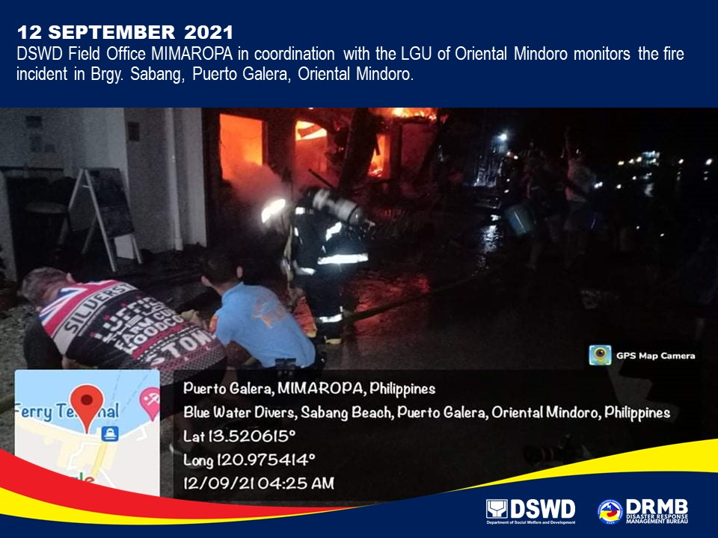
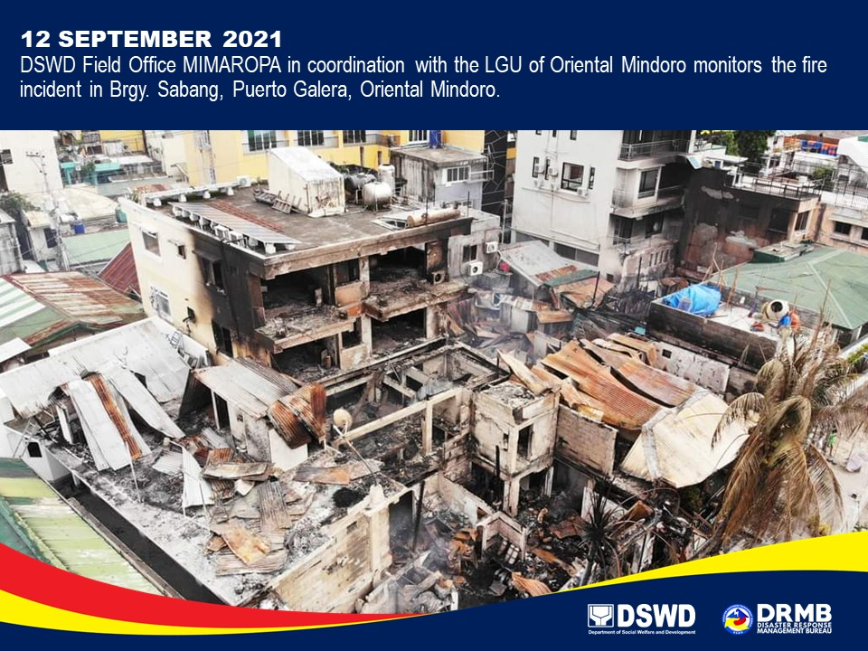

*****
This terminal report is based on the latest report submitted by DSWD-FO MIMAROPA on 15 September 2021. The Disaster Response Operations Monitoring and Information Center (DROMIC) of DSWD-DRMB continues to closely coordinate with DSWD-FO MIMAROPA for any request of Technical Assistance and Resource Augmentation (TARA).

Prepared by:  JOANNA CAMILLE R. JACINTO | Released by:  RODEL V. CABADDU

