DSWD DROMIC Terminal Report on the
Flashflood Incident in Hamtic, Antique
26 November 2021, 6PM

- Situation Overview
On 16 September 2021, a flashflood incident occurred in Barangays Calacja 2 and Asluman, Hamtic, Antique due to heavy rainfall.
Source: DSWD-Field Office (FO) VI

- Status of Affected Areas and Population
A total of 126 families or 417 persons were affected in four (4) barangays in Hamtic, Antique (see Table 1).

Table 1. Number of Affected Families / Persons
REGION / PROVINCE / MUNICIPALITY |  | NUMBER OF AFFECTED
 |  | Barangays | Families | Persons
GRAND TOTAL |  | 4 | 126 | 417
REGION VI |  | 4 | 126 | 417
Antique |  | 4 | 126 | 417
 | Hamtic | 4 | 126 | 417
Source: DSWD-FO VI

- Status of Displaced Population

- Inside Evacuation Center
There are 18 families or 77 persons who are currently staying in one (1) Evacuation Center in Brgy. Calacja 2 (See Table 2).

Table 2. Number of Displaced Families / Persons Outside Evacuation Center
REGION / PROVINCE / MUNICIPALITY |  | NUMBER OF EVACUATION CENTERS (ECs) |  | NUMBER OF DISPLACED
 |  |  |  | INSIDE ECs
 |  |  |  | Families |  | Persons
 |  | CUM | NOW | CUM | NOW | CUM | NOW
GRAND TOTAL |  | 1 | 1 | 18 | 18 | 77 | 77
REGION VI |  | 1 | 1 | 18 | 18 | 77 | 77
Antique |  | 1 | 1 | 18 | 18 | 77 | 77
 | Hamtic | 1 | 1 | 18 | 18 | 77 | 77
Note: Since all of the families are now on the process of recovering and rebuilding their homes, the LGU on its part will monitor the progress as to the recovery and rebuilding phase of each affected families.
Source: DSWD-FO VI

- Outside Evacuation Center
There were 108 families or 340 persons who sought temporary shelter with their relatives and/or friends (see Table 3).

Table 3. Number of Displaced Families / Persons Outside Evacuation Center
REGION / PROVINCE / MUNICIPALITY |  | NUMBER OF DISPLACED
 |  | OUTSIDE ECs
 |  | Families |  | Persons
 |  | CUM | NOW | CUM | NOW
GRAND TOTAL |  | 108 | - | 340 | -
REGION VI |  | 108 | - | 340 | -
Antique |  | 108 | - | 340 | -
 | Hamtic | 108 | - | 340 | -
Source: DSWD-FO VI

- Total Displaced Population
There are 18 families or 77 persons still displaced in Hamtic, Antique (See Table 4).

Table 4. Number of Displaced Families / Persons Outside Evacuation Center
REGION / PROVINCE / MUNICIPALITY |  | TOTAL DISPLACED SERVED
 |  | Families |  | Persons
 |  | Total Families |  | Total Persons
 |  | CUM | NOW | CUM | NOW
GRAND TOTAL |  | 126 | 18 | 417 | 77
REGION VI |  | 126 | 18 | 417 | 77
Antique |  | 126 | 18 | 417 | 77
 | Hamtic | 126 | 18 | 417 | 77
Source: DSWD-FO VI

- Damaged Houses
There were 19 damaged houses due to flashflood; of which 13 are totally damaged and six (6) are partially damaged (see Table 5).

Table 5. Number of Damaged Houses
REGION / PROVINCE / MUNICIPALITY |  | NO. OF DAMAGED HOUSES
 |  | Total | Totally | Partially
GRAND TOTAL |  | 19 | 13 | 6
REGION VI |  | 19 | 13 | 6
Antique |  | 19 | 13 | 6
 | Hamtic | 19 | 13 | 6
Source: DSWD-FO VI

- Cost of Human Assistance Provided
A total of ₱215,311.10 worth of assistance was provided to the affected families; of which, ₱139,611.10 from the DSWD and ₱75,700.00 from Local Government Unit (LGU) (see Table 6).

Table 6. Cost of Assistance Provided to Affected Families / Persons
REGION / PROVINCE / MUNICIPALITY |  | COST OF ASSISTANCE
 |  | DSWD | LGU | NGOs | OTHERS | GRAND TOTAL
GRAND TOTAL |  | 139,611.10 | 75,700.00 | - | - | 215,311.10
REGION VI |  | 139,611.10 | 75,700.00 | - | - | 215,311.10
Antique |  | 139,611.10 | 75,700.00 | - | - | 215,311.10
 | Hamtic | 139,611.10 | 75,700.00 | - | - | 215,311.10
Source: DSWD-FO VI

- Photo Documentation

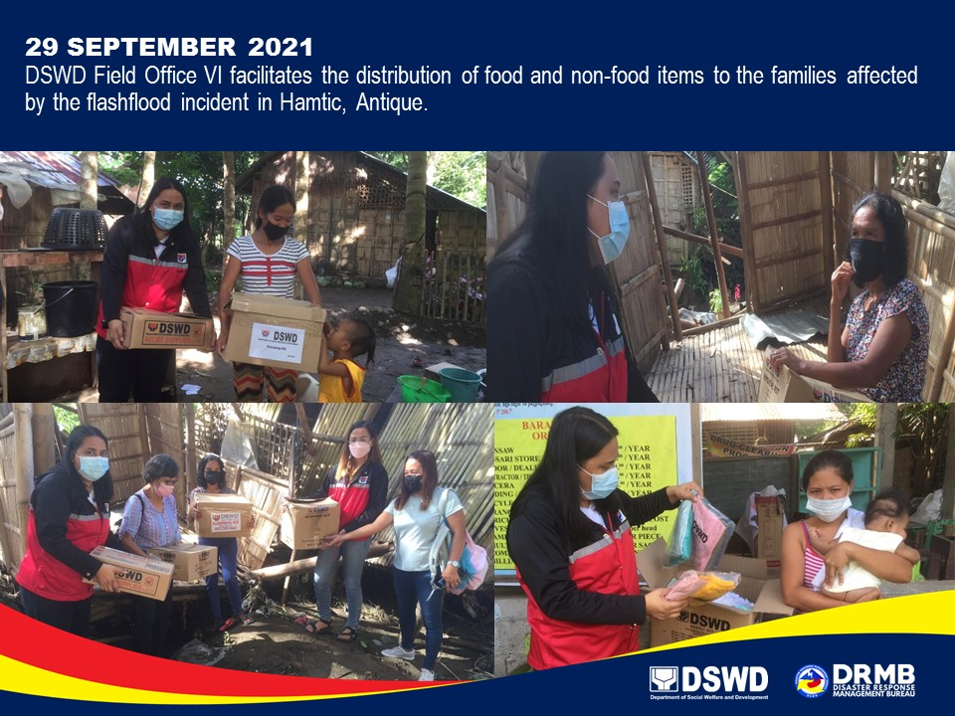

*****
This terminal report is based on the latest report submitted by DSWD-FO VI on 04 November 2021. The
Disaster Response Operations Monitoring and Information Center (DROMIC) of DSWD-DRMB continues to
closely coordinate with DSWD-FO VI for any request of Technical Assistance and Resource Augmentation
(TARA).

Prepared by:  PHIL JOBERT A. ZALDIVAR | Released by:  RODEL V. CABADDU

