DSWD DROMIC Report #1 on Tropical Depression “LANNIE”
as of 06 October 2021, 6PM

- Situation Overview
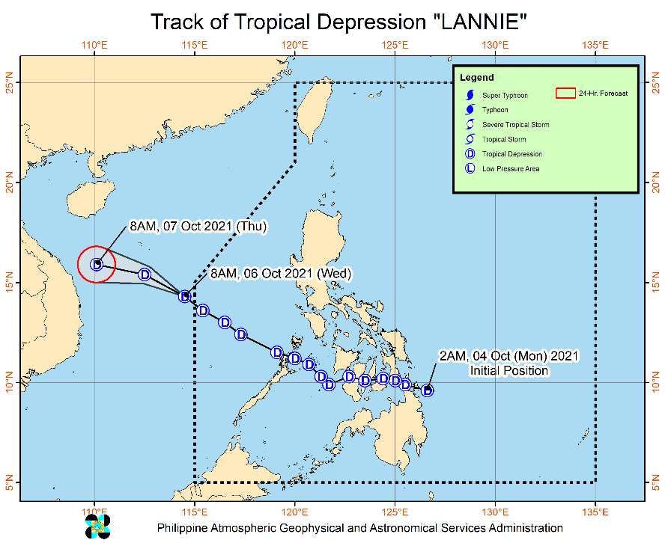
Issued at 11 AM, 06 October 2021, “LANNIE” IS NOW OUTSIDE THE PHILIPPINE AREA OF RESPONSIBILITY (PAR).

- The center of Tropical Depression “LANNIE” was estimated based on all available data at 770 km West of Calapan City, Oriental Mindoro or 670 km West of Subic, Zambales (14.4°N, 114.1°E) (outside the PAR)

Heavy Rainfall:
- The trough of this tropical depression may bring rains over Metro Manila, Central and Southern Luzon, Antique, and Aklan. For more information, refer to Weather Advisory #2 issued at 11:00 AM today.

Severe Winds:
- In the next 24 hours, the enhanced northeasterly wind flow will bring occasional gusts reaching near gale to at times gale force in strength over Extreme Northern Luzon, while the enhanced southwesterlies will bring the same conditions over the coastal and upland/mountain areas along the western section of Central and Southern Luzon.

Track:
- Tropical Depression “LANNIE” exited the PAR at 5:00 AM today. On the forecast track, the tropical depression is forecast to move west northwestward in the next 24 hours towards central Vietnam.

Source: DOST-PAGASA Weather Advisory

- Status of Affected Areas and Population

A total of 1,558 families or 7,686 persons were affected by the Tropical Depression “Lannie” in 17 Barangays in Regions VI (see Table 1).

Table 1. Number of Affected Families / Persons
REGION / PROVINCE / MUNICIPALITY |  | NUMBER OF AFFECTED
 |  | Barangays | Families | Persons
GRAND TOTAL |  | 17 | 1,558 | 7,686
REGION VI |  | 17 | 1,558 | 7,686
Capiz |  | 3 | 8 | 22
 | Mambusao | 3 | 8 | 22
Iloilo |  | 14 | 1,550 | 7,664
 | Banate | 11 | 1,500 | 7,500
 | Iloilo City (capital) | 3 | 50 | 164
Note: Ongoing assessment and validation are continuously being conducted.
Source: DSWD-Field Offices (FOs)

- Status of Displaced Population

- Inside Evacuation Centers
There are 55 families or 179 persons currently taking temporary shelter in seven (7) evacuation centers in Region VI (see Table 2).

Table 2. Number of Displaced Families / Persons Inside Evacuation Centers
REGION / PROVINCE / MUNICIPALITY |  | NUMBER OF EVACUATION CENTERS (ECs) |  | NUMBER OF DISPLACED
 |  |  |  | INSIDE ECs
 |  |  |  | Families |  | Persons (Actual)
 |  | CUM | NOW | CUM | NOW | CUM | NOW
GRAND TOTAL |  | 7 | 7 | 55 | 55 | 179 | 179
REGION VI |  | 7 | 7 | 55 | 55 | 179 | 179
Capiz |  | 2 | 2 | 5 | 5 | 15 | 15
 | Mambusao | 2 | 2 | 5 | 5 | 15 | 15
Iloilo |  | 5 | 5 | 50 | 50 | 164 | 164
 | Banate | - | - | - | - | - | -
 | Iloilo City (capital) | 5 | 5 | 50 | 50 | 164 | 164
Note: Ongoing assessment and validation are continuously being conducted.
Source: DSWD-Field Offices (FOs)

- Outside Evacuation Centers
There are three (3) families or seven (7) persons temporarily staying with their relatives and/or friends in Regions VI (see Table 3).

Table 3. Number of Displaced Families / Persons Outside Evacuation Centers
REGION / PROVINCE / MUNICIPALITY |  | NUMBER OF DISPLACED
 |  | OUTSIDE ECs
 |  | Families |  | Persons
 |  | CUM | NOW | CUM | NOW
GRAND TOTAL |  | 3 | 3 | 7 | 7
REGION VI |  | 3 | 3 | 7 | 7
Capiz |  | 3 | 3 | 7 | 7
 | Mambusao | 3 | 3 | 7 | 7
Iloilo |  | - | - | - | -
 | Banate | - | - | - | -
 | Iloilo City (capital) | - | - | - | -
Note: Ongoing assessment and validation are continuously being conducted.
Source: DSWD-Field Offices (FOs)

- Total Displaced Population
There are 58 families or 186 persons displaced in Regions VI due to Tropical Depression “Lannie” (see Table 4).

Table 4. Total Number of Displaced Families / Persons
REGION / PROVINCE / MUNICIPALITY |  | TOTAL DISPLACED SERVED
 |  | Families |  | Persons
 |  | Total Families |  | Total Persons
 |  | CUM | NOW | CUM | NOW
GRAND TOTAL |  | 58 | 58 | 186 | 186
REGION VI |  | 58 | 58 | 186 | 186
Capiz |  | 8 | 8 | 22 | 22
 | Mambusao | 8 | 8 | 22 | 22
Iloilo |  | 50 | 50 | 164 | 164
 | Banate | - | - | - | -
 | Iloilo City (capital) | 50 | 50 | 164 | 164
Note: Ongoing assessment and validation are continuously being conducted.
Source: DSWD-Field Offices (FOs)

- Response Actions and Interventions

- Standby Funds and Prepositioned Relief Stockpile

OFFICE | STANDBY FUNDS | STOCKPILE |  |  |  |  | TOTAL STANDBY FUNDS & STOCKPILE
 |  | FAMILY FOOD PACKS |  | OTHER FOOD ITEMS | NON-FOOD RELIEF ITEMS | OTHER FOOD AND NON-FOOD ITEMS (FNIs)
 |  | QUANTITY | TOTAL COST | TOTAL COST | TOTAL COST
TOTAL | 147,244,705.84 | 365,402 | 213,432,218.82 | 233,209,429.15 | 507,316,771.03 | 740,526,200.18 | 1,101,203,124.84
DSWD-CO | 92,874,861.35 | - | - | - | - | - | 92,874,861.35
NRLMB-NROC | - | 81,159 | 60,168,280.70 | 61,512,111.59 | 106,771,371.01 | 168,283,482.60 | 228,451,763.30
NRLMB-VDRC | - | 14,034 | 6,666,150.00 | 15,241,679.69 | 9,305,876.50 | 24,547,556.19 | 31,213,706.19
DSWD-FO VI | 5,518,196.42 | 21,716 | 10,237,052.62 | 30,172,779.06 | 16,425,576.68 | 46,598,355.74 | 62,353,604.78
Other FOs | 48,851,648.07 | 248,493 | 136,360,735.50 | 126,282,858.81 | 374,813,946.84 | 501,096,805.65 | 686,309,189.22
Note: The Inventory Summary is as of 06 October 2021
Source: DSWD-NRLMB

  - Standby Funds
    - ₱92.7 million Quick Response Fund (QRF) at the DSWD-Central Office.
    - ₱5.5 million available at DSWD-FO VI
    - ₱48.8 million available in other DSWD FOs which may support the relief needs of the affected and displaced families due to TD “LANNIE” through inter-FO augmentation.

  - Prepositioned FFPs and Other Relief Items
    - 95,193 FFPs available in Disaster Response Centers; of which, 81,159 FFPs are at the National Resource Operations Center (NROC), Pasay City and 14,034 FFPs are at the Visayas Disaster Response Center (VDRC), Cebu City.
    - 21,716 FFPs available at DSWD-FO VI.
    - 248,493 FFPs in other DSWD-FOs which may support the relief needs of the displaced families due to Typhoon “JOLINA” through inter-FO augmentation.
    - ₱740.5 million worth of other FNIs at NROC, VDRC and DSWD-FO warehouses countrywide.

- Other Activities

DSWD-FO MIMAROPA
DATE | ACTIVITIES
06 October 2021 | - There are 70 families and 300 persons who sought temporary shelter with their relatives and/or friends. All of these families have returned home

DSWD-FO V
DATE | ACTIVITIES
04 October 2021 | - DSWD-FO V thru its DRMD is closely coordinating with the LSWDOs for any significant updates relative to TD LANNIE.  - DSWD-FO V QRTs are on standby alert

DSWD-FO VI
DATE | ACTIVITIES
06 October 2021 | - DSWD-FO VI thru its DRMD is closely coordinating with the LSWDOs for any significant updates on the status of the affected families, assistance and relief efforts  - DSWD-FO VI thru its DRMD receive and assess augmentation request from Municipality of Banate and City of Iloilo.

DSWD-FO VII
DATE | ACTIVITIES
04 October 2021 | - There are two (2) families Brgy. Pangalaycayan, Negros Oriental who were evacuated to Bindoy Central School due to severe flooding.  - DSWD-FO VII QRT Team are on standby alert for possible activation.

DSWD-FO VIII
DATE | ACTIVITIES
04 October 2021 | - A total of seven (7) families or 30 individuals were pre-emptively evacuated in Brgy. Mercedes, Silago, Southern Leyte.
05 October 2021 | - DSWD-FO VIII continuously coordinated with the LSWDOs for significant updates relative to TD Lannie preparedness measures.  - DSWD-FO VIII emergency operations center are activated to monitor possible pre-emptive evacuations.

DSWD-CARAGA
DATE | ACTIVITIES
04 October 2021 | - DSWD-FO CARAGA attended the PDRA/ERP meeting spearheaded by the OCD CARAGA.  - DSWD-FO CARAGA thru its DRMD is continuously monitoring and coordinating with the LSWDOs for significant updates relative to TD LANNIE.

*****
The Disaster Response Operations Monitoring and Information Center (DROMIC) of DSWD-DRMB is closely coordinating with the concerned DSWD-FOs for significant disaster response updates and assistance provided.

Prepared by:  MARIE JOYCE G. RAFANAN  AARON JOHN B. PASCUA | Released by:  RODEL V. CABADDU

