DSWD DROMIC Report #2 on Severe Tropical Storm “MARING”
as of 12 October 2021, 6PM

- Situation Overview
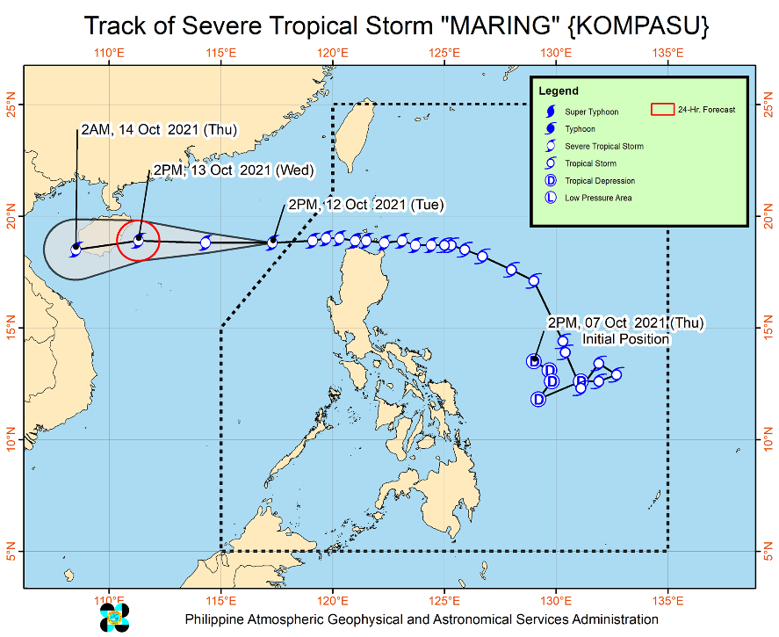
Issued at 5:00 PM, 12 October 2021, SEVERE TROPICAL STORM “MARING” ACCELERATES WHILE MOVING WESTWARD OVER THE WEST PHILIPPINE SEA.

- The center of Severe Tropical Storm “MARING” was estimated based on all available data over 505 km West of Calayan, Cagayan (18.7°N, 116.7°E) (outside the PAR).

Heavy Rainfall:
- Tonight through tomorrow morning, light to moderate with at times heavy rains are highly likely over Ilocos Region, Cordillera Administrative Region, Cagayan Valley, and Central Luzon. Under these conditions, scattered to widespread flooding (including flash floods) and rain-induced landslides are highly likely especially in areas that are highly or very highly susceptible to these hazard as identified in hazard maps.
- Under the influence of the Southwest Monsoon enhanced by Severe Tropical Storm “MARING”, monsoon rains are possible over Metro Manila, MIMAROPA, and CALABARZON in the next 24 hours.

Severe Winds:
- Winds will continue to reach gale-force to storm-force strength within any of the areas where Tropical Cyclone Wind Signal (TCWS) #2 is in effect. This may result in generally light to moderate damage to structures and vegetation.
- Strong winds (strong breeze to near gale conditions) with higher gusts will continue within any of the areas where TCWS #1 is currently in effect. This may generally bring up to very light damage to structures and vegetation.
- The expansive wind field of the severe tropical storm and the enhanced Southwest Monsoon will bring gusty conditions reaching strong to gale-force in strength over Visayas, Zamboanga del Norte, and the rest of Luzon in the next 24 hours.

Track:
- Severe Tropical Storm “MARING” exited the PAR at 11:00 AM today. The storm will continue moving westward and is likely to make landfall in the vicinity of Hainan, China tomorrow evening. Within the next 24 hours, the storm is forecast to gradually intensify reaching a peak intensity of 110 km/h prior to making landfall over Hainan Island.

Source: DOST-PAGASA Weather Advisory
- Status of Affected Areas and Population

A total of 2,137 families or 7,842 persons were affected by Severe Tropical Storm (STS) “Maring” in 95 Barangays in Regions NCR, II and CAR (see Table 1).

Table 1. Number of Affected Families / Persons
REGION / PROVINCE / MUNICIPALITY |  | NUMBER OF AFFECTED
 |  | Barangays | Families | Persons
GRAND TOTAL |  | 95 | 2,137 | 7,842
NCR |  | 1 | 212 | 745
Metro Manila |  | 1 | 212 | 745
Manila City |  | 1 | 212 | 745
REGION II |  | 93 | 1,920 | 7,078
Batanes |  | 1 | 1 | 2
 | Basco | 1 | 1 | 2
Cagayan |  | 90 | 1,912 | 7,045
 | Abulug | 1 | 29 | 111
 | Allacapan | 4 | 15 | 40
 | Aparri | 3 | 64 | 197
 | Baggao | 21 | 479 | 1,722
 | Ballesteros | 1 | 3 | 10
 | Buguey | 4 | 48 | 179
 | Calayan | 1 | 2 | 11
 | Camalaniugan | 3 | 24 | 56
 | Claveria | 4 | 26 | 99
 | Gattaran | 8 | 95 | 293
 | Gonzaga | 6 | 59 | 213
 | Lal-lo | 5 | 17 | 63
 | Lasam | 3 | 13 | 34
 | Pamplona | 6 | 113 | 295
 | Peñablanca | 2 | 5 | 22
 | Rizal | 1 | 33 | 118
 | Sanchez-Mira | 1 | 4 | 10
 | Santa Ana | 6 | 19 | 88
 | Santa Praxedes | 1 | 5 | 20
 | Santa Teresita | 9 | 859 | 3,464
Nueva Vizcaya |  | 2 | 7 | 31
 | Quezon | 2 | 7 | 31
CAR |  | 1 | 5 | 19
Apayao |  | 1 | 5 | 19
 | Calanasan (Bayag) | 1 | 5 | 19
Note: Ongoing assessment and validation are continuously being conducted.
Source: DSWD-Field Offices (FOs)

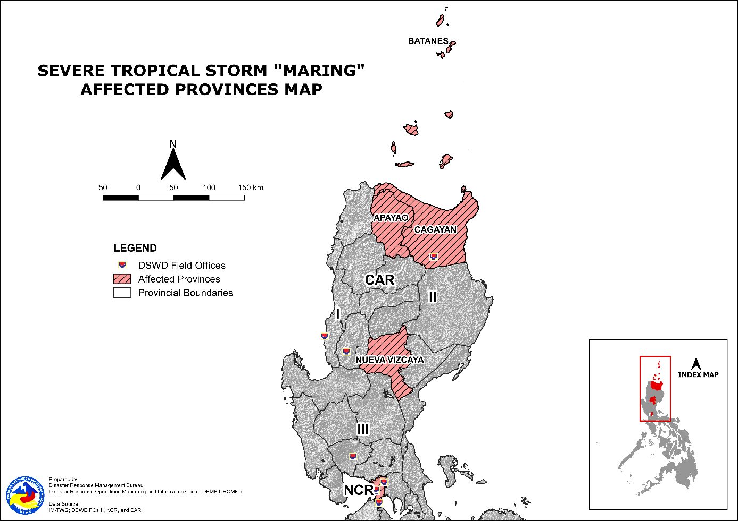

- Status of Displaced Population

- Inside Evacuation Centers
There are 762 families or 2,536 persons currently taking temporary shelter in 58 evacuation centers in Regions NCR, II and CAR (see Table 2).

Table 2. Number of Displaced Families / Persons Inside Evacuation Centers
REGION / PROVINCE / MUNICIPALITY |  | NUMBER OF EVACUATION CENTERS (ECs) |  | NUMBER OF DISPLACED
 |  |  |  | INSIDE ECs
 |  |  |  | Families |  | Persons
 |  | CUM | NOW | CUM | NOW | CUM | NOW
GRAND TOTAL |  | 59 | 58 | 764 | 762 | 2,547 | 2,536
NCR |  | 1 | 1 | 212 | 212 | 745 | 745
Metro Manila |  | 1 | 1 | 212 | 212 | 745 | 745
Manila City |  | 1 | 1 | 212 | 212 | 745 | 745
REGION II |  | 57 | 56 | 550 | 548 | 1,793 | 1,782
Batanes |  | 1 | 1 | 1 | 1 | 2 | 2
 | Basco | 1 | 1 | 1 | 1 | 2 | 2
Cagayan |  | 54 | 53 | 542 | 540 | 1,760 | 1,749
 | Abulug | 1 | 1 | 29 | 29 | 111 | 111
 | Alcala | 2 | 2 | 5 | 5 | 18 | 18
 | Baggao | 11 | 11 | 138 | 138 | 509 | 509
 | Ballesteros | 1 | 1 | 3 | 3 | 10 | 10
 | Calayan | 1 | - | 2 | - | 11 | -
 | Camalaniugan | 3 | 3 | 24 | 24 | 56 | 56
 | Claveria | 4 | 4 | 26 | 26 | 99 | 99
 | Gattaran | 8 | 8 | 95 | 95 | 293 | 293
 | Gonzaga | 4 | 4 | 41 | 41 | 137 | 137
 | Lal-lo | 2 | 2 | 8 | 8 | 26 | 26
 | Lasam | 2 | 2 | 12 | 12 | 32 | 32
 | Pamplona | 2 | 2 | 56 | 56 | 145 | 145
 | Peñablanca | 1 | 1 | 1 | 1 | 2 | 2
 | Sanchez-Mira | 1 | 1 | 4 | 4 | 10 | 10
 | Santa Ana | 2 | 2 | 4 | 4 | 13 | 13
 | Santa Praxedes | 1 | 1 | 5 | 5 | 20 | 20
 | Santa Teresita | 8 | 8 | 89 | 89 | 268 | 268
Nueva Vizcaya |  | 2 | 2 | 7 | 7 | 31 | 31
 | Quezon | 2 | 2 | 7 | 7 | 31 | 31
CAR |  | 1 | 1 | 2 | 2 | 9 | 9
Apayao |  | 1 | 1 | 2 | 2 | 9 | 9
 | Calanasan (Bayag) | 1 | 1 | 2 | 2 | 9 | 9
Note: Ongoing assessment and validation are continuously being conducted.
Source: DSWD-Field Offices (FOs)

- Outside Evacuation Centers
There are 491 families or 1,702 persons temporarily staying with their relatives and/or friends in Regions II and CAR (see Table 3).

Table 3. Number of Displaced Families / Persons Outside Evacuation Centers
REGION / PROVINCE / MUNICIPALITY |  | NUMBER OF DISPLACED
 |  | OUTSIDE ECs
 |  | Families |  | Persons
 |  | CUM | NOW | CUM | NOW
GRAND TOTAL |  | 491 | 491 | 1,702 | 1,702
REGION II |  | 488 | 488 | 1,692 | 1,692
Cagayan |  | 488 | 488 | 1,692 | 1,692
 | Allacapan | 7 | 7 | 15 | 15
 | Aparri | 9 | 9 | 29 | 29
 | Baggao | 316 | 316 | 1,104 | 1,104
 | Gonzaga | 18 | 18 | 76 | 76
 | Lasam | 1 | 1 | 2 | 2
 | Pamplona | 57 | 57 | 150 | 150
 | Peñablanca | 4 | 4 | 20 | 20
 | Santa Ana | 15 | 15 | 75 | 75
 | Santa Teresita | 61 | 61 | 221 | 221
CAR |  | 3 | 3 | 10 | 10
Apayao |  | 3 | 3 | 10 | 10
 | Calanasan (Bayag) | 3 | 3 | 10 | 10
Note: Ongoing assessment and validation are continuously being conducted.
Source: DSWD-Field Offices (FOs)

- Total Displaced Population
There are 1,253 families or 4,238 persons displaced in Regions NCR, II and CAR due to STS “Maring” (see Table 4).

Table 4. Total Number of Displaced Families / Persons
REGION / PROVINCE / MUNICIPALITY |  | TOTAL DISPLACED SERVED
 |  | Families |  | Persons
 |  | Total Families |  | Total Persons
 |  | CUM | NOW | CUM | NOW
GRAND TOTAL |  | 1,255 | 1,253 | 4,249 | 4,238
NCR |  | 212 | 212 | 745 | 745
Metro Manila |  | 212 | 212 | 745 | 745
Manila City |  | 212 | 212 | 745 | 745
REGION II |  | 1,038 | 1,036 | 3,485 | 3,474
Batanes |  | 1 | 1 | 2 | 2
 | Basco | 1 | 1 | 2 | 2
Cagayan |  | 1,030 | 1,028 | 3,452 | 3,441
 | Abulug | 29 | 29 | 111 | 111
 | Alcala | 5 | 5 | 18 | 18
 | Allacapan | 7 | 7 | 15 | 15
 | Aparri | 9 | 9 | 29 | 29
 | Baggao | 454 | 454 | 1,613 | 1,613
 | Ballesteros | 3 | 3 | 10 | 10
 | Calayan | 2 | - | 11 | -
 | Camalaniugan | 24 | 24 | 56 | 56
 | Claveria | 26 | 26 | 99 | 99
 | Gattaran | 95 | 95 | 293 | 293
 | Gonzaga | 59 | 59 | 213 | 213
 | Lal-lo | 8 | 8 | 26 | 26
 | Lasam | 13 | 13 | 34 | 34
 | Pamplona | 113 | 113 | 295 | 295
 | Peñablanca | 5 | 5 | 22 | 22
 | Sanchez-Mira | 4 | 4 | 10 | 10
 | Santa Ana | 19 | 19 | 88 | 88
 | Santa Praxedes | 5 | 5 | 20 | 20
 | Santa Teresita | 150 | 150 | 489 | 489
Nueva Vizcaya |  | 7 | 7 | 31 | 31
 | Quezon | 7 | 7 | 31 | 31
CAR |  | 5 | 5 | 19 | 19
Apayao |  | 5 | 5 | 19 | 19
 | Calanasan (Bayag) | 5 | 5 | 19 | 19
Note: Ongoing assessment and validation are continuously being conducted.
Source: DSWD-Field Offices (FOs)

- Cost of Humanitarian Assistance Provided
A total of ₱7,650.00 worth of assistance was provided by the Local Government Units (LGUs) to the affected families (see Table 5).

Table 5. Cost of Assistance Provided to Affected Families / Persons
REGION / PROVINCE / MUNICIPALITY |  | COST OF ASSISTANCE
 |  | DSWD | LGUs | NGOs | OTHERS | GRAND TOTAL
GRAND TOTAL |  | - | 7,650.00 | - | - | 7,650.00
REGION II |  | - | 5,800.00 | - | - | 5,800.00
Cagayan |  | - | 3,000.00 | - | - | 3,000.00
 | Santa Teresita | - | 3,000.00 | - | - | 3,000.00
Nueva Vizcaya |  | - | 2,800.00 | - | - | 2,800.00
 | Quezon | - | 2,800.00 | - | - | 2,800.00
CAR |  | - | 1,850.00 | - | - | 1,850.00
Apayao |  | - | 1,850.00 | - | - | 1,850.00
 | Calanasan (Bayag) | - | 1,850.00 | - | - | 1,850.00
Source: DSWD-Field Offices (FOs)

- Response Actions and Interventions

- Standby Funds and Prepositioned Relief Stockpile

REGIONAL / FIELD OFFICE | STANDBY FUNDS | FAMILY FOOD PACKS |  | OTHER FOOD ITEMS | NON-FOOD RELIEF ITEMS | TOTAL STANDBY FUNDS & STOCKPILE
 |  | QUANTITY | TOTAL COST | TOTAL COST | TOTAL COST
TOTAL | 133,710,932.27 | 381,893.00 | 225,685,946.48 | 208,249,808.88 | 497,496,031.65 | 1,065,142,719.28
Central Office | 87,863,010.35 | - | - | - | - | 87,863,010.35
NRLMB - NROC | - | 93,324 | 67,806,470.70 | 53,377,942.74 | 99,162,531.01 | 220,346,944.45
NRLMB - VDRC | - | 134 | 63,650.00 | 12,764,090.09 | 9,305,876.50 | 22,133,616.59
II | 4,959,298.68 | 22,457 | 11,624,928.40 | 5,843,966.88 | 10,825,463.13 | 33,253,657.09
NCR | 3,002,563.30 | 1,080 | 659,469.60 | 5,227,100.10 | 1,924,229.71 | 10,813,362.71
CAR | 157,117.12 | 27,329 | 14,183,407.52 | 2,958,449.07 | 19,159,818.97 | 36,458,792.68
Other FOs | 37,728,942.82 | 237,569 | 131,348,020.26 | 128,078,260.00 | 357,118,112.33 | 654,273,335.41
Note: The Inventory Summary is as of 12 October 2021, 4PM.
Source: DSWD-NRLMB

  - Standby Funds
    - ₱87.86 million Quick Response Fund (QRF) at the DSWD-Central Office.
    - ₱8.12 million available at DSWD-FOs II, NCR and CAR.
    - ₱37.73 million in other DSWD-FOs which may support the relief needs of the displaced families due to Severe Tropical Storm “MARING” through inter-FO augmentation.

  - Prepositioned FFPs and Other Relief Items
    - 93,458 FFPs available in Disaster Response Centers; of which, 93,324 FFPs are at the National Resource Operations Center (NROC), Pasay City and 134 FFPs are at the Visayas Disaster Response Center (VDRC), Cebu City.
    - 50,866 FFPs available at DSWD-FOs II, NCR and CAR.
    - 237,569 FFPs in other DSWD-FOs which may support the relief needs of the displaced families due to Severe Tropical Storm “Maring” through inter-FO augmentation.
    - ₱497.50 million worth of other food and non-food items (FNIs) at NROC, VDRC and DSWD-FO warehouses countrywide.

- Food and Non-Food Items

DSWD-FO I
DATE | ACTIVITIES
11 October 2021 | - DSWD-FO I facilitated the assembly of slotted cartons in preparation for the production of family food packs at DSWD Regional Warehouse, Biday, San Fernando, La Union.
DSWD-FO III
DATE | ACTIVITIES
11 October 2021 | - Relief goods were prepositioned for augmentation to LGUs.

DSWD-FO CAR
DATE | ACTIVITIES
11 October 2021 | - Relief goods were prepositioned for augmentation to LGUs.

- Camp Coordination and Camp Management

DSWD-FO NCR
DATE | ACTIVITIES
11 October 2021 | - DSWD-FO NCR through the Manila Department of Social Welfare activated the camp coordination and camp management and continuously coordinating with concerned agencies for conducting assessment and validation of the affected families using the Disaster Assistance Family Access Card (DAFAC) / White Card for the affected families.

DSWD-FO CAR
DATE | ACTIVITIES
11 October 2021 | - DSWD-FO CAR monitored the active evacuation centers through Local Social Welfare and Development in LGUs.

- Other Activities

DSWD-FO I
DATE | ACTIVITIES
11 October 2021 | - DSWD-FO CAR is closely coordinating with the Regional Disaster Risk Reduction and Management Council 1 (RDRRMC1) and Provincial Operations Offices (POOs) though Provincial/City/Municipal Disaster Risk Reduction and Management Councils (P/C/MDRRMCs) and Provincial/City/ Municipality Social Welfare and Development Offices (P/C/MSWDOs) to monitor the adverse effects that might be brought by the weather disturbance.  - DSWD-FO I still activated the Incident Management Team (IMT) for on duty while other DSWD staff are on standby for possible augmentation.

DSWD-FO II
DATE | ACTIVITIES
12 October 2021 | - DSWD-FO II conducted Rapid Damage Assessment Needs Analysis (RDANA) in District 1 and 2 of Cagayan by two teams (one team headed by RD Cezario Joel C. Espejo and the other team headed by OIC ARDO Franco G. Lopez).  - DSWD-FO II prepositioned of 2,400 FFPs at Magapit, Lallo for possible augmentation support to LGUs with affected families based on the assessment of RD Cezario Joel C. Espejo and OIC ARDO Franco G. Lopez.
11 October 2021 | - DSWD-FO II deployed Disaster Monitoring and Response Teams, SWAD Offices, and Municipal Actions Teams (MATs) for a 24-hour duty to continuously monitor the effects of STS “Maring”.  - DSWD-FO II with MATs and MDRRMO advised vulnerable residents to move to relatives living in higher grounds or evacuation centers.

DSWD-FO III
DATE | ACTIVITIES
11 October 2021 | - DSWD-FO III activated the Regional Operations Center and the DSWD Provincial Extension Officers for the monitoring of incidents related to the current weather.  - DSWD-FO III attended the Pre-Disaster risk Assessment conducted by the Regional Disaster Risk Reduction and Management Council 3.

DSWD-FO V
DATE | ACTIVITIES
09 October 2021 | - DSWD-FO V DRMD continuous to monitor weather updates and information.  - Resource Operation Section ensures the availability of family food packs and non-food items as need arises.  - DSWD-FO V QRTs are alerted and PAT and MAT members in the 6 provinces are activated and instructed to coordinate with the P/MDRRMOs, C/MSWDOs for weather reports and updates.

DSWD-FO VIII
DATE | ACTIVITIES
11 October 2021 | - A total of four (4) families or 22 persons took pre-emptive evacuation in Brgy. Bolusao, Lawaan, Eastern Samar. All of these families have returned home. Hence, DSWD-FO VIII submitted their terminal report.

DSWD-FO Caraga
DATE | ACTIVITIES
08 October 2021 | - DSWD-FO Caraga Quick Response Team (QRT) members on standby for possible deployment.  - DSWD-FO Caraga has one (1) operational disaster vehicle and one (1) wingvan on standby to be utilized for logistics support.  - DSWD-FO Caraga has 2 Huawei Smartphones available to be utilized for communication support in the Emergency Operations Center;  - SWAD Team Leaders are advised to monitor their respective Area of Responsibility (AOR) and provide updates on disaster situation;  - DSWD-FO Caraga is coordinating with SWADTLs and LSWDOs to monitor the situation in their respective area of responsibility.

- Photo Documentation
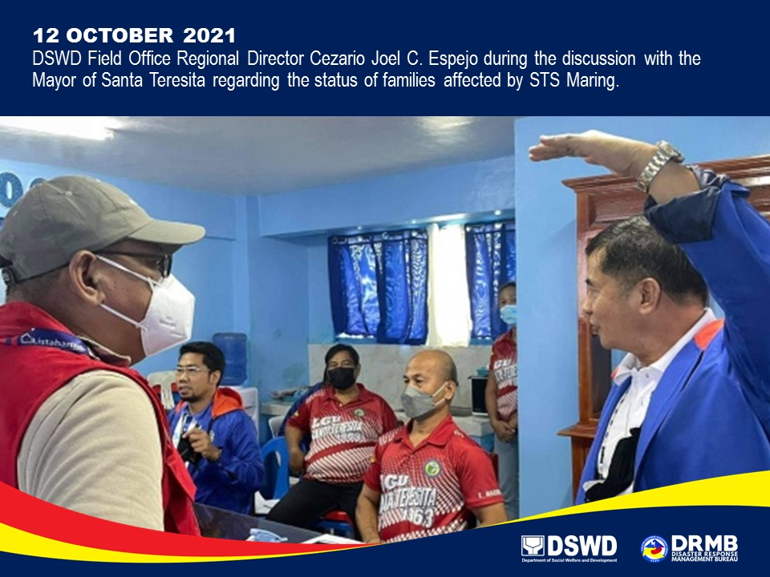

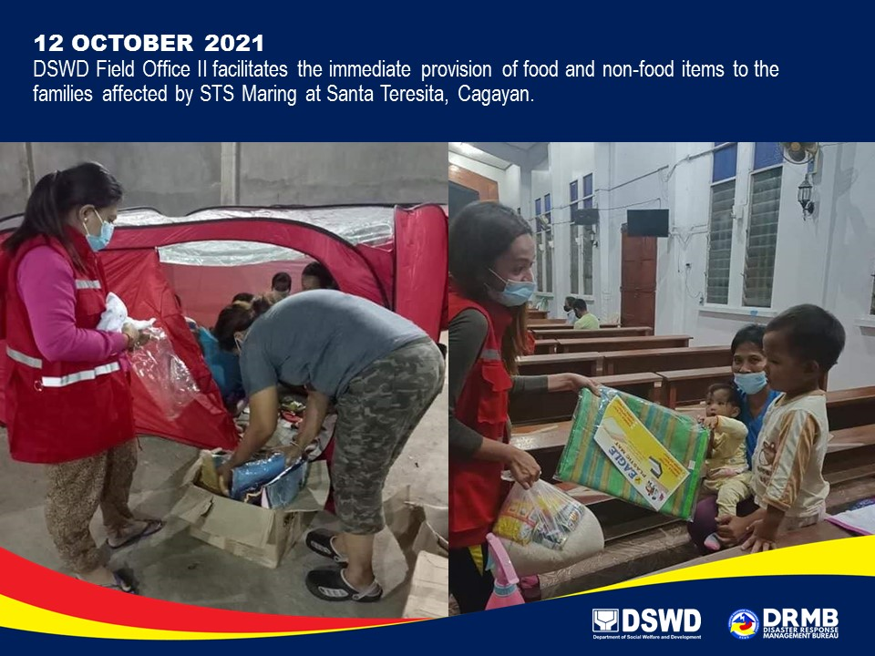

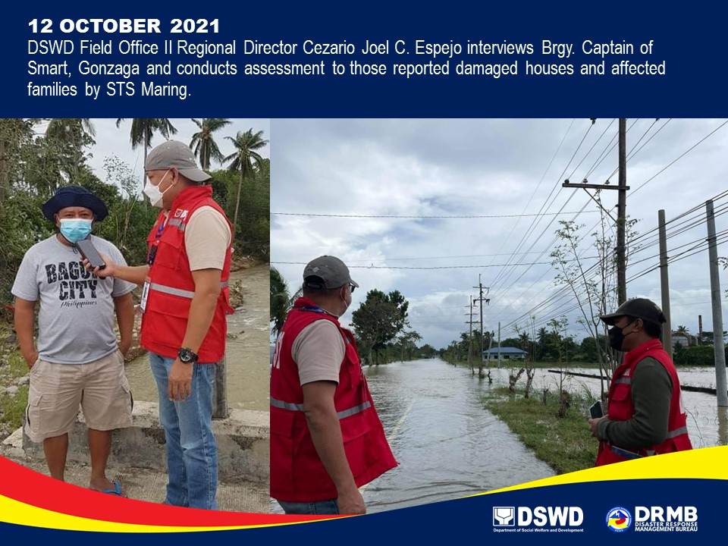

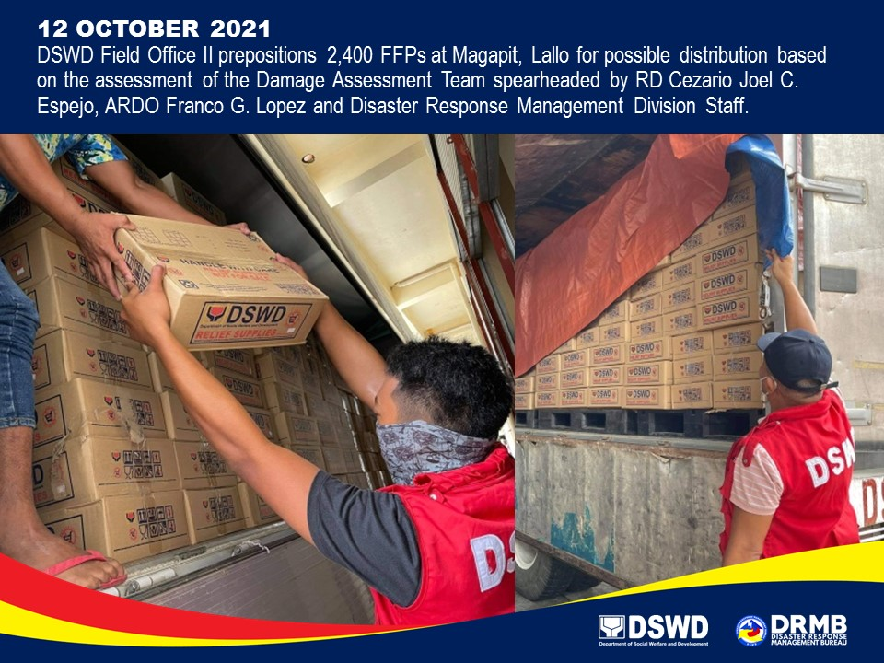

*****
The Disaster Response Operations Monitoring and Information Center (DROMIC) of DSWD-DRMB is closely coordinating with the concerned DSWD-FOs for significant disaster response updates and assistance provided.

Prepared by:  DIANE C. PELEGRINO  JEM ERIC F. FAMORCAN  MARIE JOYCE G. RAFANAN  JOANNA CAMILLE R. JACINTO | Released by:  LESLIE R. JAWILI

