DSWD DROMIC Report #3 on Severe Tropical Storm “MARING”
as of 13 October 2021, 6PM

- Situation Overview
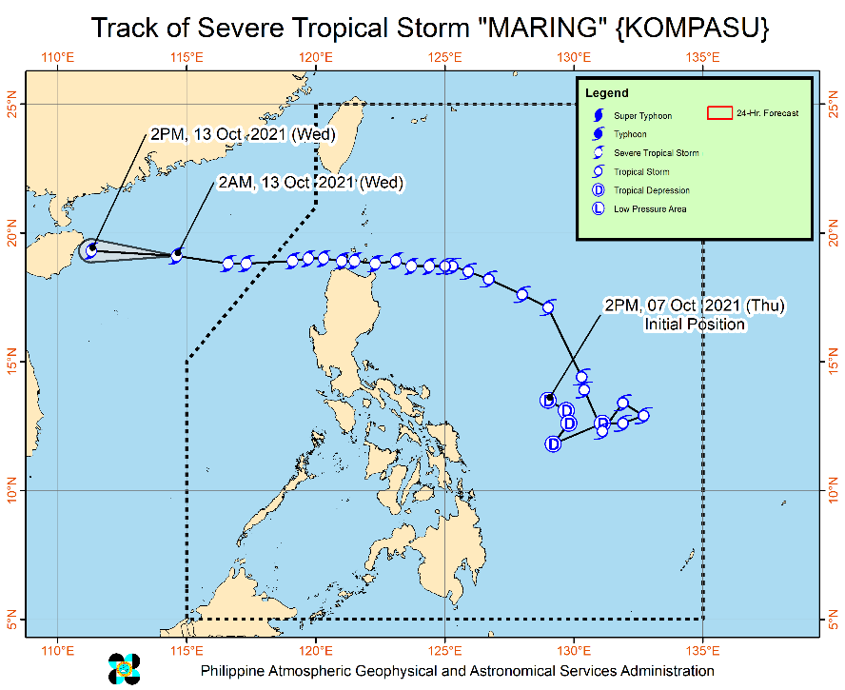
Issued at 5:00 AM, 13 October 2021, SEVERE TROPICAL STORM “MARING” CONTINUES TO MOVE AWAY FROM THE COUNTRY.

- The The center of Severe Tropical Storm “MARING” was estimated based on all available data over 765 km
West of Calayan, Cagayan (outside the PAR) (19.1°N, 114.2°E)
Heavy Rainfall:
- Despite weakening trend of forecast rainfall over Northern Luzon in the next 24 hours, the high saturation of soil moisture in these areas due to large amounts of antecedent rainfall meant that flooding (including flash floods) and rain-induced landslides are still likely especially in areas that are highly or very highly susceptible to these hazard as identified in hazard maps even in the event of light to moderate rains.
- Under the influence of the Southwest Monsoon enhanced by Severe Tropical Storm “MARING”, monsoon rains are possible over Bataan, Zambales, Occidental Mindoro, and Palawan within the next 24 hours. For more information, refer to Weather Advisory #7 issued at 11:00 PM yesterday and the 24-Hour Public Weather Forecast at 4:00 AM today.

Severe Winds:
- Owing to the consolidation in the wind field of “MARING” and its continuous westward movement, prevailing winds over the country are now below warning criteria necessary for the hoisting of a Tropical Cyclone Wind Signal (TCWS). As such, all wind signals in the country have been lifted. Nevertheless, gusty conditions reaching strong to galeforce in strength due to the enhanced Southwest Monsoon remain likely over MIMAROPA, Western Visayas, Bicol Region, and Extreme Northern Luzon, and possible over the rest of Luzon.

Track:
- The storm will continue moving westward over the West Philippine Sea and maintain its strength until it makes landfall in the vicinity of Hainan, China this afternoon or tonight.

Source: DOST-PAGASA Weather Advisory

- Status of Affected Areas and Population

A total of 45,000 families or 175,501 persons were affected by Severe Tropical Storm (STS) “Maring” in 563 Barangays in Regions I, II, III, X, Caraga, NCR and CAR (see Table 1).

Table 1. Number of Affected Families / Persons
REGION / PROVINCE / MUNICIPALITY |  | NUMBER OF AFFECTED
 |  | Barangays | Families | Persons
GRAND TOTAL |  | 563 | 45,000 | 175,501
NCR |  | 1 | 212 | 745
Metro Manila |  | 1 | 212 | 745
Manila City |  | 1 | 212 | 745
REGION I |  | 246 | 26,534 | 105,979
Ilocos Norte |  | 3 | 17 | 57
 | Bangui | 1 | 14 | 47
 | Marcos | 1 | 2 | 9
 | Pinili | 1 | 1 | 1
Ilocos Sur |  | 49 | 366 | 1,486
 | Bantay | 2 | 4 | 18
 | CITY OF CANDON | 9 | 64 | 223
 | Caoayan | 4 | 61 | 225
 | Cervantes | 2 | 3 | 15
 | Gregorio del Pilar (Concepcion) | 3 | 7 | 35
 | Salcedo (Baugen) | 4 | 39 | 191
 | San Emilio | 1 | 1 | 7
 | San Esteban | 2 | 2 | 9
 | San Vicente | 1 | 1 | 7
 | Santa | 3 | 7 | 32
 | Santa Cruz | 2 | 8 | 34
 | Santiago | 1 | 1 | 2
 | Suyo | 3 | 80 | 317
 | Tagudin | 9 | 51 | 204
 | CITY OF VIGAN (Capital) | 3 | 37 | 167
La Union |  | 125 | 20,952 | 80,197
 | Agoo | 9 | 30 | 111
 | Aringay | 1 | 6 | 31
 | Bagulin | 1 | 13 | 37
 | Balaoan | 6 | 33 | 119
 | Bangar | 5 | 103 | 357
 | Bauang | 16 | 2,056 | 7,420
 | Burgos | 2 | 47 | 142
 | Luna | 40 | 13,314 | 53,256
 | Pugo | 4 | 21 | 90
 | Rosario | 2 | 5 | 33
 | San Gabriel | 3 | 1,271 | 5,211
 | San Juan | 26 | 3,301 | 10,426
 | Santo Tomas | 7 | 718 | 2,880
 | Santol | 1 | 10 | 41
 | Sudipen | 2 | 24 | 43
Pangasinan |  | 69 | 5,199 | 24,239
 | CITY OF ALAMINOS | 1 | 30 | 90
 | Asingan | 6 | 661 | 2,644
 | Balungao | 4 | 864 | 4,320
 | Bautista | 4 | 486 | 1,944
 | Binalonan | 1 | 6 | 17
 | Dagupan City | 6 | 58 | 218
 | Laoac | 11 | 598 | 2,990
 | LINGAYEN (Capital) | 4 | 23 | 84
 | Manaoag | 1 | 6 | 22
 | Pozzorubio | 2 | 3 | 10
 | San Fabian | 3 | 182 | 661
 | San Jacinto | 11 | 544 | 2,660
 | San Nicolas | 2 | 31 | 115
 | San Quintin | 1 | 25 | 105
 | Santa Barbara | 9 | 1,570 | 7,850
 | Sual | 1 | 28 | 92
 | Tayug | 1 | 1 | 2
 | CITY OF URDANETA | 1 | 83 | 415
REGION II |  | 172 | 9,625 | 33,934
Batanes |  | 1 | 1 | 2
 | Basco | 1 | 1 | 2
Cagayan |  | 159 | 9,593 | 33,794
 | Abulug | 1 | 31 | 119
 | Allacapan | 4 | 15 | 40
 | Aparri | 14 | 3,616 | 13,165
 | Baggao | 40 | 1,549 | 5,101
 | Ballesteros | 1 | 3 | 10
 | Buguey | 4 | 48 | 179
 | Calayan | 1 | 2 | 11
 | Camalaniugan | 6 | 156 | 496
 | Claveria | 5 | 35 | 134
 | Gattaran | 13 | 336 | 1,034
 | Gonzaga | 21 | 1,658 | 5,520
 | Lal-lo | 7 | 494 | 1,772
 | Lasam | 4 | 33 | 99
 | Pamplona | 9 | 183 | 491
 | Peñablanca | 2 | 5 | 22
 | Piat | 1 | 13 | 20
 | Rizal | 5 | 99 | 274
 | Sanchez-Mira | 1 | 4 | 10
 | Santa Ana | 6 | 19 | 88
 | Santa Praxedes | 2 | 17 | 53
 | Santa Teresita | 12 | 1,277 | 5,156
Isabela |  | 2 | 14 | 62
 | Divilacan | 2 | 14 | 62
Nueva Vizcaya |  | 10 | 17 | 76
 | Ambaguio | 3 | 4 | 22
 | Aritao | 1 | 2 | 6
 | Kayapa | 1 | 2 | 9
 | Quezon | 2 | 7 | 31
 | Solano | 3 | 2 | 8
REGION III |  | 5 | 48 | 155
Bataan |  | 1 | 37 | 125
 | Bagac | 1 | 37 | 125
Bulacan |  | 1 | 8 | 15
 | Bulacan | 1 | 8 | 15
Zambales |  | 3 | 3 | 15
 | Botolan | 1 | 1 | 5
 | Iba (capital) | 2 | 2 | 10
CARAGA |  | 2 | 41 | 128
Surigao del Sur |  | 2 | 41 | 128
 | San Miguel | 2 | 41 | 128
CAR |  | 137 | 8,540 | 34,560
Abra |  | 70 | 7,962 | 32,195
 | Bangued (capital) | 1 | 20 | 65
 | Bucay | 12 | 2,411 | 11,078
 | Danglas | 2 | 2 | 7
 | Dolores | 3 | 107 | 316
 | La Paz | 5 | 143 | 629
 | Lagangilang | 11 | 553 | 1,106
 | Licuan-Baay (Licuan) | 11 | 1,422 | 5,593
 | Malibcong | 2 | 8 | 32
 | Manabo | 4 | 103 | 206
 | Pilar | 9 | 1,324 | 6,620
 | San Juan | 2 | 73 | 160
 | Villaviciosa | 8 | 1,796 | 6,383
Apayao |  | 4 | 28 | 80
 | Calanasan (Bayag) | 1 | 6 | 23
 | Pudtol | 1 | 10 | 29
 | Santa Marcela | 2 | 12 | 28
Benguet |  | 47 | 305 | 1,089
 | Atok | 4 | 8 | 43
 | Baguio City | 9 | 65 | 285
 | Bakun | 4 | 63 | 219
 | Buguias | 1 | 1 | 4
 | Itogon | 6 | 84 | 225
 | Kabayan | 1 | 3 | 9
 | Kapangan | 4 | 5 | 15
 | Kibungan | 3 | 11 | 43
 | La Trinidad (capital) | 2 | 17 | 60
 | Tuba | 9 | 41 | 159
 | Tublay | 4 | 7 | 27
Ifugao |  | 2 | 2 | 11
 | Tinoc | 2 | 2 | 11
Mountain Province |  | 14 | 243 | 1,185
 | Bontoc (capital) | 4 | 11 | 27
 | Besao | 8 | 229 | 1,145
 | Tadian | 2 | 3 | 13
Note: Ongoing assessment and validation are continuously being conducted.
Source: DSWD-Field Offices (FOs)

- Status of Displaced Population

- Inside Evacuation Centers
There are 1,457 families or 5,185 persons currently taking temporary shelter in 114 evacuation centers in Regions, I, II, III, NCR and CAR (see Table 2).

Table 2. Number of Displaced Families / Persons Inside Evacuation Centers
REGION / PROVINCE / MUNICIPALITY |  | NUMBER OF EVACUATION CENTERS (ECs) |  | NUMBER OF DISPLACED
 |  |  |  | INSIDE ECs
 |  |  |  | Families |  | Persons
 |  | CUM | NOW | CUM | NOW | CUM | NOW
GRAND TOTAL |  | 178 | 114 | 2,147 | 1,457 | 7,367 | 5,185
NCR |  | 1 | 1 | 212 | 212 | 745 | 745
Metro Manila |  | 1 | 1 | 212 | 212 | 745 | 745
Manila City |  | 1 | 1 | 212 | 212 | 745 | 745
REGION I |  | 83 | 79 | 975 | 949 | 3,623 | 3,533
Ilocos Norte |  | 1 | - | 13 | - | 42 | -
 | Bangui | 1 | - | 13 | - | 42 | -
Ilocos Sur |  | 23 | 23 | 221 | 221 | 893 | 893
 | Bantay | 1 | 1 | 1 | 1 | 3 | 3
 | CITY OF CANDON | 5 | 5 | 59 | 59 | 208 | 208
 | Caoayan | 2 | 2 | 43 | 43 | 148 | 148
 | Salcedo (Baugen) | 3 | 3 | 38 | 38 | 190 | 190
 | San Emilio | 1 | 1 | 1 | 1 | 7 | 7
 | San Esteban | 2 | 2 | 2 | 2 | 9 | 9
 | San Vicente | 1 | 1 | 1 | 1 | 7 | 7
 | Santa | 1 | 1 | 7 | 7 | 32 | 32
 | Santa Cruz | 1 | 1 | 8 | 8 | 34 | 34
 | Suyo | 4 | 4 | 10 | 10 | 51 | 51
 | Tagudin | 2 | 2 | 51 | 51 | 204 | 204
La Union |  | 30 | 30 | 337 | 337 | 1,054 | 1,054
 | Agoo | 1 | 1 | 3 | 3 | 19 | 19
 | Bagulin | 1 | 1 | 13 | 13 | 37 | 37
 | Balaoan | 6 | 6 | 33 | 33 | 119 | 119
 | Bauang | 9 | 9 | 200 | 200 | 624 | 624
 | Luna | 5 | 5 | 43 | 43 | 138 | 138
 | Pugo | 4 | 4 | 20 | 20 | 45 | 45
 | San Gabriel | 3 | 3 | 8 | 8 | 33 | 33
 | Sudipen | 1 | 1 | 17 | 17 | 39 | 39
Pangasinan |  | 29 | 26 | 404 | 391 | 1,634 | 1,586
 | CITY OF ALAMINOS | 1 | 1 | 30 | 30 | 90 | 90
 | Binalonan | 1 | - | 6 | - | 17 | -
 | Dagupan City | 7 | 7 | 58 | 58 | 218 | 218
 | Laoac | 1 | - | 5 | - | 25 | -
 | LINGAYEN (Capital) | 4 | 4 | 23 | 23 | 84 | 84
 | Manaoag | 1 | 1 | 6 | 6 | 22 | 22
 | Pozzorubio | 2 | 1 | 3 | 1 | 10 | 4
 | San Fabian | 3 | 3 | 80 | 80 | 263 | 263
 | San Jacinto | 3 | 3 | 17 | 17 | 85 | 85
 | San Nicolas | 1 | 1 | 4 | 4 | 11 | 11
 | Santa Barbara | 2 | 2 | 60 | 60 | 300 | 300
 | Sual | 1 | 1 | 28 | 28 | 92 | 92
 | Tayug | 1 | 1 | 1 | 1 | 2 | 2
 | CITY OF URDANETA | 1 | 1 | 83 | 83 | 415 | 415
REGION II |  | 79 | 23 | 857 | 225 | 2,730 | 717
Batanes |  | 1 | 1 | 1 | 1 | 2 | 2
 | Basco | 1 | 1 | 1 | 1 | 2 | 2
Cagayan |  | 75 | 22 | 847 | 224 | 2,691 | 715
 | Abulug | 1 | - | 31 | - | 119 | -
 | Allacapan | 2 | - | 5 | - | 18 | -
 | Aparri | 1 | 1 | 1 | 1 | 5 | 5
 | Baggao | 21 | 3 | 316 | 57 | 1,007 | 192
 | Ballesteros | 1 | - | 3 | - | 10 | -
 | Calayan | 1 | - | 2 | - | 11 | -
 | Camalaniugan | 4 | 1 | 33 | 9 | 89 | 33
 | Claveria | 5 | 1 | 35 | 1 | 140 | 4
 | Gattaran | 10 | 10 | 127 | 127 | 409 | 409
 | Gonzaga | 4 | 1 | 41 | 4 | 137 | 17
 | Lal-lo | 2 | - | 11 | - | 28 | -
 | Lasam | 3 | - | 30 | - | 89 | -
 | Pamplona | 2 | - | 66 | - | 170 | -
 | Peñablanca | 1 | 1 | 1 | 1 | 2 | 2
 | Piat | 1 | 1 | 13 | 13 | 20 | 20
 | Sanchez-Mira | 1 | 1 | 4 | 4 | 10 | 10
 | Santa Ana | 2 | - | 4 | - | 13 | -
 | Santa Praxedes | 2 | - | 17 | - | 53 | -
 | Santa Teresita | 11 | 2 | 107 | 7 | 361 | 23
Nueva Vizcaya |  | 3 | - | 9 | - | 37 | -
 | Aritao | 1 | - | 2 | - | 6 | -
 | Quezon | 2 | - | 7 | - | 31 | -
REGION III |  | 1 | 1 | 8 | 8 | 15 | 15
Bulacan |  | 1 | 1 | 8 | 8 | 15 | 15
 | Bulacan | 1 | 1 | 8 | 8 | 15 | 15
CAR |  | 14 | 10 | 95 | 63 | 254 | 175
Abra |  | 1 | 1 | 7 | 7 | 21 | 21
 | Villaviciosa | 1 | 1 | 7 | 7 | 21 | 21
Apayao |  | 3 | - | 24 | - | 68 | -
 | Calanasan (Bayag) | 1 | - | 3 | - | 13 | -
 | Pudtol | 1 | - | 10 | - | 29 | -
 | Santa Marcela | 1 | - | 11 | - | 26 | -
Benguet |  | 9 | 8 | 56 | 48 | 156 | 145
 | Baguio City | 3 | 2 | 22 | 14 | 75 | 64
 | Itogon | 1 | 1 | 22 | 22 | 44 | 44
 | La Trinidad (capital) | 1 | 1 | 6 | 6 | 17 | 17
 | Tuba | 4 | 4 | 6 | 6 | 20 | 20
Mountain Province |  | 1 | 1 | 8 | 8 | 9 | 9
 | Bontoc (capital) | 1 | 1 | 8 | 8 | 9 | 9
Note: Ongoing assessment and validation are continuously being conducted.
Source: DSWD-Field Offices (FOs)

- Outside Evacuation Centers
There are 1,120 families or 4,652 persons temporarily staying with their relatives and/or friends in Regions I, II, III, CAR and CARAGA (see Table 3).

Table 3. Number of Displaced Families / Persons Outside Evacuation Centers
REGION / PROVINCE / MUNICIPALITY |  | NUMBER OF DISPLACED
 |  | OUTSIDE ECs
 |  | Families |  | Persons
 |  | CUM | NOW | CUM | NOW
GRAND TOTAL |  | 2,465 | 1,120 | 9,282 | 4,652
REGION I |  | 621 | 620 | 2,947 | 2,942
Ilocos Norte |  | 1 | - | 5 | -
 | Bangui | 1 | - | 5 | -
Ilocos Sur |  | 70 | 70 | 276 | 276
 | Bantay | 3 | 3 | 15 | 15
 | Caoayan | 17 | 17 | 73 | 73
 | Cervantes | 3 | 3 | 15 | 15
 | Gregorio del Pilar (Concepcion) | 7 | 7 | 35 | 35
 | Santiago | 1 | 1 | 2 | 2
 | Suyo | 39 | 39 | 136 | 136
La Union |  | 6 | 6 | 13 | 13
 | Agoo | 6 | 6 | 13 | 13
Pangasinan |  | 544 | 544 | 2,653 | 2,653
 | San Jacinto | 527 | 527 | 2,575 | 2,575
 | San Nicolas | 17 | 17 | 78 | 78
REGION II |  | 1,527 | 268 | 5,221 | 811
Cagayan |  | 1,509 | 265 | 5,148 | 796
 | Allacapan | 7 | - | 15 | -
 | Aparri | 70 | 46 | 281 | 161
 | Baggao | 1,173 | 77 | 3,994 | 238
 | Camalaniugan | 5 | 5 | 21 | 21
 | Gattaran | 20 | 20 | 55 | 55
 | Gonzaga | 18 | - | 76 | -
 | Lasam | 3 | - | 10 | -
 | Pamplona | 117 | 117 | 321 | 321
 | Peñablanca | 4 | - | 20 | -
 | Santa Ana | 15 | - | 75 | -
 | Santa Teresita | 77 | - | 280 | -
Isabela |  | 14 | - | 56 | -
 | Divilacan | 14 | - | 56 | -
Nueva Vizcaya |  | 4 | 3 | 17 | 15
 | Kayapa | 2 | 2 | 9 | 9
 | Solano | 2 | 1 | 8 | 6
REGION III |  | 37 | 37 | 125 | 125
Bataan |  | 37 | 37 | 125 | 125
 | Bagac | 37 | 37 | 125 | 125
CARAGA |  | 4 | 4 | 13 | 13
Surigao del Sur |  | 4 | 4 | 13 | 13
 | San Miguel | 4 | 4 | 13 | 13
CAR |  | 276 | 191 | 976 | 761
Abra |  | 174 | 101 | 520 | 360
 | Bucay | 79 | 79 | 279 | 279
 | Danglas | 1 | 1 | 3 | 3
 | La Paz | 2 | 2 | 7 | 7
 | Licuan-Baay (Licuan) | 1 | 1 | 7 | 7
 | Malibcong | 8 | 8 | 32 | 32
 | Pilar | 7 | 7 | 19 | 19
 | San Juan | 73 | - | 160 | -
 | Villaviciosa | 3 | 3 | 13 | 13
Apayao |  | 4 | - | 12 | -
 | Calanasan (Bayag) | 3 | - | 10 | -
 | Santa Marcela | 1 | - | 2 | -
Benguet |  | 92 | 84 | 413 | 370
 | Atok | 8 | 8 | 43 | 43
 | Baguio City | 43 | 35 | 210 | 167
 | Bakun | 2 | 2 | 9 | 9
 | Itogon | 1 | 1 | 10 | 10
 | Kabayan | 3 | 3 | 9 | 9
 | Tuba | 29 | 29 | 108 | 108
 | Tublay | 6 | 6 | 24 | 24
Mountain Province |  | 6 | 6 | 31 | 31
 | Bontoc (capital) | 3 | 3 | 18 | 18
 | Tadian | 3 | 3 | 13 | 13
Note: Ongoing assessment and validation are continuously being conducted.
Source: DSWD-Field Offices (FOs)

- Total Displaced Population
There are 2,577 families or 9,837 persons displaced in Regions I, II, III, NCR, CAR and CARAGA due to STS “Maring” (see Table 4).

Table 4. Total Number of Displaced Families / Persons
REGION / PROVINCE / MUNICIPALITY |  | TOTAL DISPLACED SERVED
 |  | Families |  | Persons
 |  | Total Families |  | Total Persons
 |  | CUM | NOW | CUM | NOW
GRAND TOTAL |  | 4,612 | 2,577 | 16,649 | 9,837
NCR |  | 212 | 212 | 745 | 745
Metro Manila |  | 212 | 212 | 745 | 745
Makati City |  | `` | - | - | -
Manila City |  | 212 | 212 | 745 | 745
REGION I |  | 1,596 | 1,569 | 6,570 | 6,475
Ilocos Norte |  | 14 | - | 47 | -
 | Bangui | 14 | - | 47 | -
Ilocos Sur |  | 291 | 291 | 1,169 | 1,169
 | Bantay | 4 | 4 | 18 | 18
 | CITY OF CANDON | 59 | 59 | 208 | 208
 | Caoayan | 60 | 60 | 221 | 221
 | Cervantes | 3 | 3 | 15 | 15
 | Gregorio del Pilar (Concepcion) | 7 | 7 | 35 | 35
 | Salcedo (Baugen) | 38 | 38 | 190 | 190
 | San Emilio | 1 | 1 | 7 | 7
 | San Esteban | 2 | 2 | 9 | 9
 | San Vicente | 1 | 1 | 7 | 7
 | Santa | 7 | 7 | 32 | 32
 | Santa Cruz | 8 | 8 | 34 | 34
 | Santiago | 1 | 1 | 2 | 2
 | Suyo | 49 | 49 | 187 | 187
 | Tagudin | 51 | 51 | 204 | 204
La Union |  | 343 | 343 | 1,067 | 1,067
 | Agoo | 9 | 9 | 32 | 32
 | Bagulin | 13 | 13 | 37 | 37
 | Balaoan | 33 | 33 | 119 | 119
 | Bauang | 200 | 200 | 624 | 624
 | Luna | 43 | 43 | 138 | 138
 | Pugo | 20 | 20 | 45 | 45
 | San Gabriel | 8 | 8 | 33 | 33
 | Sudipen | 17 | 17 | 39 | 39
Pangasinan |  | 948 | 935 | 4,287 | 4,239
 | CITY OF ALAMINOS | 30 | 30 | 90 | 90
 | Binalonan | 6 | - | 17 | -
 | Dagupan City | 58 | 58 | 218 | 218
 | Laoac | 5 | - | 25 | -
 | LINGAYEN (Capital) | 23 | 23 | 84 | 84
 | Manaoag | 6 | 6 | 22 | 22
 | Pozzorubio | 3 | 1 | 10 | 4
 | San Fabian | 80 | 80 | 263 | 263
 | San Jacinto | 544 | 544 | 2,660 | 2,660
 | San Nicolas | 21 | 21 | 89 | 89
 | Santa Barbara | 60 | 60 | 300 | 300
 | Sual | 28 | 28 | 92 | 92
 | Tayug | 1 | 1 | 2 | 2
 | CITY OF URDANETA | 83 | 83 | 415 | 415
REGION II |  | 2,384 | 493 | 7,951 | 1,528
Batanes |  | 1 | 1 | 2 | 2
 | Basco | 1 | 1 | 2 | 2
Cagayan |  | 2,356 | 489 | 7,839 | 1,511
 | Abulug | 31 | - | 119 | -
 | Allacapan | 12 | - | 33 | -
 | Aparri | 71 | 47 | 286 | 166
 | Baggao | 1,489 | 134 | 5,001 | 430
 | Ballesteros | 3 | - | 10 | -
 | Calayan | 2 | - | 11 | -
 | Camalaniugan | 38 | 14 | 110 | 54
 | Claveria | 35 | 1 | 140 | 4
 | Gattaran | 147 | 147 | 464 | 464
 | Gonzaga | 59 | 4 | 213 | 17
 | Lal-lo | 11 | - | 28 | -
 | Lasam | 33 | - | 99 | -
 | Pamplona | 183 | 117 | 491 | 321
 | Peñablanca | 5 | 1 | 22 | 2
 | Piat | 13 | 13 | 20 | 20
 | Sanchez-Mira | 4 | 4 | 10 | 10
 | Santa Ana | 19 | - | 88 | -
 | Santa Praxedes | 17 | - | 53 | -
 | Santa Teresita | 184 | 7 | 641 | 23
Isabela |  | 14 | - | 56 | -
 | Divilacan | 14 | - | 56 | -
Nueva Vizcaya |  | 13 | 3 | 54 | 15
 | Aritao | 2 | - | 6 | -
 | Kayapa | 2 | 2 | 9 | 9
 | Quezon | 7 | - | 31 | -
 | Solano | 2 | 1 | 8 | 6
REGION III |  | 45 | 45 | 140 | 140
Bataan |  | 37 | 37 | 125 | 125
 | Bagac | 37 | 37 | 125 | 125
Bulacan |  | 8 | 8 | 15 | 15
 | Bulacan | 8 | 8 | 15 | 15
CARAGA |  | 4 | 4 | 13 | 13
Surigao del Sur |  | 4 | 4 | 13 | 13
 | San Miguel | 4 | 4 | 13 | 13
CAR |  | 371 | 254 | 1,230 | 936
Abra |  | 181 | 108 | 541 | 381
 | Bucay | 79 | 79 | 279 | 279
 | Danglas | 1 | 1 | 3 | 3
 | La Paz | 2 | 2 | 7 | 7
 | Licuan-Baay (Licuan) | 1 | 1 | 7 | 7
 | Malibcong | 8 | 8 | 32 | 32
 | Pilar | 7 | 7 | 19 | 19
 | San Juan | 73 | - | 160 | -
 | Villaviciosa | 10 | 10 | 34 | 34
Apayao |  | 28 | - | 80 | -
 | Calanasan (Bayag) | 6 | - | 23 | -
 | Pudtol | 10 | - | 29 | -
 | Santa Marcela | 12 | - | 28 | -
Benguet |  | 148 | 132 | 569 | 515
 | Atok | 8 | 8 | 43 | 43
 | Baguio City | 65 | 49 | 285 | 231
 | Bakun | 2 | 2 | 9 | 9
 | Itogon | 23 | 23 | 54 | 54
 | Kabayan | 3 | 3 | 9 | 9
 | La Trinidad (capital) | 6 | 6 | 17 | 17
 | Tuba | 35 | 35 | 128 | 128
 | Tublay | 6 | 6 | 24 | 24
Mountain Province |  | 14 | 14 | 40 | 40
 | Bontoc (capital) | 11 | 11 | 27 | 27
 | Tadian | 3 | 3 | 13 | 13
Note: Ongoing assessment and validation are continuously being conducted.
Source: DSWD-Field Offices (FOs)

- Damaged Houses
A total of 987 houses were damaged; of which, 88 are totally damaged and 899
are partially damaged (see Table 5).

Table 5. Number of Damaged Houses
REGION / PROVINCE / MUNICIPALITY |  | NO. OF DAMAGED HOUSES
 |  | Total | Totally | Partially
GRAND TOTAL |  | 987 | 88 | 899
REGION I |  | 826 | 25 | 801
Ilocos Norte |  | 3 | - | 3
 | Marcos | 2 | - | 2
 | Pinili | 1 | - | 1
Ilocos Sur |  | 24 | 4 | 20
 | Cervantes | 1 | - | 1
 | Suyo | 23 | 4 | 19
La Union |  | 799 | 21 | 778
 | Agoo | 16 | - | 16
 | Bauang | 9 | 1 | 8
 | San Juan | 760 | 20 | 740
 | Santo Tomas | 11 | - | 11
 | Santol | 3 | - | 3
REGION II |  | 12 | 6 | 6
Cagayan |  | 5 | 5 | -
 | Gonzaga | 5 | 5 | -
Nueva Vizcaya |  | 7 | 1 | 6
 | Ambaguio | 4 | - | 4
 | Solano | 3 | 1 | 2
REGION III |  | 29 | 28 | 1
Bataan |  | 28 | 28 | -
 | Bagac | 28 | 28 | -
Zambales |  | 1 | - | 1
 | Botolan | 1 | - | 1
CARAGA |  | 41 | 4 | 37
Surigao del Sur |  | 41 | 4 | 37
 | San Miguel | 41 | 4 | 37
CAR |  | 79 | 25 | 54
Benguet |  | 77 | 25 | 52
 | Atok | 1 | 1 | -
 | Baguio City | 7 | 3 | 4
 | Bakun | 7 | 2 | 5
 | Buguias | 1 | 1 | -
 | Itogon | 19 | 8 | 11
 | Kabayan | 3 | 1 | 2
 | Kapangan | 5 | 4 | 1
 | Kibungan | 9 | 3 | 6
 | La Trinidad (capital) | 6 | 2 | 4
 | Tuba | 13 | - | 13
 | Tublay | 6 | - | 6
Ifugao |  | 2 | - | 2
 | Tinoc | 2 | - | 2
Source: DSWD-Field Offices (FOs)

- Cost of Humanitarian Assistance Provided
A total of ₱2,743,129.81 worth of assistance was provided to the affected families; of which, ₱1,808,226.27 from DSWD and ₱934,903.54 from the Local Government Units (LGUs) (see Table 6).

Table 6. Cost of Assistance Provided to Affected Families / Persons
REGION / PROVINCE / MUNICIPALITY |  | COST OF ASSISTANCE
 |  | DSWD | LGU | NGOs | OTHERS | GRAND TOTAL
GRAND TOTAL |  | 1,808,226.27 | 934,903.54 | - | - | 2,743,129.81
REGION I |  | - | 833,233.54 | - | - | 833,233.54
Ilocos Norte |  | - | 8,105.90 | - | - | 8,105.90
 | Bangui | - | 7,150.00 | - | - | 7,150.00
 | Marcos | - | 955.90 | - | - | 955.90
La Union |  | - | 812,227.64 | - | - | 812,227.64
 | Agoo | - | 5,400.00 | - | - | 5,400.00
 | Balaoan | - | 20,000.00 | - | - | 20,000.00
 | Bauang | - | 23,675.00 | - | - | 23,675.00
 | Luna | - | 3,500.00 | - | - | 3,500.00
 | San Gabriel | - | 724,052.64 | - | - | 724,052.64
 | San Juan | - | 35,600.00 | - | - | 35,600.00
Pangasinan |  | - | 12,900.00 | - | - | 12,900.00
 | San Quintin | - | 12,500.00 | - | - | 12,500.00
 | Tayug | - | 400.00 | - | - | 400.00
REGION II |  | 839,829.27 | 5,800.00 | - | - | 845,629.27
Cagayan |  | 839,829.27 | 3,000.00 | - | - | 842,829.27
 | Abulug | 120,477.60 | - | - | - | 120,477.60
 | Aparri | 100,398.00 | - | - | - | 100,398.00
 | Gonzaga | 250,995.00 | - | - | - | 250,995.00
 | Pamplona | 56,724.87 | - | - | - | 56,724.87
 | Santa Praxedes | 60,238.80 | - | - | - | 60,238.80
 | Santa Teresita | 250,995.00 | 3,000.00 | - | - | 253,995.00
Nueva Vizcaya |  | - | 2,800.00 | - | - | 2,800.00
 | Quezon | - | 2,800.00 | - | - | 2,800.00
CAR |  | 968,397.00 | 95,870.00 | - | - | 1,064,267.00
Abra |  | 643,470.00 | 9,790.00 | - | - | 653,260.00
 | Bangued (capital) | - | 7,400.00 | - | - | 7,400.00
 | Bucay | 313,140.00 | - | - | - | 313,140.00
 | Lagangilang | 265,440.00 | - | - | - | 265,440.00
 | Licuan-Baay (Licuan) | - | 2,390.00 | - | - | 2,390.00
 | Manabo | 64,890.00 | - | - | - | 64,890.00
Apayao |  | - | 13,080.00 | - | - | 13,080.00
 | Calanasan (Bayag) | - | 2,220.00 | - | - | 2,220.00
 | Pudtol | - | 5,400.00 | - | - | 5,400.00
 | Santa Marcela | - | 5,460.00 | - | - | 5,460.00
Benguet |  | 324,927.00 | 73,000.00 | - | - | 397,927.00
 | Baguio City | - | 73,000.00 | - | - | 73,000.00
 | Itogon | 273,756.00 | - | - | - | 273,756.00
 | La Trinidad (capital) | 51,171.00 | - | - | - | 51,171.00
Source: DSWD-Field Offices (FOs)

- Response Actions and Interventions

- Standby Funds and Prepositioned Relief Stockpile

REGIONAL / FIELD OFFICE | STANDBY FUNDS | FAMILY FOOD PACKS |  | OTHER FOOD AND NON-FOOD ITEMS (FNIs) | TOTAL STANDBY FUNDS & STOCKPILE
 |  | QUANTITY | TOTAL COST
TOTAL | 138,710,932.27 | 387,691 | 231,389,953.39 | 682,524,692.28 | 1,052,625,577.94
Central Office | 87,863,010.35 | - | - | - | 87,863,010.35
NRLMB - NROC | - | 90,164 | 65,815,670.70 | 152,892,033.75 | 218,707,704.54
NRLMB - VDRC | - | 134 | 63,650.00 | 22,069,966.59 | 22,133,616.59
II | 4,959,298.68 | 22,457 | 11,624,928.40 | 16,669,430.01 | 33,253,657.09
NCR | 3,002,563.30 | 1,600 | 976,992 | 7,887,241.81 | 11,866,797.11
CAR | 5,157,117.12 | 36,902 | 20,434,907.52 | 21,327,476.40 | 46,919,501.04
Other FOs | 37,728,942.82 | 236,434 | 132,473,804.77 | 461,678,543.72 | 631,881,291.31
Note: The Inventory Summary is as of 13 October 2021, 4PM.
Source: DSWD-NRLMB

  - Standby Funds
    - ₱87.86 million Quick Response Fund (QRF) at the DSWD-Central Office.
    - ₱13.12 million available at DSWD-FOs II, NCR and CAR.
    - ₱37.73 million in other DSWD-FOs which may support the relief needs of the displaced families due to Severe Tropical Storm “MARING” through inter-FO augmentation.

  - Prepositioned FFPs and Other Relief Items
    - 90,298 FFPs available in Disaster Response Centers; of which, 90,164 FFPs are at the National Resource Operations Center (NROC), Pasay City and 134 FFPs are at the Visayas Disaster Response Center (VDRC), Cebu City.
    - 60,959 FFPs available at DSWD-FOs II, NCR and CAR.
    - 236,434 FFPs in other DSWD-FOs which may support the relief needs of the displaced families due to Severe Tropical Storm “Maring” through inter-FO augmentation.
    - ₱682.52 million worth of other food and non-food items (FNIs) at NROC, VDRC and DSWD-FO warehouses countrywide.

- Food and Non-Food Items

DSWD-FO I
DATE | ACTIVITIES
11 October 2021 | - DSWD-FO I facilitated the assembly of slotted cartons in preparation for the production of family food packs at DSWD Regional Warehouse, Biday, San Fernando, La Union.
DSWD-FO III
DATE | ACTIVITIES
12 October 2021 | - DSWD-FO II delivered a total of 1,673 Family Food Packs amounting to ₱839,829.27 as augmentation support to the LGUs of Cagayan greatly flooded and affected by TS “MARING”.
11 October 2021 | - Relief goods were prepositioned for augmentation to LGUs.

DSWD-FO CAR
DATE | ACTIVITIES
11 October 2021 | - Relief goods were prepositioned for augmentation to LGUs.

- Camp Coordination and Camp Management

DSWD-FO NCR
DATE | ACTIVITIES
11 October 2021 | - DSWD-FO NCR through the Manila Department of Social Welfare activated the camp coordination and camp management and continuously coordinating with concerned agencies for conducting assessment and validation of the affected families using the Disaster Assistance Family Access Card (DAFAC) / White Card for the affected families.

DSWD-FO CAR
DATE | ACTIVITIES
11 October 2021 | - DSWD-FO CAR monitored the active evacuation centers through Local Social Welfare and Development in LGUs.

- Other Activities

DSWD-FO I
DATE | ACTIVITIES
11 October 2021 | - DSWD-FO CAR is closely coordinating with the Regional Disaster Risk Reduction and Management Council 1 (RDRRMC1) and Provincial Operations Offices (POOs) though Provincial/City/Municipal Disaster Risk Reduction and Management Councils (P/C/MDRRMCs) and Provincial/City/ Municipality Social Welfare and Development Offices (P/C/MSWDOs) to monitor the adverse effects that might be brought by the weather disturbance.  - DSWD-FO I still activated the Incident Management Team (IMT) for on duty while other DSWD staff are on standby for possible augmentation.

DSWD-FO II
DATE | ACTIVITIES
12 October 2021 | - DSWD-FO II conducted Rapid Damage Assessment Needs Analysis (RDANA) in District 1 and 2 of Cagayan by two teams (one team headed by RD Cezario Joel C. Espejo and the other team headed by OIC ARDO Franco G. Lopez).  - DSWD-FO II prepositioned of 2,400 FFPs at Magapit, Lallo for possible augmentation support to LGUs with affected families based on the assessment of RD Cezario Joel C. Espejo and OIC ARDO Franco G. Lopez.
11 October 2021 | - DSWD-FO II deployed Disaster Monitoring and Response Teams, SWAD Offices, and Municipal Actions Teams (MATs) for a 24-hour duty to continuously monitor the effects of STS “Maring”.  - DSWD-FO II with MATs and MDRRMO advised vulnerable residents to move to relatives living in higher grounds or evacuation centers.

DSWD-FO III
DATE | ACTIVITIES
11 October 2021 | - DSWD-FO III activated the Regional Operations Center and the DSWD Provincial Extension Officers for the monitoring of incidents related to the current weather.  - DSWD-FO III attended the Pre-Disaster risk Assessment conducted by the Regional Disaster Risk Reduction and Management Council 3.

DSWD-FO V
DATE | ACTIVITIES
09 October 2021 | - DSWD-FO V DRMD continuous to monitor weather updates and information.  - Resource Operation Section ensures the availability of family food packs and non-food items as need arises.  - DSWD-FO V QRTs are alerted and PAT and MAT members in the 6 provinces are activated and instructed to coordinate with the P/MDRRMOs, C/MSWDOs for weather reports and updates.

DSWD-FO VIII
DATE | ACTIVITIES
11 October 2021 | - A total of four (4) families or 22 persons took pre-emptive evacuation in Brgy. Bolusao, Lawaan, Eastern Samar. All of these families have returned home. Hence, DSWD-FO VIII submitted their terminal report.

DSWD-FO X
DATE | ACTIVITIES
13 October 2021 | - DSWD-FO X submitted their terminal report.

DSWD-FO Caraga
DATE | ACTIVITIES
08 October 2021 | - DSWD-FO Caraga Quick Response Team (QRT) members on standby for possible deployment.  - DSWD-FO Caraga has one (1) operational disaster vehicle and one (1) wingvan on standby to be utilized for logistics support.  - DSWD-FO Caraga has 2 Huawei Smartphones available to be utilized for communication support in the Emergency Operations Center;  - SWAD Team Leaders are advised to monitor their respective Area of Responsibility (AOR) and provide updates on disaster situation;  - DSWD-FO Caraga is coordinating with SWADTLs and LSWDOs to monitor the situation in their respective area of responsibility.

- Photo Documentation

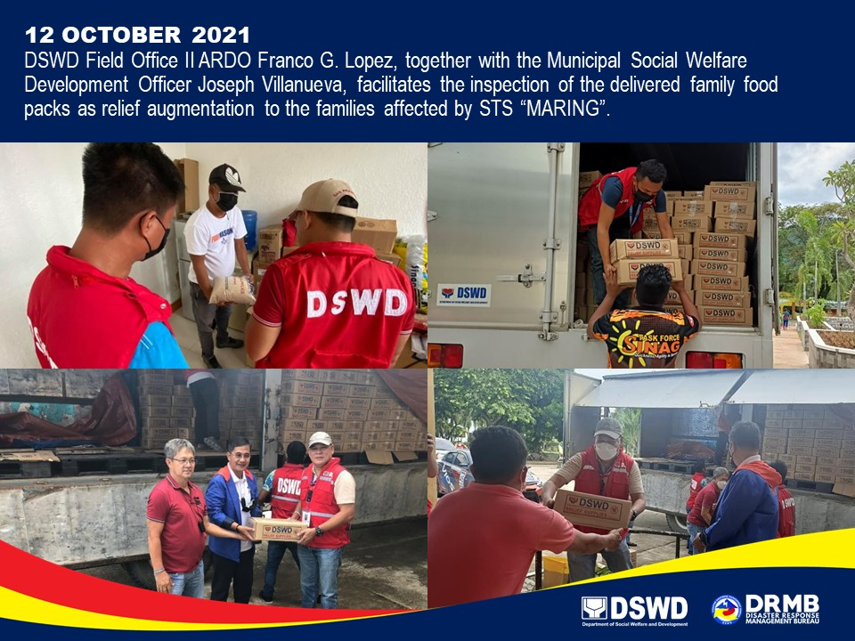
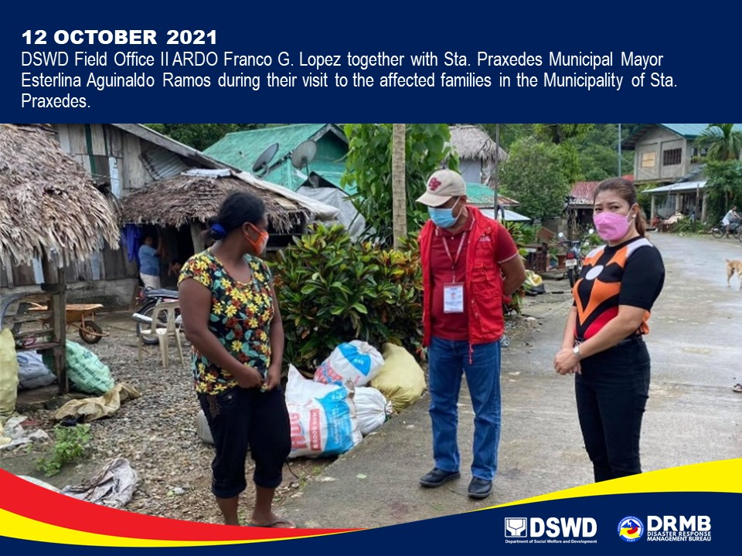

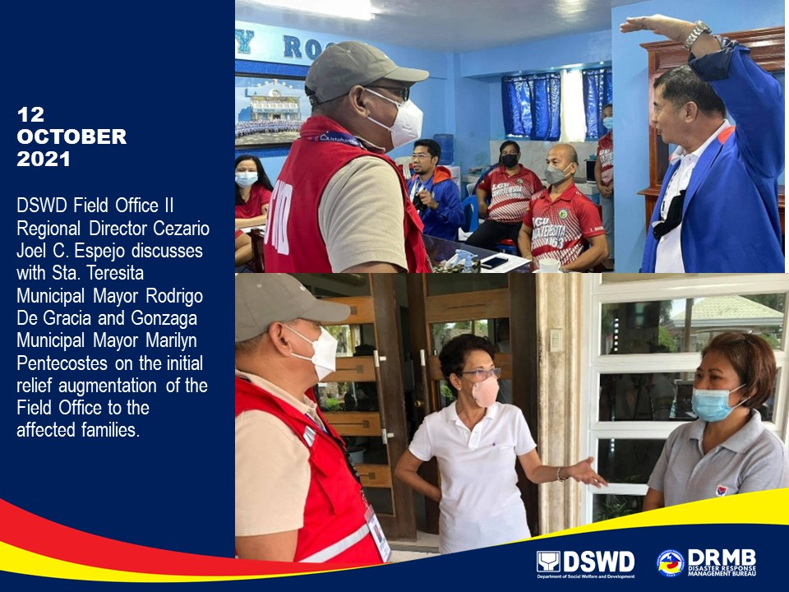

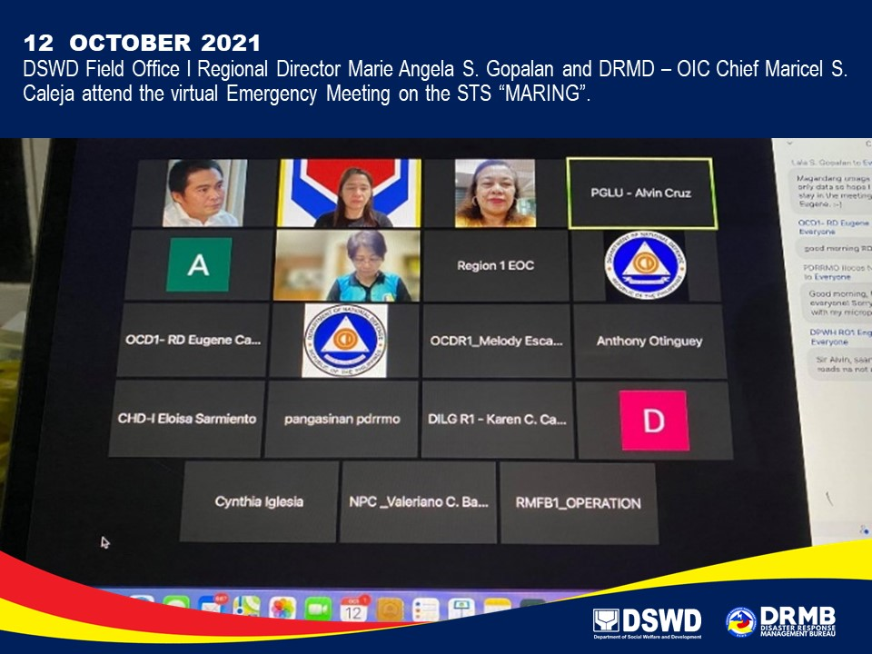

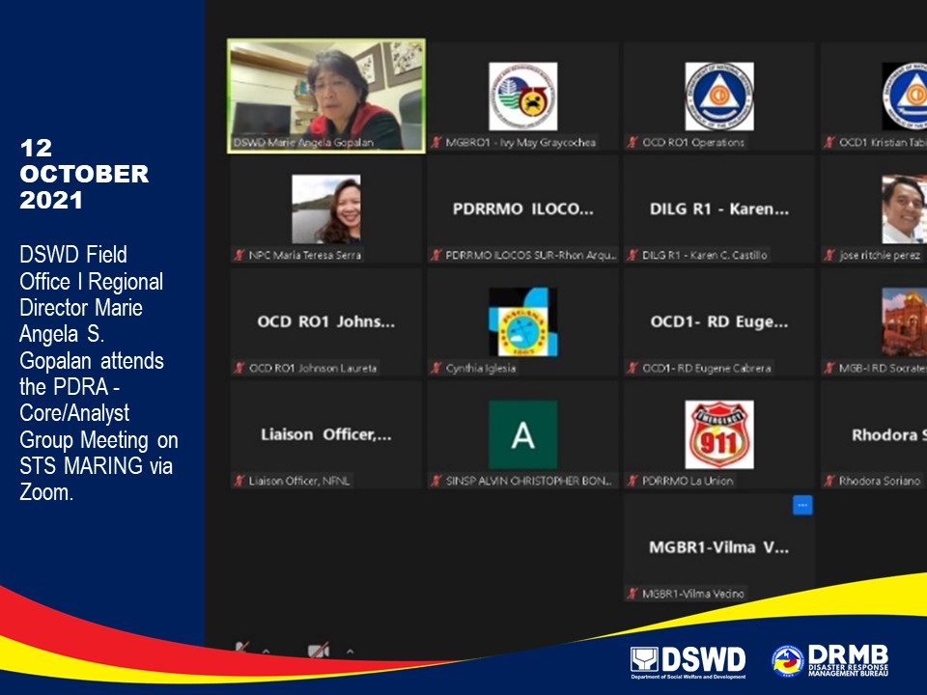

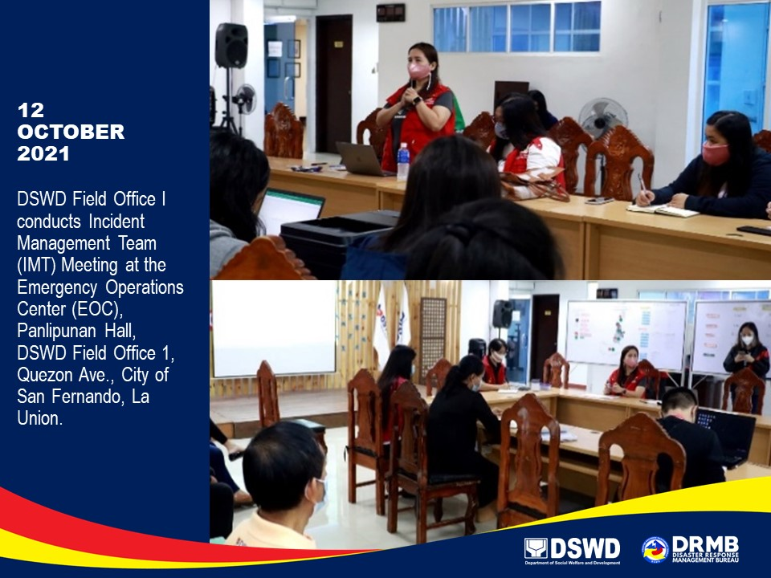

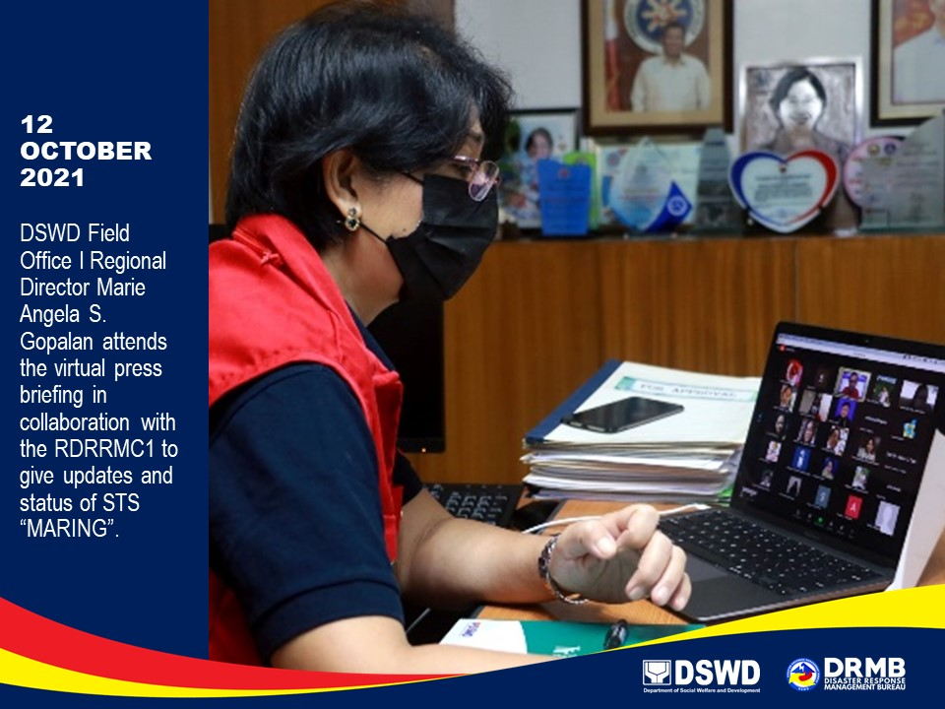

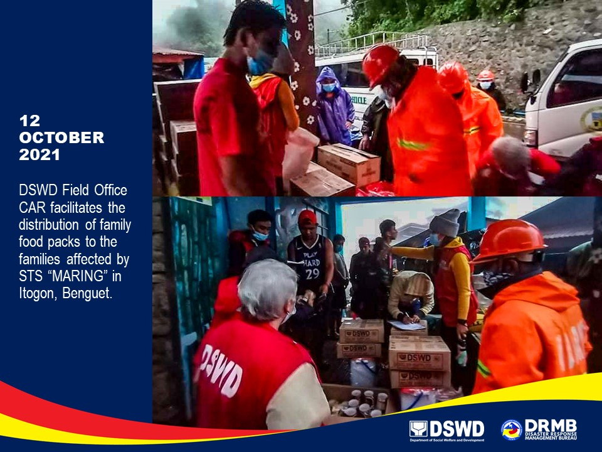

****
The Disaster Response Operations Monitoring and Information Center (DROMIC) of DSWD-DRMB is closely coordinating with the concerned DSWD-FOs for significant disaster response updates and assistance provided.

Prepared by:  DIANE C. PELEGRINO  AARON JOHN B. PASCUA  MARIE JOYCE G. RAFANAN  JOANNA CAMILLE R. JACINTO | Released by:  LESLIE R. JAWILI

