DSWD DROMIC Report #3 on the Fire Incident in
Brgy. Matina Pangi, Talomo A District, Davao City
as of 20 October 2021, 6PM

- Situation Overview
A fire incident occurred at Purok Tinago, Brgy. Matina Pangi, Talomo A District, Davao City on 06 October 2021 at around 3:35 PM.
Source: DSWD-Field Office (FO) XI

- Status of Affected Areas and Population
There are 22 families or 110 persons affected in Purok Tinago, Brgy. Matina Pangi, Talomo A District, Davao City (see Table 1).

Table 1. Number of Affected Families / Persons
REGION / PROVINCE / MUNICIPALITY |  | NUMBER OF AFFECTED
 |  | Barangays | Families | Persons
GRAND TOTAL |  | 1 | 22 | 110
REGION XI |  | 1 | 22 | 110
Davao del Sur |  | 1 | 22 | 110
 | Davao City | 1 | 22 | 110
Note: Ongoing assessment and validation are continuously being conducted.
Source: DSWD-FO XI

- Status of Displaced Population

- Inside Evacuation Center
There are 12 families or 60 persons currently taking temporary shelter at Tinago Gymnasium (see Table 2).

Table 2. Number of Displaced Families / Persons Inside Evacuation Center
REGION / PROVINCE / MUNICIPALITY |  | NUMBER OF EVACUATION CENTERS (ECs) |  | NUMBER OF DISPLACED
 |  |  |  | INSIDE ECs
 |  |  |  | Families |  | Persons (Actual)
 |  | CUM | NOW | CUM | NOW | CUM | NOW
GRAND TOTAL |  | 1 | 1 | 14 | 12 | 70 | 60
REGION XI |  | 1 | 1 | 14 | 12 | 70 | 60
Davao del Sur |  | 1 | 1 | 14 | 12 | 70 | 60
 | Davao City | 1 | 1 | 14 | 12 | 70 | 60
Note: Ongoing assessment and validation are continuously being conducted.
Source: DSWD-FO XI

- Outside Evacuation Centers

There are eight (8) families or 40 persons temporarily staying with their relatives and/or friends. (see Table 3).

Table 3. Number of Displaced Families / Persons Outside Evacuation Centers
REGION / PROVINCE / MUNICIPALITY |  | NUMBER OF DISPLACED
 |  | OUTSIDE ECs
 |  | Families |  | Persons
 |  | CUM | NOW | CUM | NOW
GRAND TOTAL |  | 8 | 8 | 40 | 40
REGION XI |  | 8 | 8 | 40 | 40
Davao del Sur |  | 8 | 8 | 40 | 40
 | Davao City | 8 | 8 | 40 | 40
Note: Ongoing assessment and validation are continuously being conducted.
Source: DSWD-FO X

- Total Displaced Population
There are 20 families or 100 persons still displaced in Purok Tinago, Brgy. Matina Pangi, Talomo A District, Davao City due to the fire incident (see Table 4).

Table 4. Total Number of Displaced Families / Persons
REGION / PROVINCE / MUNICIPALITY |  | TOTAL DISPLACED
 |  | Families |  | Persons
 |  | CUM | NOW | CUM | NOW
GRAND TOTAL |  | 22 | 20 | 110 | 100
REGION XI |  | 22 | 20 | 110 | 100
Davao del Sur |  | 22 | 20 | 110 | 100
 | Davao City | 22 | 20 | 110 | 100
Note: Ongoing assessment and validation are continuously being conducted.
Source: DSWD-FO X

- Damaged Houses
A total of 14 houses were damaged; of which, 10 are totally damaged and four (4) are partially damaged. (see Table 5).

Table 5. Number of Damaged Houses
REGION / PROVINCE / MUNICIPALITY |  | NO. OF DAMAGED HOUSES
 |  | Total | Totally | Partially
GRAND TOTAL |  | 14 | 10 | 4
REGION XI |  | 14 | 10 | 4
Davao del Sur |  | 14 | 10 | 4
 | Davao City | 14 | 10 | 4
Note: Ongoing assessment and validation being conducted.
Source: DSWD-FO XI

- Cost of Humanitarian Assistance Provided
A total of ₱88,268.84 worth of assistance was provided by DSWD to the affected families (see Table 6).

Table 6. Cost of Assistance Provided to Affected Families / Persons
REGION / PROVINCE / MUNICIPALITY |  | COST OF ASSISTANCE
 |  | DSWD | LGU | NGOs | OTHERS | GRAND TOTAL
GRAND TOTAL |  | 88,268.84 | - | - | - | 88,268.84
REGION XI |  | 88,268.84 | - | - | - | 88,268.84
Davao del Sur |  | 88,268.84 | - | - | - | 88,268.84
 | Davao City | 88,268.84 | - | - | - | 88,268.84
Source: DSWD-FO X

- Response Actions and Interventions

- Standby Funds and Prepositioned Relief Stockpile

OFFICE | STANDBY FUNDS | STOCKPILE |  |  | TOTAL STANDBY FUNDS & STOCKPILE
 |  | FAMILY FOOD PACKS |  | OTHER FOOD AND NON-FOOD ITEMS (FNIs)
 |  | QUANTITY | COST
DSWD-CO | 1,002,681,260.35 | - | - | - | 1,002,681,260.35
NRLMB-NROC | - | 28,712 | 21,606,302.70 | 140,363,984.63 | 161,970,287.33
NRLMB-VDRC | - | 4,534 | 2,160,150.00 | 41,922,936.09 | 44,083,086.09
DSWD-FO XI | 3,000,000.00 | 18,268 | 9,108,546.40 | 22,621,364.30 | 34,729,910.70
Other FOs | 57,450,190.49 | 266,693 | 151,748,009.89 | 503,867,823.36 | 713,066,023.74
TOTAL | 1,063,131,450.84 | 318,207 | 184,623,008.99 | 708,776,108.38 | 1,956,530,568.21
Note: The Inventory Summary is as of 20 October 2021, 4PM.
Source: DSWD-DRMB and DSWD-NRLMB

  - Standby Funds
- ₱1 million Quick Response Fund (QRF) at the DSWD Central Office.
- ₱3 million available standby funds at DSWD-Field Office (FO) XI.

  - Prepositioned FFPs and Other Relief Items
- 18,268 FFPs available at DSWD-FO XI.
- 33,246 FFPs available in Disaster Response Centers; of which 28,712 FFPs are at the National Resource Operations Center (NROC), Pasay City and 4,534 FFPs are at the Visayas Disaster Response Center (VDRC), Cebu City.
- ₱204.81 million worth of other FNIs at NROC, VDRC and DSWD-FO XI warehouses.

- Food and Non-food Items

DATE | ACTIVITIES
19 October 2021 | - DSWD Field Office XI provided family Food Packs and Non-food items to the affected families, 44 Family Food Packs (₱22,202.84), 22 Hygiene Kits (₱32,417.00), 22 Sleeping Kit (₱17,380.00), 22 Kitchen Kits (₱16,269.00)

- Internally Displaced Person (IDPs)

DATE | ACTIVITIES
20 October 2021 | - DSWD Field Office XI together with the City Social Welfare and Development Office (CSWDO) of Davao provided relief assistance, psychological first aid and assess needed intervention of the affected families and individuals.  - DSWD-FO XI is continuously coordinating with the City Government in monitoring the situation of the IDPs in ECs to ensure compliance with the provision of emergency relief and protection for the children (RA10821) before, during and after disasters and other emergency situations as well as to monitor the compliance with the safety health protocols set by the IATF.

- Camp Coordination and Camp Management (CCCM)

DATE | ACTIVITIES
20 October 2021 | - DSWD Field Office XI together with the City Social Welfare and Development Office (CSWDO) of Davao provided hot meals for the displaced families inside the evacuation center in Purok Tinago Gym.  - Modular tents provided by Davao City government were also set up inside evacuation center.

- Photo Documentation

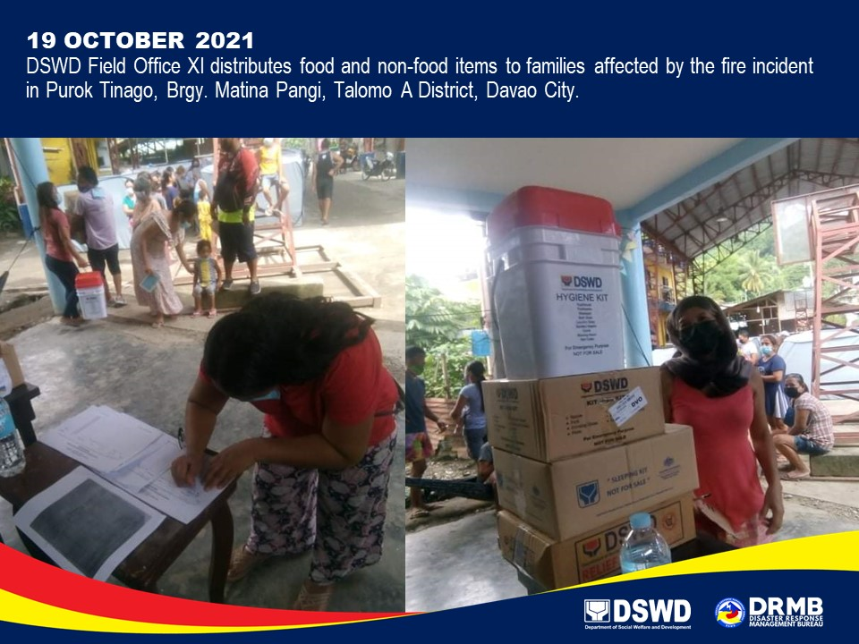
*****
The Disaster Response Operations Monitoring and Information Center (DROMIC) of DSWD-DRMB is closely coordinating with DSWD-FO XI for significant disaster response updates and assistance provided.

Prepared by:  AARON JOHN B. PASCUA | Released by:  LESLIE R. JAWILI

