DSWD DROMIC Report #3 on the Fire Incident
in Brgy. Recodo, Zamboanga City
as of 29 October 2021, 6PM

- Situation Overview

On 13 October 2021 at 2:00 AM, a fire incident occurred at Purok 2 (Acacia) and Purok 3 (Las Vegas) in Brgy. Recodo, Zamboanga City. The fire was declared out at 5:30 AM. The cause of fire is under investigation.

Source: DSWD-Field Office (FO) IX

- Status of Affected Areas and Population

A total of 487 families or 2,247 persons were affected in Brgy. Recodo, Zamboanga City (see Table 1).

Table 1. Number of Affected Families / Persons
REGION / PROVINCE / MUNICIPALITY |  | NUMBER OF AFFECTED
 |  | Barangays | Families | Persons
GRAND TOTAL |  | 1 | 487 | 2,247
REGION IX |  | 1 | 487 | 2,247
Zamboanga del Sur |  | 1 | 487 | 2,247
 | Zamboanga City | 1 | 487 | 2,247
Note: Changes in figures are based on the ongoing assessment and validation being conducted.
Source: DSWD-FO IX

- Status of Displaced Population

- Inside Evacuation Centers
There are 378 families or 1,686 persons currently taking temporary shelter at the three (3) evacuation centers (see Table 2).

Table 2. Number of Displaced Families / Persons Inside Evacuation Centers
REGION / PROVINCE / MUNICIPALITY |  | NUMBER OF EVACUATION CENTERS (ECs) |  | NUMBER OF DISPLACED
 |  |  |  | INSIDE ECs
 |  |  |  | Families |  | Persons
 |  | CUM | NOW | CUM | NOW | CUM | NOW
GRAND TOTAL |  | 3 | 3 | 378 | 378 | 1,686 | 1,686
REGION IX |  | 3 | 3 | 378 | 378 | 1,686 | 1,686
Zamboanga del Sur |  | 3 | 3 | 378 | 378 | 1,686 | 1,686
 | Zamboanga City | 3 | 3 | 378 | 378 | 1,686 | 1,686
Note: Changes in figures are based on the ongoing assessment and validation being conducted.
Source: DSWD-FO IX

- Outside Evacuation Center
There are 109 families or 561 persons temporarily staying with their relatives and/or friends (see Table 3).

Table 3. Number of Displaced Families / Persons Outside Evacuation Center
REGION / PROVINCE / MUNICIPALITY |  | NUMBER OF DISPLACED
 |  | OUTSIDE ECs
 |  | Families |  | Persons
 |  | CUM | NOW | CUM | NOW
GRAND TOTAL |  | 109 | 109 | 561 | 561
REGION IX |  | 109 | 109 | 561 | 561
Zamboanga del Sur |  | 109 | 109 | 561 | 561
 | Zamboanga City | 109 | 109 | 561 | 561
Note: Changes in figures are based on the ongoing assessment and validation being conducted.
Source: DSWD-FO IX

- Total Displaced Population
There are 364 families or 2,247 persons still displaced in Brgy. Recodo, Zamboanga City (see Table 4).

Table 4. Total Number of Displaced Families / Persons
REGION / PROVINCE / MUNICIPALITY |  | TOTAL DISPLACED SERVED
 |  | Families |  | Persons
 |  | Total Families |  | Total Persons
 |  | CUM | NOW | CUM | NOW
GRAND TOTAL |  | 487 | 364 | 2,247 | 2,247
REGION IX |  | 487 | 364 | 2,247 | 2,247
Zamboanga del Sur |  | 487 | 364 | 2,247 | 2,247
 | Zamboanga City | 487 | 364 | 2,247 | 2,247
Note: Changes in figures are based on the ongoing assessment and validation being conducted
Source: DSWD-FOs

- Damaged Houses

A total of 300 houses were totally damaged by the fire (see Table 3).

Table 3. Number of Damaged Houses
REGION / PROVINCE / MUNICIPALITY |  | NO. OF DAMAGED HOUSES
 |  | Total | Totally | Partially
GRAND TOTAL |  | 300 | 300 | -
REGION IX |  | 300 | 300 | -
Zamboanga del Sur |  | 300 | 300 | -
 | Zamboanga City | 300 | 300 | -
Note: Ongoing assessment and validation being conducted.
Source: DSWD-FO IX

- Cost of Humanitarian Assistance Provided
A total of ₱2,249,020.24 worth of assistance was provided to the affected families by DSWD (see Table 4).

Table 4. Cost of Assistance Provided to Affected Families / Persons
REGION / PROVINCE / MUNICIPALITY |  | COST OF ASSISTANCE
 |  | DSWD | LGU | NGOs | OTHERS | GRAND TOTAL
GRAND TOTAL |  | 2,249,020.24 | - | - | - | 2,249,020.24
REGION IX |  | 2,249,020.24 | - | - | - | 2,249,020.24
Zamboanga del Sur |  | 2,249,020.24 | - | - | - | 2,249,020.24
 | Zamboanga City | 2,249,020.24 | - | - | - | 2,249,020.24
Source: DSWD-FO IX

- Response Actions and Interventions

- Standby Funds and Prepositioned Relief Stockpile
Office | STANDBY  FUNDS | Family Food Packs (FFPs) |  | Other Food and Non-Food Items (FNFIs) | Total
 |  | No. | Cost
DSWD-FO IX | 3,000,000.00 | 21,443 | 11,718,385.07 | 18,218,131.29 | 32,936,516.36
Note: The Inventory Summary is as of 29 October 2021, 4PM.
Source: DSWD-FO IX

  - Standby Funds
- ₱3,000,000.00 standby funds at the DSWD-FO IX

  - Prepositioned FFPs and Other Relief Items
- 21,443 FFPs available at DSWD-FO IX.
- ₱18.22 million worth of FNFIs readily available at DSWD-FO IX.

- Other Activities

- DSWD-FO IX DRMD through the Disaster Response Information Management Section conducted Disaster Needs Assessment to identify the needs of the affected families and also facilitated the geotagging of fire incident to generate spatial data on the scope of the damage from the fire.
- DSWD-FO IX facilitated the provision of financial assistance thru Assistance to Individuals in Crisis Situation (AICS) Funds during the distribution of hygiene kits.
- DSWD-FO IX DRMD through the Disaster Response Information Management Section is continuously coordinating with the ZCSWDO Field Office IX on the status of the families inside evacuation centers and any relief augmentation needed.

- DSWD-FO IX DRMD continuously coordinates with the LGU of Zamboanga City for further updates and for possible augmentation assistance needed by the affected families.

- Photo Documentation

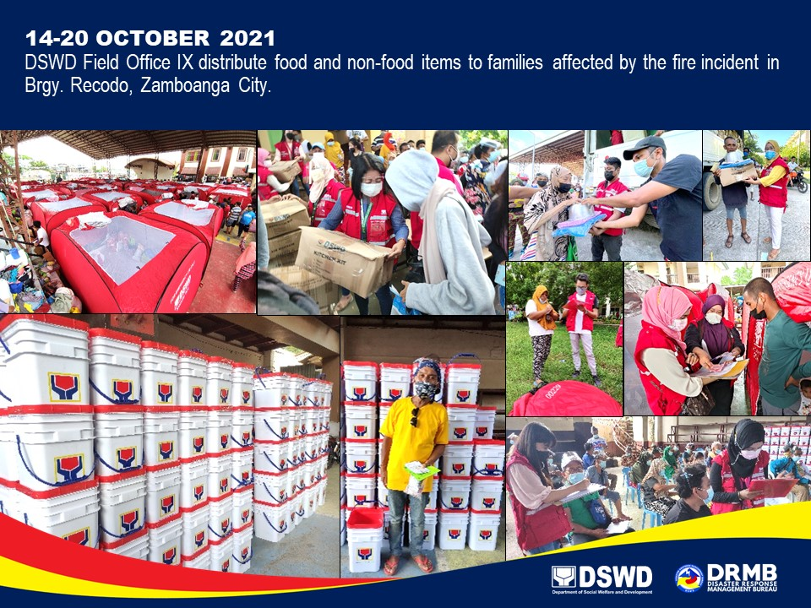

*****
The Disaster Response Operations Monitoring and Information Center (DROMIC) of DSWD-DRMB is closely coordinating with DSWD-FO IX for significant disaster response updates and assistance provided.

Prepared by:  AARON JOHN B. PASCUA | Released by:  LESLIE R. JAWILI

