DSWD DROMIC Report #4 on the Effects of Southwest Monsoon enhanced by STS “Maring”
as of 15 October 2021, 6PM

- Situation Overview

On 12 October 2021 at 11 AM, it was forecasted that the Southwest Monsoon enhanced by Severe Tropical Storm “MARING” would bring moderate to heavy rains over Occidental Mindoro, and Palawan. Meanwhile, light to moderate with at times heavy rains would prevail over Metro Manila, Bataan, Cavite, Batangas, Antique, Aklan, Negros Occidental, and the rest of MIMAROPA. Under these conditions, flash flooding and rain-induced landslides were possible especially in areas that are highly or very highly susceptible to these hazards as identified in hazard maps.

On 13 October 2021 at 5 AM, the Southwest Monsoon enhanced by Severe Tropical Storm (STS) “Maring” would possibly bring monsoon rains over Bataan, Zambales, Occidental Mindoro, and Palawan within the next 24 hours.

Issued on 14 October 2021 at 4 PM, Intertropical Convergence Zone (ICTZ) affecting Luzon and Visayas.

Source: DOST-PAGASA Weather Advisory

- Status of Affected Areas and Population
A total of 3,611 families or 12,950 persons were affected by the Southwest Monsoon enhanced by STS “Maring” in 55 barangays in Regions VI and MIMAROPA (see Table 1).

Table 1. Number of Affected Families / Persons
REGION / PROVINCE / MUNICIPALITY |  | NUMBER OF AFFECTED
 |  | Barangays | Families | Persons
GRAND TOTAL |  | 55 | 3,611 | 12,950
MIMAROPA |  | 54 | 3,609 | 12,940
Occidental Mindoro |  | 2 | 18 | 86
 | San Jose | 2 | 18 | 86
Palawan |  | 52 | 3,591 | 12,854
 | Aborlan | 1 | 1 | 7
 | Balabac | 2 | 2 | 12
 | Bataraza | 5 | 487 | 1,227
 | Brooke's Point | 7 | 209 | 756
 | Narra | 18 | 1,658 | 5,287
 | Quezon | 7 | 656 | 2,931
 | Rizal (Marcos) | 6 | 221 | 908
 | Sofronio Española | 6 | 357 | 1,726
REGION VI |  | 1 | 2 | 10
Iloilo |  | 1 | 2 | 10
 | Iloilo City (capital) | 1 | 2 | 10
Note: Ongoing assessment and validation are continuously being conducted.
Source: DSWD-Field Offices (FOs) VI and MIMAROPA

- Status of Displaced Population
- Inside Evacuation Center
There are 482 families or 1,531 persons currently taking temporary shelter in 18 evacuation centers in Region VI and MIMAROPA (see Table 2).

Table 2. Number of Displaced Families / Persons Inside Evacuation Center
REGION / PROVINCE / MUNICIPALITY |  | NUMBER OF EVACUATION CENTERS (ECs) |  | NUMBER OF DISPLACED
 |  |  |  | INSIDE ECs
 |  |  |  | Families |  | Persons
 |  | CUM | NOW | CUM | NOW | CUM | NOW
GRAND TOTAL |  | 54 | 18 | 1,408 | 482 | 5,175 | 1,531
MIMAROPA |  | 53 | 17 | 1,406 | 480 | 5,165 | 1,521
Occidental Mindoro |  | 2 | - | 18 | - | 86 | -
 | San Jose | 2 | - | 18 | - | 86 | -
Palawan |  | 51 | 17 | 1,388 | 480 | 5,079 | 1,521
 | Aborlan | 1 | - | 1 | - | 7 | -
 | Bataraza | 4 | - | 36 | - | 168 | -
 | Brooke's Point | 13 | - | 209 | - | 756 | -
 | Narra | 18 | 17 | 637 | 480 | 2,022 | 1,521
 | Quezon | 7 | - | 420 | - | 1,751 | -
 | Rizal (Marcos) | 2 | - | 27 | - | 85 | -
 | Sofronio Española | 6 | - | 58 | - | 290 | -
REGION VI |  | 1 | 1 | 2 | 2 | 10 | 10
Iloilo |  | 1 | 1 | 2 | 2 | 10 | 10
 | Iloilo City (capital) | 1 | 1 | 2 | 2 | 10 | 10
Note: Ongoing assessment and validation are continuously being conducted.
Source: DSWD-FOs VI and MIMAROPA

- Outside Evacuation Center
There are 238 families or 1,187 persons temporarily staying with their relatives and/or friends in MIMAROPA (see Table 3).

Table 3. Number of Displaced Families / Persons Outside Evacuation Center
REGION / PROVINCE / MUNICIPALITY |  | NUMBER OF DISPLACED
 |  | OUTSIDE ECs
 |  | Families |  | Persons
 |  | CUM | NOW | CUM | NOW
GRAND TOTAL |  | 2,203 | 238 | 7,775 | 1,187
MIMAROPA |  | 2,203 | 238 | 7,775 | 1,187
Palawan |  | 2,203 | 238 | 7,775 | 1,187
 | Balabac | 2 | - | 12 | -
 | Bataraza | 451 | 2 | 1,059 | 7
 | Narra | 1,021 | - | 3,265 | -
 | Quezon | 236 | 236 | 1,180 | 1,180
 | Rizal (Marcos) | 194 | - | 823 | -
 | Sofronio Española | 299 | - | 1,436 | -
Note: Ongoing assessment and validation are continuously being conducted.
Source: DSWD-FO MIMAROPA

- Total Displaced Population
There are 720 families or 2,718 persons displaced in Regions VI and MIMAROPA (see Table 4).

Table 4. Total Number of Displaced Families / Persons
REGION / PROVINCE / MUNICIPALITY |  | TOTAL DISPLACED SERVED
 |  | Families |  | Persons
 |  | Total Families |  | Total Persons
 |  | CUM | NOW | CUM | NOW
GRAND TOTAL |  | 3,611 | 720 | 12,950 | 2,718
MIMAROPA |  | 3,609 | 718 | 12,940 | 2,708
Occidental Mindoro |  | 18 | - | 86 | -
 | San Jose | 18 | - | 86 | -
Palawan |  | 3,591 | 718 | 12,854 | 2,708
 | Aborlan | 1 | - | 7 | -
 | Balabac | 2 | - | 12 | -
 | Bataraza | 487 | 2 | 1,227 | 7
 | Brooke's Point | 209 | - | 756 | -
 | Narra | 1,658 | 480 | 5,287 | 1,521
 | Quezon | 656 | 236 | 2,931 | 1,180
 | Rizal (Marcos) | 221 | - | 908 | -
 | Sofronio Española | 357 | - | 1,726 | -
REGION VI |  | 2 | 2 | 10 | 10
Iloilo |  | 2 | 2 | 10 | 10
 | Iloilo City (capital) | 2 | 2 | 10 | 10
Note: Ongoing assessment and validation are continuously being conducted.
Source: DSWD-FOs VI and MIMAROPA

- Damaged Houses
A total of 114 houses were damaged; of which, 52 are totally damaged and 62 are partially damaged (see Table 5).

Table 5. Number of Damaged Houses
REGION / PROVINCE / MUNICIPALITY |  | NO. OF DAMAGED HOUSES
 |  | Total | Totally | Partially
GRAND TOTAL |  | 114 | 52 | 62
MIMAROPA |  | 112 | 52 | 60
Palawan |  | 112 | 52 | 60
 | Balabac | 2 | 1 | 1
 | Bataraza | 2 | 2 | -
 | Brooke's Point | 6 | 5 | 1
 | Narra | 85 | 36 | 49
 | Quezon | 8 | 8 | -
 | Rizal (Marcos) | 1 | - | 1
 | San Vicente | 8 | - | 8
REGION VI |  | 2 | - | 2
Iloilo |  | 2 | - | 2
 | Iloilo City (capital) | 2 | - | 2
Source: DSWD-FOs VI and MIMAROPA

- Cost of Humanitarian Assistance Provided
A total of ₱4,798,566.80 worth of assistance was provided to the affected families; of which ₱2,462,902.80 from DSWD and ₱2,335,664.00 from the Local Government Units (LGUs) (see Table 6).

Table 6. Cost of Assistance Provided to Affected Families / Persons
REGION / PROVINCE / MUNICIPALITY |  | COST OF ASSISTANCE
 |  | DSWD | LGUs | NGOs | OTHERS | GRAND TOTAL
GRAND TOTAL |  | 2,462,902.80 | 2,335,664.00 | - | - | 4,798,566.80
MIMAROPA |  | 2,462,902.80 | 2,333,730.00 | - | - | 4,796,632.80
Palawan |  | 2,462,902.80 | 2,333,730.00 | - | - | 4,796,632.80
 | Bataraza | 340,900.00 | 65,000.00 | - | - | 405,900.00
 | Narra | 1,480,864.00 | 1,340,000.00 | - | - | 2,820,864.00
 | Quezon | 401,138.80 | 885,275.00 | - | - | 1,286,413.80
 | Rizal (Marcos) | - | 2,700.00 | - | - | 2,700.00
 | Sofronio Española | 240,000.00 | 40,755.00 | - | - | 280,755.00
REGION VI |  | - | 1,934.00 | - | - | 1,934.00
Iloilo |  | - | 1,934.00 | - | - | 1,934.00
 | Iloilo City (capital) | - | 1,934.00 | - | - | 1,934.00
Source: DSWD-FOs VI and MIMAROPA

- Response Actions and Interventions

- Standby Funds and Prepositioned Relief Stockpile

OFFICE | STANDBY FUNDS | STOCKPILE |  |  | TOTAL STANDBY FUNDS & STOCKPILE
 |  | FAMILY FOOD PACKS |  | OTHER FOOD AND NON-FOOD ITEMS (FNIs)
 |  | QUANTITY | TOTAL COST
TOTAL | 1,127,229,182.27 | 365,882 | 219,442,534.11 | 681,125,989.45 | 2,027,824,705.83
DSWD-CO | 1,076,381,260.35 | - | - | - | 1,076,381,260.35
NRLMB-NROC | - | 77,812 | 57,570,230.70 | 157,933,260.63 | 215,503,491.33
NRLMB-VDRC | - | 4,234 | 2,017,650.00 | 32,108,392.25 | 34,126,042.25
DSWD-FO MIMAROPA | 5,000,000.00 | 21,882 | 15,354,246.55 | 21,494,866.15 | 41,849,112.70
DSWD-FO VI | 646.42 | 10,300 | 5,023,497.98 | 37,824,691.13 | 42,848,835.53
Other FOs | 45,847,275.50 | 251,654 | 139,476,908.88 | 431,791,779.29 | 617,115,963.67
Note: The Inventory Summary is as of 15 October 2021, 4PM.
Source: DSWD-DRMB and DSWD-NRLMB

  - Standby Funds
- ₱1.07 billion Quick Response Fund (QRF) at the DSWD Central Office.
- A total of ₱5 million available standby funds at DSWD-FOs VI and MIMAROPA. Standby fund for DSWD-FO VI is on the process of replenishment.
- ₱45.85 million available in other DSWD-FOs which may support the relief needs of the displaced families due to the effects of Southwest Monsoon enhanced by STS “Maring” through inter-FO augmentation.

  - Prepositioned FFPs and Other Relief Items
- 82,046 FFPs available in Disaster Response Centers; of which 77,812 FFPs are at the National Resource Operations Center (NROC), Pasay City and 4,234 FFPs are at the Visayas Disaster Response Center (VDRC), Cebu City.
- A total of 32,182 FFPs available at DSWD-FOs VI and MIMAROPA.
- 251,654 FFPs available in other DSWD-FOs which may support the relief needs of the displaced families due to the effects of Southwest Monsoon enhanced by STS “Maring” through inter-FO augmentation.
- ₱681,13 million worth of other FNIs at NROC, VDRC and DSWD-FO warehouses countrywide.

- Food and Non-Food Items

DSWD-FO MIMAROPA
DATE | ACTIVITIES
15 October 2021 | - DSWD-FO MIMAROPA is coordinating with NRLMB for loading 3,000 kitted FPPs to container vans for replenishment of stockpiles in the province of Palawan in partnership with World Food Program (WFP).
14 October 2021 | - There is an ongoing distribution of 1,100 FFPs out of 1,700 allocated FFPs from the DSWD. The remaining 600 FFPs will be hauled by the LGU today.  - There are 2,000 FFPs from the Provincial Social Welfare and Development Office (PSWDO) provided and being distributed in Narra, Palawan.
13 October 2021 | - DSWD-FO MIMAROPA has an ongoing replenishment of stockpile to complete the required number of goods as mandated by the DSWD Administrative Order (AO) No. 2, series of 2021 or the Omnibus Guidelines on FNI and Logistics Management for Disaster Response Operations.  - DSWD-FO MIMAROPA is coordinating with NRLMB for the delivery of 3,000 FFPs in partnership with Cebu Pacific.

- Camp Coordination and Camp Management

DSWD-FO MIMAROPA
DATE | ACTIVITIES
13 October 2021 | - The Social Welfare and Development Team (SWADT) Provincial Staff and all the Provincial/City/Municipal (P/C/M) Quick Response Teams (QRTs) are monitoring the situation of the internally displaced persons (IDPs) in evacuation centers to ensure proper establishment of health protocols as part of the campaign to prevent COVID-19 transmission.

- Other Activities

DSWD-FO MIMAROPA
DATE | ACTIVITIES
12 October 2021 | - DSWD-FO MIMAROPA activated its Virtual Emergency Operations Center.  - DSWD-FO MIMAROPA coordinated with its SWADT Palawan to thoroughly assess and evaluate the present condition of the internally displaced persons (IDPs) and provide support to the immediate needs of the affected families/individuals.  - DSWD-FO MIMAROPA coordinated with SWADT Palawan on the provision of FNIs to the affected families and individuals in the area.  - DSWD-FO MIMAROPA attended Pre-Disaster Risk Assessment (PDRA) Analyst and Core Group Meeting for TD “Maring”.  - DSWD-FO MIMAROPA closely coordinated with the Office of Civil Defense (OCD) and Regional Disaster Risk Reduction and Management Council (RDRRMC) MIMAROPA for any updates for monitoring purposes and response mechanism for areas that will be affected.

DSWD-FO VI
DATE | ACTIVITIES
13 October 2021 | - DSWD-FO VI is coordinating with the Iloilo City Social Welfare and Development Office (CSWDO) for updates on the status of affected families/individuals and for possible relief augmentation.

- Photo Documentation
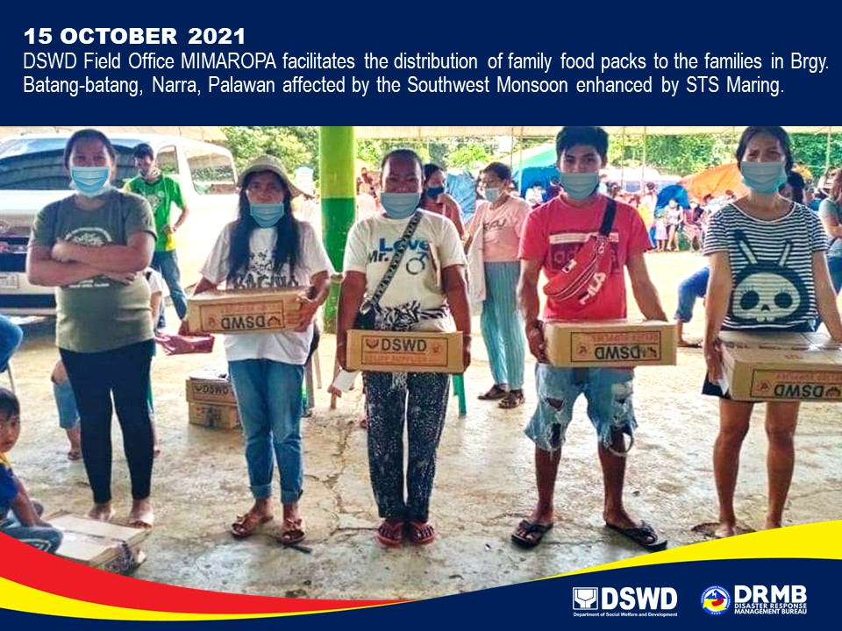

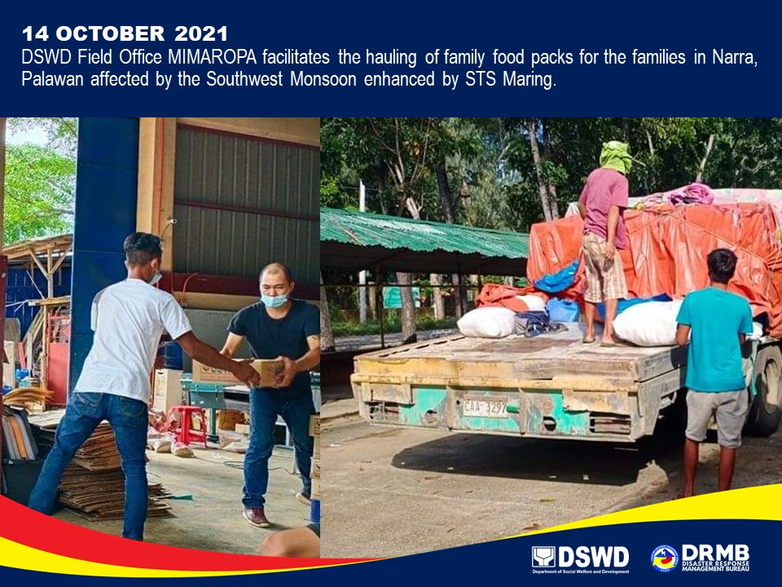

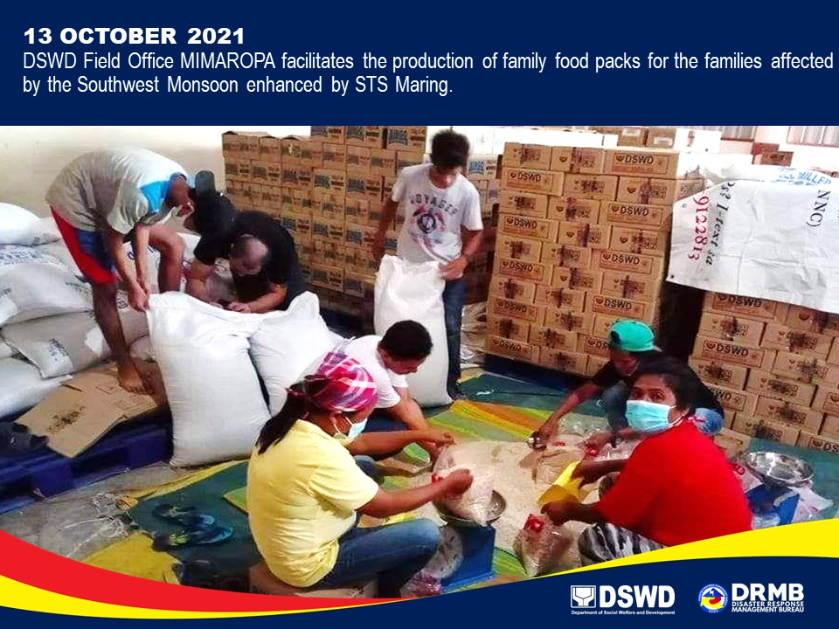

*****
The Disaster Response Operations Monitoring and Information Center (DROMIC) of DSWD-DRMB is closely coordinating with the concerned DSWD-FOs for significant disaster response updates and assistance provided.

Prepared by:  DIANE C. PELEGRINO  JEM ERIC F. FAMORCAN  MARIE JOYCE G. RAFANAN  JOANNA CAMILLE R. JACINTO | Released by:  LESLIE R. JAWILI

