DSWD DROMIC Report #5 on Severe Tropical Storm “MARING”
as of 15 October 2021, 6PM

- Situation Overview

On 07 October 2021, the Low Pressure Area (LPA) East of Camarines Norte developed into a Tropical Depression and was named "MARING". "MARING" became a large Tropical Storm as it moved over the Philippine Sea on 08 October 2021. Tropical Storm "MARING" merged with the remnants of "NANDO" as it moved North Northwestward over the Philippine Sea on 10 October 2021.

On 11 October 2021, "MARING" intensified into a Severe Tropical Storm (STS) as it moved Westward towards Babuyan Islands bringing moderate to heavy with at times intense rains over Batanes, Cagayan including Babuyan Islands, Cordillera Administrative Region and Ilocos Region and also brought light to moderate with at times heavy rains over Central Luzon and the rest of Cagayan Valley. The expansive wind field of STS “MARING” and the enhanced Southwest Monsoon brought occasional gusts reaching strong to gale-force in strength over the island, coastal, and upland/mountain localities of Visayas, Dinagat Islands, Surigao del Norte, Agusan del Norte, Misamis Oriental, Misamis Occidental, Camiguin, Zamboanga del Norte, and the rest of Luzon.
On 12 October 2021, STS "MARING" accelerated while moving Westward over the West Philippine Sea and exited the Philippine Area of Responsibility (PAR) at 11 AM.

Source: DOST-PAGASA Weather Advisory

- Status of Affected Areas and Population

A total of 139,155 families or 567,062 persons were affected by Severe Tropical Storm (STS) “Maring” in 1,228 Barangays in Regions I, II, III, Caraga, NCR and CAR (see Table 1).

Table 1. Number of Affected Families / Persons
REGION / PROVINCE / MUNICIPALITY |  | NUMBER OF AFFECTED
 |  | Barangays | Families | Persons
GRAND TOTAL |  | 1,228 | 139,155 | 567,062
NCR |  | 1 | 212 | 745
Metro Manila |  | 1 | 212 | 745
Manila City |  | 1 | 212 | 745
REGION I |  | 716 | 94,372 | 407,221
Ilocos Norte |  | 16 | 273 | 700
 | Bacarra | 1 | 1 | 4
 | Badoc | 1 | 1 | 5
 | Bangui | 1 | 14 | 47
 | Banna (Espiritu) | 3 | 8 | 25
 | CITY OF BATAC | 2 | 216 | 485
 | Dingras | 1 | 1 | 5
 | LAOAG CITY (Capital) | 1 | 1 | 5
 | Marcos | 1 | 2 | 9
 | Pagudpud | 2 | 26 | 104
 | Pinili | 2 | 2 | 8
 | Sarrat | 1 | 1 | 3
Ilocos Sur |  | 257 | 32,027 | 151,513
 | Alilem | 2 | 14 | 44
 | Banayoyo | 12 | 238 | 1190
 | Bantay | 2 | 4 | 18
 | CITY OF CANDON | 9 | 64 | 223
 | Caoayan | 17 | 7246 | 36230
 | Cervantes | 3 | 20 | 96
 | Galimuyod | 13 | 87 | 365
 | Gregorio del Pilar (Concepcion) | 6 | 16 | 75
 | Lidlidda | 7 | 26 | 96
 | Magsingal | 2 | 2 | 10
 | Quirino (Angkaki) | 1 | 29 | 87
 | Salcedo (Baugen) | 10 | 113 | 524
 | San Emilio | 8 | 36 | 169
 | San Ildefonso | 2 | 2 | 9
 | San Vicente | 1 | 1 | 8
 | Santa | 10 | 1304 | 6520
 | Santa Catalina | 2 | 2 | 10
 | Santa Cruz | 18 | 1038 | 4276
 | Santa Lucia | 17 | 4283 | 15221
 | Santa Maria | 33 | 7141 | 35705
 | Santiago | 3 | 64 | 320
 | Sigay | 5 | 29 | 120
 | Sugpon | 3 | 78 | 283
 | Suyo | 3 | 80 | 317
 | Tagudin | 33 | 9189 | 45913
 | CITY OF VIGAN (Capital) | 35 | 921 | 3684
La Union |  | 288 | 37,599 | 138,696
 | Agoo | 15 | 97 | 289
 | Aringay | 22 | 3,775 | 15,566
 | Bacnotan | 47 | 4,984 | 16,543
 | Bagulin | 1 | 602 | 1,997
 | Balaoan | 6 | 33 | 119
 | Bangar | 5 | 113 | 357
 | Bauang | 25 | 3,911 | 14,734
 | Burgos | 2 | 47 | 155
 | Caba | 8 | 30 | 117
 | Luna | 40 | 13,314 | 53,526
 | Naguilian | 29 | 1,551 | 5,518
 | Pugo | 8 | 42 | 145
 | Rosario | 2 | 38 | 149
 | CITY OF SAN FERNANDO (Capital) | 10 | 35 | 129
 | San Gabriel | 15 | 4,685 | 14,891
 | San Juan | 26 | 3,301 | 10,426
 | Santo Tomas | 7 | 718 | 2,880
 | Santol | 9 | 69 | 273
 | Sudipen | 11 | 254 | 882
Pangasinan |  | 155 | 24,473 | 116,312
 | CITY OF ALAMINOS | 1 | 30 | 90
 | Asingan | 9 | 1,475 | 5,900
 | Balungao | 5 | 1,057 | 5,285
 | Bani | 1 | 2 | 8
 | Basista | 1 | 1 | 3
 | Bautista | 4 | 486 | 1,944
 | Binalonan | 8 | 593 | 2,273
 | Bolinao | 3 | 26 | 87
 | Calasiao | 15 | 8,265 | 41,325
 | Dagupan City | 12 | 194 | 676
 | Labrador | 1 | 283 | 1,650
 | Laoac | 18 | 1,281 | 6,342
 | LINGAYEN (Capital) | 7 | 34 | 123
 | Mabini | 1 | 2 | 10
 | Malasiqui | 5 | 225 | 1,018
 | Manaoag | 2 | 31 | 112
 | Mangaldan | 1 | 9 | 35
 | Pozzorubio | 3 | 4 | 14
 | San Fabian | 8 | 2,342 | 9,301
 | San Jacinto | 11 | 544 | 2,660
 | San Nicolas | 2 | 31 | 115
 | San Quintin | 1 | 25 | 105
 | Santa Barbara | 26 | 6,601 | 32,695
 | Sison | 2 | 4 | 16
 | Sual | 1 | 28 | 92
 | Tayug | 3 | 74 | 303
 | CITY OF URDANETA | 4 | 826 | 4,130
REGION II |  | 191 | 12,107 | 42,806
Batanes |  | 1 | 1 | 2
 | Basco | 1 | 1 | 2
Cagayan |  | 178 | 12,073 | 42,666
 | Abulug | 1 | 31 | 119
 | Allacapan | 4 | 15 | 40
 | Aparri | 17 | 3,827 | 13,677
 | Baggao | 43 | 1,852 | 5,942
 | Ballesteros | 1 | 3 | 10
 | Buguey | 13 | 1,542 | 5,684
 | Calayan | 1 | 2 | 11
 | Camalaniugan | 10 | 460 | 1,909
 | Claveria | 5 | 36 | 144
 | Gattaran | 13 | 336 | 1,034
 | Gonzaga | 21 | 1,658 | 5,520
 | Lal-lo | 7 | 494 | 1,772
 | Lasam | 4 | 33 | 99
 | Pamplona | 9 | 183 | 491
 | Peñablanca | 2 | 5 | 22
 | Piat | 1 | 13 | 20
 | Rizal | 5 | 99 | 274
 | Sanchez-Mira | 1 | 4 | 10
 | Santa Ana | 6 | 19 | 88
 | Santa Praxedes | 2 | 17 | 53
 | Santa Teresita | 12 | 1,444 | 5,747
Isabela |  | 2 | 16 | 62
 | Divilacan | 2 | 16 | 62
Nueva Vizcaya |  | 10 | 17 | 76
 | Ambaguio | 3 | 4 | 22
 | Aritao | 1 | 2 | 6
 | Kayapa | 1 | 2 | 9
 | Quezon | 2 | 7 | 31
 | Solano | 3 | 2 | 8
REGION III |  | 5 | 48 | 155
Bataan |  | 1 | 37 | 125
 | Bagac | 1 | 37 | 125
Bulacan |  | 1 | 8 | 15
 | Bulacan | 1 | 8 | 15
Zambales |  | 3 | 3 | 15
 | Botolan | 1 | 1 | 5
 | Iba (capital) | 2 | 2 | 10
CARAGA |  | 12 | 564 | 2,255
Agusan del Norte |  | 10 | 523 | 2,127
 | City of Cabadbaran | 10 | 523 | 2,127
Surigao del Sur |  | 2 | 41 | 128
 | San Miguel | 2 | 41 | 128
CAR |  | 303 | 31,852 | 113,880
Abra |  | 175 | 30,898 | 110,013
 | Bangued (capital) | 3 | 1,684 | 5,245
 | Boliney | 8 | 1,117 | 4,481
 | Bucay | 12 | 2,411 | 11,078
 | Daguioman | 4 | 483 | 2,065
 | Danglas | 7 | 615 | 1,741
 | Dolores | 4 | 112 | 336
 | La Paz | 6 | 256 | 1,048
 | Lacub | 6 | 1,139 | 5,707
 | Lagangilang | 17 | 4,633 | 14,519
 | Lagayan | 2 | 428 | 1,383
 | Langiden | 6 | 1,248 | 4,091
 | Licuan-Baay (Licuan) | 11 | 1,455 | 5,593
 | Luba | 8 | 1,738 | 6,923
 | Malibcong | 12 | 1,122 | 4,500
 | Manabo | 11 | 3,605 | 8,137
 | Pilar | 9 | 1,324 | 6,620
 | Sallapadan | 9 | 2,012 | 7,397
 | San Juan | 12 | 280 | 619
 | San Quintin | 6 | 1,830 | 5,652
 | Tayum | 4 | 200 | 650
 | Tubo | 10 | 1,410 | 5,845
 | Villaviciosa | 8 | 1,796 | 6,383
Apayao |  | 5 | 32 | 91
 | Calanasan (Bayag) | 1 | 6 | 23
 | Luna | 1 | 4 | 11
 | Pudtol | 1 | 10 | 29
 | Santa Marcela | 2 | 12 | 28
Benguet |  | 88 | 568 | 2,240
 | Atok | 5 | 14 | 59
 | Baguio City | 30 | 180 | 707
 | Bakun | 5 | 85 | 245
 | Bokod | 2 | 5 | 30
 | Buguias | 1 | 1 | 4
 | Itogon | 7 | 108 | 466
 | Kabayan | 1 | 3 | 9
 | Kapangan | 8 | 22 | 94
 | Kibungan | 4 | 32 | 139
 | La Trinidad (capital) | 5 | 32 | 103
 | Mankayan | 1 | 1 | 6
 | Sablan | 4 | 9 | 21
 | Tuba | 9 | 41 | 159
 | Tublay | 6 | 35 | 198
Ifugao |  | 4 | 4 | 21
 | Alfonso Lista (Potia) | 1 | 1 | 3
 | Tinoc | 3 | 3 | 18
Mountain Province |  | 31 | 350 | 1,515
 | Barlig | 2 | 14 | 19
 | Bontoc (capital) | 5 | 13 | 33
 | Bauko | 13 | 64 | 259
 | Besao | 8 | 255 | 1,189
 | Sagada | 1 | 1 | 2
 | Tadian | 2 | 3 | 13
Note: Ongoing assessment and validation are continuously being conducted.
Source: DSWD-Field Offices (FOs)

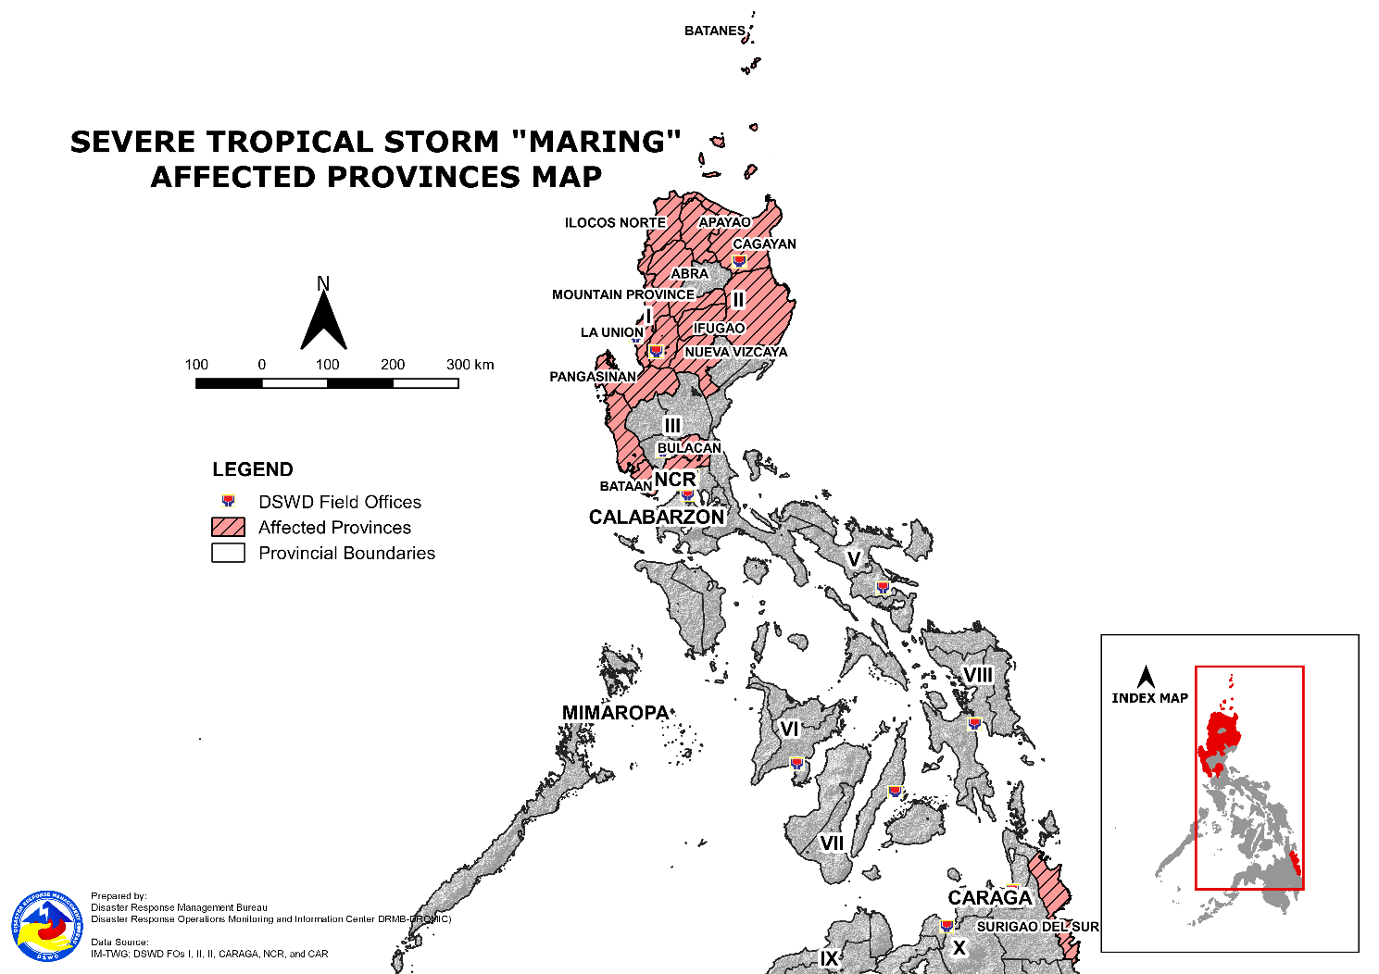

- Status of Displaced Population

- Inside Evacuation Center
There are 4,074 families or 14,034 persons currently taking temporary shelter in 92 evacuation centers in Regions, I, II and CAR (see Table 2).

Table 2. Number of Displaced Families / Persons Inside Evacuation Center
REGION / PROVINCE / MUNICIPALITY |  | NUMBER OF EVACUATION CENTERS (ECs) |  | NUMBER OF DISPLACED
 |  |  |  | INSIDE ECs
 |  |  |  | Families |  | Persons
 |  | CUM | NOW | CUM | NOW | CUM | NOW
GRAND TOTAL |  | 251 | 92 | 6,603 | 4,074 | 23,651 | 14,034
NCR |  | 1 | - | 212 | - | 745 | -
Metro Manila |  | 1 | - | 212 | - | 745 | -
Manila City |  | 1 | - | 212 | - | 745 | -
REGION I |  | 134 | 83 | 4,766 | 4,054 | 17,067 | 13,969
Ilocos Norte |  | 1 | - | 13 | - | 42 | -
 | Bangui | 1 | - | 13 | - | 42 | -
Ilocos Sur |  | 34 | 7 | 3,362 | 3,040 | 12,089 | 10,535
 | Bantay | 1 | - | 1 | - | 3 | -
 | CITY OF CANDON | 5 | 5 | 64 | - | 223 | -
 | Caoayan | 2 | - | 45 | - | 411 | -
 | Salcedo (Baugen) | 3 | - | 38 | - | 190 | -
 | San Emilio | 1 | - | 1 | - | 7 | -
 | San Ildefonso | 2 | - | 2 | - | 9 | -
 | San Vicente | 1 | - | 1 | - | 8 | -
 | Santa | 1 | - | 7 | - | 32 | -
 | Santa Cruz | 2 | - | 15 | - | 56 | -
 | Santa Lucia | 1 | 1 | 3039 | 3039 | 10529 | 10529
 | Suyo | 4 | - | 10 | - | 51 | -
 | Tagudin | 2 | - | 51 | - | 204 | -
 | CITY OF VIGAN (Capital) | 9 | 1 | 88 | 1 | 366 | 6
La Union |  | 52 | 52 | 740 | 740 | 2,353 | 2,353
 | Agoo | 1 | 1 | 3 | 3 | 19 | 19
 | Bacnotan | 7 | 7 | 25 | 25 | 90 | 90
 | Bagulin | 2 | 2 | 34 | 34 | 109 | 109
 | Balaoan | 6 | 6 | 33 | 33 | 119 | 119
 | Bangar | 5 | 5 | 113 | 113 | 357 | 357
 | Bauang | 9 | 9 | 200 | 200 | 624 | 624
 | Luna | 4 | 4 | 43 | 43 | 138 | 138
 | Pugo | 1 | 1 | 21 | 21 | 43 | 43
 | Rosario | 2 | 2 | 9 | 9 | 47 | 47
 | San Gabriel | 3 | 3 | 8 | 8 | 33 | 33
 | San Juan | 11 | 11 | 234 | 234 | 735 | 735
 | Sudipen | 1 | 1 | 17 | 17 | 39 | 39
Pangasinan |  | 47 | 24 | 651 | 274 | 2,583 | 1,081
 | CITY OF ALAMINOS | 1 | - | 30 | - | 90 | -
 | Bani | 1 | - | 2 | - | 8 | -
 | Binalonan | 1 | - | 6 | - | 17 | -
 | Bolinao | 3 | - | 26 | - | 87 | -
 | Calasiao | 2 | 2 | 12 | 12 | 48 | 48
 | Dagupan City | 14 | 12 | 194 | 166 | 676 | 583
 | Laoac | 1 | - | 5 | - | 24 | -
 | LINGAYEN (Capital) | 6 | 6 | 29 | 29 | 122 | 122
 | Manaoag | 1 | - | 6 | - | 22 | -
 | Mangaldan | 1 | - | 9 | - | 35 | -
 | Pozzorubio | 2 | - | 3 | - | 10 | -
 | San Fabian | 3 | - | 80 | - | 263 | -
 | San Jacinto | 3 | - | 17 | - | 85 | -
 | San Nicolas | 1 | - | 4 | - | 11 | -
 | Santa Barbara | 3 | 3 | 64 | 64 | 317 | 317
 | Sual | 1 | - | 28 | - | 92 | -
 | Tayug | 1 | 1 | 3 | 3 | 11 | 11
 | CITY OF URDANETA | 2 | - | 133 | - | 665 | -
REGION II |  | 81 | 1 | 865 | 1 | 2,759 | 2
Batanes |  | 1 | 1 | 1 | 1 | 2 | 2
 | Basco | 1 | 1 | 1 | 1 | 2 | 2
Cagayan |  | 76 | - | 853 | - | 2,714 | -
 | Abulug | 1 | - | 31 | - | 119 | -
 | Allacapan | 2 | - | 5 | - | 18 | -
 | Aparri | 2 | - | 7 | - | 28 | -
 | Baggao | 21 | - | 316 | - | 1,007 | -
 | Ballesteros | 1 | - | 3 | - | 10 | -
 | Calayan | 1 | - | 2 | - | 11 | -
 | Camalaniugan | 4 | - | 33 | - | 89 | -
 | Claveria | 5 | - | 35 | - | 140 | -
 | Gattaran | 10 | - | 127 | - | 409 | -
 | Gonzaga | 4 | - | 41 | - | 137 | -
 | Lal-lo | 2 | - | 11 | - | 28 | -
 | Lasam | 3 | - | 30 | - | 89 | -
 | Pamplona | 2 | - | 66 | - | 170 | -
 | Peñablanca | 1 | - | 1 | - | 2 | -
 | Piat | 1 | - | 13 | - | 20 | -
 | Sanchez-Mira | 1 | - | 4 | - | 10 | -
 | Santa Ana | 2 | - | 4 | - | 13 | -
 | Santa Praxedes | 2 | - | 17 | - | 53 | -
 | Santa Teresita | 11 | - | 107 | - | 361 | -
Isabela |  | 1 | - | 2 | - | 6 | -
 | Divilacan | 1 | - | 2 | - | 6 | -
Nueva Vizcaya |  | 3 | - | 9 | - | 37 | -
 | Aritao | 1 | - | 2 | - | 6 | -
 | Quezon | 2 | - | 7 | - | 31 | -
REGION III |  | 1 | - | 8 | - | 15 | -
Bulacan |  | 1 | - | 8 | - | 15 | -
 | Bulacan | 1 | - | 8 | - | 15 | -
CARAGA |  | 10 | - | 523 | - | 2,127 | -
Agusan del Norte |  | 10 | - | 523 | - | 2,127 | -
 | City of Cabadbaran | 10 | - | 523 | - | 2,127 | -
CAR |  | 24 | 8 | 229 | 19 | 938 | 63
Abra |  | 7 | - | 153 | - | 708 | -
 | Dolores | 1 | - | 2 | - | 6 | -
 | La Paz | 1 | - | 84 | - | 420 | -
 | Lagangilang | 1 | - | 25 | - | 98 | -
 | Manabo | 2 | - | 32 | - | 153 | -
 | San Juan | 1 | - | 3 | - | 10 | -
 | Villaviciosa | 1 | - | 7 | - | 21 | -
Apayao |  | 3 | - | 24 | - | 68 | -
 | Calanasan (Bayag) | 1 | - | 3 | - | 13 | -
 | Pudtol | 1 | - | 10 | - | 29 | -
 | Santa Marcela | 1 | - | 11 | - | 26 | -
Benguet |  | 13 | 8 | 44 | 19 | 153 | 63
 | Baguio City | 5 | - | 25 | - | 90 | -
 | Bakun | 1 | 1 | 1 | 1 | 4 | 4
 | Itogon | 2 | 2 | 6 | 6 | 22 | 22
 | La Trinidad (capital) | 1 | 1 | 6 | 6 | 17 | 17
 | Tuba | 4 | 4 | 6 | 6 | 20 | 20
Mountain Province |  | 1 | - | 8 | - | 9 | -
 | Bontoc (capital) | 1 | - | 8 | - | 9 | -
Note: Ongoing assessment and validation are continuously being conducted.
Source: DSWD-FOs

- Outside Evacuation Center
There are 5,951 families or 28,424 persons temporarily staying with their relatives and/or friends in Regions I, III, and CAR (see Table 3).

Table 3. Number of Displaced Families / Persons Outside Evacuation Center
REGION / PROVINCE / MUNICIPALITY |  | NUMBER OF DISPLACED
 |  | OUTSIDE ECs
 |  | Families |  | Persons
 |  | CUM | NOW | CUM | NOW
GRAND TOTAL |  | 12,050 | 5,951 | 50,872 | 28,424
REGION I |  | 8,106 | 5,079 | 37,820 | 25,247
Ilocos Norte |  | 1 | - | 5 | -
 | Bangui | 1 | - | 5 | -
Ilocos Sur |  | 1,953 | 134 | 7,125 | 525
 | Bantay | 3 | - | 15 | -
 | Caoayan | 17 | - | 73 | -
 | Cervantes | 4 | - | 16 | -
 | Gregorio del Pilar (Concepcion) | 14 | - | 67 | -
 | Lidlidda | 26 | 26 | 96 | 96
 | Quirino (Angkaki) | 29 | - | 87 | -
 | San Emilio | 32 | 5 | 153 | 20
 | Santa Catalina | 2 | - | 10 | -
 | Santiago | 1 | 1 | 2 | 2
 | Sigay | 29 | 29 | 120 | 120
 | Suyo | 39 | - | 136 | -
 | Tagudin | 915 | - | 3442 | -
 | CITY OF VIGAN (Capital) | 842 | 73 | 2908 | 287
La Union |  | 6 | 6 | 13 | 13
 | Agoo | 6 | 6 | 13 | 13
Pangasinan |  | 6,146 | 4,939 | 30,677 | 24,709
 | Balungao | 1,057 | 1,057 | 5,285 | 5,285
 | Basista | 1 | 1 | 3 | 3
 | Binalonan | 2 | 1 | 11 | 6
 | Calasiao | 2 | 2 | 10 | 10
 | LINGAYEN (Capital) | 4 | 4 | 13 | 13
 | Mabini | 2 | - | 10 | -
 | Malasiqui | 195 | 195 | 1,018 | 1,018
 | San Fabian | 8 | 8 | 28 | 28
 | San Jacinto | 527 | - | 2,575 | -
 | San Nicolas | 17 | - | 78 | -
 | Santa Barbara | 3,637 | 2,977 | 18,175 | 14,875
 | Sison | 1 | 1 | 6 | 6
 | CITY OF URDANETA | 693 | 693 | 3,465 | 3,465
REGION II |  | 1,800 | - | 5,983 | -
Cagayan |  | 1,782 | - | 5,910 | -
 | Allacapan | 7 | - | 15 | -
 | Aparri | 71 | - | 281 | -
 | Baggao | 1,444 | - | 4,746 | -
 | Camalaniugan | 5 | - | 21 | -
 | Claveria | 1 | - | 10 | -
 | Gattaran | 20 | - | 55 | -
 | Gonzaga | 18 | - | 76 | -
 | Lasam | 3 | - | 10 | -
 | Pamplona | 117 | - | 321 | -
 | Peñablanca | 4 | - | 20 | -
 | Santa Ana | 15 | - | 75 | -
 | Santa Teresita | 77 | - | 280 | -
Isabela |  | 14 | - | 56 | -
 | Divilacan | 14 | - | 56 | -
Nueva Vizcaya |  | 4 | - | 17 | -
 | Kayapa | 2 | - | 9 | -
 | Solano | 2 | - | 8 | -
REGION III |  | 37 | 37 | 125 | 125
Bataan |  | 37 | 37 | 125 | 125
 | Bagac | 37 | 37 | 125 | 125
CARAGA |  | 4 | - | 13 | -
Surigao del Sur |  | 4 | - | 13 | -
 | San Miguel | 4 | - | 13 | -
CAR |  | 2,103 | 835 | 6,931 | 3,052
Abra |  | 1,722 | 484 | 5,393 | 1,610
 | Bangued (capital) | 20 | - | 65 | -
 | Bucay | 79 | - | 279 | -
 | Daguioman | 3 | - | 15 | -
 | Danglas | 136 | - | 274 | -
 | Dolores | 3 | - | 9 | -
 | La Paz | 51 | 49 | 203 | 196
 | Lagangilang | 515 | - | 1,846 | -
 | Lagayan | 428 | 428 | 1,383 | 1,383
 | Langiden | 7 | - | 24 | -
 | Licuan-Baay (Licuan) | 5 | - | 19 | -
 | Luba | 12 | - | 33 | -
 | Malibcong | 15 | 7 | 63 | 31
 | Manabo | 14 | - | 50 | -
 | Pilar | 7 | - | 19 | -
 | San Juan | 217 | - | 429 | -
 | San Quintin | 7 | - | 19 | -
 | Tayum | 200 | - | 650 | -
 | Villaviciosa | 3 | - | 13 | -
Apayao |  | 4 | - | 12 | -
 | Calanasan (Bayag) | 3 | - | 10 | -
 | Santa Marcela | 1 | - | 2 | -
Benguet |  | 368 | 348 | 1,487 | 1,429
 | Atok | 8 | 8 | 43 | 43
 | Baguio City | 142 | 122 | 578 | 520
 | Bakun | 60 | 60 | 208 | 208
 | Bokod | 2 | 2 | 11 | 11
 | Buguias | 1 | 1 | 4 | 4
 | Itogon | 83 | 83 | 357 | 357
 | Kabayan | 3 | 3 | 9 | 9
 | Kapangan | 22 | 22 | 94 | 94
 | Kibungan | 6 | 6 | 30 | 30
 | Sablan | 2 | 2 | 4 | 4
 | Tuba | 29 | 29 | 108 | 108
 | Tublay | 10 | 10 | 41 | 41
Mountain Province |  | 9 | 3 | 39 | 13
 | Bontoc (capital) | 5 | - | 24 | -
 | Sagada | 1 | - | 2 | -
 | Tadian | 3 | 3 | 13 | 13
N ote: Ongoing assessment and validation are continuously being conducted.
Source: DSWD-FOs

- Total Displaced Population
There are 9,785 families or 41,376 persons still displaced in Regions I, II, III, CAR and CARAGA (see Table 4).

Table 4. Total Number of Displaced Families / Persons
REGION / PROVINCE / MUNICIPALITY |  | TOTAL DISPLACED SERVED
 |  | Families |  | Persons
 |  | Total Families |  | Total Persons
 |  | CUM | NOW | CUM | NOW
GRAND TOTAL |  | 17,045 | 9,785 | 67,803 | 41,376
NCR |  | 212 | - | 745 | -
Metro Manila |  | 212 | - | 745 | -
Makati City |  | `` | - | - | -
Manila City |  | 212 | - | 745 | -
REGION I |  | 11,264 | 8,893 | 48,167 | 38,134
Ilocos Norte |  | 14 | - | 47 | -
 | Bangui | 14 | - | 47 | -
Ilocos Sur |  | 4,025 | 3,169 | 13,971 | 11,040
 | Bantay | 4 | - | 18 | -
 | CITY OF CANDON | 64 | - | 223 | -
 | Cervantes | 4 | - | 16 | -
 | Gregorio del Pilar (Concepcion) | 13 | - | 63 | -
 | Lidlidda | 26 | 26 | 96 | 96
 | Quirino (Angkaki) | 29 | - | 87 | -
 | Salcedo (Baugen) | 4 | - | 20 | -
 | San Emilio | 6 | - | 42 | -
 | San Ildefonso | 2 | - | 9 | -
 | San Vicente | 1 | - | 8 | -
 | Santa | 7 | - | 32 | -
 | Santa Catalina | 2 | - | 10 | -
 | Santa Cruz | 7 | - | 22 | -
 | Santa Lucia | 3039 | 3039 | 10529 | 10529
 | Santiago | 1 | 1 | 2 | 2
 | Sigay | 29 | 29 | 120 | 120
 | Suyo | 49 | - | 187 | -
 | Tagudin | 155 | - | 661 | -
 | CITY OF VIGAN (Capital) | 583 | 74 | 1826 | 293
La Union |  | 712 | 712 | 2,244 | 2,244
 | Bagulin | 34 | 34 | 109 | 109
 | Balaoan | 33 | 33 | 119 | 119
 | Bangar | 113 | 113 | 357 | 357
 | Bauang | 200 | 200 | 624 | 624
 | Luna | 43 | 43 | 138 | 138
 | Pugo | 21 | 21 | 43 | 43
 | Rosario | 9 | 9 | 47 | 47
 | San Gabriel | 8 | 8 | 33 | 33
 | San Juan | 234 | 234 | 735 | 735
 | Sudipen | 17 | 17 | 39 | 39
Pangasinan |  | 6,513 | 5,012 | 31,905 | 24,850
 | CITY OF ALAMINOS | 30 | - | 90 | -
 | Balungao | 1,057 | 1,057 | 5,285 | 5,285
 | Bani | 2 | - | 8 | -
 | Basista | 1 | 1 | 3 | 3
 | Binalonan | 8 | 1 | 28 | 6
 | Bolinao | 26 | - | 87 | -
 | Calasiao | 8 | 8 | 28 | 28
 | Dagupan City | 149 | 121 | 516 | 423
 | Laoac | 5 | - | 24 | -
 | LINGAYEN (Capital) | 33 | 33 | 135 | 135
 | Mabini | 2 | - | 10 | -
 | Malasiqui | 195 | 195 | 1,018 | 1,018
 | Manaoag | 6 | - | 22 | -
 | Mangaldan | 9 | - | 35 | -
 | Pozzorubio | 3 | - | 10 | -
 | San Fabian | 88 | 8 | 291 | 28
 | San Jacinto | 544 | - | 2,660 | -
 | San Nicolas | 21 | - | 89 | -
 | Santa Barbara | 3,701 | 3,041 | 18,492 | 15,192
 | Sison | 1 | 1 | 6 | 6
 | Sual | 28 | - | 92 | -
 | Tayug | 3 | 3 | 11 | 11
 | CITY OF URDANETA | 593 | 543 | 2,965 | 2,715
REGION II |  | 2,665 | 1 | 8,742 | 2
Batanes |  | 1 | 1 | 2 | 2
 | Basco | 1 | 1 | 2 | 2
Cagayan |  | 2,635 | - | 8,624 | -
 | Abulug | 31 | - | 119 | -
 | Allacapan | 12 | - | 33 | -
 | Aparri | 78 | - | 309 | -
 | Baggao | 1,760 | - | 5,753 | -
 | Ballesteros | 3 | - | 10 | -
 | Calayan | 2 | - | 11 | -
 | Camalaniugan | 38 | - | 110 | -
 | Claveria | 36 | - | 150 | -
 | Gattaran | 147 | - | 464 | -
 | Gonzaga | 59 | - | 213 | -
 | Lal-lo | 11 | - | 28 | -
 | Lasam | 33 | - | 99 | -
 | Pamplona | 183 | - | 491 | -
 | Peñablanca | 5 | - | 22 | -
 | Piat | 13 | - | 20 | -
 | Sanchez-Mira | 4 | - | 10 | -
 | Santa Ana | 19 | - | 88 | -
 | Santa Praxedes | 17 | - | 53 | -
 | Santa Teresita | 184 | - | 641 | -
Isabela |  | 16 | - | 62 | -
 | Divilacan | 16 | - | 62 | -
Nueva Vizcaya |  | 13 | - | 54 | -
 | Aritao | 2 | - | 6 | -
 | Kayapa | 2 | - | 9 | -
 | Quezon | 7 | - | 31 | -
 | Solano | 2 | - | 8 | -
REGION III |  | 45 | 37 | 140 | 125
Bataan |  | 37 | 37 | 125 | 125
 | Bagac | 37 | 37 | 125 | 125
Bulacan |  | 8 | - | 15 | -
 | Bulacan | 8 | - | 15 | -
CARAGA |  | 527 | - | 2,140 | -
Agusan del Norte |  | 523 | - | 2,127 | -
 | City of Cabadbaran | 523 | - | 2,127 | -
Surigao del Sur |  | 4 | - | 13 | -
 | San Miguel | 4 | - | 13 | -
CAR |  | 2,332 | 854 | 7,869 | 3,115
Abra |  | 1,875 | 484 | 6,101 | 1,610
 | Bangued (capital) | 20 | - | 65 | -
 | Bucay | 79 | - | 279 | -
 | Daguioman | 3 | - | 15 | -
 | Danglas | 136 | - | 274 | -
 | Dolores | 5 | - | 15 | -
 | La Paz | 135 | 49 | 623 | 196
 | Lagangilang | 540 | - | 1,944 | -
 | Lagayan | 428 | 428 | 1,383 | 1,383
 | Langiden | 7 | - | 24 | -
 | Licuan-Baay (Licuan) | 5 | - | 19 | -
 | Luba | 12 | - | 33 | -
 | Malibcong | 15 | 7 | 63 | 31
 | Manabo | 46 | - | 203 | -
 | Pilar | 7 | - | 19 | -
 | San Juan | 220 | - | 439 | -
 | San Quintin | 7 | - | 19 | -
 | Tayum | 200 | - | 650 | -
 | Villaviciosa | 10 | - | 34 | -
Apayao |  | 28 | - | 80 | -
 | Calanasan (Bayag) | 6 | - | 23 | -
 | Pudtol | 10 | - | 29 | -
 | Santa Marcela | 12 | - | 28 | -
Benguet |  | 412 | 367 | 1,640 | 1,492
 | Atok | 8 | 8 | 43 | 43
 | Baguio City | 167 | 122 | 668 | 520
 | Bakun | 61 | 61 | 212 | 212
 | Bokod | 2 | 2 | 11 | 11
 | Buguias | 1 | 1 | 4 | 4
 | Itogon | 89 | 89 | 379 | 379
 | Kabayan | 3 | 3 | 9 | 9
 | Kapangan | 22 | 22 | 94 | 94
 | Kibungan | 6 | 6 | 30 | 30
 | La Trinidad (capital) | 6 | 6 | 17 | 17
 | Sablan | 2 | 2 | 4 | 4
 | Tuba | 35 | 35 | 128 | 128
 | Tublay | 10 | 10 | 41 | 41
Mountain Province |  | 17 | 3 | 48 | 13
 | Bontoc (capital) | 13 | - | 33 | -
 | Sagada | 1 | - | 2 | -
 | Tadian | 3 | 3 | 13 | 13
Note: Ongoing assessment and validation are continuously being conducted.
Source: DSWD FOs

- Damaged Houses
A total of 6,497 houses were damaged; of which, 225 are totally damaged and 6,272
are partially damaged (see Table 5).

Table 5. Number of Damaged Houses
REGION / PROVINCE / MUNICIPALITY |  | NO. OF DAMAGED HOUSES
 |  | Total | Totally | Partially
GRAND TOTAL |  | 6,497 | 225 | 6,272
REGION I |  | 5,569 | 131 | 5,438
Ilocos Norte |  | 17 | 1 | 16
 | Bacarra | 1 | - | 1
 | Banna (Espiritu) | 8 | - | 8
 | CITY OF BATAC | 1 | - | 1
 | Marcos | 2 | - | 2
 | Pagudpud | 2 | - | 2
 | Pinili | 2 | - | 2
 | Sarrat | 1 | 1 | -
Ilocos Sur |  | 1,111 | 36 | 1,075
 | Banayoyo | 44 | 1 | 43
 | Caoayan | 209 | 2 | 207
 | Cervantes | 17 | - | 17
 | Galimuyod | 32 | 1 | 31
 | Gregorio del Pilar (Concepcion) | 1 | - | 1
 | Lidlidda | 26 | 6 | 20
 | Magsingal | 2 | - | 2
 | San Emilio | 16 | - | 16
 | Santa Catalina | 2 | 1 | 1
 | Santa Cruz | 515 | 13 | 502
 | Sigay | 5 | - | 5
 | Sugpon | 2 | - | 2
 | Suyo | 23 | 4 | 19
 | CITY OF VIGAN (Capital) | 217 | 8 | 209
La Union |  | 4,399 | 66 | 4,333
 | Agoo | 23 | - | 23
 | Aringay | 56 | 3 | 53
 | Bacnotan | 1,078 | 19 | 1,059
 | Bauang | 51 | 1 | 50
 | Caba | 8 | 1 | 7
 | San Juan | 3,126 | 40 | 3,086
 | Santo Tomas | 10 | - | 10
 | Santol | 45 | - | 45
 | Sudipen | 2 | 2 | -
Pangasinan |  | 42 | 28 | 14
 | Balungao | 5 | - | 5
 | Basista | 1 | 1 | -
 | Binalonan | 2 | 1 | 1
 | Mabini | 2 | 1 | 1
 | San Fabian | 29 | 25 | 4
 | Sison | 3 | - | 3
REGION II |  | 12 | 6 | 6
Cagayan |  | 5 | 5 | -
 | Gonzaga | 5 | 5 | -
Nueva Vizcaya |  | 7 | 1 | 6
 | Ambaguio | 4 | - | 4
 | Solano | 3 | 1 | 2
REGION III |  | 29 | 28 | 1
Bataan |  | 28 | 28 | -
 | Bagac | 28 | 28 | -
Zambales |  | 1 | - | 1
 | Botolan | 1 | - | 1
CARAGA |  | 41 | 4 | 37
Surigao del Sur |  | 41 | 4 | 37
 | San Miguel | 41 | 4 | 37
CAR |  | 846 | 56 | 790
Abra |  | 588 | 13 | 575
 | Boliney | 1 | - | 1
 | Dolores | 11 | 1 | 10
 | La Paz | 1 | - | 1
 | Lacub | 1 | - | 1
 | Lagangilang | 557 | 12 | 545
 | Licuan-Baay (Licuan) | 2 | - | 2
 | Manabo | 1 | - | 1
 | Sallapadan | 3 | - | 3
 | San Juan | 6 | - | 6
 | San Quintin | 5 | - | 5
Benguet |  | 254 | 43 | 211
 | Atok | 13 | 2 | 11
 | Baguio City | 33 | 3 | 30
 | Bakun | 53 | 17 | 36
 | Buguias | 1 | 1 | -
 | Itogon | 36 | 5 | 31
 | Kabayan | 3 | 1 | 2
 | Kapangan | 19 | 5 | 14
 | Kibungan | 30 | 5 | 25
 | La Trinidad (capital) | 32 | 2 | 30
 | Sablan | 9 | 2 | 7
 | Tuba | 14 | - | 14
 | Tublay | 11 | - | 11
Ifugao |  | 4 | - | 4
 | Alfonso Lista (Potia) | 1 | - | 1
 | Tinoc | 3 | - | 3
Source: DSWD-FOs

- Cost of Humanitarian Assistance Provided
A total of ₱17,935,965.80 worth of assistance was provided to the affected families; of which, ₱5,735,769.80 from DSWD, ₱12,169,696.00 from the Local Government Units (LGUs), ₱19,500.00 from Non-Government Organizations (NGOs), and ₱11,000.00 from Other Partners (see Table 6).

Table 6. Cost of Assistance Provided to Affected Families / Persons
REGION / PROVINCE / MUNICIPALITY |  | COST OF ASSISTANCE
 |  | DSWD | LGU | NGOs | OTHERS | GRAND TOTAL
GRAND TOTAL |  | 5,735,769.80 | 12,169,696.00 | 19,500.00 | 11,000.00 | 17,935,965.80
REGION I |  | 1,275,000.00 | 11,167,715.00 | 14,500.00 | 11,000.00 | 12,468,215.00
Ilocos Norte |  | - | 130,678.90 | - | 11,000.00 | 141,678.90
 | Bacarra | - | - | - | 1,000.00 | 1,000.00
 | Badoc | - | 3,000.00 | - | - | 3,000.00
 | Bangui | - | 7,150.00 | - | - | 7,150.00
 | Banna (Espiritu) | - | 2,800.00 | - | - | 2,800.00
 | CITY OF BATAC | - | 107,500.00 | - | - | 107,500.00
 | Dingras | - | 500.00 | - | - | 500.00
 | LAOAG CITY (Capital) | - | 1,750.00 | - | 10,000.00 | 11,750.00
 | Marcos | - | 955.90 | - | - | 955.90
 | Pagudpud | - | 6,214.00 | - | - | 6,214.00
 | Pinili | - | 429.00 | - | - | 429.00
 | Sarrat | - | 380.00 | - | - | 380.00
Ilocos Sur |  | 765,000.00 | 1,584,256.60 | - | - | 2,349,256.60
 | Banayoyo | - | 585,000.00 | - | - | 585,000.00
 | Caoayan | - | 18,528.00 | - | - | 18,528.00
 | Cervantes | - | 29,780.00 | - | - | 29,780.00
 | Galimuyod | - | 51,350.00 | - | - | 51,350.00
 | Salcedo (Baugen) | - | 56,500.00 | - | - | 56,500.00
 | San Vicente | - | 3,500.00 | - | - | 3,500.00
 | Santa | - | 499,888.40 | - | - | 499,888.40
 | Santa Maria | 510,000.00 | - | - | - | 510,000.00
 | Suyo | - | 3,500.00 | - | - | 3,500.00
 | Tagudin | 255,000.00 | 41,126.00 | - | - | 296,126.00
 | CITY OF VIGAN (Capital) | - | 295,084.20 | - | - | 295,084.20
La Union |  | 510,000.00 | 6,334,854.00 | 14,500.00 | - | 6,859,354.00
 | Agoo | - | 106,200.00 | - | - | 106,200.00
 | Aringay | - | 1,057,500.00 | - | - | 1,057,500.00
 | Balaoan | - | 20,000.00 | - | - | 20,000.00
 | Bangar | - | 1,214,207.00 | - | - | 1,214,207.00
 | Bauang | - | 1,036,582.00 | - | - | 1,036,582.00
 | Burgos | - | 10,700.00 | - | - | 10,700.00
 | Luna | 510,000.00 | 1,376,506.00 | - | - | 1,886,506.00
 | Naguilian | - | 573,280.00 | - | - | 573,280.00
 | Pugo | - | 22,890.00 | - | - | 22,890.00
 | Rosario | - | 23,900.00 | - | - | 23,900.00
 | CITY OF SAN FERNANDO (Capital) | - | 17,031.00 | - | - | 17,031.00
 | San Gabriel | - | 724,053.00 | - | - | 724,053.00
 | San Juan | - | 117,295.00 | 14,500.00 | - | 131,795.00
 | Sudipen | - | 34,710.00 | - | - | 34,710.00
Pangasinan |  | - | 3,117,925.50 | - | - | 3,117,925.50
 | Basista | - | 1,500.00 | - | - | 1,500.00
 | Binalonan | - | 6,000.00 | - | - | 6,000.00
 | Calasiao | - | 2,702,700.00 | - | - | 2,702,700.00
 | Dagupan City | - | 173,197.00 | - | - | 173,197.00
 | LINGAYEN (Capital) | - | 5,751.00 | - | - | 5,751.00
 | Malasiqui | - | 63,360.00 | - | - | 63,360.00
 | San Jacinto | - | 6,561.50 | - | - | 6,561.50
 | San Nicolas | - | 9,300.00 | - | - | 9,300.00
 | San Quintin | - | 12,500.00 | - | - | 12,500.00
 | Sison | - | 8,356.00 | - | - | 8,356.00
 | Tayug | - | 28,800.00 | - | - | 28,800.00
 | CITY OF URDANETA | - | 99,900.00 | - | - | 99,900.00
REGION II |  | 2,254,126.40 | 5,800.00 | - | - | 2,259,926.40
Cagayan |  | 2,254,126.40 | 3,000.00 | - | - | 2,257,126.40
 | Abulug | 120,477.60 | - | - | - | 120,477.60
 | Aparri | 714,798.00 | - | - | - | 714,798.00
 | Gonzaga | 609,395.00 | - | - | - | 609,395.00
 | Pamplona | 100,398.00 | - | - | - | 100,398.00
 | Santa Praxedes | 60,238.80 | - | - | - | 60,238.80
 | Santa Teresita | 648,819.00 | 3,000.00 | - | - | 651,819.00
Nueva Vizcaya |  | - | 2,800.00 | - | - | 2,800.00
 | Quezon | - | 2,800.00 | - | - | 2,800.00
CARAGA |  | - | 290,788.00 | - | - | 290,788.00
Agusan del Norte |  | - | 290,788.00 | - | - | 290,788.00
 | City of Cabadbaran | - | 290,788.00 | - | - | 290,788.00
CAR |  | 2,206,643.40 | 705,393.00 | 5,000.00 | - | 2,917,036.40
Abra |  | 1,865,040.00 | 488,788.00 | - | - | 2,353,828.00
 | Bangued (capital) | 1,060,920.00 | 7,400.00 | - | - | 1,068,320.00
 | Bucay | 313,140.00 | - | - | - | 313,140.00
 | Dolores | - | 254,750.00 | - | - | 254,750.00
 | La Paz | 160,650.00 | - | - | - | 160,650.00
 | Lagangilang | 265,440.00 | 170,700.00 | - | - | 436,140.00
 | Licuan-Baay (Licuan) | - | 2,868.00 | - | - | 2,868.00
 | Manabo | 64,890.00 | - | - | - | 64,890.00
 | Tayum | - | 53,070.00 | - | - | 53,070.00
Apayao |  | - | 15,080.00 | - | - | 15,080.00
 | Calanasan (Bayag) | - | 2,220.00 | - | - | 2,220.00
 | Luna | - | 2,000.00 | - | - | 2,000.00
 | Pudtol | - | 5,400.00 | - | - | 5,400.00
 | Santa Marcela | - | 5,460.00 | - | - | 5,460.00
Benguet |  | 341,603.40 | 193,000.00 | 5,000.00 | - | 539,603.40
 | Baguio City | 28,240.00 | 123,000.00 | - | - | 151,240.00
 | Itogon | 245,176.00 | - | - | - | 245,176.00
 | Kibungan | - | 70,000.00 | 5,000.00 | - | 75,000.00
 | La Trinidad (capital) | 68,187.40 | - | - | - | 68,187.40
Ifugao |  | - | 500.00 | - | - | 500.00
 | Alfonso Lista (Potia) | - | 500.00 | - | - | 500.00
Mountain Province |  | - | 8,025.00 | - | - | 8,025.00
 | Bontoc (capital) | - | 8,025.00 | - | - | 8,025.00
Source: DSWD-FOs

- Response Actions and Interventions

- Standby Funds and Prepositioned Relief Stockpile

OFFICE | STANDBY FUNDS | STOCKPILE |  |  | TOTAL STANDBY FUNDS & STOCKPILE
 |  | FAMILY FOOD PACKS |  | OTHER FOOD AND NON-FOOD ITEMS (FNIs)
 |  | QUANTITY | TOTAL COST
TOTAL | 1,127,229,182.27 | 365,882 | 219,442,534.11 | 681,125,989.45 | 2,027,824,705.83
DSWD-CO | 1,076,381,260.35 | - | - | - | 1,076,381,260.35
NRLMB-NROC | - | 77,812 | 57,570,230.70 | 157,933,260.63 | 215,503,491.33
NRLMB-VDRC | - | 4,234 | 2,017,650.00 | 32,108,392.25 | 34,126,042.25
DSWD-FO NCR | 3,002,563.30 | 661 | 403,619.82 | 7,155,132.13 | 10,561,315.25
DSWD-FO CAR | 5,157,117.12 | 33,560 | 18,547,217.52 | 22,048,761.24 | 45,753,095.88
DSWD-FO I | 5,091,035.20 | 14,727 | 7,510,770.00 | 34,053,554.28 | 46,655,359.48
DSWD-FO II | 4,959,298.68 | 22,457 | 11,624,928.40 | 16, 784,510.01 | 33,368,737.09
DSWD-FO III | 3,000,000.00 | 20,960 | 13,612,965.19 | 18,419,012.32 | 35,031,977.51
DSWD-FO CARAGA | 5,000,000.00 | 3,895 | 1,616,619.75 | 10,609,065.84 | 17,225,685.59
Other FOs | 24,637,907.62 | 187,576 | 106,538,532.73 | 372,293,688.34 | 513,217,741.10
Note: The Inventory Summary is as of 15 October 2021, 4PM.
Source: DSWD-DRMB and DSWD-NRLMB

  - Standby Funds
    - ₱1.08 billion Quick Response Fund (QRF) at the DSWD-Central Office.
    - ₱26.21 million available at DSWD-FOs I, II, III, Caraga, NCR, and CAR.
    - ₱24.64 million in other DSWD-FOs which may support the relief needs of the displaced families due to STS “MARING” through inter-FO augmentation.

  - Prepositioned FFPs and Other Relief Items
    - 82,046 FFPs available in Disaster Response Centers; of which, 77,812 FFPs are at the National Resource Operations Center (NROC), Pasay City and 4,234 FFPs are at the Visayas Disaster Response Center (VDRC), Cebu City.
    - 96,260 FFPs available at DSWD-FOs I, II, III, Caraga, NCR and CAR.
    - 187,576 FFPs in other DSWD-FOs which may support the relief needs of the displaced families due to STS “MARING” through inter-FO augmentation.
    - ₱681.13 million worth of other food and non-food items (FNIs) at NROC, VDRC and DSWD-FO warehouses countrywide.

- Food and Non-Food Items

DSWD-FO NCR
DATE | ACTIVITIES
11 October 2021 | - Manila Department of Social Welfare (MDSW) provided hot meals and other relief items to the affected families.

DSWD-FO CAR
DATE | ACTIVITIES
15 October 2021 | - DSWD FO CAR provided the following augmentation:  - 3,163 FPPS to the Province of Abra and Angat amounting to PhP 1,806,890.00  - 105 Non-food Items to the Province of Benguet amounting to PhP 190,243.00  - Ready to Eat Food (RTEF) amounting to PhP 41,184.00

DSWD-FO I
DATE | ACTIVITIES
13 October 2021 | - Production of FFPs at the DSWD Regional Warehouse, Biday, City of San Fernando, La Union was conducted.
11 October 2021 | - DSWD-FO I facilitated the assembly of slotted cartons in preparation for the production of FFPs at the DSWD Regional Warehouse, Biday, City of San Fernando, La Union.

DSWD-FO II
DATE | ACTIVITIES
13 October 2021 | - DSWD-FO II delivered additional 2,677 FFPs as augmentation support to LGUs of Aparri, Sta. Teresita and Gonzaga in Cagayan that were greatly flooded and affected by STS “MARING”.
12 October 2021 | - DSWD-FO II delivered a total of 1,673 Family Food Packs amounting to ₱839,829.27 as augmentation support to the LGUs of Cagayan greatly flooded and affected by TS “MARING”.

- Camp Coordination and Camp Management

DSWD-FO NCR
DATE | ACTIVITIES
11 October 2021 | - The MDSW activated the camp coordination and camp management (CCCM) and maintained continuous coordination with concerned agencies for the conduct of assessment and validation of affected families.  - The MDSW advocated and implemented strict adherence to safety measures in evacuation centers in compliance with health and safety protocols.

DSWD-FO CAR
DATE | ACTIVITIES
13 October 2021 | - The DSWD-FO CAR conducted a monitoring of evacuation centers and provided FNIs with the assistance of the Local Social Welfare and Development Offices (LSWDOs) and Local Disaster Risk Reduction and Management Offices (LDRRMOs) of the affected LGUs. This was to ensure that all the affected families are provided with necessary assistance and ensure their safety while staying in evacuation centers or with their relatives.
11 October 2021 | - DSWD-FO CAR monitored the active evacuation centers through LSWDOs of affected LGUs.

- Internally Displaced Person (IDP) Protection

DSWD-FO CAR
DATE | ACTIVITIES
13 October 2021 | - The DSWD-FO CAR Personnel conducted Psychological First Aid (PFA) to IDPs in the Municipalities of La Trinidad and Itogon in Benguet.

- Other Activities

DSWD-FO NCR
DATE | ACTIVITIES
14 October 2021 | - DSWD-FO NCR submitted their terminal report.

DSWD-FO CAR
DATE | ACTIVITIES
13 October 2021 | - The Quick Response Teams (QRTs) of DSWD-FO CAR are on standby for the possible activation.  - The Crisis Intervention Section of DSWD-FO CAR conducted interview, assessment and provision of financial assistance to the bereaved families in Ambiong, La Trinidad, Benguet and Dominican Hill-Mirador, Baguio City.

DSWD-FO I
DATE | ACTIVITIES
14 October 2021 | - DSWD-FO I maintained coordination with the Regional Disaster Risk Reduction and Management Council (RDRRMC) 1. Its Provincial Operations Offices (POOs) closely coordinated with Provincial/City/Municipal Disaster Risk Reduction and Management Councils (P/C/MDRRMCs) and Provincial/City/Municipality Social Welfare and Development Offices (P/C/MSWDOs) to monitor the adverse effects that might be brought by the weather disturbance.  - The Incident Management Team (IMT) of DSWD-FO I remained activated and are still on duty while other DSWD staff are on standby for possible augmentation.
13 October 2021 | - The IMT conducted a meeting to discuss the updates on DSWD-FO I operations, and effects and damages of STS “MARING” in the Region.

DSWD-FO II
DATE | ACTIVITIES
12 October 2021 | - DSWD-FO II conducted Rapid Damage Assessment Needs Analysis (RDANA) in Districts 1 and 2 of Cagayan by two teams (one team headed by RD Cezario Joel C. Espejo and the other team headed by OIC-ARDO Franco G. Lopez).  - DSWD-FO II prepositioned of 2,400 FFPs at Magapit, Lallo for possible augmentation support to LGUs with affected families based on the assessment of RD Espejo and OIC-ARDO Lopez.
11 October 2021 | - DSWD-FO II deployed its Disaster Monitoring and Response Teams, Social Welfare and Development Offices (SWADOs), and Municipal Actions Teams (MATs) for a 24-hour duty to continuously monitor the effects of STS “MARING”.  - DSWD-FO II with MATs and LDRRMOs advised vulnerable residents to move to evacuation centers or to their relatives living in higher grounds.

DSWD-FO III
DATE | ACTIVITIES
14 October 2021 | - DSWD-FO III submitted their terminal report noting that the Tropical Cyclone Warning Signal issued by the DOST-PAGASA has already been lifted and the situation in affected areas is already manageable by the LGUs.
11 October 2021 | - DSWD-FO III activated the Regional Operations Center and the DSWD Provincial Extension Offices (DPEOs) to monitor incidents related to the current weather disturbance.  - DSWD-FO III attended the Pre-Disaster Risk Assessment (PDRA) conducted by the Regional Disaster Risk Reduction and Management Council (RDRRMC) 3.

DSWD-FO CALABARZON
DATE | ACTIVITIES
11 October 2021 | - DSWD FO-CALABARZON remained on heightened alert status to monitor the effects of STS “MARING”.  - DSWD FO-CALABARZON coordinated with Provincial and Local Social Welfare and Development Offices (P/LSWDOs) in the conduct of pre-emptive evacuation should need arises

DSWD-FO V
DATE | ACTIVITIES
09 October 2021 | - DSWD-FO V DRMD continued to monitor weather updates and information.  - The Resource Operation Section of DSWD-FO V ensured availability of FFPs and FNIs as need arises.  - DSWD-FO V QRTs were alerted, and the Provincial/Municipal Action Team (P/MAT) members in the six (6) provinces were activated and instructed to coordinate with the LDRRMOs and LSWDOs for updates.

DSWD-FO VIII
DATE | ACTIVITIES
11 October 2021 | - A total of four (4) families or 22 persons took pre-emptive evacuation in Brgy. Bolusao, Lawaan, Eastern Samar. All of these families have returned home. Hence, DSWD-FO VIII submitted their terminal report.

DSWD-FO X
DATE | ACTIVITIES
13 October 2021 | - DSWD-FO X submitted their terminal report.

DSWD-FO Caraga
DATE | ACTIVITIES
14 October 2021 | - DSWD-FO Caraga is constantly coordinating with the LSWDOs on the status of affected families for the provision of necessary assistance.
08 October 2021 | - DSWD-FO Caraga QRT members were on standby for possible deployment.  - SWAD Team Leaders were advised to monitor their respective area of responsibility (AOR) and provide updates on the effects of STS “MARING”.

Photo Documentation

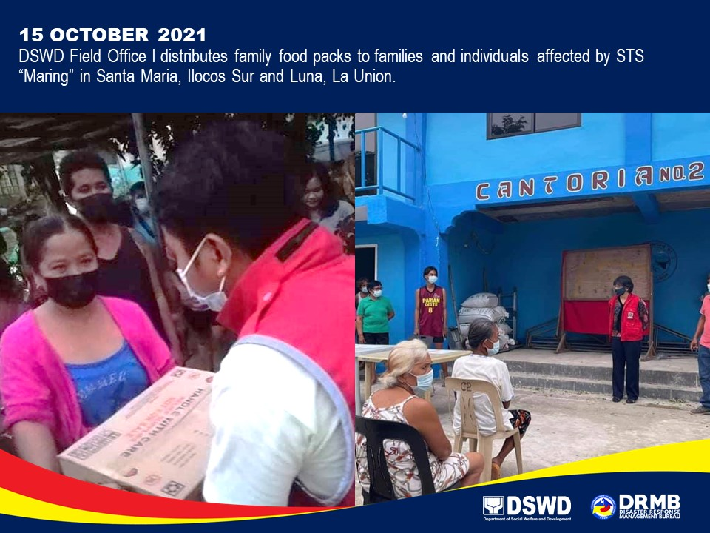

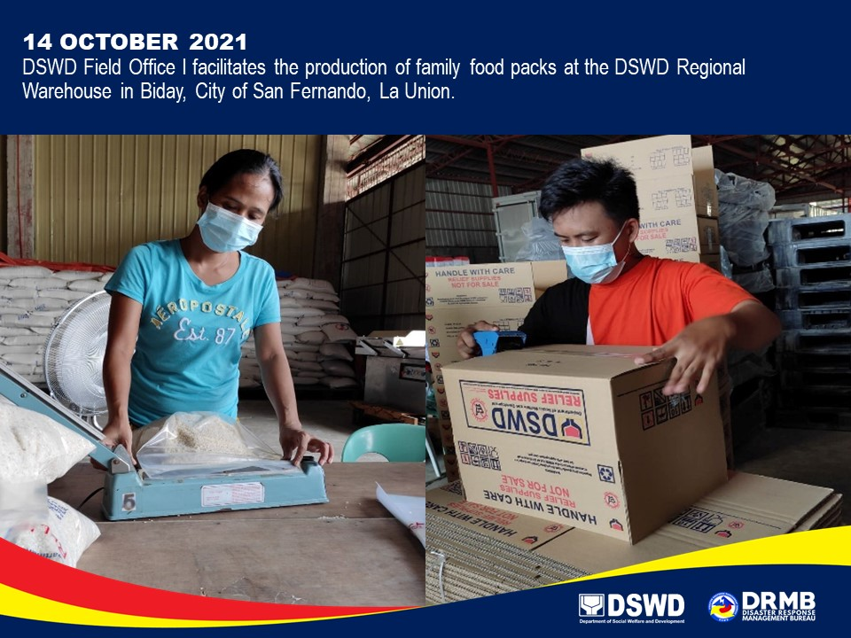

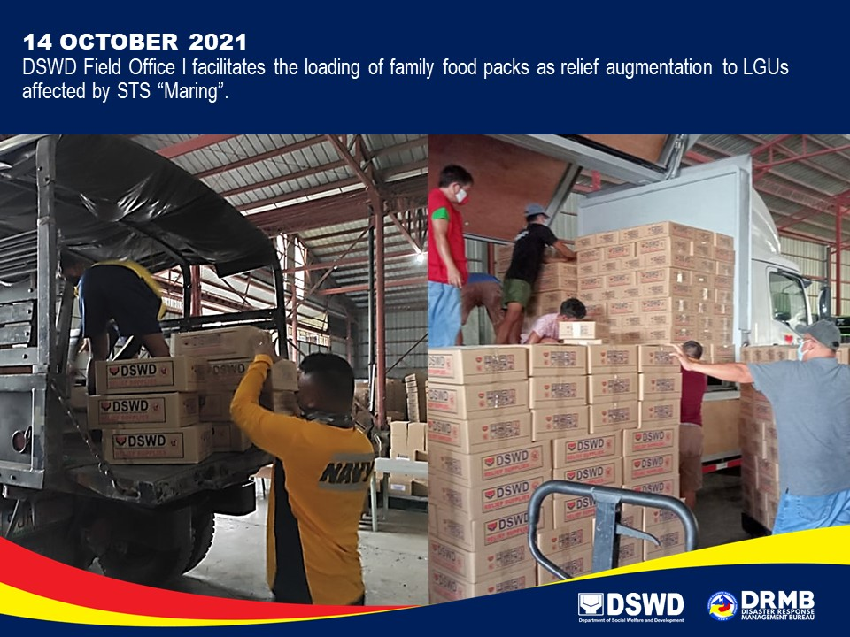
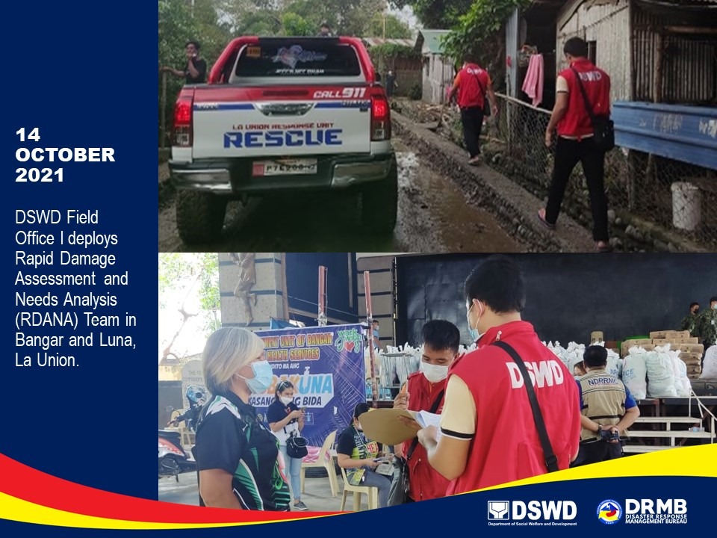

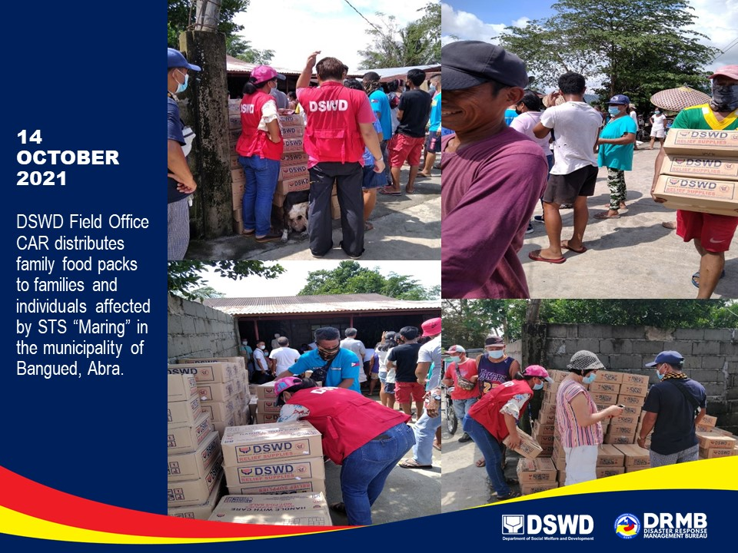

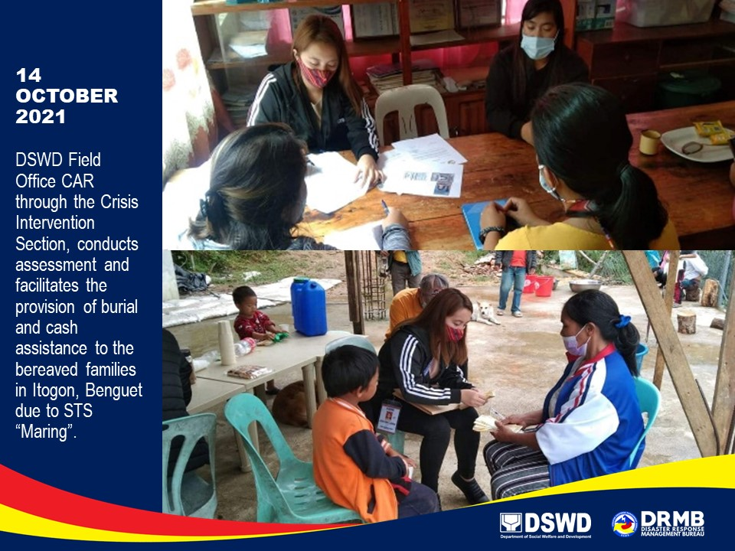

*****
The Disaster Response Operations Monitoring and Information Center (DROMIC) of DSWD-DRMB is closely coordinating with the concerned DSWD-FOs for significant disaster response updates and assistance provided.

Prepared by:  DIANE C. PELEGRINO  AARON JOHN B. PASCUA  MARIE JOYCE G. RAFANAN  JOANNA CAMILLE R. JACINTO  JEM ERIC F. FAMORCAN | Released by:  LESLIE R. JAWILI

