DSWD DROMIC Report #6 on the Effects of Southwest Monsoon enhanced by STS “Maring”
as of 17 October 2021, 6PM

- Situation Overview

On 12 October 2021 at 11 AM, it was forecasted that the Southwest Monsoon enhanced by Severe Tropical Storm “MARING” would bring moderate to heavy rains over Occidental Mindoro, and Palawan. Meanwhile, light to moderate with at times heavy rains would prevail over Metro Manila, Bataan, Cavite, Batangas, Antique, Aklan, Negros Occidental, and the rest of MIMAROPA. Under these conditions, flash flooding and rain-induced landslides were possible especially in areas that are highly or very highly susceptible to these hazards as identified in hazard maps.

On 13 October 2021 at 5 AM, the Southwest Monsoon enhanced by Severe Tropical Storm (STS) “Maring” would possibly bring monsoon rains over Bataan, Zambales, Occidental Mindoro, and Palawan within the next 24 hours.

Issued on 14 October 2021 at 4 PM, Intertropical Convergence Zone (ICTZ) affecting Luzon and Visayas.

Source: DOST-PAGASA Weather Advisory

- Status of Affected Areas and Population

A total of 5,968 families or 25,035 persons were affected by the Southwest Monsoon enhanced by STS “Maring” in 74 barangays in Regions VI and MIMAROPA (see Table 1).

Table 1. Number of Affected Families / Persons
REGION / PROVINCE / MUNICIPALITY |  | NUMBER OF AFFECTED
 |  | Barangays | Families | Persons
GRAND TOTAL |  | 74 | 5,968 | 25,035
MIMAROPA |  | 73 | 5,966 | 25,025
Occidental Mindoro |  | 2 | 18 | 86
 | San Jose | 2 | 18 | 86
Palawan |  | 71 | 5,948 | 24,939
 | Aborlan | 12 | 1,055 | 5,277
 | Balabac | 2 | 2 | 12
 | Bataraza | 12 | 1,300 | 5,923
 | Brooke's Point | 7 | 209 | 756
 | Narra | 19 | 2,148 | 7,406
 | Quezon | 7 | 656 | 2,931
 | Rizal (Marcos) | 6 | 221 | 908
 | Sofronio Española | 6 | 357 | 1,726
REGION VI |  | 1 | 2 | 10
Iloilo |  | 1 | 2 | 10
 | Iloilo City (capital) | 1 | 2 | 10
Note: Ongoing assessment and validation are continuously being conducted.
Source: DSWD-Field Offices (FOs) VI and MIMAROPA

- Status of Displaced Population

- Inside Evacuation Center
There are 42 families or 214 persons currently taking temporary shelter in four (4) evacuation centers in Region VI and MIMAROPA (see Table 2).

Table 2. Number of Displaced Families / Persons Inside Evacuation Center
REGION / PROVINCE / MUNICIPALITY |  | NUMBER OF EVACUATION CENTERS (ECs) |  | NUMBER OF DISPLACED
 |  |  |  | INSIDE ECs
 |  |  |  | Families |  | Persons
 |  | CUM | NOW | CUM | NOW | CUM | NOW
GRAND TOTAL |  | 55 | 5 | 994 | 42 | 3,996 | 214
MIMAROPA |  | 54 | 4 | 992 | 40 | 3,986 | 204
Occidental Mindoro |  | 2 | - | 18 | - | 86 | -
 | San Jose | 2 | - | 18 | - | 86 | -
Palawan |  | 52 | 4 | 974 | 40 | 3,900 | 204
 | Aborlan | 1 | - | 1 | - | 7 | -
 | Bataraza | 4 | - | 36 | - | 158 | -
 | Brooke's Point | 13 | - | 209 | - | 756 | -
 | Narra | 19 | 4 | 223 | 40 | 853 | 204
 | Quezon | 7 | - | 420 | - | 1,751 | -
 | Rizal (Marcos) | 2 | - | 27 | - | 85 | -
 | Sofronio Española | 6 | - | 58 | - | 290 | -
REGION VI |  | 1 | 1 | 2 | 2 | 10 | 10
Iloilo |  | 1 | 1 | 2 | 2 | 10 | 10
 | Iloilo City (capital) | 1 | 1 | 2 | 2 | 10 | 10
Note: The decrease in the number of displaced in Palawan is due to the validated report submitted by DSWD-FO MIMAROPA. Hence, ongoing assessment and validation being conducted.
Source: DSWD-FOs VI and MIMAROPA

- Outside Evacuation Center
There were a total of 4,974 families or 21,039 persons who took temporary shelter with their relatives and/or friends and have already returned home in Region MIMAROPA (see Table 3).

Table 3. Number of Displaced Families / Persons Outside Evacuation Center
REGION / PROVINCE / MUNICIPALITY |  | NUMBER OF DISPLACED
 |  | OUTSIDE ECs
 |  | Families |  | Persons
 |  | CUM | NOW | CUM | NOW
GRAND TOTAL |  | 4,974 | - | 21,039 | -
MIMAROPA |  | 4,974 | - | 21,039 | -
Palawan |  | 4,974 | - | 21,039 | -
 | Aborlan | 1,054 | - | 5,270 | -
 | Balabac | 2 | - | 12 | -
 | Bataraza | 1,264 | - | 5,765 | -
 | Narra | 1,925 | - | 6,553 | -
 | Quezon | 236 | - | 1,180 | -
 | Rizal (Marcos) | 194 | - | 823 | -
 | Sofronio Española | 299 | - | 1,436 | -
Note: Ongoing assessment and validation are continuously being conducted.
Source: DSWD-FO MIMAROPA

- Total Displaced Population
There are 42 families or 214 persons still displaced in Regions VI and MIMAROPA (see Table 4).

Table 4. Total Number of Displaced Families / Persons
REGION / PROVINCE / MUNICIPALITY |  | TOTAL DISPLACED
 |  | Families |  | Persons
 |  | CUM | NOW | CUM | NOW
GRAND TOTAL |  | 5,968 | 42 | 25,035 | 214
MIMAROPA |  | 5,966 | 40 | 25,025 | 204
Occidental Mindoro |  | 18 | - | 86 | -
 | San Jose | 18 | - | 86 | -
Palawan |  | 5,948 | 40 | 24,939 | 204
 | Aborlan | 1,055 | - | 5,277 | -
 | Balabac | 2 | - | 12 | -
 | Bataraza | 1,300 | - | 5,923 | -
 | Brooke's Point | 209 | - | 756 | -
 | Narra | 2,148 | 40 | 7,406 | 204
 | Quezon | 656 | - | 2,931 | -
 | Rizal (Marcos) | 221 | - | 908 | -
 | Sofronio Española | 357 | - | 1,726 | -
REGION VI |  | 2 | 2 | 10 | 10
Iloilo |  | 2 | 2 | 10 | 10
 | Iloilo City (capital) | 2 | 2 | 10 | 10
Note: Ongoing assessment and validation are continuously being conducted.
Source: DSWD-FOs VI and MIMAROPA

- Damaged Houses

A total of 304 houses were damaged; of which, 56 are totally damaged and 248 are partially damaged (see Table 5).

Table 5. Number of Damaged Houses
REGION / PROVINCE / MUNICIPALITY |  | NO. OF DAMAGED HOUSES
 |  | Total | Totally | Partially
GRAND TOTAL |  | 304 | 56 | 248
MIMAROPA |  | 302 | 56 | 246
Palawan |  | 302 | 56 | 246
 | Aborlan | 5 | 1 | 4
 | Balabac | 2 | 1 | 1
 | Bataraza | 2 | 2 | -
 | Brooke's Point | 6 | 5 | 1
 | Narra | 270 | 39 | 231
 | Quezon | 8 | 8 | -
 | Rizal (Marcos) | 1 | - | 1
REGION VI |  | 2 | - | 2
Iloilo |  | 2 | - | 2
 | Iloilo City (capital) | 2 | - | 2
Note: Ongoing assessment and validation are continuously being conducted.
Source: DSWD-FOs VI and MIMAROPA

- Cost of Humanitarian Assistance Provided

A total of ₱5,566,146.65 worth of assistance was provided to the affected families; of which, ₱2,821,357.65 from DSWD and ₱2,744,789.00 from the Local Government Units (LGUs) (see Table 6).

Table 6. Cost of Assistance Provided to Affected Families / Persons
REGION / PROVINCE / MUNICIPALITY |  | COST OF ASSISTANCE
 |  | DSWD | LGUs | NGOs | OTHERS | GRAND TOTAL
GRAND TOTAL |  | 2,821,357.65 | 2,744,789.00 | - | - | 5,566,146.65
MIMAROPA |  | 2,821,357.65 | 2,742,855.00 | - | - | 5,564,212.65
Palawan |  | 2,821,357.65 | 2,742,855.00 | - | - | 5,564,212.65
 | Aborlan | - | 409,125.00 |  |  | 409,125.00
 | Bataraza | 696,900.00 | 65,000.00 | - | - | 761,900.00
 | Narra | 1,480,864.00 | 1,340,000.00 | - | - | 2,820,864.00
 | Quezon | 403,593.65 | 885,275.00 | - | - | 1,288,868.65
 | Rizal (Marcos) | - | 2,700.00 | - | - | 2,700.00
 | Sofronio Española | 240,000.00 | 40,755.00 | - | - | 280,755.00
REGION VI |  | - | 1,934.00 | - | - | 1,934.00
Iloilo |  | - | 1,934.00 | - | - | 1,934.00
 | Iloilo City (capital) | - | 1,934.00 | - | - | 1,934.00
Source: DSWD-FOs VI and MIMAROPA

- Response Actions and Interventions

- Standby Funds and Prepositioned Relief Stockpile
OFFICE | STANDBY FUNDS | STOCKPILE |  |  | TOTAL STANDBY FUNDS & STOCKPILE
 |  | FAMILY FOOD PACKS |  | OTHER FOOD AND NON-FOOD ITEMS (FNIs)
 |  | QUANTITY | TOTAL COST
DSWD-CO | 1,076,381,260.35 | - | - | - | 1,076,381,260.35
NRLMB-NROC | - | 65,112.00 | 49,569,230.70 | 158,207,260.63 | 207,776,491.33
NRLMB-VDRC | - | 6,834.00 | 3,252,650.00 | 42,836,392.25 | 46,089,042.25
DSWD-FO MIMAROPA | 5,000,000.00 | 21,882.00 | 15,354,246.55 | 21,494,866.15 | 41,849,112.70
DSWD-FO VI | 646.42 | 14,032.00 | 6,625,346.60 | 29,499,958.91 | 36,125,951.93
Other FOs | 45,847,275.50 | 248,549.00 | 137,892,931.36 | 430,606,612.78 | 614,346,819.64
TOTAL | 1,127,229,182.27 | 356,409.00 | 212,694,405.21 | 682,645,090.72 | 2,022,568,678.20
Note: The Inventory Summary is as of 17 October 2021, 4PM.
Source: DSWD-DRMB and DSWD-NRLMB

  - Standby Funds
- ₱1.08 billion Quick Response Fund (QRF) at the DSWD Central Office.
- A total of ₱5 million available standby funds at DSWD-FOs VI and MIMAROPA. Standby fund for DSWD-FO VI is on the process of replenishment.
- ₱45.85 million available in other DSWD-FOs which may support the relief needs of the displaced families due to the effects of Southwest Monsoon enhanced by STS “Maring” through inter-FO augmentation.

  - Prepositioned FFPs and Other Relief Items
- 71,946 FFPs available in Disaster Response Centers; of which 65,112 FFPs are at the National Resource Operations Center (NROC), Pasay City and 6,834 FFPs are at the Visayas Disaster Response Center (VDRC), Cebu City.
- A total of 35,914 FFPs available at DSWD-FOs VI and MIMAROPA.
- 248,549 FFPs available in other DSWD-FOs which may support the relief needs of the displaced families due to the effects of Southwest Monsoon enhanced by STS “Maring” through inter-FO augmentation.
- ₱682.64 million worth of other FNIs at NROC, VDRC and DSWD-FO warehouses countrywide.

- Food and Non-Food Items

DSWD-FO MIMAROPA
DATE | ACTIVITIES
17 October 2021 | - DSWD FO MIMAROPA allocated 300 FFPs and 100 Malongs for the affected families in Sofronio Española, Palawan waiting to be picked up by the LGU on Monday, Oct 18, 2021.  - Allocated 487 FFPs to LGU of Bataraza, Palawan.
16 October 2021 | - 1,460 out of 1,700 FFPs delivered to the Municipality of Narra, Palawan were already distributed to the affected families and individuals.  - 59 out of 545 FFPs delivered to the Municipality of Quezon, Palawan were already distributed to affected families and individuals.  - The Provincial Social Welfare and Development Office (PSWDO) provided FFPs to the Municipalities of Quezon (1,000) and Narra (2,000) in Palawan.
15 October 2021 | - DSWD-FO MIMAROPA coordinated with NRLMB for loading 3,000 kitted FPPs to container vans as replenishment of stockpiles in the Province of Palawan in partnership with World Food Program (WFP). The delivery is scheduled on 18 October 2021, Monday.
14 October 2021 | - LGU of Quezon, Palawan distributed 545 FFPs to affected families.
13 October 2021 | - DSWD-FO MIMAROPA has an ongoing replenishment of stockpile to complete the required number of goods as mandated by the DSWD Administrative Order (AO) No. 2, series of 2021 or the Omnibus Guidelines on FNI and Logistics Management for Disaster Response Operations.  - DSWD-FO MIMAROPA is coordinating with NRLMB for the delivery of 3,000 FFPs in partnership with Cebu Pacific.

- Camp Coordination and Camp Management

DSWD-FO MIMAROPA
DATE | ACTIVITIES
13 October 2021 | - The Social Welfare and Development Team (SWADT) Provincial Staff and all the Provincial/City/Municipal (P/C/M) Quick Response Teams (QRTs) monitored the situation of the internally displaced persons (IDPs) in evacuation centers to ensure proper establishment of health protocols as part of the campaign to prevent COVID-19 transmission.

- Other Activities

DSWD-FO MIMAROPA
DATE | ACTIVITIES
15 October 2021 | - DSWD-FO MIMAROPA through its SWADT Palawan has provided burial assistance through Assistance to Individuals in Crisis (AICS) to the bereaved families; each family received ₱10,000.00.
12 October 2021 | - DSWD-FO MIMAROPA activated its Virtual Emergency Operations Center.  - DSWD-FO MIMAROPA coordinated with its SWADT Palawan to thoroughly assess and evaluate the present condition of the internally displaced persons (IDPs) and provide support to the immediate needs of the affected families/individuals.  - DSWD-FO MIMAROPA coordinated with SWADT Palawan on the provision of FNIs to the affected families and individuals in the area.  - DSWD-FO MIMAROPA attended Pre-Disaster Risk Assessment (PDRA) Analyst and Core Group Meeting for TD “Maring”.  - DSWD-FO MIMAROPA closely coordinated with the Office of Civil Defense (OCD) and Regional Disaster Risk Reduction and Management Council (RDRRMC) MIMAROPA for any updates for monitoring purposes and response mechanism for areas that will be affected.

DSWD-FO VI
DATE | ACTIVITIES
13 October 2021 | - DSWD-FO VI coordinated with the Iloilo City Social Welfare and Development Office (CSWDO) for updates on the status of affected families/individuals and for possible relief augmentation.

- Photo Documentation

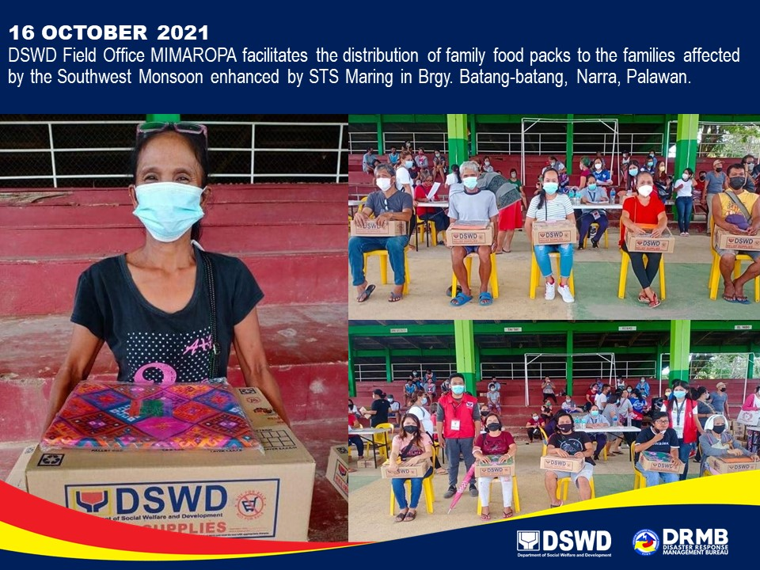

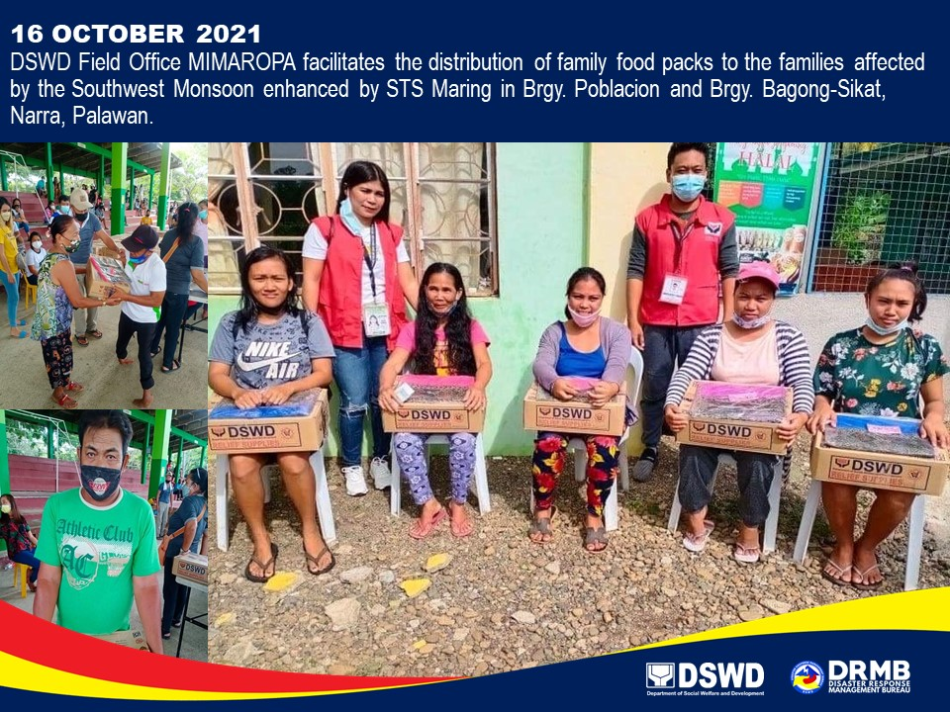
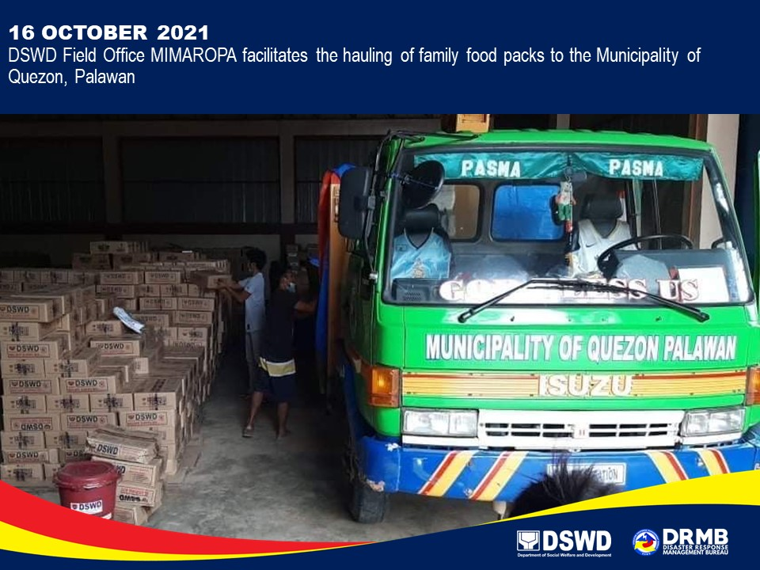

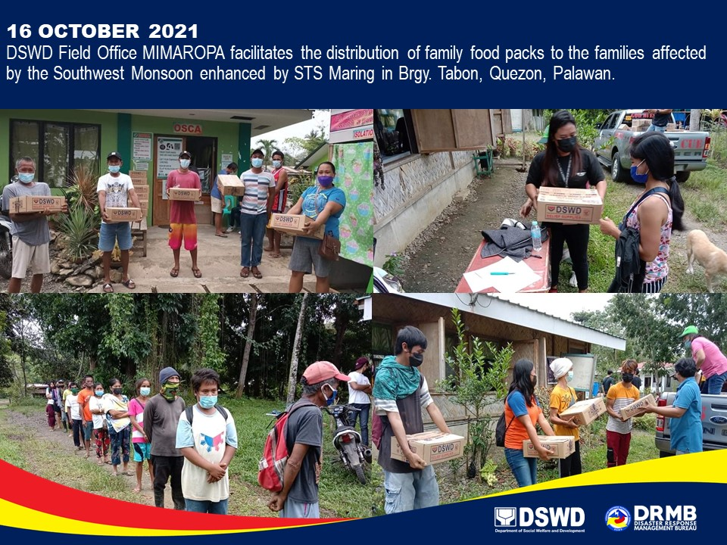

*****
The Disaster Response Operations Monitoring and Information Center (DROMIC) of DSWD-DRMB is closely coordinating with the concerned DSWD-FOs for significant disaster response updates and assistance provided.

Prepared by:  JOANNA CAMILLE R. JACINTO  JEM ERIC F. FAMORCAN | Released by:  RODEL V. CABADDU

