DSWD DROMIC Report #1 on the Fire Incident
in Brgy. Buanao, Malibcong, Abra
as of 03 November 2021, 6PM

- Situation Overview

On 28 October 2021 at 10:00 AM, a fire incident occurred in Brgy. Buanao, Malibcong, Abra. The fire was declared out at 12:15PM.

Source: DSWD-Field Office (FO) CAR

- Status of Affected Areas and Population

A total of 13 families or 55 persons were affected in Brgy. Buanao, Malibcong, Abra (see Table 1).

Table 1. Number of Affected Families / Persons
REGION / PROVINCE / MUNICIPALITY |  | NUMBER OF AFFECTED
 |  | Barangays | Families | Persons
GRAND TOTAL |  | 1 | 13 | 55
CAR |  | 1 | 13 | 55
Abra |  | 1 | 13 | 55
 | Malibcong | 1 | 13 | 55
Note: Ongoing assessment and validation being conducted.
Source: DSWD-FO CAR

- Status of Displaced Population

- Outside Evacuation Center
There are nine (9) families or 36 persons temporarily staying with their relatives and/or friends (see Table 2).

Table 2. Number of Displaced Families / Persons Outside Evacuation Center
REGION / PROVINCE / MUNICIPALITY |  | NUMBER OF DISPLACED
 |  | OUTSIDE ECs
 |  | Families |  | Persons
 |  | CUM | NOW | CUM | NOW
GRAND TOTAL |  | 9 | 9 | 36 | 36
CAR |  | 9 | 9 | 36 | 36
Abra |  | 9 | 9 | 36 | 36
 | Malibcong | 9 | 9 | 36 | 36
Note: Ongoing assessment and validation being conducted.
Source: DSWD-FO CAR

- Damaged Houses

A total of 13 houses were damaged by the fire; of which nine (9) are totally damaged and four (4) are partially damaged (see Table 3).

Table 3. Number of Damaged Houses
REGION / PROVINCE / MUNICIPALITY |  | NO. OF DAMAGED HOUSES
 |  | Total | Totally | Partially
GRAND TOTAL |  | 13 | 9 | 4
CAR |  | 13 | 9 | 4
Abra |  | 13 | 9 | 4
 | Malibcong | 13 | 9 | 4
Note: Ongoing assessment and validation being conducted.
Source: DSWD-FO CAR

- Cost of Humanitarian Assistance Provided
A total of ₱97,824.35 worth of assistance was provided to the affected families by DSWD (see Table 4).

Table 4. Cost of Assistance Provided to Affected Families / Persons
REGION / PROVINCE / MUNICIPALITY |  | COST OF ASSISTANCE
 |  | DSWD | LGU | NGOs | OTHERS | GRAND TOTAL
GRAND TOTAL |  | 97,824.35 | - | - | - | 97,824.35
CAR |  | 97,824.35 | - | - | - | 97,824.35
Abra |  | 97,824.35 | - | - | - | 97,824.35
 | Malibcong | 97,824.35 | - | - | - | 97,824.35
Source: DSWD-FO CAR

- Response Actions and Interventions

- Standby Funds and Prepositioned Relief Stockpile
Office | STANDBY  FUNDS | Family Food Packs (FFPs) |  | Other Food and Non-Food Items (FNFIs) | Total
 |  | No. | Cost
DSWD-FO CAR | 5,000,355.12 | 23,546 | 13,759,790.00 | 24,775,241.00 | 43,535,386.12
Note: The Inventory Summary is as of 03 November 2021, 4PM.
Source: DSWD-FO CAR

  - Standby Funds
- ₱5,000,355.12 standby funds at the DSWD-FO CAR

  - Prepositioned FFPs and Other Relief Items
- 23,546 FFPs available at DSWD-FO CAR.
- ₱24.78 million worth of FNFIs readily available at DSWD-FO CAR.

- Other Activities

- DSWD-FO CAR facilitated the provision of financial assistance thru the Crisis Intervention Unit (CIU).
- DSWD-FO CAR DRMD through the Disaster Response Information Management Section is continuously coordinating with key agencies for updates on the incident.

- Photo Documentation

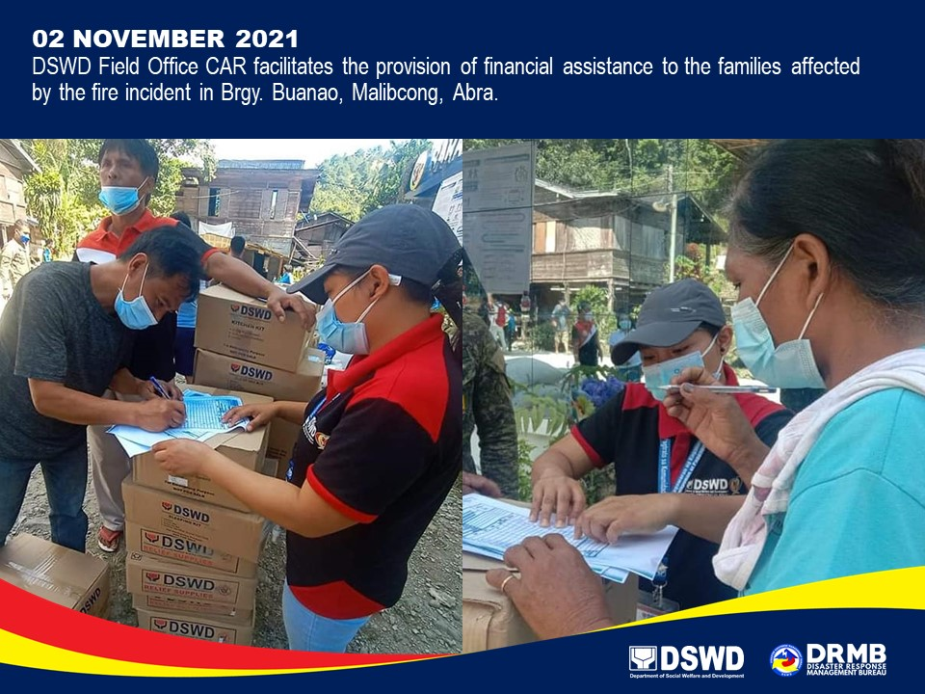

*****
The Disaster Response Operations Monitoring and Information Center (DROMIC) of DSWD-DRMB is closely coordinating with DSWD-FO CAR for significant disaster response updates and assistance provided.

Prepared by:  AARON JOHN B. PASCUA | Released by:  RODEL V. CABADDU

