DSWD DROMIC Report #2 on the Fire Incident
in Brgy. Calumpang, General Santos City
as of 16 November 2021, 6PM

- Situation Overview

On 03 November 2021 at 1:00 PM, a fire incident occurred in Brgy. Calumpang, General Santos City.
Source: DSWD-Field Office (FO) XII

- Status of Affected Areas and Population

A total of 671 families or 3,355 persons were affected in Brgy. Calumpang, General Santos City (see Table 1).

Table 1. Number of Affected Families / Persons
REGION / PROVINCE / MUNICIPALITY | NUMBER OF AFFECTED
 | Barangays | Families | Persons
GRAND TOTAL | 1 | 671 | 3,355
REGION XII | 1 | 671 | 3,355
South Cotabato | 1 | 671 | 3,355
General Santos City (Dadiangas) | 1 | 671 | 3,355
Note: Ongoing assessment and validation being conducted.
Source: DSWD-FO XII

- Status of Displaced Population

- Inside Evacuation Center
There are 203 families or 1,015 persons currently taking temporary shelter at the Romana C. Acharon Elementary School in General Santos City (see Table 2).

Table 2. Number of Displaced Families / Persons Inside Evacuation Center
REGION / PROVINCE / MUNICIPALITY |  | NUMBER OF EVACUATION CENTERS (ECs) |  | NUMBER OF DISPLACED
 |  |  |  | INSIDE ECs
 |  |  |  | Families |  | Persons
 |  | CUM | NOW | CUM | NOW | CUM | NOW
GRAND TOTAL |  | 3 | 1 | 571 | 203 | 2,855 | 1,015
REGION XII |  | 3 | 1 | 571 | 203 | 2,855 | 1,015
South Cotabato |  | 3 | 1 | 571 | 203 | 2,855 | 1,015
 | General Santos City (Dadiangas) | 3 | 1 | 571 | 203 | 2,855 | 1,015
Note: Previously reported 571 families and 2,855 persons who stayed in two (2) evacuation centers were transferred to the newly opened EC – Romana C. Acharon Elementary School. Hence, ongoing assessment and validation being conducted.
Source: DSWD-FO XII

- Outside Evacuation Center
There are 100 families or 500 persons temporarily staying with their relatives and/or friends (see Table 3).

Table 3. Number of Displaced Families / Persons Outside Evacuation Center
REGION / PROVINCE / MUNICIPALITY | NUMBER OF DISPLACED
 | OUTSIDE ECs
 | Families |  | Persons
 | CUM | NOW | CUM | NOW
GRAND TOTAL | 100 | 100 | 500 | 500
REGION XII | 100 | 100 | 500 | 500
South Cotabato | 100 | 100 | 500 | 500
General Santos City (Dadiangas) | 100 | 100 | 500 | 500
Note: Ongoing assessment and validation being conducted.
Source: DSWD-FO XII

- Total Displaced Population
There are 303 families or 1,515 persons still displaced in Brgy. Calumpang, General Santos City (see Table 4).

Table 4. Total Number of Displaced Families / Persons
REGION / PROVINCE / MUNICIPALITY |  | TOTAL DISPLACED SERVED
 |  | Families |  | Persons
 |  | CUM | NOW | CUM | NOW
GRAND TOTAL |  | 671 | 303 | 3,355 | 1,515
REGION XII |  | 671 | 303 | 3,355 | 1,515
South Cotabato |  | 671 | 303 | 3,355 | 1,515
 | General Santos City (Dadiangas) | 671 | 303 | 3,355 | 1,515
Note: Ongoing assessment and validation being conducted.
Source: DSWD-FO XII

- Damaged Houses

A total of 400 houses were totally damaged by the fire (see Table 3).

Table 3. Number of Damaged Houses
REGION / PROVINCE / MUNICIPALITY | NO. OF DAMAGED HOUSES
 | Total | Totally | Partially
GRAND TOTAL | 400 | 400 | -
REGION XII | 400 | 400 | -
South Cotabato | 400 | 400 | -
General Santos City (Dadiangas) | 400 | 400 | -
Note: Ongoing assessment and validation being conducted.
Source: DSWD-FO XII

- Cost of Humanitarian Assistance Provided

A total of ₱1,774,899.50 worth of assistance was provided to the affected families; of which, ₱1,670,899.50 from DSWD, ₱96,000.00 from the Local Government Unit (LGU) and ₱8,000.00 from NGOs (see Table 4).

Table 4. Cost of Assistance Provided to Affected Families / Persons
REGION / PROVINCE / MUNICIPALITY |  | COST OF ASSISTANCE
 |  | DSWD | LGUs | NGOs | OTHERS | GRAND TOTAL
GRAND TOTAL |  | 1,670,899.50 | 96,000.00 | 8,000.00 | - | 1,774,899.50
REGION XII |  | 1,670,899.50 | 96,000.00 | 8,000.00 | - | 1,774,899.50
South Cotabato |  | 1,670,899.50 | 96,000.00 | 8,000.00 | - | 1,774,899.50
 | General Santos City (Dadiangas) | 1,670,899.50 | 96,000.00 | 8,000.00 | - | 1,774,899.50
Source: DSWD-FO XII

- Response Actions and Interventions

- Standby Funds and Prepositioned Relief Stockpile
Office | STANDBY  FUNDS | Family Food Packs (FFPs) |  | Other Food and Non-Food Items (FNFIs) | Total
 |  | No. | Cost
DSWD-CO | 405,541,429.37 | - | - | - | 405,541,429.37
NRLMB-NROC | - | 79,111 | 56,777,878.00 | 87,616,419.67 | 144,394,297.67
NRLMB-VDRC | - | 18,602 | 10,659,160.00 | 27,813,699.25 | 38,472,859.25
DSWD-FO XII | 3,000,969.85 | 10,523 | 6,414,745.25 | 35,202,225.33 | 44,617,940.43
Other FOs | 68,536,910.34 | 303,327 | 177,836,607.55 | 459,491,376.30 | 705,864,894.19
TOTAL | 477,079,309.56 | 411,563 | 251,688,390.80 | 610,123,720.55 | 1,338,891,420.91
Note: The Inventory Summary is as of 16 November 2021, 4PM.
Source: DSWD-DRMB and DSWD-NRLMB

  - Standby Funds
    - ₱405.54 million Quick Response Fund (QRF) at the DSWD-Central Office.
    - ₱3 million available at DSWD-FO XII.
    - ₱68.54 million in other DSWD-FOs which may support the relief needs of the displaced families due to the fire incident through inter-FO augmentation.

  - Prepositioned FFPs and Other Relief Items
    - 97,713 FFPs available in Disaster Response Centers; of which, 79,111 FFPs are at the National Resource Operations Center (NROC), Pasay City and 18,602 FFPs are at the Visayas Disaster Response Center (VDRC), Cebu City.
    - 10,523 FFPs available at DSWD-FO XII.
    - 324,061 FFPs in other DSWD-FOs which may support the relief needs of the displaced families due to the fire incident through inter-FO augmentation.
    - ₱610.12 million worth of other FNIs at NROC, VDRC and DSWD-FO warehouses countrywide.

- Other Activities

- As of 06 November 2021, DSWD-FO XII has distributed a total of ₱4,820,000.00 cash assistance to 482 affected families.
- DSWD-FO XII through its Disaster Response Management Division (DRMD) continuously coordinates with LGU General Santos City for further updates and possible augmentation assistance needed by the affected families.

- Photo Documentation

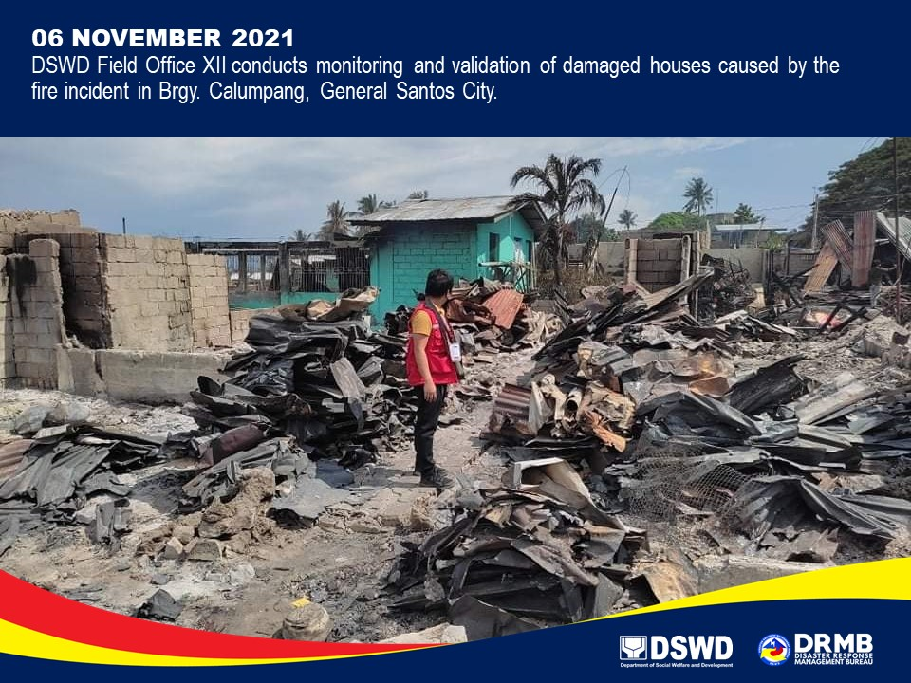

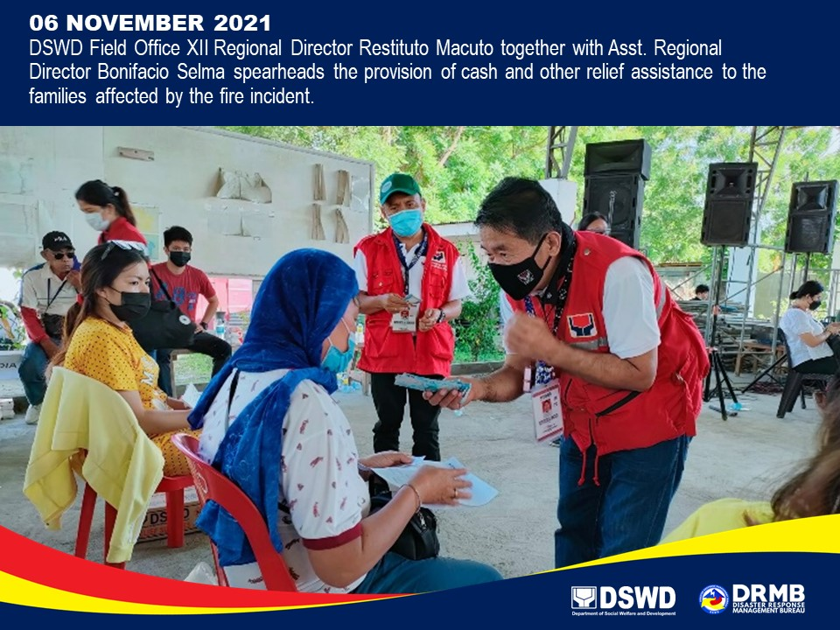

*****
The Disaster Response Operations Monitoring and Information Center (DROMIC) of DSWD-DRMB is closely coordinating with DSWD-FO XII for significant disaster response updates and assistance provided.

Prepared by:  MARIE JOYCE G. RAFANAN | Released by:  MARC LEO L. BUTAC

