DSWD DROMIC Terminal Report on the
Fire Incident in Brgy. Poblacion, Tinoc, Ifugao
30 November 2021, 6PM

- Situation Overview
On 03 November 2021, at 1:12 AM, a fire incident transpired in Brgy. Poblacion, Tinoc, Ifugao which had totally damaged a residential house of one family. The fire was declared out eventually at around 3 AM of the same day.
Source: DSWD-Field Office (FO) CAR

- Status of Affected Areas and Population
A total of one (1) family or eight (8) persons were affected in Brgy. Poblacion, Tinoc, Ifugao (see Table 1).

Table 1. Number of Affected Families / Persons
REGION / PROVINCE / MUNICIPALITY |  | NUMBER OF AFFECTED
 |  | Barangays | Families | Persons
GRAND TOTAL |  | 1 | 1 | 8
CAR |  | 1 | 1 | 8
Ifugao |  | 1 | 1 | 8
 | Tinoc | 1 | 1 | 8
Source: DSWD-FO CAR

- Status of Displaced Population

- Outside Evacuation Center
There is one (1) family or eight (8) persons who are temporarily taking shelter with their relatives and/or friends (see Table 2).

Table 2. Number of Displaced Families / Persons Outside Evacuation Center
REGION / PROVINCE / MUNICIPALITY |  | NUMBER OF DISPLACED
 |  | OUTSIDE ECs
 |  | Families |  | Persons
 |  | CUM | NOW | CUM | NOW
GRAND TOTAL |  | 1 | 1 | 8 | 8
CAR |  | 1 | 1 | 8 | 8
Ifugao |  | 1 | 1 | 8 | 8
 | Tinoc | 1 | 1 | 8 | 8
Source: DSWD-FO CAR

- Damaged Houses
There was one (1) totally damaged house due to the fire (see Table 3).

Table 3. Number of Damaged Houses
REGION / PROVINCE / MUNICIPALITY |  | NO. OF DAMAGED HOUSES
 |  | Total | Totally | Partially
GRAND TOTAL |  | 1 | 1 | -
CAR |  | 1 | 1 | -
Ifugao |  | 1 | 1 | -
 | Tinoc | 1 | 1 | -
Source: DSWD-FO CAR

- Cost of Human Assistance Provided
A total of ₱8,356.48 worth of assistance was provided by DSWD to the affected families (see Table 4).

Table 4. Cost of Assistance Provided to Affected Families / Persons
REGION / PROVINCE / MUNICIPALITY |  | COST OF ASSISTANCE
 |  | DSWD | LGU | NGOs | OTHERS | GRAND TOTAL
GRAND TOTAL |  | 8,356.48 | - | - | - | 8,356.48
CAR |  | 8,356.48 | - | - | - | 8,356.48
Ifugao |  | 8,356.48 | - | - | - | 8,356.48
 | Tinoc | 8,356.48 | - | - | - | 8,356.48
Source: DSWD-FO CAR

- Photo Documentation
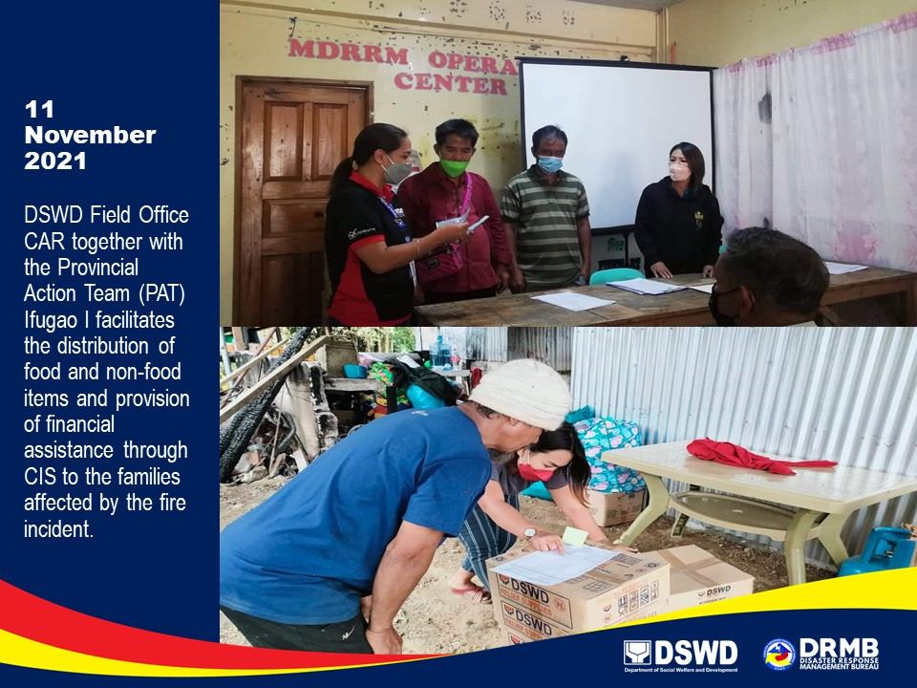

*****
This terminal report is based on the latest report submitted by DSWD-FO CAR on 18 November 2021. The
Disaster Response Operations Monitoring and Information Center (DROMIC) of DSWD-DRMB continues to
closely coordinate with DSWD-FO CAR for any request of Technical Assistance and Resource Augmentation
(TARA).

Prepared by:  PHIL JOBERT A. ZALDIVAR | Released by:  LESLIE R. JAWILI

