DSWD DROMIC Preparedness for Response Report #1 on Tropical Depression ODETTE
as of 13 December 2021, 6PM

Situation Overview

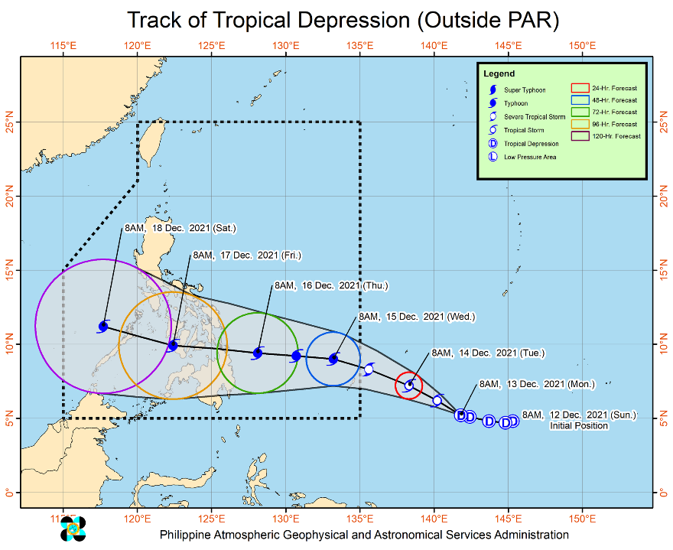
Issued at 11:00 AM, 13 December 2021, the Tropical Depression outside the Philippine Area of Responsibility (PAR) maintain its strength as it continues to move westward.

Track and Intensity:
- The tropical depression is forecast to move generally west northwestward and will likely enter the PAR region as a severe tropical storm on Tuesday (14 December) evening. The west northwestward movement is forecast to continue until Wednesday (15 December) morning. Afterwards, the tropical cyclone will turn westward and may make landfall in the vicinity of Caraga or Eastern Visayas by Thursday (16 December) afternoon or evening.
- Once inside the PAR, the domestic name “ODETTE” will be assigned to this tropical cyclone.
- This tropical cyclone is forecast to gradually intensify within the forecast period and may reach typhoon category by Wednesday. A peak intensity of around 150 km/h may be reached prior to landfall.

Strong Winds:
- Current track and intensity forecast shows that there is a high likelihood that Tropical Cyclone Wind Signals will be hoisted for Visayas, large portions of Mindanao, and several provinces in Southern Luzon due to the threat of strong to typhoon-force winds. The highest possible wind signal that may be hoisted is TCWS #3. Localities situated in the eastern portions of Visayas and Mindanao may be placed under TCWS #1 as early as Tuesday afternoon or evening.
Rainfall:
- The passage of this tropical cyclone over the central portion of the archipelago may bring heavy rainfall over Visayas, large portions of Mindanao, and several provinces in Southern Luzon. Coastal inundation due to high waves near the coast and storm surge are also possible for low-lying localities near and along the path of the typhoon. Residents over the northern and eastern portions of Northern Luzon and the eastern portion of Central Luzon are also advised to monitor for updates regarding possible heavy rainfall which may occur in relation to the behavior of the shear line during and after the passage of this tropical cyclone.
At 10:00 AM today, the center of the Tropical Depression was estimated based on all available data at 1,760 km east of Mindanao (5.2°N, 141.6°E) (outside the PAR).
Source: DOST-PAGASA Severe Weather Bulletin

Predictive Analytics for Humanitarian Response

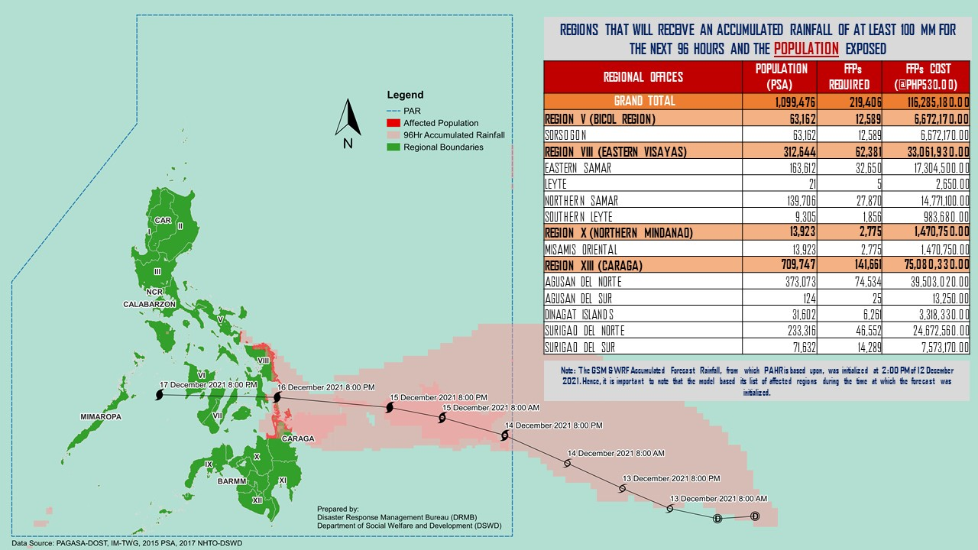

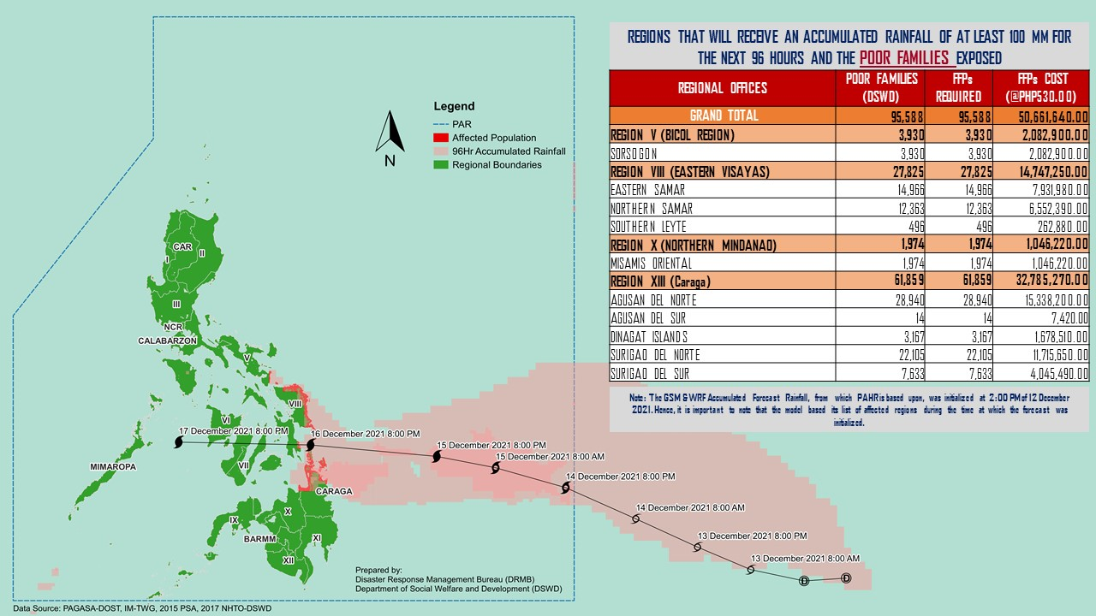
Status of Prepositioned Resources: Stockpile and Standby Funds

The DSWD Central Office (CO), Field Offices (FOs), and National Resource Operations Center (NROC) have stockpiles and standby funds amounting to ₱951,753,168.98 with breakdown as follows (see Table 2):

- Standby Funds
A total of ₱87,333,083.77 standby funds in the CO and FOs. Of the said amount, ₱19,678,617.37 is the available Quick Response Fund (QRF) in the CO.

- Stockpiles
A total of 365,706 family food packs (FFPs) amounting to ₱224,800,348.60, other food items amounting to ₱215,922,457.69 and non-food items (FNIs) amounting to ₱423,697,278.92 are available.

Table 1. Available Stockpiles and Standby Funds
REGIONAL / FIELD OFFICE | STANDBY FUNDS | FAMILY FOOD PACKS |  | OTHER FOOD ITEMS | NON-FOOD RELIEF ITEMS | TOTAL STANDBY FUNDS & STOCKPILE
 |  | QUANTITY | TOTAL COST | TOTAL COST | TOTAL COST
TOTAL | 87,333,083.77 | 365,706 | 224,800,348.60 | 215,922,457.69 | 423,697,278.92 | 951,753,168.98
Central Office | 19,678,617.37 | - | - | - | - | 19,678,617.37
NRLMB - NROC | - | 74,007 | 52,672,010.00 | 32,398,838.37 | 42,285,942.67 | 127,356,791.04
NRLMB - VDRC | - | 5,498 | 3,058,840.00 | 48,904,133.35 | 2,842,510.00 | 54,805,483.35
I | 5,123,035.20 | 19,588 | 12,291,538.00 | 10,820,010.00 | 12,935,065.67 | 41,169,648.87
II | 4,959,298.68 | 11,429 | 8,451,961.00 | 3,831,966.40 | 14,193,427.69 | 31,436,653.77
III | 3,000,000.00 | 11,608 | 8,288,453.04 | 7,070,544.55 | 15,842,510.27 | 34,201,507.86
CALABARZON | 5,000,000.00 | 15,004 | 11,482,077.30 | 3,157,768.00 | 103,311,874.34 | 122,951,719.64
MIMAROPA | 1,114,569.78 | 26,771 | 18,846,286.24 | 9,984,849.00 | 16,851,693.25 | 46,797,398.27
V | 5,000,608.00 | 26,568 | 15,486,432.80 | 4,015,253.00 | 25,975,007.15 | 50,477,300.95
VI | 5,000,661.42 | 19,433 | 9,946,901.86 | 3,608,625.60 | 14,609,255.29 | 33,165,444.17
VII | 5,000,000.00 | 31,777 | 14,650,905.00 | 22,282,247.34 | 15,304,807.82 | 57,237,960.16
VIII | 4,215,000.00 | 20,100 | 10,177,179.31 | 9,370,284.82 | 20,530,262.37 | 44,292,726.50
IX | 3,000,000.00 | 10,686 | 5,839,792.14 | 2,312,603.52 | 18,438,362.25 | 29,590,757.91
X | 5,238,559.92 | 30,346 | 20,883,561.54 | 36,781,340.93 | 44,823,410.31 | 107,726,872.70
XI | 5,000,000.00 | 15,681 | 7,448,475.00 | 1,291,893.00 | 19,954,165.80 | 33,694,533.80
XII | 3,000,969.85 | 12,552 | 7,317,322.95 | 6,520,217.30 | 24,631,720.03 | 41,470,230.13
CARAGA | 5,000,813.43 | 11,272 | 5,647,145.00 | 4,681,110.88 | 10,061,013.90 | 25,390,083.21
NCR | 3,000,000.00 | 209 | 125,352.12 | 3,656,727.30 | 1,199,759.96 | 7,981,839.38
CAR | 5,000,950.12 | 23,177 | 12,186,115.30 | 5,234,044.33 | 19,906,490.15 | 42,327,599.90
Note: The Inventory Summary is as of 13 December 2021, 4PM. Replenishment of standby funds for DSWD-FO MIMAROPA is being
processed.
Source: DRMB and NRLMB

Situational Reports

DSWD-DRMB
DATE | SITUATIONS / ACTIONS UNDERTAKEN
13 December 2021 | - The Disaster Response Management Bureau (DRMB) is closely coordinating with the concerned field offices for significant disaster response updates.  - DRMB participated in the Online Pre-Disaster Risk Assessment Meeting on Tropical Depression (ODETTE) outside PAR on 13 December 2021 with other response cluster member agencies. Further meetings shall be conducted on the implementation of COVID-19 protocols during the response efforts on the Tropical Depression (ODETTE) outside PAR.

DSWD-FO V
DATE | SITUATIONS / ACTIONS UNDERTAKEN
13 December 2021 | - DSWD-FO V is continuously monitoring weather updates.  - DSWD-FO V Quick Response Team (QRT) members are on standby alert and are ready for mobilization for any assistance and augmentation support needed from the LGUs.  - DSWD-FO V ensures the availability of family food packs and other non-food items.  - DSWD-FO V is closely coordinating with the P/MDRRMOs for status reports and updates.

DSWD-FO VII
DATE | SITUATIONS / ACTIONS UNDERTAKEN
13 December 2021 | - DSWD-FO VII is continuously monitoring weather updates.  - DSWD-FO VII Quick Response Team (QRT) members are on standby alert and are ready for mobilization for any assistance and augmentation support needed from the LGUs.  - DSWD-FO VII ensures the availability of family food packs and other non-food items.  - DSWD-FO VII is closely coordinating with their local counterparts and their respective LDRRMCs. Field staff were requested to monitor AOR and provide reports and updates to the Regional DROMIC Focal for any impacts/effects.

DSWD-FO VIII
DATE | SITUATIONS / ACTIONS UNDERTAKEN
10 December 2021 | - DSWD-FO VIII is continuously monitoring weather updates.  - DSWD-FO VIII Quick Response Team (QRT) members are on standby alert and are ready for mobilization for any assistance and augmentation support needed from the LGUs.  - DSWD-FO VIII ensures the availability of family food packs and other non-food items.  - DSWD-FO VIII prepositioned Family Food Packs (FFPs) in Samar Island and Biliran which can be distributed immediately by the P/C/MATs to Local Government Units that need augmentation support.

*****
The Disaster Response Operations Monitoring and Information Center (DROMIC) of the DSWD-DRMB is closely monitoring the effects of the Tropical Depression (ODETTE) outside PAR and is coordinating with the concerned DSWD Field Offices for any significant updates.

Prepared by:  MARIE JOYCE G. RAFANAN  AARON JOHN B. PASCUA  DIANE C. PELEGRINO | Released by:  RODEL V. CABADDU

