DSWD DROMIC Preparedness for Response Report #2 on Tropical Depression ODETTE
as of 14 December 2021, 6PM

Situation Overview

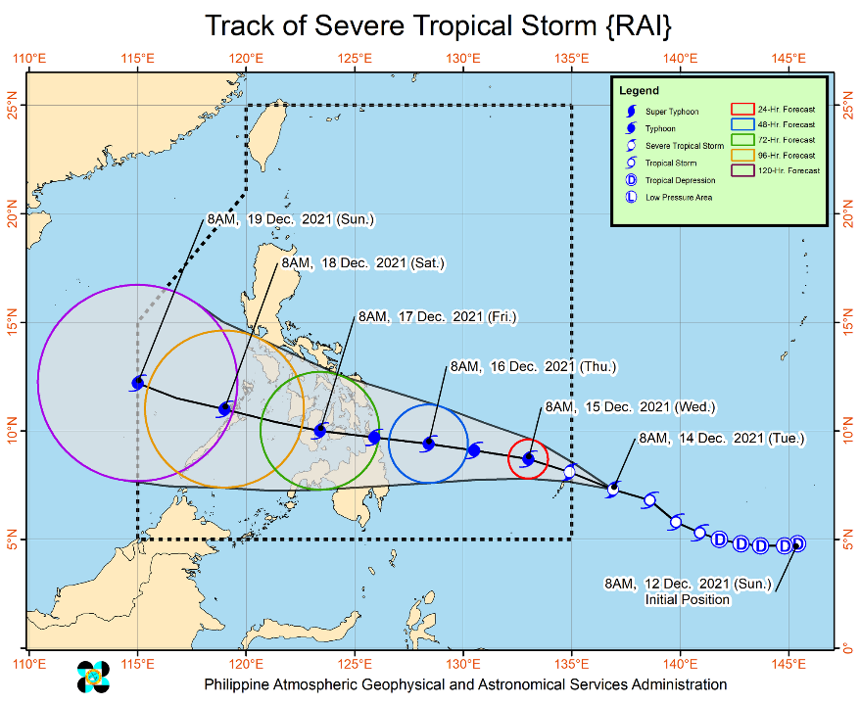
Issued at 11:00 AM, 14 December 2021, “RAI” intensifies into Severe Tropical Storm (STS) while moving West Northwestward towards Palau.

Track and Intensity:
- STS “RAI” is forecast to move west northwestward while gradually intensifying and enter the Philippine Area of Responsibility (PAR) as a severe tropical storm this afternoon or evening.
- Once inside PAR, the domestic name “ODETTE” will be assigned to this tropical cyclone.
- STS “RAI” will begin moving westward over the Philippine Sea on Wednesday afternoon and may make landfall in the vicinity of CARAGA or Eastern Visayas by Thursday (16 December) afternoon or evening. While inside the PAR, favorable atmospheric conditions will favor sustained intensification prior to landfall. This tropical cyclone is forecast to reach typhoon category on Wednesday. A pre-landfall peak intensity of around 155 km/h may be reached by Thursday morning or afternoon.

Strong Winds:
- There is a high likelihood that Tropical Cyclone Wind Signals will be hoisted for Visayas, large portions of Mindanao, and several provinces in Southern Luzon due to the threat of strong to typhoon-force winds associated with the passage of STS “RAI”. The highest possible wind signal that may be hoisted is TCWS #3. Localities situated in the eastern portions of Visayas and Mindanao may be placed under TCWS #1 as early as this afternoon or evening.

Rainfall:
- In the next 24 hours, the trough of STS “RAI” will bring light to moderate with at times heavy rains over CARAGA and Davao Oriental. The passage of this tropical cyclone over the central portion of the archipelago may bring heavy to torrential rainfall over Visayas, Mindanao, and several provinces in Southern Luzon, which may bring possible flooding and rain-induced landslides. Coastal inundation due to high waves near the coast and storm surge are also possible for low-lying localities near and along the path of the typhoon.
The center of the STS “RAI” was estimated based on all available data at 1,165 km East of Mindanao (7.3°N, 136.4°E) (outside the PAR) with maximum sustained winds of 95 km/h near the center, gustiness up to 115 km/h, and central pressure of 990 hPa.
Source: DOST-PAGASA Severe Weather Bulletin

Predictive Analytics for Humanitarian Response

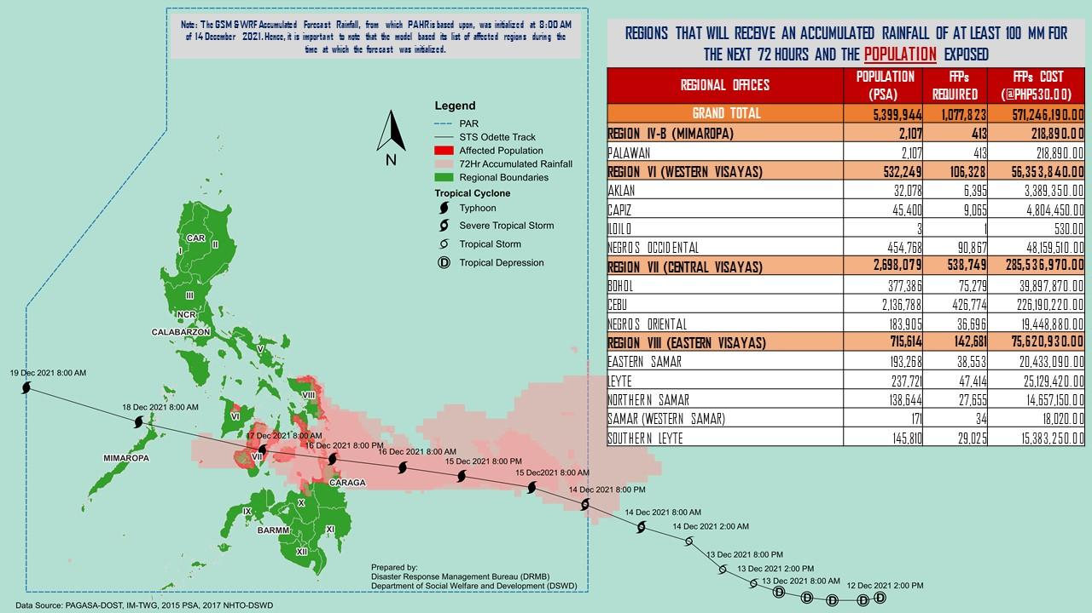

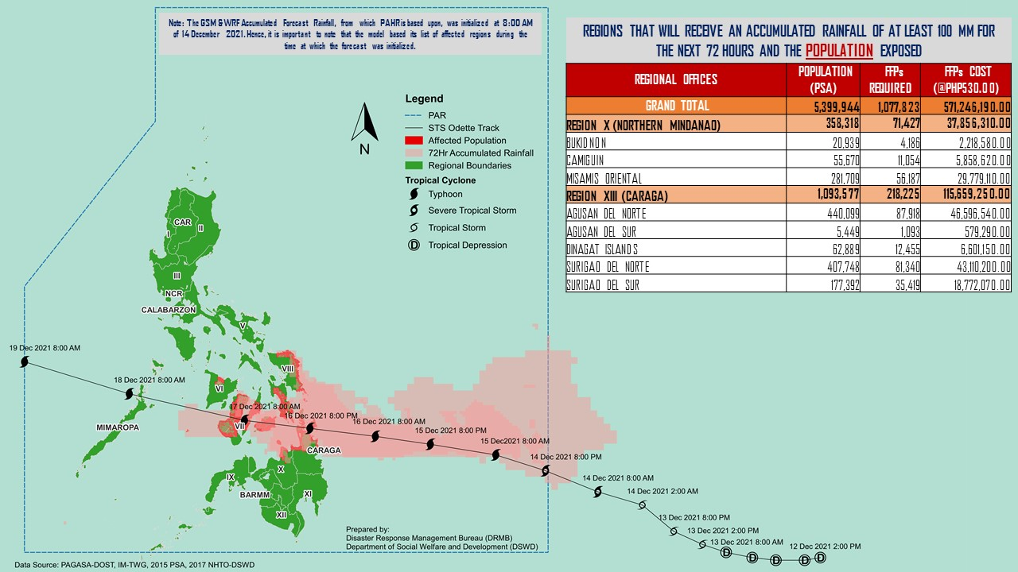

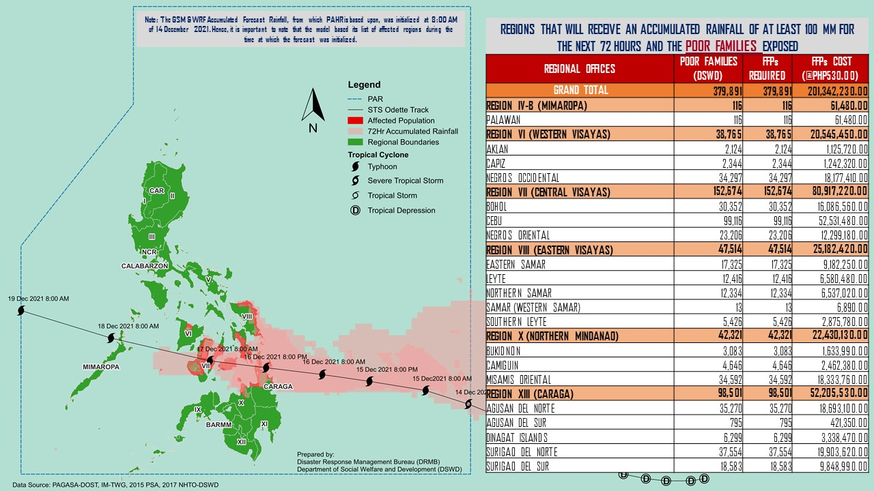

Status of Prepositioned Resources: Stockpile and Standby Funds

The DSWD Central Office (CO), Field Offices (FOs), and National Resource Operations Center (NROC) have stockpiles and standby funds amounting to ₱930,129,310.44 with breakdown as follows (see Table 2):

- Standby Funds
A total of ₱83,085,333.77 standby funds in the CO and FOs. Of the said amount, ₱19,678,617.37 is the available Quick Response Fund (QRF) in the CO.

- Stockpiles
A total of 357,651 family food packs (FFPs) amounting to ₱217,418,190.98, other food items amounting to ₱207,594,231.39 and non-food items (FNIs) amounting to ₱422,031,554.30 are available.

Table 1. Available Stockpiles and Standby Funds
REGIONAL / FIELD OFFICE | STANDBY FUNDS | FAMILY FOOD PACKS |  | OTHER FOOD ITEMS | NON-FOOD RELIEF ITEMS | TOTAL STANDBY FUNDS & STOCKPILE
 |  | QUANTITY | TOTAL COST | TOTAL COST | TOTAL COST
TOTAL | 83,085,333.77 | 357,651 | 217,418,190.98 | 207,594,231.39 | 422,031,554.30 | 930,129,310.44
Central Office | 19,678,617.37 | - | - | - | - | 19,678,617.37
NRLMB - NROC | - | 70,207 | 50,878,035.00 | 32,398,838.37 | 40,390,942.67 | 123,667,816.04
NRLMB - VDRC | - | 6,498 | 3,638,840.00 | 48,663,503.15 | 2,842,510.00 | 55,144,853.15
I | 5,123,035.20 | 19,588 | 12,291,538.00 | 10,820,010.00 | 12,935,065.67 | 41,169,648.87
II | 4,959,298.68 | 10,679 | 7,891,154.80 | 3,831,966.40 | 14,193,427.69 | 30,875,847.57
III | 3,000,000.00 | 14,708 | 8,288,453.04 | 7,070,544.55 | 15,842,510.27 | 34,201,507.86
CALABARZON | 5,000,000.00 | 14,754 | 11,297,514.80 | 3,157,768.00 | 103,311,874.34 | 122,767,157.14
MIMAROPA | 1,114,569.78 | 27,751 | 19,571,415.54 | 9,984,849.00 | 16,904,646.70 | 47,575,481.02
V | 5,000,608.00 | 26,260 | 15,337,409.20 | 4,015,253.00 | 25,975,007.15 | 50,328,277.35
VI | 5,000,661.42 | 19,433 | 9,946,901.86 | 3,608,625.60 | 14,609,255.29 | 33,165,444.17
VII | 752,250.00 | 31,777 | 14,650,905.00 | 22,282,247.34 | 15,304,807.82 | 52,990,210.16
VIII | 4,215,000.00 | 20,600 | 10,433,724.31 | 9,349,514.82 | 20,530,262.37 | 44,528,501.50
IX | 3,000,000.00 | 10,686 | 5,839,792.14 | 2,312,603.52 | 18,438,362.25 | 29,590,757.91
X | 5,238,559.92 | 15,991 | 10,866,355.44 | 26,176,182.83 | 44,631,989.11 | 86,913,087.30
XI | 5,000,000.00 | 15,681 | 7,448,475.00 | 1,291,893.00 | 20,253,045.80 | 33,993,413.80
XII | 3,000,969.85 | 12,552 | 7,317,322.95 | 6,520,217.30 | 24,631,720.03 | 41,470,230.13
CARAGA | 5,000,813.43 | 11,272 | 5,512,175.00 | 4,681,110.88 | 10,061,013.90 | 25,255,113.21
NCR | 3,000,000.00 | 1,034 | 645,993.60 | 6,195,059.30 | 1,199,759.96 | 11,040,812.86
CAR | 5,000,950.12 | 28,180 | 15,562,185.30 | 5,234,044.33 | 19,975,353.28 | 45,772,533.03
Note: The Inventory Summary is as of 14 December 2021, 4PM. Replenishment of standby funds for DSWD-FOs VII and MIMAROPA are being processed.
Source: DRMB and NRLMB

Situational Reports

DSWD-DRMB
DATE | SITUATIONS / ACTIONS UNDERTAKEN
14 December 2021 | - The Disaster Response Management Bureau (DRMB) is closely coordinating with the concerned Field Offices (FOs) for significant disaster response updates.  - DRMB participated in the Online Pre-Disaster Risk Assessment (PDRA) Meeting on STS “RAI” on 14 December 2021 with other response cluster member agencies. Further meetings shall be conducted on the implementation of COVID-19 protocols during the response efforts on STS “RAI”.  - All DRMB Quick Response Team (QRT) members and emergency equipment are on standby and ready for deployment.

DSWD-FO V
DATE | SITUATIONS / ACTIONS UNDERTAKEN
13 December 2021 | - DSWD-FO V is continuously monitoring weather updates.  - DSWD-FO V QRT members are on standby alert and are ready for mobilization for any assistance and augmentation support needed from the LGUs.  - DSWD-FO V ensures the availability of Family Food Packs (FFPs) and other Food and Non-food Items (FNIs).  - DSWD-FO V is closely coordinating with the P/MDRRMOs for status reports and updates.

DSWD-FO VI
DATE | SITUATIONS / ACTIONS UNDERTAKEN
14 December 2021 | - DSWD-FO VI is continuously monitoring weather updates.  - DSWD-FO VI QRT members are on standby alert and are ready for mobilization for any assistance and augmentation support needed from the LGUs.  - DSWD-FO VI ensures the availability of FFPs and other FNIs.

DSWD-FO VII
DATE | SITUATIONS / ACTIONS UNDERTAKEN
13 December 2021 | - DSWD-FO VII is continuously monitoring weather updates.  - DSWD-FO VII QRT members are on standby alert and are ready for mobilization for any assistance and augmentation support needed from the LGUs.  - DSWD-FO VII ensures the availability of FFPs and other FNIs.  - DSWD-FO VII is closely coordinating with their local counterparts and their respective LDRRMCs. Field staff were requested to monitor AOR and provide reports and updates to the Regional DROMIC Focal for any impacts/effects.

DSWD-FO VIII
DATE | SITUATIONS / ACTIONS UNDERTAKEN
10 December 2021 | - DSWD-FO VIII is continuously monitoring weather updates.  - DSWD-FO VIII QRT members are on standby alert and are ready for mobilization for any assistance and augmentation support needed from the LGUs.  - DSWD-FO VIII ensures the availability of FFPs and other FNIs.  - DSWD-FO VIII prepositioned Family Food Packs (FFPs) in Samar Island and Biliran which can be distributed immediately by the P/C/MATs to Local Government Units that needs augmentation support.

DSWD-FO X
DATE | SITUATIONS / ACTIONS UNDERTAKEN
14 December 2021 | - DSWD-FO X is continuously monitoring weather updates.  - DSWD-FO X QRT members are on standby alert and are ready for mobilization for any assistance and augmentation support needed from the LGUs.  - DSWD-FO X ensures the availability of FFPs and other FNIs.

DSWD-FO XI
DATE | SITUATIONS / ACTIONS UNDERTAKEN
14 December 2021 | - DSWD-FO XI is continuously monitoring weather updates.  - DSWD-FO XI QRT members are on standby alert and are ready for mobilization for any assistance and augmentation support needed from the LGUs.  - DSWD-FO XI ensures the availability of FFPs and other FNIs.

DSWD-FO CARAGA
DATE | SITUATIONS / ACTIONS UNDERTAKEN
14 December 2021 | - DSWD-FO CARAGA is continuously monitoring weather updates.  - DSWD-FO CARAGA QRT members are on standby alert and are ready for mobilization for any assistance and augmentation support needed from the LGUs.  - DSWD-FO CARAGA ensures the availability of FFPs and other FNIs.  - DSWD-FO CARAGA is continuously coordinating with SWADTLs and LSWDOs to monitor the situation in their respective areas.

*****
The Disaster Response Operations Monitoring and Information Center (DROMIC) of the DSWD-DRMB is closely monitoring the effects of STS “RAI” and is coordinating with the concerned DSWD Field Offices for any significant updates.

Prepared by:  MARIE JOYCE G. RAFANAN  AARON JOHN B. PASCUA  DIANE C. PELEGRINO | Released by:  RODEL V. CABADDU

