DSWD DROMIC Preparedness for Response Report #3 on Typhoon ODETTE
as of 15 December 2021, 6PM

Situation Overview

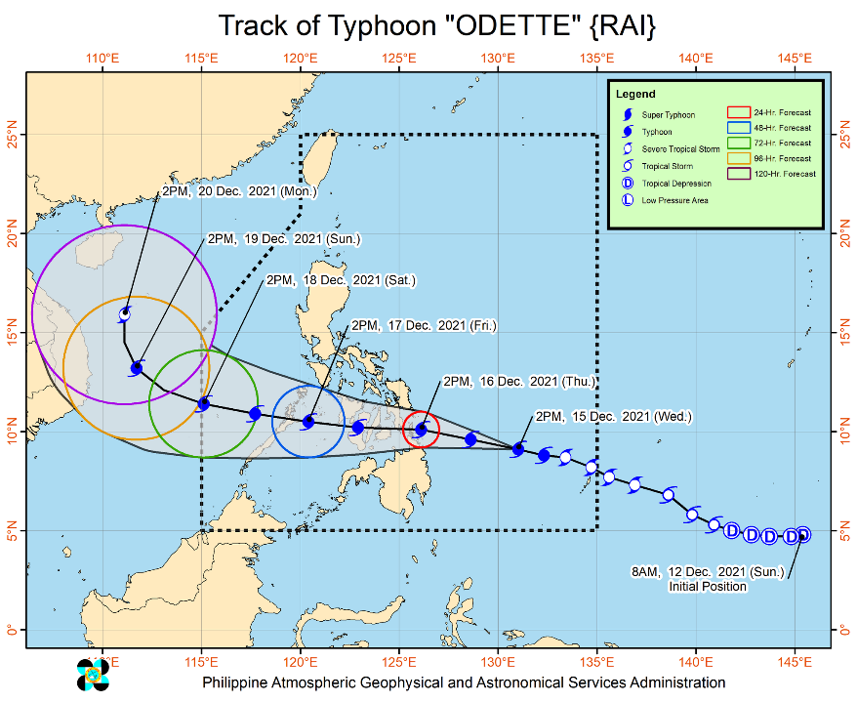
Issued at 5:00PM, 15 December 2021, “ODETTE” further intensifies while moving west northwestward over the Philippine Sea.
Track and Intensity:
- Typhoon “ODETTE” is forecast to move west northwestward until tonight or tomorrow early morning, then westward thereafter. On the forecast track, the center of this tropical cyclone is forecast to make landfall in the vicinity of Caraga or Eastern Visayas tomorrow afternoon or evening. Afterwards, the center of “ODETTE” will continue moving generally westward and cross several provinces in Central and Western Visayas regions before emerging over the Sulu Sea on Friday morning or afternoon. After passing near or over the Cuyo archipelago, this tropical cyclone is forecast to cross the northern portion of Palawan on Friday evening before emerging over the West Philippine Sea.
- Further intensification is expected today through tomorrow as the typhoon crosses the Philippine Sea and may reach a peak intensity of 155 km/h prior to making landfall tomorrow afternoon. This tropical cyclone may see some slight weakening as it crosses the Visayas and Palawan, but it is forecast to remain within the typhoon category. Re-intensification is likely once “ODETTE” emerges over the West Philippine Sea.

Severe Winds:
- Gale- to storm-force strength will be experienced within any of the areas where TCWS #2 is in effect. This may result in generally light to moderate damage to structures and vegetation.
- Strong winds (strong breeze to near gale) with higher gusts will be experienced within any of the areas where TCWS #1 is currently in effect during the passage of the severe tropical storm. This may generally bring up to very light damage to structures and vegetation.
- Areas under TCWS will be expanded in succeeding bulletins, while the hoisted wind signals in some localities of the country will be upgraded as “ODETTE” moves closer. The highest level of wind signal that may be hoisted during the passage of “ODETTE” is TCWS #3 due to possible destructive typhoon-force winds in localities near or along the path of this tropical cyclone.

Heavy Rainfall:

- Today through tomorrow early morning: Light to moderate with at times heavy rains are possible over CARAGA, Davao Oriental, Eastern Samar, Samar, and Southern Leyte due to the trough and the outermost rain bands of “ODETTE”
- Tomorrow early morning through Friday early morning: Heavy to intense with at times torrential rains over Dinagat Islands, Surigao del Norte, the northern portion of Surigao del Sur, Agusan del Norte, the northern portion of Agusan del Sur, Camiguin, Misamis Oriental, Southern Leyte, Bohol, Cebu, Siquijor, Negros Oriental, and Negros Occidental. Moderate to heavy with at times intense rains over Leyte, the southern portions of Eastern Samar and Samar, Iloilo, Capiz, Aklan, Antique, Guimaras, the northern portion of Zamboanga del Norte and the rest of CARAGA. Light to moderate with at times heavy rains over Bicol Region, the rest of Zamboanga del Norte, Oriental Mindoro, Romblon, and the rest of Visayas and Northern Mindanao
- Friday early morning through Saturday early morning: Heavy to intense with at times torrential rains over Western Visayas, and the northern and central portions of Palawan including Cuyo and Cagayancillo Islands. Moderate to heavy with at times intense rains over Occidental Mindoro, Oriental Mindoro, and Negros Oriental. Light to moderate with at times heavy rains over Bicol Region, Zamboanga del Norte, Quezon, Aurora, the eastern portions of Cagayan and Isabela, and the rest of Visayas.
- Under these conditions, scattered to widespread flooding (including flash floods) and rain-induced landslides are expected especially in areas that are highly or very highly susceptible to these hazard as identified in hazard maps, and in localities with significant antecedent rainfall.
The center of Typhoon “ODETTE” was estimated based on all available data at 485 km East of Hinatuan, Surigao del Sur (9.1°N, 130.7°E)
Source: DOST-PAGASA Severe Weather Bulletin

Predictive Analytics for Humanitarian Response

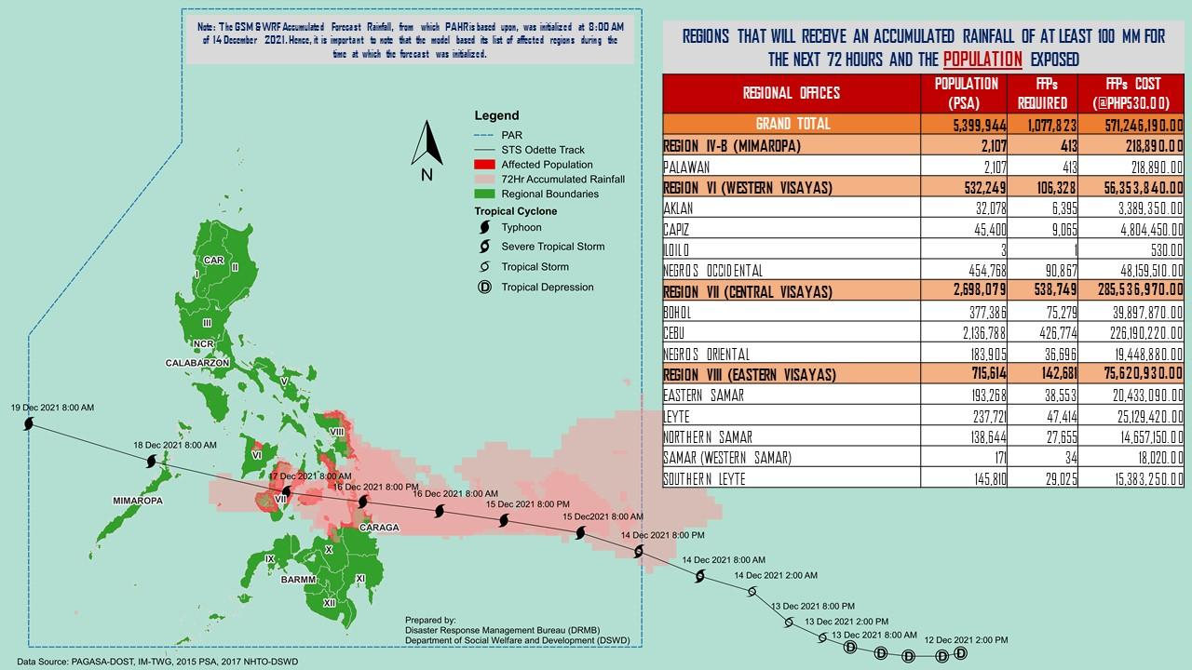

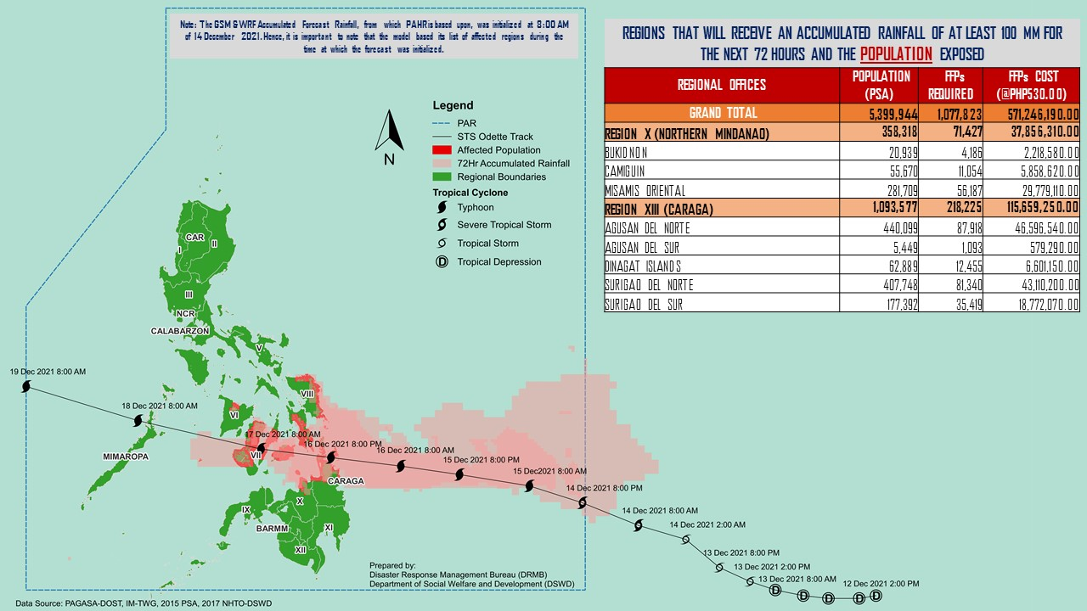

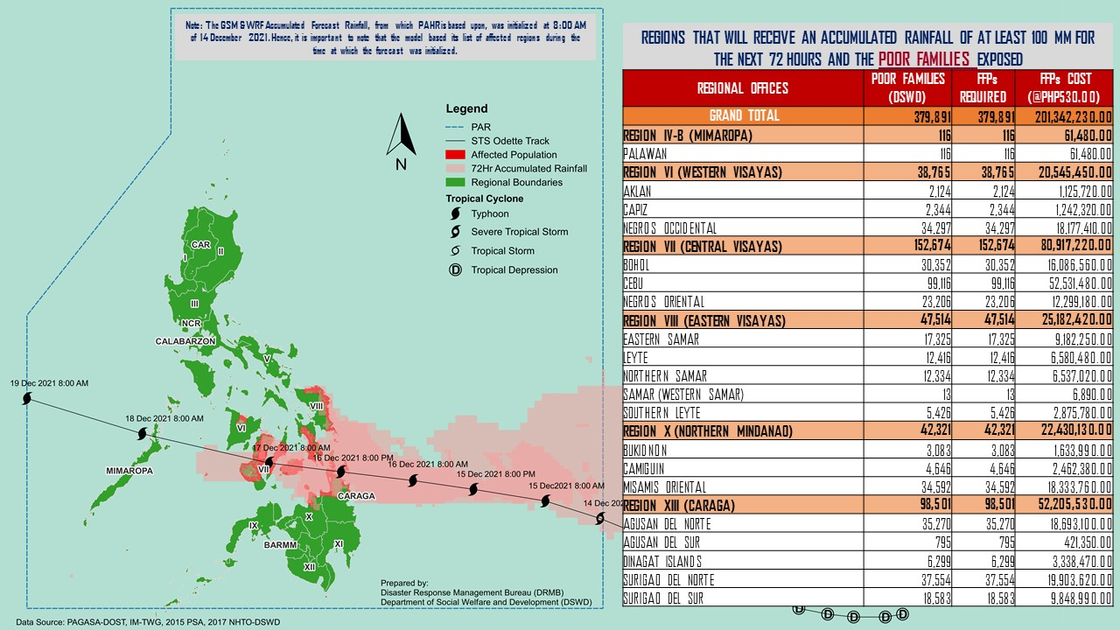

Status of Prepositioned Resources: Stockpile and Standby Funds

The DSWD Central Office (CO), Field Offices (FOs), and National Resource Operations Center (NROC) have stockpiles and standby funds amounting to ₱933,436,640.74 with breakdown as follows (see Table 2):

- Standby Funds
A total of ₱88,085,360.76 standby funds in the CO and FOs. Of the said amount, ₱19,678,617.37 is the available Quick Response Fund (QRF) in the CO.

- Stockpiles
A total of 357,619 family food packs (FFPs) amounting to ₱217,358,561.25, other food items amounting to ₱207,838,866.28 and non-food items (FNIs) amounting to ₱420,153,852.45 are available.

Table 1. Available Stockpiles and Standby Funds
REGIONAL / FIELD OFFICE | STANDBY FUNDS | FAMILY FOOD PACKS |  | OTHER FOOD ITEMS | NON-FOOD RELIEF ITEMS | TOTAL STANDBY FUNDS & STOCKPILE
 |  | QUANTITY | TOTAL COST | TOTAL COST | TOTAL COST
TOTAL | 88,085,360.76 | 357,619 | 217,358,561.25 | 207,838,866.28 | 420,153,852.45 | 933,436,640.74
Central Office | 19,678,617.37 | - | - | - | - | 19,678,617.37
NRLMB - NROC | - | 75,107 | 54,623,335.00 | 36,121,102.37 | 40,390,942.67 | 131,135,380.04
NRLMB - VDRC | - | 6,498 | 3,638,840.00 | 48,663,503.15 | 2,842,510.00 | 55,144,853.15
I | 5,123,035.20 | 19,588 | 12,291,538.00 | 10,820,010.00 | 12,935,065.67 | 41,169,648.87
II | 4,959,298.68 | 10,679 | 7,891,154.80 | 3,831,966.40 | 14,193,427.69 | 30,875,847.57
III | 3,000,000.00 | 14,608 | 8,288,453.04 | 7,070,544.55 | 15,842,510.27 | 34,201,507.86
CALABARZON | 5,000,000.00 | 14,754 | 11,297,514.80 | 3,157,768.00 | 103,311,874.34 | 122,767,157.14
MIMAROPA | 6,114,596.77 | 27,751 | 19,571,415.54 | 9,984,849.00 | 16,904,646.70 | 52,575,508.01
V | 5,000,608.00 | 20,948 | 12,395,671.20 | 4,015,253.00 | 25,975,007.15 | 47,386,539.35
VI | 5,000,661.42 | 19,433 | 9,946,901.86 | 3,608,625.60 | 14,609,255.29 | 33,165,444.17
VII | 752,250.00 | 31,777 | 14,650,905.00 | 22,282,247.34 | 15,304,807.82 | 52,990,210.16
VIII | 4,215,000.00 | 21,092 | 10,732,050.14 | 9,629,648.84 | 20,530,262.37 | 45,106,961.35
IX | 3,000,000.00 | 10,686 | 5,839,792.14 | 2,312,603.52 | 18,438,362.25 | 29,590,757.91
X | 5,238,559.92 | 12,679 | 8,573,959.60 | 23,859,317.87 | 43,312,887.26 | 80,984,724.65
XI | 5,000,000.00 | 15,681 | 7,448,475.00 | 1,291,893.00 | 20,253,045.80 | 33,993,413.80
XII | 3,000,969.85 | 12,552 | 7,317,322.95 | 6,520,217.30 | 24,631,720.03 | 41,470,230.13
CARAGA | 5,000,813.43 | 14,572 | 6,643,053.28 | 3,240,212.71 | 9,502,413.90 | 24,386,493.32
NCR | 3,000,000.00 | 1,034 | 645,993.60 | 6,195,059.30 | 1,199,759.96 | 11,040,812.86
CAR | 5,000,950.12 | 28,180 | 15,562,185.30 | 5,234,044.33 | 19,975,353.28 | 45,772,533.03
Note: The Inventory Summary is as of 15 December 2021, 4PM. Replenishment of standby funds for DSWD-FO VII is being processed.

Source: DRMB and NRLMB

Situational Reports

DSWD-DRMB
DATE | SITUATIONS / ACTIONS UNDERTAKEN
15 December 2021 | - The Disaster Response Management Bureau (DRMB) is closely coordinating with the concerned Field Offices (FOs) for significant disaster response updates.  - DSWD-DRMB Quick Response Team (QRT) members and emergency equipment are on standby and are ready for deployment.  - The Response Cluster is activated and is placed on standby status on 14 December 2021 to monitor and facilitate emergency and humanitarian assistance response to the effects of Typhoon “ODETTE”.  - DRMB participated in the Online Pre-Disaster Risk Assessment (PDRA) Meeting on STS “RAI” on 14 December 2021 with other response cluster member agencies. Further meetings shall be conducted on the implementation of COVID-19 protocols during the response efforts on STS “RAI”.

DSWD-FO II
DATE | SITUATIONS / ACTIONS UNDERTAKEN
15 December 2021 | - DSWD-FO II is continuously monitoring weather updates.  - DSWD-FO II QRT members are on standby alert and are ready for mobilization for any assistance and augmentation support needed from the LGUs.  - DSWD-FO II ensures the availability of Family Food Packs (FFPs) and other Food and Non-food Items (FNIs).  - DSWD-FO II attended the PDRA Core Group Meeting relative to the preparedness response measures of every member council of Cagayan Valley Regional Disaster Risk Reduction Management Council (CVRDRRMC) wherein DSWD presented the preparedness plan on the possible effects of Typhoon Odette and the Northeast Monsoon

DSWD-FO V
DATE | SITUATIONS / ACTIONS UNDERTAKEN
13 December 2021 | - DSWD-FO V is continuously monitoring weather updates.  - DSWD-FO V QRT members are on standby alert and are ready for mobilization for any assistance and augmentation support needed from the LGUs.  - DSWD-FO V ensures the availability of Family Food Packs (FFPs) and other Food and Non-food Items (FNIs).  - DSWD-FO V is closely coordinating with the P/MDRRMOs for status reports and updates.

DSWD-FO VI
DATE | SITUATIONS / ACTIONS UNDERTAKEN
14 December 2021 | - DSWD-FO VI is continuously monitoring weather updates.  - DSWD-FO VI QRT members are on standby alert and are ready for mobilization for any assistance and augmentation support needed from the LGUs.  - DSWD-FO VI ensures the availability of FFPs and other FNIs.

DSWD-FO VII
DATE | SITUATIONS / ACTIONS UNDERTAKEN
14 December 2021 | - DSWD-FO VII is continuously monitoring weather updates.  - DSWD-FO VII QRT members are on standby alert and are ready for mobilization for any assistance and augmentation support needed from the LGUs.  - DSWD-FO VII ensures the availability of FFPs and other FNIs.  - DSWD-FO VII is closely coordinating with their local counterparts and their respective LDRRMCs. Field staff were requested to monitor AOR and provide reports and updates to the Regional DROMIC Focal for any impacts/effects.

DSWD-FO VIII
DATE | SITUATIONS / ACTIONS UNDERTAKEN
15 December 2021 | - DSWD-FO VIII is continuously monitoring weather updates.  - DSWD-FO VIII QRT members are on standby alert and are ready for mobilization for any assistance and augmentation support needed from the LGUs.  - DSWD-FO VIII ensures the availability of FFPs and other FNIs.  - DSWD-FO VIII prepositioned Family Food Packs (FFPs) in Samar Island and Biliran which can be distributed immediately by the P/C/MATs to Local Government Units that needs augmentation support.

DSWD-FO X
DATE | SITUATIONS / ACTIONS UNDERTAKEN
14 December 2021 | - DSWD-FO X is continuously monitoring weather updates.  - DSWD-FO X QRT members are on standby alert and are ready for mobilization for any assistance and augmentation support needed from the LGUs.  - DSWD-FO X ensures the availability of FFPs and other FNIs.

DSWD-FO XI
DATE | SITUATIONS / ACTIONS UNDERTAKEN
14 December 2021 | - DSWD-FO XI is continuously monitoring weather updates.  - DSWD-FO XI QRT members are on standby alert and are ready for mobilization for any assistance and augmentation support needed from the LGUs.  - DSWD-FO XI ensures the availability of FFPs and other FNIs.

DSWD-FO CARAGA
DATE | SITUATIONS / ACTIONS UNDERTAKEN
15 December 2021 | - A total of 3,183 families have taken pre-emptive evacuation in the City of Tandag, Surigao Del Sur, on-going accounting of total affected individuals were conducted by the CSWD Office of Tandag.  - DSWD-FO CARAGA is continuously monitoring weather updates.  - DSWD-FO CARAGA QRT members are on standby alert and are ready for mobilization for any assistance and augmentation support needed from the LGUs.  - DSWD-FO CARAGA ensures the availability of FFPs and other FNIs.  - DSWD-FO CARAGA is continuously coordinating with SWADTLs and LSWDOs to monitor the situation in their respective areas.

Photo Documentation

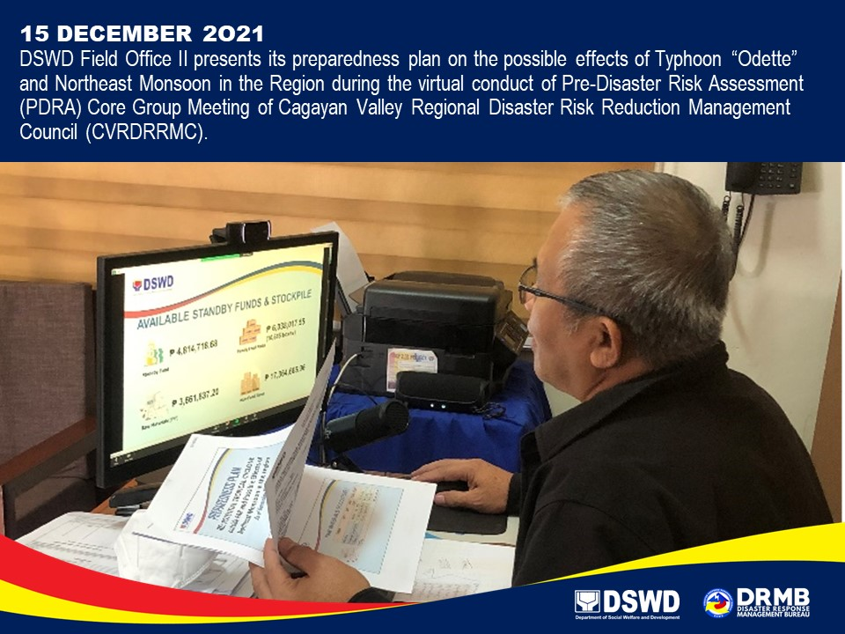
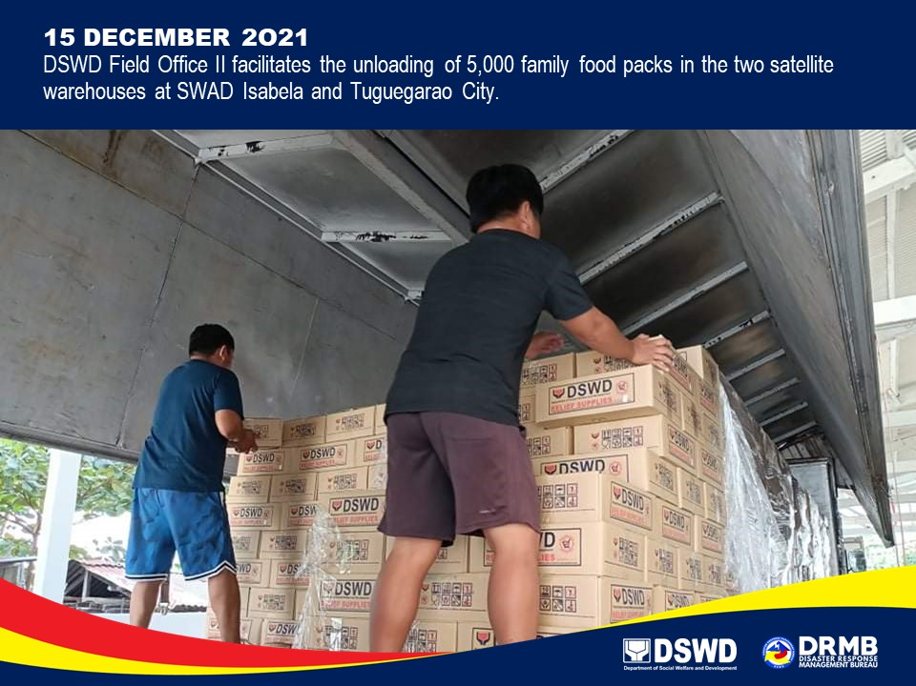

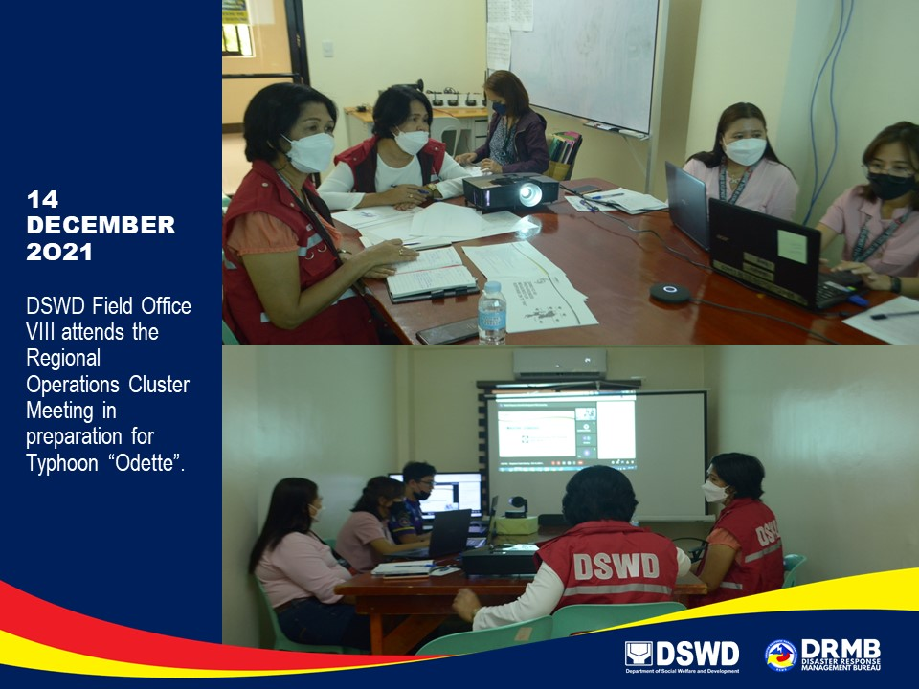

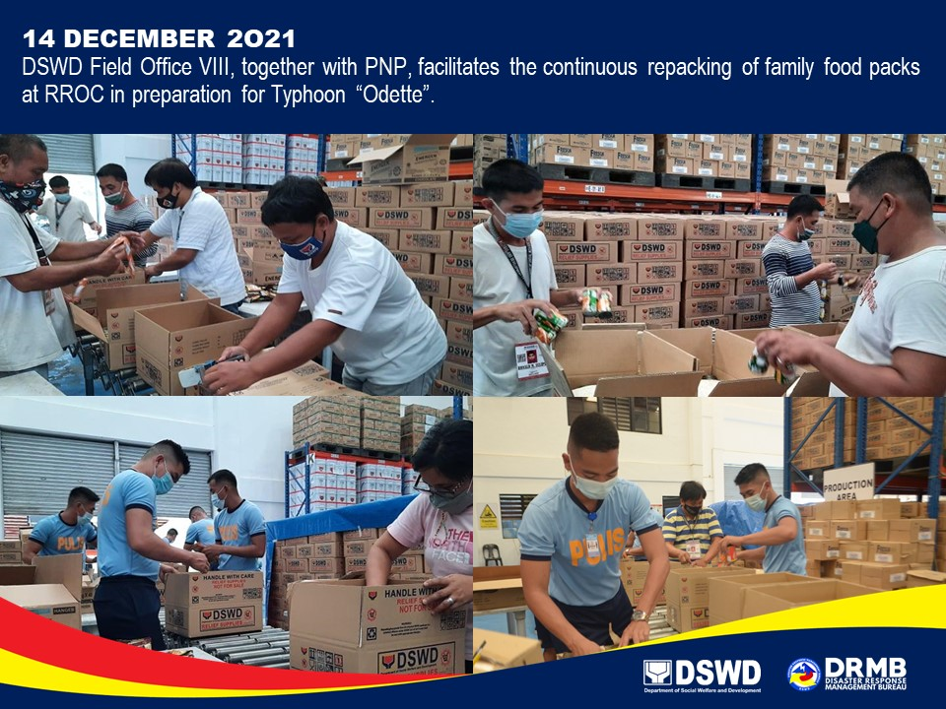

*****
The Disaster Response Operations Monitoring and Information Center (DROMIC) of the DSWD-DRMB is closely monitoring the effects of Typhoon “ODETTE” and is coordinating with the concerned DSWD Field Offices for any significant updates.

Prepared by:  MARIE JOYCE G. RAFANAN  AARON JOHN B. PASCUA | Released by:  RODEL V. CABADDU

