DSWD DROMIC Report #19 on Typhoon “ODETTE”
as of 24 December 2021, 6AM

- Situation Overview

On 14 December 2021, the center of Severe Tropical Storm (STS) “ODETTE” was estimated on all available data at 890 km east of Mindanao (8.3°N, 134.4°E). On 15 December 2021, “ODETTE” intensified into a Typhoon as it moved westward over the Philippine Sea east of Mindanao. On 16 December 2021, Typhoon “ODETTE” further intensified and made its initial landfall in Siargao Island, Surigao Del Norte at 1:30 PM bringing torrential rains over Caraga, Central Visayas, Misamis Oriental, Camiguin, Southern Leyte, and Negros Occidental; moderate to heavy with at times intense rains over Leyte, the southern portions of Eastern Samar and Samar, Zamboanga del Norte, Lanao del Sur, Davao Oriental, Davao de Oro, Davao del Norte, and the rest of Northern Mindanao and light to moderate with at times heavy rains over Bicol Region, Quezon, and the rest of Visayas, the rest of Zamboanga Peninsula, and mainland Bangsamoro.

On the same day, Typhoon “ODETTE” made another landfall in Cagdianao, Dinagat Islands at 3:10 PM, third at Liloan, Southern Leyte at 4:50 PM, fourth at Padre Burgos, Southern Leyte at 5:40 PM, fifth at Pres. Carlos P. Garcia, Bohol at 6:30 PM, sixth at Bien Unido, Bohol at 7:30 PM, and seventh at Carcar, Cebu at 10:00 PM. On 17 December 2021, Typhoon “ODETTE” made its eighth landfall in La Libertad, Negros Oriental at 12 AM, and finally, it made its ninth landfall in Roxas, Palawan at 3:10 PM.

“ODETTE” left the Philippine Area of Responsibility (PAR) on 18 December 2021 at 12:40 PM.
Source: DOST-PAGASA Severe Weather Bulletin

- Status of Affected Areas and Population
A total of 927,369 families or 3,599,109 persons were affected by Typhoon “ODETTE” in 5,652 Barangays in Regions V, VI, VII, VIII, IX, X, XI, XII, MIMAROPA, and Caraga (see Table 1).

Table 1. Number of Affected Families / Persons
REGION / PROVINCE / MUNICIPALITY |  | NUMBER OF AFFECTED
 |  | Barangays | Families | Persons
GRAND TOTAL |  | 5,652 | 927,369 | 3,599,109
MIMAROPA |  | 212 | 34,189 | 155,874
Oriental Mindoro |  | 4 | 56 | 254
 | Naujan | 2 | 4 | 19
 | Puerto Galera | 1 | 25 | 100
 | Victoria | 1 | 27 | 135
Palawan |  | 191 | 33,915 | 154,708
 | Aborlan | 7 | 1,143 | 4,567
 | Agutaya | 3 | 200 | 800
 | Araceli | 7 | 280 | 943
 | Cagayancillo | 12 | 402 | 1,696
 | Coron | 21 | 1,428 | 5,202
 | Culion | 5 | 89 | 309
 | Cuyo | 6 | 442 | 1,596
 | Dumaran | 5 | 209 | 1,045
 | El Nido (Bacuit) | 5 | 79 | 390
 | Linapacan | 3 | 392 | 1,863
 | Magsaysay | 8 | 709 | 2,234
 | Narra | 12 | 641 | 1,920
 | Puerto Princesa City (Capital) | 50 | 14,373 | 63,255
 | Quezon | 1 | 107 | 481
 | Roxas | 8 | 698 | 2,690
 | San Vicente | 7 | 268 | 1,219
 | Taytay | 31 | 12,455 | 64,498
Romblon |  | 17 | 218 | 912
 | Banton | 7 | 113 | 512
 | Cajidiocan | 3 | 53 | 219
 | Corcuera | 1 | 4 | 12
 | Ferrol | 3 | 40 | 131
 | Santa Fe | 3 | 8 | 38
REGION V |  | 39 | 1,397 | 4,337
Albay |  | 7 | 447 | 1,241
 | Guinobatan | 5 | 427 | 1,184
 | City of Ligao | 2 | 20 | 57
Masbate |  | 32 | 950 | 3,096
 | Aroroy | 3 | 83 | 373
 | Baleno | 1 | 23 | 62
 | Cataingan | 1 | 64 | 206
 | Esperanza | 15 | 585 | 1,706
 | City of Masbate (capital) | 1 | 7 | 32
 | Palanas | 3 | 53 | 193
 | Pio V. Corpuz (Limbuhan) | 2 | 66 | 248
 | Placer | 3 | 29 | 120
 | San Jacinto | 2 | 36 | 143
 | Uson | 1 | 4 | 13
REGION VI |  | 2,250 | 326,526 | 1,317,791
Aklan |  | 249 | 15,651 | 60,790
 | Altavas | 14 | 1,595 | 5,428
 | Balete | 10 | 1,252 | 4,733
 | Banga | 14 | 111 | 544
 | Batan | 4 | 38 | 156
 | Kalibo (capital) | 16 | 336 | 2,596
 | Libacao | 7 | 187 | 777
 | Madalag | 13 | 344 | 1,127
 | New Washington | 17 | 1,720 | 6,821
 | Buruanga | 15 | 5,263 | 20,905
 | Ibajay | 31 | 468 | 1,755
 | Lezo | 13 | 305 | 1,011
 | Makato | 18 | 650 | 2,709
 | Malay | 17 | 536 | 2,337
 | Malinao | 12 | 190 | 667
 | Nabas | 17 | 1,432 | 5,205
 | Numancia | 17 | 678 | 2,160
 | Tangalan | 14 | 546 | 1,859
Antique |  | 379 | 23,879 | 95,903
 | Anini-y | 22 | 1,976 | 6,607
 | Belison | 11 | 2,820 | 14,127
 | Hamtic | 27 | 814 | 2,845
 | San Jose (capital) | 25 | 1,046 | 4,667
 | San Remigio | 32 | 249 | 1,249
 | Sibalom | 39 | 1,815 | 7,735
 | Tobias Fornier (Dao) | 12 | 325 | 564
 | Valderrama | 17 | 319 | 1,211
 | Barbaza | 10 | 512 | 1,575
 | Bugasong | 20 | 653 | 2,336
 | Caluya | 21 | 2,359 | 8,731
 | Culasi | 41 | 2,668 | 10,686
 | Laua-an | 31 | 1,089 | 4,488
 | Libertad | 21 | 4,851 | 21,273
 | Pandan | 13 | 235 | 785
 | Patnongon | 17 | 619 | 2,494
 | Tibiao | 20 | 1,529 | 4,530
Capiz |  | 366 | 35,676 | 126,801
 | Cuartero | 22 | 2,293 | 7,888
 | Dao | 19 | 1,210 | 4,326
 | Dumalag | 28 | 674 | 2,142
 | Dumarao | 18 | 7,470 | 27,880
 | Ivisan | 13 | 485 | 1,617
 | Jamindan | 20 | 824 | 2,631
 | Mambusao | 22 | 829 | 2,655
 | Panay | 40 | 1,445 | 4,794
 | Panitan | 22 | 515 | 2,525
 | Pilar | 23 | 2,531 | 7,822
 | Pontevedra | 26 | 2,527 | 8,418
 | President Roxas | 21 | 2,310 | 8,491
 | Roxas City (capital) | 33 | 2,313 | 7,571
 | Sapi-an | 17 | 663 | 2,540
 | Sigma | 21 | 8,835 | 32,925
 | Tapaz | 21 | 752 | 2,576
Guimaras |  | 29 | 2,140 | 9,644
 | Buenavista | 18 | 1,440 | 7,200
 | San Lorenzo | 7 | 443 | 1,494
 | Jordan (capital) | 2 | 96 | 385
 | Nueva Valencia | 1 | 88 | 317
 | Sibunag | 1 | 73 | 248
Iloilo |  | 794 | 58,353 | 220,254
 | Ajuy | 26 | 6,911 | 27,164
 | Anilao | 13 | 359 | 1,409
 | Balasan | 23 | 2,075 | 7,426
 | Banate | 18 | 2,233 | 7,532
 | Barotac Nuevo | 29 | 3,218 | 16,090
 | Batad | 12 | 141 | 509
 | Bingawan | 5 | 52 | 234
 | Cabatuan | 39 | 559 | 2,073
 | Calinog | 34 | 389 | 1,670
 | Carles | 33 | 4,330 | 17,100
 | Concepcion | 24 | 3,448 | 11,521
 | Dingle | 3 | 61 | 305
 | Dueñas | 9 | 114 | 444
 | Dumangas | 16 | 108 | 515
 | Estancia | 19 | 1,016 | 3,626
 | Guimbal | 33 | 303 | 1,130
 | Iloilo City (capital) | 36 | 1,193 | 4,329
 | Janiuay | 32 | 515 | 2,756
 | Lambunao | 65 | 2,023 | 8,438
 | Leganes | 18 | 1,799 | 7,107
 | Lemery | 29 | 1,658 | 5,491
 | Leon | 61 | 476 | 1,924
 | Miagao | 15 | 346 | 1,380
 | Mina | 4 | 35 | 168
 | Pavia | 12 | 520 | 2,500
 | Pototan | 21 | 202 | 837
 | San Enrique | 23 | 7,864 | 27,908
 | San Joaquin | 38 | 1,437 | 4,603
 | San Rafael | 9 | 525 | 1,805
 | Santa Barbara | 8 | 67 | 261
 | Sara | 40 | 10,556 | 38,095
 | Tigbauan | 14 | 279 | 1,026
 | Tubungan | 9 | 84 | 344
 | Zarraga | 24 | 3,457 | 12,534
Negros Occidental |  | 433 | 190,827 | 804,399
 | Bacolod City (capital) | 36 | 1,220 | 4,986
 | Bago City | 24 | 13,386 | 66,970
 | Binalbagan | 16 | 18,258 | 91,290
 | Cadiz City | 20 | 1,901 | 6,924
 | Calatrava | 1 | 166 | 498
 | Candoni | 9 | 7,239 | 26,497
 | Cauayan | 17 | 12,450 | 48,868
 | Enrique B. Magalona (Saravia) | 23 | 9,963 | 49,815
 | City of Escalante | 21 | 1,903 | 6,464
 | City of Himamaylan | 19 | 34,264 | 99,128
 | Hinigaran | 1 | 50 | 250
 | Hinoba-an (Asia) | 13 | 1,043 | 3,984
 | Ilog | 15 | 16,728 | 83,615
 | City of Kabankalan | 29 | 27,399 | 113,168
 | La Carlota City | 14 | 11,517 | 57,585
 | La Castellana | 6 | 183 | 683
 | Manapla | 12 | 2,221 | 11,105
 | Moises Padilla (Magallon) | 3 | 47 | 155
 | Murcia | 3 | 47 | 155
 | Pontevedra | 10 | 516 | 2,044
 | Pulupandan | 19 | 684 | 2,199
 | Sagay City | 26 | 5,651 | 26,735
 | Salvador Benedicto | 7 | 7,860 | 29,273
 | San Carlos City | 12 | 1,290 | 5,624
 | San Enrique | 10 | 3,962 | 19,810
 | Silay City | 15 | 697 | 2,588
 | City of Sipalay | 13 | 1,064 | 3,750
 | City of Talisay | 21 | 823 | 4,115
 | Toboso | 1 | 250 | 750
 | Valladolid | 16 | 6,130 | 25,796
 | City of Victorias | 1 | 1,915 | 9,575
REGION VII |  | 1,053 | 149,470 | 491,050
Bohol |  | 271 | 25,780 | 69,715
 | Alburquerque | 9 | 129 | 541
 | Anda | 16 | 5,508 | 8,605
 | Baclayon | 6 | 26 | 81
 | Balilihan | 1 | 145 | 541
 | Bien Unido | 5 | 158 | 584
 | Bilar | 5 | 148 | 711
 | Buenavista | 1 | 43 | 184
 | Calape | 33 | 2,185 | 4,874
 | Candijay | 18 | 1,260 | 4,477
 | Dauis | 1 | 223 | 887
 | Dimiao | 16 | 120 | 461
 | Duero | 1 | 174 | 564
 | Garcia Hernandez | 30 | 2,581 | 9,829
 | Inabanga | 7 | 70 | 104
 | Jagna | 9 | 653 | 1,693
 | Lila | 3 | 58 | 284
 | Loay | 5 | 93 | 400
 | Mabini | 8 | 495 | 1,654
 | Maribojoc | 1 | 752 | 2,844
 | Panglao | 3 | 10 | 48
 | Pilar | 1 | 5 | 18
 | Pres. Carlos P. Garcia (Pitogo) | 23 | 9,000 | 23,000
 | San Isidro | 2 | 14 | 67
 | San Miguel | 17 | 260 | 1,026
 | Sevilla | 4 | 25 | 55
 | Sierra Bullones | 11 | 220 | 905
 | Tagbilaran City (capital) | 10 | 271 | 1,063
 | Talibon | 1 | 60 | 261
 | Trinidad | 6 | 19 | 84
 | Tubigon | 16 | 861 | 2,881
 | Ubay | 1 | 178 | 859
 | Valencia | 1 | 36 | 130
Cebu |  | 604 | 62,926 | 218,477
 | Alegria | 4 | 199 | 813
 | Argao | 10 | 270 | 999
 | Asturias | 8 | 199 | 904
 | Badian | 29 | 2,897 | 11,899
 | Balamban | 28 | 1,534 | 7,236
 | Bantayan | 12 | 390 | 1,545
 | Barili | 6 | 86 | 269
 | Boljoon | 3 | 63 | 294
 | Borbon | 4 | 79 | 303
 | City of Carcar | 2 | 272 | 1,372
 | Carmen | 16 | 549 | 1,920
 | Catmon | 14 | 413 | 1,569
 | Cebu City (capital) | 80 | 4,400 | 22,000
 | Compostela | 17 | 181 | 509
 | Consolacion | 9 | 231 | 961
 | Cordoba | 12 | 400 | 2,341
 | Daanbantayan | 1 | 1,575 | 5,879
 | Danao City | 42 | 2,391 | 6,628
 | Dumanjug | 8 | 558 | 623
 | Lapu-Lapu City (Opon) | 30 | 13,194 | 44,897
 | Liloan | 14 | 2,028 | 1,785
 | Mandaue City | 23 | 2,368 | 4,071
 | Medellin | 19 | 9,115 | 29,123
 | Minglanilla | 11 | 930 | 2,034
 | Moalboal | 14 | 7,786 | 26,929
 | City of Naga | 26 | 456 | 2,842
 | Oslob | 9 | 738 | 92
 | Pilar | 13 | 216 | 661
 | Ronda | 8 | 263 | 974
 | Samboan | 1 | 74 | 414
 | San Fernando | 10 | 540 | 1,437
 | San Francisco | 13 | 868 | 5,243
 | San Remigio | 22 | 73 | 192
 | Santa Fe | 6 | 502 | 2,010
 | Sibonga | 7 | 109 | 482
 | Sogod | 18 | 2,359 | 8,250
 | Tabogon | 11 | 651 | 2,048
 | Tabuelan | 7 | 696 | 942
 | City of Talisay | 22 | 2,555 | 13,865
 | Toledo City | 1 | 55 | 220
 | Tuburan | 5 | 255 | 804
 | Tudela | 9 | 408 | 1,098
Siquijor |  | 11 | 269 | 1,112
 | Enrique Villanueva | 1 | 16 | 60
 | Larena | 1 | 60 | 199
 | Lazi | 3 | 50 | 252
 | Maria | 1 | 9 | 17
 | San Juan | 1 | 57 | 364
 | Siquijor (capital) | 4 | 77 | 220
Negros Oriental |  | 167 | 60,495 | 201,746
 | Amlan (Ayuquitan) | 4 | 127 | 557
 | Ayungon | 15 | 568 | 2,008
 | Bais City | 6 | 230 | 991
 | Basay | 1 | 191 | 861
 | City of Bayawan (Tulong) | 5 | 814 | 3,659
 | Bindoy (Payabon) | 64 | 33,823 | 110,494
 | Canlaon City | - | 15,914 | 52,982
 | Dumaguete City (capital) | 37 | 1,904 | 4,305
 | City of Guihulngan | 11 | 758 | 1,672
 | Jimalalud | 6 | 233 | 916
 | La Libertad | 1 | 67 | 118
 | Mabinay | - | 3,253 | 12,871
 | Manjuyod | 5 | 138 | 521
 | Pamplona | 1 | 12 | 45
 | San Jose | - | 1,476 | 5,866
 | Santa Catalina | - | 316 | 1,279
 | Siaton | - | 230 | 905
 | Sibulan | - | 172 | 661
 | City of Tanjay | 1 | 122 | 366
 | Tayasan | 7 | 60 | 300
 | Valencia (Luzurriaga) | 1 | 29 | 144
 | Vallehermoso | 1 | 36 | 134
 | Zamboanguita | 1 | 22 | 91
REGION VIII |  | 1,024 | 226,812 | 899,412
Eastern Samar |  | 194 | 46,121 | 171,173
 | Arteche | 20 | 4,614 | 17,294
 | City of Borongan (capital) | 4 | 1,276 | 4,782
 | Can-Avid | 10 | 329 | 1,645
 | Dolores | 1 | 443 | 2,215
 | Jipapad | 4 | 51 | 216
 | Maslog | 12 | 1,572 | 7,870
 | Oras | 23 | 681 | 2,897
 | San Julian | 1 | 4,255 | 21,275
 | San Policarpo | 1 | 4,565 | 17,290
 | Sulat | 12 | 1,034 | 2,351
 | Taft | 1 | 213 | 914
 | Balangiga | 13 | 4,336 | 15,921
 | Balangkayan | 14 | 607 | 2,239
 | General MacArthur | 16 | 1,295 | 4,587
 | Giporlos | 18 | 3,569 | 11,402
 | Guiuan | 14 | 4,677 | 14,809
 | Hernani | 10 | 2,069 | 7,877
 | Lawaan | 15 | 1,689 | 5,426
 | Llorente | 1 | 367 | 1,445
 | Maydolong | 1 | 1,214 | 4,054
 | Mercedes | 1 | 1,725 | 3,648
 | Quinapondan | 1 | 1,905 | 8,950
 | Salcedo | 1 | 3,635 | 12,066
Leyte |  | 444 | 99,753 | 392,194
 | Alangalang | 39 | 5,276 | 21,358
 | Santa Fe | 20 | 1,776 | 6,722
 | Tacloban City (capital) | 99 | 3,904 | 17,002
 | Tanauan | 45 | 6,991 | 22,268
 | Dulag | 36 | 2,846 | 9,672
 | MacArthur | 1 | 2,807 | 9,409
 | Mayorga | 16 | 1,775 | 8,875
 | Leyte | 1 | 176 | 880
 | Ormoc City | 11 | 427 | 2,135
 | Abuyog | 7 | 5,171 | 21,153
 | Bato | 8 | 2,410 | 9,785
 | City of Baybay | 1 | 9,016 | 45,080
 | Hilongos | 51 | 19,133 | 61,482
 | Hindang | 1 | 285 | 1,425
 | Inopacan | 20 | 6,106 | 24,424
 | Javier (Bugho) | 28 | 7,968 | 28,304
 | Mahaplag | 28 | 5,307 | 26,535
 | Matalom | 32 | 18,379 | 75,685
Western Samar |  | 16 | 2,667 | 10,027
 | San Jorge | 1 | 124 | 509
 | Santo Nino | 1 | 29 | 110
 | Tagapul-an | 14 | 2,514 | 9,408
Southern Leyte |  | 370 | 78,271 | 326,018
 | Bontoc | 40 | 5,000 | 25,000
 | Limasawa | 6 | 1,794 | 6,426
 | Macrohon | 30 | 7,916 | 39,580
 | Malitbog | 37 | 5,523 | 24,820
 | Padre Burgos | 11 | 3,617 | 11,342
 | Tomas Oppus | 29 | 5,588 | 16,980
 | Anahawan | 14 | 2,316 | 8,575
 | Hinunangan | 4 | 3,500 | 17,500
 | Hinundayan | 17 | 3,727 | 13,547
 | Libagon | 14 | 4,489 | 22,445
 | Liloan | 24 | 6,267 | 15,783
 | Pintuyan | 23 | 3,150 | 11,480
 | Saint Bernard | 30 | 5,919 | 28,414
 | San Francisco | 22 | 4,500 | 22,500
 | San Juan (Cabalian) | 18 | 4,887 | 15,203
 | San Ricardo | 15 | 2,998 | 11,023
 | Silago | 15 | 2,424 | 12,120
 | Sogod | 21 | 4,656 | 23,280
REGION IX |  | 8 | 322 | 1,610
Zamboanga del Norte |  | 6 | 99 | 495
 | Dipolog City (capital) | 6 | 99 | 495
Zamboanga del Sur |  | 2 | 223 | 1,115
 | Bayog | 1 | 8 | 40
 | Zamboanga City | 1 | 215 | 1,075
REGION X |  | 348 | 34,272 | 135,996
Bukidnon |  | 53 | 4,157 | 13,957
 | Libona | 2 | 69 | 345
 | Malitbog | 8 | 369 | 1,350
 | Sumilao | 2 | 26 | 90
 | Cabanglasan | 3 | 71 | 355
 | Impasug-ong | 5 | 59 | 186
 | City of Malaybalay (capital) | 12 | 395 | 1,519
 | San Fernando | 1 | 1 | 3
 | Maramag | 2 | 71 | 480
 | City of Valencia | 18 | 3,096 | 9,629
Camiguin |  | 32 | 1,351 | 5,862
 | Mahinog | 8 | 565 | 2,898
 | Mambajao (capital) | 8 | 238 | 974
 | Catarman | 3 | 57 | 268
 | Guinsiliban | 6 | 317 | 1,152
 | Sagay | 7 | 174 | 570
Lanao del Norte |  | 48 | 3,242 | 17,956
 | Iligan City | 30 | 2,476 | 14,856
 | Bacolod | 6 | 347 | 1,553
 | Kolambugan | 3 | 152 | 627
 | Maigo | 1 | 129 | 421
 | Matungao | 4 | 74 | 254
 | Tubod (capital) | 1 | 16 | 80
 | Lala | 3 | 48 | 165
Misamis Occidental |  | 18 | 4,862 | 17,012
 | Aloran | 1 | 62 | 225
 | Lopez Jaena | 2 | 238 | 1,250
 | Oroquieta City (capital) | 5 | 4,425 | 15,011
 | Panaon | 1 | 1 | 8
 | Plaridel | 3 | 81 | 288
 | Clarin | 1 | 11 | 55
 | Don Victoriano Chiongbian (Don Mariano Marcos) | 2 | 29 | 130
 | Ozamis City | 2 | 6 | 25
 | Sinacaban | 1 | 9 | 20
Misamis Oriental |  | 197 | 20,660 | 81,209
 | Cagayan De Oro City (capital) | 29 | 2,888 | 10,701
 | Balingasag | 17 | 1,330 | 6,311
 | Balingoan | 5 | 430 | 1,574
 | Binuangan | 7 | 504 | 2,505
 | Gingoog City | 24 | 2,687 | 10,031
 | Kinoguitan | 2 | 150 | 1,150
 | Lagonglong | 10 | 1,515 | 6,465
 | Magsaysay (Linugos) | 4 | 117 | 504
 | Medina | 4 | 25 | 105
 | Salay | 8 | 789 | 2,672
 | Sugbongcogon | 11 | 2,972 | 8,583
 | Talisayan | 10 | 944 | 3,712
 | Alubijid | 3 | 226 | 958
 | Claveria | 4 | 111 | 443
 | City of El Salvador | 6 | 485 | 1,404
 | Initao | 2 | 20 | 94
 | Jasaan | 14 | 1,946 | 9,626
 | Libertad | 4 | 270 | 990
 | Lugait | 5 | 208 | 901
 | Manticao | 4 | 225 | 1,012
 | Naawan | 6 | 126 | 702
 | Opol | 2 | 449 | 1,789
 | Tagoloan | 9 | 2,108 | 8,438
 | Villanueva | 7 | 135 | 539
REGION XI |  | 4 | 297 | 998
Davao de Oro |  | 3 | 295 | 985
 | Nabunturan (capital) | 2 | 107 | 371
 | New Bataan | 1 | 188 | 614
Davao del Sur |  | 1 | 2 | 13
 | Davao City | 1 | 2 | 13
REGION XII |  | 1 | 2,106 | 8,884
North Cotabato |  | 1 | 2,106 | 8,884
 | Kabacan | 1 | 2,106 | 8,884
CARAGA |  | 713 | 151,978 | 583,157
Agusan del Norte |  | 178 | 40,466 | 163,362
 | Buenavista | 17 | 766 | 2,811
 | Butuan City (capital) | 58 | 10,612 | 40,788
 | City of Cabadbaran | 28 | 11,468 | 56,803
 | Carmen | 6 | 233 | 781
 | Jabonga | 15 | 7,862 | 27,023
 | Kitcharao | 11 | 5,995 | 21,278
 | Las Nieves | 5 | 27 | 137
 | Magallanes | 7 | 777 | 2,574
 | Nasipit | 16 | 530 | 1,837
 | Remedios T. Romualdez | 5 | 529 | 1,625
 | Santiago | 9 | 1,636 | 7,629
 | Tubay | 1 | 31 | 76
Agusan del Sur |  | 97 | 21,876 | 82,689
 | City of Bayugan | 3 | 446 | 2,132
 | Bunawan | 10 | 978 | 3,778
 | Esperanza | 2 | 179 | 895
 | La Paz | 2 | 93 | 465
 | Loreto | 5 | 147 | 476
 | Prosperidad (capital) | 24 | 5,365 | 19,498
 | Rosario | 11 | 12,230 | 45,977
 | San Francisco | 1 | 106 | 404
 | San Luis | 1 | 7 | 26
 | Santa Josefa | 1 | 17 | 60
 | Sibagat | 18 | 1,110 | 3,162
 | Talacogon | 2 | 130 | 540
 | Trento | 16 | 1,062 | 5,250
 | Veruela | 1 | 6 | 26
Dinagat Island |  | 13 | 475 | 1,553
 | Libjo (Albor) | 4 | 107 | 322
 | San Jose (capital) | 9 | 368 | 1,231
Surigao del Norte |  | 224 | 40,561 | 150,400
 | Alegria | 12 | 786 | 3,842
 | Bacuag | 9 | 3,420 | 17,100
 | Burgos | 6 | 600 | 2,785
 | Claver | 14 | 2,747 | 10,137
 | Dapa | 6 | 694 | 2,882
 | Del Carmen | 20 | 8,439 | 23,596
 | General Luna | 7 | 531 | 2,378
 | Gigaquit | 13 | 3,180 | 14,519
 | Mainit | 13 | 1,094 | 3,831
 | Malimono | 14 | 2,688 | 9,096
 | Pilar | 15 | 2,367 | 8,121
 | Placer | 20 | 3,542 | 13,200
 | San Benito | 1 | 14 | 49
 | San Francisco (Anao-aon) | 1 | 30 | 90
 | San Isidro | 10 | 867 | 2,881
 | Santa Monica (Sapao) | 11 | 2,980 | 10,738
 | Sison | 3 | 293 | 1,036
 | Socorro | 12 | 1,360 | 4,971
 | Surigao City (capital) | 17 | 2,700 | 10,971
 | Tagana-an | 11 | 1,031 | 3,956
 | Tubod | 9 | 1,198 | 4,221
Surigao del Sur |  | 201 | 48,600 | 185,153
 | Barobo | 17 | 4,326 | 16,771
 | Cantilan | 17 | 3,490 | 13,431
 | Carmen | 8 | 1,865 | 6,881
 | Carrascal | 11 | 1,285 | 4,434
 | Cortes | 12 | 2,131 | 7,659
 | Hinatuan | 24 | 10,386 | 41,351
 | Lanuza | 12 | 1,463 | 5,417
 | Lianga | 13 | 3,296 | 12,553
 | Lingig | 12 | 3,508 | 13,013
 | Madrid | 6 | 468 | 1,894
 | Marihatag | 12 | 3,071 | 12,767
 | San Agustin | 13 | 3,821 | 15,022
 | San Miguel | 13 | 953 | 4,185
 | Tagbina | 7 | 402 | 1,429
 | Tago | 24 | 8,135 | 28,346
Note: Most areas affected by Typhoon ODETTE are experiencing power outage and limited internet access; hence, the challenge in gathering data on affected population and other significant updates.
*This version reflects the actual number of affected and displaced population in Oriental Mindoro, Marinduque and Palawan based on the result of validation conducted on 21 December 2021. Hence, the decrease in data.
*Changes in figures are based on the ongoing assessment and validation being conducted.
Source: DSWD-Field Offices
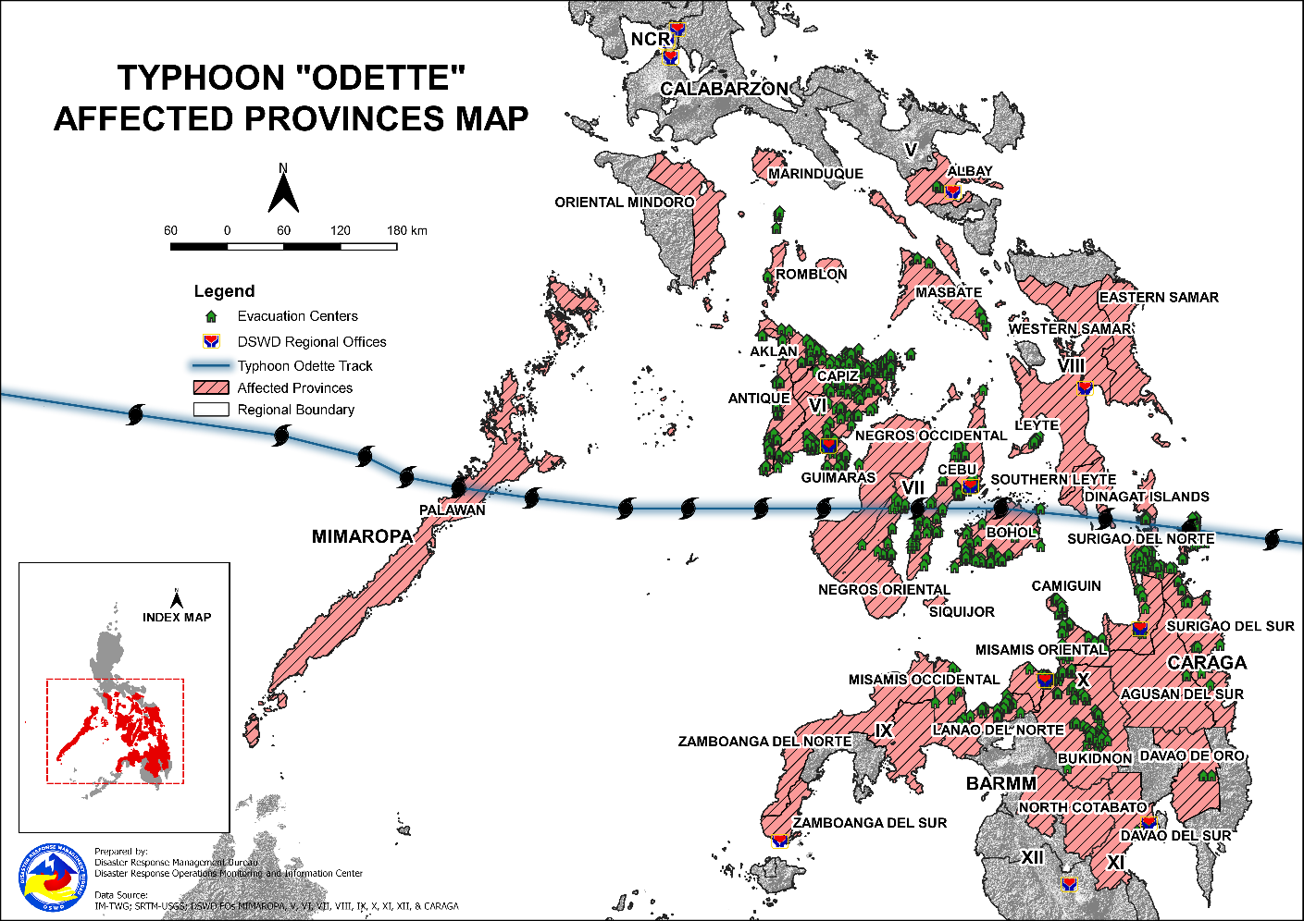

- Status of Displaced Population
- Inside Evacuation Centers
There are 76,293 families or 303,592 persons taking temporary shelter in 1,242 evacuation centers in Regions VI, VII, VIII, X, MIMAROPA, and Caraga (see Table 2).

Table 2. Number of Displaced Families / Persons Inside Evacuation Centers
REGION / PROVINCE / MUNICIPALITY |  | NUMBER OF EVACUATION CENTERS (ECs) |  | NUMBER OF DISPLACED
 |  |  |  | INSIDE ECs
 |  |  |  | Families |  | Persons
 |  | CUM | NOW | CUM | NOW | CUM | NOW
GRAND TOTAL |  | 6,163 | 1,242 | 304,228 | 76,293 | 1,209,152 | 303,592
MIMAROPA |  | 300 | 78 | 33,671 | 2,535 | 154,035 | 10,358
Oriental Mindoro |  | 5 | - | 56 | - | 254 | -
 | Naujan | 2 | - | 4 | - | 19 | -
 | Puerto Galera | 2 | - | 25 | - | 100 | -
 | Victoria | 1 | - | 27 | - | 135 | -
Palawan |  | 271 | 78 | 33,418 | 2,535 | 152,993 | 10,358
 | Aborlan | 7 | - | 1,143 | - | 4,567 | -
 | Agutaya | 5 | - | 200 | - | 800 | -
 | Araceli | 21 | 21 | 280 | 280 | 943 | 943
 | Cagayancillo | 12 | 12 | 394 | 394 | 1,664 | 1,664
 | Coron | 47 | - | 1,404 | - | 5,082 | -
 | Culion | 5 | 5 | 89 | 89 | 309 | 309
 | Cuyo | 7 | - | 435 | - | 1,579 | -
 | Dumaran | 9 | 9 | 209 | 209 | 1,045 | 1,045
 | El Nido (Bacuit) | 4 | - | 79 | - | 390 | -
 | Linapacan | 12 | - | 392 | - | 1,863 | -
 | Magsaysay | 18 | 1 | 439 | 17 | 1,277 | 85
 | Narra | 16 | - | 460 | - | 1,366 | -
 | Puerto Princesa City (Capital) | 53 | 6 | 14,366 | 473 | 63,220 | 1,932
 | Quezon | 2 | 2 | 107 | 107 | 481 | 471
 | Roxas | 6 | 6 | 698 | 698 | 2,690 | 2,690
 | San Vicente | 16 | 16 | 268 | 268 | 1,219 | 1,219
 | Taytay | 31 | - | 12,455 | - | 64,498 | -
Romblon |  | 24 | - | 197 | - | 788 | -
 | Banton | 10 | - | 92 | - | 388 | -
 | Cajidiocan | 3 | - | 53 | - | 219 | -
 | Corcuera | 3 | - | 4 | - | 12 | -
 | Ferrol | 5 | - | 40 | - | 131 | -
 | Santa Fe | 3 | - | 8 | - | 38 | -
REGION V |  | 38 | - | 1,397 | - | 4,337 | -
Albay |  | 7 | - | 447 | - | 1,241 | -
 | Guinobatan | 4 | - | 427 | - | 1,184 | -
 | City of Ligao | 3 | - | 20 | - | 57 | -
Masbate |  | 31 | - | 950 | - | 3,096 | -
 | Aroroy | 3 | - | 83 | - | 373 | -
 | Baleno | 1 | - | 23 | - | 62 | -
 | Cataingan | 2 | - | 64 | - | 206 | -
 | Esperanza | 15 | - | 585 | - | 1,706 | -
 | City of Masbate (capital) | 1 | - | 7 | - | 32 | -
 | Palanas | 3 | - | 53 | - | 193 | -
 | Pio V. Corpuz (Limbuhan) | 2 | - | 66 | - | 248 | -
 | Placer | 1 | - | 29 | - | 120 | -
 | San Jacinto | 2 | - | 36 | - | 143 | -
 | Uson | 1 | - | 4 | - | 13 | -
REGION VI |  | 2,830 | 250 | 91,031 | 25,374 | 363,065 | 114,933
Aklan |  | 355 | - | 6,241 | - | 23,753 | -
 | Altavas | 31 | - | 596 | - | 2,116 | -
 | Balete | 31 | - | 552 | - | 2,155 | -
 | Banga | 18 | - | 62 | - | 209 | -
 | Batan | 5 | - | 38 | - | 156 | -
 | Kalibo (capital) | 12 | - | 265 | - | 1,096 | -
 | Libacao | 3 | - | 125 | - | 503 | -
 | Madalag | 21 | - | 186 | - | 588 | -
 | New Washington | 30 | - | 1,582 | - | 6,259 | -
 | Buruanga | 49 | - | 203 | - | 701 | -
 | Ibajay | 25 | - | 458 | - | 1,668 | -
 | Lezo | 20 | - | 116 | - | 433 | -
 | Makato | 22 | - | 237 | - | 935 | -
 | Malay | 7 | - | 453 | - | 1,813 | -
 | Malinao | 29 | - | 135 | - | 511 | -
 | Nabas | 15 | - | 664 | - | 2,446 | -
 | Numancia | 17 | - | 244 | - | 934 | -
 | Tangalan | 20 | - | 325 | - | 1,230 | -
Antique |  | 505 | 42 | 8,210 | 978 | 29,571 | 3,709
 | Anini-y | 31 | 9 | 583 | 81 | 2,037 | 327
 | Belison | 9 | - | 141 | - | 390 | -
 | Hamtic | 26 | 26 | 660 | 660 | 2,205 | 2,205
 | San Jose (capital) | 38 | - | 365 | 8 | 1,260 | 32
 | San Remigio | 1 | - | 28 | - | 139 | -
 | Sibalom | 34 | - | 619 | - | 2,426 | -
 | Tobias Fornier (Dao) | 7 | 7 | 229 | 229 | 1,145 | 1,145
 | Valderrama | 23 | - | 319 | - | 1,211 | -
 | Barbaza | 15 | - | 440 | - | 1,329 | -
 | Bugasong | 31 | - | 475 | - | 1,795 | -
 | Caluya | 53 | - | 1,043 | - | 3,855 | -
 | Culasi | 69 | - | 735 | - | 2,914 | -
 | Laua-an | 40 | - | 429 | - | 1,838 | -
 | Libertad | 43 | - | 418 | - | 1,471 | -
 | Pandan | 21 | - | 185 | - | 630 | -
 | Patnongon | 23 | - | 304 | - | 1,357 | -
 | Tibiao | 41 | - | 1,237 | - | 3,569 | -
Capiz |  | 648 | - | 13,039 | - | 45,025 | -
 | Cuartero | 18 | - | 327 | - | 1,252 | -
 | Dao | 47 | - | 490 | - | 1,735 | -
 | Dumalag | 26 | - | 314 | - | 939 | -
 | Dumarao | 62 | - | 649 | - | 2,458 | -
 | Ivisan | 13 | - | 302 | - | 1,039 | -
 | Mambusao | 40 | - | 364 | - | 1,314 | -
 | Panay | 75 | - | 825 | - | 2,928 | -
 | Panitan | 23 | - | 317 | - | 1,541 | -
 | Pilar | 75 | - | 1,852 | - | 5,956 | -
 | Pontevedra | 62 | - | 2,527 | - | 8,418 | -
 | President Roxas | 19 | - | 1,410 | - | 4,967 | -
 | Roxas City (capital) | 95 | - | 2,234 | - | 7,306 | -
 | Sapi-an | 18 | - | 338 | - | 1,318 | -
 | Sigma | 41 | - | 489 | - | 1,756 | -
 | Tapaz | 34 | - | 601 | - | 2,098 | -
Guimaras |  | 19 | 2 | 730 | 21 | 2,140 | 105
 | Buenavista | 1 | 1 | 351 | 20 | 770 | 100
 | San Lorenzo | 14 | - | 151 | - | 517 | -
 | Jordan (capital) | 1 | - | 96 | - | 385 | -
 | Nueva Valencia | 2 | 1 | 88 | 1 | 317 | 5
 | Sibunag | 1 | - | 44 | - | 151 | -
Iloilo |  | 755 | 25 | 19,090 | 437 | 71,015 | 1,616
 | Ajuy | 66 | - | 1,540 | - | 5,141 | -
 | Anilao | 10 | - | 247 | - | 1,029 | -
 | Balasan | 47 | - | 676 | - | 2,606 | -
 | Banate | 37 | - | 2,233 | - | 7,532 | -
 | Barotac Nuevo | 13 | - | 1,536 | - | 7,680 | -
 | Batad | 15 | - | 141 | - | 473 | -
 | Bingawan | 7 | - | 48 | - | 223 | -
 | Carles | 81 | - | 1,659 | - | 6,974 | -
 | Concepcion | 128 | - | 1,723 | - | 6,118 | -
 | Dingle | 3 | - | 61 | - | 170 | -
 | Dueñas | 4 | - | 111 | - | 432 | -
 | Dumangas | 19 | - | 108 | - | 515 | -
 | Estancia | 30 | - | 1,016 | - | 3,626 | -
 | Guimbal | 8 | - | 109 | - | 342 | -
 | Iloilo City (capital) | 51 | 2 | 1,143 | 7 | 4,167 | 35
 | Janiuay | 6 | - | 38 | - | 162 | -
 | Leganes | 13 | - | 327 | - | 963 | -
 | Lemery | 29 | - | 1,474 | - | 4,967 | -
 | Leon | 18 | - | 116 | - | 472 | -
 | Miagao | 19 | - | 290 | - | 1,163 | -
 | Mina | 7 | - | 23 | - | 116 | -
 | Pavia | 5 | - | 37 | - | 118 | -
 | Pototan | 21 | - | 202 | - | 837 | -
 | San Enrique | 13 | - | 170 | - | 657 | -
 | San Joaquin | 22 | 22 | 429 | 429 | 1,576 | 1,576
 | San Rafael | 23 | - | 525 | - | 1,805 | -
 | Santa Barbara | 4 | 1 | 16 | 1 | 65 | 5
 | Sara | 24 | - | 2,751 | - | 9,807 | -
 | Tigbauan | 20 | - | 279 | - | 1,026 | -
 | Tubungan | 6 | - | 56 | - | 235 | -
 | Zarraga | 6 | - | 6 | - | 18 | -
Negros Occidental |  | 548 | 181 | 43,721 | 23,938 | 191,561 | 109,503
 | Bacolod City (capital) | 26 | 26 | 1,220 | 1,184 | 4,986 | 2,942
 | Bago City | 13 | - | 514 | - | 2,570 | -
 | Binalbagan | 35 | 14 | 569 | 101 | 2,444 | 402
 | Cadiz City | 81 | 1 | 1,762 | 2 | 6,444 | 6
 | Calatrava | 1 | 1 | 166 | 166 | 498 | 498
 | Candoni | 5 | - | 1,056 | 1,056 | 2,722 | 2,722
 | Cauayan | 16 | 16 | 2,149 | 2,149 | 10,004 | 10,004
 | Enrique B. Magalona (Saravia) | 37 | 10 | 553 | 141 | 1,107 | 130
 | City of Escalante | 28 | - | 1,903 | - | 6,375 | -
 | City of Himamaylan | 10 | - | 506 | - | 2,530 | -
 | Hinigaran | 1 | 1 | 50 | 50 | 250 | 250
 | Hinoba-an (Asia) | 30 | 2 | 929 | 5 | 3,649 | 25
 | Ilog | 15 | 15 | 16,728 | 16,728 | 83,615 | 83,615
 | City of Kabankalan | 24 | 2 | 3,611 | 25 | 12,316 | 100
 | La Carlota City | 30 | - | 960 | - | 3,043 | -
 | La Castellana | 9 | 9 | 183 | 183 | 683 | 683
 | Manapla | 1 | 1 | 30 | 30 | 150 | 150
 | Moises Padilla (Magallon) | 1 | 1 | 47 | 47 | 155 | 155
 | Murcia | 3 | 3 | 47 | 47 | 155 | 155
 | Pontevedra | 10 | 10 | 516 | 516 | 2,044 | 2,044
 | Pulupandan | 1 | 1 | 301 | 301 | 1,114 | 1,114
 | Sagay City | 49 | - | 1,251 | - | 4,718 | -
 | Salvador Benedicto | 10 | 7 | 90 | 57 | 357 | 238
 | San Carlos City | 11 | - | 913 | 7 | 3,985 | 28
 | San Enrique | 10 | 10 | 164 | 164 | 510 | 510
 | Silay City | 15 | 15 | 697 | 697 | 2,588 | 2,588
 | City of Sipalay | 40 | 34 | 994 | 274 | 3,521 | 1,106
 | City of Talisay | 21 | - | 823 | - | 4,115 | -
 | Toboso | 1 | - | 250 | - | 750 | -
 | Valladolid | 13 | 2 | 2,824 | 8 | 14,588 | 38
 | City of Victorias | 1 | - | 1,915 | - | 9,575 | -
REGION VII |  | 1,000 | 451 | 44,217 | 23,485 | 159,827 | 80,096
Bohol |  | 163 | 108 | 5,678 | 3,666 | 21,168 | 16,343
 | Alburquerque | 12 | 12 | 129 | 129 | 541 | 541
 | Balilihan | 1 | 1 | 145 | 145 | 541 | 541
 | Bilar | 8 | 8 | 148 | 148 | 711 | 711
 | Candijay | 22 | 22 | 801 | 36 | 2,706 | 16
 | Dimiao | 12 | 12 | 75 | 75 | 248 | 248
 | Duero | 1 | 1 | 174 | 174 | 564 | 564
 | Garcia Hernandez | 29 | 29 | 2,581 | 2,581 | 9,829 | 9,829
 | Lila | 5 | 5 | 58 | 58 | 284 | 284
 | Mabini | 1 | - | 495 | - | 1,654 | -
 | Maribojoc | 57 | 3 | 752 | 13 | 2,844 | 2,416
 | Pilar | 3 | 3 | 8 | - | 31 | -
 | Sevilla | 2 | 2 | 5 | - | 22 | -
 | Tagbilaran City (capital) | 8 | 8 | 271 | 271 | 1,063 | 1,063
 | Valencia | 2 | 2 | 36 | 36 | 130 | 130
Cebu |  | 768 | 319 | 37,451 | 19,120 | 134,475 | 61,099
 | Alegria | 6 | 6 | 166 | 166 | 705 | 705
 | Argao | 10 | 10 | 270 | 270 | 999 | 999
 | Asturias | 9 | - | 199 | - | 904 | -
 | Badian | 81 | 81 | 558 | 558 | 2,112 | 2,112
 | Balamban | 52 | - | 1,478 | - | 6,970 | -
 | Bantayan | 18 | - | 374 | - | 1,285 | -
 | Barili | 6 | 6 | 86 | 86 | 269 | 269
 | Boljoon | 6 | 6 | 63 | 63 | 294 | 294
 | Borbon | 4 | - | 79 | - | 303 | -
 | City of Carcar | 2 | 2 | 272 | 272 | 1,372 | 1,372
 | Carmen | 17 | - | 549 | - | 1,920 | -
 | Catmon | 27 | - | 413 | - | 1,569 | -
 | Cebu City (capital) | 1 | - | 4,400 | - | 22,000 | -
 | Compostela | 5 | 5 | 181 | 181 | 509 | 509
 | Consolacion | 10 | 10 | 231 | 231 | 961 | 961
 | Cordoba | 13 | 13 | 400 | 400 | 2,341 | 2,341
 | Daanbantayan | 65 | - | 1,575 | - | 5,879 | -
 | Dumanjug | 11 | 11 | 558 | 558 | 623 | 623
 | Lapu-Lapu City (Opon) | 30 | 30 | 6,900 | 6,839 | 25,874 | 25,278
 | Liloan | 36 | 36 | 2,028 | 2,028 | 1,785 | 1,785
 | Mandaue City | 28 | 28 | 2,368 | 2,368 | 4,071 | 4,071
 | Medellin | 57 | - | 1,818 | - | 6,006 | -
 | Minglanilla | 14 | - | 930 | - | 2,034 | -
 | City of Naga | 1 | 1 | 456 | 456 | 2,842 | 2,842
 | Oslob | 10 | 10 | 738 | 738 | 92 | 92
 | Pilar | 23 | - | 216 | - | 706 | -
 | Ronda | 15 | 8 | 263 | 115 | 974 | 393
 | Samboan | 8 | - | 74 | - | 414 | -
 | San Fernando | 1 | 1 | 540 | 540 | 1,437 | 1,437
 | San Francisco | 42 | - | 868 | - | 5,243 | -
 | San Remigio | 4 | - | 928 | - | 2,601 | -
 | Santa Fe | 19 | - | 493 | - | 1,945 | -
 | Sogod | 18 | - | 2,359 | - | 8,250 | -
 | Tabogon | 25 | - | 651 | - | 2,048 | -
 | Tabuelan | 22 | 15 | 696 | 696 | 1,151 | 1,151
 | City of Talisay | 40 | 40 | 2,555 | 2,555 | 13,865 | 13,865
 | Toledo City | 2 | - | 55 | - | 220 | -
 | Tuburan | 7 | - | 255 | - | 804 | -
 | Tudela | 23 | - | 408 | - | 1,098 | -
Siquijor |  | 7 | - | 127 | - | 458 | -
 | Lazi | 3 | - | 50 | - | 238 | -
 | Siquijor (capital) | 4 | - | 77 | - | 220 | -
Negros Oriental |  | 62 | 24 | 961 | 699 | 3,726 | 2,654
 | Amlan (Ayuquitan) | 7 | - | 127 | - | 557 | -
 | Basay | 1 | 1 | 6 | 6 | 26 | 26
 | City of Bayawan (Tulong) | 22 | 22 | 692 | 692 | 2,621 | 2,621
 | City of Guihulngan | 22 | - | - | - | - | -
 | Mabinay | 1 | 1 | 1 | 1 | 7 | 7
 | Manjuyod | 9 | - | 135 | - | 515 | -
REGION VIII |  | 128 | 32 | 14,582 | 3,493 | 54,781 | 14,101
Eastern Samar |  | 3 | - | 465 | - | 2,325 | -
 | Dolores | 1 | - | 443 | - | 2,215 | -
 | Giporlos | 1 | - | 1 | - | 5 | -
 | Hernani | 1 | - | 21 | - | 105 | -
Leyte |  | 31 | - | 4,080 | - | 17,439 | -
 | Dulag | 6 | - | 79 | - | 324 | -
 | Abuyog | 1 | - | 931 | - | 2,560 | -
 | Bato | 8 | - | 1,933 | - | 8,870 | -
 | Inopacan | 16 | - | 1,137 | - | 5,685 | -
Southern Leyte |  | 94 | 32 | 10,037 | 3,493 | 35,017 | 14,101
 | City of Maasin (capital) | 31 | 31 | 167 | 167 | 637 | 637
 | Tomas Oppus | 34 | - | 5,588 | - | 16,980 | -
 | Libagon | 13 | - | 124 | - | 1,427 | -
 | Liloan | 15 | - | 832 | - | 2,509 | -
 | Saint Bernard | 1 | 1 | 3,326 | 3,326 | 13,464 | 13,464
REGION X |  | 452 | 21 | 29,824 | 537 | 120,899 | 2,652
Bukidnon |  | 54 | - | 4,110 | - | 13,770 | -
 | Libona | 2 | - | 69 | - | 345 | -
 | Malitbog | 10 | - | 323 | - | 1,166 | -
 | Sumilao | 2 | - | 26 | - | 90 | -
 | Cabanglasan | 3 | - | 71 | - | 355 | -
 | Impasug-ong | 5 | - | 59 | - | 186 | -
 | City of Malaybalay (capital) | 12 | - | 395 | - | 1,519 | -
 | Maramag | 2 | - | 71 | - | 480 | -
 | City of Valencia | 18 | - | 3,096 | - | 9,629 | -
Camiguin |  | 34 | - | 1,351 | - | 5,862 | -
 | Mahinog | 9 | - | 565 | - | 2,898 | -
 | Mambajao (capital) | 9 | - | 238 | - | 974 | -
 | Catarman | 3 | - | 57 | - | 268 | -
 | Guinsiliban | 6 | - | 317 | - | 1,152 | -
 | Sagay | 7 | - | 174 | - | 570 | -
Lanao del Norte |  | 64 | - | 3,242 | - | 17,936 | -
 | Iligan City | 38 | - | 2,476 | - | 14,856 | -
 | Bacolod | 12 | - | 347 | - | 1,553 | -
 | Kolambugan | 3 | - | 152 | - | 607 | -
 | Maigo | 2 | - | 129 | - | 421 | -
 | Matungao | 5 | - | 74 | - | 254 | -
 | Tubod (capital) | 1 | - | 16 | - | 80 | -
 | Lala | 3 | - | 48 | - | 165 | -
Misamis Occidental |  | 18 | 1 | 461 | - | 2,122 | -
 | Aloran | 1 | - | 62 | - | 225 | -
 | Lopez Jaena | 2 | - | 139 | - | 868 | -
 | Oroquieta City (capital) | 6 | - | 134 | - | 558 | -
 | Panaon | 1 | 1 | 1 | - | 8 | -
 | Plaridel | 3 | - | 81 | - | 288 | -
 | Don Victoriano Chiongbian (Don Mariano Marcos) | 2 | - | 29 | - | 130 | -
 | Ozamis City | 2 | - | 6 | - | 25 | -
 | Sinacaban | 1 | - | 9 | - | 20 | -
Misamis Oriental |  | 282 | 20 | 20,660 | 537 | 81,209 | 2,652
 | Cagayan De Oro City (capital) | 44 | 1 | 2,888 | 14 | 10,701 | 76
 | Balingasag | 27 | 2 | 1,330 | 10 | 6,311 | 50
 | Balingoan | 6 | - | 430 | - | 1,574 | -
 | Binuangan | 16 | 16 | 504 | 504 | 2,505 | 2,505
 | Gingoog City | 26 | - | 2,687 | - | 10,031 | -
 | Kinoguitan | 5 | - | 150 | - | 1,150 | -
 | Lagonglong | 10 | - | 1,515 | - | 6,465 | -
 | Magsaysay (Linugos) | 4 | - | 117 | - | 504 | -
 | Medina | 5 | - | 25 | - | 105 | -
 | Salay | 17 | - | 789 | - | 2,672 | -
 | Sugbongcogon | 11 | - | 2,972 | - | 8,583 | -
 | Talisayan | 22 | - | 944 | - | 3,712 | -
 | Alubijid | 3 | - | 226 | - | 958 | -
 | Claveria | 2 | - | 111 | - | 443 | -
 | City of El Salvador | 6 | - | 485 | - | 1,404 | -
 | Initao | 2 | - | 20 | - | 94 | -
 | Jasaan | 21 | - | 1,946 | - | 9,626 | -
 | Libertad | 5 | - | 270 | - | 990 | -
 | Lugait | 5 | - | 208 | - | 901 | -
 | Manticao | 6 | - | 225 | - | 1,012 | -
 | Naawan | 6 | - | 126 | - | 702 | -
 | Opol | 2 | - | 449 | - | 1,789 | -
 | Tagoloan | 23 | 1 | 2,108 | 9 | 8,438 | 21
 | Villanueva | 8 | - | 135 | - | 539 | -
REGION XI |  | 10 | - | 295 | - | 848 | -
Davao de Oro |  | 10 | - | 295 | - | 848 | -
 | Nabunturan (capital) | 2 | - | 107 | - | 371 | -
 | New Bataan | 8 | - | 188 | - | 477 | -
REGION XII |  | 1 | - | 669 | - | 3,096 | -
North Cotabato |  | 1 | - | 669 | - | 3,096 | -
 | Kabacan | 1 | - | 669 | - | 3,096 | -
CARAGA |  | 1,404 | 410 | 88,542 | 20,869 | 348,264 | 81,452
Agusan del Norte |  | 310 | 8 | 22,538 | 259 | 91,969 | 1,132
 | Buenavista | 17 | - | 762 | - | 2,782 | -
 | Butuan City (capital) | 96 | 4 | 10,001 | 124 | 38,743 | 598
 | City of Cabadbaran | 62 | 4 | 6,092 | 135 | 29,923 | 534
 | Carmen | 16 | - | 229 | - | 760 | -
 | Jabonga | 44 | - | 1,597 | - | 5,124 | -
 | Kitcharao | 22 | - | 742 | - | 2,774 | -
 | Las Nieves | 4 | - | 24 | - | 124 | -
 | Magallanes | 13 | - | 773 | - | 2,550 | -
 | Nasipit | 22 | - | 524 | - | 1,809 | -
 | Remedios T. Romualdez | 2 | - | 529 | - | 1,625 | -
 | Santiago | 11 | - | 1,234 | - | 5,679 | -
 | Tubay | 1 | - | 31 | - | 76 | -
Agusan del Sur |  | 136 | - | 5,375 | - | 22,481 | -
 | City of Bayugan | 1 | - | 446 | - | 2,132 | -
 | Bunawan | 18 | - | 960 | - | 3,730 | -
 | Esperanza | 3 | - | 179 | - | 895 | -
 | La Paz | 2 | - | 82 | - | 410 | -
 | Loreto | 5 | - | 147 | - | 476 | -
 | Prosperidad (capital) | 12 | - | 488 | - | 2,741 | -
 | Rosario | 32 | - | 756 | - | 3,186 | -
 | San Francisco | 6 | - | 106 | - | 404 | -
 | San Luis | 1 | - | 7 | - | 26 | -
 | Santa Josefa | 1 | - | 17 | - | 60 | -
 | Sibagat | 30 | - | 1,072 | - | 3,018 | -
 | Talacogon | 6 | - | 130 | - | 540 | -
 | Trento | 18 | - | 983 | - | 4,855 | -
 | Veruela | 1 | - | 2 | - | 8 | -
Dinagat Island |  | 18 | 18 | 475 | 475 | 1,553 | 1,553
 | Libjo (Albor) | 4 | 4 | 107 | 107 | 322 | 322
 | San Jose (capital) | 14 | 14 | 368 | 368 | 1,231 | 1,231
Surigao del Norte |  | 522 | 359 | 23,616 | 17,140 | 90,838 | 67,186
 | Alegria | 17 | - | 538 | - | 2,555 | -
 | Bacuag | 40 | 34 | 978 | 827 | 3,599 | 2,985
 | Burgos | 15 | 11 | 443 | 259 | 2,097 | 1,184
 | Claver | 32 | 32 | 2,405 | 2,405 | 9,048 | 9,048
 | Dapa | 8 | 8 | 694 | 694 | 2,882 | 2,882
 | Del Carmen | 6 | 6 | 43 | 43 | 159 | 159
 | General Luna | 8 | 8 | 531 | 531 | 2,378 | 2,378
 | Gigaquit | 42 | 41 | 3,180 | 3,083 | 14,519 | 14,034
 | Mainit | 32 | 32 | 1,094 | 1,094 | 3,831 | 3,831
 | Malimono | 54 | - | 2,117 | - | 7,125 | -
 | Pilar | 47 | 47 | 2,367 | 2,367 | 8,121 | 8,121
 | Placer | 67 | 28 | 2,290 | 355 | 8,399 | 1,633
 | San Benito | 1 | 1 | 14 | 14 | 49 | 49
 | San Francisco (Anao-aon) | 1 | 1 | 30 | 30 | 90 | 90
 | San Isidro | 34 | 31 | 782 | 645 | 2,576 | 2,118
 | Santa Monica (Sapao) | 6 | 6 | 215 | 215 | 911 | 911
 | Sison | 3 | 3 | 293 | 293 | 1,036 | 1,036
 | Socorro | 19 | 17 | 836 | 703 | 2,967 | 2,509
 | Surigao City (capital) | 34 | 33 | 2,673 | 2,551 | 10,872 | 10,262
 | Tagana-an | 20 | 20 | 1,031 | 1,031 | 3,956 | 3,956
 | Tubod | 36 | - | 1,062 | - | 3,668 | -
Surigao del Sur |  | 418 | 25 | 36,538 | 2,995 | 141,423 | 11,581
 | Barobo | 41 | - | 4,259 | - | 16,503 | -
 | Cantilan | 27 | 20 | 3,490 | 2,590 | 13,431 | 10,001
 | Carmen | 17 | - | 1,278 | - | 4,664 | -
 | Carrascal | 12 | - | 1,285 | - | 4,434 | -
 | Cortes | 15 | - | 1,992 | - | 7,076 | -
 | Hinatuan | 56 | - | 9,044 | - | 35,983 | -
 | Lanuza | 27 | - | 1,273 | - | 4,735 | -
 | Lianga | 30 | - | 2,856 | - | 10,801 | -
 | Lingig | 45 | - | 3,168 | - | 11,781 | -
 | Madrid | 5 | 5 | 405 | 405 | 1,580 | 1,580
 | Marihatag | 48 | - | 1,694 | - | 6,746 | -
 | San Agustin | 26 | - | 2,038 | - | 7,780 | -
 | San Miguel | 13 | - | 869 | - | 3,720 | -
 | Tagbina | 15 | - | 402 | - | 1,429 | -
 | Tago | 41 | - | 2,485 | - | 10,760 | -
Note: Ongoing assessment and validation are continuously being conducted.
Source: DSWD-Field Offices

- Outside Evacuation Centers
There are 70,042 families or 243,288 persons temporarily staying with their relatives and/or friends in Regions VI, VII, VIII, MIMAROPA and Caraga (see Table 3).

Table 3. Number of Displaced Families / Persons Outside Evacuation Centers
REGION / PROVINCE / MUNICIPALITY |  | NUMBER OF DISPLACED
 |  | OUTSIDE ECs
 |  | Families |  | Persons
 |  | CUM | NOW | CUM | NOW
GRAND TOTAL |  | 149,849 | 70,042 | 550,824 | 243,288
MIMAROPA |  | 305 | 7 | 1,133 | 35
Palawan |  | 284 | 7 | 1,009 | 35
 | Cuyo | 7 | - | 17 | -
 | Magsaysay | 270 | - | 957 | -
 | Puerto Princesa City (Capital) | 7 | 7 | 35 | 35
Romblon |  | 21 | - | 124 | -
 | Banton | 21 | - | 124 | -
REGION VI |  | 119,704 | 52,738 | 429,170 | 170,716
Aklan |  | 4,761 | - | 18,182 | -
 | Altavas | 999 | - | 3,312 | -
 | Balete | 720 | - | 2,577 | -
 | Banga | 49 | - | 335 | -
 | Kalibo (capital) | 71 | - | 1,500 | -
 | Libacao | 18 | - | 62 | -
 | Madalag | 158 | - | 539 | -
 | New Washington | 138 | - | 562 | -
 | Buruanga | 330 | - | 918 | -
 | Ibajay | 132 | - | 711 | -
 | Lezo | 189 | - | 578 | -
 | Makato | 396 | - | 1,774 | -
 | Malay | 83 | - | 524 | -
 | Malinao | 55 | - | 176 | -
 | Nabas | 768 | - | 2,759 | -
 | Numancia | 434 | - | 1,226 | -
 | Tangalan | 221 | - | 629 | -
Antique |  | 6,555 | 910 | 22,899 | 3,126
 | Anini-y | 1,320 | 527 | 4,288 | 1,942
 | Belison | 18 | 6 | 41 | 6
 | Hamtic | 146 | 146 | 541 | 541
 | San Jose (capital) | 199 | - | 768 | -
 | San Remigio | 90 | - | 451 | -
 | Sibalom | 475 | - | 1,754 | -
 | Tobias Fornier (Dao) | 30 | 30 | 150 | 150
 | Barbaza | 72 | - | 246 | -
 | Bugasong | 178 | - | 541 | -
 | Caluya | 1,316 | 118 | 4,876 | 320
 | Culasi | 759 | - | 2,548 | -
 | Laua-an | 660 | - | 2,650 | -
 | Libertad | 685 | 83 | 1,947 | 167
 | Patnongon | 315 | - | 1,137 | -
 | Tibiao | 292 | - | 961 | -
Capiz |  | 6,926 | - | 23,377 | -
 | Cuartero | 1,966 | - | 6,636 | -
 | Dao | 680 | - | 2,353 | -
 | Dumarao | 867 | - | 3,454 | -
 | Ivisan | 183 | - | 578 | -
 | Mambusao | 465 | - | 1,341 | -
 | Panay | 558 | - | 1,757 | -
 | Panitan | 8 | - | 45 | -
 | Pilar | 648 | - | 1,740 | -
 | President Roxas | 522 | - | 1,996 | -
 | Roxas City (capital) | 49 | - | 160 | -
 | Sapi-an | 309 | - | 1,078 | -
 | Sigma | 520 | - | 1,761 | -
 | Tapaz | 151 | - | 478 | -
Guimaras |  | 358 | 112 | 1,212 | 385
 | Buenavista | 37 | 37 | 138 | 138
 | San Lorenzo | 292 | 46 | 977 | 150
 | Sibunag | 29 | 29 | 97 | 97
Iloilo |  | 19,526 | 314 | 66,880 | 1,498
 | Anilao | 112 | - | 380 | -
 | Balasan | 1,399 | - | 4,820 | -
 | Banate | 1,726 | - | 4,960 | -
 | Barotac Nuevo | 52 | 52 | 260 | 260
 | Bingawan | 4 | - | 11 | -
 | Carles | 2,521 | - | 9,530 | -
 | Concepcion | 1,253 | - | 3,258 | -
 | Dueñas | 3 | 2 | 12 | 7
 | Guimbal | 96 | - | 366 | -
 | Lambunao | 2,023 | - | 8,438 | -
 | Leganes | 189 | - | 677 | -
 | Leon | 360 | - | 1,452 | -
 | Pavia | 229 | 229 | 1,104 | 1,104
 | Pototan | 4 | 1 | 13 | 1
 | San Enrique | 710 | 2 | 98 | 12
 | San Joaquin | 987 | - | 3,027 | -
 | Santa Barbara | 27 | 12 | 70 | 46
 | Sara | 7,805 | - | 28,288 | -
 | Tubungan | 16 | 16 | 68 | 68
 | Zarraga | 10 | - | 48 | -
Negros Occidental |  | 81,578 | 51,402 | 296,620 | 165,707
 | Bago City | 118 | - | 590 | -
 | Binalbagan | 3,797 | 409 | 18,206 | 1,861
 | Cadiz City | 137 | - | 474 | -
 | Candoni | 6,184 | 6,184 | 24,410 | 24,258
 | Cauayan | 10,301 | 10,301 | 38,864 | 38,864
 | Enrique B. Magalona (Saravia) | 309 | - | 1,042 | -
 | City of Himamaylan | 33,758 | 33,758 | 96,598 | 96,598
 | Hinoba-an (Asia) | 113 | - | 334 | -
 | City of Kabankalan | 23,755 | - | 100,698 | -
 | La Carlota City | 1,223 | - | 6,082 | -
 | Salvador Benedicto | 319 | 4 | 1,347 | 10
 | San Enrique | 665 | 665 | 3,829 | 3,829
 | City of Sipalay | 70 | 70 | 229 | 229
 | Valladolid | 829 | 11 | 3,917 | 58
REGION VII |  | 2,988 | 2,362 | 12,744 | 9,920
Bohol |  | 122 | 14 | 458 | 68
 | Anda | 34 | - | 119 | -
 | Candijay | 67 | - | 248 | -
 | Dimiao | 18 | 14 | 85 | 68
 | Sevilla | 3 | - | 6 | -
Cebu |  | 2,863 | 2,348 | 12,280 | 9,852
 | Badian | 2,339 | 2,339 | 9,787 | 9,787
 | Balamban | 56 | - | 266 | -
 | Bantayan | 16 | - | 260 | -
 | Medellin | 389 | - | 1,692 | -
 | Pilar | 54 | - | 210 | -
 | Santa Fe | 9 | 9 | 65 | 65
Negros Oriental |  | 3 | - | 6 | -
 | Manjuyod | 3 | - | 6 | -
REGION VIII |  | 2,134 | 1,794 | 8,860 | 6,426
Southern Leyte |  | 2,134 | 1,794 | 8,860 | 6,426
 | Limasawa | 1,794 | 1,794 | 6,426 | 6,426
 | Libagon | 102 | - | 1,137 | -
 | Liloan | 238 | - | 1,297 | -
REGION X |  | 4,447 | - | 15,074 | -
Bukidnon |  | 46 | - | 184 | -
 | Malitbog | 46 | - | 184 | -
Misamis Occidental |  | 4,401 | - | 14,890 | -
 | Lopez Jaena | 99 | - | 382 | -
 | Oroquieta City (capital) | 4,291 | - | 14,453 | -
 | Clarin | 11 | - | 55 | -
CARAGA |  | 20,271 | 13,141 | 83,843 | 56,191
Agusan del Norte |  | 7,523 | 5,389 | 33,969 | 26,945
 | Buenavista | 4 | - | 29 | -
 | Butuan City (capital) | 611 | - | 2,045 | -
 | City of Cabadbaran | 5,376 | 5,376 | 26,880 | 26,880
 | Carmen | 4 | - | 21 | -
 | Jabonga | 1,135 | - | 3,655 | -
 | Kitcharao | 380 | - | 1,274 | -
 | Las Nieves | 3 | 3 | 13 | 13
 | Magallanes | 4 | 4 | 24 | 24
 | Nasipit | 6 | 6 | 28 | 28
Agusan del Sur |  | 2,223 | 2,084 | 8,699 | 8,094
 | Bunawan | 18 | - | 48 | -
 | La Paz | 11 | 11 | 55 | 55
 | Prosperidad (capital) | 2,073 | 2,073 | 8,039 | 8,039
 | Sibagat | 38 | - | 144 | -
 | Trento | 79 | - | 395 | -
 | Veruela | 4 | - | 18 | -
Surigao del Norte |  | 3,149 | 2,765 | 11,245 | 9,405
 | Alegria | 248 | - | 1,287 | -
 | Bacuag | 524 | 524 | 1,614 | 1,614
 | Burgos | 157 | 157 | 688 | 688
 | Claver | 342 | 342 | 1,089 | 1,089
 | Malimono | 571 | 571 | 1,971 | 1,971
 | Placer | 559 | 559 | 1,681 | 1,681
 | San Isidro | 85 | 85 | 305 | 305
 | Socorro | 500 | 500 | 1,958 | 1,958
 | Surigao City (capital) | 27 | 27 | 99 | 99
 | Tubod | 136 | - | 553 | -
Surigao del Sur |  | 7,376 | 2,903 | 29,930 | 11,747
 | Barobo | 67 | - | 268 | -
 | Carmen | 587 | 587 | 2,217 | 2,217
 | Cortes | 139 | - | 583 | -
 | Hinatuan | 1,342 | - | 5,368 | -
 | Lanuza | 190 | 190 | 682 | 682
 | Lianga | 440 | - | 1,752 | -
 | Lingig | 340 | - | 1,232 | -
 | Madrid | 63 | 63 | 314 | 314
 | Marihatag | 1,377 | 196 | 6,021 | 827
 | San Agustin | 1,783 | 1,783 | 7,242 | 7,242
 | San Miguel | 84 | 84 | 465 | 465
 | Tago | 964 | - | 3,786 | -
N ote: Ongoing assessment and validation are continuously being conducted.
Source: DSWD-Field Offices

- Total Displaced Population
There are 146,335 families or 546,880 persons still displaced in Regions VI, VII, VIII, X, MIMAROPA and Caraga due to Typhoon “ODETTE” (see Table 4).

Table 4. Total Number of Displaced Families / Persons
REGION / PROVINCE / MUNICIPALITY |  | TOTAL DISPLACED SERVED
 |  | Families |  | Persons
 |  | Total Families |  | Total Persons
 |  | CUM | NOW | CUM | NOW
GRAND TOTAL |  | 454,077 | 146,335 | 1,759,976 | 546,880
MIMAROPA |  | 33,976 | 2,542 | 155,168 | 10,393
Oriental Mindoro |  | 56 | - | 254 | -
 | Naujan | 4 | - | 19 | -
 | Puerto Galera | 25 | - | 100 | -
 | Victoria | 27 | - | 135 | -
Palawan |  | 33,702 | 2,542 | 154,002 | 10,393
 | Aborlan | 1,143 | - | 4,567 | -
 | Agutaya | 200 | - | 800 | -
 | Araceli | 280 | 280 | 943 | 943
 | Cagayancillo | 394 | 394 | 1,664 | 1,664
 | Coron | 1,404 | - | 5,082 | -
 | Culion | 89 | 89 | 309 | 309
 | Cuyo | 442 | - | 1,596 | -
 | Dumaran | 209 | 209 | 1,045 | 1,045
 | El Nido (Bacuit) | 79 | - | 390 | -
 | Linapacan | 392 | - | 1,863 | -
 | Magsaysay | 709 | 17 | 2,234 | 85
 | Narra | 460 | - | 1,366 | -
 | Puerto Princesa City (Capital) | 14,373 | 480 | 63,255 | 1,967
 | Quezon | 107 | 107 | 481 | 471
 | Roxas | 698 | 698 | 2,690 | 2,690
 | San Vicente | 268 | 268 | 1,219 | 1,219
 | Taytay | 12,455 | - | 64,498 | -
Romblon |  | 218 | - | 912 | -
 | Banton | 113 | - | 512 | -
 | Cajidiocan | 53 | - | 219 | -
 | Corcuera | 4 | - | 12 | -
 | Ferrol | 40 | - | 131 | -
 | Santa Fe | 8 | - | 38 | -
REGION V |  | 1,397 | - | 4,337 | -
Albay |  | 447 | - | 1,241 | -
 | Guinobatan | 427 | - | 1,184 | -
 | City of Ligao | 20 | - | 57 | -
Masbate |  | 950 | - | 3,096 | -
 | Aroroy | 83 | - | 373 | -
 | Baleno | 23 | - | 62 | -
 | Cataingan | 64 | - | 206 | -
 | Esperanza | 585 | - | 1,706 | -
 | City of Masbate (capital) | 7 | - | 32 | -
 | Palanas | 53 | - | 193 | -
 | Pio V. Corpuz (Limbuhan) | 66 | - | 248 | -
 | Placer | 29 | - | 120 | -
 | San Jacinto | 36 | - | 143 | -
 | Uson | 4 | - | 13 | -
REGION VI |  | 210,735 | 78,112 | 792,235 | 285,649
Aklan |  | 11,002 | - | 41,935 | -
 | Altavas | 1,595 | - | 5,428 | -
 | Balete | 1,272 | - | 4,732 | -
 | Banga | 111 | - | 544 | -
 | Batan | 38 | - | 156 | -
 | Kalibo (capital) | 336 | - | 2,596 | -
 | Libacao | 143 | - | 565 | -
 | Madalag | 344 | - | 1,127 | -
 | New Washington | 1,720 | - | 6,821 | -
 | Buruanga | 533 | - | 1,619 | -
 | Ibajay | 590 | - | 2,379 | -
 | Lezo | 305 | - | 1,011 | -
 | Makato | 633 | - | 2,709 | -
 | Malay | 536 | - | 2,337 | -
 | Malinao | 190 | - | 687 | -
 | Nabas | 1,432 | - | 5,205 | -
 | Numancia | 678 | - | 2,160 | -
 | Tangalan | 546 | - | 1,859 | -
Antique |  | 14,765 | 1,888 | 52,470 | 6,835
 | Anini-y | 1,903 | 608 | 6,325 | 2,269
 | Belison | 159 | 6 | 431 | 6
 | Hamtic | 806 | 806 | 2,746 | 2,746
 | San Jose (capital) | 564 | 8 | 2,028 | 32
 | San Remigio | 118 | - | 590 | -
 | Sibalom | 1,094 | - | 4,180 | -
 | Tobias Fornier (Dao) | 259 | 259 | 1,295 | 1,295
 | Valderrama | 319 | - | 1,211 | -
 | Barbaza | 512 | - | 1,575 | -
 | Bugasong | 653 | - | 2,336 | -
 | Caluya | 2,359 | 118 | 8,731 | 320
 | Culasi | 1,494 | - | 5,462 | -
 | Laua-an | 1,089 | - | 4,488 | -
 | Libertad | 1,103 | 83 | 3,418 | 167
 | Pandan | 185 | - | 630 | -
 | Patnongon | 619 | - | 2,494 | -
 | Tibiao | 1,529 | - | 4,530 | -
Capiz |  | 19,965 | - | 68,402 | -
 | Cuartero | 2,293 | - | 7,888 | -
 | Dao | 1,170 | - | 4,088 | -
 | Dumalag | 314 | - | 939 | -
 | Dumarao | 1,516 | - | 5,912 | -
 | Ivisan | 485 | - | 1,617 | -
 | Mambusao | 829 | - | 2,655 | -
 | Panay | 1,383 | - | 4,685 | -
 | Panitan | 325 | - | 1,586 | -
 | Pilar | 2,500 | - | 7,696 | -
 | Pontevedra | 2,527 | - | 8,418 | -
 | President Roxas | 1,932 | - | 6,963 | -
 | Roxas City (capital) | 2,283 | - | 7,466 | -
 | Sapi-an | 647 | - | 2,396 | -
 | Sigma | 1,009 | - | 3,517 | -
 | Tapaz | 752 | - | 2,576 | -
Guimaras |  | 1,088 | 133 | 3,352 | 490
 | Buenavista | 388 | 57 | 908 | 238
 | San Lorenzo | 443 | 46 | 1,494 | 150
 | Jordan (capital) | 96 | - | 385 | -
 | Nueva Valencia | 88 | 1 | 317 | 5
 | Sibunag | 73 | 29 | 248 | 97
Iloilo |  | 38,616 | 751 | 137,895 | 3,114
 | Ajuy | 1,540 | - | 5,141 | -
 | Anilao | 359 | - | 1,409 | -
 | Balasan | 2,075 | - | 7,426 | -
 | Banate | 3,959 | - | 12,492 | -
 | Barotac Nuevo | 1,588 | 52 | 7,940 | 260
 | Batad | 141 | - | 473 | -
 | Bingawan | 52 | - | 234 | -
 | Carles | 4,180 | - | 16,504 | -
 | Concepcion | 2,976 | - | 9,376 | -
 | Dingle | 61 | - | 170 | -
 | Dueñas | 114 | 2 | 444 | 7
 | Dumangas | 108 | - | 515 | -
 | Estancia | 1,016 | - | 3,626 | -
 | Guimbal | 205 | - | 708 | -
 | Iloilo City (capital) | 1,143 | 7 | 4,167 | 35
 | Janiuay | 38 | - | 162 | -
 | Lambunao | 2,023 | - | 8,438 | -
 | Leganes | 516 | - | 1,640 | -
 | Lemery | 1,474 | - | 4,967 | -
 | Leon | 476 | - | 1,924 | -
 | Miagao | 290 | - | 1,163 | -
 | Mina | 23 | - | 116 | -
 | Pavia | 266 | 229 | 1,222 | 1,104
 | Pototan | 206 | 1 | 850 | 1
 | San Enrique | 880 | 2 | 755 | 12
 | San Joaquin | 1,416 | 429 | 4,603 | 1,576
 | San Rafael | 525 | - | 1,805 | -
 | Santa Barbara | 43 | 13 | 135 | 51
 | Sara | 10,556 | - | 38,095 | -
 | Tigbauan | 279 | - | 1,026 | -
 | Tubungan | 72 | 16 | 303 | 68
 | Zarraga | 16 | - | 66 | -
Negros Occidental |  | 125,299 | 75,340 | 488,181 | 275,210
 | Bacolod City (capital) | 1,220 | 1,184 | 4,986 | 2,942
 | Bago City | 632 | - | 3,160 | -
 | Binalbagan | 4,366 | 510 | 20,650 | 2,263
 | Cadiz City | 1,899 | 2 | 6,918 | 6
 | Calatrava | 166 | 166 | 498 | 498
 | Candoni | 7,240 | 7,240 | 27,132 | 26,980
 | Cauayan | 12,450 | 12,450 | 48,868 | 48,868
 | Enrique B. Magalona (Saravia) | 862 | 141 | 2,149 | 130
 | City of Escalante | 1,903 | - | 6,375 | -
 | City of Himamaylan | 34,264 | 33,758 | 99,128 | 96,598
 | Hinigaran | 50 | 50 | 250 | 250
 | Hinoba-an (Asia) | 1,042 | 5 | 3,983 | 25
 | Ilog | 16,728 | 16,728 | 83,615 | 83,615
 | City of Kabankalan | 27,366 | 25 | 113,014 | 100
 | La Carlota City | 2,183 | - | 9,125 | -
 | La Castellana | 183 | 183 | 683 | 683
 | Manapla | 30 | 30 | 150 | 150
 | Moises Padilla (Magallon) | 47 | 47 | 155 | 155
 | Murcia | 47 | 47 | 155 | 155
 | Pontevedra | 516 | 516 | 2,044 | 2,044
 | Pulupandan | 301 | 301 | 1,114 | 1,114
 | Sagay City | 1,251 | - | 4,718 | -
 | Salvador Benedicto | 409 | 61 | 1,704 | 248
 | San Carlos City | 913 | 7 | 3,985 | 28
 | San Enrique | 829 | 829 | 4,339 | 4,339
 | Silay City | 697 | 697 | 2,588 | 2,588
 | City of Sipalay | 1,064 | 344 | 3,750 | 1,335
 | City of Talisay | 823 | - | 4,115 | -
 | Toboso | 250 | - | 750 | -
 | Valladolid | 3,653 | 19 | 18,505 | 96
 | City of Victorias | 1,915 | - | 9,575 | -
REGION VII |  | 47,205 | 25,847 | 172,571 | 90,016
Bohol |  | 5,800 | 3,680 | 21,626 | 16,411
 | Alburquerque | 129 | 129 | 541 | 541
 | Anda | 34 | - | 119 | -
 | Balilihan | 145 | 145 | 541 | 541
 | Bilar | 148 | 148 | 711 | 711
 | Candijay | 868 | 36 | 2,954 | 16
 | Dimiao | 93 | 89 | 333 | 316
 | Duero | 174 | 174 | 564 | 564
 | Garcia Hernandez | 2,581 | 2,581 | 9,829 | 9,829
 | Lila | 58 | 58 | 284 | 284
 | Mabini | 495 | - | 1,654 | -
 | Maribojoc | 752 | 13 | 2,844 | 2,416
 | Pilar | 8 | - | 31 | -
 | Sevilla | 8 | - | 28 | -
 | Tagbilaran City (capital) | 271 | 271 | 1,063 | 1,063
 | Valencia | 36 | 36 | 130 | 130
Cebu |  | 40,314 | 21,468 | 146,755 | 70,951
 | Alegria | 166 | 166 | 705 | 705
 | Argao | 270 | 270 | 999 | 999
 | Asturias | 199 | - | 904 | -
 | Badian | 2,897 | 2,897 | 11,899 | 11,899
 | Balamban | 1,534 | - | 7,236 | -
 | Bantayan | 390 | - | 1,545 | -
 | Barili | 86 | 86 | 269 | 269
 | Boljoon | 63 | 63 | 294 | 294
 | Borbon | 79 | - | 303 | -
 | City of Carcar | 272 | 272 | 1,372 | 1,372
 | Carmen | 549 | - | 1,920 | -
 | Catmon | 413 | - | 1,569 | -
 | Cebu City (capital) | 4,400 | - | 22,000 | -
 | Compostela | 181 | 181 | 509 | 509
 | Consolacion | 231 | 231 | 961 | 961
 | Cordoba | 400 | 400 | 2,341 | 2,341
 | Daanbantayan | 1,575 | - | 5,879 | -
 | Dumanjug | 558 | 558 | 623 | 623
 | Lapu-Lapu City (Opon) | 6,900 | 6,839 | 25,874 | 25,278
 | Liloan | 2,028 | 2,028 | 1,785 | 1,785
 | Mandaue City | 2,368 | 2,368 | 4,071 | 4,071
 | Medellin | 2,207 | - | 7,698 | -
 | Minglanilla | 930 | - | 2,034 | -
 | City of Naga | 456 | 456 | 2,842 | 2,842
 | Oslob | 738 | 738 | 92 | 92
 | Pilar | 270 | - | 916 | -
 | Ronda | 263 | 115 | 974 | 393
 | Samboan | 74 | - | 414 | -
 | San Fernando | 540 | 540 | 1,437 | 1,437
 | San Francisco | 868 | - | 5,243 | -
 | San Remigio | 928 | - | 2,601 | -
 | Santa Fe | 502 | 9 | 2,010 | 65
 | Sogod | 2,359 | - | 8,250 | -
 | Tabogon | 651 | - | 2,048 | -
 | Tabuelan | 696 | 696 | 1,151 | 1,151
 | City of Talisay | 2,555 | 2,555 | 13,865 | 13,865
 | Toledo City | 55 | - | 220 | -
 | Tuburan | 255 | - | 804 | -
 | Tudela | 408 | - | 1,098 | -
Siquijor |  | 127 | - | 458 | -
 | Lazi | 50 | - | 238 | -
 | Siquijor (capital) | 77 | - | 220 | -
Negros Oriental |  | 964 | 699 | 3,732 | 2,654
 | Amlan (Ayuquitan) | 127 | - | 557 | -
 | Basay | 6 | 6 | 26 | 26
 | City of Bayawan (Tulong) | 692 | 692 | 2,621 | 2,621
 | Mabinay | 1 | 1 | 7 | 7
 | Manjuyod | 138 | - | 521 | -
REGION VIII |  | 16,716 | 5,287 | 63,641 | 20,527
Eastern Samar |  | 465 | - | 2,325 | -
 | Dolores | 443 | - | 2,215 | -
 | Giporlos | 1 | - | 5 | -
 | Hernani | 21 | - | 105 | -
Leyte |  | 4,080 | - | 17,439 | -
 | Dulag | 79 | - | 324 | -
 | Abuyog | 931 | - | 2,560 | -
 | Bato | 1,933 | - | 8,870 | -
 | Inopacan | 1,137 | - | 5,685 | -
Southern Leyte |  | 12,171 | 5,287 | 43,877 | 20,527
 | Limasawa | 1,794 | 1,794 | 6,426 | 6,426
 | City of Maasin (capital) | 167 | 167 | 637 | 637
 | Tomas Oppus | 5,588 | - | 16,980 | -
 | Libagon | 226 | - | 2,564 | -
 | Liloan | 1,070 | - | 3,806 | -
 | Saint Bernard | 3,326 | 3,326 | 13,464 | 13,464
REGION X |  | 34,271 | 537 | 135,973 | 2,652
Bukidnon |  | 4,156 | - | 13,954 | -
 | Libona | 69 | - | 345 | -
 | Malitbog | 369 | - | 1,350 | -
 | Sumilao | 26 | - | 90 | -
 | Cabanglasan | 71 | - | 355 | -
 | Impasug-ong | 59 | - | 186 | -
 | City of Malaybalay (capital) | 395 | - | 1,519 | -
 | Maramag | 71 | - | 480 | -
 | City of Valencia | 3,096 | - | 9,629 | -
Camiguin |  | 1,351 | - | 5,862 | -
 | Mahinog | 565 | - | 2,898 | -
 | Mambajao (capital) | 238 | - | 974 | -
 | Catarman | 57 | - | 268 | -
 | Guinsiliban | 317 | - | 1,152 | -
 | Sagay | 174 | - | 570 | -
Lanao del Norte |  | 3,242 | - | 17,936 | -
 | Iligan City | 2,476 | - | 14,856 | -
 | Bacolod | 347 | - | 1,553 | -
 | Kolambugan | 152 | - | 607 | -
 | Maigo | 129 | - | 421 | -
 | Matungao | 74 | - | 254 | -
 | Tubod (capital) | 16 | - | 80 | -
 | Lala | 48 | - | 165 | -
Misamis Occidental |  | 4,862 | - | 17,012 | -
 | Aloran | 62 | - | 225 | -
 | Lopez Jaena | 238 | - | 1,250 | -
 | Oroquieta City (capital) | 4,425 | - | 15,011 | -
 | Panaon | 1 | - | 8 | -
 | Plaridel | 81 | - | 288 | -
 | Clarin | 11 | - | 55 | -
 | Don Victoriano Chiongbian (Don Mariano Marcos) | 29 | - | 130 | -
 | Ozamis City | 6 | - | 25 | -
 | Sinacaban | 9 | - | 20 | -
Misamis Oriental |  | 20,660 | 537 | 81,209 | 2,652
 | Cagayan De Oro City (capital) | 2,888 | 14 | 10,701 | 76
 | Balingasag | 1,330 | 10 | 6,311 | 50
 | Balingoan | 430 | - | 1,574 | -
 | Binuangan | 504 | 504 | 2,505 | 2,505
 | Gingoog City | 2,687 | - | 10,031 | -
 | Kinoguitan | 150 | - | 1,150 | -
 | Lagonglong | 1,515 | - | 6,465 | -
 | Magsaysay (Linugos) | 117 | - | 504 | -
 | Medina | 25 | - | 105 | -
 | Salay | 789 | - | 2,672 | -
 | Sugbongcogon | 2,972 | - | 8,583 | -
 | Talisayan | 944 | - | 3,712 | -
 | Alubijid | 226 | - | 958 | -
 | Claveria | 111 | - | 443 | -
 | City of El Salvador | 485 | - | 1,404 | -
 | Initao | 20 | - | 94 | -
 | Jasaan | 1,946 | - | 9,626 | -
 | Libertad | 270 | - | 990 | -
 | Lugait | 208 | - | 901 | -
 | Manticao | 225 | - | 1,012 | -
 | Naawan | 126 | - | 702 | -
 | Opol | 449 | - | 1,789 | -
 | Tagoloan | 2,108 | 9 | 8,438 | 21
 | Villanueva | 135 | - | 539 | -
REGION XI |  | 295 | - | 848 | -
Davao de Oro |  | 295 | - | 848 | -
 | Nabunturan (capital) | 107 | - | 371 | -
 | New Bataan | 188 | - | 477 | -
REGION XII |  | 669 | - | 3,096 | -
North Cotabato |  | 669 | - | 3,096 | -
 | Kabacan | 669 | - | 3,096 | -
CARAGA |  | 108,813 | 34,010 | 432,107 | 137,643
Agusan del Norte |  | 30,061 | 5,648 | 125,938 | 28,077
 | Buenavista | 766 | - | 2,811 | -
 | Butuan City (capital) | 10,612 | 124 | 40,788 | 598
 | City of Cabadbaran | 11,468 | 5,511 | 56,803 | 27,414
 | Carmen | 233 | - | 781 | -
 | Jabonga | 2,732 | - | 8,779 | -
 | Kitcharao | 1,122 | - | 4,048 | -
 | Las Nieves | 27 | 3 | 137 | 13
 | Magallanes | 777 | 4 | 2,574 | 24
 | Nasipit | 530 | 6 | 1,837 | 28
 | Remedios T. Romualdez | 529 | - | 1,625 | -
 | Santiago | 1,234 | - | 5,679 | -
 | Tubay | 31 | - | 76 | -
Agusan del Sur |  | 7,598 | 2,084 | 31,180 | 8,094
 | City of Bayugan | 446 | - | 2,132 | -
 | Bunawan | 978 | - | 3,778 | -
 | Esperanza | 179 | - | 895 | -
 | La Paz | 93 | 11 | 465 | 55
 | Loreto | 147 | - | 476 | -
 | Prosperidad (capital) | 2,561 | 2,073 | 10,780 | 8,039
 | Rosario | 756 | - | 3,186 | -
 | San Francisco | 106 | - | 404 | -
 | San Luis | 7 | - | 26 | -
 | Santa Josefa | 17 | - | 60 | -
 | Sibagat | 1,110 | - | 3,162 | -
 | Talacogon | 130 | - | 540 | -
 | Trento | 1,062 | - | 5,250 | -
 | Veruela | 6 | - | 26 | -
Dinagat Island |  | 475 | 475 | 1,553 | 1,553
 | Libjo (Albor) | 107 | 107 | 322 | 322
 | San Jose (capital) | 368 | 368 | 1,231 | 1,231
Surigao del Norte |  | 26,765 | 19,905 | 102,083 | 76,591
 | Alegria | 786 | - | 3,842 | -
 | Bacuag | 1,502 | 1,351 | 5,213 | 4,599
 | Burgos | 600 | 416 | 2,785 | 1,872
 | Claver | 2,747 | 2,747 | 10,137 | 10,137
 | Dapa | 694 | 694 | 2,882 | 2,882
 | Del Carmen | 43 | 43 | 159 | 159
 | General Luna | 531 | 531 | 2,378 | 2,378
 | Gigaquit | 3,180 | 3,083 | 14,519 | 14,034
 | Mainit | 1,094 | 1,094 | 3,831 | 3,831
 | Malimono | 2,688 | 571 | 9,096 | 1,971
 | Pilar | 2,367 | 2,367 | 8,121 | 8,121
 | Placer | 2,849 | 914 | 10,080 | 3,314
 | San Benito | 14 | 14 | 49 | 49
 | San Francisco (Anao-aon) | 30 | 30 | 90 | 90
 | San Isidro | 867 | 730 | 2,881 | 2,423
 | Santa Monica (Sapao) | 215 | 215 | 911 | 911
 | Sison | 293 | 293 | 1,036 | 1,036
 | Socorro | 1,336 | 1,203 | 4,925 | 4,467
 | Surigao City (capital) | 2,700 | 2,578 | 10,971 | 10,361
 | Tagana-an | 1,031 | 1,031 | 3,956 | 3,956
 | Tubod | 1,198 | - | 4,221 | -
Surigao del Sur |  | 43,914 | 5,898 | 171,353 | 23,328
 | Barobo | 4,326 | - | 16,771 | -
 | Cantilan | 3,490 | 2,590 | 13,431 | 10,001
 | Carmen | 1,865 | 587 | 6,881 | 2,217
 | Carrascal | 1,285 | - | 4,434 | -
 | Cortes | 2,131 | - | 7,659 | -
 | Hinatuan | 10,386 | - | 41,351 | -
 | Lanuza | 1,463 | 190 | 5,417 | 682
 | Lianga | 3,296 | - | 12,553 | -
 | Lingig | 3,508 | - | 13,013 | -
 | Madrid | 468 | 468 | 1,894 | 1,894
 | Marihatag | 3,071 | 196 | 12,767 | 827
 | San Agustin | 3,821 | 1,783 | 15,022 | 7,242
 | San Miguel | 953 | 84 | 4,185 | 465
 | Tagbina | 402 | - | 1,429 | -
 | Tago | 3,449 | - | 14,546 | -
N ote: Ongoing assessment and validation are continuously being conducted.
Source: DSWD-Field Offices

- Damaged Houses
A total of 299,298 houses were damaged; of which, 95,434 are totally damaged and 203,864 are partially damaged in Regions VI, VII, VIII, IX, X, MIMAROPA and Caraga (see Table 5).

Table 5. Number of Damaged Houses
REGION / PROVINCE / MUNICIPALITY |  | NO. OF DAMAGED HOUSES
 |  | Total | Totally | Partially
GRAND TOTAL |  | 299,298 | 95,434 | 203,864
MIMAROPA |  | 9,669 | 1,611 | 8,058
Oriental Mindoro |  | 2 | 2 | -
 | Naujan | 2 | 2 | -
Palawan |  | 9,667 | 1,609 | 8,058
 | Aborlan | 23 | 10 | 13
 | Narra | 4 | 1 | 3
 | Puerto Princesa City (Capital) | 9,639 | 1,598 | 8,041
 | San Vicente | 1 | - | 1
REGION VI |  | 150,063 | 46,523 | 103,540
Aklan |  | 112 | 15 | 97
 | Libacao | 32 | 8 | 24
 | Madalag | 3 | 1 | 2
 | New Washington | 76 | 6 | 70
 | Buruanga | 1 | - | 1
Antique |  | 3,826 | 988 | 2,838
 | Belison | 717 | 5 | 712
 | Hamtic | 728 | 71 | 657
 | San Jose (capital) | 741 | 36 | 705
 | Sibalom | 596 | 47 | 549
 | Bugasong | 2 | 2 | -
 | Caluya | 4 | - | 4
 | Culasi | 764 | 727 | 37
 | Laua-an | 139 | 21 | 118
 | Tibiao | 135 | 79 | 56
Capiz |  | 30 | - | 30
 | Dao | 30 | - | 30
Guimaras |  | 1,567 | 117 | 1,450
 | Buenavista | 1,440 | 90 | 1,350
 | San Lorenzo | 127 | 27 | 100
Iloilo |  | 25,714 | 460 | 25,254
 | Alimodian | 9 | 6 | 3
 | Badiangan | 472 | 4 | 468
 | Banate | 1,661 | 14 | 1,647
 | Barotac Nuevo | 3,218 | 84 | 3,134
 | Cabatuan | 3 | 1 | 2
 | Concepcion | 251 | 6 | 245
 | Dingle | 12 | - | 12
 | Dueñas | 21 | 1 | 20
 | Guimbal | 1,081 | 83 | 998
 | Janiuay | 515 | 22 | 493
 | Lambunao | 2,023 | - | 2,023
 | Leganes | 1,799 | 61 | 1,738
 | Lemery | 784 | 21 | 763
 | Leon | 368 | 30 | 338
 | Miagao | 554 | 18 | 536
 | Pototan | 77 | 3 | 74
 | San Enrique | 2 | 2 | -
 | Santa Barbara | 60 | 3 | 57
 | Sara | 10,556 | 54 | 10,502
 | Zarraga | 2,248 | 47 | 2,201
Negros Occidental |  | 118,814 | 44,943 | 73,871
 | Bacolod City (capital) | 578 | 578 | -
 | Bago City | 11,615 | 10,089 | 1,526
 | Binalbagan | 15,535 | 3,162 | 12,373
 | Cadiz City | 13 | 3 | 10
 | Candoni | 6,420 | 1,127 | 5,293
 | Cauayan | 12,450 | 3,479 | 8,971
 | Enrique B. Magalona (Saravia) | 9,963 | 316 | 9,647
 | City of Himamaylan | 21,848 | 13,111 | 8,737
 | Ilog | 14,504 | 10,366 | 4,138
 | La Carlota City | 10,444 | 1,130 | 9,314
 | Manapla | 2,221 | 121 | 2,100
 | Pontevedra | 1,766 | 321 | 1,445
 | Pulupandan | 1,656 | 203 | 1,453
 | Salvador Benedicto | 2,949 | 296 | 2,653
 | City of Talisay | 43 | 3 | 40
 | Valladolid | 6,809 | 638 | 6,171
REGION VII |  | 15,460 | 2,741 | 12,719
Bohol |  | 951 | 119 | 832
 | Lila | 951 | 119 | 832
Cebu |  | 11,218 | 1,628 | 9,590
 | Alegria | 256 | 106 | 150
 | Catmon | 103 | 9 | 94
 | Lapu-Lapu City (Opon) | 10,859 | 1,513 | 9,346
Siquijor |  | 35 | 35 | -
 | Siquijor (capital) | 35 | 35 | -
Negros Oriental |  | 3,256 | 959 | 2,297
 | Bais City | 165 | 100 | 65
 | Canlaon City | 1,950 | 736 | 1,214
 | Sibulan | 1,141 | 123 | 1,018
REGION VIII |  | 105,774 | 39,587 | 66,187
Eastern Samar |  | 463 | 62 | 401
 | Sulat | 46 | 4 | 42
 | Balangiga | 99 | - | 99
 | Balangkayan | 27 | 11 | 16
 | Giporlos | 138 | 26 | 112
 | Guiuan | 2 | - | 2
 | Hernani | 151 | 21 | 130
Leyte |  | 57,937 | 11,125 | 46,812
 | Alangalang | 46 | 2 | 44
 | Santa Fe | 231 | 1 | 230
 | Dulag | 1,147 | 174 | 973
 | MacArthur | 8 | 8 | -
 | Mayorga | 1,775 | 23 | 1,752
 | Leyte | 176 | 2 | 174
 | Ormoc City | 427 | 39 | 388
 | Abuyog | 5,171 | 869 | 4,302
 | Bato | 1,966 | 1,596 | 370
 | City of Baybay | 9,016 | 501 | 8,515
 | Hilongos | 16,411 | 5,094 | 11,317
 | Hindang | 285 | 83 | 202
 | Inopacan | 4,900 | 513 | 4,387
 | Javier (Bugho) | 3,476 | 71 | 3,405
 | Mahaplag | 5,307 | 564 | 4,743
 | Matalom | 7,595 | 1,585 | 6,010
Southern Leyte |  | 47,374 | 28,400 | 18,974
 | Bontoc | 2,019 | 2,019 | -
 | Malitbog | 5,113 | 4,869 | 244
 | Padre Burgos | 2,689 | 2,151 | 538
 | Tomas Oppus | 4,245 | 2,393 | 1,852
 | Anahawan | 1,560 | 263 | 1,297
 | Libagon | 2,414 | 887 | 1,527
 | Liloan | 4,856 | 1,957 | 2,899
 | Pintuyan | 3,000 | 2,709 | 291
 | Saint Bernard | 4,129 | 1,144 | 2,985
 | San Francisco | 3,500 | 3,430 | 70
 | San Juan (Cabalian) | 3,778 | 2,346 | 1,432
 | San Ricardo | 2,370 | 1,714 | 656
 | Silago | 2,177 | 206 | 1,971
 | Sogod | 5,524 | 2,312 | 3,212
REGION IX |  | 215 | 135 | 80
Zamboanga del Sur |  | 215 | 135 | 80
 | Zamboanga City | 215 | 135 | 80
REGION X |  | 1,583 | 332 | 1,251
Bukidnon |  | 70 | 31 | 39
 | Malitbog | 63 | 31 | 32
 | Sumilao | 2 | - | 2
 | Cabanglasan | 5 | - | 5
Misamis Occidental |  | 21 | 6 | 15
 | Aloran | 4 | - | 4
 | Lopez Jaena | 9 | 1 | 8
 | Oroquieta City (capital) | 8 | 5 | 3
Misamis Oriental |  | 1,492 | 295 | 1,197
 | Cagayan De Oro City (capital) | 170 | 49 | 121
 | Balingasag | 62 | 13 | 49
 | Gingoog City | 512 | 35 | 477
 | Lagonglong | 109 | 16 | 93
 | Magsaysay (Linugos) | 45 | 10 | 35
 | Salay | 29 | 2 | 27
 | Sugbongcogon | 104 | 1 | 103
 | Jasaan | 312 | 50 | 262
 | Libertad | 3 | - | 3
 | Tagoloan | 143 | 119 | 24
 | Villanueva | 3 | - | 3
CARAGA |  | 16,534 | 4,505 | 12,029
Agusan del Norte |  | 5,618 | 925 | 4,693
 | Butuan City (capital) | 54 | 27 | 27
 | Carmen | 6 | 3 | 3
 | Jabonga | 1,600 | 287 | 1,313
 | Kitcharao | 3,958 | 608 | 3,350
Agusan del Sur |  | 68 | 36 | 32
 | City of Bayugan | 11 | 3 | 8
 | Sibagat | 54 | 30 | 24
 | Trento | 3 | 3 | -
Surigao del Norte |  | 9,340 | 3,459 | 5,881
 | Bacuag | 3,004 | 1,295 | 1,709
 | Claver | 1,232 | 51 | 1,181
 | Malimono | 2,686 | 503 | 2,183
 | Santa Monica (Sapao) | 2,418 | 1,610 | 808
Surigao del Sur |  | 1,508 | 85 | 1,423
 | Barobo | 221 | 25 | 196
 | Carmen | 765 | 12 | 753
 | Lianga | 260 | 16 | 244
 | San Miguel | 3 | 1 | 2
 | Tago | 259 | 31 | 228
N ote: Ongoing assessment and validation are continuously being conducted.
Source: DSWD-FOs

- Cost of Humanitarian Assistance Provided
A total of ₱90,105,917.88 worth of assistance was provided to the affected families; of which, ₱67,540,000.68 from the DSWD, ₱21,494,142.20 was provided by the Local Government Units (LGUs), and ₱1,071,775.00 from Non-Government Organizations (NGOs) (see Table 6).

Table 6. Cost of Assistance Provided to Affected Families / Persons
REGION / PROVINCE / MUNICIPALITY |  | COST OF ASSISTANCE
 |  | DSWD | LGU | NGOs | OTHERS | GRAND TOTAL
GRAND TOTAL |  | 67,540,000.68 | 21,494,142.20 | 1,071,775.00 | - | 90,105,917.88
MIMAROPA |  | 2,745,805.75 | 14,713.00 | - | - | 2,760,518.75
Oriental Mindoro |  | - | 14,213.00 | - | - | 14,213.00
 | Naujan | - | 3,350.00 | - | - | 3,350.00
 | Victoria | - | 10,863.00 | - | - | 10,863.00
Palawan |  | 2,745,805.75 | 500.00 | - | - | 2,746,305.75
 | Aborlan | 282,900.00 | - | - | - | 282,900.00
 | Araceli | 180,000.00 | - | - | - | 180,000.00
 | Dumaran | 180,000.00 | - | - | - | 180,000.00
 | Narra | 157,500.00 | - | - | - | 157,500.00
 | Puerto Princesa City (Capital) | 965,405.75 | - | - | - | 965,405.75
 | Quezon | - | 500.00 | - | - | 500.00
 | Roxas | 280,000.00 | - | - | - | 280,000.00
 | San Vicente | 700,000.00 | - | - | - | 700,000.00
REGION VI |  | 14,949,872.88 | 10,721,882.00 | 1,071,775.00 | - | 26,743,529.88
Aklan |  | 262,200.00 | 658,204.00 | 41,315.00 | - | 961,719.00
 | Altavas | - | 124,800.00 | - | - | 124,800.00
 | Balete | - | 33,750.00 | - | - | 33,750.00
 | Banga | 34,200.00 | 14,853.00 | 9,583.00 | - | 58,636.00
 | Libacao | - | 35,000.00 | 14,900.00 | - | 49,900.00
 | Madalag | - | 99,000.00 | - | - | 99,000.00
 | New Washington | 228,000.00 | 117,040.00 | - | - | 345,040.00
 | Ibajay | - | 2,062.00 | 2,062.00 | - | 4,124.00
 | Lezo | - | 94,579.00 | - | - | 94,579.00
 | Malay | - | 37,370.00 | 14,770.00 | - | 52,140.00
 | Numancia | - | 33,750.00 | - | - | 33,750.00
 | Tangalan | - | 66,000.00 | - | - | 66,000.00
Antique |  | 3,306,707 | 1,497,503 | - | - | 4,804,210
 | Anini-y | 135,308.40 | - | - | - | 135,308.40
 | Belison | - | 67,392.00 | - | - | 67,392.00
 | Hamtic | - | 621,200.00 | - | - | 621,200.00
 | Sibalom | 395,708.22 | 197,010.00 | - | - | 592,718.22
 | Tobias Fornier (Dao) | 779,638.00 | - | - | - | 779,638.00
 | Barbaza | 93,004.00 | - | - | - | 93,004.00
 | Bugasong | 451,408.80 | - | - | - | 451,408.80
 | Caluya | - | 47,181.00 | - | - | 47,181.00
 | Culasi | 999,860.00 | 207,720.00 | - | - | 1,207,580.00
 | Laua-an | - | 326,400.00 | - | - | 326,400.00
 | Libertad | 451,780.00 | 30,600.00 | - | - | 482,380.00
Capiz |  | 1,318,774.66 | 2,119,042.00 | - | - | 3,437,816.66
 | Cuartero | - | 295,050.00 | - | - | 295,050.00
 | Dao | 228,000.00 | - | - | - | 228,000.00
 | Dumalag | - | 49,006.00 | - | - | 49,006.00
 | Dumarao | 228,000.00 | 850.00 | - | - | 228,850.00
 | Ivisan | - | 179,480.00 | - | - | 179,480.00
 | Mambusao | - | 78,320.00 | - | - | 78,320.00
 | Panay | - | 16,000.00 | - | - | 16,000.00
 | Pilar | - | 740,269.00 | - | - | 740,269.00
 | Pontevedra | 569,232.34 | 637,938.00 | - | - | 1,207,170.34
 | President Roxas | - | 4,200.00 | - | - | 4,200.00
 | Sapi-an | 293,542.32 | 107,250.00 | - | - | 400,792.32
 | Sigma | - | 1,850.00 | - | - | 1,850.00
 | Tapaz | - | 8,829.00 | - | - | 8,829.00
Guimaras |  | 813,604.00 | 208,210.00 | - | - | 1,021,814.00
 | Buenavista | 162,884.80 | - | - | - | 162,884.80
 | San Lorenzo | 162,064.80 | 208,210.00 | - | - | 370,274.80
 | Jordan (capital) | 162,884.80 | - | - | - | 162,884.80
 | Nueva Valencia | 162,884.80 | - | - | - | 162,884.80
 | Sibunag | 162,884.80 | - | - | - | 162,884.80
Iloilo |  | 2,939,980.00 | 1,080,494.00 | 18,050.00 | - | 4,038,524.00
 | Balasan | 225,890.00 | - | - | - | 225,890.00
 | Banate | 677,670.00 | - | - | - | 677,670.00
 | Batad | 225,890.00 | - | - | - | 225,890.00
 | Concepcion | 225,890.00 | - | - | - | 225,890.00
 | Estancia | 225,890.00 | - | - | - | 225,890.00
 | Guimbal | - | 17,500.00 | - | - | 17,500.00
 | Igbaras | - | 104,000.00 | - | - | 104,000.00
 | Iloilo City (capital) | - | 128,722.00 | - | - | 128,722.00
 | Janiuay | - | 32,950.00 | 18,050.00 | - | 51,000.00
 | Lambunao | 126,000.00 | - | - | - | 126,000.00
 | Leon | - | 32,220.00 | - | - | 32,220.00
 | Miagao | 100,800.00 | - | - | - | 100,800.00
 | Pototan | - | 11,180.00 | - | - | 11,180.00
 | San Dionisio | 225,890.00 | 502,160.00 | - | - | 728,050.00
 | San Joaquin | 227,140.00 | 114,912.00 | - | - | 342,052.00
 | Sara | 225,890.00 | 136,850.00 | - | - | 362,740.00
 | Tubungan | 227,140.00 | - | - | - | 227,140.00
 | Zarraga | 225,890.00 | - | - | - | 225,890.00
Negros Occidental |  | 6,308,606.80 | 5,158,429.00 | 1,012,410.00 | - | 12,479,445.80
 | Bago City | 903,560.00 | - | - | - | 903,560.00
 | Binalbagan | - | 3,258,990.00 | - | - | 3,258,990.00
 | Cadiz City | - | 439,280.00 | 372,500.00 | - | 811,780.00
 | Candoni | 223,027.00 | - | - | - | 223,027.00
 | Cauayan | 448,917.00 | - | - | - | 448,917.00
 | Enrique B. Magalona (Saravia) | - | 12,000.00 | 30,000.00 | - | 42,000.00
 | City of Himamaylan | 186,600.00 | 875,000.00 | - | - | 1,061,600.00
 | Hinoba-an (Asia) | 135,534.00 | 195,299.00 | 609,910.00 | - | 940,743.00
 | Ilog | 2,342,558.00 | - | - | - | 2,342,558.00
 | City of Kabankalan | 681,433.20 | - | - | - | 681,433.20
 | La Castellana | 90,356.00 | - | - | - | 90,356.00
 | Manapla | - | 30,000.00 | - | - | 30,000.00
 | Pulupandan | 135,534.00 | - | - | - | 135,534.00
 | Salvador Benedicto | - | 86,800.00 | - | - | 86,800.00
 | San Carlos City | - | 80,000.00 | - | - | 80,000.00
 | San Enrique | 248,479.00 | - | - | - | 248,479.00
 | City of Sipalay | 641,540.60 | - | - | - | 641,540.60
 | City of Talisay | - | 181,060.00 | - | - | 181,060.00
 | Toboso | 135,534.00 | - | - | - | 135,534.00
 | Valladolid | 135,534.00 | - | - | - | 135,534.00
REGION VII |  | 2,965,770.00 | 1,082,520.00 | - | - | 4,048,290.00
Bohol |  | 1,082,520.00 | 1,082,520.00 | - | - | 2,165,040.00
 | Candijay | 465,000.00 | 465,000.00 | - | - | 930,000.00
 | Pres. Carlos P. Garcia (Pitogo) | 617,520.00 | 617,520.00 | - | - | 1,235,040.00
Cebu |  | 558,000.00 | - | - | - | 558,000.00
 | Lapu-Lapu City (Opon) | 558,000.00 | - | - | - | 558,000.00
Negros Oriental |  | 1,325,250.00 | - | - | - | 1,325,250.00
 | Ayungon | 23,250.00 | - | - | - | 23,250.00
 | Manjuyod | 930,000.00 | - | - | - | 930,000.00
 | Tayasan | 372,000.00 | - | - | - | 372,000.00
REGION VIII |  | 18,320,700.86 | 127,504.00 | - | - | 18,448,204.86
Leyte |  | 2,279,158.35 | - | - | - | 2,279,158.35
 | Tacloban City (capital) | 1,282,725.00 | - | - | - | 1,282,725.00
 | Dulag | 511,756.85 | - | - | - | 511,756.85
 | Hilongos | 356,404.00 | - | - | - | 356,404.00
 | Hindang | 128,272.50 | - | - | - | 128,272.50
Western Samar |  | - | 127,504.00 | - | - | 127,504.00
 | Santa Rita | - | 127,504.00 | - | - | 127,504.00
Southern Leyte |  | 16,041,542.51 | - | - | - | 16,041,542.51
 | Bontoc | 510,423.70 | - | - | - | 510,423.70
 | Limasawa | 1,026,180.00 | - | - | - | 1,026,180.00
 | City of Maasin (capital) | 769,635.00 | - | - | - | 769,635.00
 | Macrohon | 615,708.00 | - | - | - | 615,708.00
 | Malitbog | 389,522.50 | - | - | - | 389,522.50
 | Padre Burgos | 333,508.50 | - | - | - | 333,508.50
 | Tomas Oppus | 513,090.00 | - | - | - | 513,090.00
 | Anahawan | 1,077,489.00 | - | - | - | 1,077,489.00
 | Hinunangan | 1,784,779.00 | - | - | - | 1,784,779.00
 | Hinundayan | 1,912,286.43 | - | - | - | 1,912,286.43
 | Libagon | 307,854.00 | - | - | - | 307,854.00
 | Liloan | 1,744,506.00 | - | - | - | 1,744,506.00
 | Pintuyan | 697,802.40 | - | - | - | 697,802.40
 | Saint Bernard | 755,840.00 | - | - | - | 755,840.00
 | San Francisco | 820,944.00 | - | - | - | 820,944.00
 | San Juan (Cabalian) | 499,749.66 | - | - | - | 499,749.66
 | San Ricardo | 405,341.10 | - | - | - | 405,341.10
 | Silago | 1,209,866.22 | - | - | - | 1,209,866.22
 | Sogod | 667,017.00 | - | - | - | 667,017.00
REGION X |  | 15,753,877.24 | - | - | - | 15,753,877.24
Bukidnon |  | 2,112,550.00 | - | - | - | 2,112,550.00
 | Malitbog | 2,112,550.00 | - | - | - | 2,112,550.00
Lanao del Norte |  | 10,804,671.24 | - | - | - | 10,804,671.24
 | Iligan City | 10,804,671.24 | - | - | - | 10,804,671.24
Misamis Oriental |  | 2,836,656.00 | - | - | - | 2,836,656.00
 | Kinoguitan | 1,395,640.00 | - | - | - | 1,395,640.00
 | Talisayan | 1,441,016.00 | - | - | - | 1,441,016.00
REGION XI |  | 593,750.00 | - | - | - | 593,750.00
Davao de Oro |  | 593,750.00 | - | - | - | 593,750.00
 | Province | 593,750.00 | - | - | - | 593,750.00
REGION XII |  | - | 299,547.00 | - | - | 299,547.00
North Cotabato |  | - | 299,547.00 | - | - | 299,547.00
 | Kabacan | - | 299,547.00 | - | - | 299,547.00
CARAGA |  | 12,210,223.95 | 9,247,976.20 | - | - | 21,458,200.15
Agusan del Norte |  | 119,736.00 | 5,605,786.00 | - | - | 5,725,522.00
 | Buenavista | 119,736.00 | 22,736.00 | - | - | 142,472.00
 | Butuan City (capital) | - | 3,443,050.00 | - | - | 3,443,050.00
 | Jabonga | - | 2,000,000.00 | - | - | 2,000,000.00
 | Remedios T. Romualdez | - | 140,000.00 | - | - | 140,000.00
Agusan del Sur |  | - | 1,432,787.20 | - | - | 1,432,787.20
 | Sibagat | - | 885,751.00 | - | - | 885,751.00
 | Trento | - | 547,036.20 | - | - | 547,036.20
Surigao del Norte |  | 11,845,721.45 | - | - | - | 11,845,721.45
 | Alegria | 263,902.79 | - | - | - | 263,902.79
 | Bacuag | 326,647.05 | - | - | - | 326,647.05
 | Burgos | 603,607.73 | - | - | - | 603,607.73
 | Dapa | 962,500.00 | - | - | - | 962,500.00
 | Del Carmen | 412,500.00 | - | - | - | 412,500.00
 | Mainit | 275,000.00 | - | - | - | 275,000.00
 | Malimono | 1,223,832.50 | - | - | - | 1,223,832.50
 | Pilar | 412,500.00 | - | - | - | 412,500.00
 | San Benito | 412,500.00 | - | - | - | 412,500.00
 | San Isidro | 412,500.00 | - | - | - | 412,500.00
 | Santa Monica (Sapao) | 604,192.05 | - | - | - | 604,192.05
 | Sison | 550,000.00 | - | - | - | 550,000.00
 | Socorro | 412,500.00 | - | - | - | 412,500.00
 | Surigao City (capital) | 4,129,374.50 | - | - | - | 4,129,374.50
 | Tagana-an | 550,000.00 | - | - | - | 550,000.00
 | Tubod | 294,164.83 | - | - | - | 294,164.83
Surigao del Sur |  | 244,766.50 | 2,209,403.00 | - | - | 2,454,169.50
 | Barobo | - | 384,789.00 | - | - | 384,789.00
 | Carmen | - | 183,050.00 | - | - | 183,050.00
 | Lianga | - | 1,232,859.00 | - | - | 1,232,859.00
 | Marihatag | 244,766.50 | - | - | - | 244,766.50
 | San Miguel | - | 26,565.00 | - | - | 26,565.00
 | Tago | - | 382,140.00 | - | - | 382,140.00
S ource: DSWD-FOs

- Response Actions and Interventions

- Standby Funds and Prepositioned Relief Stockpile
OFFICE | STANDBY FUNDS | STOCKPILE |  |  | TOTAL STANDBY FUNDS & STOCKPILE
 |  | FAMILY FOOD PACKS |  | OTHER FOOD AND NON-FOOD ITEMS (FNIs)
 |  | QUANTITY | TOTAL COST
TOTAL | 122,270,120.00 | 296,989 | 188,235,578.21 | 629,823,768.25 | 940,329,466.46
DSWD-CO | 57,043,312.51 | - | - | - | 57,043,312.51
NRLMB-NROC | - | 47,902 | 33,878,022.50 | 110,767,293.28 | 144,645,315.78
NRLMB-VDRC | - | 5,098 | 2,627,550.00 | 49,595,625.95 | 52,223,175.95
DSWD-FO MIMAROPA | 5,000,000.00 | 34,528 | 24,222,381.06 | 26,889,495.70 | 56,111,876.76
DSWD-FO V | 5,000,608.00 | 22,186 | 13,856,662.86 | 29,990,260.15 | 48,847,531.01
DSWD-FO VI | 5,000,661.42 | 12,267 | 5,987,123.76 | 17,533,301.69 | 28,521,086.87
DSWD-FO VII | 5,752,250.00 | 16,246 | 9,790,626.90 | 40,556,000.22 | 56,098,877.12
DSWD-FO VIII | - | 7,876 | 4,153,096.44 | 21,779,818.53 | 25,932,914.97
DSWD-FO IX | - | 11,734 | 6,412,513.66 | 20,750,965.77 | 27,163,479.43
DSWD-FO X | 5,389,034.22 | 11,153 | 7,756,961.85 | 49,433,315.57 | 62,579,311.64
DSWD-FO XI | 5,000,000.00 | 4,931 | 2,342,225.00 | 18,523,538.80 | 25,865,763.80
DSWD-FO CARAGA | 5,000,000.00 | 11,487 | 5,412,067.46 | 9,257,599.52 | 19,669,666.98
Other FOs | 29,084,253.85 | 111,581 | 71,796,346.72 | 234,746,553.07 | 335,627,153.64
Note: The Inventory Summary is as of 24 December 2021,12AM. Replenishment of standby funds for DSWD-FOs VIII and IX is being processed.
Source: DSWD-DRMB and DSWD-NRLMB

  - Standby Funds
    - ₱57.04 million Quick Response Fund (QRF) at the DSWD-Central Office.
    - ₱36.14 million available at DSWD-FO MIMAROPA, V, VI, VII, X, XI, and Caraga.
    - ₱29.08 million in other DSWD-FOs which may support the relief needs of the displaced families due to Typhoon “Odette” through inter-FO augmentation.

  - Prepositioned FFPs and Other Relief Items
    - 53,000 FFPs available in Disaster Response Centers; of which, 47,902 FFPs are at the National Resource Operations Center (NROC), Pasay City and 5,098 FFPs are at the Visayas Disaster Response Center (VDRC), Cebu City.
    - 132,408 FFPs available at DSWD-FO V, VI, VII, VIII, IX, X, XI, MIMAROPA, and Caraga.
    - 111,581 FFPs in other DSWD-FOs which may support the relief needs of the displaced families due to Typhoon “Odette” through inter-FO augmentation.
    - ₱629.82 million worth of food and non-food items (FNIs) at NROC, VDRC and DSWD-FO warehouses countrywide.

- Food and Non-Food Items

DSWD-FO II
DATE | ACTIVITIES
16 December 2021 | - DSWD-FO II unloaded additional 5,000 FFPs out of the 20,000 FFPs requested from DRMB to Tuguegarao City satellite warehouse.
15 December 2021 | - DSWD-FO II unloaded 5,000 FFPs to the two (2) satellite warehouses at Social Welfare and Development (SWAD)-Isabela (1,700 FPPs) and Tuguegarao City (3,300 FFPs) as initial delivery out of the 20,000 FFPs requested from DRMB.

DSWD-FO MIMAROPA
DATE | ACTIVITIES
22 December 2021 | - DSWD-FO MIMAROPA facilitated the provision of 1,600 FFPs to the affected families in San Vicente, Palawan amounting to PHP1,120,000.00.
21 December 2021 | - DSWD-FO MIMAROPA continuously repacking FFPs in the Province of Palawan to support the resource augmentation of LGUs with request and other affected municipalities.  - Calapan City LGU provided assistance amounting to 30,000.00 to the stranded trucking drivers in Calapan Port area.
18 December 2021 | - LGU Bulalacao, Oriental Mindoro distributed 3.5 sacks of rice and 80 tin cans of sardines, and LGU Mansalay, Oriental Mindoro distributed 12 boxes of FFPs to affected families.  - The City of Calapan, Oriental Mindoro distributed porridge, bread, packed lunch, and water to 250 strandees at Calapan Port while LGU Victoria, Oriental Mindoro provided 100 kilos of rice, 9 diapers, 57 tin cans of sardines, 72 packs of beef noodles, 72 packs of chicken noodles, 54 sachets of powdered milk, and 108 sachets of 3-in-1 coffee to IDPs in Brgy. Malabo.
17 December 2021 | - 226 out of 500 modular tents were provided/delivered to Marinduque, Romblon, and Palawan. The Provinces of Oriental Mindoro and Occidental Mindoro are scheduled to pick up the tents once their vehicles are available.  - DSWD-FO MIMAROPA coordinated with the Provincial Social Welfare and Development Offices (PSWDOs) in the Region with regard to the hauling/delivery of 500 modular tents to LGUs.

DSWD-FO V
DATE | ACTIVITIES
13 December 2021 | - DSWD-FO V ensured the availability of FFPs and other FNIs.

DSWD-FO VI
DATE | ACTIVITIES
20 December 2021 | - DSWD-FO VI facilitated the continuous repacking of FFPs at the Regional warehouse through the help of volunteers from Academe and DSWD-FO VI QRTs.  - DSWD-FO VI has an ongoing delivery of FFPs as augmentation to the requesting affected LGUs, and also facilitated delivery of raw materials to strategic areas served as repacking sites in Dumarao, Capiz and San Raphael, Iloilo.  - DSWD-FO VI facilitated procurement of drinking water to be distributed to the evacuation centers serving affected and displaced families in Negros Occidental.
19 December 2021 | - DSWD-FO VI facilitated the continuous repacking of FFPs at the Regional warehouse through the help of volunteers and DSWD-FO 6 personnel.  - DSWD-FO VI inspected the DSWD FFPs in Silay Airport intended for the Municipality of Ilog, Negros Occidental  - DSWD-FO VI assisted in the distribution of FFPs in Tobias Fornier, Antique.
18 December 2021 | - DSWD-FO VI Regional Director Ma. Evelyn B. Macapobre monitored the repacking and releasing of FFPs to the requesting LGUs affected by Typhoon ODETTE.  - DSWD-FO VI staff facilitated the hauling of FFPs bound to the Municipality of Banate, Iloilo for the families affected by Typhoon ODETTE.  - 1,000 FFPs were in transit to SWAD Guimaras and ready for possible augmentation to LGUs.
14 December 2021 | - DSWD-FO VI ensured the availability of FFPs and other FNIs.

DSWD-FO VII
DATE | ACTIVITIES
23 December 2021 | - DSWD-FO VII continuously repacking of FFPs in Bohol, Negros Oriental and Cebu hubs with the help of the CFW grantees/beneficiaries and FO personnel.
21 December 2021 | - DSWD-FO VII personnel deployed to the Regional resource warehouse to continuously repack goods to produce needed FFP requirements to address augmentation requests from LGUs.  - DSWD-FO VII facilitated the release of 600 FPPs to LGU Manjuyod.  - DSWD-FO VII coordinated with AFP to transport 1,700 food packs to Negros Oriental.
20 December 2021 | - DSWD-FO VII facilitated the release of 2,000 FPPs to LGU Carlos P. Garcia in Bohol for preparation of the RDRRMC Joint Venture Response Activities.  - DSWD-FO VII facilitated the release of 600 FPPs to LGU Manjuyod.  - DSWD-FO VII coordinated with AFP to transport 1,700 food packs to Negros Oriental.
19 December 2021 | - DSWD-FO VII facilitated the airlift of at least 2,000 FPPs to Bohol in coordination with OCD-VII and the Philippine Force.
18 December 2021 | - DSWD-FO VII conducted repacking of FFPs at the provincial warehouses located in Bohol, Negros Oriental and Cebu through the help of the Cash-for-Work (CFW) grantees/beneficiaries.  - DSWD-FO VII coordinated and requested 330,000 FFPs from NRLMB to augment their stockpiles.
14 December 2021 | - DSWD-FO VII ensured the availability of FFPs and other FNIs.

DSWD-FO VIII
DATE | ACTIVITIES
23 December 2021 | - DSWD-FO VIII facilitated the unloading of 12,000 FFPs box containers from VDRC.
21 December 2021 | - DSWD-FO VIII facilitated continuous delivery of additional FFPs as resource augmentation to the following severely affected LGUs in the province of Southern Leyte:  - 1,627 FFPs in Hinundayan  - 1,000 FFPs in Tomas Oppus
20 December 2021 | - DSWD-FO VIII continuously producing FFPs at the Regional Resource Operations Center (RROC) through the help of DSWD Quick Response Team (QRT) members, DRMD Staff and volunteers from AFP and other organizations  - DSWD FO VIII strategically prepositioned a total of 10,774 FFPs & 3,904 NFIs across the region and 3,452 FFPs & 6,286 NFIs are in RROC in Pawing, Palo, Leyte.  - DSWD-FO VIII augmented a total of 1,475 FFPs to the Municipality of Dulag and Tacloban City.  - DSWD-FO VIII facilitated continuous delivery of additional FFPs as resource augmentation to the following severely affected LGUs in the province of Southern Leyte:  - 608 FFPs in Silago  - 1,700 FFPs in HInundayan  - 2,600 FFPs in Hinunangan  - 2,900 FFPs in Sogod  - 1,000 FFPs in Maasis  - 1,000 FFPs in Liloan  - 1,000 FFPs in Limasawa
19 December 2021 | - DSWD-FO VIII is continuously producing FFPs at the Regional Resource Operations Center (RROC) through the help of DSWD Quick Response Team (QRT) members, Disaster Response Management Division (DRMD) personnel, volunteers from Armed Forces of the Philippines (AFP) and other organizations.  - DSWD-FO VIII pulled out 530 sacks of rice from National Food Authority (NFA) with logistical support from AFP.
18 December 2021 | - DSWD-FO VIII released 1,000 FFPs to LGU Dulag, Leyte as augmentation support for the affected families and individuals.  - DSWD-FO VIII distributed FFPs to the affected families in Dulag, Leyte with the help of the LGU staff.
17 December 2021 | - DSWD-FO VIII pulled out 120 sacks of rice from NFA with logistical support from AFP.
16 December 2021 | - DSWD-FO VIII unloaded 5,000 FFPs in Maasin City, Southern Leyte as prepositioned goods in anticipation of Typhoon ODETTE.  - DSWD-FO VIII facilitated the repacking of FFPs at the RROC in preparation for the possible augmentation.
15 December 2021 | - DSWD-FO VIII ensured the availability of FFPs and other FNIs.  - DSWD-FO VIII prepositioned FFPs in Samar Island and Biliran, which could be distributed immediately by the Provincial/City/Municipal Action Teams (P/C/MATs) to LGUs that need augmentation support.

DSWD-FO IX
DATE | ACTIVITIES
23 December 2021 | - DSWD-FO IX thru DRMD augmented Family Food Packs and Non-Food Items to CARAGA Region was greatly devastated affected by Typhoon Odette last December 19, 2021 with the help of AFP – Western Mindanao Command (WESMINCOM) through the LC298 Cargo Vessel (Navy). Meanwhile, additional 4,000 FFPs were augmented for Surigao today, December 23, 2021.
19 December 2021 | - DSWD-FO IX is continuously repacking goods to maintain the required 20,000 FFPs.
16 December 2021 | - DSWD-FO IX ensured the availability of FFPs and other FNIs.

DSWD-FO X
DATE | ACTIVITIES
23 December 2021 | - DSWD-FO X has prepositioned a total of 11,153 FFPs to their warehouses strategically located in Cagayan de Oro City, Iligan City, Bukidnon, Camiguin and Misamis Occidental to easily access and immediately deliver to LGUs that need augmentation support.
14 December 2021 | - DSWD-FO X ensured the availability of FFPs and other FNIs.

DSWD-FO XI
DATE | ACTIVITIES
17 December 2021 | - The Provincial Disaster Risk Reduction and Management Council (PDRRMC) in partnership with Provincial Social Welfare and Development (PSWDO) deployed a composite team for the distribution of lunch, snacks, bottled water, and 62 Jerry Cans filled with potable water.  - The LGU Nabunturan in Davao de Oro distributed FFPs, hygiene kits to the IDPs.  - Philippine Red Cross distributed hot meals in coordination with the Provincial Local Government Unit (PLGU) of Davao de Oro through PDRRMO and PSWDO.
14 December 2021 | - DSWD-FO XI ensured the availability of FFPs and other FNIs.

DSWD-FO Caraga
DATE | ACTIVITIES
23 December 2021 | - DSWD-FO CARAGA facilitated a total of 46,097 FFPs amounting to P23,650,354.95 AND 95 rolls of laminated sacks amounting to 326,647.05 as augmentation support to the affected LGUs including Dinagat and Siargao Islands.  - DSWD-FO CARAGA augmented and delivered a total of 21,355 FFPs to Surigao and Dinagat Islands to the families affected by TY Odette.
17 December 2021 | - Packing of food items was conducted.
15 December 2021 | - DSWD-FO Caraga ensured the availability of FFPs and other FNIs.

- Camp Coordination and Camp Management

DSWD-FO MIMAROPA
DATE | SITUATIONS / ACTIONS UNDERTAKEN
23 December 2021 | - A total of 615 families or 2,890 persons took pre-emptive evacuation and stayed temporarily in evacuation centers or with their relatives/friends.
19 December 2021 | - DSWD-FO MIMAROPA coordinated with the PSWDOs the hauling and or delivery of the modular tents to all Cities/Municipalities in the Region

DSWD-FO VI
DATE | SITUATIONS / ACTIONS UNDERTAKEN
22 December 2021 | - DSWD-FO VI CCCM coordinated and monitored the status of LGUs with opened ECs and reporting of closed ECs.
19 December 2021 | - DSWD-FO VI conducted field visit to Negros Occidental to provide technical assistance on DROMIC reporting and monitoring of the immediate needs on CCCM.
18 December 2021 | - 3,386 Families or 12,830 persons who took pre-emptive evacuation are still taking temporary shelter in 188 evacuation centers while 249 families or 897 persons are temporarily staying with their relatives and/or friends.

DSWD-FO VII
DATE | SITUATIONS / ACTIONS UNDERTAKEN
21 December 2021 | - DSWD-FO VII provided 2,000 FFPs amounting to 930,000.00 to families who took pre-emptive evacuation in Sibonga.
18 December 2021 | - Around 7,000 families from Bohol, Cebu and Negros Oriental have been evacuated to at least 100 evacuation centers.
17 December 2021 | - 54 LGUs have implemented pre-emptive evacuation.

DSWD-FO VIII
DATE | SITUATIONS / ACTIONS UNDERTAKEN
20 December 2021 | - 87,210 Families or 353,795 persons who took pre-emptive evacuation are currently taking temporary shelter in 1,386 evacuation centers while 9,025 families or 31,094 persons are temporarily staying with their relatives and/or friends.

DSWD-FO IX
DATE | SITUATIONS / ACTIONS UNDERTAKEN
18 December 2021 | - The affected LGUs in Region IX through their respective LSWDOs facilitated pre-emptive evacuation of the families.

DSWD-FO X
DATE | SITUATIONS / ACTIONS UNDERTAKEN
16 December 2021 | - A total of 64 families or 320 persons have taken pre-emptive evacuation in seven (7) evacuation centers in Cagayan de Oro, Misamis Oriental while 107 families or 414 persons also took pre-emptive evacuation in four (4) evacuation centers in Gingoog City, Misamis Oriental.

DSWD-FO XI
DATE | SITUATIONS / ACTIONS UNDERTAKEN
21 December 2021 | - The LDRRMO of New Bataan, Davao de Oro and the PDRRMC conducted inspections on water, sanitation and hygiene (WASH) in evacuation centers.  - Pre-emptive evacuation of families and individuals was implemented in Nabunturan, Davao de Oro.

DSWD-FO CARAGA
DATE | SITUATIONS / ACTIONS UNDERTAKEN
20 December 2021 | - A total of 516 families or 1,689 persons took pre-emptive evacuation and stayed temporarily in 10 evacuation centers.

- Internally Displaced Persons (IDPs) Protection

DSWD-FO MIMAROPA
DATE | SITUATIONS / ACTIONS UNDERTAKEN
19 December 2021 | - DSWD-FO MIMAROPA coordinated with the PSWDOs the hauling and or delivery of the modular tents to all Cities/Municipalities in the Region

DSWD-FO VI
DATE | ACTIVITIES
17 December 2021 | - DSWD-FO VI coordinated with LGU Dao in Capiz for the conduct of psychosocial activities for displaced children.

DSWD-FO XI
DATE | ACTIVITIES
21 December 2021 | - All displaced families were provided needed intervention while staying in temporary shelters and monitored by the Barangay Responders in close coordination with PSWDO.  - DSWD-FO XI closely coordinated with the PSWDO of Davao De Oro in monitoring the situation of the IDPs inside the evacuation centers to ensure compliance with the provision of emergency relief and protection for the children during emergency situations (Republic Act No. 10821) as well as to monitor the compliance with the safety and health protocols set by the Inter-Agency Task Force (IATF).

- Other Activities

DSWD-DRMB
DATE | SITUATIONS / ACTIONS UNDERTAKEN
23 December 2021 | - DSWD-DRMB continuously coordinate with the deployed team in CARAGA on the initial data on the affected population in Siargao Island:  - 134 brgy in nine (9) municipalities  - 43,114 families  - 29,709 damaged houses  - 7,039 partially damaged houses  - 23 deaths  - 296 injured  - DSWD-DRMB coordinated with OCD on the details of the PIHA Cluster meeting.  - DSWD-DRMB prepared the sub-allotment and transfer of funds for FO VI PHP5,596,000.00 intended for relief augmentation and admin cost.  - DSWD-DRMB continuously coordinated with the deployed team in FO CARAGA (Siargao Island) on the initial data on 14,700 FFPs delivered of which 7,000 FPPs is augmented from FO IX.  - DSWD-DRMB attended the PDRA for weather updates on LPA outside PAR.
22 December 2021 | - DSWD-DRMB facilitated the meeting with IOM on the support of Displacement Tracking Matrix (DTM).  - DSWD-DRMB attended the PDRA Analyst Group Meeting on the observed weather disturbance outside PAR, NCPWG Emergency Meeting on TY Odette, and Emergency meeting with FOs.  - DSWD-DRMB facilitated the approved sub-allotment and transfer of funds to FO X amounting to PHP365,825.00.
20 December 2021 | - DSWD-DRMB CCCM and IDPP Focal together with USec. Felicisimo C. Budiongan was deployed to CARAGA Region to monitor, assist and provide technical assistance to FO relative to the disaster response and recovery operations.  - DSWD-DRMB attended the Emergency Response Cluster Meeting re: Compliance of Agencies to President’s Directives in connection with TY Odette.
19 December 2021 | - The Disaster Response Management Bureau (DRMB) is on RED alert status and is closely coordinating with the concerned Field Offices (FOs) or significant reports on the status of affected families, assistance, and relief efforts.  - DSWD-DRMB QRT members and emergency equipment are on standby and ready for deployment.  - DSWD-DRMB through its Disaster Response Operations and Management Division (DROMD) continuous coordinates with CCCM and IDP Protection Focal Persons for significant updates on disaster response operations relative to Typhoon ODETTE.  - DSWD-DRMB attended the following meetings:  - National Disaster Risk Reduction and Management Council (NDRRMC) Emergency Meeting on the declaration of a state of calamity for Typhoon ODETTE.  - Emergency Meeting on augmentation support (staff deployment) to Regions affected by Typhoon ODETTE (Regions VII and Caraga).  - EOC Briefing/Response Clusters Meeting.  - NDRRMC TWG Response emergency meeting.  - DSWD-DRMB issued a Memorandum to Field Offices affected by Typhoon ODETTE with regard to augmentation of FNIs.  - DSWD-DRMB coordinated with DSWD-FO VIII to submit necessary documents relative to their request for operational expenses.  - DSWD-DRMB processed a request issuance sheet (RIS) for approval relative to the request of DSWD-FO MIMAROPA for 10,000 FFPs intended for Puerto Princesa City.  - DSWD-DRMB facilitated the downloading of funds to DSWD-FO VII as their standby fund.
18 December 2021 | - DSWD-DRMB through its DROMD coordinate with concerned Field Offices for their immediate FNI needs. Also, a communication letter was issued to them to coordinate with the identified focal person for faster facilitation of requests.
17 December 2021 | - DSWD-DRMB attended the First NDRRMC Response Cluster Meeting and SHR Sub-cluster Meeting in connection with the preparedness and response initiative on Typhoon ODETTE.  - DSWD-FO DRMB facilitated the request for funding of DSWD-FO X to cover administrative cost for repacking, loading and unloading of FFPs, rice sealer and food for volunteers with a total amount of ₱365,652.00  - DSWD-FO DRMB facilitated the approval of the request of DSWD-FO VI to utilize FFPs covered by Memorandum Circular (MC) No. 11, series of 2021 as response to Typhoon ODETTE and other related disasters.  - DSWD-DRMB facilitated the augmentation of 5,500 FFPs to DSWD-FO MIMAROPA for delivery to the DSWD Regional warehouses in the Provinces of Palawan, Oriental Mindoro, Occidental Mindoro, and Romblon.  - DSWD-DRMB coordinated with VDRC and DSWD-FOs affected by Typhoon ODETTE relative to the FNI requests.  - DSWD-DRMB coordinated with NRLMB and International Organization for Migration (IOM) for the release of 100 boxes of USAID tarpaulin for distribution to LGUs affected by Typhoon ODETTE in Southern Leyte.
16 December 2021 | - DRMB is currently coordinating with IOM for the pull-out of 100 boxes/rolls of USAID donated tarpaulins at the NRLMB warehouse in Pasay City.
14 December 2021 | - The NDRRMC Response Cluster was activated and placed on standby status to monitor the effects of Typhoon “ODETTE” and facilitate emergency and humanitarian assistance response.  - DSWD-DRMB participated in the virtual Pre-Disaster Risk Assessment (PDRA) Meeting together with the other Response Cluster member agencies. Further meetings on the implementation of COVID-19 protocols during the response efforts relative to the slow onset hazard would be conducted.

NRLMB
DATE | SITUATIONS / ACTIONS UNDERTAKEN
21 December 2021 | - DSWD-NRLMB facilitated loading of 13,750 Family Food Packs, 1,212 bound to Field Offices VII, MIMAROPA AND CARAGA.  - DSWD-NRLMB facilitated receiving and checking of the following delivered items in NROC:  - 2,513 sets of Family KIts  - 4,800 pre-packed FFPs  - 845 set of kitchen kit  - 132,480 tins of can goods
20 December 2021 | - DSWD-NRLMB FNI Focal together with USec. Felicisimo C. Budiongan was deployed to CARAGA Region to monitor, assist and provide technical assistance to FO relative to the disaster response and recovery operations.  - DSWD-NRLMB attended the Emergency Response Cluster Meeting re: Compliance of Agencies to President’s Directives in connection with TY Odette.
19 December 2021 | - DSWD-NRLMB facilitated loading of 17,700 FFPs, 1,212 Hygiene kits and 300 rolls of Laminated Sacks bound Field Offices VII, VIII and CARAGA.
18 December 2021 | - DSWD-NRLMB facilitated loading of 8,100 FFPs bound to Iligan City, Bukidnon and Bacolod City.  - DSWD-NRLMB facilitated and coordinated PAF loading of 100 FFPs to thru C130 bound for Surigao City.  - DSWD-NRLMB facilitates unloading and receiving of 7 cargo trucks containers with a total of 3,500 of 50 kilos bags of donated china rice to support response operations for TY Odette affected areas.  - DSWD-NRLMB Facilitates continuous repacking of Food Pack through the mechanized production system with the assistance of the volunteers from Brgy. 178, PNP and PCG personnel.

DSWD-FO II
DATE | SITUATIONS / ACTIONS UNDERTAKEN
21 December 2021 | - DSWD-FO II submitted their terminal report.
16 December 2021 | - DSWD-FO II attended the 4th Quarter RDRRMC Full Council Meeting via Zoom video teleconferencing.  - DSWD-FO II monitored and disseminated weather advisories to all SWAD Teams and MATs for their information and appropriate action.
15 December 2021 | - DSWD-FO II QRT members were on standby alert and ready for mobilization for any assistance and augmentation support needed by the LGUs.  - DSWD-FO II attended the PDRA Core Group Meeting relative to the preparedness response measures of every council member of Cagayan Valley Regional Disaster Risk Reduction and Management Council (CVRDRRMC) wherein they presented the preparedness plan for the possible effects of the heavy to intense with at times torrential rains due to Typhoon “Odette” and Northeast Monsoon.

DSWD-FO CALABARZON
DATE | SITUATIONS / ACTIONS UNDERTAKEN
23 December 2021 | - DSWD-FO CALABARZON Regional Director coordinated with the RDRRMC CALABARZON Chairperson to convene the members of Regional Response Cluster to discuss and ensure availability of resources that will complement the ongoing response operations in the affected Regions.  - DSWD-FO CALABARZON-DRMD coordinated with the Batangas PDRRMO, Batangas Police Provincial Office, Philippine Coast Guard-Southern Tagalog and Philippine Red Cross - Batangas Chapter for the mobilization of personnel to assist the hauling of Family Tents to be delivered in the affected regions.  - DSWD-FO CALABARZON Regional and Provincial quick response teams were advised to be on standby alert status and ready for deployment to the affected regions by TY Odette.  - DSWD-FO CALABARZON EOC remains on heightened alert status to provide coordination support to the ongoing humanitarian assistance and disaster response operations relative to TY Odette.
16 December 2021 | - DSWD-FO CALABARZON Emergency Operations Center (EOC) has released an advisory to all officials and employees relative to the preparedness for response of the Field Office (FO).  - DSWD-FO CALABARZON EOC coordinated with the five (5) PSWDOs in the Region to conduct pre-emptive evacuation should the need arise and report immediately to FO.

DSWD-FO MIMAROPA
DATE | SITUATIONS / ACTIONS UNDERTAKEN
23 December 2021 | - DSWD-FO MIMAROPA witnessed the visit and distribution of relief assistance led by President Rodrigo R. Duterte in Barangay Bagong sikat, Puerto Princesa City  - DSWD-FO MIMAROPA continuously and in close coordination with the National Resource Operations Center (NROC), Office of Civil Defense (OCD), Armed Forces of THe Philippines (AFP) Air Asia, and Philippine Coast Guard (PCG) Oriental Mindoro relative to the hauling and transportation of the FFPs to the Province of Palawan.
22 December 2021 | - DSWD-FO MIMAROPA attended the situation briefing with RD Carandang from OCD, RD of DSWD MIMAROPA, J. Bolusa from Provincial Admin, Jerry Yap Alili from PDRRMO, Abegail Ablaña from PSWDO and DILG representatives at the Provincial Emergency Operation Center, Puerto Princesa, Palawan.  - DSWD-FO MIMAROPA Disaster Response Vice Chair conducted an aerial viewing and ocular visit to duster-stricken areas to validate and assess the extent of damaged in the Province of Palawan brought by TY Odette.  - DSWD-FO MIMAROPA facilitated the mobilization of P/C/M/QRT to conduct RDANA.
21 December 2021 | - DSWD-FO MIMAROPA coordinated with SWDA-Ayala Foundation as another option in transporting F/NFIs and deployment of staff through Air Swift Airline.  - DSWD-FO MIMAROPA coordinated with CAAP in term of communication with SWADT Palawan to support the gathering of report and response effort.
21 December 2021 | - DSWD-FO MIMAROPA coordinated with OCD-MIMAROPA regarding the request for Aerial viewing and support on the transportation of staff for immediate deployment to Palawan.  - DSWD-FO MIMAROPA coordinated with NROC, Air Asia, OCD, AFP, and PCG Oriental Mindoro with regards to hauling and transportation of FFPs to the Palawan Province.  - DSWD-FO MIMAROPA requested C130 to OCD on the transportation of 10,000 FFPs to support the immediate needs of affected populace in the Palawan Province.  - DSWD-FO MIMAROPA facilitated the deployment of additional DSWD Regional QRT Staff in Palawan to lead and assist in the distribution of goods, and to assess the damages brought by TY Odette.
20 December 2021 | - DSWD-FO MIMAROPA participated in the conduct of Rapid Damage Assessment and Needs Analysis (RDANA) within the affected areas.
19 December 2021 | - DSWD-FO MIMAROPA conducted and facilitated online cluster meetings to discuss the effects of Typhoon Odette in the Region.  - DSWD-FO MIMAROPA QRT renders 24/7 duty together with the Provincial/City/Municipal (P/C/M) QRT at the EOC and in virtual EOC to monitor any untoward incidents or eventualities in their area of responsibility (AOR).
18 December 2021 | - DSWD-FO MIMAROPA deployed its DRMD staff to the Provinces of Occidental Mindoro, Oriental Mindoro, Romblon, and Palawan and ensured that fleet vehicles are on standby in preparation for the possible effects of Typhoon ODETTE.  - DSWD-FO MIMAROPA issued memorandum regarding the activation of Response Clusters to capture all pertinent details related to Food and Non-Food Items (FNFI), Camp Coordination and Camp Management (CCCM), Internally Displaced Persons (IDP) Protection, Health, Logistics, Law and Order, Search, Rescue, and Retrieval (SRR), and Management of the Dead and Missing (MDM) whenever possible.  - DSWD-FO MIMAROPA ensured provision of information to all SWAD Teams, offices, divisions, sections, and units, and on-call status of the expanded R/P/C/M QRTs together with special projects staff on a 24/7 duty schedule for possible augmentation and response in case any untoward incidents and eventualities are reported.  - DSWD-FO MIMAROPA closely coordinated with the Office of Civil Defense (OCD), RDRRMC MIMAROPA, Department of Science and Technology-Philippine Atmospheric, Geophysical, Astronomical Services Administration (DOST-PAGASA), Department of Environment and Natural Resources-Mines and Geosciences Bureau (DENR-MGB), and other surveillance agencies to monitor any updates, bulletins, warnings, and other advisories for areas that would be affected.  - DSWD-FO MIMAROPA ensured adherence to the NDRRMC’s guidelines on COVID-19 Preparedness Measures for the anticipated rainy season, particularly the safety protocols.  - DSWD-FO MIMAROPA encouraged LGUs to conduct early and immediate pre-emptive evacuation instead of reactive evacuation, giving priority to areas considered as highly vulnerable to flooding, landslide, and storm surge.
14 December 2021 | - DSWD-FO MIMAROPA attended and participated in the PDRA Analyst Group Meeting on 13-14 December 2021.

DSWD-FO V
DATE | SITUATIONS / ACTIONS UNDERTAKEN
17 December 2021 | - DSWD-FO V continuously monitored weather updates.  - The RROS of DSWD-FO V ensure the availability of FFPs and NFIs.  - DSWD-FO V QRT members were on standby alert and ready for mobilization for any assistance and augmentation support needed from the LGUs.  - DSWD-FO V closely coordinated with the Local Disaster Risk Reduction and Management Offices (LDRRMOs) for status reports and updates.  - DSWD-FO V P/MAT members in the six (6) provinces were activated and instructed to coordinate with the LDRRMOs, Local Social Welfare and Development Offices (LSWDOs) for weather reports and updates.

DSWD-FO VI
DATE | SITUATIONS / ACTIONS UNDERTAKEN
23 December 2021 | - DSWD-FO VI Regional Director Ma. Evelyn Macapobre with Usec. Danilo Pamonag visited the Field Office Operations Center and DSWD warehouse to inspect the current situation and repacking of goods for the region.
22 December 2021 | - DSWD-FO VI attended the RDRRMC meeting for updates on the status of response operations for Typhoon Odette.  - DSWD-FO VI received logistical support with the Philippine Army for the utilization of five (5) PA trucks for the transfer of food packs to Iloilo City port for turnover to Philippine Coast Guard boat for sea level travel of the goods in Negros Occidental.  - DSWD-FO VI conducted the orientation to the QRT on Response Actions.  - DSWD-FO VI Regional Director Ma. Evelyn Macapobre visited the staff working in night shift at the DSWD Operations Center and discussed updates on the coordination with the Action Officer on duty.  - DSWD-FO VI Division Chief Judith T. Barredo attended the virtual meeting on RED Alert Regional Emergency and Disaster Risk Management Program convened by the OCD.  - DSWD-FO VI AICS provided PHP180,000.00 to nine (9) casualties of TY Odette in Iloilo City and Provinces of Guimaras and Negros Occidental.
20 December 2021 | - DSWD-FO VI prepared and provided a briefer and status report for PRRD on the ongoing response operations in Western Visayas for his visit in Negros Occidental.  - DSWD-FO VI Regional Director Ma. Evelyn Macapobre brief SWD Secretary Joselito Bautista on the status of the affected families and areas in the province of Negros Occidental.  - DSWD-FO VI representative attended the Logistics Cluster meeting and requested thru the Office of Civil Defense (OCD) logistical support from the AFP (Army Navy and Coast Guard) and PNP to transport relief augmentation all throughout the Region.  - DSWD-FO VI convened the Response Cluster to conduct regular meetings to discuss and address issues, concerns related to the ongoing Response Operations for TY Odette.  - DSWD-FO VI facilitated requests for additional funds intended for the ongoing response operations in the Region.
19 December 2021 | - DSWD-FO VI headed by Dir Ma. Evelyn Macapobre inspected the FFPs in Sibalom, Antique to ensure good quality before distributing to the affected families in the area.  - DSWD-FO VI through AICS released 25,000 intended for TY Odette survivors in Iloilo City.  - DSWD-FO VI coordinated with RDRRMC-6 for the logistics requirement to transfer FFPs.
18 December 2021 | - QRTs of DSWD-FO VI were on duty in every LGU, SWAD Office, and Provincial Operations Office (POO) to provide augmentation in repacking of relief goods, management of evacuation centers, relief distribution, and report generation and submission.  - DSWD-FO VI staff conducted an emergency meeting with LGU Tobias Fornier, Antique.  - DSWD-FO VI Pantawid Division Chief Belen Gebusion led the Operations Center at the FO to address typhoon-related operational concerns.
17 December 2021 | - DSWD-FO VI coordinated with the MDM Cluster through Department of Interior and Local Government (DILG) for updates on the number of casualties for possible provision of burial assistance.  - The Response Section of DSWD-FO VI DRMD coordinated with the LGUs for possible relief augmentation.  - DSWD-FO VI continuously monitored weather updates.  - DSWD-FO VI QRT members were on standby alert and ready for mobilization for any assistance and augmentation support needed from the LGUs.
16 December 2021 | - Additional raw materials were delivered to the Regional Warehouse.  - Information on the available FFPs in prepositioned sites within the Region was disseminated to all provinces through SWAD Offices or Provincial QRT.  - Site visit to LGUs in Capiz for CCCM, FNIs, and IDP Protection Clusters was conducted.

DSWD-FO VII
DATE | SITUATIONS / ACTIONS UNDERTAKEN
23 December 2021 | - DSWD-FO VII mobilized the social workers from SWAD Cebu Office to render 24-hr duty together with the QRT in order to fast track the processing and assessment of LGU requests received at the FO for relief augmentation.  - DSWD-FO VII continuously conducts an inventory of personnel affected by the typhoon as well as the updates on the provisions of assistance through cash for those with totally and partially damaged houses.
21 December 2021 | - DSWD-FO VII Regional Director Geamala joined the Office of Civil Defense (OCD) 7 for the conduct of RDANA and it has been observed that Cebu Province was the hardest hit by TY Odette among other provinces in the Region.  - DSWD-FO VII conducts regular coordination meetings presided by RD Geanala together with the FO Management Team and QRTs to present and discuss response actions and plan out activities related to TY Odette ongoing response operations.  - DSWD-FO VII SWAD Team leaders continuously attending coordination meetings in Bohol and Negros Oriental. Ocular surveys and assessments were also conducted in areas highly affected by the typhoon.
20 December 2021 | - DSWD-FO VII DRRS head together with Assistant Secretary Rudy Encabo attended the Disaster Response Cluster meeting together with member agencies to discuss concerns along with but not limited to logistical concerns related to the ongoing response operations in the Region.  - DSWD-FO VII coordinated and negotiated with uniformed personnel for the use of the M35 vehicle to deliver FFPs in Carcar City.
16 December 2021 | - DSWD-FO VII C/MATs continued to assist the LGU counterparts in the evacuation camps; activities include DAFAC enlisting and administration, relief packing and distribution, attendance and participation to Local Disaster Risk Reduction and Management Council (LDRRMC) coordination meetings and discussion.  - DSWD-FO VII deployed duty personnel at the RDRRMC-7 EOC established at the OCD-7 Office in Mactan Airbase.  - DSWD-FO VII Regional Director Rebecca P. Geamala presided over the RDRRMC Meeting in relation to Typhoon ODETTE.  - DSWD-FO VII quick response teams visit the towns and cities in Cebu that are badly hit by Typhoon "Odette". The deployed teams made a courtesy call to the Local Chief Executives and other LGU officials to know their situation in relation to the augmentation of the Department to the LGUs.
14 December 2021 | - DSWD-FO VII QRT members were on standby alert and ready for mobilization for any assistance and augmentation support needed by the LGUs.  - DSWD-FO VII ensured the availability of FFPs and other FNIs.  - DSWD-FO VII closely coordinated with local counterparts and respective LDRRMCs. Field staff were requested to monitor AOR and provide reports and updates to the Regional DROMIC Focal for any impacts/effects.

DSWD-FO VIII
DATE | SITUATIONS / ACTIONS UNDERTAKEN
21 December 2021 | - DSWD-FO VIII facilitated the installation of VSAT Internet at the Sub Field Office in Maasin City, Southern Leyte.  - DSWD-FO VIII attended the morning RDRRMC Meeting at the OCD Operations Center.
20 December 2021 | - DSWD-FO VIII attended the Management of the Dead and Missing (MDM) Cluster Meeting presided by the DILG- RO7 at the OCD OPCen.
19 December 2021 | - Rapid Damage Assessment and Needs Analysis (RDANA) in highly affected areas of Southern Leyte is being done by DSWD-FO VIII QRT members and DRMD personnel. RDANA for the Provinces of Leyte and Eastern Samar has already been conducted and reported.
18 December 2021 | - DSWD-FO VIII continues to monitor weather updates and situation in areas affected by Typhoon ODETTE through coordination with LSWDOs and LDRRMOs.
17 December 2021 | - DSWD FO-VIII continued to gather updates from the DSWD SFOs, C/MATs, and partner agencies on the status of families/persons pre-emptively evacuated and/or affected due to Typhoon ODETTE.  - DSWD-FO VIII attended the Regional Response Cluster Meeting at the OCD Operations Center.
15 December 2021 | - DSWD-FO VIII QRT members were on standby alert and ready for mobilization for any assistance and augmentation support needed from the LGUs.

DSWD-FO IX
DATE | ACTIVITIES
23 December 2021 | - DSWD-FO IX together with LGU of Zamboanga provided family food packs (5 kls. of rice, 3 cans of sardines and corned beef), plastic mat and blanket to the families in Brgy. Lagbuan.
16 December 2021 | - DSWD-FO IX through its DRMD closely monitored the updates from DOST-PAGASA and coordinated with LSWDOs and LDRRMOs of Zamboanga del Sur and del Norte, Zamboanga Sibugay, and Zamboanga City for possible assistance in the areas.  - DSWD-FO IX activated its Regional QRT for possible augmentation during disaster response and relief operations.

DSWD-FO X
DATE | SITUATIONS / ACTIONS UNDERTAKEN
21 December 2021 | - DSWD-FO X QRT assisted in the escorting and delivery of food packs to different provinces in the Region.  - DSWD-FO X coordinated with OCD for the logistical support on the transport of relief augmentation in the Region.
19 December 2021 | - DSWD-FO X personnel conducted Rapid Damaged Assessment and Needs Analysis (RDANA) in the areas affected by TY Odette provinces of Bukidnon and Camiguin.
14 December 2021 | - DSWD-FO X QRT members were on standby alert and ready for mobilization for any assistance and augmentation support needed by the LGUs.

DSWD-FO XI
DATE | SITUATIONS / ACTIONS UNDERTAKEN
21 December 2021 | - DSWD-FO XI facilitated the delivery of FNIs amounting to P15,421,400.00 and 593,750.00 as augmentation support to FO CARAGA and Davao de Oro province respectively.  - DSWD-FO XI is closely coordinating with the PSWDO in Davao de Oro for significant updates related to the monitoring and reporting of those affected due to TY Odette.  - DSWD-FO XI attended and participated in several response cluster coordination meetings presided by RDRRMC-OCD 11.  - DSWD-FO XI organized a pool of volunteers to continuously repack FFPs in the Regional warehouse.
17 December 2021 | - DSWD-FO XI closely coordinated with the PSWDO in Davao de Oro to monitor the situation and get updates.  - The members of Disaster Response Cluster were convened to present preparedness measures and activities on the potential threat brought by Typhoon ODETTE.  - DSWD-FO XI has also attended/participated in the virtual EOC of RDRRMC via Zoom to closely monitor the situation of the most vulnerable municipalities in Davao Region.
16 December 2021 | - DSWD-FO XI convened the members of the RDRRMC Response Cluster to present the preparedness measures and activities on the potential threat that might be brought by the Typhoon ODETTE.  - DSWD-FO XI attended and participated in the RDRRMC Virtual EOC Meeting via Zoom to closely monitor the situation of the most vulnerable municipalities in Davao Region.
14 December 2021 | - DSWD-FO XI QRT members were on standby alert and ready for mobilization for any assistance and augmentation support needed by the LGUs.

DSWD-FO CARAGA
DATE | SITUATIONS / ACTIONS UNDERTAKEN
22 December 2021 | - DSWD-FO CARAGA deployed seven (7) staff in Surigao City and Surigao del Norte mainland areas, seven (7) personnel for Dapa, Surigao del Norte and Siargao Island areas, five (5) staff of the Municipalities of Province of Dinagat Islands for the period of 21-27 December 2021.
19 December 2021 | - DSWD-FO CARAGA personnel conducted Rapid Damaged Assessment and Needs Analysis (RDANA) in the areas affected by TY Odette provinces of Agusan del Norte and Surigao del Norte.
16 December 2021 | - DSWD-FO CARAGA activated its QRTs and reported on 24/7 shift.

- Photo Documentation

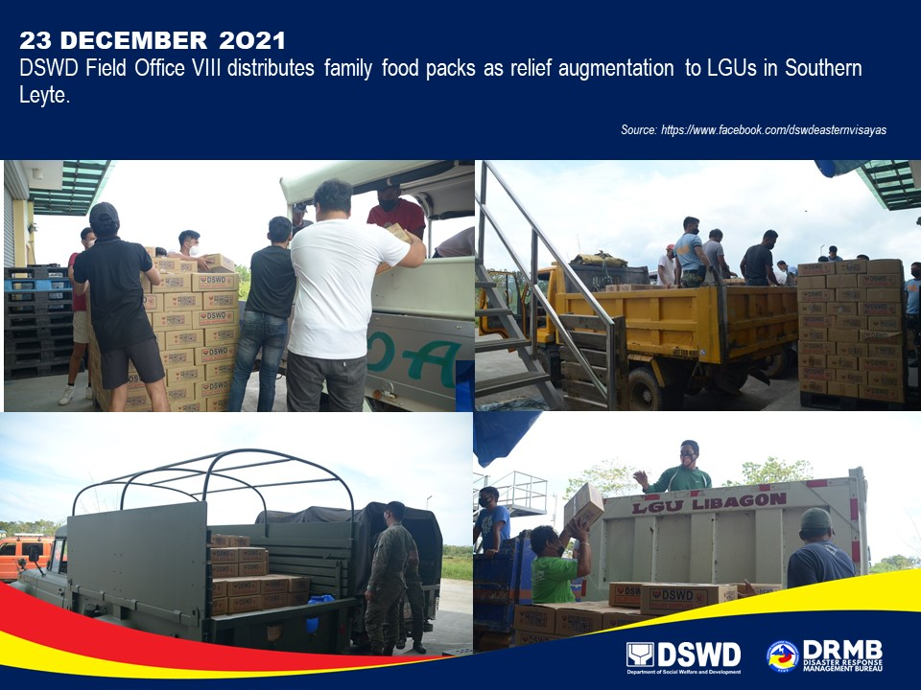

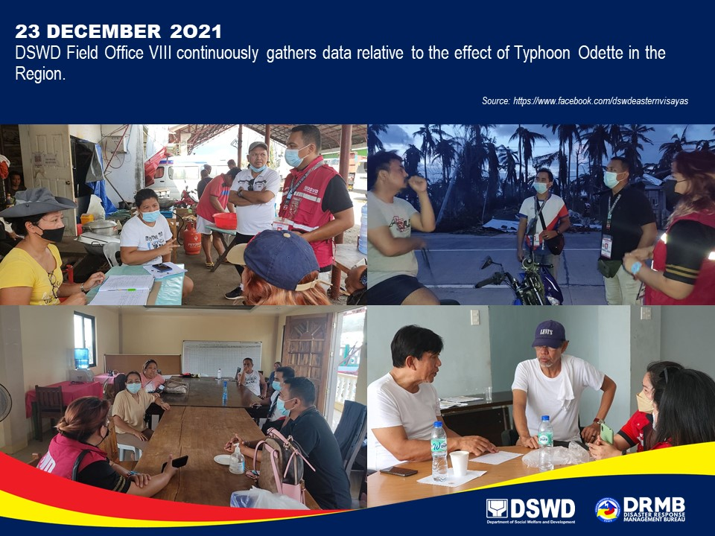

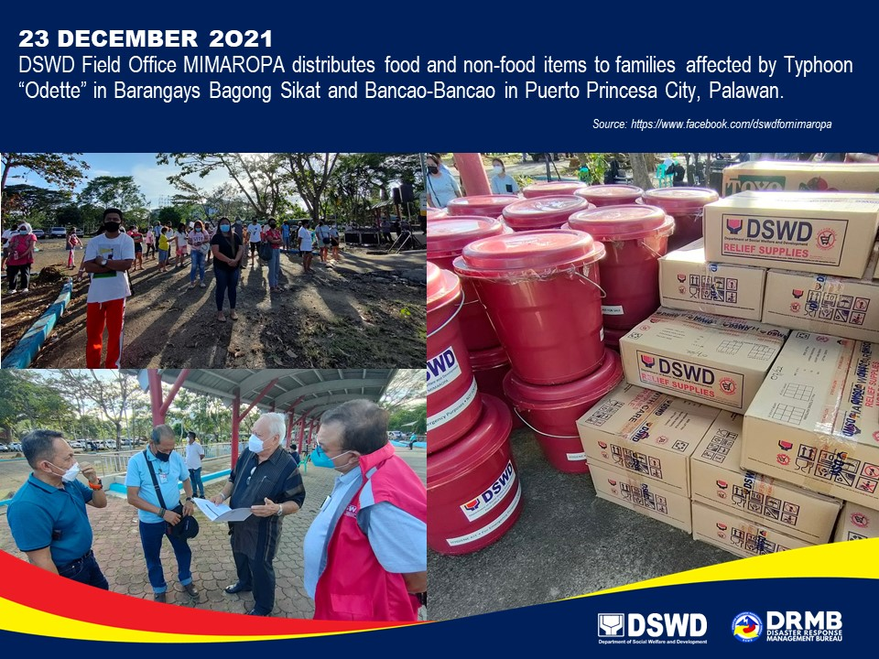

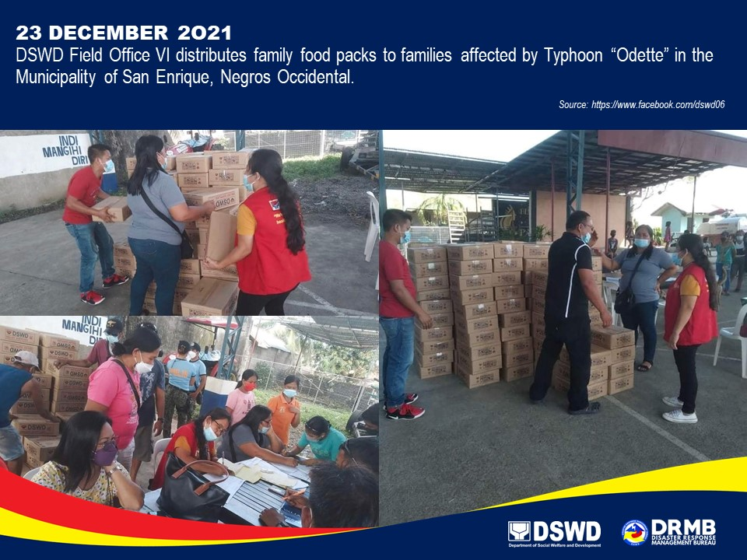

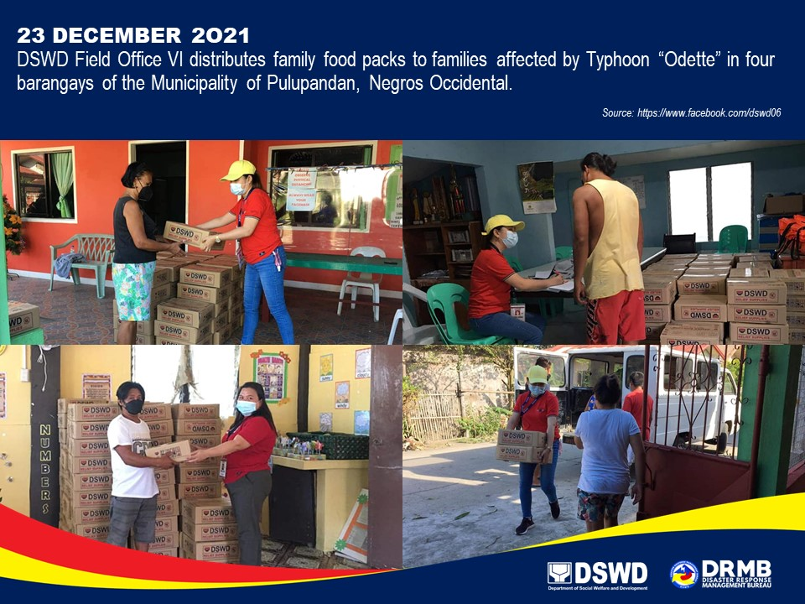

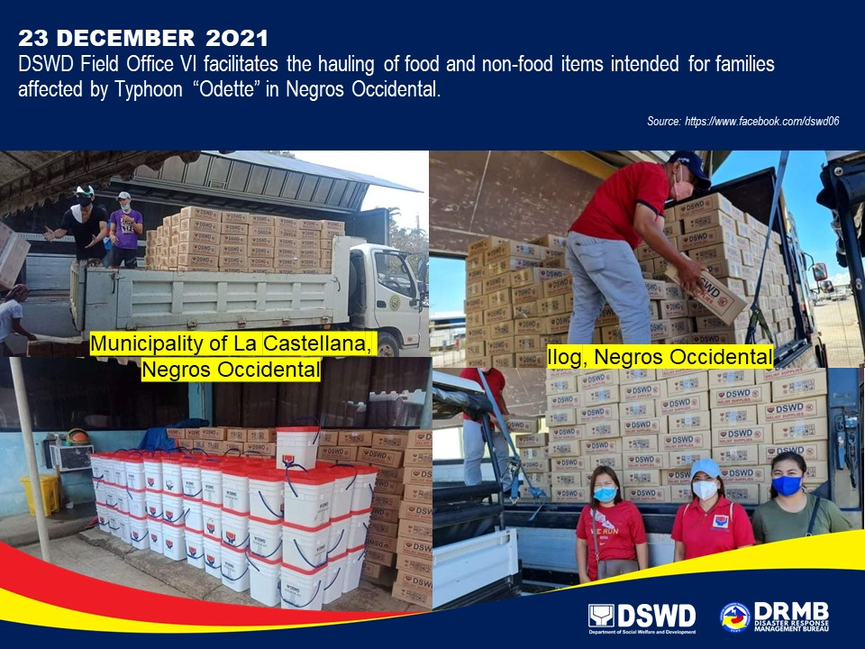

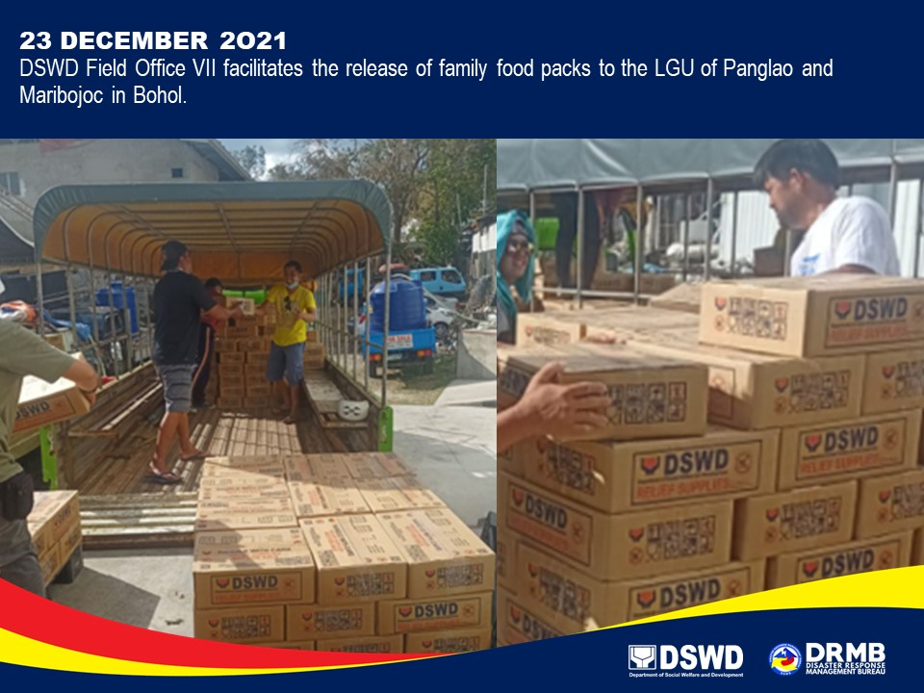

*****
The Disaster Response Operations Monitoring and Information Center (DROMIC) of DSWD-DRMB is closely coordinating with the concerned DSWD-FOs for significant disaster response updates and assistance provided.

Prepared by:  AARON JOHN B. PASCUA  JOANNA CAMILLE R. JACINTO  JEM ERIC F. FAMORCAN | Released by:  RODEL V. CABADDU

