DSWD DROMIC Report #2 on the Fire incident
in Brgy. 775, Manila City
as of 09 December 2021, 6PM

- Situation Overview

On 07 December 2021 at 4:56 PM, a fire incident occurred at Onyx corner Zobel Roxas, Brgy. 775, Zone 84, San Andres Bukid, Manila City. The incident was declared fire out at 6:43 PM.
Source: DSWD-Field Office (FO) NCR

- Status of Affected Areas and Population

A total of 196 families or 731 persons were affected in Brgy. 775, Manila City (see Table 1).

Table 1. Number of Affected Families / Persons
REGION / PROVINCE / MUNICIPALITY | NUMBER OF AFFECTED
 | Barangays | Families | Persons
GRAND TOTAL | 1 | 196 | 731
NCR | 1 | 196 | 731
Metro Manila | 1 | 196 | 731
Manila City | 1 | 196 | 731
Note: Ongoing assessment and validation being conducted.
Source: DSWD-FO NCR

- Status of Displaced Population

- Inside Evacuation Centers
There are 196 families or 731 persons taking temporary shelter at the Amadome Covered Court (see Table 2).

Table 2. Number of Displaced Families / Persons Inside Evacuation Centers
REGION / PROVINCE / MUNICIPALITY | NUMBER OF EVACUATION CENTERS (ECs) |  | NUMBER OF DISPLACED
 |  |  | INSIDE ECs
 |  |  | Families |  | Persons
 | CUM | NOW | CUM | NOW | CUM | NOW
GRAND TOTAL | 1 | 1 | 196 | 196 | 731 | 731
NCR | 1 | 1 | 196 | 196 | 731 | 731
Metro Manila | 1 | 1 | 196 | 196 | 731 | 731
Manila City | 1 | 1 | 196 | 196 | 731 | 731
Source: DSWD-FO NCR

- Damaged Houses
A total of 65 houses were totally damaged by the fire (see Table 3).

Table 3. Number of Damaged Houses
REGION / PROVINCE / MUNICIPALITY | NO. OF DAMAGED HOUSES
 | Total | Totally | Partially
GRAND TOTAL | 65 | 65 | -
NCR | 65 | 65 | -
Metro Manila | 65 | 65 | -
Manila City | 65 | 65 | -
Note: Ongoing assessment and validation being conducted.
Source: DSWD-FO NCR

- Response Actions and Interventions

- Standby Funds and Prepositioned Relief Stockpile
OFFICE | STANDBY FUNDS | STOCKPILE |  |  | TOTAL STANDBY FUNDS & STOCKPILE
 |  | FAMILY FOOD PACKS |  | OTHER FOOD AND NON-FOOD ITEMS (FNIs)
 |  | QUANTITY | TOTAL COST
TOTAL | 22,678,617.37 | 67,036 | 48,595,842.12 | 138,389,868.05 | 209,664,327.54
DSWD-CO | 19,678,617.37 | - | - | - | 19,678,617.37
NRLMB-NROC | - | 62,229 | 45,933,650.00 | 81,304,753.84 | 127,238,403.84
NRLMB-VDRC | - | 4,598 | 2,536,840.00 | 52,228,626.95 | 54,765,466.95
DSWD-FO NCR | 3,000,000.00 | 209 | 125,352.12 | 4,856,487.26 | 7,981,839.38
Note: The Inventory Summary is as of 09 December 2021, 4PM.
Source: DSWD-DRMB and DSWD-NRLMB

  - Standby Funds
    - ₱19.69 million Quick Response Fund (QRF) at the DSWD-Central Office.
    - ₱3 million available at DSWD-FO NCR.

  - Prepositioned FFPs and Other Relief Items
    - 66,827 FFPs available in Disaster Response Centers; of which, 62,229 FFPs are at the National Resource Operations Center (NROC), Pasay City and 4,598 FFPs are at the Visayas Disaster Response Center (VDRC), Cebu City.
    - 209 FFPs available at DSWD-FO NCR.
    - ₱138.39 million worth of other FNIs at NROC, VDRC and DSWD-FO NCR warehouses.

- Food and Non-Food Items (FNFIs)
    - DSWD-FO NCR is continuously coordinating with the Local Government Unit of Manila City through its Department of Social Welfare relative to the needed augmentation assistance for the affected families. Family food packs, sleeping kits, and family kits are being prepared by DSWD-FO NCR for augmentation support to the LGU of Manila.

- Other Activities
    - DSWD-FO NCR through the Disaster Response Management Division (DRMD) conducted monitoring and spot visit in the area of the incident on December 8, 2021. Also, coordinated with the Manila Department of Social Welfare as to the required augmentation assistance needed.

- Photo Documentation

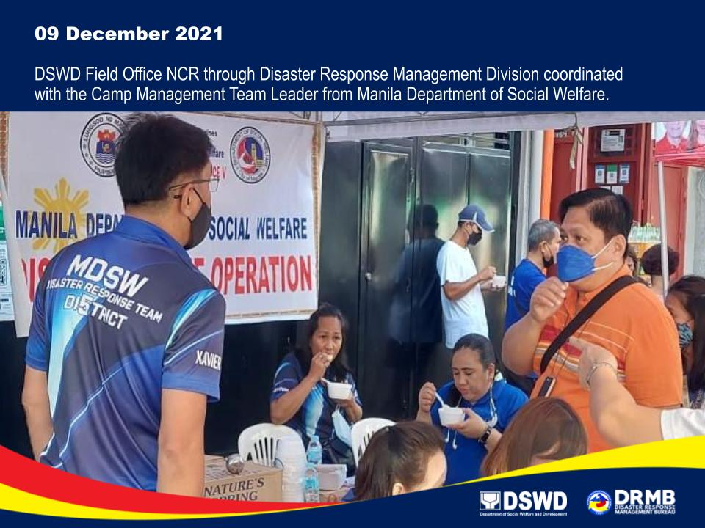

*****
The Disaster Response Operations Monitoring and Information Center (DROMIC) of DSWD-DRMB is closely coordinating with DSWD-FO NCR for significant disaster response updates and assistance provided.

Prepared by:  MARIE JOYCE G. RAFANAN | Released by:  LESLIE R. JAWILI

