DSWD DROMIC Report #2 on the Fire incident
in Brgy. 87 and 89, Pasay City
as of 11 December 2021, 6PM

- Situation Overview

On 07 December 2021 at 6:15 PM, a fire incident occurred in Brgy. 87 and 89, Pasay City. The fire was put under control at 8:31 PM.
Source: DSWD-Field Office (FO) NCR

- Status of Affected Areas and Population

A total of 88 families or 252 persons were affected in Brgy. 87 and 89, Pasay City (see Table 1).

Table 1. Number of Affected Families / Persons
REGION / PROVINCE / MUNICIPALITY | NUMBER OF AFFECTED
 | Barangays | Families | Persons
GRAND TOTAL | 1 | 88 | 252
NCR | 1 | 88 | 252
Metro Manila | 1 | 88 | 252
Pasay City | 1 | 88 | 252
Note: All of the affected families were from Brgy. 87 based on the validated report submitted by DSWD-FO NCR. Hence, the decrease in the number of barangays and affected persons. *Ongoing assessment and validation being conducted.
Source: DSWD-FO NCR

- Status of Displaced Population

- Inside Evacuation Center
There are 88 families or 252 persons currently taking temporary shelter at the P. Villanueva Elementary School (see Table 2).

Table 2. Number of Displaced Families / Persons Inside Evacuation Center
REGION / PROVINCE / MUNICIPALITY | NUMBER OF EVACUATION CENTERS (ECs) |  | NUMBER OF DISPLACED
 |  |  | INSIDE ECs
 |  |  | Families |  | Persons
 | CUM | NOW | CUM | NOW | CUM | NOW
GRAND TOTAL | 1 | 1 | 88 | 88 | 252 | 252
NCR | 1 | 1 | 88 | 88 | 252 | 252
Metro Manila | 1 | 1 | 88 | 88 | 252 | 252
Pasay City | 1 | 1 | 88 | 88 | 252 | 252
Note: The decrease in the number of affected persons is based on the validated report submitted by DSWD-FO NCR. Hence, ongoing assessment and validation being conducted.
Source: DSWD-FO NCR

- Damaged Houses
A total of 29 houses were totally damaged by the fire (see Table 3).

Table 3. Number of Damaged Houses
REGION / PROVINCE / MUNICIPALITY | NO. OF DAMAGED HOUSES
 | Total | Totally | Partially
GRAND TOTAL | 29 | 29 | -
NCR | 29 | 29 | -
Metro Manila | 29 | 29 | -
Pasay City | 29 | 29 | -
Note: Ongoing assessment and validation being conducted.
Source: DSWD-FO NCR

- Response Actions and Interventions

- Standby Funds and Prepositioned Relief Stockpile
OFFICE | STANDBY FUNDS | STOCKPILE |  |  | TOTAL STANDBY FUNDS & STOCKPILE
 |  | FAMILY FOOD PACKS |  | OTHER FOOD AND NON-FOOD ITEMS (FNIs)
 |  | QUANTITY | TOTAL COST
TOTAL | 22,678,617.37 | 79,214 | 55,882,327.12 | 133,935,447.65 | 212,496,392.14
DSWD-CO | 19,678,617.37 | - | - | - | 19,678,617.37
NRLMB-NROC | - | 73,507 | 52,698,135.00 | 77,332,317.04 | 130,030,452.04
NRLMB-VDRC | - | 5,498 | 3,058,840.00 | 51,746,643.35 | 54,805,483.35
DSWD-FO NCR | 3,000,000.00 | 209 | 125,352.12 | 4,856,487.26 | 7,981,839.38
Note: The Inventory Summary is as of 11 December 2021, 4PM.
Source: DSWD-DRMB and DSWD-NRLMB

  - Standby Funds
    - ₱19.69 million Quick Response Fund (QRF) at the DSWD-Central Office.
    - ₱3 million available at DSWD-FO NCR.

  - Prepositioned FFPs and Other Relief Items
    - 79,005 FFPs available in Disaster Response Centers; of which, 73,507 FFPs are at the National Resource Operations Center (NROC), Pasay City and 5,498 FFPs are at the Visayas Disaster Response Center (VDRC), Cebu City.
    - 209 FFPs available at DSWD-FO NCR.

- Camp Coordination and Camp Management (CCCM)
    - The Pasay City Social Welfare and Development Office (PSWDO) activated and established camp coordination and camp management response cluster.
    - The PSWDO conducted an Intake Interview and master listing for the affected families. Also, conducted assessment and validation of the affected families using the Disaster Assistance Family Access Card (DAFAC) / White Card.
    - DSWD-FO NCR provided relief items to the affected families.

- Other Activities
- DSWD-FO NCR through the Disaster Response Management Division (DRMD) conducted monitoring and spot visit in the area of incident on December 8, 2021. Also, coordinated with the Pasay City Social Welfare and Development Office (CSWDO) as to the assistance required to support the disaster operation of Pasay CSWDO.

- Photo Documentation
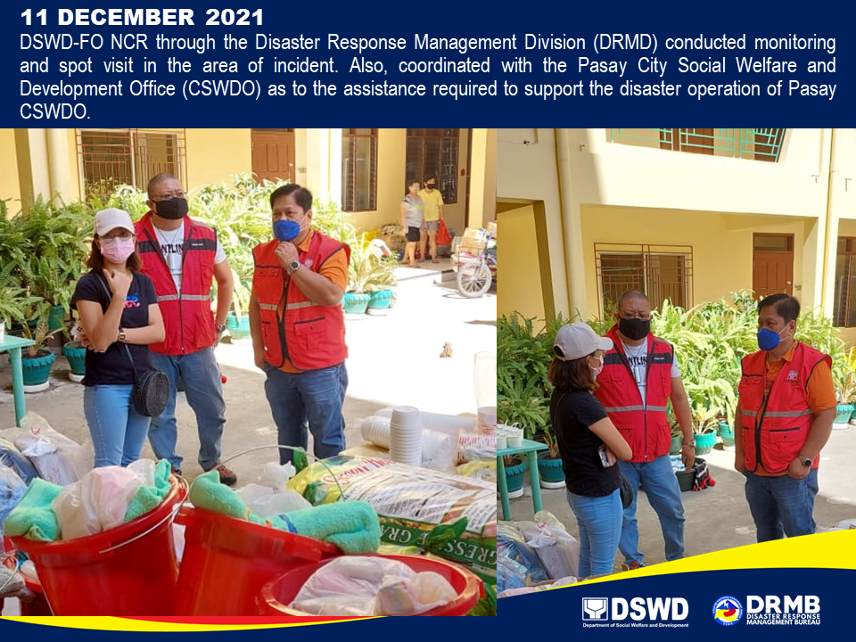

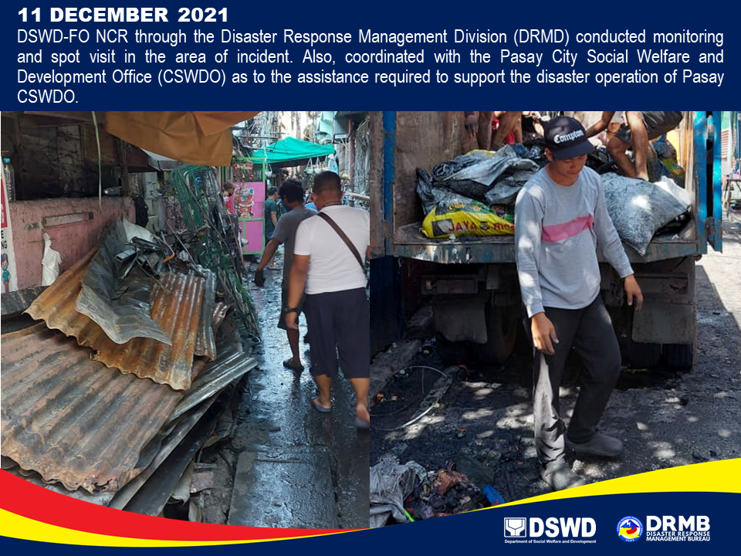

*****
The Disaster Response Operations Monitoring and Information Center (DROMIC) of DSWD-DRMB is closely coordinating with DSWD-FO NCR for significant disaster response updates and assistance provided.

Prepared by:  MARIE JOYCE G. RAFANAN | Released by:  LESLIE R. JAWILI

