DSWD DROMIC Report #4 on Typhoon “ODETTE”
as of 16 December 2021, 6PM

- Situation Overview
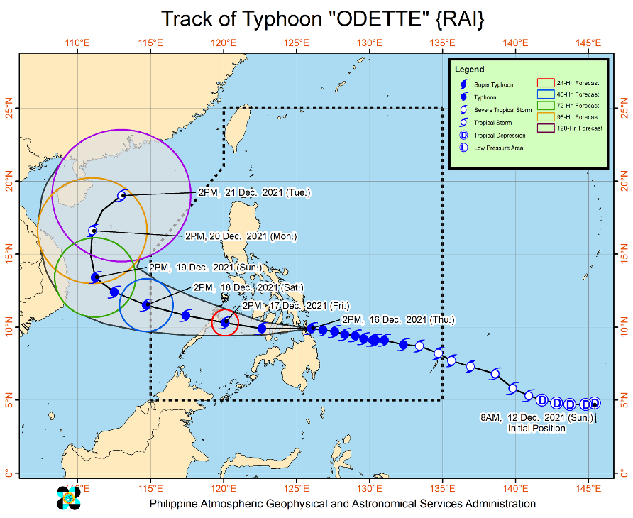
Issued at 5:00 PM, 16 December 2021, TYPHOON “ODETTE” MAINTAINS ITS STRENGTH AND IS NOW OVER LILOAN, SOUTHERN LEYTE.
Location of Center (4:50 PM)
- The center of the eye of Typhoon “ODETTE” was located based on all available data including those from Guiuan and Mactan Doppler Weather Radar in the vicinity of Liloan, Southern Leyte (10.1°N, 125.2°E)
Intensity:
- Maximum sustained winds of 195 km/h near the center, gustiness of up to 270 km/h, and central pressure of 915 hPa

Heavy Rainfall:
- Today through tomorrow early morning: Heavy to torrential rains over Caraga, Central Visayas, Misamis Oriental, Camiguin, Southern Leyte, and Negros Occidental. Moderate to heavy with at times intense rains over Leyte, the southern portions of Eastern Samar and Samar, Zamboanga del Norte, Lanao del Sur, Davao Oriental, Davao de Oro, Davao del Norte, and the rest of Northern Mindanao. Light to moderate with at times heavy rains over Bicol Region, Quezon, and the rest of Visayas, the rest of Zamboanga Peninsula, and mainland Bangsamoro.
- Tomorrow early morning through Saturday early morning: Heavy to intense with at times torrential rains over Central Visayas, Western Visayas, and Palawan including Calamian Islands, Cuyo, and Cagayancillo Islands. Moderate to heavy with at times intense rains over Bicol Region, Zamboanga Peninsula, Quezon, Occidental Mindoro, Oriental Mindoro, Romblon, Marinduque, Lanao del Norte, Lanao del Sur, and the rest of Visayas. Light to moderate with at times heavy rains over Caraga, the southern portion of Aurora, and the rest of Northern Mindanao.
- Saturday early morning through Sunday early morning: Heavy to torrential rains over Kalayaan Islands. Light to moderate with at times heavy rains over Cagayan Valley, Aurora, Quezon, mainland Palawan and Calamian Islands.
- Under these conditions, scattered to widespread flooding (including flash floods) and rain-induced landslides are expected especially in areas that are highly or very highly susceptible to these hazard as identified in hazard maps, and in localities with significant antecedent rainfall.

Severe Winds:
- Winds may reach typhoon strength up to 195 km/h in strength within any of the areas where TCWS #4 is hoisted during the passage of the typhoon. This may cause generally heavy to very heavy damage to structures and vegetation.
- Destructive typhoon-force winds will be experienced within any of the areas where TCWS #3 is in effect. This may bring moderate to heavy damage to structures and vegetation.
- Damaging winds reaching gale- to storm-force strength will be experienced within any of the areas where TCWS #2 is in effect. This may result in generally light to moderate damage to structures and vegetation.
- Strong winds (strong breeze to near gale) with higher gusts will be experienced within any of the areas where TCWS #1 is currently in effect during the passage of the typhoon. This may generally bring up to very light damage to structures and vegetation.

Track and Intensity Outlook
- Recent Landfall: Siargao Island, Surigao del Norte (1:30 PM); Cagdianao, Dinagat Islands (3:10 PM); Liloan, Southern Leyte (4:50 PM)
- On the forecast track, “ODETTE” will continue moving westward and may make another landfall over the southern portion of Southern Leyte this afternoon. Afterwards, the center of the tropical cyclone will cross several provinces in Central and Western Visayas regions before emerging over the Sulu Sea tomorrow morning. After passing near or in the vicinity of either Cuyo or Cagayancillo archipelago, “ODETTE” is forecast to cross the northern or central portion of Palawan tomorrow afternoon or evening before emerging over the West Philippine Sea.
- “ODETTE” may see some slight weakening as it crosses Visayas and Palawan, but it is forecast to remain as a typhoon. Re-intensification is likely once “ODETTE” emerges over the West Philippine Sea. However, weakening may ensue beginning Saturday evening or Sunday as the typhoon becomes exposed to increasing vertical wind shear and the surge of the Northeast Monsoon.
Source: DOST-PAGASA Severe Weather Bulletin

- Status of Affected Areas and Population
A total of 10,111 families or 36,303 persons were affected by Typhoon “ODETTE” in 134 Barangays in Region Caraga (see Table 1).

Table 1. Number of Affected Families / Persons
REGION / PROVINCE / MUNICIPALITY |  | NUMBER OF AFFECTED
 |  | Barangays | Families | Persons
GRAND TOTAL |  | 134 | 10,111 | 36,303
CARAGA |  | 134 | 10,111 | 36,303
Agusan del Norte |  | 7 | 95 | 302
 | Butuan City (capital) | 3 | 37 | 126
 | Jabonga | 2 | 37 | 115
 | Nasipit | 2 | 21 | 61
Dinagat Island |  | 9 | 368 | 1,231
 | San Jose (capital) | 9 | 368 | 1,231
Surigao del Norte |  | 80 | 7,243 | 25,886
 | Bacuag | 5 | 586 | 2,044
 | Burgos | 6 | 600 | 2,785
 | Claver | 9 | 711 | 2,506
 | Gigaquit | 3 | 223 | 653
 | Placer | 18 | 1,782 | 6,410
 | San Benito | 1 | 14 | 49
 | San Isidro | 10 | 867 | 2,881
 | Santa Monica (Sapao) | 5 | 188 | 659
 | Sison | 3 | 293 | 1,036
 | Socorro | 4 | 605 | 2,328
 | Tagana-an | 11 | 1,114 | 3,570
 | Tubod | 5 | 260 | 965
Surigao del Sur |  | 38 | 2,405 | 8,884
 | Barobo | 2 | 354 | 1,259
 | Carmen | 6 | 96 | 384
 | Carrascal | 8 | 811 | 2,648
 | Cortes | 5 | 572 | 2,245
 | Lanuza | 8 | 293 | 1,135
 | Lingig | 3 | 154 | 775
 | Marihatag | 5 | 62 | 210
 | Tagbina | 1 | 63 | 228
Note: Ongoing assessment and validation are continuously being conducted.
Source: DSWD-Field Office (FO) Caraga

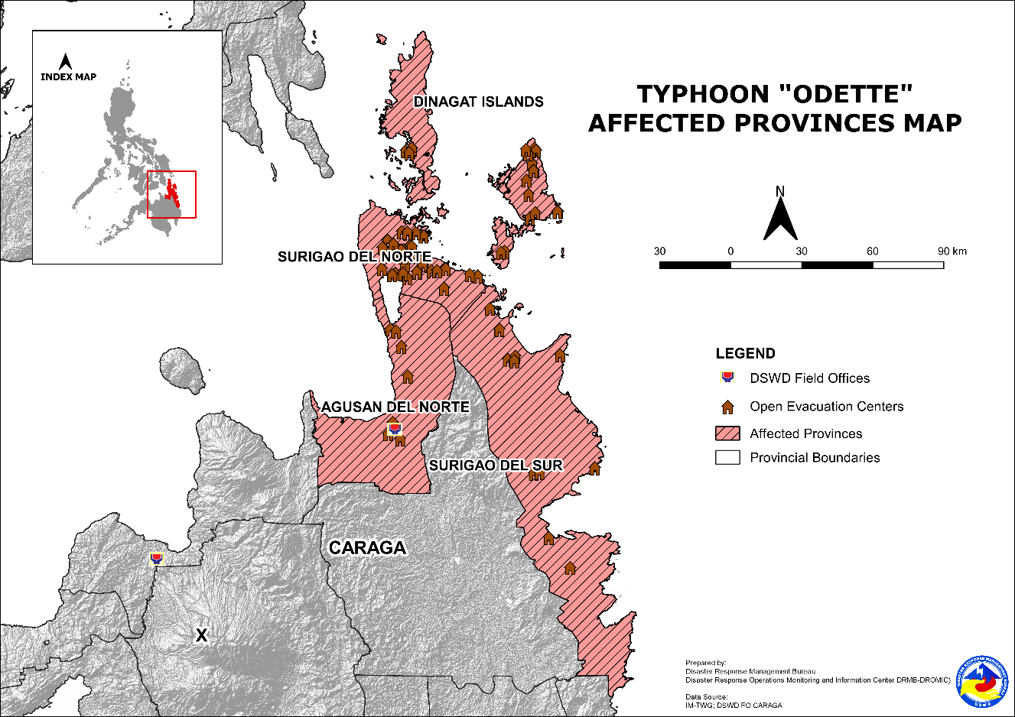
- Status of Displaced Population
- Inside Evacuation Centers
There are 9,343 families or 33,477 persons sought temporary shelter in 254 evacuation centers in Region Caraga (see Table 2).

Table 2. Number of Displaced Families / Persons Inside Evacuation Centers
REGION / PROVINCE / MUNICIPALITY |  | NUMBER OF EVACUATION CENTERS (ECs) |  | NUMBER OF DISPLACED
 |  |  |  | INSIDE ECs
 |  |  |  | Families |  | Persons
 |  | CUM | NOW | CUM | NOW | CUM | NOW
GRAND TOTAL |  | 254 | 254 | 9,343 | 9,343 | 33,477 | 33,477
CARAGA |  | 254 | 254 | 9,343 | 9,343 | 33,477 | 33,477
Agusan del Norte |  | 7 | 7 | 95 | 95 | 302 | 302
 | Butuan City (capital) | 3 | 3 | 37 | 37 | 126 | 126
 | Jabonga | 2 | 2 | 37 | 37 | 115 | 115
 | Nasipit | 2 | 2 | 21 | 21 | 61 | 61
Dinagat Island |  | 14 | 14 | 368 | 368 | 1,231 | 1,231
 | San Jose (capital) | 14 | 14 | 368 | 368 | 1,231 | 1,231
Surigao del Norte |  | 189 | 189 | 6,475 | 6,475 | 23,060 | 23,060
 | Bacuag | 17 | 17 | 520 | 520 | 1,810 | 1,810
 | Burgos | 15 | 15 | 443 | 443 | 2,097 | 2,097
 | Claver | 19 | 19 | 654 | 654 | 2,304 | 2,304
 | Gigaquit | 7 | 7 | 223 | 223 | 653 | 653
 | Placer | 48 | 48 | 1,518 | 1,518 | 5,440 | 5,440
 | San Benito | 1 | 1 | 14 | 14 | 49 | 49
 | San Isidro | 34 | 34 | 782 | 782 | 2,576 | 2,576
 | Santa Monica (Sapao) | 5 | 5 | 188 | 188 | 659 | 659
 | Sison | 3 | 3 | 293 | 293 | 1,036 | 1,036
 | Socorro | 11 | 11 | 466 | 466 | 1,901 | 1,901
 | Tagana-an | 14 | 14 | 1,114 | 1,114 | 3,570 | 3,570
 | Tubod | 15 | 15 | 260 | 260 | 965 | 965
Surigao del Sur |  | 44 | 44 | 2,405 | 2,405 | 8,884 | 8,884
 | Barobo | 2 | 2 | 354 | 354 | 1,259 | 1,259
 | Carmen | 7 | 7 | 96 | 96 | 384 | 384
 | Carrascal | 12 | 12 | 811 | 811 | 2,648 | 2,648
 | Cortes | 6 | 6 | 572 | 572 | 2,245 | 2,245
 | Lanuza | 5 | 5 | 293 | 293 | 1,135 | 1,135
 | Lingig | 3 | 3 | 154 | 154 | 775 | 775
 | Marihatag | 5 | 5 | 62 | 62 | 210 | 210
 | Tagbina | 4 | 4 | 63 | 63 | 228 | 228
Note: Ongoing assessment and validation are continuously being conducted.
Source: DSWD-FO Caraga

- Outside Evacuation Centers
There are 744 families or 2,780 persons temporarily staying with their relatives and/or friends in Region Caraga (see Table 3).

Table 3. Number of Displaced Families / Persons Outside Evacuation Centers
REGION / PROVINCE / MUNICIPALITY |  | NUMBER OF DISPLACED
 |  | OUTSIDE ECs
 |  | Families |  | Persons
 |  | CUM | NOW | CUM | NOW
GRAND TOTAL |  | 744 | 744 | 2,780 | 2,780
CARAGA |  | 744 | 744 | 2,780 | 2,780
Surigao del Norte |  | 744 | 744 | 2,780 | 2,780
 | Bacuag | 66 | 66 | 234 | 234
 | Burgos | 157 | 157 | 688 | 688
 | Claver | 57 | 57 | 202 | 202
 | Placer | 264 | 264 | 970 | 970
 | San Isidro | 85 | 85 | 305 | 305
 | Socorro | 115 | 115 | 381 | 381
Note: Ongoing assessment and validation are continuously being conducted.
Source: DSWD-FO Caraga

- Total Displaced Population
There are 10,087 families or 36,257 persons displaced in Region Caraga due to Typhoon “Odette” (see Table 4).

Table 4. Total Number of Displaced Families / Persons
REGION / PROVINCE / MUNICIPALITY |  | TOTAL DISPLACED SERVED
 |  | Families |  | Persons
 |  | Total Families |  | Total Persons
 |  | CUM | NOW | CUM | NOW
GRAND TOTAL |  | 10,087 | 10,087 | 36,257 | 36,257
CARAGA |  | 10,087 | 10,087 | 36,257 | 36,257
Agusan del Norte |  | 95 | 95 | 302 | 302
 | Butuan City (capital) | 37 | 37 | 126 | 126
 | Jabonga | 37 | 37 | 115 | 115
 | Nasipit | 21 | 21 | 61 | 61
Dinagat Island |  | 368 | 368 | 1,231 | 1,231
 | San Jose (capital) | 368 | 368 | 1,231 | 1,231
Surigao del Norte |  | 7,219 | 7,219 | 25,840 | 25,840
 | Bacuag | 586 | 586 | 2,044 | 2,044
 | Burgos | 600 | 600 | 2,785 | 2,785
 | Claver | 711 | 711 | 2,506 | 2,506
 | Gigaquit | 223 | 223 | 653 | 653
 | Placer | 1,782 | 1,782 | 6,410 | 6,410
 | San Benito | 14 | 14 | 49 | 49
 | San Isidro | 867 | 867 | 2,881 | 2,881
 | Santa Monica (Sapao) | 188 | 188 | 659 | 659
 | Sison | 293 | 293 | 1,036 | 1,036
 | Socorro | 581 | 581 | 2,282 | 2,282
 | Tagana-an | 1,114 | 1,114 | 3,570 | 3,570
 | Tubod | 260 | 260 | 965 | 965
Surigao del Sur |  | 2,405 | 2,405 | 8,884 | 8,884
 | Barobo | 354 | 354 | 1,259 | 1,259
 | Carmen | 96 | 96 | 384 | 384
 | Carrascal | 811 | 811 | 2,648 | 2,648
 | Cortes | 572 | 572 | 2,245 | 2,245
 | Lanuza | 293 | 293 | 1,135 | 1,135
 | Lingig | 154 | 154 | 775 | 775
 | Marihatag | 62 | 62 | 210 | 210
 | Tagbina | 63 | 63 | 228 | 228
Note: Ongoing assessment and validation are continuously being conducted.
Source: DSWD-FO Caraga
- Response Actions and Interventions

- Standby Funds and Prepositioned Relief Stockpile
OFFICE | STANDBY FUNDS | STOCKPILE |  |  | TOTAL STANDBY FUNDS & STOCKPILE
 |  | FAMILY FOOD PACKS |  | OTHER FOOD AND NON-FOOD ITEMS (FNIs)
 |  | QUANTITY | TOTAL COST
TOTAL | 78,533,982.90 | 392,563 | 241,563,592.48 | 633,624,484.42 | 953,722,059.80
DSWD-CO | 10,127,239.51 | - | - | - | 10,127,239.51
NRLMB-NROC | - | 89,407 | 64,075,935.00 | 82,262,919.68 | 146,338,854.68
NRLMB-VDRC | - | 7,298 | 4,122,840.00 | 51,078,249.75 | 55,201,089.75
DSWD-FO CARAGA | 5,000,813.43 | 19,572 | 8,794,803.28 | 10,838,526.61 | 24,634,143.32
Other FOs | 63,405,929.96 | 276,286 | 164,570,014.20 | 489,444,788.38 | 717,420,732.54
Note: The Inventory Summary is as of 16 December 2021, 4PM.
Source: DSWD-National Resource and Logistics Management Bureau (NRLMB)

  - Standby Funds
    - ₱10.13 million Quick Response Fund (QRF) at the DSWD-Central Office.
    - ₱5 million available at DSWD-FO CARAGA.
    - ₱63.41 million in other DSWD-FOs which may support the relief needs of the displaced families due to Typhoon “Odette” through inter-FO augmentation.

  - Prepositioned FFPs and Other Relief Items
    - 96,705 FFPs available in Disaster Response Centers; of which, 89,407 FFPs are at the National Resource Operations Center (NROC), Pasay City and 7,298 FFPs are at the Visayas Disaster Response Center (VDRC), Cebu City.
    - 19,572 FFPs available at DSWD-FO CARAGA.
    - 276,286 FFPs in other DSWD-FOs which may support the relief needs of the displaced families due to Typhoon “Odette” through inter-FO augmentation.
    - ₱633.62 million worth of food and non-food items (FNIs) at NROC, VDRC and DSWD-FO warehouses countrywide.

- Food and Non-Food Items

DSWD-FO II
DATE | ACTIVITIES
16 December 2021 | - DSWD-FO II unloaded an additional 5,000 FFPs to Tuguegarao City satellite warehouse amounting to PhP3,110,000.00 out of the 20,000 FPPs requested to DRMB.
15 December 2021 | - DSWD-FO II unloaded 5,000 FFPs to the two (2) satellite warehouses at SWAD Isabela (1,700 FPPs) and Tuguegarao City (3,300 FFPs) with an aggregate amount of PhP3,516,875.00 as initial delivery out of the 20,000 FFPs requested to DRMB.

DSWD-FO V
DATE | ACTIVITIES
13 December 2021 | - DSWD-FO V ensures the availability of Family Food Packs (FFPs) and other Food and Non-food Items (FNIs).

DSWD-FO VI
DATE | ACTIVITIES
14 December 2021 | - DSWD-FO VI ensures the availability of FFPs and other FNIs.

DSWD-FO VII
DATE | ACTIVITIES
14 December 2021 | - DSWD-FO VII ensures the availability of FFPs and other FNIs.

DSWD-FO VIII
DATE | ACTIVITIES
16 December 2021 | - DSWD-FO VII facilitated the repacking of FPPs in FO-VIII Regional Resources Operations Center in the preparation for the possible augmentation support.
15 December 2021 | - DSWD-FO VIII ensures the availability of FFPs and other FNIs.  - DSWD-FO VIII prepositioned Family Food Packs (FFPs) in Samar Island and Biliran which can be distributed immediately by the P/C/MATs to Local Government Units that needs augmentation support.
DSWD-FO IX
DATE | ACTIVITIES
16 December 2021 | - DSWD-FO IX ensures the availability of FFPs and other FNIs.

DSWD-FO X
DATE | ACTIVITIES
14 December 2021 | - DSWD-FO X ensures the availability of FFPs and other FNIs.

DSWD-FO XI
DATE | ACTIVITIES
14 December 2021 | - DSWD-FO XI ensures the availability of FFPs and other FNIs.

DSWD-FO Caraga
DATE | ACTIVITIES
15 December 2021 | - DSWD-FO CARAGA ensures the availability of FFPs and other FNIs.

- Camp Coordination and Camp Management

- Other Activities

DSWD-DRMB
DATE | SITUATIONS / ACTIONS UNDERTAKEN
16 December 2021 | - The Disaster Response Management Bureau (DRMB) is closely coordinating with the concerned Field Offices (FOs) for significant disaster response updates.  - DSWD-DRMB Quick Response Team (QRT) members and emergency equipment are on standby and are ready for deployment.  - The Response Cluster is activated and is placed on standby status on 14 December 2021 to monitor and facilitate emergency and humanitarian assistance response to the effects of Typhoon “ODETTE”.  - DRMB participated in the Online Pre-Disaster Risk Assessment (PDRA) Meeting on STS “RAI” on 14 December 2021 with other response cluster member agencies. Further meetings shall be conducted on the implementation of COVID-19 protocols during the response efforts on STS “RAI”.  - DRMB is currently coordinating with IOM for the pull-out of 100 boxes/rolls of USAID donated tarpaulins at the NRLMB warehouse in Pasay City.

DSWD-FO CAR
DATE | ACTIVITIES

DSWD-FO II
DATE | SITUATIONS / ACTIONS UNDERTAKEN
15 December 2021 | - DSWD-FO II is continuously monitoring weather updates.  - DSWD-FO II QRT members are on standby alert and are ready for mobilization for any assistance and augmentation support needed from the LGUs.  - DSWD-FO II attended the PDRA Core Group Meeting relative to the preparedness response measures of every member council of Cagayan Valley Regional Disaster Risk Reduction Management Council (CVRDRRMC) wherein DSWD presented the preparedness plan on the possible effects of Typhoon Odette and the Northeast Monsoon

DSWD-FO V
DATE | SITUATIONS / ACTIONS UNDERTAKEN
13 December 2021 | - DSWD-FO V is continuously monitoring weather updates.  - DSWD-FO V QRT members are on standby alert and are ready for mobilization for any assistance and augmentation support needed from the LGUs.  - DSWD-FO V is closely coordinating with the P/MDRRMOs for status reports and updates.

DSWD-FO VI
DATE | SITUATIONS / ACTIONS UNDERTAKEN
14 December 2021 | - DSWD-FO VI is continuously monitoring weather updates.  - DSWD-FO VI QRT members are on standby alert and are ready for mobilization for any assistance and augmentation support needed from the LGUs.

DSWD-FO VII
DATE | SITUATIONS / ACTIONS UNDERTAKEN
16 December 2021 | - 41 LGUs have already implemented pre-emptive evacuation in Region VII.  - Around 3,500 families from 94 barangays have been evacuated to atleast 149 evacuation centers.
14 December 2021 | - DSWD-FO VII is continuously monitoring weather updates.  - DSWD-FO VII QRT members are on standby alert and are ready for mobilization for any assistance and augmentation support needed from the LGUs.  - DSWD-FO VII ensures the availability of FFPs and other FNIs.  - DSWD-FO VII is closely coordinating with their local counterparts and their respective LDRRMCs. Field staff were requested to monitor AOR and provide reports and updates to the Regional DROMIC Focal for any impacts/effects.

DSWD-FO VIII
DATE | SITUATIONS / ACTIONS UNDERTAKEN
16 December 2021 | - Out of the 10,087 families or 40,922 persons that took pre-emptive evacuation in Region VIII, 9,439 families or 38,816 persons are currently taking temporary shelter in 222 evacuation centers while 229 families or 681 persons are temporarily staying with their relatives and/or friends.
15 December 2021 | - DSWD-FO VIII is continuously monitoring weather updates.  - DSWD-FO VIII QRT members are on standby alert and are ready for mobilization for any assistance and augmentation support needed from the LGUs.

DSWD-FO IX
DATE | ACTIVITIES
16 December 2021 | - DSWD-FO IX thru DRMD is closely monitoring updates from PAGASA and coordinate with MSWDO and C/M/PDRRMO of Zamboanga del Sur and del Norte, Zamboanga Sibugay, and Zamboanga City for possible assistance in the areas.  - DSWD-FO IX activated the Regional QRT to be augmented during disaster response and relief operations.

DSWD-FO X
DATE | SITUATIONS / ACTIONS UNDERTAKEN
16 December 2021 | - A total of 64 families or 320 persons have taken pre-emptive evacuation in seven (7) evacuation centers in Cagayan de Oro, Misamis Oriental while 107 families or 414 persons also took pre-emptive evacuation in four (4) evacuation centers in Gingoog City, Misamis Oriental.
14 December 2021 | - DSWD-FO X is continuously monitoring weather updates.  - DSWD-FO X QRT members are on standby alert and are ready for mobilization for any assistance and augmentation support needed from the LGUs.

DSWD-FO XI
DATE | SITUATIONS / ACTIONS UNDERTAKEN
14 December 2021 | - DSWD-FO XI is continuously monitoring weather updates.  - DSWD-FO XI QRT members are on standby alert and are ready for mobilization for any assistance and augmentation support needed from the LGUs.

DSWD-FO CARAGA
DATE | SITUATIONS / ACTIONS UNDERTAKEN
16 December 2021 | - DSWD-FO activated the QRTs and reporting 24/7 shift.
15 December 2021 | - DSWD-FO CARAGA is continuously monitoring weather updates.  - DSWD-FO CARAGA QRT members are on standby alert and are ready for mobilization for any assistance and augmentation support needed from the LGUs.  - DSWD-FO CARAGA is continuously coordinating with SWADTLs and LSWDOs to monitor the situation in their respective areas.

- Photo Documentation
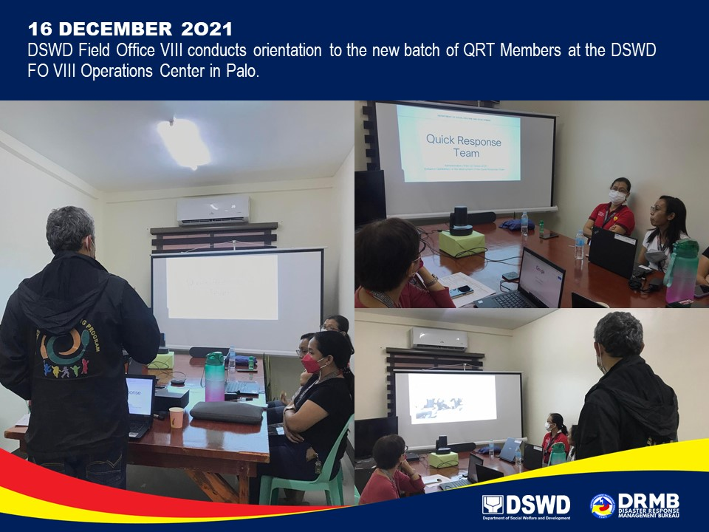

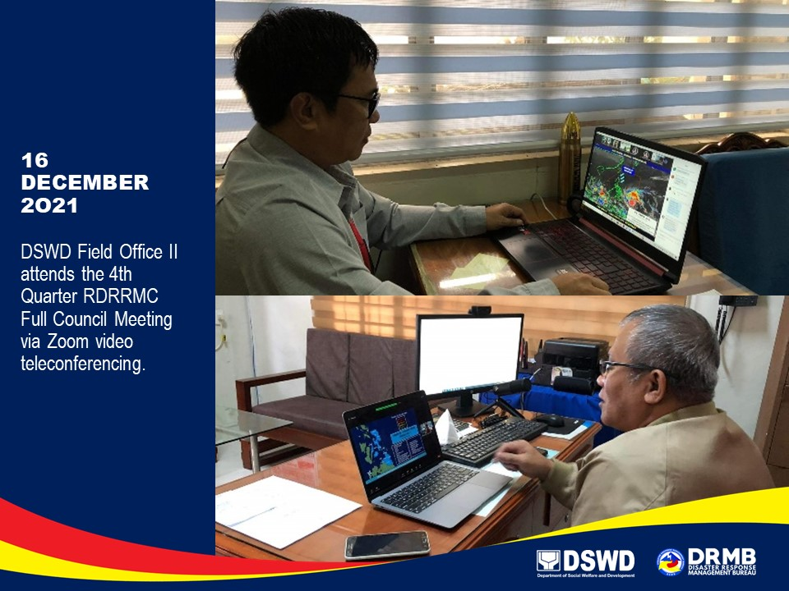

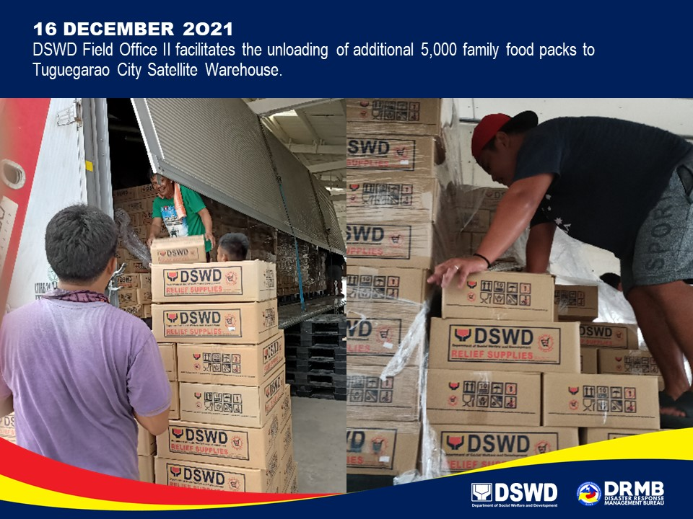

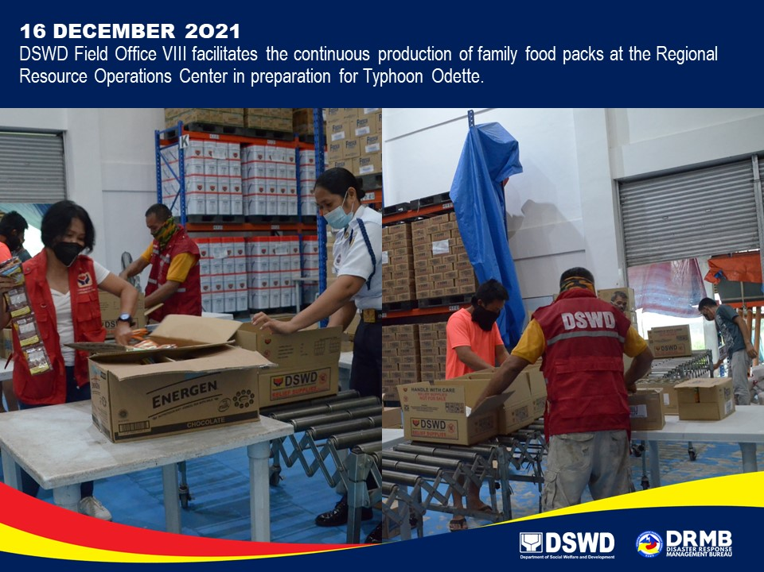

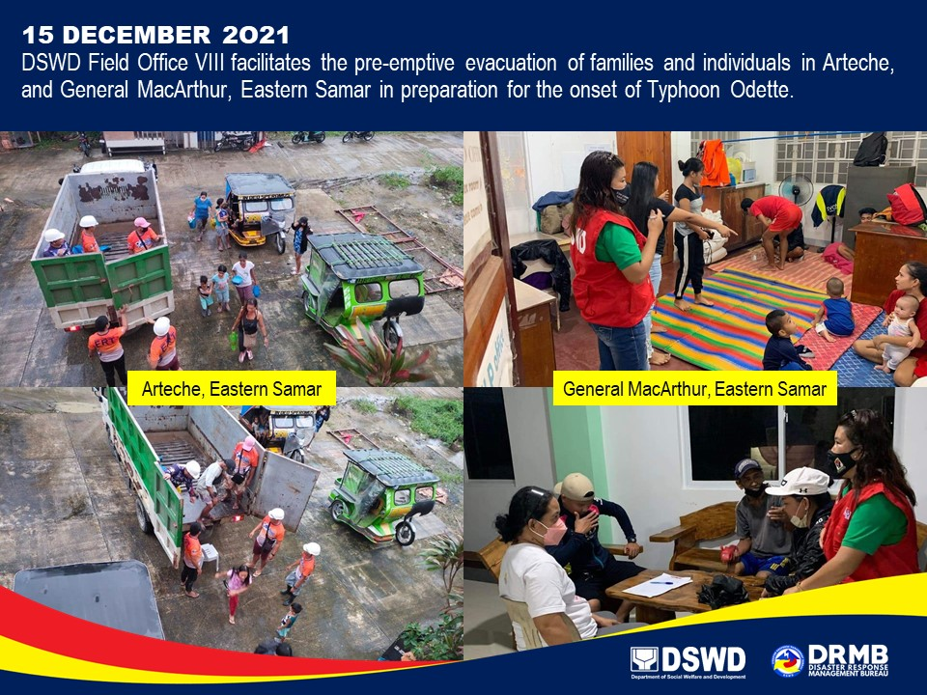

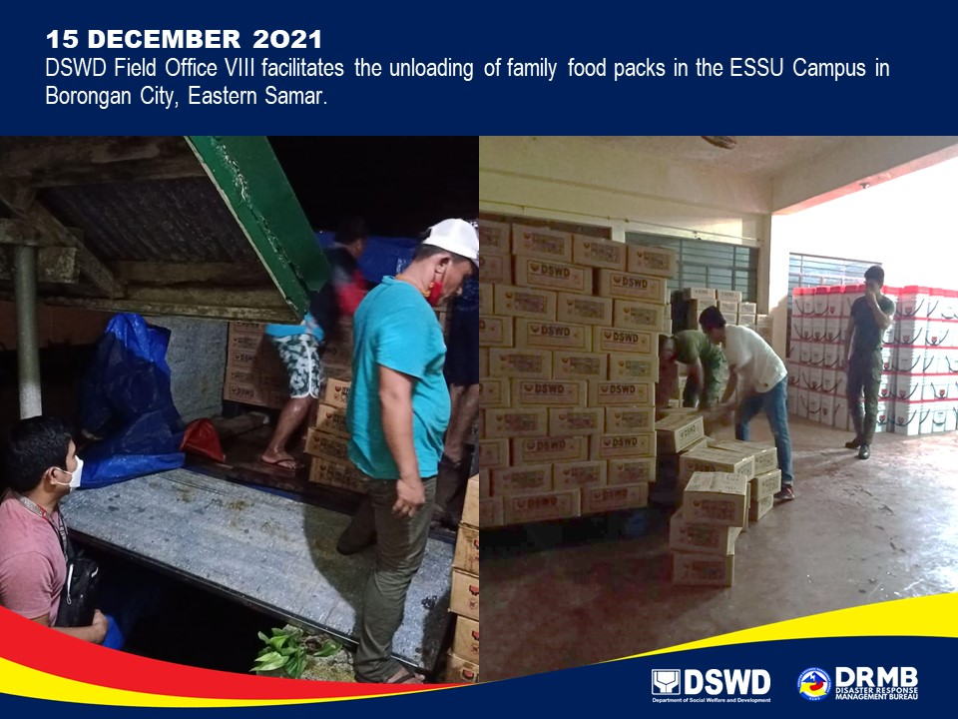

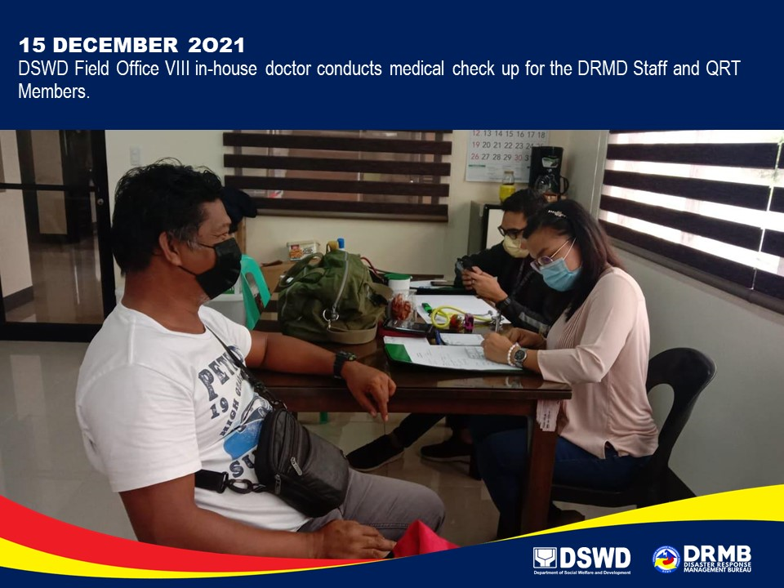

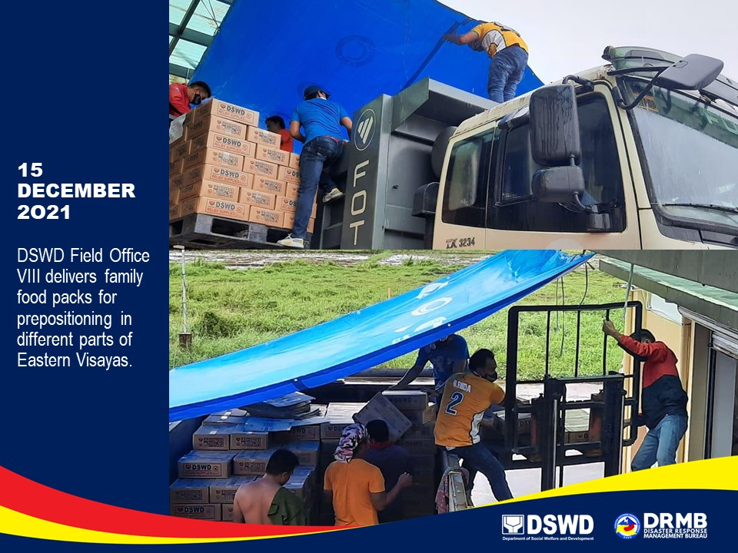

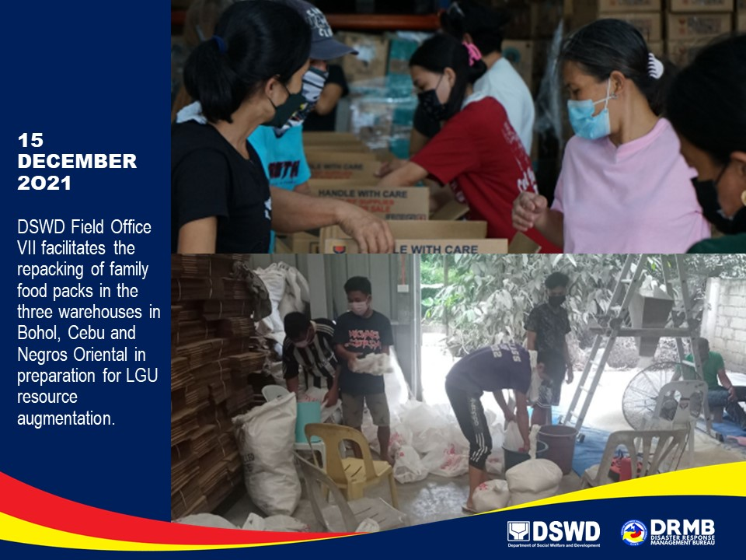

*****
The Disaster Response Operations Monitoring and Information Center (DROMIC) of DSWD-DRMB is closely coordinating with the concerned DSWD-FOs for significant disaster response updates and assistance provided.

Prepared by:  DIANE C. PELEGRINO  JEM ERIC F. FAMORCAN  MARIE JOYCE G. RAFANAN | Released by:  LESLIE R. JAWILI

