DSWD DROMIC Report #5 on Typhoon “ODETTE”
as of 17 December 2021, 6AM

- Situation Overview
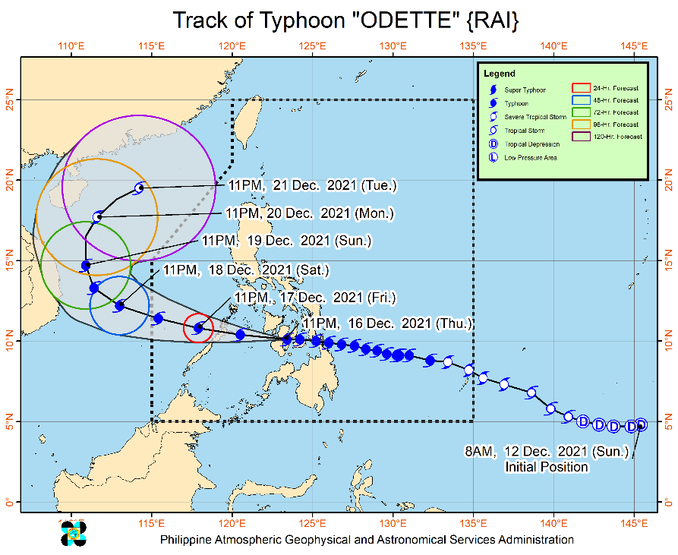
Issued at 5:00 AM, 17 December 2021, TYPHOON “ODETTE” IS NOW OVER THE PANAY GULF.
Location of Center (4:00 AM)
- The center of the eye of Typhoon “ODETTE” was located based on all available data 75 km Southwest of Iloilo City (10.2°N, 122.1°E)
Intensity:
- Maximum sustained winds of 155 km/h near the center, gustiness of up to 235 km/h, and central pressure of 950 hPa

Heavy Rainfall:
- Today: Heavy to torrential rains over Western Visayas, Palawan including Calamian, Cuyo, and Cagayancillo Islands, and Negros Oriental. Moderate to heavy with at times intense rains over the Bicol Region, Zamboanga Peninsula, Quezon, and the rest of MIMAROPA. Light to moderate with at times heavy rains over the Metro Manila, Cagayan Valley, Cordillera Administrative Region, Caraga, Northern Mindanao, Aurora, Lanao del Sur, and the rest of Visayas,
- Tomorrow: Heavy to intense with at times torrential rains over Kalayaan Islands. Moderate to heavy rains over Catanduanes, Camarines Provinces, Quezon, and Aurora. Light to moderate with at times heavy rains over Cagayan Valley, Cordillera Administrative Region, Metro Manila, Eastern Visayas, Rizal, Bulacan, mainland Palawan including Calamian Islands, and the rest of Bicol Region.
- Under these conditions, scattered to widespread flooding (including flash floods) and rain-induced landslides are expected especially in areas that are highly or very highly susceptible to these hazard as identified in hazard maps, and in localities with significant antecedent rainfall.

Severe Winds:
- Destructive typhoon-force winds will be experienced within any of the areas where TCWS #3 is in effect. This may bring moderate to heavy damage to structures and vegetation.
- Damaging winds reaching gale- to storm-force strength will be experienced within any of the areas where TCWS #2 is in effect. This may result in generally light to moderate damage to structures and vegetation.
- Strong winds (strong breeze to near gale) with higher gusts will be experienced within any of the areas where TCWS #1 is currently in effect during the passage of the typhoon. This may generally bring up to very light damage to structures and vegetation.

Track and Intensity Outlook
- Moving generally westward, the typhoon is forecast to cross the Sulu Sea and pass near or in the vicinity of either Cuyo or Cagayancillo archipelago this noon before making landfall in the vicinity of northern or central portion of Palawan this afternoon. After re-emerging over the West Philippine Sea tonight, “ODETTE” is forecast to pass in the vicinity of Kalayaan Islands tomorrow.
- “ODETTE” may still see some slight weakening until it crosses Palawan, but it is forecast to remain as a typhoon. Re-intensification is likely once “ODETTE” emerges over the West Philippine Sea. However, continuous weakening may ensue beginning Sunday as the typhoon becomes exposed to increasing vertical wind shear and the surge of the Northeast Monsoon.
Source: DOST-PAGASA Severe Weather Bulletin

- Status of Affected Areas and Population
A total of 18,246 families or 67,647 persons were affected by Typhoon “ODETTE” in 170 Barangays in Region VIII, X, XI and Caraga (see Table 1).

Table 1. Number of Affected Families / Persons
REGION / PROVINCE / MUNICIPALITY |  | NUMBER OF AFFECTED
 |  | Barangays | Families | Persons
GRAND TOTAL |  | 170 | 18,246 | 67,647
REGION VIII |  | 34 | 5,275 | 20,103
Eastern Samar |  | 34 | 5,275 | 20,103
 | Arteche | 20 | 4,614 | 17,294
 | Guiuan | 14 | 661 | 2,809
REGION X |  | 54 | 2,627 | 10,490
Bukidnon |  | 9 | 219 | 1,064
 | Talakag | 1 | 30 | 121
 | City of Malaybalay (capital) | 7 | 188 | 940
 | San Fernando | 1 | 1 | 3
Camiguin |  | 8 | 183 | 813
 | Mambajao (capital) | 3 | 111 | 461
 | Sagay | 5 | 72 | 352
Misamis Oriental |  | 37 | 2,225 | 8,613
 | Cagayan De Oro City (capital) | 29 | 1,855 | 7,062
 | Balingoan | 4 | 263 | 1,016
 | Gingoog City | 4 | 107 | 535
REGION XI |  | 2 | 233 | 751
Davao de Oro |  | 2 | 233 | 751
 | Nabunturan (capital) | 1 | 45 | 137
 | New Bataan | 1 | 188 | 614
CARAGA |  | 134 | 10,111 | 36,303
Agusan del Norte |  | 7 | 95 | 302
 | Butuan City (capital) | 3 | 37 | 126
 | Jabonga | 2 | 37 | 115
 | Nasipit | 2 | 21 | 61
Dinagat Island |  | 9 | 368 | 1,231
 | San Jose (capital) | 9 | 368 | 1,231
Surigao del Norte |  | 80 | 7,243 | 25,886
 | Bacuag | 5 | 586 | 2,044
 | Burgos | 6 | 600 | 2,785
 | Claver | 9 | 711 | 2,506
 | Gigaquit | 3 | 223 | 653
 | Placer | 18 | 1,782 | 6,410
 | San Benito | 1 | 14 | 49
 | San Isidro | 10 | 867 | 2,881
 | Santa Monica (Sapao) | 5 | 188 | 659
 | Sison | 3 | 293 | 1,036
 | Socorro | 4 | 605 | 2,328
 | Tagana-an | 11 | 1,114 | 3,570
 | Tubod | 5 | 260 | 965
Surigao del Sur |  | 38 | 2,405 | 8,884
 | Barobo | 2 | 354 | 1,259
 | Carmen | 6 | 96 | 384
 | Carrascal | 8 | 811 | 2,648
 | Cortes | 5 | 572 | 2,245
 | Lanuza | 8 | 293 | 1,135
 | Lingig | 3 | 154 | 775
 | Marihatag | 5 | 62 | 210
 | Tagbina | 1 | 63 | 228
Note: Ongoing assessment and validation are continuously being conducted.
Source: DSWD-Field Offices

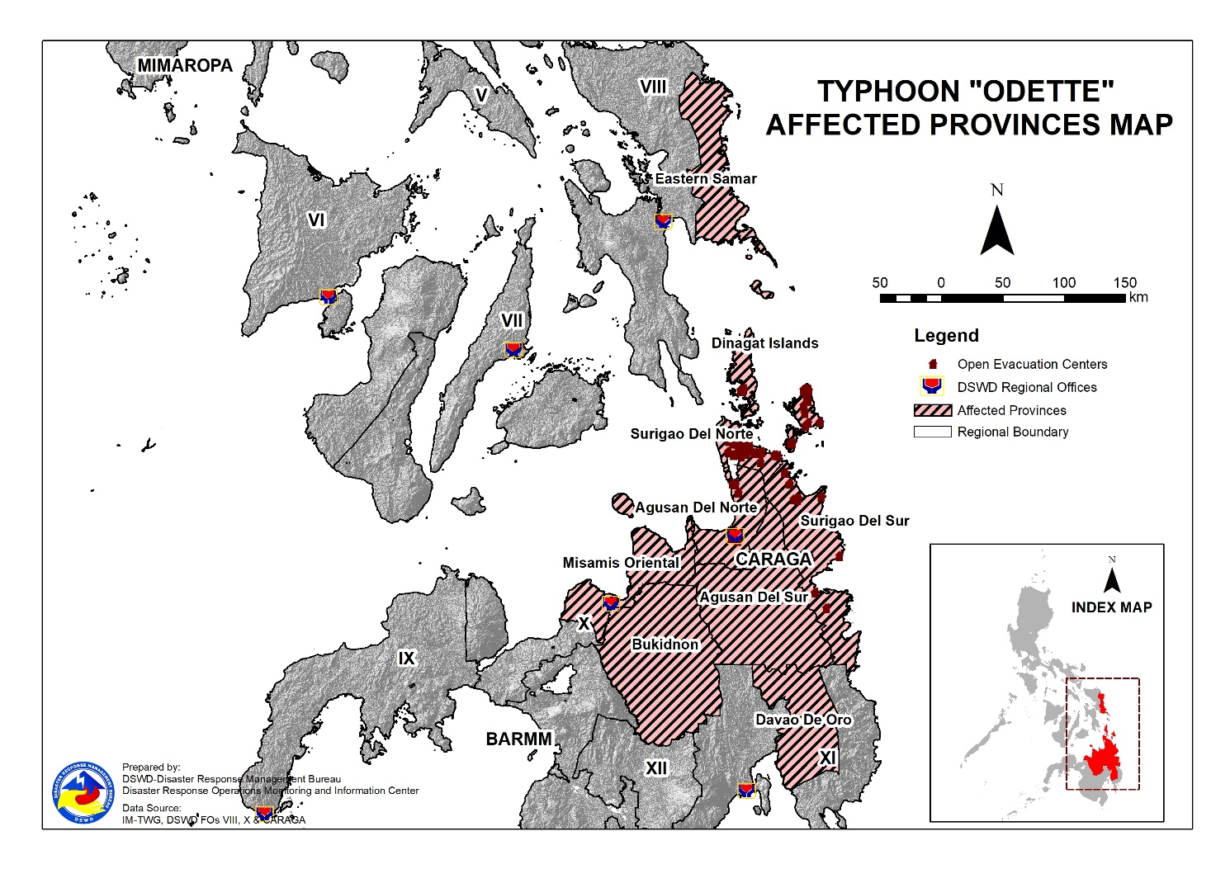
- Status of Displaced Population
- Inside Evacuation Centers
There are 12,203 families or 44,578 persons sought temporary shelter in 332 evacuation centers in Region X, XI and Caraga (see Table 2).

Table 2. Number of Displaced Families / Persons Inside Evacuation Centers
REGION / PROVINCE / MUNICIPALITY |  | NUMBER OF EVACUATION CENTERS (ECs) |  | NUMBER OF DISPLACED
 |  |  |  | INSIDE ECs
 |  |  |  | Families |  | Persons
 |  | CUM | NOW | CUM | NOW | CUM | NOW
GRAND TOTAL |  | 332 | 332 | 12,203 | 12,203 | 44,578 | 44,578
REGION X |  | 69 | 69 | 2,627 | 2,627 | 10,487 | 10,487
Bukidnon |  | 8 | 8 | 218 | 218 | 1,061 | 1,061
 | Talakag | 1 | 1 | 30 | 30 | 121 | 121
 | City of Malaybalay (capital) | 7 | 7 | 188 | 188 | 940 | 940
Camiguin |  | 10 | 10 | 183 | 183 | 813 | 813
 | Mambajao (capital) | 5 | 5 | 111 | 111 | 461 | 461
 | Sagay | 5 | 5 | 72 | 72 | 352 | 352
Misamis Oriental |  | 51 | 51 | 2,226 | 2,226 | 8,613 | 8,613
 | Cagayan De Oro City (capital) | 42 | 42 | 1,856 | 1,856 | 7,062 | 7,062
 | Balingoan | 5 | 5 | 263 | 263 | 1,016 | 1,016
 | Gingoog City | 4 | 4 | 107 | 107 | 535 | 535
REGION XI |  | 9 | 9 | 233 | 233 | 614 | 614
Davao de Oro |  | 9 | 9 | 233 | 233 | 614 | 614
 | Nabunturan (capital) | 1 | 1 | 45 | 45 | 137 | 137
 | New Bataan | 8 | 8 | 188 | 188 | 477 | 477
CARAGA |  | 254 | 254 | 9,343 | 9,343 | 33,477 | 33,477
Agusan del Norte |  | 7 | 7 | 95 | 95 | 302 | 302
 | Butuan City (capital) | 3 | 3 | 37 | 37 | 126 | 126
 | Jabonga | 2 | 2 | 37 | 37 | 115 | 115
 | Nasipit | 2 | 2 | 21 | 21 | 61 | 61
Dinagat Island |  | 14 | 14 | 368 | 368 | 1,231 | 1,231
 | San Jose (capital) | 14 | 14 | 368 | 368 | 1,231 | 1,231
Surigao del Norte |  | 189 | 189 | 6,475 | 6,475 | 23,060 | 23,060
 | Bacuag | 17 | 17 | 520 | 520 | 1,810 | 1,810
 | Burgos | 15 | 15 | 443 | 443 | 2,097 | 2,097
 | Claver | 19 | 19 | 654 | 654 | 2,304 | 2,304
 | Gigaquit | 7 | 7 | 223 | 223 | 653 | 653
 | Placer | 48 | 48 | 1,518 | 1,518 | 5,440 | 5,440
 | San Benito | 1 | 1 | 14 | 14 | 49 | 49
 | San Isidro | 34 | 34 | 782 | 782 | 2,576 | 2,576
 | Santa Monica (Sapao) | 5 | 5 | 188 | 188 | 659 | 659
 | Sison | 3 | 3 | 293 | 293 | 1,036 | 1,036
 | Socorro | 11 | 11 | 466 | 466 | 1,901 | 1,901
 | Tagana-an | 14 | 14 | 1,114 | 1,114 | 3,570 | 3,570
 | Tubod | 15 | 15 | 260 | 260 | 965 | 965
Surigao del Sur |  | 44 | 44 | 2,405 | 2,405 | 8,884 | 8,884
 | Barobo | 2 | 2 | 354 | 354 | 1,259 | 1,259
 | Carmen | 7 | 7 | 96 | 96 | 384 | 384
 | Carrascal | 12 | 12 | 811 | 811 | 2,648 | 2,648
 | Cortes | 6 | 6 | 572 | 572 | 2,245 | 2,245
 | Lanuza | 5 | 5 | 293 | 293 | 1,135 | 1,135
 | Lingig | 3 | 3 | 154 | 154 | 775 | 775
 | Marihatag | 5 | 5 | 62 | 62 | 210 | 210
 | Tagbina | 4 | 4 | 63 | 63 | 228 | 228
Note: Ongoing assessment and validation are continuously being conducted.
Source: DSWD-Field Offices

- Outside Evacuation Centers
There are 744 families or 2,780 persons temporarily staying with their relatives and/or friends in Region Caraga (see Table 3).

Table 3. Number of Displaced Families / Persons Outside Evacuation Centers
REGION / PROVINCE / MUNICIPALITY |  | NUMBER OF DISPLACED
 |  | OUTSIDE ECs
 |  | Families |  | Persons
 |  | CUM | NOW | CUM | NOW
GRAND TOTAL |  | 744 | 744 | 2,780 | 2,780
CARAGA |  | 744 | 744 | 2,780 | 2,780
Surigao del Norte |  | 744 | 744 | 2,780 | 2,780
 | Bacuag | 66 | 66 | 234 | 234
 | Burgos | 157 | 157 | 688 | 688
 | Claver | 57 | 57 | 202 | 202
 | Placer | 264 | 264 | 970 | 970
 | San Isidro | 85 | 85 | 305 | 305
 | Socorro | 115 | 115 | 381 | 381
Note: Ongoing assessment and validation are continuously being conducted.
Source: DSWD-Field Offices

- Total Displaced Population
There are 12,947 families or 47,358 persons displaced in Region X, XI and Caraga due to Typhoon “Odette” (see Table 4).

Table 4. Total Number of Displaced Families / Persons
REGION / PROVINCE / MUNICIPALITY |  | TOTAL DISPLACED SERVED
 |  | Families |  | Persons
 |  | Total Families |  | Total Persons
 |  | CUM | NOW | CUM | NOW
GRAND TOTAL |  | 12,947 | 12,947 | 47,358 | 47,358
REGION X |  | 2,627 | 2,627 | 10,487 | 10,487
Bukidnon |  | 218 | 218 | 1,061 | 1,061
 | Talakag | 30 | 30 | 121 | 121
 | City of Malaybalay (capital) | 188 | 188 | 940 | 940
Camiguin |  | 183 | 183 | 813 | 813
 | Mambajao (capital) | 111 | 111 | 461 | 461
 | Sagay | 72 | 72 | 352 | 352
Misamis Oriental |  | 2,226 | 2,226 | 8,613 | 8,613
 | Cagayan De Oro City (capital) | 1,856 | 1,856 | 7,062 | 7,062
 | Balingoan | 263 | 263 | 1,016 | 1,016
 | Gingoog City | 107 | 107 | 535 | 535
REGION XI |  | 233 | 233 | 614 | 614
Davao de Oro |  | 233 | 233 | 614 | 614
 | Nabunturan (capital) | 45 | 45 | 137 | 137
 | New Bataan | 188 | 188 | 477 | 477
CARAGA |  | 10,087 | 10,087 | 36,257 | 36,257
Agusan del Norte |  | 95 | 95 | 302 | 302
 | Butuan City (capital) | 37 | 37 | 126 | 126
 | Jabonga | 37 | 37 | 115 | 115
 | Nasipit | 21 | 21 | 61 | 61
Dinagat Island |  | 368 | 368 | 1,231 | 1,231
 | San Jose (capital) | 368 | 368 | 1,231 | 1,231
Surigao del Norte |  | 7,219 | 7,219 | 25,840 | 25,840
 | Bacuag | 586 | 586 | 2,044 | 2,044
 | Burgos | 600 | 600 | 2,785 | 2,785
 | Claver | 711 | 711 | 2,506 | 2,506
 | Gigaquit | 223 | 223 | 653 | 653
 | Placer | 1,782 | 1,782 | 6,410 | 6,410
 | San Benito | 14 | 14 | 49 | 49
 | San Isidro | 867 | 867 | 2,881 | 2,881
 | Santa Monica (Sapao) | 188 | 188 | 659 | 659
 | Sison | 293 | 293 | 1,036 | 1,036
 | Socorro | 581 | 581 | 2,282 | 2,282
 | Tagana-an | 1,114 | 1,114 | 3,570 | 3,570
 | Tubod | 260 | 260 | 965 | 965
Surigao del Sur |  | 2,405 | 2,405 | 8,884 | 8,884
 | Barobo | 354 | 354 | 1,259 | 1,259
 | Carmen | 96 | 96 | 384 | 384
 | Carrascal | 811 | 811 | 2,648 | 2,648
 | Cortes | 572 | 572 | 2,245 | 2,245
 | Lanuza | 293 | 293 | 1,135 | 1,135
 | Lingig | 154 | 154 | 775 | 775
 | Marihatag | 62 | 62 | 210 | 210
 | Tagbina | 63 | 63 | 228 | 228
Note: Ongoing assessment and validation are continuously being conducted.
Source: DSWD-Field Offices
- Response Actions and Interventions

- Standby Funds and Prepositioned Relief Stockpile
OFFICE | STANDBY FUNDS | STOCKPILE |  |  | TOTAL STANDBY FUNDS & STOCKPILE
 |  | FAMILY FOOD PACKS |  | OTHER FOOD AND NON-FOOD ITEMS (FNIs)
 |  | QUANTITY | TOTAL COST
TOTAL | 78,533,982.90 | 400,067 | 246,366,355.93 | 627,488,095.64 | 952,388,434.47
DSWD-CO | 10,127,239.51 | - | - | - | 10,127,239.51
NRLMB-NROC | - | 94,942 | 67,890,185.00 | 78,190,633.08 | 146,080,818.08
NRLMB-VDRC | - | 7,298 | 4,122,840.00 | 51,078,249.75 | 55,201,089.75
DSWD-FO VIII | 4,215,000.00 | 25,092 | 12,788,955.14 | 27,543,751.21 | 44,547,706.35
DSWD-FO X | 5,238,559.92 | 11,273 | 7,803,677.46 | 66,167,494.03 | 79,209,731.41
DSWD-FO XI | 5,000,000.00 | 15,681 | 7,448,475.00 | 21,669,938.80 | 34,118,413.80
DSWD-FO CARAGA | 5,000,813.43 | 19,572 | 8,794,803.28 | 10,838,526.61 | 24,634,143.32
Other FOs | 48,952,370.04 | 226,209 | 137,517,420.05 | 371,999,502.16 | 558,469,292.25
Note: The Inventory Summary is as of 17 December 2021, 12AM.
Source: DSWD-National Resource and Logistics Management Bureau (NRLMB)

  - Standby Funds
    - ₱10.13 million Quick Response Fund (QRF) at the DSWD-Central Office.
    - ₱19.45 million available at DSWD-FO VIII, X,XI and CARAGA.
    - ₱48.95 million in other DSWD-FOs which may support the relief needs of the displaced families due to Typhoon “Odette” through inter-FO augmentation.

  - Prepositioned FFPs and Other Relief Items
    - 102,240 FFPs available in Disaster Response Centers; of which, 94,942 FFPs are at the National Resource Operations Center (NROC), Pasay City and 7,298 FFPs are at the Visayas Disaster Response Center (VDRC), Cebu City.
    - 71,618 FFPs available at DSWD-FO VIII, X,XI and CARAGA.
    - 226,209 FFPs in other DSWD-FOs which may support the relief needs of the displaced families due to Typhoon “Odette” through inter-FO augmentation.
    - ₱627.49 million worth of food and non-food items (FNIs) at NROC, VDRC and DSWD-FO warehouses countrywide.

- Food and Non-Food Items

DSWD-FO II
DATE | ACTIVITIES
16 December 2021 | - DSWD-FO II unloaded an additional 5,000 FFPs to Tuguegarao City satellite warehouse amounting to PhP3,110,000.00 out of the 20,000 FPPs requested to DRMB.
15 December 2021 | - DSWD-FO II unloaded 5,000 FFPs to the two (2) satellite warehouses at SWAD Isabela (1,700 FPPs) and Tuguegarao City (3,300 FFPs) with an aggregate amount of PhP3,516,875.00 as initial delivery out of the 20,000 FFPs requested to DRMB.

DSWD-FO V
DATE | ACTIVITIES
13 December 2021 | - DSWD-FO V ensures the availability of Family Food Packs (FFPs) and other Food and Non-food Items (FNIs).

DSWD-FO VI
DATE | ACTIVITIES
14 December 2021 | - DSWD-FO VI ensures the availability of FFPs and other FNIs.

DSWD-FO VII
DATE | ACTIVITIES
14 December 2021 | - DSWD-FO VII ensures the availability of FFPs and other FNIs.

DSWD-FO VIII
DATE | ACTIVITIES
16 December 2021 | - Unloaded 5,000 FFPs in Maasin City, Southern Leyte to serve as prepositioned goods in anticipation of Typhoon Odette.  - DSWD-FO VIII facilitated the repacking of FPPs in FO-VIII Regional Resources Operations Center in the preparation for the possible augmentation support.
15 December 2021 | - DSWD-FO VIII ensures the availability of FFPs and other FNIs.  - DSWD-FO VIII prepositioned Family Food Packs (FFPs) in Samar Island and Biliran which can be distributed immediately by the P/C/MATs to Local Government Units that needs augmentation support.
DSWD-FO IX
DATE | ACTIVITIES
16 December 2021 | - DSWD-FO IX ensures the availability of FFPs and other FNIs.

DSWD-FO X
DATE | ACTIVITIES
14 December 2021 | - DSWD-FO X ensures the availability of FFPs and other FNIs.

DSWD-FO XI
DATE | ACTIVITIES
14 December 2021 | - DSWD-FO XI ensures the availability of FFPs and other FNIs.

DSWD-FO Caraga
DATE | ACTIVITIES
15 December 2021 | - DSWD-FO CARAGA ensures the availability of FFPs and other FNIs.

- Camp Coordination and Camp Management

- Internally Displaced Persons (IDPs) Protection

DSWD-FO XI
DATE | ACTIVITIES
16 December 2021 | - DSWD-FO XI is in close coordination with Provincial Social Welfare Development Office (PSWDO) in Davao De Oro in monitoring of the situation of the IDPs inside the evacuation centers to ensure compliance with the provision of emergency relief and protection for the children (RA10821) during emergency situations as well as to monitor the compliance with the safety health protocols set by the IATF.

- Other Activities

DSWD-DRMB
DATE | SITUATIONS / ACTIONS UNDERTAKEN
16 December 2021 | - The Disaster Response Management Bureau (DRMB) is closely coordinating with the concerned Field Offices (FOs) for significant disaster response updates.  - DSWD-DRMB Quick Response Team (QRT) members and emergency equipment are on standby and ready for deployment.  - The Response Cluster is activated and is placed on standby status on 14 December 2021 to monitor and facilitate emergency and humanitarian assistance response to the effects of Typhoon “ODETTE”.  - DRMB participated in the Online Pre-Disaster Risk Assessment (PDRA) Meeting on STS “RAI” on 14 December 2021 with other response cluster member agencies. Further meetings shall be conducted on the implementation of COVID-19 protocols during the response efforts on STS “RAI”.  - DRMB is currently coordinating with IOM for the pull-out of 100 boxes/rolls of USAID donated tarpaulins at the NRLMB warehouse in Pasay City.

DSWD-FO CAR
DATE | ACTIVITIES

DSWD-FO II
DATE | SITUATIONS / ACTIONS UNDERTAKEN
15 December 2021 | - DSWD-FO II is continuously monitoring weather updates.  - DSWD-FO II QRT members are on standby alert and are ready for mobilization for any assistance and augmentation support needed from the LGUs.  - DSWD-FO II attended the PDRA Core Group Meeting relative to the preparedness response measures of every member council of Cagayan Valley Regional Disaster Risk Reduction Management Council (CVRDRRMC) wherein DSWD presented the preparedness plan on the possible effects of Typhoon Odette and the Northeast Monsoon

DSWD-FO MIMAROPA
DATE | SITUATIONS / ACTIONS UNDERTAKEN
16 December 2021 | - DSWD-FO MIMAROPA QRT render on 24/7 duty schedule, together with the P/C/M QRT, in DSWD EOC and MIMAROPA Virtual EOC to monitor any untoward incident/s or eventuality/ies in their area of responsibilities;  - Deployment of Regional DRMD staff to the provinces of Occidental Mindoro, Oriental Mindoro, Romblon and Palawan and ensure standby of fleet vehicles in preparation for the possible effects of the Tropical Cyclone;  - Coordination with PSWDOs regarding the hauling/delivery of the 500 modular tents to all City/ Municipalities of MIMAROPA ready for hauling/delivery;  - Issued memorandum regarding the activation of Response Clusters to capture all pertinent details related to Food and Non-Food Items (F/NFI), Camp Coordination and Camp Management (CCCM), Internally Displaced Persons (IDP) Protection, Health, Logistics, Law and Order, Search, Rescue, and Retrieval (SRR), and Management of the Dead and Missing (MDM) whenever possible;  - Ensure provision of information to all SWADT, offices, divisions, sections, and units, and on-call status of the expanded R/P/C/M QRTs together with special projects staff on a 24/7 duty schedule for possible augmentation and response in case any untoward incidents and eventualities are reported;  - Attendance and participation in Pre-Disaster Risk Assessment Analyst Group Meeting dated 13 and 14 December 2021;  - Close coordination with the Office of Civil Defense (OCD), RDRRMC MIMAROPA, DOST-PAGASA, DENR-MGB, and other surveillance agencies to monitor any updates, bulletins, warnings, and other advisories for areas that will be affected;  - Ensure adherence to the NDRRMC’s guidelines on COVID-19 Preparedness Measures for the anticipated rainy season particularly the safety protocols; and  - Encourage LGUs to conduct early and immediate pre-emptive evacuation instead of reactive evacuation, giving priority to areas considered as highly vulnerable to flooding, landslide, and storm surge.

DSWD-FO V
DATE | SITUATIONS / ACTIONS UNDERTAKEN
13 December 2021 | - DSWD-FO V is continuously monitoring weather updates.  - DSWD-FO V QRT members are on standby alert and are ready for mobilization for any assistance and augmentation support needed from the LGUs.  - DSWD-FO V is closely coordinating with the P/MDRRMOs for status reports and updates.

DSWD-FO VI
DATE | SITUATIONS / ACTIONS UNDERTAKEN
14 December 2021 | - DSWD-FO VI is continuously monitoring weather updates.  - DSWD-FO VI QRT members are on standby alert and are ready for mobilization for any assistance and augmentation support needed from the LGUs.

DSWD-FO VII
DATE | SITUATIONS / ACTIONS UNDERTAKEN
16 December 2021 | - 54 LGUs have already implemented pre-emptive evacuation in Region VII.  - Around 7,000 families from Bohol, Cebu and Negros Oriental have been evacuated to atleast 100 evacuation centers.  - DSWD-FO VII City/Municipal Actions Teams continue to assist the LGU counterparts at the evacuation camps – DAFAC enlisting and administration, relief packing and distribution, attendance and participation to LDRRMC coordination meetings and discussion.  - DSWD-FO VII deployed duty personnel at the RDRRMC-7 EOC established at the OCD-7 office in Mactan Airbase.  - DSWD-FO VII Regional Director Rebecca P. Geamala presided the RDRRMC Meeting in relation to the TY Odette
14 December 2021 | - DSWD-FO VII is continuously monitoring weather updates.  - DSWD-FO VII QRT members are on standby alert and are ready for mobilization for any assistance and augmentation support needed from the LGUs.  - DSWD-FO VII ensures the availability of FFPs and other FNIs.  - DSWD-FO VII is closely coordinating with their local counterparts and their respective LDRRMCs. Field staff were requested to monitor AOR and provide reports and updates to the Regional DROMIC Focal for any impacts/effects.

DSWD-FO VIII
DATE | SITUATIONS / ACTIONS UNDERTAKEN
16 December 2021 | - DSWD FO-VIII continuously gathering the data updates on the pre-emptive evacuees and affected families/persons due to Typhoon Odette from the DSWD SFOs, C/MATs, and partner agencies.  - Out of the 57,686 families or 242,351 persons that took pre-emptive evacuation in Region VIII, 55,959 families or 236,580 persons are currently taking temporary shelter in 795 evacuation centers while 750 families or 3,238 persons are temporarily staying with their relatives and/or friends.
15 December 2021 | - DSWD-FO VIII is continuously monitoring weather updates.  - DSWD-FO VIII QRT members are on standby alert and are ready for mobilization for any assistance and augmentation support needed from the LGUs.

DSWD-FO IX
DATE | ACTIVITIES
16 December 2021 | - DSWD-FO IX thru DRMD is closely monitoring updates from PAGASA and coordinate with MSWDO and C/M/PDRRMO of Zamboanga del Sur and del Norte, Zamboanga Sibugay, and Zamboanga City for possible assistance in the areas.  - DSWD-FO IX activated the Regional QRT ready to augment during disaster response and relief operations.

DSWD-FO X
DATE | SITUATIONS / ACTIONS UNDERTAKEN
16 December 2021 | - A total of 64 families or 320 persons have taken pre-emptive evacuation in seven (7) evacuation centers in Cagayan de Oro, Misamis Oriental while 107 families or 414 persons also took pre-emptive evacuation in four (4) evacuation centers in Gingoog City, Misamis Oriental.
14 December 2021 | - DSWD-FO X is continuously monitoring weather updates.  - DSWD-FO X QRT members are on standby alert and are ready for mobilization for any assistance and augmentation support needed from the LGUs.

DSWD-FO XI
DATE | SITUATIONS / ACTIONS UNDERTAKEN
16 December 2021 | - DSWD-FO XI convened the members of Disaster Response Cluster to present the preparedness measures and activities on the potential threat brought by the Tropical Cyclone ‘ODETTE”.  - Attended/participated in the RDRRMC Virtual EOC Meeting via Zoom to closely monitor the situation of the most vulnerable municipalities in Davao region.  - DSWD DRMD Staff render skeleton duty schedule at the FO EOC.
14 December 2021 | - DSWD-FO XI is continuously monitoring weather updates.  - DSWD-FO XI QRT members are on standby alert and are ready for mobilization for any assistance and augmentation support needed from the LGUs.

DSWD-FO CARAGA
DATE | SITUATIONS / ACTIONS UNDERTAKEN
16 December 2021 | - DSWD-FO CARAGA activated the QRTs and reporting on 24/7 shift.
15 December 2021 | - DSWD-FO CARAGA is continuously monitoring the weather updates.  - DSWD-FO CARAGA QRT members are on standby alert and are ready for mobilization for any assistance and augmentation support needed from the LGUs.  - DSWD-FO CARAGA is continuously coordinating with SWADTLs and LSWDOs to monitor the situation in their respective areas.

- Photo Documentation

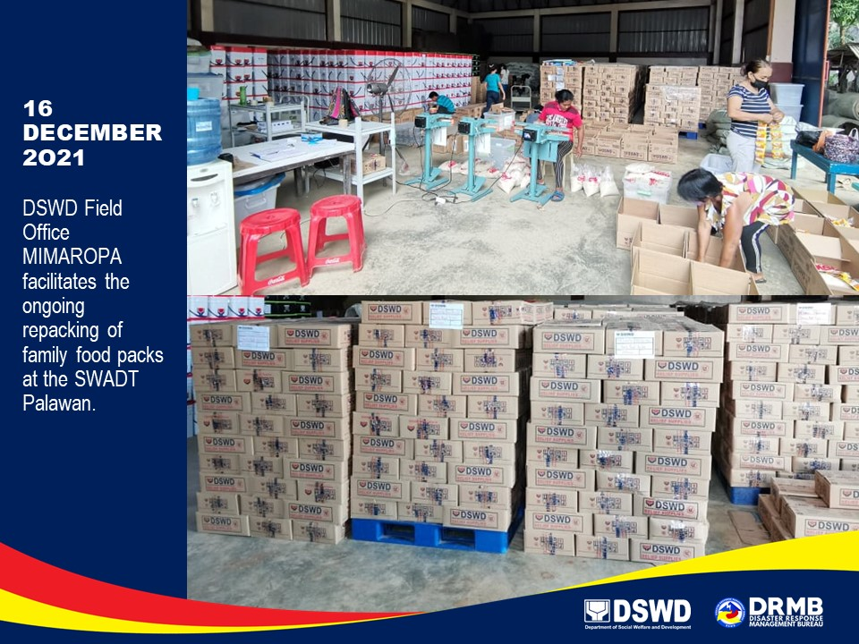

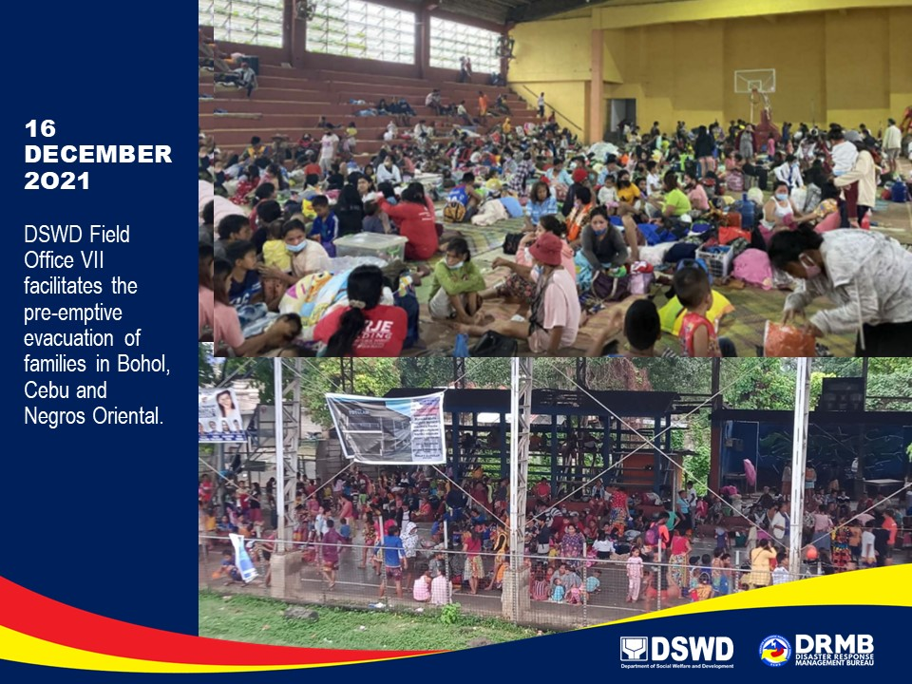

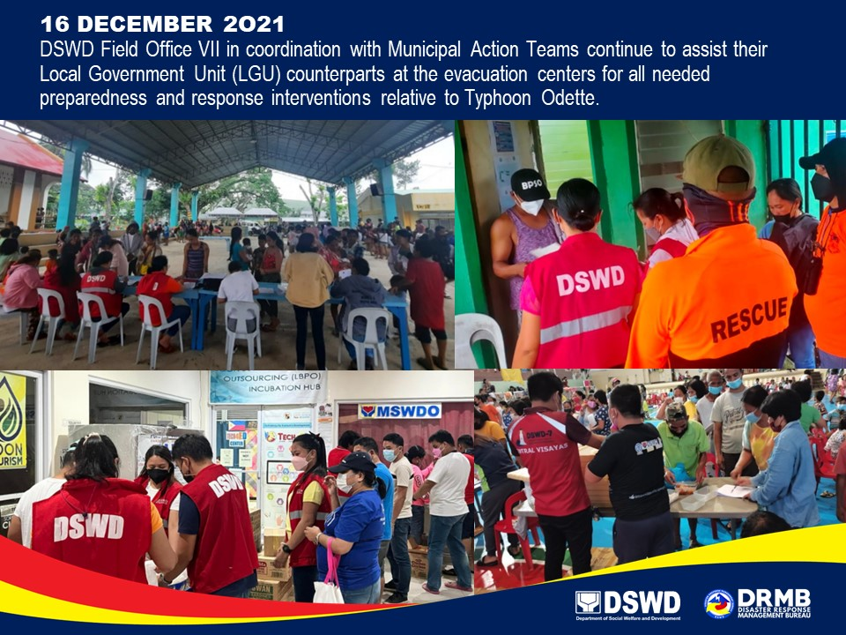

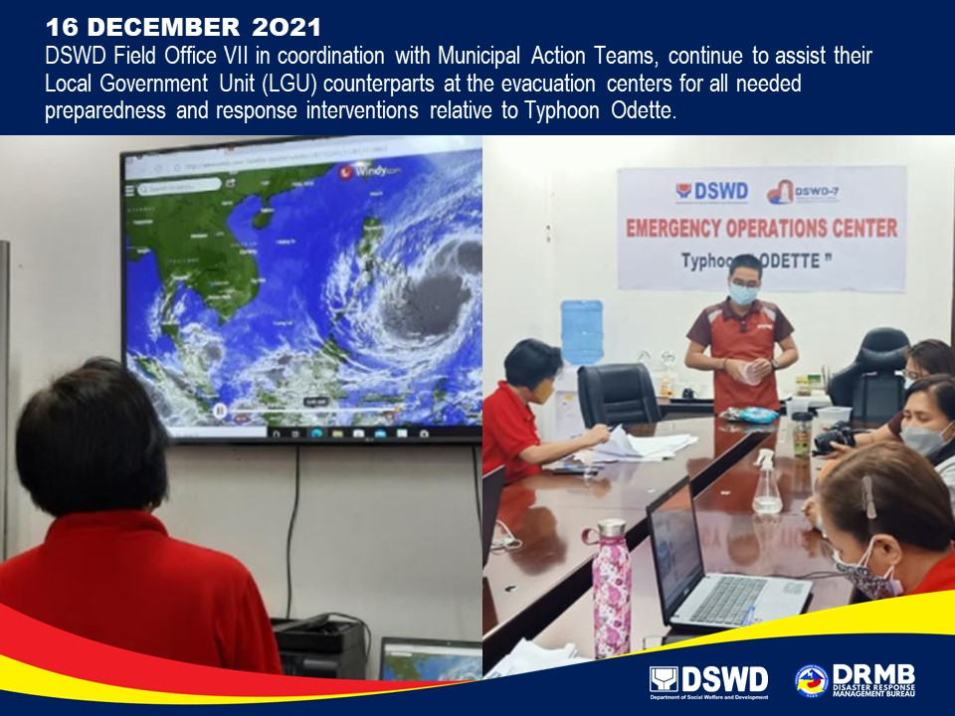

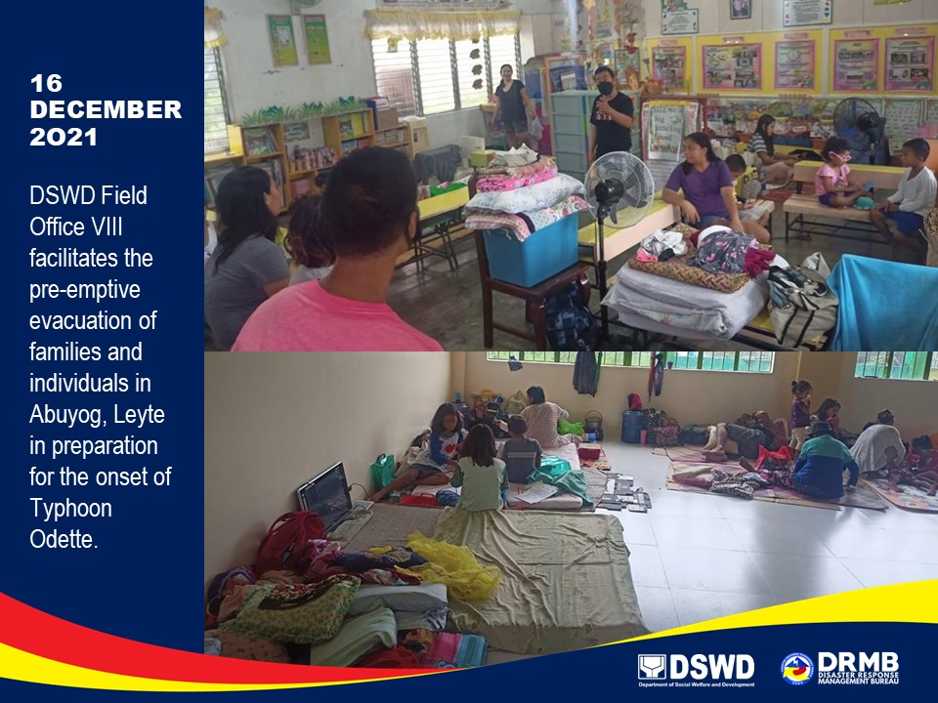

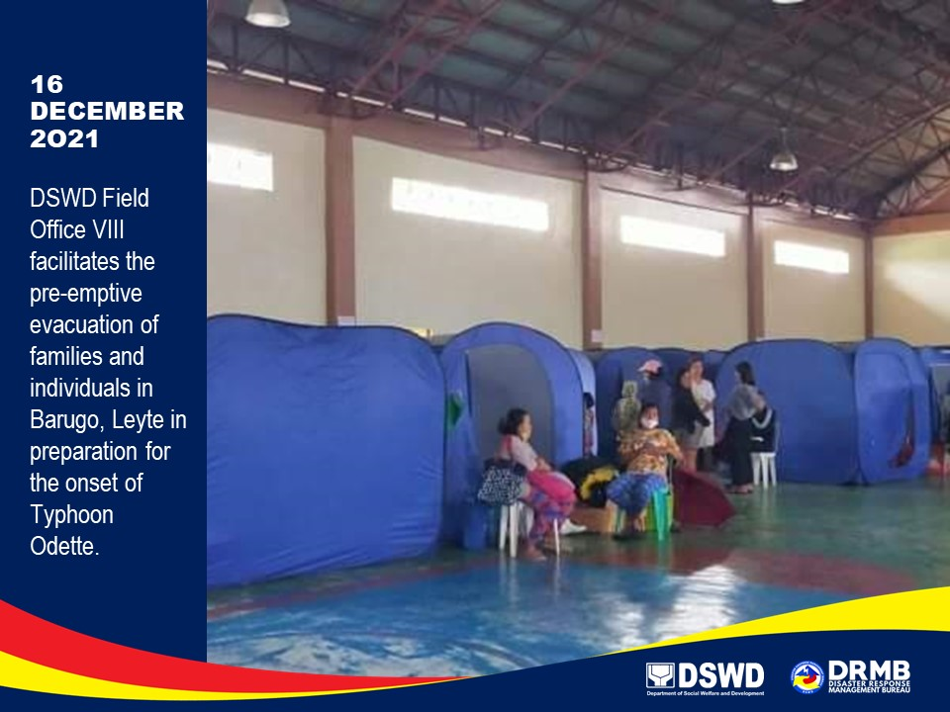

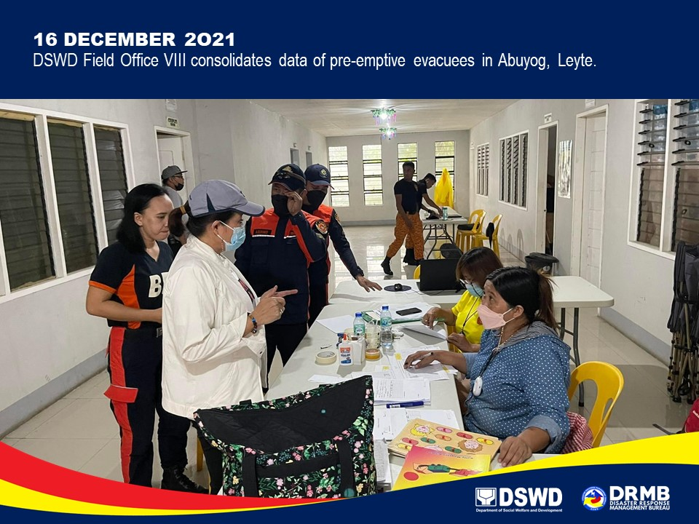

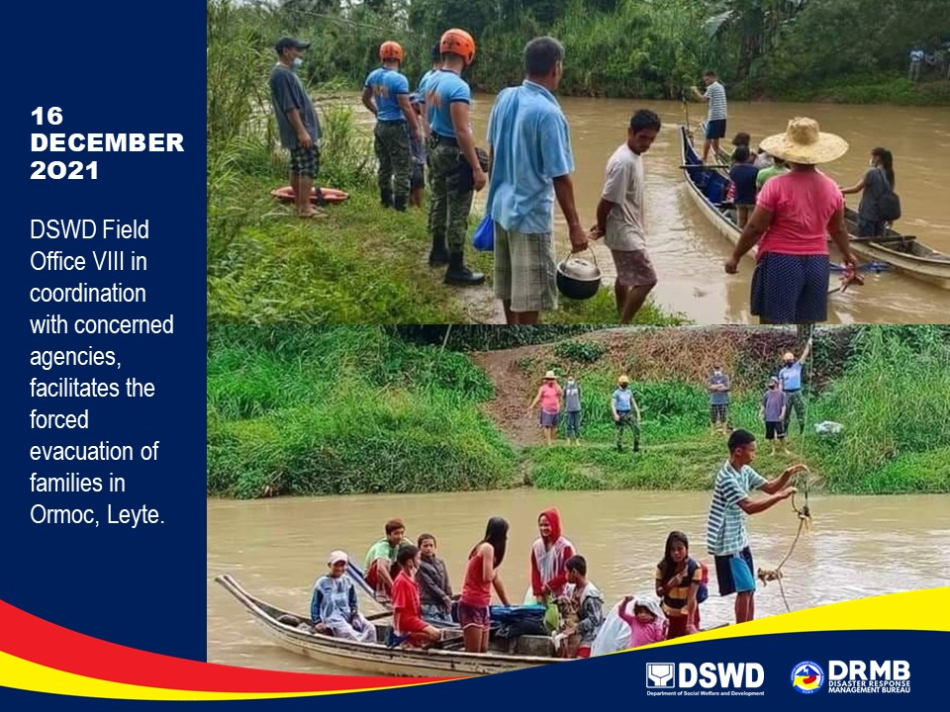

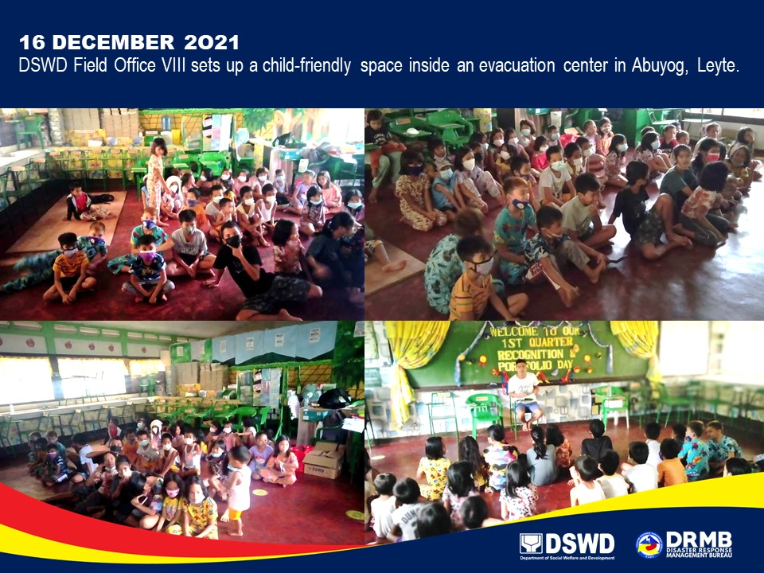

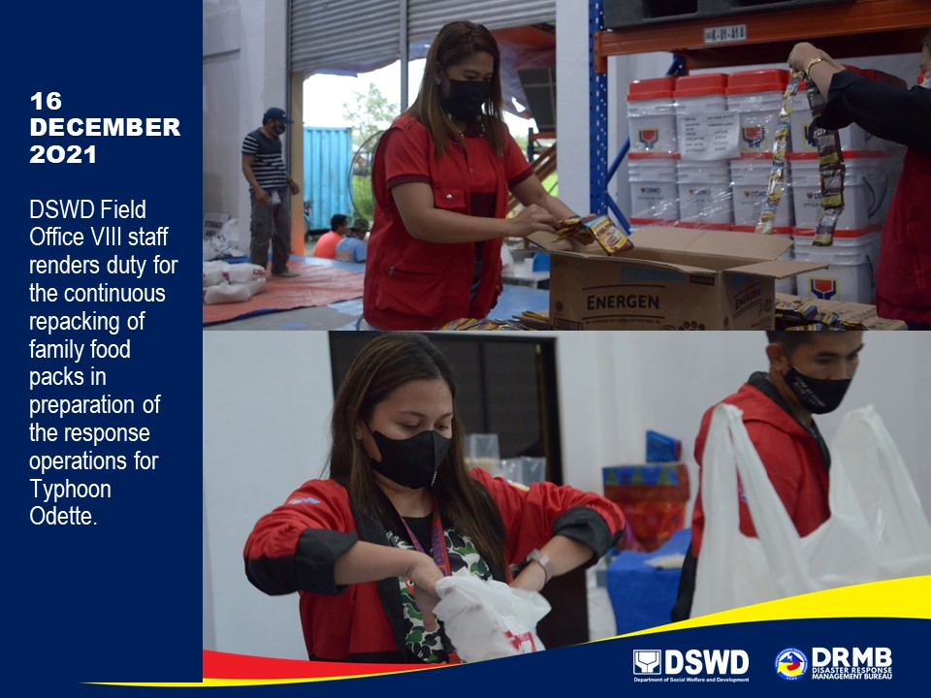

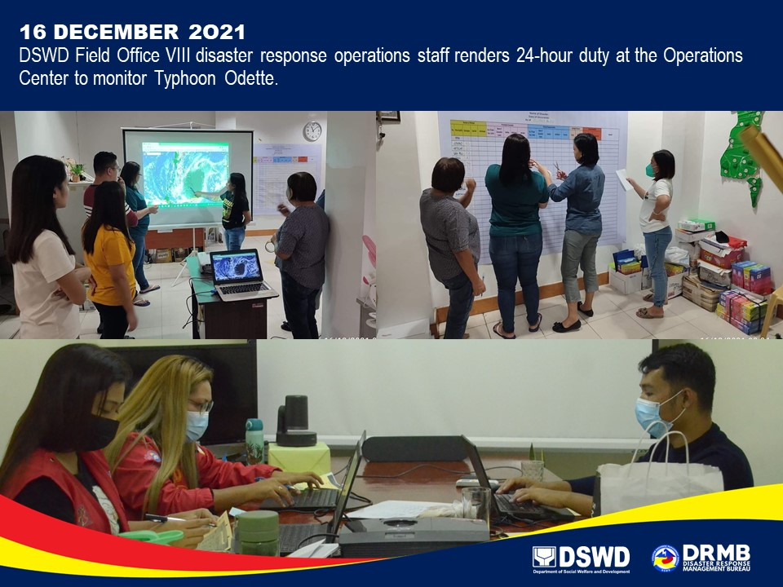

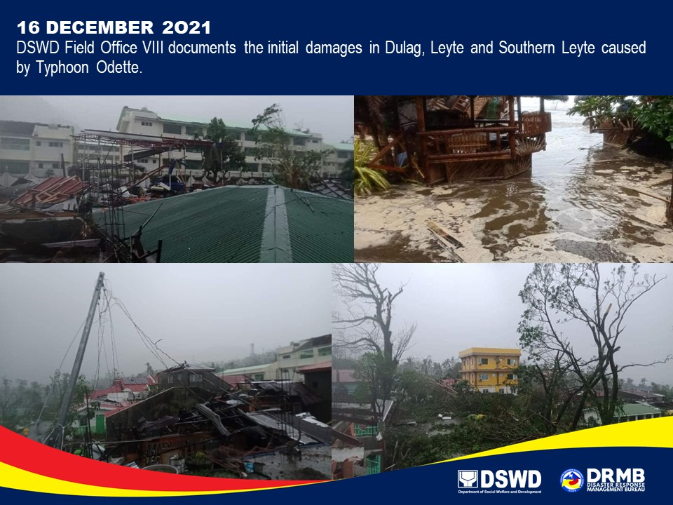

*****
The Disaster Response Operations Monitoring and Information Center (DROMIC) of DSWD-DRMB is closely coordinating with the concerned DSWD-FOs for significant disaster response updates and assistance provided.

Prepared by:  AARON JOHN B. PASCUA  JEM ERIC F. FAMORCAN  MARIE JOYCE G. RAFANAN  JOANNA CAMILLE R. JACINTO | Released by:  RODEL V. CABADDU

