DSWD DROMIC Report #6 on Typhoon “ODETTE”
as of 17 December 2021, 6PM

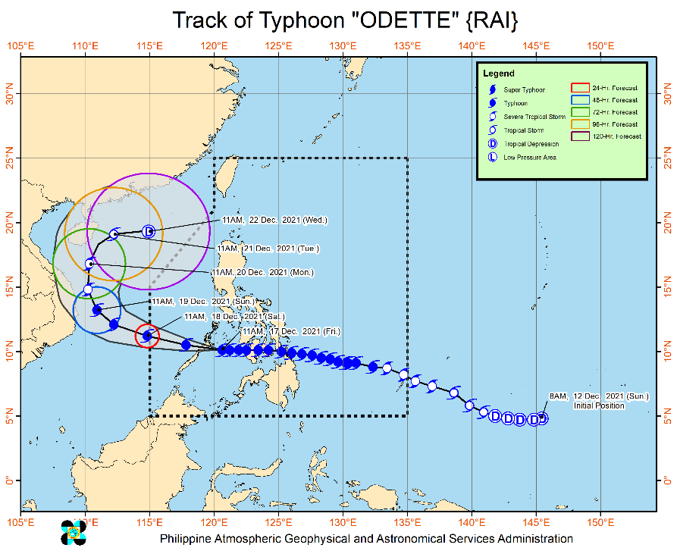
- Situation Overview
Issued at 2:00 PM, 17 December 2021, Typhoon “ODETTE” maintains its strength as it approaches Palawan.

Location of Center (1:00 PM)
- The center of the eye of Typhoon “ODETTE” was located based on all available data at 130 km Southwest of Cuyo, Palawan or 155 km East Northeast of Puerto Princesa City, Palawan (10.1°N, 120.1°E).

Intensity:
- Maximum sustained winds of 155 km/h near the center, gustiness of up to 215 km/h, and central pressure of 955 hPa.

Heavy Rainfall:
- Today: Heavy to torrential rains over Western Visayas, Palawan including Calamian, Cuyo, and Cagayancillo Islands, and Negros Oriental. Moderate to heavy with at times intense rains over the Bicol Region, Zamboanga Peninsula, Quezon, and the rest of MIMAROPA. Light to moderate with at times heavy rains over Cagayan Valley, the rest of CALABARZON, Cordillera Administrative Region, Aurora, Lanao del Norte, Misamis Occidental, Lanao del Sur, and the rest of Visayas.
- Tomorrow: Heavy to torrential rains over Kalayaan Islands. Moderate to heavy rains over Catanduanes, Camarines Provinces, Quezon, and Aurora. Light to moderate with at times heavy rains over Cagayan Valley, Cordillera Administrative Region, Eastern Visayas, Rizal, Bulacan, mainland Palawan including Calamian Islands, and the rest of Bicol Region.
- Under these conditions, scattered to widespread flooding (including flash floods) and rain-induced landslides are expected especially in areas that are highly or very highly susceptible to these hazard as identified in hazard maps, and in localities with significant antecedent rainfall

Severe Winds:
- Destructive typhoon-force winds will be experienced within any of the areas where TCWS #3 is in effect. This may bring moderate to heavy damage to structures and vegetation
- Damaging winds reaching gale- to storm-force strength will be experienced within any of the areas where TCWS #2 is in effect. This may result in generally light to moderate damage to structures and vegetation.
- Strong winds (strong breeze to near gale) with higher gusts will be experienced within any of the areas where TCWS #1 is currently in effect during the passage of the typhoon. This may generally bring up to very light damage to structures and vegetation.

Track and Intensity Outlook
- Moving generally westward, the typhoon is forecast to make landfall in the vicinity of northern or central portion of Palawan this afternoon, re-emerge over the West Philippine Sea tonight, and pass in the vicinity of Kalayaan Islands tomorrow. The typhoon is forecast to exit the Philippine Area of Responsibility tomorrow morning or early afternoon.
- “ODETTE” may still see some slight weakening until it crosses Palawan, but it is forecast to remain as a typhoon. Re-intensification is likely once “ODETTE” emerges over the West Philippine Sea. However, continuous weakening may ensue beginning Sunday as the typhoon becomes exposed to increasing vertical wind shear and the surge of the Northeast Monsoon.
Source: DOST-PAGASA Severe Weather Bulletin

- Status of Affected Areas and Population

A total of 32,690 families or 121,545 persons were affected by the Typhoon “ODETTE” in 453 Barangays in Regions V, VI, VIII, X, XI, Caraga, and MIMAROPA (see Table 1).

Table 1. Number of Affected Families / Persons
REGION / PROVINCE / MUNICIPALITY |  | NUMBER OF AFFECTED
 |  | Barangays | Families | Persons
GRAND TOTAL |  | 453 | 32,690 | 121,545
MIMAROPA |  | 11 | 157 | 655
Romblon |  | 11 | 157 | 655
 | Banton | 7 | 113 | 512
 | Corcuera | 1 | 4 | 12
 | Ferrol | 3 | 40 | 131
REGION V |  | 21 | 759 | 2,438
Albay |  | 7 | 447 | 1,241
 | Guinobatan | 5 | 427 | 1,184
 | City of Ligao | 2 | 20 | 57
Masbate |  | 14 | 312 | 1,197
 | Aroroy | 3 | 83 | 373
 | Baleno | 1 | 23 | 62
 | Cataingan | 1 | 64 | 206
 | City of Masbate (capital) | 1 | 7 | 32
 | Pio V. Corpuz (Limbuhan) | 2 | 66 | 248
 | Placer | 3 | 29 | 120
 | San Jacinto | 2 | 36 | 143
 | Uson | 1 | 4 | 13
REGION VI |  | 236 | 9,454 | 35,868
Aklan |  | 12 | 568 | 2,325
 | Balete | 9 | 384 | 1,580
 | New Washington | 3 | 184 | 745
Antique |  | 6 | 170 | 601
 | Tibiao | 6 | 170 | 601
Capiz |  | 81 | 2,590 | 9,277
 | Dao | 6 | 30 | 100
 | Dumarao | 3 | 155 | 640
 | Ivisan | 2 | 27 | 100
 | Mambusao | 3 | 11 | 55
 | Panay | 6 | 70 | 251
 | Pilar | 19 | 982 | 3,293
 | Pontevedra | 14 | 490 | 1,579
 | President Roxas | 7 | 74 | 296
 | Roxas City (capital) | 17 | 655 | 2,531
 | Sapi-an | 3 | 66 | 310
 | Sigma | 1 | 30 | 122
Guimaras |  | 9 | 319 | 1,195
 | San Lorenzo | 5 | 62 | 245
 | Jordan (capital) | 2 | 96 | 385
 | Nueva Valencia | 1 | 88 | 317
 | Sibunag | 1 | 73 | 248
Iloilo |  | 64 | 2,372 | 9,291
 | Balasan | 4 | 23 | 79
 | Banate | 14 | 782 | 3,090
 | Batad | 3 | 10 | 41
 | Carles | 24 | 1,402 | 5,468
 | Pototan | 17 | 134 | 531
 | Sara | 2 | 21 | 82
Negros Occidental |  | 64 | 3,435 | 13,179
 | Bago City | 10 | 322 | 1,513
 | Candoni | 2 | 10 | 45
 | Cauayan | 7 | 1,220 | 5,491
 | City of Escalante | 10 | 924 | 2,529
 | Hinigaran | 1 | 50 | 250
 | Hinoba-an (Asia) | 9 | 318 | 809
 | Ilog | 12 | 137 | 530
 | City of Kabankalan | 7 | 95 | 373
 | Sagay City | 4 | 335 | 1,526
 | Salvador Benedicto | 2 | 24 | 113
REGION VIII |  | 49 | 7,818 | 29,621
Eastern Samar |  | 34 | 5,275 | 20,103
 | Arteche | 20 | 4,614 | 17,294
 | Guiuan | 14 | 661 | 2,809
Western Samar |  | 15 | 2,543 | 9,518
 | Santo Nino | 1 | 29 | 110
 | Tagapul-an | 14 | 2,514 | 9,408
REGION X |  | 81 | 4,158 | 15,909
Bukidnon |  | 9 | 219 | 1,064
 | Cabanglasan | 1 | 30 | 121
 | City of Malaybalay (capital) | 7 | 188 | 940
 | San Fernando | 1 | 1 | 3
Camiguin |  | 8 | 183 | 813
 | Mambajao (capital) | 3 | 111 | 461
 | Sagay | 5 | 72 | 352
Lanao del Norte |  | 27 | 1,531 | 5,419
 | Iligan City | 27 | 1,531 | 5,419
Misamis Oriental |  | 37 | 2,225 | 8,613
 | Cagayan De Oro City (capital) | 29 | 1,855 | 7,062
 | Balingoan | 4 | 263 | 1,016
 | Gingoog City | 4 | 107 | 535
REGION XI |  | 2 | 233 | 751
Davao de Oro |  | 2 | 233 | 751
 | Nabunturan (capital) | 1 | 45 | 137
 | New Bataan | 1 | 188 | 614
CARAGA |  | 134 | 10,111 | 36,303
Agusan del Norte |  | 7 | 95 | 302
 | Butuan City (capital) | 3 | 37 | 126
 | Jabonga | 2 | 37 | 115
 | Nasipit | 2 | 21 | 61
Dinagat Island |  | 9 | 368 | 1,231
 | San Jose (capital) | 9 | 368 | 1,231
Surigao del Norte |  | 80 | 7,243 | 25,886
 | Bacuag | 5 | 586 | 2,044
 | Burgos | 6 | 600 | 2,785
 | Claver | 9 | 711 | 2,506
 | Gigaquit | 3 | 223 | 653
 | Placer | 18 | 1,782 | 6,410
 | San Benito | 1 | 14 | 49
 | San Isidro | 10 | 867 | 2,881
 | Santa Monica (Sapao) | 5 | 188 | 659
 | Sison | 3 | 293 | 1,036
 | Socorro | 4 | 605 | 2,328
 | Tagana-an | 11 | 1,114 | 3,570
 | Tubod | 5 | 260 | 965
Surigao del Sur |  | 38 | 2,405 | 8,884
 | Barobo | 2 | 354 | 1,259
 | Carmen | 6 | 96 | 384
 | Carrascal | 8 | 811 | 2,648
 | Cortes | 5 | 572 | 2,245
 | Lanuza | 8 | 293 | 1,135
 | Lingig | 3 | 154 | 775
 | Marihatag | 5 | 62 | 210
 | Tagbina | 1 | 63 | 228
Note: Ongoing assessment and validation are continuously being conducted.
Source: DSWD-Field Offices

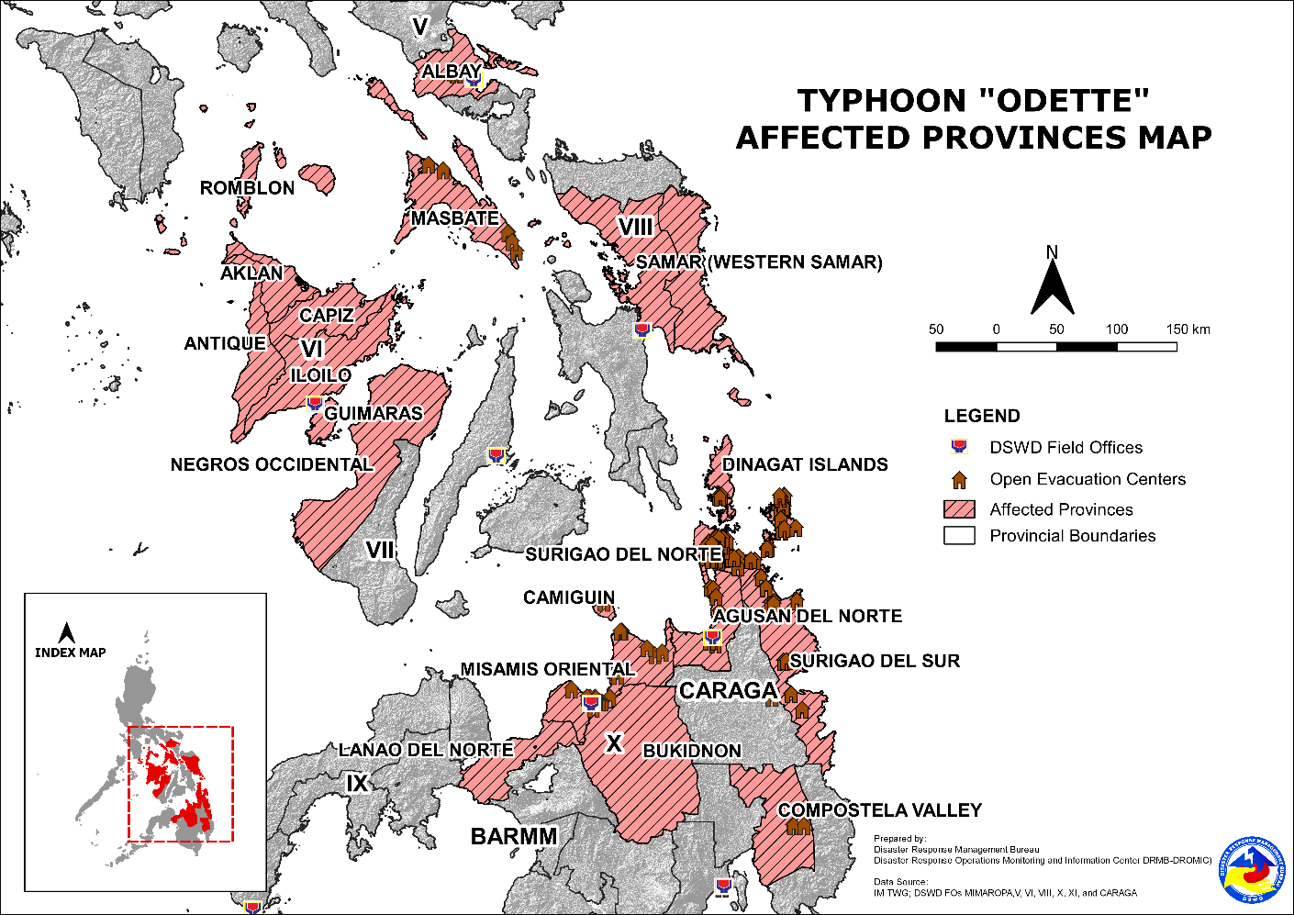
- Status of Displaced Population

- Inside Evacuation Centers
There are 22,260 families or 82,156 persons sought temporary shelter in 674 evacuation centers in Regions V, VI, X, XI, Caraga, and MIMAROPA (see Table 2).

Table 2. Number of Displaced Families / Persons Inside Evacuation Centers
REGION / PROVINCE / MUNICIPALITY |  | NUMBER OF EVACUATION CENTERS (ECs) |  | NUMBER OF DISPLACED
 |  |  |  | INSIDE ECs
 |  |  |  | Families |  | Persons
 |  | CUM | NOW | CUM | NOW | CUM | NOW
GRAND TOTAL |  | 680 | 674 | 22,300 | 22,260 | 82,314 | 82,156
MIMAROPA |  | 18 | 18 | 136 | 136 | 531 | 531
Romblon |  | 18 | 18 | 136 | 136 | 531 | 531
 | Banton | 10 | 10 | 92 | 92 | 388 | 388
 | Corcuera | 3 | 3 | 4 | 4 | 12 | 12
 | Ferrol | 5 | 5 | 40 | 40 | 131 | 131
REGION V |  | 20 | 17 | 759 | 739 | 2,438 | 2,381
Albay |  | 7 | 4 | 447 | 427 | 1,241 | 1,184
 | Guinobatan | 4 | 4 | 427 | 427 | 1,184 | 1,184
 | City of Ligao | 3 | - | 20 | - | 57 | -
Masbate |  | 13 | 13 | 312 | 312 | 1,197 | 1,197
 | Aroroy | 3 | 3 | 83 | 83 | 373 | 373
 | Baleno | 1 | 1 | 23 | 23 | 62 | 62
 | Cataingan | 2 | 2 | 64 | 64 | 206 | 206
 | City of Masbate (capital) | 1 | 1 | 7 | 7 | 32 | 32
 | Pio V. Corpuz (Limbuhan) | 2 | 2 | 66 | 66 | 248 | 248
 | Placer | 1 | 1 | 29 | 29 | 120 | 120
 | San Jacinto | 2 | 2 | 36 | 36 | 143 | 143
 | Uson | 1 | 1 | 4 | 4 | 13 | 13
REGION VI |  | 277 | 274 | 7,671 | 7,651 | 29,348 | 29,247
Aklan |  | 31 | 31 | 539 | 539 | 2,237 | 2,237
 | Balete | 25 | 25 | 375 | 375 | 1,555 | 1,555
 | New Washington | 6 | 6 | 164 | 164 | 682 | 682
Antique |  | 6 | 6 | 170 | 170 | 601 | 601
 | Tibiao | 6 | 6 | 170 | 170 | 601 | 601
Capiz |  | 150 | 147 | 2,369 | 2,351 | 8,497 | 8,404
 | Dao | 9 | 9 | 26 | 26 | 87 | 87
 | Dumarao | 7 | 7 | 154 | 154 | 636 | 636
 | Ivisan | 2 | 2 | 24 | 24 | 90 | 90
 | Panay | 6 | 6 | 68 | 68 | 241 | 241
 | Pilar | 48 | 48 | 886 | 885 | 2,952 | 2,950
 | Pontevedra | 20 | 18 | 438 | 422 | 1,407 | 1,327
 | President Roxas | 7 | 7 | 74 | 74 | 296 | 296
 | Roxas City (capital) | 45 | 44 | 606 | 605 | 2,371 | 2,360
 | Sapi-an | 5 | 5 | 63 | 63 | 295 | 295
 | Sigma | 1 | 1 | 30 | 30 | 122 | 122
Guimaras |  | 10 | 10 | 274 | 272 | 1,033 | 1,025
 | San Lorenzo | 6 | 6 | 46 | 44 | 180 | 172
 | Jordan (capital) | 1 | 1 | 96 | 96 | 385 | 385
 | Nueva Valencia | 2 | 2 | 88 | 88 | 317 | 317
 | Sibunag | 1 | 1 | 44 | 44 | 151 | 151
Iloilo |  | 65 | 65 | 884 | 884 | 3,801 | 3,801
 | Balasan | 3 | 3 | 6 | 6 | 22 | 22
 | Batad | 3 | 3 | 10 | 10 | 41 | 41
 | Carles | 40 | 40 | 713 | 713 | 3,125 | 3,125
 | Pototan | 17 | 17 | 134 | 134 | 531 | 531
 | Sara | 2 | 2 | 21 | 21 | 82 | 82
Negros Occidental |  | 15 | 15 | 3,435 | 3,435 | 13,179 | 13,179
 | Bago City | 1 | 1 | 322 | 322 | 1,513 | 1,513
 | Candoni | 1 | 1 | 10 | 10 | 45 | 45
 | Cauayan | 2 | 2 | 1,220 | 1,220 | 5,491 | 5,491
 | City of Escalante | 1 | 1 | 924 | 924 | 2,529 | 2,529
 | Hinigaran | 1 | 1 | 50 | 50 | 250 | 250
 | Hinoba-an (Asia) | 1 | 1 | 318 | 318 | 809 | 809
 | Ilog | 1 | 1 | 137 | 137 | 530 | 530
 | City of Kabankalan | 1 | 1 | 95 | 95 | 373 | 373
 | Sagay City | 5 | 5 | 335 | 335 | 1,526 | 1,526
 | Salvador Benedicto | 1 | 1 | 24 | 24 | 113 | 113
REGION X |  | 102 | 102 | 4,158 | 4,158 | 15,906 | 15,906
Bukidnon |  | 8 | 8 | 218 | 218 | 1,061 | 1,061
 | Cabanglasan | 1 | 1 | 30 | 30 | 121 | 121
 | City of Malaybalay (capital) | 7 | 7 | 188 | 188 | 940 | 940
Camiguin |  | 10 | 10 | 183 | 183 | 813 | 813
 | Mambajao (capital) | 5 | 5 | 111 | 111 | 461 | 461
 | Sagay | 5 | 5 | 72 | 72 | 352 | 352
Lanao del Norte |  | 33 | 33 | 1,531 | 1,531 | 5,419 | 5,419
 | Iligan City | 33 | 33 | 1,531 | 1,531 | 5,419 | 5,419
Misamis Oriental |  | 51 | 51 | 2,226 | 2,226 | 8,613 | 8,613
 | Cagayan De Oro City (capital) | 42 | 42 | 1,856 | 1,856 | 7,062 | 7,062
 | Balingoan | 5 | 5 | 263 | 263 | 1,016 | 1,016
 | Gingoog City | 4 | 4 | 107 | 107 | 535 | 535
REGION XI |  | 9 | 9 | 233 | 233 | 614 | 614
Davao de Oro |  | 9 | 9 | 233 | 233 | 614 | 614
 | Nabunturan (capital) | 1 | 1 | 45 | 45 | 137 | 137
 | New Bataan | 8 | 8 | 188 | 188 | 477 | 477
CARAGA |  | 254 | 254 | 9,343 | 9,343 | 33,477 | 33,477
Agusan del Norte |  | 7 | 7 | 95 | 95 | 302 | 302
 | Butuan City (capital) | 3 | 3 | 37 | 37 | 126 | 126
 | Jabonga | 2 | 2 | 37 | 37 | 115 | 115
 | Nasipit | 2 | 2 | 21 | 21 | 61 | 61
Dinagat Island |  | 14 | 14 | 368 | 368 | 1,231 | 1,231
 | San Jose (capital) | 14 | 14 | 368 | 368 | 1,231 | 1,231
Surigao del Norte |  | 189 | 189 | 6,475 | 6,475 | 23,060 | 23,060
 | Bacuag | 17 | 17 | 520 | 520 | 1,810 | 1,810
 | Burgos | 15 | 15 | 443 | 443 | 2,097 | 2,097
 | Claver | 19 | 19 | 654 | 654 | 2,304 | 2,304
 | Gigaquit | 7 | 7 | 223 | 223 | 653 | 653
 | Placer | 48 | 48 | 1,518 | 1,518 | 5,440 | 5,440
 | San Benito | 1 | 1 | 14 | 14 | 49 | 49
 | San Isidro | 34 | 34 | 782 | 782 | 2,576 | 2,576
 | Santa Monica (Sapao) | 5 | 5 | 188 | 188 | 659 | 659
 | Sison | 3 | 3 | 293 | 293 | 1,036 | 1,036
 | Socorro | 11 | 11 | 466 | 466 | 1,901 | 1,901
 | Tagana-an | 14 | 14 | 1,114 | 1,114 | 3,570 | 3,570
 | Tubod | 15 | 15 | 260 | 260 | 965 | 965
Surigao del Sur |  | 44 | 44 | 2,405 | 2,405 | 8,884 | 8,884
 | Barobo | 2 | 2 | 354 | 354 | 1,259 | 1,259
 | Carmen | 7 | 7 | 96 | 96 | 384 | 384
 | Carrascal | 12 | 12 | 811 | 811 | 2,648 | 2,648
 | Cortes | 6 | 6 | 572 | 572 | 2,245 | 2,245
 | Lanuza | 5 | 5 | 293 | 293 | 1,135 | 1,135
 | Lingig | 3 | 3 | 154 | 154 | 775 | 775
 | Marihatag | 5 | 5 | 62 | 62 | 210 | 210
 | Tagbina | 4 | 4 | 63 | 63 | 228 | 228
Note: Ongoing assessment and validation are continuously being conducted.
Source: DSWD-Field Offices

- Outside Evacuation Centers
There are 1,682 families or 6,056 persons temporarily staying with their relatives and/or friends in Regions VI, Caraga and MIMAROPA (see Table 3).

Table 3. Number of Displaced Families / Persons Outside Evacuation Centers
REGION / PROVINCE / MUNICIPALITY |  | NUMBER OF DISPLACED
 |  | OUTSIDE ECs
 |  | Families |  | Persons
 |  | CUM | NOW | CUM | NOW
GRAND TOTAL |  | 1,698 | 1,682 | 6,106 | 6,056
MIMAROPA |  | 21 | 21 | 124 | 124
Romblon |  | 21 | 21 | 124 | 124
 | Banton | 21 | 21 | 124 | 124
REGION VI |  | 933 | 917 | 3,202 | 3,152
Aklan |  | 9 | 9 | 24 | 24
 | Balete | 9 | 9 | 24 | 24
Capiz |  | 173 | 157 | 616 | 566
 | Dao | 9 | 9 | 24 | 24
 | Dumarao | 1 | 1 | 4 | 4
 | Ivisan | 3 | 3 | 10 | 10
 | Mambusao | 11 | 11 | 55 | 55
 | Panay | 2 | 2 | 10 | 10
 | Pilar | 95 | 95 | 338 | 338
 | Roxas City (capital) | 49 | 33 | 160 | 110
 | Sapi-an | 3 | 3 | 15 | 15
Guimaras |  | 45 | 45 | 162 | 162
 | San Lorenzo | 16 | 16 | 65 | 65
 | Sibunag | 29 | 29 | 97 | 97
Iloilo |  | 706 | 706 | 2,400 | 2,400
 | Balasan | 17 | 17 | 57 | 57
 | Carles | 689 | 689 | 2,343 | 2,343
CARAGA |  | 744 | 744 | 2,780 | 2,780
Surigao del Norte |  | 744 | 744 | 2,780 | 2,780
 | Bacuag | 66 | 66 | 234 | 234
 | Burgos | 157 | 157 | 688 | 688
 | Claver | 57 | 57 | 202 | 202
 | Placer | 264 | 264 | 970 | 970
 | San Isidro | 85 | 85 | 305 | 305
 | Socorro | 115 | 115 | 381 | 381
Note: Ongoing assessment and validation are continuously being conducted.
Source: DSWD-Field Offices

- Total Displaced Population
There are 23,942 families or 88,212 persons displaced in Regions V, VI, X, XI, Caraga, and MIMAROPA due to Typhoon “ODETTE” (see Table 4).

Table 4. Total Number of Displaced Families / Persons
REGION / PROVINCE / MUNICIPALITY |  | TOTAL DISPLACED SERVED
 |  | Families |  | Persons
 |  | Total Families |  | Total Persons
 |  | CUM | NOW | CUM | NOW
GRAND TOTAL |  | 23,998 | 23,942 | 88,420 | 88,212
MIMAROPA |  | 157 | 157 | 655 | 655
Romblon |  | 157 | 157 | 655 | 655
 | Banton | 113 | 113 | 512 | 512
 | Corcuera | 4 | 4 | 12 | 12
 | Ferrol | 40 | 40 | 131 | 131
REGION V |  | 759 | 739 | 2,438 | 2,381
Albay |  | 447 | 427 | 1,241 | 1,184
 | Guinobatan | 427 | 427 | 1,184 | 1,184
 | City of Ligao | 20 | - | 57 | -
Masbate |  | 312 | 312 | 1,197 | 1,197
 | Aroroy | 83 | 83 | 373 | 373
 | Baleno | 23 | 23 | 62 | 62
 | Cataingan | 64 | 64 | 206 | 206
 | City of Masbate (capital) | 7 | 7 | 32 | 32
 | Pio V. Corpuz (Limbuhan) | 66 | 66 | 248 | 248
 | Placer | 29 | 29 | 120 | 120
 | San Jacinto | 36 | 36 | 143 | 143
 | Uson | 4 | 4 | 13 | 13
REGION VI |  | 8,604 | 8,568 | 32,550 | 32,399
Aklan |  | 548 | 548 | 2,261 | 2,261
 | Balete | 384 | 384 | 1,579 | 1,579
 | New Washington | 164 | 164 | 682 | 682
Antique |  | 170 | 170 | 601 | 601
 | Tibiao | 170 | 170 | 601 | 601
Capiz |  | 2,542 | 2,508 | 9,113 | 8,970
 | Dao | 35 | 35 | 111 | 111
 | Dumarao | 155 | 155 | 640 | 640
 | Ivisan | 27 | 27 | 100 | 100
 | Mambusao | 11 | 11 | 55 | 55
 | Panay | 70 | 70 | 251 | 251
 | Pilar | 981 | 980 | 3,290 | 3,288
 | Pontevedra | 438 | 422 | 1,407 | 1,327
 | President Roxas | 74 | 74 | 296 | 296
 | Roxas City (capital) | 655 | 638 | 2,531 | 2,470
 | Sapi-an | 66 | 66 | 310 | 310
 | Sigma | 30 | 30 | 122 | 122
Guimaras |  | 319 | 317 | 1,195 | 1,187
 | San Lorenzo | 62 | 60 | 245 | 237
 | Jordan (capital) | 96 | 96 | 385 | 385
 | Nueva Valencia | 88 | 88 | 317 | 317
 | Sibunag | 73 | 73 | 248 | 248
Iloilo |  | 1,590 | 1,590 | 6,201 | 6,201
 | Balasan | 23 | 23 | 79 | 79
 | Batad | 10 | 10 | 41 | 41
 | Carles | 1,402 | 1,402 | 5,468 | 5,468
 | Pototan | 134 | 134 | 531 | 531
 | Sara | 21 | 21 | 82 | 82
Negros Occidental |  | 3,435 | 3,435 | 13,179 | 13,179
 | Bago City | 322 | 322 | 1,513 | 1,513
 | Candoni | 10 | 10 | 45 | 45
 | Cauayan | 1,220 | 1,220 | 5,491 | 5,491
 | City of Escalante | 924 | 924 | 2,529 | 2,529
 | Hinigaran | 50 | 50 | 250 | 250
 | Hinoba-an (Asia) | 318 | 318 | 809 | 809
 | Ilog | 137 | 137 | 530 | 530
 | City of Kabankalan | 95 | 95 | 373 | 373
 | Sagay City | 335 | 335 | 1,526 | 1,526
 | Salvador Benedicto | 24 | 24 | 113 | 113
REGION X |  | 4,158 | 4,158 | 15,906 | 15,906
Bukidnon |  | 218 | 218 | 1,061 | 1,061
 | Cabanglasan | 30 | 30 | 121 | 121
 | City of Malaybalay (capital) | 188 | 188 | 940 | 940
Camiguin |  | 183 | 183 | 813 | 813
 | Mambajao (capital) | 111 | 111 | 461 | 461
 | Sagay | 72 | 72 | 352 | 352
Lanao del Norte |  | 1,531 | 1,531 | 5,419 | 5,419
 | Iligan City | 1,531 | 1,531 | 5,419 | 5,419
Misamis Oriental |  | 2,226 | 2,226 | 8,613 | 8,613
 | Cagayan De Oro City (capital) | 1,856 | 1,856 | 7,062 | 7,062
 | Balingoan | 263 | 263 | 1,016 | 1,016
 | Gingoog City | 107 | 107 | 535 | 535
REGION XI |  | 233 | 233 | 614 | 614
Davao de Oro |  | 233 | 233 | 614 | 614
 | Nabunturan (capital) | 45 | 45 | 137 | 137
 | New Bataan | 188 | 188 | 477 | 477
CARAGA |  | 10,087 | 10,087 | 36,257 | 36,257
Agusan del Norte |  | 95 | 95 | 302 | 302
 | Butuan City (capital) | 37 | 37 | 126 | 126
 | Jabonga | 37 | 37 | 115 | 115
 | Nasipit | 21 | 21 | 61 | 61
Dinagat Island |  | 368 | 368 | 1,231 | 1,231
 | San Jose (capital) | 368 | 368 | 1,231 | 1,231
Surigao del Norte |  | 7,219 | 7,219 | 25,840 | 25,840
 | Bacuag | 586 | 586 | 2,044 | 2,044
 | Burgos | 600 | 600 | 2,785 | 2,785
 | Claver | 711 | 711 | 2,506 | 2,506
 | Gigaquit | 223 | 223 | 653 | 653
 | Placer | 1,782 | 1,782 | 6,410 | 6,410
 | San Benito | 14 | 14 | 49 | 49
 | San Isidro | 867 | 867 | 2,881 | 2,881
 | Santa Monica (Sapao) | 188 | 188 | 659 | 659
 | Sison | 293 | 293 | 1,036 | 1,036
 | Socorro | 581 | 581 | 2,282 | 2,282
 | Tagana-an | 1,114 | 1,114 | 3,570 | 3,570
 | Tubod | 260 | 260 | 965 | 965
Surigao del Sur |  | 2,405 | 2,405 | 8,884 | 8,884
 | Barobo | 354 | 354 | 1,259 | 1,259
 | Carmen | 96 | 96 | 384 | 384
 | Carrascal | 811 | 811 | 2,648 | 2,648
 | Cortes | 572 | 572 | 2,245 | 2,245
 | Lanuza | 293 | 293 | 1,135 | 1,135
 | Lingig | 154 | 154 | 775 | 775
 | Marihatag | 62 | 62 | 210 | 210
 | Tagbina | 63 | 63 | 228 | 228
Note: Ongoing assessment and validation are continuously being conducted.
Source: DSWD-Field Offices

- Response Actions and Interventions

- Standby Funds and Prepositioned Relief Stockpile
OFFICE | STANDBY FUNDS | STOCKPILE |  |  | TOTAL STANDBY FUNDS & STOCKPILE
 |  | FAMILY FOOD PACKS |  | OTHER FOOD AND NON-FOOD ITEMS (FNIs)
 |  | QUANTITY | TOTAL COST
TOTAL | 78,533,982.90 | 402,172 | 248,275,549.75 | 633,175,976.82 | 959,985,509.47
DSWD-CO | 10,127,239.51 | - | - | - | 10,127,239.51
NRLMB-NROC | - | 90,742 | 65,835,785.00 | 82,940,633.08 | 148,776,418.08
NRLMB-VDRC | - | 7,298 | 4,122,840.00 | 51,078,249.75 | 55,201,089.75
DSWD-FO V | 5,000,608.00 | 20,748 | 12,299,499.20 | 29,990,260.15 | 47,290,367.35
DSWD-FO VI | 5,000,661.42 | 19,433 | 9,946,901.86 | 18,217,880.89 | 33,165,444.17
DSWD-FO VIII | 4,215,000.00 | 26,350 | 13,434,422.36 | 27,155,423.39 | 44,804,845.75
DSWD-FO X | 5,238,559.92 | 11,273 | 7,803,677.46 | 66,167,494.03 | 79,209,731.41
DSWD-FO XI | 5,000,000.00 | 15,681 | 7,448,475.00 | 21,669,938.80 | 34,118,413.80
DSWD-FO CARAGA | 5,000,813.43 | 19,572 | 8,794,803.28 | 10,838,526.61 | 24,634,143.32
Other FOs | 38,951,100.62 | 191,075 | 118,589,145.59 | 325,117,570.12 | 482,657,816.33
Note: The Inventory Summary is as of 17 December 2021, 4PM.
Source: DSWD-DRMB and DSWD-NRLMB

  - Standby Funds
    - ₱10.13 million Quick Response Fund (QRF) at the DSWD-Central Office.
    - ₱29.46 million available at DSWD-FO V, VI, VIII, X, XI, and Caraga.
    - ₱38.95 million in other DSWD-FOs which may support the relief needs of the displaced families due to Typhoon “Odette” through inter-FO augmentation.

  - Prepositioned FFPs and Other Relief Items
    - 98,040 FFPs available in Disaster Response Centers; of which, 90,742 FFPs are at the National Resource Operations Center (NROC), Pasay City and 7,298 FFPs are at the Visayas Disaster Response Center (VDRC), Cebu City.
    - 113,057 FFPs available at DSWD-FO V, VI, VIII, X, XI, and Caraga.
    - 191,075 FFPs in other DSWD-FOs which may support the relief needs of the displaced families due to Typhoon “Odette” through inter-FO augmentation.
    - ₱633.18 million worth of food and non-food items (FNIs) at NROC, VDRC and DSWD-FO warehouses countrywide.

- Food and Non-Food Items

DSWD-FO II
DATE | ACTIVITIES
16 December 2021 | - DSWD-FO II unloaded an additional 5,000 FFPs to Tuguegarao City satellite warehouse amounting to PhP3,110,000.00 out of the 20,000 FPPs requested to DRMB.
15 December 2021 | - DSWD-FO II unloaded 5,000 FFPs to the two (2) satellite warehouses at SWAD Isabela (1,700 FPPs) and Tuguegarao City (3,300 FFPs) with an aggregate amount of PhP3,516,875.00 as initial delivery out of the 20,000 FFPs requested to DRMB.

DSWD-FO MIMAROPA
DATE | ACTIVITIES
17 December 2021 | - DSWD-FO MIMAROPA has an ongoing repacking of FFPs in the Province of Palawan to support the resource augmentation of LGUs with request and other affected municipalities.  - 82 Modular tents were provided/delivered to nine (9) municipalities in Romblon, namely: Alcantara, Calatrava, Ferrol, Looc, Odiongan, San Agustin, San Andres, Sta. Fe and Sta. Maria).  - DSWD-FO MIMAROPA coordinated with the PSWDOs in the Region with regard to the hauling/delivery of 500 modular tents to LGUs.

DSWD-FO V
DATE | ACTIVITIES
13 December 2021 | - DSWD-FO V ensures the availability of Family Food Packs (FFPs) and other Food and Non-food Items (FNIs).

DSWD-FO VI
DATE | ACTIVITIES
14 December 2021 | - DSWD-FO VI ensures the availability of FFPs and other FNIs.

DSWD-FO VII
DATE | ACTIVITIES
14 December 2021 | - DSWD-FO VII ensures the availability of FFPs and other FNIs.

DSWD-FO VIII
DATE | ACTIVITIES
17 December 2021 | - Repacking of FFPs by QRT member and DRMD staff at the Regional Resource Operations Center (RROC) of DSWD-FO VIII is ongoing.  - 120 Sacks of rice were pulled out from NFA with logistical support from AFP.
16 December 2021 | - Unloaded 5,000 FFPs in Maasin City, Southern Leyte to serve as prepositioned goods in anticipation of Typhoon Odette.  - DSWD-FO VIII facilitated the repacking of FPPs in FO-VIII Regional Resources Operations Center in the preparation for the possible augmentation support.
15 December 2021 | - DSWD-FO VIII ensures the availability of FFPs and other FNIs.  - DSWD-FO VIII prepositioned Family Food Packs (FFPs) in Samar Island and Biliran which can be distributed immediately by the P/C/MATs to Local Government Units that needs augmentation support.

DSWD-FO IX
DATE | ACTIVITIES
16 December 2021 | - DSWD-FO IX ensures the availability of FFPs and other FNIs.

DSWD-FO X
DATE | ACTIVITIES
14 December 2021 | - DSWD-FO X ensures the availability of FFPs and other FNIs.

DSWD-FO XI
DATE | ACTIVITIES
14 December 2021 | - DSWD-FO XI ensures the availability of FFPs and other FNIs.

DSWD-FO Caraga
DATE | ACTIVITIES
15 December 2021 | - DSWD-FO CARAGA ensures the availability of FFPs and other FNIs.

- Camp Coordination and Camp Management

DSWD-FO MIMAROPA
DATE | SITUATIONS / ACTIONS UNDERTAKEN
17 December 2021 | - There are 1,372 families or 4,995 persons that took pre-emptive evacuation in 60 evacuation centers in Region MIMAROPA while 25 families or 79 persons are temporarily staying with their relatives and/or friends.

DSWD-FO VIII
DATE | SITUATIONS / ACTIONS UNDERTAKEN
17 December 2021 | - Out of the 68,602 families or 290,669 persons that took pre-emptive evacuation in Region VIII, 66,365 families or 282,854 persons are currently taking temporary shelter in 981 evacuation centers while 2,194 families or 9,104 persons are temporarily staying with their relatives and/or friends.

- Internally Displaced Persons (IDPs) Protection

DSWD-FO XI
DATE | ACTIVITIES
16 December 2021 | - DSWD-FO XI is in close coordination with Provincial Social Welfare Development Office (PSWDO) in Davao De Oro in monitoring of the situation of the IDPs inside the evacuation centers to ensure compliance with the provision of emergency relief and protection for the children (RA10821) during emergency situations as well as to monitor the compliance with the safety health protocols set by the IATF.

- Other Activities

DSWD-DRMB
DATE | SITUATIONS / ACTIONS UNDERTAKEN
17 December 2021 | - The Disaster Response Management Bureau (DRMB) is on RED alert status and is closely coordinating with the concerned Field Offices (FOs) for significant disaster response updates.  - DSWD-DRMB Quick Response Team (QRT) members and emergency equipment are on standby and ready for deployment.
16 December 2021 | - The Response Cluster is activated and is placed on standby status on 14 December 2021 to monitor and facilitate emergency and humanitarian assistance response to the effects of Typhoon “ODETTE”.  - DRMB participated in the Online Pre-Disaster Risk Assessment (PDRA) Meeting on STS “RAI” on 14 December 2021 with other response cluster member agencies. Further meetings shall be conducted on the implementation of COVID-19 protocols during the response efforts on STS “RAI”.  - DRMB is currently coordinating with IOM for the pull-out of 100 boxes/rolls of USAID donated tarpaulins at the NRLMB warehouse in Pasay City.

DSWD-FO II
DATE | SITUATIONS / ACTIONS UNDERTAKEN
17 December 2021 | - Attended the PDRA Core Group Meeting relative to the preparedness response measures of every council member of Cagayan Valley Regional Disaster Risk Reduction and Management Council (CVRDRRMC) wherein DSWD-FO II presented the preparedness plan on the possible effects of the heavy to intense with at times torrential rains due to Typhoon “Odette” and Northeast Monsoon.
16 December 2021 | - Attended the 4th Quarter RDRRMC Full Council Meeting via Zoom video teleconferencing.  - Unloaded additional 5,000 FFPs to Tuguegarao City satellite warehouse.  - Continuously monitoring and disseminating of weather advisory to all SWADTs and MATs for their information and appropriate action.
15 December 2021 | - DSWD-FO II is continuously monitoring weather updates.  - DSWD-FO II QRT members are on standby alert and are ready for mobilization for any assistance and augmentation support needed from the LGUs.  - DSWD-FO II attended the PDRA Core Group Meeting relative to the preparedness response measures of every member council of Cagayan Valley Regional Disaster Risk Reduction Management Council (CVRDRRMC) wherein DSWD presented the preparedness plan on the possible effects of Typhoon Odette and the Northeast Monsoon

DSWD-FO CALABARZON
DATE | SITUATIONS / ACTIONS UNDERTAKEN
16 December 2021 | - The Emergency Operations Center (EOC) of DSWD-FO CALABARZON has released an advisory to all officials and employees relative to the preparedness for response of the Field Office (FO).  - The EOC coordinated with the five (5) Provincial Social Welfare and Development Offices (PSWDOs) in the Region to conduct pre-emptive evacuation should need arises and report immediately to FO.

DSWD-FO MIMAROPA
DATE | SITUATIONS / ACTIONS UNDERTAKEN
16 December 2021 | - DSWD-FO MIMAROPA QRT rendered on 24/7 duty schedule, together with the P/C/M QRT, in DSWD EOC and MIMAROPA Virtual EOC to monitor any untoward incident/s or eventuality/ies in their area of responsibilities.  - Deployment of Regional DRMD staff to the provinces of Occidental Mindoro, Oriental Mindoro, Romblon and Palawan and ensure standby of fleet vehicles in preparation for the possible effects of the Tropical Cyclone;  - Coordination with PSWDOs regarding the hauling/delivery of the 500 modular tents to all City/ Municipalities of MIMAROPA ready for hauling/delivery.  - Issued memorandum regarding the activation of Response Clusters to capture all pertinent details related to Food and Non-Food Items (F/NFI), Camp Coordination and Camp Management (CCCM), Internally Displaced Persons (IDP) Protection, Health, Logistics, Law and Order, Search, Rescue, and Retrieval (SRR), and Management of the Dead and Missing (MDM) whenever possible.  - Ensured provision of information to all SWADT, offices, divisions, sections, and units, and on-call status of the expanded R/P/C/M QRTs together with special projects staff on a 24/7 duty schedule for possible augmentation and response in case any untoward incidents and eventualities are reported.  - Attended and participated in the Pre-Disaster Risk Assessment Analyst Group Meeting dated 13 and 14 December 2021.  - Closed coordination with the Office of Civil Defense (OCD), RDRRMC MIMAROPA, DOST-PAGASA, DENR-MGB, and other surveillance agencies to monitor any updates, bulletins, warnings, and other advisories for areas that will be affected.  - Ensured adherence to the NDRRMC’s guidelines on COVID-19 Preparedness Measures for the anticipated rainy season particularly the safety protocols; and  - Encouraged LGUs to conduct early and immediate pre-emptive evacuation instead of reactive evacuation, giving priority to areas considered as highly vulnerable to flooding, landslide, and storm surge.

DSWD-FO V
DATE | SITUATIONS / ACTIONS UNDERTAKEN
17 December 2021 | - DSWD-FO V is continuously monitoring weather updates.  - The Resource Operation Section of DSWD-FO V ensured the availability of FFPs and NFIs.  - DSWD-FO V QRT members were on standby alert and ready for mobilization for any assistance and augmentation support needed from the LGUs.  - DSWD-FO V closely coordinated with the P/MDRRMOs for status reports and updates.  - P/MAT members in the six (6) provinces were activated and instructed to coordinate with the P/MDRRMOs, C/MSWDOs for weather reports and updates.

DSWD-FO VI
DATE | SITUATIONS / ACTIONS UNDERTAKEN
17 December 2021 | - Out of the 3,406 families or 265 persons that took pre-emptive evacuation in Region VI, 3,386 families or 12,830 persons are currently taking temporary shelter in 188 evacuation centers while 249 families or 897 persons are temporarily staying with their relatives and/or friends.  - DSWD-FO VI is continuously monitoring weather updates.  - DSWD-FO VI QRT members are on standby alert and are ready for mobilization for any assistance and augmentation support needed from the LGUs.
16 December 2021 | - Additional raw materials were delivered to the Regional Warehouse.  - Disseminated data to all provinces through SWAD offices/Provincial QRT relative to available food packs in prepositioned sites in the provinces.  - Conducted site visit to LGUs in Capiz for Camp Coordination and Camp Management, Food and Non-Food Items, and IDP Protection Clusters.

DSWD-FO VII
DATE | SITUATIONS / ACTIONS UNDERTAKEN
16 December 2021 | - 54 LGUs have already implemented pre-emptive evacuation in Region VII.  - Around 7,000 families from Bohol, Cebu and Negros Oriental have been evacuated to atleast 100 evacuation centers.  - DSWD-FO VII City/Municipal Actions Teams continue to assist the LGU counterparts at the evacuation camps – DAFAC enlisting and administration, relief packing and distribution, attendance and participation to LDRRMC coordination meetings and discussion.  - DSWD-FO VII deployed duty personnel at the RDRRMC-7 EOC established at the OCD-7 office in Mactan Airbase.  - DSWD-FO VII Regional Director Rebecca P. Geamala presided the RDRRMC Meeting in relation to the TY Odette
14 December 2021 | - DSWD-FO VII is continuously monitoring weather updates.  - DSWD-FO VII QRT members are on standby alert and are ready for mobilization for any assistance and augmentation support needed from the LGUs.  - DSWD-FO VII ensures the availability of FFPs and other FNIs.  - DSWD-FO VII is closely coordinating with their local counterparts and their respective LDRRMCs. Field staff were requested to monitor AOR and provide reports and updates to the Regional DROMIC Focal for any impacts/effects.

DSWD-FO VIII
DATE | SITUATIONS / ACTIONS UNDERTAKEN
17 December 2021 | - DSWD FO-VIII is continuously gathering data updates from the DSWD SFOs, C/MATs, and partner agencies on the pre-emptive evacuees and affected families/persons due to Typhoon Odette.  - DSWD-FO VIII attended the Regional Response Cluster Meeting at the OCD Operations Center.
15 December 2021 | - DSWD-FO VIII is continuously monitoring weather updates.  - DSWD-FO VIII QRT members are on standby alert and are ready for mobilization for any assistance and augmentation support needed from the LGUs.

DSWD-FO IX
DATE | ACTIVITIES
16 December 2021 | - DSWD-FO IX thru DRMD is closely monitoring updates from PAGASA and coordinate with MSWDO and C/M/PDRRMO of Zamboanga del Sur and del Norte, Zamboanga Sibugay, and Zamboanga City for possible assistance in the areas.  - DSWD-FO IX activated the Regional QRT ready to augment during disaster response and relief operations.

DSWD-FO X
DATE | SITUATIONS / ACTIONS UNDERTAKEN
16 December 2021 | - A total of 64 families or 320 persons have taken pre-emptive evacuation in seven (7) evacuation centers in Cagayan de Oro, Misamis Oriental while 107 families or 414 persons also took pre-emptive evacuation in four (4) evacuation centers in Gingoog City, Misamis Oriental.
14 December 2021 | - DSWD-FO X is continuously monitoring weather updates.  - DSWD-FO X QRT members are on standby alert and are ready for mobilization for any assistance and augmentation support needed from the LGUs.

DSWD-FO XI
DATE | SITUATIONS / ACTIONS UNDERTAKEN
16 December 2021 | - DSWD-FO XI convened the members of Disaster Response Cluster to present the preparedness measures and activities on the potential threat brought by the Tropical Cyclone ‘ODETTE”.  - Attended/participated in the RDRRMC Virtual EOC Meeting via Zoom to closely monitor the situation of the most vulnerable municipalities in Davao region.  - DSWD DRMD Staff render skeleton duty schedule at the FO EOC.
14 December 2021 | - DSWD-FO XI is continuously monitoring weather updates.  - DSWD-FO XI QRT members are on standby alert and are ready for mobilization for any assistance and augmentation support needed from the LGUs.

DSWD-FO CARAGA
DATE | SITUATIONS / ACTIONS UNDERTAKEN
16 December 2021 | - DSWD-FO CARAGA activated the QRTs and reporting on 24/7 shift.
15 December 2021 | - A total of 3,183 families have taken pre-emptive evacuation in the City of Tandag, Surigao Del Sur, on-going accounting of total affected individuals were conducted by the CSWD Office of Tandag.  - DSWD-FO CARAGA is continuously monitoring the weather updates.  - DSWD-FO CARAGA QRT members are on standby alert and are ready for mobilization for any assistance and augmentation support needed from the LGUs.  - DSWD-FO CARAGA is continuously coordinating with SWADTLs and LSWDOs to monitor the situation in their respective areas.

- Photo Documentation

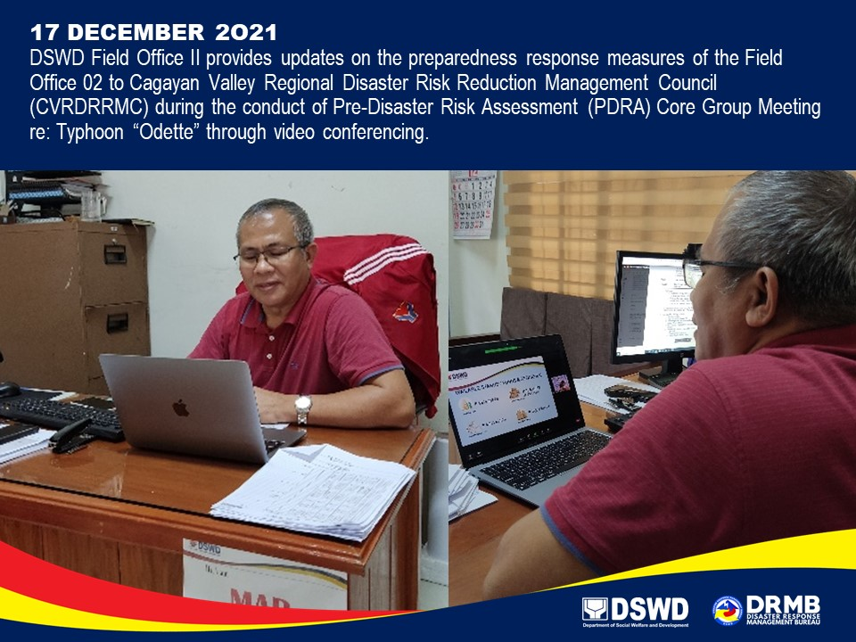

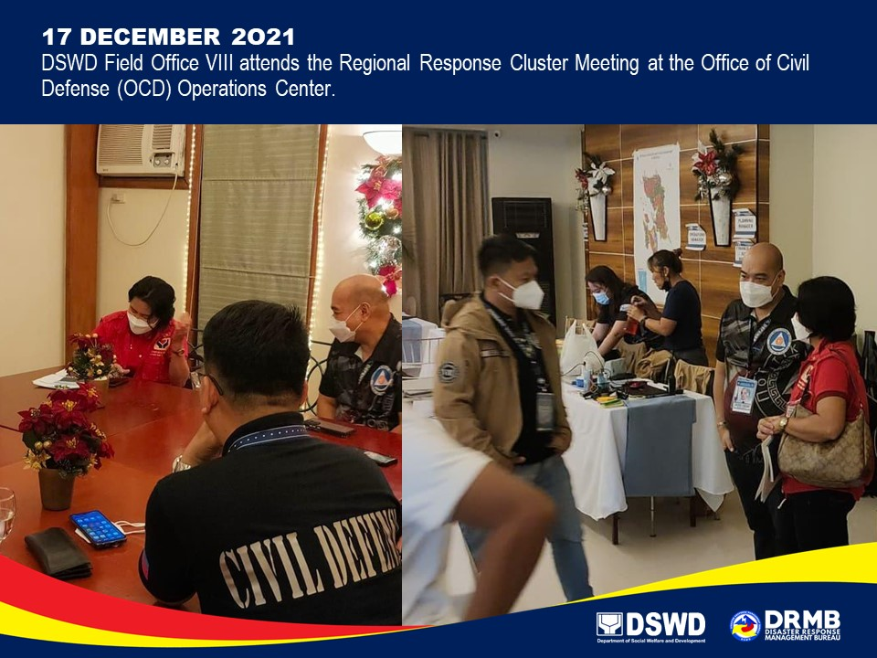

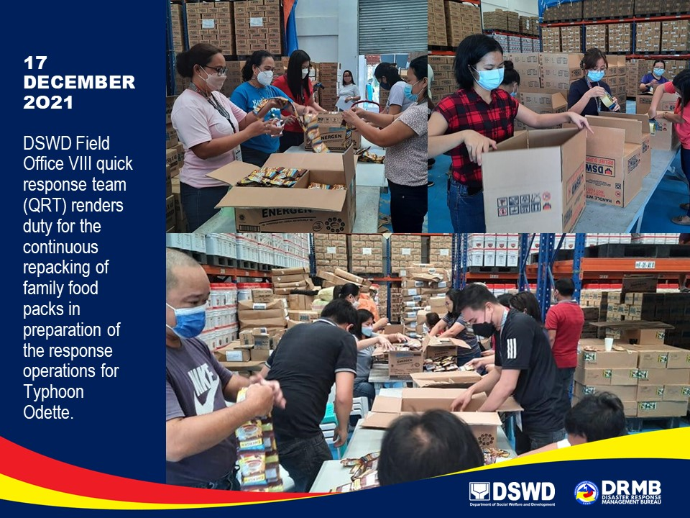

*****
The Disaster Response Operations Monitoring and Information Center (DROMIC) of DSWD-DRMB is closely coordinating with the concerned DSWD-FOs for significant disaster response updates and assistance provided.

Prepared by:  DIANE C. PELEGRINO  JEM ERIC F. FAMORCAN  MARIE JOYCE G. RAFANAN  JOANNA CAMILLE R. JACINTO  JAN ERWIN ANDREW I. ONTANILLAS | Released by:  MARC LEO L. BUTAC

