DSWD DROMIC Terminal Report on the Fire incident
in Brgy. 87 and 89, Pasay City
31 March 2022, 6PM

- Situation Overview

On 07 December 2021 at 6:15 PM, a fire incident occurred in Brgy. 87 and 89, Pasay City. The fire was put under control at 8:31 PM.
Source: DSWD-Field Office (FO) NCR

- Status of Affected Areas and Population

A total of 93 families or 262 persons were affected in Brgy. 87 and 89, Pasay City (see Table 1).

Table 1. Number of Affected Families / Persons
REGION / PROVINCE / MUNICIPALITY | NUMBER OF AFFECTED
 | Barangays | Families | Persons
GRAND TOTAL | 1 | 93 | 262
NCR | 1 | 93 | 262
Metro Manila | 1 | 93 | 262
Pasay City | 1 | 93 | 262
Source: DSWD-FO NCR

- Status of Displaced Population
- Inside Evacuation Center
There were a total of 93 families or 262 persons who took temporary shelter at the P. Villanueva Elementary School (see Table 2).

Table 2. Number of Displaced Families / Persons Inside Evacuation Center
REGION / PROVINCE / MUNICIPALITY | NUMBER OF EVACUATION CENTERS (ECs) |  | NUMBER OF DISPLACED
 |  |  | INSIDE ECs
 |  |  | Families |  | Persons
 | CUM | NOW | CUM | NOW | CUM | NOW
GRAND TOTAL | 1 | - | 93 | - | 262 | -
NCR | 1 | - | 93 | - | 262 | -
Metro Manila | 1 | - | 93 | - | 262 | -
Pasay City | 1 | - | 93 | - | 262 | -
Source: DSWD-FO NCR

- Damaged Houses
A total of 29 houses were totally damaged by the fire (see Table 3).

Table 3. Number of Damaged Houses
REGION / PROVINCE / MUNICIPALITY | NO. OF DAMAGED HOUSES
 | Total | Totally | Partially
GRAND TOTAL | 29 | 29 | -
NCR | 29 | 29 | -
Metro Manila | 29 | 29 | -
Pasay City | 29 | 29 | -
Source: DSWD-FO NCR
- Cost of Humanitarian Assistance Provided
A total of ₱45,796.50 worth of assistance was provided by DSWD to the affected families (see Table 3).

Table 3. Cost of Assistance Provided to Affected Families / Persons
REGION / PROVINCE / MUNICIPALITY |  | COST OF ASSISTANCE
 |  | DSWD | LGU | NGOs | OTHERS | GRAND TOTAL
GRAND TOTAL |  | 45,796.50 | - | - | - | 45,796.50
NCR |  | 45,796.50 | - | - | - | 45,796.50
Metro Manila |  | 45,796.50 | - | - | - | 45,796.50
 | Pasay City | 45,796.50 | - | - | - | 45,796.50
Source: DSWD-FO NCR

PHOTO DOCUMENTATION
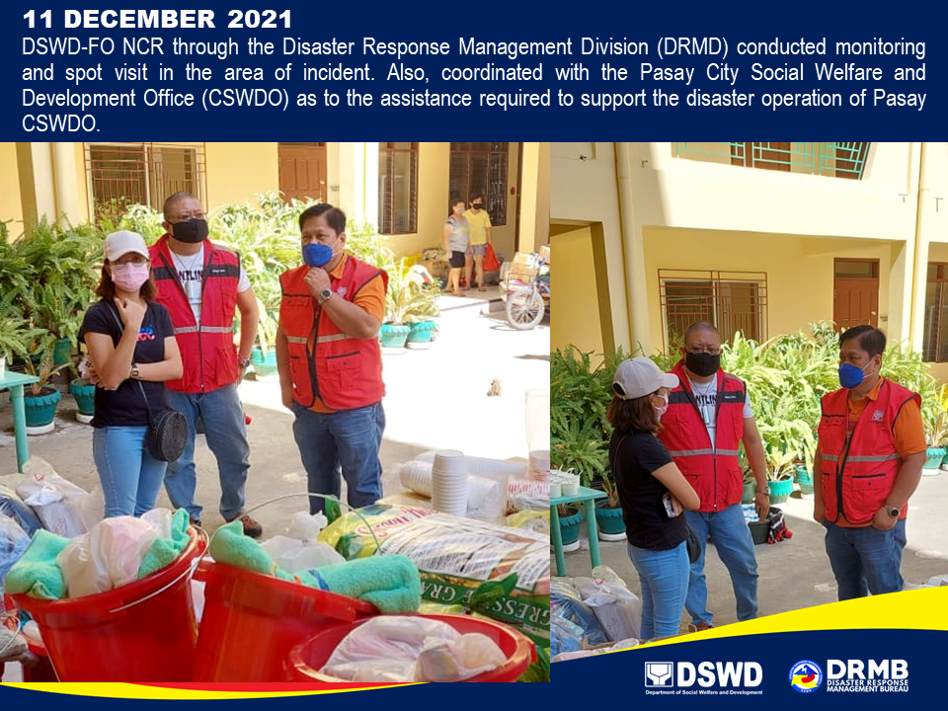

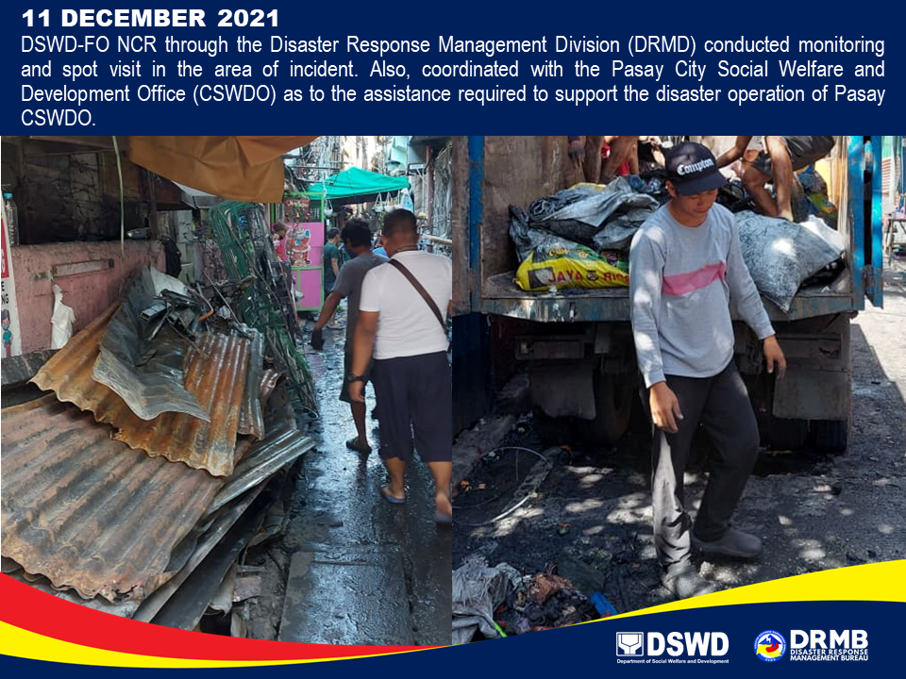

*****
This terminal report is based on the latest report submitted by DSWD-FO NCR on 09 March 2022. The Disaster Response Operations Monitoring and Information Center (DROMIC) of DSWD-DRMB continues to closely coordinate with DSWD-FO NCR for any request of Technical Assistance and Resource Augmentation (TARA).

Prepared by:  JOANNA CAMILLE R. JACINTO | Released by:  LESLIE R. JAWILI

