DSWD DROMIC Terminal Report on the Flooding Incident
in Oriental Mindoro
03 February 2022, 6PM

- Situation Overview

On 27 December 2021, Oriental Mindoro experienced flooding due to continuous heavy rains caused by the Shear Line or Northeast Monsoon.
Source: DSWD-Field Office (FO) MIMAROPA

- Status of Affected Areas and Population

A total of 10,901 families or 54,405 persons were affected in 35 barangays in Oriental Mindoro (see Table 1).

Table 1. Number of Affected Families / Persons
REGION / PROVINCE / MUNICIPALITY |  | NUMBER OF AFFECTED
 |  | Barangays | Families | Persons
GRAND TOTAL |  | 35 | 10,901 | 54,405
MIMAROPA |  | 35 | 10,901 | 54,405
Oriental Mindoro |  | 35 | 10,901 | 54,405
 | Baco | 16 | 8,821 | 44,105
 | Naujan | 16 | 2,020 | 10,089
 | City of Calapan (capital) | 3 | 60 | 211
Source: DSWD-FO MIMAROPA

- Status of Displaced Population

- Inside Evacuation Center
There were a total of 666 families or 3,230 persons who took temporary shelter in 18 evacuation centers in Oriental Mindoro and have now returned home (see Table 2).

Table 2. Number of Displaced Families / Persons Inside Evacuation Center
REGION / PROVINCE / MUNICIPALITY |  | NUMBER OF EVACUATION CENTERS (ECs) |  | NUMBER OF DISPLACED
 |  |  |  | INSIDE ECs
 |  |  |  | Families |  | Persons
 |  | CUM | NOW | CUM | NOW | CUM | NOW
GRAND TOTAL |  | 18 | - | 666 | - | 3,230 | -
MIMAROPA |  | 18 | - | 666 | - | 3,230 | -
Oriental Mindoro |  | 18 | - | 666 | - | 3,230 | -
 | Baco | 11 | - | 602 | - | 3,010 | -
 | Naujan | 2 | - | 9 | - | 34 | -
 | City of Calapan (capital) | 5 | - | 55 | - | 186 | -
Source: DSWD-FO MIMAROPA

- Outside Evacuation Center
There were a total of 192 families or 960 persons who temporarily stayed with their relatives and/or friends and have now returned home (see Table 3).

Table 3. Number of Displaced Families / Persons Outside Evacuation Center
REGION / PROVINCE / MUNICIPALITY |  | NUMBER OF DISPLACED
 |  | OUTSIDE ECs
 |  | Families |  | Persons
 |  | CUM | NOW | CUM | NOW
GRAND TOTAL |  | 192 | - | 960 | -
MIMAROPA |  | 192 | - | 960 | -
Oriental Mindoro |  | 192 | - | 960 | -
 | Baco | 187 | - | 935 | -
 | City of Calapan (capital) | 5 | - | 25 | -
Source: DSWD-FO MIMAROPA

- Total Displaced Population
A total of 858 families or 4,190 persons were displaced in Oriental Mindoro and have now returned home (see Table 4).

Table 4. Total Number of Displaced Families/Persons
REGION / PROVINCE / MUNICIPALITY |  | TOTAL DISPLACED
 |  | Families |  | Persons
 |  | CUM | NOW | CUM | NOW
GRAND TOTAL |  | 858 | - | 4,190 | -
MIMAROPA |  | 858 | - | 4,190 | -
Oriental Mindoro |  | 858 | - | 4,190 | -
 | Baco | 789 | - | 3,945 | -
 | City of Calapan | 60 | - | 211 | -
 | Naujan | 9 | - | 34 | -
Source: DSWD-FO MIMAROPA

- Cost of Humanitarian Assistance Provided

A total of ₱2,893,066.00 worth of assistance was provided to the affected families; of which, ₱2,076,200.00 was provided by DSWD and ₱816,866.00 was provided by the Local Government Units (LGUs) to the affected families (see Table 5).

Table 5. Cost of Assistance Provided to Affected Families / Persons
REGION / PROVINCE / MUNICIPALITY |  | COST OF ASSISTANCE
 |  | DSWD | LGUs | NGOs | OTHERS | GRAND TOTAL
GRAND TOTAL |  | 2,076,200.00 | 816,866.00 | - | - | 2,893,066.00
MIMAROPA |  | 2,076,200.00 | 816,866.00 | - | - | 2,893,066.00
Oriental Mindoro |  | 2,076,200.00 | 816,866.00 | - | - | 2,893,066.00
 | Baco | 700,000.00 | 627,650.00 | - | - | 1,327,650.00
 | Naujan | 1,376,200.00 | 189,216.00 | - | - | 1,565,416.00
Source: DSWD-FO MIMAROPA

- Photo Documentation

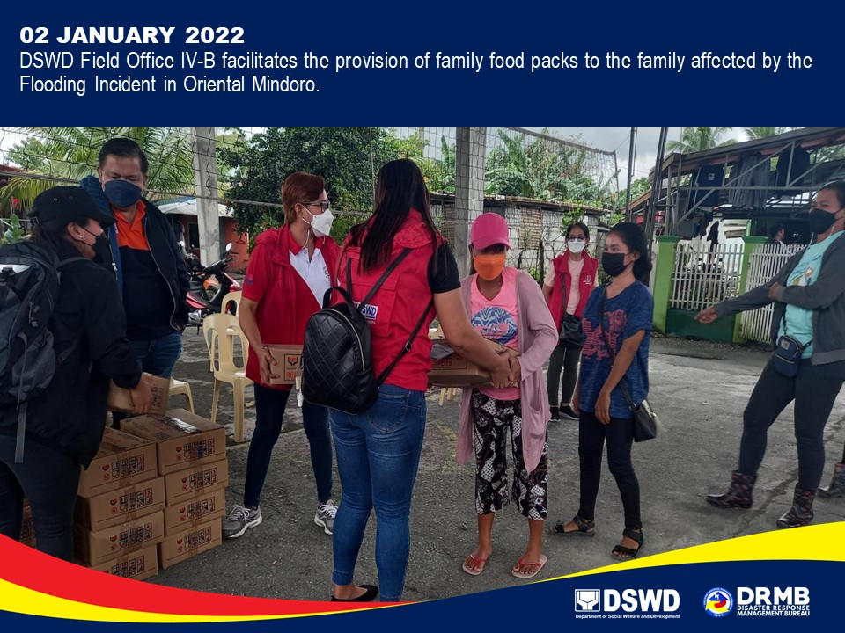

*****
This final report is based on the terminal report submitted by DSWD-FO MIMAROPA on 03 January 2022. The Disaster Response Operations Monitoring and Information Center (DROMIC) of DSWD-DRMB continues to closely coordinate with DSWD-FO MIMAROPA for any request of Technical Assistance and Resource Augmentation (TARA).

Prepared by:  MARIE JOYCE G. RAFANAN | Released by:  RODEL V. CABADDU

