DSWD DROMIC Terminal Report on the Fire Incident
in Brgy. Bitu, Hingyon, Ifugao
03 February 2022, 6PM

- Situation Overview

On 16 January 2022 at 7:50 PM, a fire incident occurred in Sitio Culob, Brgy. Bitu Hingyon, Ifugao.
Source: DSWD-Field Office (FO) CAR

- Status of Affected Areas and Population

There is one (1) family or seven (7) persons affected in Brgy. Bitu Hingyon, Ifugao (see Table 1).

Table 1. Number of Affected Families / Persons
REGION / PROVINCE / MUNICIPALITY |  | NUMBER OF AFFECTED
 |  | Barangays | Families | Persons
GRAND TOTAL |  | 1 | 1 | 7
CAR |  | 1 | 1 | 7
Ifugao |  | 1 | 1 | 7
 | Hingyon | 1 | 1 | 7

Source: DSWD-FO CAR

- Status of Displaced Population
- Outside Evacuation Center
There is one (1) family or seven (7) persons who are temporarily staying with their relatives and/or friends (see Table 2).

Table 2. Number of Displaced Families / Persons Outside Evacuation Center
REGION / PROVINCE / MUNICIPALITY |  | NUMBER OF DISPLACED
 |  | OUTSIDE ECs
 |  | Families |  | Persons
 |  | CUM | NOW | CUM | NOW
GRAND TOTAL |  | 1 | 1 | 7 | 7
CAR |  | 1 | 1 | 7 | 7
Ifugao |  | 1 | 1 | 7 | 7
 | Hingyon | 1 | 1 | 7 | 7
Source: DSWD-FO CAR

- Cost of Humanitarian Assistance Provided

A total of ₱9,646.51 worth of assistance was provided by DSWD to the affected families (see Table 3).

Table 3. Cost of Assistance Provided to Affected Families / Persons
REGION / PROVINCE / MUNICIPALITY |  | COST OF ASSISTANCE
 |  | DSWD | LGU | NGOs | OTHERS | GRAND TOTAL
GRAND TOTAL |  | 9,646.51 | - | - | - | 9,646.51
CAR |  | 9,646.51 | - | - | - | 9,646.51
Ifugao |  | 9,646.51 | - | - | - | 9,646.51
 | Hingyon | 9,646.51 | - | - | - | 9,646.51
Source: DSWD-FO CAR

- Photo Documentation
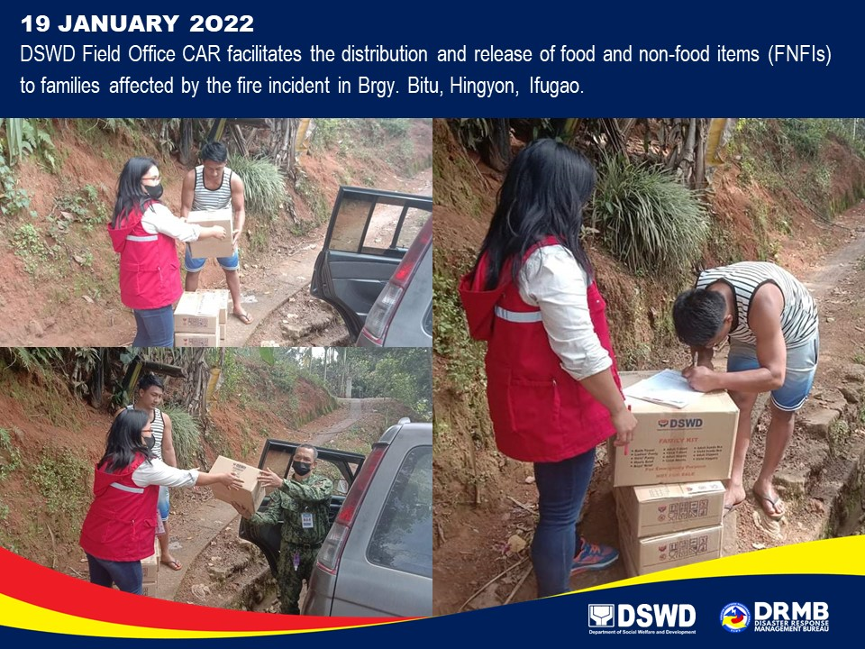

*****
This final report is based on the terminal report submitted by DSWD-FO CAR on 21 January 2022. The Disaster Response Operations Monitoring and Information Center (DROMIC) of DSWD-DRMB continues to closely coordinate with DSWD-FO CAR for any request of Technical Assistance and Resource Augmentation (TARA).

Prepared by:  MARIE JOYCE G. RAFANAN | Released by:  RODEL V. CABADDU

