DSWD DROMIC Report #1 on the Effects of Low Pressure Area
as of 10 March 2022, 6PM

- Situation Overview

Issued on 10 March 2022 at 4 AM, the Low Pressure Area (LPA) was estimated based on all available data at 465 km West of Zamboanga City or 255 km South Southwest of Puerto Princesa City (7.6°N, 117.9°E).
Source: DOST-PAGASA Daily Weather Forecast

- Status of Affected Areas and Population

There are 3,780 families or 16,194 persons affected in 35 barangays in Regions X, XI and XII (see Table 1).

Table 1. Number of Affected Families / Persons
REGION / PROVINCE / MUNICIPALITY |  | NUMBER OF AFFECTED
 |  | Barangays | Families | Persons
GRAND TOTAL |  | 35 | 3,780 | 16,194
REGION X |  | 8 | 770 | 2,286
Lanao del Norte |  | 8 | 770 | 2,286
 | Baloi | 8 | 770 | 2,286
REGION XI |  | 15 | 606 | 2,062
Davao de Oro |  | 12 | 158 | 711
 | Compostela | 1 | 1 | 5
 | Mawab | 5 | 65 | 393
 | Nabunturan (capital) | 3 | 80 | 264
 | New Bataan | 3 | 12 | 49
Davao del Sur |  | 2 | 441 | 1,316
 | Davao City | 2 | 441 | 1,316
Davao Oriental |  | 1 | 7 | 35
 | City of Mati (capital) | 1 | 7 | 35
REGION XII |  | 20 | 2,404 | 11,846
Sarangani |  | 12 | 934 | 4,441
 | Maitum | 12 | 934 | 4,441
South Cotabato |  | 4 | 96 | 535
 | Lake Sebu | 2 | 79 | 462
 | T'boli | 2 | 17 | 73
Sultan Kudarat |  | 4 | 1,374 | 6,870
 | Lambayong (Mariano Marcos) | 4 | 1,374 | 6,870
Note: Ongoing assessment and validation are continuously being conducted.
Source: DSWD-Field Offices (FOs) X, XII and XII

- Status of Displaced Population

    - Inside Evacuation Center
There are 886 families or 3,362 persons currently taking temporary shelter inside 13 evacuation centers (see Table 2).

Table 2. Number of Displaced Families / Persons Inside Evacuation Center
REGION / PROVINCE / MUNICIPALITY |  | NUMBER OF EVACUATION CENTERS (ECs) |  | NUMBER OF DISPLACED
 |  |  |  | INSIDE ECs
 |  |  |  | Families |  | Persons
 |  | CUM | NOW | CUM | NOW | CUM | NOW
GRAND TOTAL |  | 13 | 13 | 886 | 886 | 3,362 | 3,362
REGION XI |  | 7 | 7 | 506 | 506 | 1,709 | 1,709
Davao de Oro |  | 5 | 5 | 65 | 65 | 393 | 393
 | Mawab | 5 | 5 | 65 | 65 | 393 | 393
Davao del Sur |  | 2 | 2 | 441 | 441 | 1,316 | 1,316
 | Davao City | 2 | 2 | 441 | 441 | 1,316 | 1,316
REGION XII |  | 6 | 6 | 380 | 380 | 1,653 | 1,653
Sarangani |  | 1 | 1 | 287 | 287 | 1,206 | 1,206
 | Maitum | 1 | 1 | 287 | 287 | 1,206 | 1,206
South Cotabato |  | 5 | 5 | 93 | 93 | 447 | 447
 | Lake Sebu | 4 | 4 | 79 | 79 | 383 | 383
 | T'boli | 1 | 1 | 14 | 14 | 64 | 64
Note: Ongoing assessment and validation are continuously being conducted.
Source: DSWD-FOs XI and XII

    - Outside Evacuation Center
There are 83 families or 279 persons temporarily staying with their relatives and/or friends in Region XI (see Table 3).

Table 3. Number of Displaced Families / Persons Outside Evacuation Center
REGION / PROVINCE / MUNICIPALITY |  | NUMBER OF DISPLACED
 |  | OUTSIDE ECs
 |  | Families |  | Persons
 |  | CUM | NOW | CUM | NOW
GRAND TOTAL |  | 83 | 83 | 279 | 279
REGION XI |  | 83 | 83 | 279 | 279
Davao de Oro |  | 83 | 83 | 279 | 279
 | Compostela | 1 | 1 | 5 | 5
 | Nabunturan (capital) | 80 | 80 | 264 | 264
 | New Bataan | 2 | 2 | 10 | 10
Note: Ongoing assessment and validation are continuously being conducted.
Source: DSWD-FO XI

    - Total Displaced Population
There are 969 families or 3,641 persons temporarily staying either in evacuation centers or with their relatives and/or friends in Regions XI and XII (see Table 4).

Table 4. Total Number of Displaced Families / Persons
REGION / PROVINCE / MUNICIPALITY |  | TOTAL DISPLACED
 |  | Families |  | Persons
 |  | CUM | NOW | CUM | NOW
GRAND TOTAL |  | 969 | 969 | 3,641 | 3,641
REGION XI |  | 589 | 589 | 1,988 | 1,988
Davao de Oro |  | 148 | 148 | 672 | 672
 | Compostela | 1 | 1 | 5 | 5
 | Mawab | 65 | 65 | 393 | 393
 | Nabunturan (capital) | 80 | 80 | 264 | 264
 | New Bataan | 2 | 2 | 10 | 10
Davao del Sur |  | 441 | 441 | 1,316 | 1,316
 | Davao City | 441 | 441 | 1,316 | 1,316
REGION XII |  | 380 | 380 | 1,653 | 1,653
Sarangani |  | 287 | 287 | 1,206 | 1,206
 | Maitum | 287 | 287 | 1,206 | 1,206
South Cotabato |  | 93 | 93 | 447 | 447
 | Lake Sebu | 79 | 79 | 383 | 383
 | T'boli | 14 | 14 | 64 | 64
Note: Ongoing assessment and validation are continuously being conducted.
Source: DSWD-FOs XI and XII

- Damaged Houses

A total of seven (7) houses were partially damaged in Region XI (see Table 5).

Table 5. Number of Damaged Houses
REGION / PROVINCE / MUNICIPALITY |  | NO. OF DAMAGED HOUSES
 |  | Total | Totally | Partially
GRAND TOTAL |  | 7 | - | 7
REGION XI |  | 7 | - | 7
Davao Oriental |  | 7 | - | 7
 | City of Mati (capital) | 7 | - | 7
Note: Ongoing assessment and validation being conducted.
Source: DSWD-FO XI

- Response Actions and Interventions

- Standby Funds and Prepositioned Relied Stockpile

OFFICE | STANDBY FUNDS | STOCKPILE |  |  | TOTAL STANDBY FUNDS & STOCKPILE
 |  | FAMILY FOOD PACKS |  | OTHER FOOD AND NON-FOOD ITEMS (FNIs)
 |  | QUANTITY | TOTAL COST
TOTAL | 241,679,686.35 | 75,070 | 45,150,784.88 | 393,124,839.95 | 679,955,311.18
DSWD-CO | 225,485,399.00 | - | - | - | 225,485,399.00
NRLMB-NROC | - | 13,776 | 8,489,257.00 | 267,109,575.75 | 275,598,832.75
NRLMB-VDRC | - | 4,061 | 2,525,942.00 | 32,115,796.70 | 34,641,738.70
DSWD-FO X | 6,193,317.50 | 15,172 | 10,475,929.38 | 37,472,388.83 | 54,141,635.71
DSWD-FO XI | 5,000,000.00 | 22,609 | 13,079,306.50 | 23,972,222.80 | 42,051,529.30
DSWD-FO XII | 5,000,969.85 | 19,452 | 10,580,350.00 | 32,454,855.87 | 48,036,175.72
Note: Inventory Summary is as of 10 March 2022, 4PM.
Source: DSWD-DRMB and DSWD-NRLMB

  - Standby Funds
    - ₱225.49 million Quick Response Fund (QRF) at the DSWD-Central Office.
    - ₱16.19 million available at DSWD-FOs X, XI and XII.

  - Prepositioned FFPs and Other Relief Items
    - 17,837 FFPs available in Disaster Response Centers; of which, 13,776 FFPs are at the National Resource Operations Center (NROC), Pasay City and 4,061 FFPs are at the Visayas Disaster Response Center (VDRC), Cebu City.
    - 57,233 FFPs available at DSWD-FOs X, XI and XII.
    - ₱393.12 million worth of other FNIs at NROC, VDRC and DSWD-FOs X, XI and XII warehouses.

- Food and Non-Food Items

DSWD-FO XI
DATE | SITUATIONS / ACTIONS UNDERTAKEN
07 March 2022 | - The Davao City Government through its City Social Welfare and Development Office (CSWDO) provided hot meals to the affected families during their stay in the evacuation centers.

DSWD-FO XII
DATE | SITUATIONS / ACTIONS UNDERTAKEN
09 March 2022 | - The LGU of Lake Sebu, South Cotabato has immediately provided hot meals to individuals who stayed inside evacuation centers.  - The LGU of Maitum, Sarangani has also provided hot meals, sleeping kits and clothes to the affected families.

- Internally Displaced Person (IDP) Protection

DSWD-FO XI
DATE | SITUATIONS / ACTIONS UNDERTAKEN
07 March 2022 | - The Provincial Government of Davao de Oro in coordination with Municipal counterparts had provided Psychological First Aid and assessed the needs of the affected families and individuals.

- Camp Coordination and Camp Management (CCCM)

DSWD-FO XI
DATE | SITUATIONS / ACTIONS UNDERTAKEN
07 March 2022 | - DSWD-FO XI through its Disaster Response Management Division (DRMD) is in close coordination with LGUs for reports and updates on the situation of the IDPs inside evacuation centers and to ensure compliance with the provision of emergency relief and protection for the children (Republic Act No. 10821) before, during and after disasters and other emergency situations as well as to monitor the compliance with the safety and health protocols set by the Inter-Agency Task Force (IATF).

- Other Activities

DSWD-FO XII
DATE | SITUATIONS / ACTIONS UNDERTAKEN
09 March 2022 | - The LGU of T’boli, South Cotabato has conducted profiling of all affected families and provided them with relief assistance.

- Photo Documentation

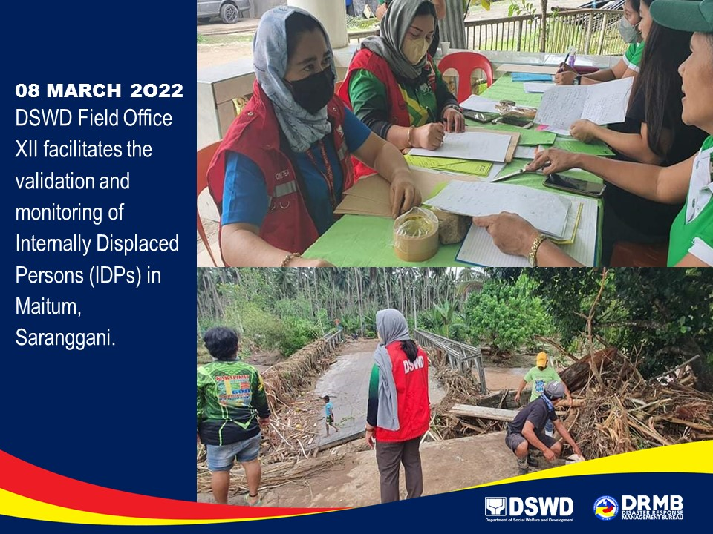

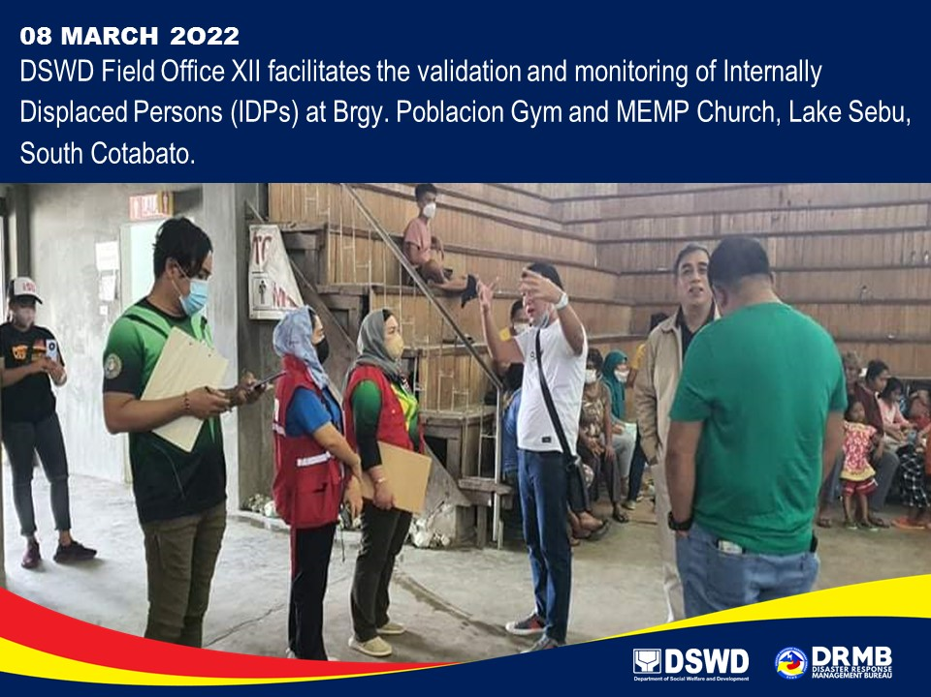

*****
The Disaster Response Operations Monitoring and Information Center (DROMIC) of DSWD-DRMB is closely coordinating with concerned DSWD-Field Offices for significant disaster response updates and assistance provided.

Prepared by:  MARIE JOYCE G. RAFANAN  JOANNA CAMILLE R. JACINTO  AARON JOHN B. PASCUA | Released by:  MARC LEO L. BUTAC

