DSWD DROMIC Report #1 on the Effects of Shear Line
as of 21 February 2022, 6PM

- Situation Overview

Issued on 11 February 2022 at 7PM, the Shear Line brought Light to moderate to at times heavy rains with possible lightning and strong winds are being experienced over portions of Camiguin, Zamboanga del Sur (Molave and Conception), Zamboanga del Norte (Dipolog, Dapitan, Pinan, Mutia, La Libertad, and Sergio Ozmena), Misamis Occidental, Lanao del Norte, Lanao del Sur, Maguindanao (Matanog, Buldon, Barira, Parang, and Sultan Kudarat), North Cotabato (Alamada, Banisilan, Libungan, and Pigcawayan), Bukidnon (Talakag, Baungon, Manolo Fortich, Malitbog, Impasugong, Kalilangan, and Pangantukan), Misamis Oriental (Lugait, Manticao, Balingasag, and Cagayande Oro City) and may affect nearby areas.

Source: DOST-PAGASA RAINFALL ADVISORY

- Status of Affected Areas and Population

A total of 4,177 families or 16,634 persons are affected in 31 barangays in Regions II and VIII (see Table 1).

Table 1. Number of Affected Families / Persons
REGION / PROVINCE / MUNICIPALITY |  | NUMBER OF AFFECTED
 |  | Barangays | Families | Persons
GRAND TOTAL |  | 31 | 4,177 | 16,634
REGION II |  | 16 | 1,077 | 4,791
Cagayan |  | 16 | 1,077 | 4,791
 | Claveria | 16 | 1,077 | 4,791
REGION VIII |  | 15 | 3,100 | 11,843
Eastern Samar |  | 13 | 2,714 | 9,913
 | Jipapad | 13 | 2,714 | 9,913
Northern Samar |  | 2 | 386 | 1,930
 | San Roque | 2 | 386 | 1,930
Note: Ongoing assessment and validation being conducted.
Source: DSWD-Field Office (FO) II and VIII

- Status of Displaced Population

- Inside Evacuation Center
A total of 381 families or 1,855 persons sought temporary shelter in nine (9) evacuation centers in Regions II and VIII (see Table 2).

Table 2. Number of Displaced Families / Persons Inside Evacuation Center
REGION / PROVINCE / MUNICIPALITY |  | NUMBER OF EVACUATION CENTERS (ECs) |  | NUMBER OF DISPLACED
 |  |  |  | INSIDE ECs
 |  |  |  | Families |  | Person
 |  | CUM | NOW | CUM | NOW | CUM | NOW
GRAND TOTAL |  | 9 | - | 381 | - | 1,855 | -
REGION II |  | 3 | - | 48 | - | 190 | -
Cagayan |  | 3 | - | 48 | - | 190 | -
 | Claveria | 3 | - | 48 | - | 190 | -
REGION VIII |  | 6 | - | 333 | - | 1,665 | -
Eastern Samar |  | 2 | - | 20 | - | 100 | -
 | Jipapad | 2 | - | 20 | - | 100 | -
Northern Samar |  | 4 | - | 313 | - | 1,565 | -
 | San Roque | 4 | - | 313 | - | 1,565 | -
Note: Ongoing assessment and validation being conducted.
Source: DSWD-FO II and VIII

- Outside Evacuation Center
A total of 154 families or 722 persons sought temporary shelter with their relatives and/or friends in Regions II and VIII (see Table 3).

Table 3. Number of Displaced Families / Persons Outside Evacuation Centers
REGION / PROVINCE / MUNICIPALITY |  | NUMBER OF DISPLACED
 |  | OUTSIDE ECs
 |  | Families |  | Persons
 |  | CUM | NOW | CUM | NOW
GRAND TOTAL |  | 154 | - | 722 | -
REGION II |  | 81 | - | 357 | -
Cagayan |  | 81 | - | 357 | -
 | Claveria | 81 | - | 357 | -
REGION VIII |  | 73 | - | 365 | -
Northern Samar |  | 73 | - | 365 | -
 | San Roque | 73 | - | 365 | -
Note: Ongoing assessment and validation being conducted.
Source: DSWD-FO II and VIII

- Total Displaced Population
A total of 535 families or 2,577 persons were displaced in Regions II and VIII due to the effects of Shearline (see Table 4).

Table 4. Total Number of Displaced Families / Persons
REGION / PROVINCE / MUNICIPALITY |  | TOTAL DISPLACED SERVED
 |  | Families |  | Persons
 |  | Total Families |  | Total Persons
 |  | CUM | NOW | CUM | NOW
GRAND TOTAL |  | 535 | - | 2,577 | -
REGION II |  | 129 | - | 547 | -
Cagayan |  | 129 | - | 547 | -
 | Claveria | 129 | - | 547 | -
REGION VIII |  | 406 | - | 2,030 | -
Eastern Samar |  | 20 | - | 100 | -
 | Jipapad | 20 | - | 100 | -
Northern Samar |  | 386 | - | 1,930 | -
 | San Roque | 386 | - | 1,930 | -
Note: Ongoing assessment and validation being conducted.
Source: DSWD-FO II and VIII

- Damaged Houses
A total of one (1) house was totally damaged in Region II (see Table 5).

Table 5. Number of Damaged Houses
REGION / PROVINCE / MUNICIPALITY |  | NO. OF DAMAGED HOUSES
 |  | Total | Totally | Partially
GRAND TOTAL |  | 1 | - | 1
REGION II |  | 1 | - | 1
Cagayan |  | 1 | - | 1
 | Claveria | 1 | - | 1
Note: Ongoing assessment and validation being conducted.
Source: DSWD-FO II

- Cost of Humanitarian Assistance Provided
A total of ₱697,262.00 worth of assistance was provided by DSWD to the affected families (see Table 6).

Table 6. Cost of Assistance Provided to Affected Families / Persons
REGION / PROVINCE / MUNICIPALITY |  | COST OF ASSISTANCE
 |  | DSWD | LGU | NGOs | OTHERS | GRAND TOTAL
GRAND TOTAL |  | 697,262.00 | - | - | - | 697,262.00
REGION II |  | 697,262.00 | - | - | - | 697,262.00
Cagayan |  | 697,262.00 | - | - | - | 697,262.00
 | Claveria | 697,262.00 | - | - | - | 697,262.00
Source: DSWD-FO II

- Response Actions and Interventions

- Standby Funds and Prepositioned Relief Stockpile
OFFICE | STANDBY FUNDS | STOCKPILE |  |  | TOTAL STANDBY FUNDS & STOCKPILE
 |  | FAMILY FOOD PACKS |  | OTHER FOOD AND NON-FOOD ITEMS (FNIs)
 |  | QUANTITY | TOTAL COST
TOTAL | 421,070,842.71 | 113,068 | 73,240,749.75 | 334,013,266.15 | 828,324,858.61
DSWD-CO | 411,111,544.03 | - | - | - | 411,111,544.03
NRLMB-NROC | - | 41,785 | 28,221,951.50 | 249,686,985.77 | 277,908,937.27
NRLMB-VDRC | - | 18,338 | 11,479,164.00 | 38,137,498.30 | 49,616,662.30
DSWD-FO II | 4,959,298.68 | 31,011 | 19,755,634.25 | 28,842,937.71 | 53,557,870.64
DSWD-FO VIII | 5,000,000.00 | 21,934 | 13,784,000.00 | 17,345,844.37 | 36,129,844.37
Note: The Inventory Summary is as of 21 February January 2022, 4PM.
Source: DSWD-DRMB and DSWD-NRLMB

  - Standby Funds
    - ₱411.11 million Quick Response Fund (QRF) at the DSWD-Central Office.
    - ₱9.96 million available at DSWD-FOs II and VIII.

  - Prepositioned FFPs and Other Relief Items
    - 60,123 FFPs available in Disaster Response Centers; of which, 41,785 FFPs are at the National Resource Operations Center (NROC), Pasay City and 18,338 FFPs are at the Visayas Disaster Response Center (VDRC), Cebu City.
    - 52,945 FFPs available at DSWD-FOs II and VIII.
    - ₱334.01 million worth of other FNIs at NROC, VDRC and DSWD-FOs II and VIII warehouses.

- Photo Documentation

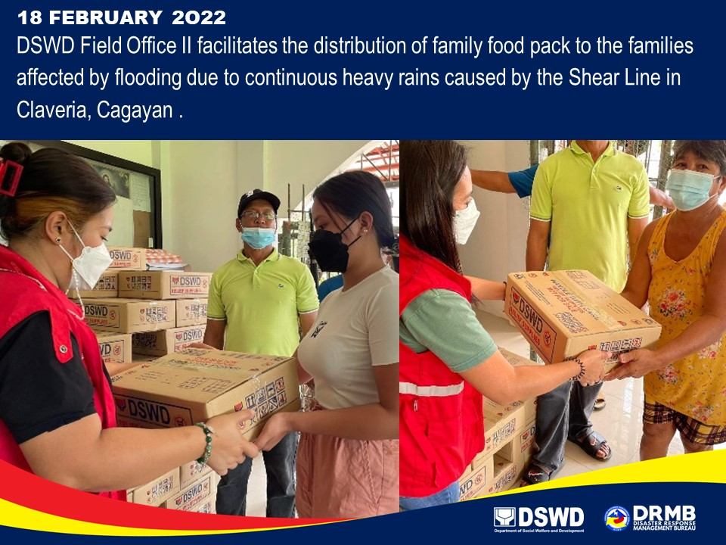

*****
The Disaster Response Operations Monitoring and Information Center (DROMIC) of DSWD-DRMB is closely coordinating with DSWD-FOs II and VIII for significant disaster response updates and assistance provided.

Prepared by:  AARON JOHN B. PASCUA  MARIE JOYCE G. RAFANAN | Released by:  RODEL V. CABADDU

