DSWD DROMIC Report #1 on the Fire Incident in
Brgy. Sta. Cruz, Arevalo, Iloilo City
as of 03 March 2022, 6PM
- Situation Overview

On 22 February 2022 at around 9 AM, a fire incident transpired in Brgy. Sta. Cruz, Arevalo, Iloilo City.
Source: DSWD-Field Office (FO) VI

- Status of Affected Areas and Population

A total of two (2) family or six (6) persons are affected in Brgy. Sta. Cruz, Arevalo, Iloilo City (see Table 1).

Table 1. Number of Affected Families / Persons
REGION / PROVINCE / MUNICIPALITY |  | NUMBER OF AFFECTED
 |  | Barangays | Families | Persons
GRAND TOTAL |  | 1 | 2 | 6
REGION VI |  | 1 | 2 | 6
Iloilo |  | 1 | 2 | 6
 | Iloilo City (capital) | 1 | 2 | 6
Note: Ongoing assessment and validation being conducted.
Source: DSWD FO VI

- Status of Displaced Population

- Outside Evacuation Center
There are two (2) families or six (6) persons currently taking temporary shelter with their relatives and/or friends in Brgy. Sta. Cruz, Arevalo, Iloilo City (see Table 2).

Table 2. Number of Displaced Families / Persons Outside Evacuation Centers
REGION / PROVINCE / MUNICIPALITY |  | NUMBER OF DISPLACED
 |  | OUTSIDE ECs
 |  | Families |  | Persons
 |  | CUM | NOW | CUM | NOW
GRAND TOTAL |  | 2 | 2 | 6 | 6
REGION VI |  | 2 | 2 | 6 | 6
Iloilo |  | 2 | 2 | 6 | 6
 | Iloilo City (capital) | 2 | 2 | 6 | 6
Note: Ongoing assessment and validation being conducted.
Source: DSWD-FO VI

- Damaged Houses
A total of two (2) houses were damaged; of which, one (1) is totally damaged and one (1) is partially damaged in Brgy. Sta. Cruz, Arevalo, Iloilo City (see Table 3).

Table 3. Number of Damaged Houses
REGION / PROVINCE / MUNICIPALITY |  | NO. OF DAMAGED HOUSES
 |  | Total | Totally | Partially
GRAND TOTAL |  | 2 | 1 | 1
REGION VI |  | 2 | 1 | 1
Iloilo |  | 2 | 1 | 1
 | Iloilo City (capital) | 2 | 1 | 1
Note: Ongoing assessment and validation being conducted.
Source: DSWD-FO VI

- Cost of Humanitarian Assistance Provided
A total of ₱17,798.50 worth of assistance was provided to the affected families; of which ₱12,777.00 was provided by the DSWD and ₱5,021.50 from the Local Government Unit (see Table 4).

Table 4. Cost of Assistance Provided to Affected Families / Persons
REGION / PROVINCE / MUNICIPALITY |  | COST OF ASSISTANCE
 |  | DSWD | LGU | NGOs | OTHERS | GRAND TOTAL
GRAND TOTAL |  | 12,777.00 | 5,021.50 | - | - | 17,798.50
REGION VI |  | 12,777.00 | 5,021.50 | - | - | 17,798.50
Iloilo |  | 12,777.00 | 5,021.50 | - | - | 17,798.50
 | Iloilo City (capital) | 12,777.00 | 5,021.50 | - | - | 17,798.50
Source: DSWD-FO VI

- Response Actions and Interventions

- Standby Funds and Prepositioned Relief Stockpile
OFFICE | STANDBY FUNDS | STOCKPILE |  |  | TOTAL STANDBY FUNDS & STOCKPILE
 |  | FAMILY FOOD PACKS |  | OTHER FOOD AND NON-FOOD ITEMS (FNIs)
 |  | QUANTITY | TOTAL COST
TOTAL | 283,406,701.92 | 54,164 | 34,087,054.51 | 319,254,333.99 | 636,748,090.42
DSWD-CO | 278,406,040.50 | - | - | - | 278,406,040.50
NRLMB-NROC | - | 22,906 | 16,649,657.50 | 273,553,044.20 | 290,202,701.70
NRLMB-VDRC | - | 16,442 | 10,226,924.00 | 32,582,103.30 | 42,809,027.30
DSWD-FO VI | 5,000,661.42 | 14,816 | 7,210,473.01 | 13,119,186.49 | 25,330,320.92
Note: The Inventory Summary is as of 03 March 2022, 4PM.
Source: DSWD-DRMB and DSWD-NRLMB

  - Standby Funds
    - ₱278.41 million Quick Response Fund (QRF) at the DSWD-Central Office.
    - ₱5 million available at DSWD-FO VI.

  - Prepositioned FFPs and Other Relief Items
    - 39,348 FFPs available in Disaster Response Centers; of which, 22,906 FFPs are at the National Resource Operations Center (NROC), Pasay City and 16,442 FFPs are at the Visayas Disaster Response Center (VDRC), Cebu City.
    - 14,816 FFPs available at DSWD-FO VI.
    - ₱319.25 million worth of other FNIs at NROC, VDRC and DSWD-FO VI warehouses.

- Photo Documentation

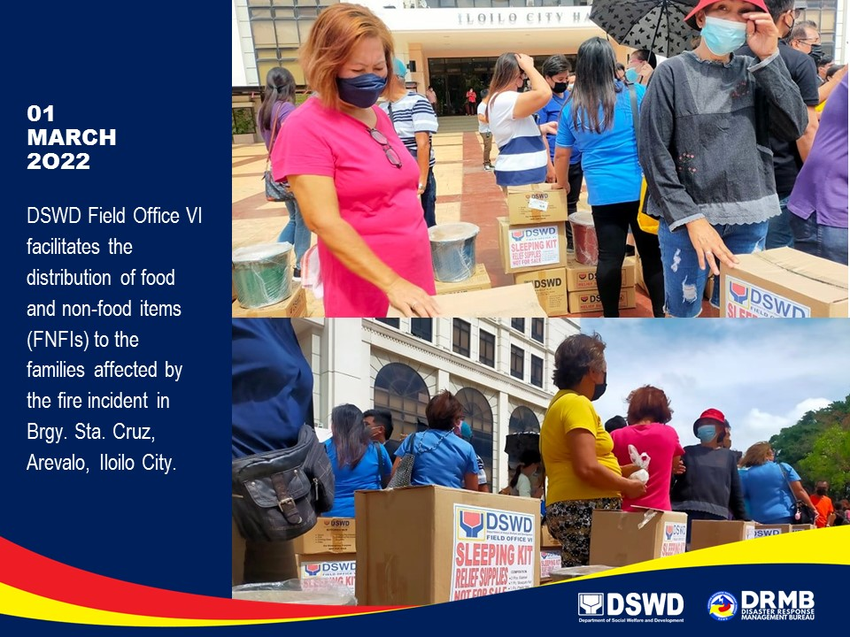

*****
The Disaster Response Operations Monitoring and Information Center (DROMIC) of DSWD-DRMB is closely coordinating with DSWD-FO VI for significant disaster response updates and assistance provided.

Prepared by:  AARON JOHN B. PASCUA  MARIE JOYCE G. RAFANAN | Released by:  RODEL V. CABADDU

