DSWD DROMIC Report #1 on the
Mw 5.3 Earthquake Incident in Burauen, Leyte
as of 24 March 2022, 6PM
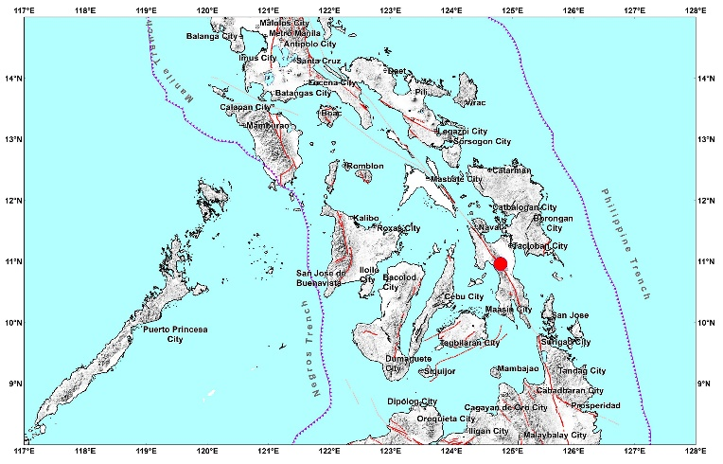

Situation Overview

On 21 March 2022 at 12:39 AM, a 5.3 magnitude earthquake jolted the municipality of Burauen, Leyte (0.95°N, 124.80°E - 010 km S 77°W) with a tectonic origin and a depth of focus of 004 km. The earthquake was also felt in the neighboring municipalities of Burauen, Leyte.

Date/Time: | 21 March 2022, 12:39:19 AM
Reported Intensities: | Intensity V - Burauen, Albuera, Ormoc City, Kananga, La Paz, Julita, Dagami, Tabontabon and Pastrana, Leyte  Intensity IV - Dulag, Sta. Fe, Barugo, Abuyog, Palo, Tolosa, Capoocan, Inopacan, Hindang, Hilongos, MacArthur, Palompon and Baybay City, Leyte; Tacloban City  Intensity III - Cebu City and Talisay City, Cebu; Lawaan, Eastern Samar; Leyte, Carigara and Alangalang, Leyte; Biliran, Biliran  Intensity II - Maasin City, Southern Leyte; Borongan City and Taft, Eastern Samar; Naval, Biliran and Gingoog, Misamis Oriental  Intensity I - Zamboanga City
Expecting Damage: | NO
Expecting Aftershocks: | YES
Source: DOST-PHIVOLCS Earthquake Bulletin

- Status of Affected Families / Persons

There were 41 families or 205 persons affected by the earthquake incident in three (3) barangays in Region VIII (see Table 1).

Table 1. Number of Affected Families / Persons
REGION / PROVINCE / MUNICIPALITY |  | NUMBER OF AFFECTED
 |  | Barangays | Families | Persons
GRAND TOTAL |  | 3 | 41 | 205
REGION VIII |  | 3 | 41 | 205
Leyte |  | 3 | 41 | 205
 | Burauen | 3 | 41 | 205
Note: Ongoing assessment and validation are continuously being conducted.
Source: DSWD-FO VIII

- Status of Displaced Population

    - Outside Evacuation Center
There is one (1) family or one (1) person temporarily staying with relatives or friends in Burauen, Leyte (see Table 2).

Table 2. Number of Displaced Families / Persons Outside Evacuation Center
REGION / PROVINCE / MUNICIPALITY |  | NUMBER OF DISPLACED
 |  | OUTSIDE ECs
 |  | Families |  | Persons
 |  | CUM | NOW | CUM | NOW
GRAND TOTAL |  | 1 | 1 | 1 | 1
REGION VIII |  | 1 | 1 | 1 | 1
Leyte |  | 1 | 1 | 1 | 1
 | Burauen | 1 | 1 | 1 | 1
Note: Ongoing assessment and validation are continuously being conducted.
Source: DSWD-FO VIII

- Damaged Houses
There were 41 damaged houses; of which, one (1) was totally damaged and 40 were partially damaged (see Table 3).

Table 3. Number of Damaged Houses
REGION / PROVINCE / MUNICIPALITY |  | NO. OF DAMAGED HOUSES
 |  | Total | Totally | Partially
GRAND TOTAL |  | 41 | 1 | 40
REGION VIII |  | 41 | 1 | 40
Leyte |  | 41 | 1 | 40
 | Burauen | 41 | 1 | 40
Note: Ongoing assessment and validation are continuously being conducted.
Source: DSWD-FO VIII

- Response Actions and Interventions

- Standby Funds and Prepositioned Relied Stockpile

OFFICE | STANDBY FUNDS | STOCKPILE |  |  | TOTAL STANDBY FUNDS & STOCKPILE
 |  | FAMILY FOOD PACKS |  | OTHER FOOD AND NON-FOOD ITEMS (FNIs)
 |  | QUANTITY | TOTAL COST
TOTAL | 73,634,464.99 | 107,169 | 72,295,448.11 | 297,515,690.01 | 443,445,603.11
DSWD-CO | 68,634,464.99 | - | - | - | 68,634,464.99
NRLMB-NROC | - | 57,213 | 40,627,425.00 | 257,874,787.14 | 298,502,212.14
NRLMB-VDRC | - | 26,464 | 16,460,608.00 | 21,116,243.50 | 37,576,851.50
DSWD-FO VIII | 5,000,000.00 | 23,492 | 15,207,415.11 | 18,524,659.37 | 38,732,074.48
Note: Inventory Summary is as of 24 March 2022, 4PM.
Source: DSWD-DRMB and DSWD-NRLMB

  - Standby Funds
    - ₱68.63 million Quick Response Fund (QRF) at the DSWD-Central Office.
    - ₱5 million available at DSWD-FO VIII.

  - Prepositioned FFPs and Other Relief Items
    - 83,677 FFPs available in Disaster Response Centers; of which, 57,213 FFPs are at the National Resource Operations Center (NROC), Pasay City and 22,964 FFPs are at the Visayas Disaster Response Center (VDRC), Cebu City.
    - 23,492 FFPs available at DSWD-FO VIII.
    - ₱297.52 million worth of other FNIs at NROC, VDRC and DSWD-FOs VIII warehouses.

- Other Activities

DSWD-FO VIII
DATE | SITUATIONS / ACTIONS UNDERTAKEN
21 March 2022 | - DSWD-FO VIII, through its Disaster Response Management Division (DRMD) had a meeting with the Municipal Disaster Risk Reduction and Management Office (MDRRMO) of Burauen, Leyte regarding the validation/assessment of damages.
22 March 2022 | - DSWD-FO VIII, through its DRMD continuously conducts monitoring of ground situation through coordination with the LGU, Local Social Welfare and Development Offices (LSWDOs) and Local DRRMOs of the affected areas.

- Photo Documentation

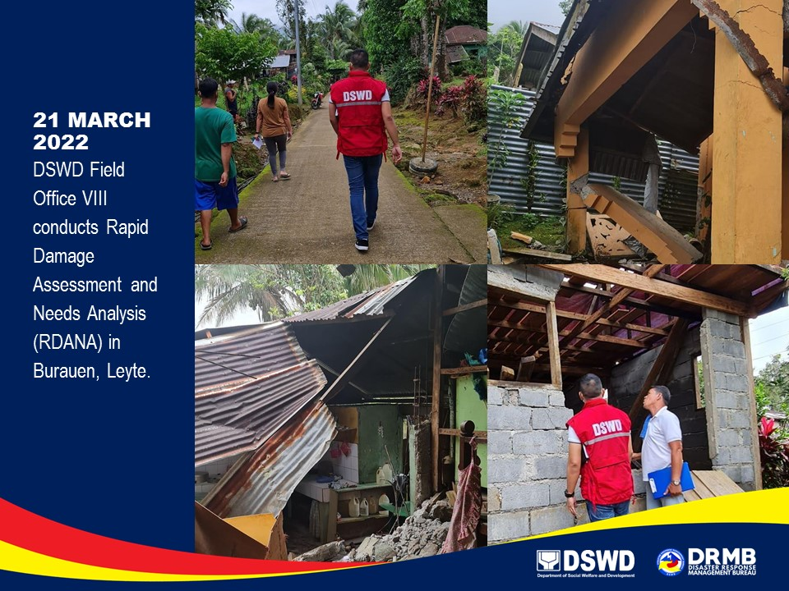
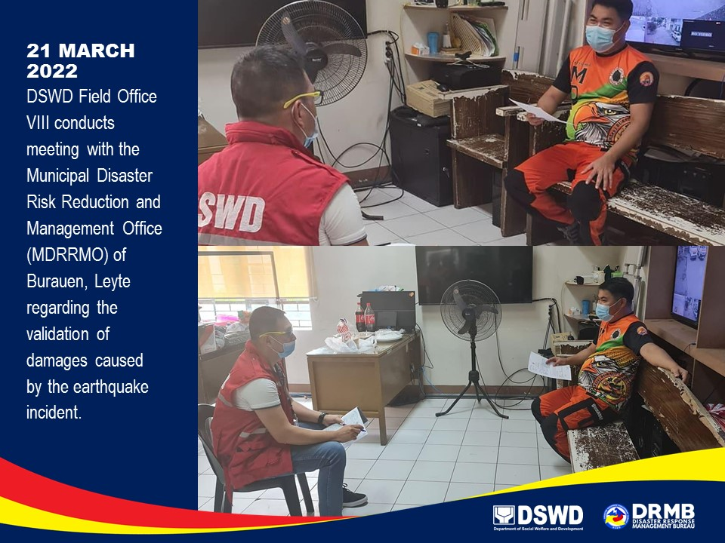

*****
The Disaster Response Operations Monitoring and Information Center (DROMIC) of DSWD-DRMB is closely coordinating with DSWD-FO VIII for significant disaster response updates and assistance provided.

Prepared by: Releasing Officer

MARIE JOYCE G. RAFANAN MARC LEO L. BUTAC
AARON JOHN B PASCUA

