DSWD DROMIC Report #2 on the Fire Incident in
Brgy. Gen. Hughes, City Proper, Iloilo City
as of 02 March 2022, 6PM

- Situation Overview

On 22 February 2022 at around 12:40 AM, a fire incident transpired in Brgy. Gen. Hughes, City Proper, Iloilo City.
Source: DSWD-Field Office (FO) VI

- Status of Affected Areas and Population

A total of 21 families or 90 persons are affected in Brgy. Gen. Hughes, City Proper, Iloilo City (see Table 1).

Table 1. Number of Affected Families / Persons
REGION / PROVINCE / MUNICIPALITY |  | NUMBER OF AFFECTED
 |  | Barangays | Families | Persons
GRAND TOTAL |  | 1 | 21 | 90
REGION VI |  | 1 | 21 | 90
Iloilo |  | 1 | 21 | 90
 | Iloilo City (capital) | 1 | 21 | 90
Note: Ongoing assessment and validation being conducted.
Source: DSWD FO VI

- Status of Displaced Population

- Inside Evacuation Center
There are 21 families or 90 persons currently taking temporary shelter in the Bali Hotel (abandoned building), Brgy. Gen. Hughes, City Proper, Iloilo City (see Table 2).

Table 2. Number of Displaced Families / Persons Inside Evacuation Center
REGION / PROVINCE / MUNICIPALITY |  | NUMBER OF EVACUATION CENTERS (ECs) |  | NUMBER OF DISPLACED
 |  |  |  | INSIDE ECs
 |  |  |  | Families |  | Persons
 |  | CUM | NOW | CUM | NOW | CUM | NOW
GRAND TOTAL |  | 1 | 1 | 21 | 21 | 90 | 90
REGION VI |  | 1 | 1 | 21 | 21 | 90 | 90
Iloilo |  | 1 | 1 | 21 | 21 | 90 | 90
 | Iloilo City (capital) | 1 | 1 | 21 | 21 | 90 | 90
Note: Ongoing assessment and validation being conducted.
Source: DSWD-FO VI

- Damaged Houses
A total of 16 houses were damaged; of which, 11 are totally damaged and 5 are partially damaged in Brgy. Gen. Hughes, City Proper, Iloilo City (see Table 3).

Table 3. Number of Damaged Houses
REGION / PROVINCE / MUNICIPALITY |  | NO. OF DAMAGED HOUSES
 |  | Total | Totally | Partially
GRAND TOTAL |  | 16 | 11 | 5
REGION VI |  | 16 | 11 | 5
Iloilo |  | 16 | 11 | 5
 | Iloilo City (capital) | 16 | 11 | 5
Note: Ongoing assessment and validation being conducted.
Source: DSWD-FO VI

- Cost of Humanitarian Assistance Provided
A total of ₱229,058.00 worth of assistance was provided to the affected families; of which, ₱134,158.50 from the DSWD and ₱94,899.50 from the Local Government Unit (see Table 4).

Table 4. Cost of Assistance Provided to Affected Families / Persons
REGION / PROVINCE / MUNICIPALITY |  | COST OF ASSISTANCE
 |  | DSWD | LGU | NGOs | OTHERS | GRAND TOTAL
GRAND TOTAL |  | 134,158.50 | 94,899.50 | - | - | 229,058.00
REGION VI |  | 134,158.50 | 94,899.50 | - | - | 229,058.00
Iloilo |  | 134,158.50 | 94,899.50 | - | - | 229,058.00
 | Iloilo City (capital) | 134,158.50 | 94,899.50 | - | - | 229,058.00
Source: DSWD-FO VI

- Response Actions and Interventions

- Standby Funds and Prepositioned Relief Stockpile
OFFICE | STANDBY FUNDS | STOCKPILE |  |  | TOTAL STANDBY FUNDS & STOCKPILE
 |  | FAMILY FOOD PACKS |  | OTHER FOOD AND NON-FOOD ITEMS (FNIs)
 |  | QUANTITY | TOTAL COST
TOTAL | 283,406,701.92 | 71,854 | 44,648,257.51 | 352,791,285.30 | 680,846,244.73
DSWD-CO | 278,406,040.50 | - | - | - | 278,406,040.50
NRLMB-NROC | - | 37,152 | 25,576,324.50 | 307,084,886.71 | 332,661,211.21
NRLMB-VDRC | - | 16,442 | 10,226,924.00 | 32,582,103.30 | 42,809,027.30
DSWD-FO VI | 5,000,661.42 | 18,260 | 8,845,009.01 | 13,124,295.29 | 26,969,965.72
Note: The Inventory Summary is as of 02 March 2022, 2PM.
Source: DSWD-DRMB and DSWD-NRLMB

  - Standby Funds
    - ₱278.41 million Quick Response Fund (QRF) at the DSWD-Central Office.
    - ₱5 million available at DSWD-FO VI.

  - Prepositioned FFPs and Other Relief Items
    - 53,594 FFPs available in Disaster Response Centers; of which, 37,152 FFPs are at the National Resource Operations Center (NROC), Pasay City and 16,442 FFPs are at the Visayas Disaster Response Center (VDRC), Cebu City.
    - 18,260 FFPs available at DSWD-FO VI.
    - ₱352.79 million worth of other FNIs at NROC, VDRC and DSWD-FO VI warehouses.

- Other Activities
- DSWD-FO VI is in close coordination with the City Social Welfare and Development Office on the status of the affected and displaced, and for possible relief augmentation.

- Photo Documentation

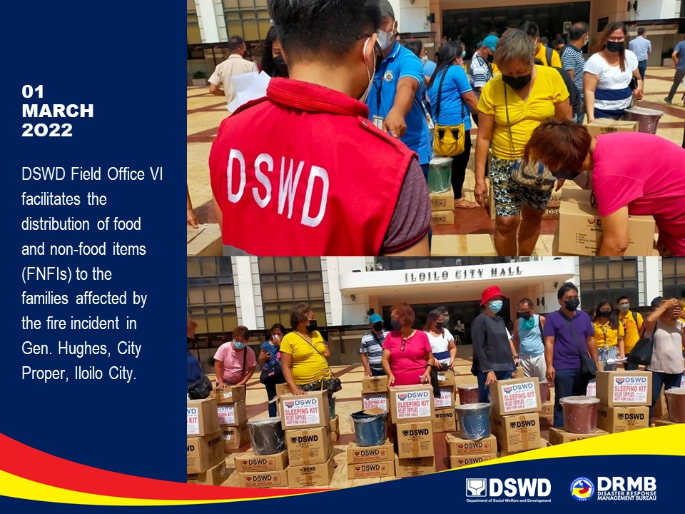

*****
The Disaster Response Operations Monitoring and Information Center (DROMIC) of DSWD-DRMB is closely coordinating with DSWD-FO VI for significant disaster response updates and assistance provided.

Prepared by:  AARON JOHN B. PASCUA | Released by:  RODEL V. CABADDU

