DROMIC Report #2 on the Fire Incident in
Brgy. Santo Niño, Tukuran, Zamboanga del Sur
as of 24 March 2022, 6PM

- Situation Overview

On 08 March 2022 at around 8 PM, a fire incident transpired in Brgy. Santo Niño, Tukuran, Zamboanga del Sur gutted several houses mostly made from light materials.
Source: DSWD-Field Office (FO) IX

- Status of Affected Areas and Population

A total of 75 families or 294 persons are affected in Brgy. Santo Niño, Tukuran, Zamboanga del Sur (see Table 1).

Table 1. Number of Affected Families / Persons
REGION / PROVINCE / MUNICIPALITY |  | NUMBER OF AFFECTED
 |  | Barangays | Families | Persons
GRAND TOTAL |  | 1 | 75 | 294
REGION IX |  | 1 | 75 | 294
Zamboanga del Sur |  | 1 | 75 | 294
 | Tukuran | 1 | 75 | 294
Note: The decrease in the number of affected families and persons is based on the validated report submitted by DSWD-FO IX.
Source: DSWD FO IX

- Status of Displaced Population

- Outside Evacuation Center
There are 75 families or 294 persons currently taking temporary shelter with their relatives and/or friends in Brgy. Santo Niño, Tukuran, Zamboanga del Sur (see Table 2).

Table 2. Number of Displaced Families / Persons Outside Evacuation Center
REGION / PROVINCE / MUNICIPALITY |  | NUMBER OF DISPLACED
 |  | OUTSIDE ECs
 |  | Families |  | Persons
 |  | CUM | NOW | CUM | NOW
GRAND TOTAL |  | 75 | 75 | 294 | 294
REGION IX |  | 75 | 75 | 294 | 294
Zamboanga del Sur |  | 75 | 75 | 294 | 294
 | Tukuran | 75 | 75 | 294 | 294
Note: The decrease in the number of displaced families and persons outside ECs is based on the validated report submitted
by DSWD-FO IX.
Source: DSWD-FO IX

- Damaged Houses

A total of 68 houses were totally in Brgy. Santo Niño, Tukuran, Zamboanga del Sur (see Table 3).

Table 3. Number of Damaged Houses
REGION / PROVINCE / MUNICIPALITY |  | NO. OF DAMAGED HOUSES
 |  | Total | Totally | Partially
GRAND TOTAL |  | 68 | 68 | -
REGION IX |  | 68 | 68 | -
Zamboanga del Sur |  | 68 | 68 | -
 | Tukuran | 68 | 68 | -
Note: Ongoing assessment and validation being conducted.
Source: DSWD-FO IX

- Cost of Humanitarian Assistance Provided

A total of ₱225,119.25 worth of assistance was provided by the DSWD to the affected families (see Table 6).

Table 6. Cost of Assistance Provided to Affected Families / Persons
REGION / PROVINCE / MUNICIPALITY |  | COST OF ASSISTANCE
 |  | DSWD | LGU | NGOs | OTHERS | GRAND TOTAL
GRAND TOTAL |  | 225,119.25 | - | - | - | 225,119.25
REGION IX |  | 225,119.25 | - | - | - | 225,119.25
Zamboanga del Sur |  | 225,119.25 | - | - | - | 225,119.25
 | Tukuran | 225,119.25 | - | - | - | 225,119.25
Source: DSWD-FO IX

- Response Actions and Interventions

- Standby Funds and Prepositioned Relief Stockpile
OFFICE | STANDBY FUNDS | STOCKPILE |  |  | TOTAL STANDBY FUNDS & STOCKPILE
 |  | FAMILY FOOD PACKS |  | OTHER FOOD AND NON-FOOD ITEMS (FNIs)
 |  | QUANTITY | TOTAL COST
TOTAL | 73,634,464.99 | 108,525 | 70,667,216.52 | 292,500,554.34 | 436,802,235.85
DSWD-CO | 68,634,464.99 | - | - | - | 68,634,464.99
NRLMB-NROC | - | 57,213 | 40,627,425.00 | 257,874,787.14 | 298,502,212.14
NRLMB-VDRC | - | 26,464 | 16,460,608.00 | 21,116,243.50 | 37,576,851.50
DSWD-FO IX | 5,000,000.00 | 24,848 | 13,579,183.52 | 13,509,523.70 | 32,088,707.22
Note: The Inventory Summary is as of 24 March 2022, 4PM.
Source: DSWD-DRMB and DSWD-NRLMB

  - Standby Funds
    - ₱68.63 million Quick Response Fund (QRF) at the DSWD-Central Office.
    - ₱5 million available at DSWD-FO IX.

  - Prepositioned FFPs and Other Relief Items
    - 83,677 FFPs available in Disaster Response Centers; of which, 57,213 FFPs are at the National Resource Operations Center (NROC), Pasay City and 26,464 FFPs are at the Visayas Disaster Response Center (VDRC), Cebu City.
    - 24,848 FFPs available at DSWD-FO IX.
    - ₱292.5 million worth of other FNIs at NROC, VDRC and DSWD-FO IX warehouses.

- Other Activities

DSWD-FO VIII
DATE | SITUATIONS / ACTIONS UNDERTAKEN
21 March 2022 | - The Disaster Response Information Management Section (DRIMS) of the DSWD-FO IX Disaster Response Management Bureau (DRMB) had coordinated with the Municipal Social Welfare and Development Office (MSWDO) of Tukuran, Zamboanga del Sur for updates on the families affected by the said incident.

- Photo Documentation

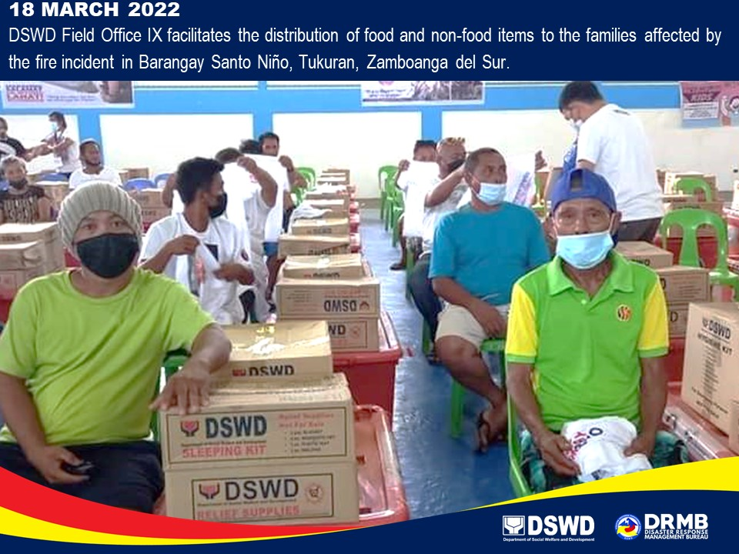

*****
The Disaster Response Operations Monitoring and Information Center (DROMIC) of DSWD-DRMB is closely coordinating with DSWD-FO IX for significant disaster response updates and assistance provided.

Prepared by:  AARON JOHN B. PASCUA  MARIE JOYCE G. RAFANAN | Released by:  MARC LEO L. BUTAC

