DSWD DROMIC Report #6 on the Effects of LPA
as of 18 March 2022, 6PM

- Situation Overview

Issued on 10 March 2022 at 4 AM, the Low Pressure Area (LPA) was estimated based on all available data at 465 km West of Zamboanga City or 255 km South Southwest of Puerto Princesa City (7.6°N, 117.9°E).
Source: DOST-PAGASA Daily Weather Forecast

- Status of Affected Areas and Population

There are 22,744 families or 96,742 persons affected in 73 barangays in Regions VIII, IX, X, XI and XII (see Table 1).

Table 1. Number of Affected Families / Persons
REGION / PROVINCE / MUNICIPALITY |  | NUMBER OF AFFECTED
 |  | Barangays | Families | Persons
GRAND TOTAL |  | 73 | 22,744 | 96,742
REGION VIII |  | 3 | 202 | 821
Leyte |  | 3 | 202 | 821
 | Tacloban City (capital) | 3 | 202 | 821
REGION IX |  | 12 | 1,097 | 5,449
Zamboanga del Norte |  | 12 | 1,097 | 5,449
 | Dapitan City | 1 | 14 | 70
 | Dipolog City (capital) | 9 | 1,026 | 5,130
 | Liloy | 2 | 57 | 249
REGION X |  | 66 | 12,336 | 55,367
Lanao del Norte |  | 53 | 11,758 | 53,528
 | Iligan City | 34 | 9,434 | 45,729
 | Bacolod | 5 | 65 | 273
 | Baloi | 9 | 1,546 | 4,623
 | Linamon | 4 | 343 | 1,627
 | Tubod (capital) | 1 | 370 | 1,276
Misamis Occidental |  | 13 | 578 | 1,839
 | Jimenez | 4 | 15 | 75
 | Bonifacio | 7 | 476 | 1,534
 | Don Victoriano Chiongbian (Don Mariano Marcos) | 2 | 87 | 230
REGION XI |  | 27 | 4,452 | 11,998
Davao de Oro |  | 12 | 158 | 711
 | Compostela | 1 | 1 | 5
 | Mawab | 5 | 65 | 393
 | Nabunturan (capital) | 3 | 80 | 264
 | New Bataan | 3 | 12 | 49
Davao del Sur |  | 14 | 4,287 | 11,252
 | Davao City | 14 | 4,287 | 11,252
Davao Oriental |  | 1 | 7 | 35
 | City of Mati (capital) | 1 | 7 | 35
REGION XII |  | 31 | 4,657 | 23,107
Sarangani |  | 13 | 961 | 4,576
 | Kiamba | 1 | 27 | 135
 | Maitum | 12 | 934 | 4,441
South Cotabato |  | 4 | 97 | 536
 | Lake Sebu | 2 | 79 | 462
 | T'boli | 2 | 18 | 74
Sultan Kudarat |  | 14 | 3,599 | 17,995
 | Isulan (capital) | 3 | 258 | 1,290
 | Lambayong (Mariano Marcos) | 4 | 1,374 | 6,870
 | Palimbang | 7 | 1,967 | 9,835
Note: Ongoing assessment and validation are continuously being conducted.
Source: DSWD-Field Offices (FOs)

- Status of Displaced Population

    - Inside Evacuation Center
There are 979 families or 4,358 persons currently taking temporary shelter in 13 evacuation centers (see Table 2).

Table 2. Number of Displaced Families / Persons Inside Evacuation Center
REGION / PROVINCE / MUNICIPALITY |  | NUMBER OF EVACUATION CENTERS (ECs) |  | NUMBER OF DISPLACED
 |  |  |  | INSIDE ECs
 |  |  |  | Families |  | Persons
 |  | CUM | NOW | CUM | NOW | CUM | NOW
GRAND TOTAL |  | 87 | 13 | 14,628 | 979 | 62,687 | 4,358
REGION X |  | 51 | 7 | 10,472 | 416 | 49,684 | 1,788
Lanao del Norte |  | 48 | 6 | 9,894 | 407 | 47,845 | 1,743
 | Iligan City | 38 | 5 | 9,434 | 407 | 45,729 | 1,743
 | Bacolod | 5 | - | 65 | - | 273 | -
 | Linamon | 4 | - | 343 | - | 1,627 | -
 | Tubod (capital) | 1 | 1 | 52 | - | 216 | -
Misamis Occidental |  | 3 | 1 | 578 | 9 | 1,839 | 45
 | Jimenez | 1 | - | 15 | - | 75 | -
 | Bonifacio | 1 | - | 476 | - | 1,534 | -
 | Don Victoriano Chiongbian (Don Mariano Marcos) | 1 | 1 | 87 | 9 | 230 | 45
REGION XI |  | 26 | - | 3,514 | - | 10,050 | -
Davao de Oro |  | 7 | - | 75 | - | 432 | -
 | Mawab | 5 | - | 65 | - | 393 | -
 | New Bataan | 2 | - | 10 | - | 39 | -
Davao del Sur |  | 19 | - | 3,439 | - | 9,618 | -
 | Davao City | 19 | - | 3,439 | - | 9,618 | -
REGION XII |  | 10 | 6 | 642 | 563 | 2,953 | 2,570
Sarangani |  | 1 | 1 | 287 | 287 | 1,206 | 1,206
 | Maitum | 1 | 1 | 287 | 287 | 1,206 | 1,206
South Cotabato |  | 6 | 2 | 97 | 18 | 457 | 74
 | Lake Sebu | 4 | - | 79 | - | 383 | -
 | T'boli | 2 | 2 | 18 | 18 | 74 | 74
Sultan Kudarat |  | 3 | 3 | 258 | 258 | 1,290 | 1,290
 | Isulan (capital) | 3 | 3 | 258 | 258 | 1,290 | 1,290
Note: Ongoing assessment and validation are continuously being conducted.
Source: DSWD-FOs

    - Outside Evacuation Center
There are 1,397 families or 6,985 persons temporarily staying with their relatives and/or friends in Region X, XI, XII (see Table 3).

Table 3. Number of Displaced Families / Persons Outside Evacuation Center
REGION / PROVINCE / MUNICIPALITY |  | NUMBER OF DISPLACED
 |  | OUTSIDE ECs
 |  | Families |  | Persons
 |  | CUM | NOW | CUM | NOW
GRAND TOTAL |  | 1,802 | 1,397 | 8,344 | 6,985
REGION X |  | 318 | - | 1,060 | -
Lanao del Norte |  | 318 | - | 1,060 | -
 | Tubod (capital) | 318 | - | 1,060 | -
REGION XI |  | 83 | 1 | 279 | 5
Davao de Oro |  | 83 | 1 | 279 | 5
 | Compostela | 1 | 1 | 5 | 5
 | Nabunturan (capital) | 80 | - | 264 | -
 | New Bataan | 2 | - | 10 | -
REGION XII |  | 1,401 | 1,396 | 7,005 | 6,980
Sarangani |  | 27 | 22 | 135 | 110
 | Kiamba | 27 | 22 | 135 | 110
Sultan Kudarat |  | 1,374 | 1,374 | 6,870 | 6,870
 | Lambayong (Mariano Marcos) | 1,374 | 1,374 | 6,870 | 6,870
Note: Ongoing assessment and validation are continuously being conducted.
Source: DSWD-FOs

    - Total Displaced Population
There are 2,376 families or 11,343 persons temporarily staying either in evacuation centers or with their relatives and/or friends in Regions X, XI and XII (see Table 4).

Table 4. Total Number of Displaced Families / Persons
REGION / PROVINCE / MUNICIPALITY |  | TOTAL DISPLACED SERVED
 |  | Families |  | Persons
 |  | Total Families |  | Total Persons
 |  | CUM | NOW | CUM | NOW
GRAND TOTAL |  | 16,430 | 2,376 | 71,031 | 11,343
REGION X |  | 10,790 | 416 | 50,744 | 1,788
Lanao del Norte |  | 10,212 | 407 | 48,905 | 1,743
 | Iligan City | 9,434 | 407 | 45,729 | 1,743
 | Bacolod | 65 | - | 273 | -
 | Linamon | 343 | - | 1,627 | -
 | Tubod (capital) | 370 | - | 1,276 | -
Misamis Occidental |  | 578 | 9 | 1,839 | 45
 | Jimenez | 15 | - | 75 | -
 | Bonifacio | 476 | - | 1,534 | -
 | Don Victoriano Chiongbian (Don Mariano Marcos) | 87 | 9 | 230 | 45
REGION XI |  | 3,597 | 1 | 10,329 | 5
Davao de Oro |  | 158 | 1 | 711 | 5
 | Compostela | 1 | 1 | 5 | 5
 | Mawab | 65 | - | 393 | -
 | Nabunturan (capital) | 80 | - | 264 | -
 | New Bataan | 12 | - | 49 | -
Davao del Sur |  | 3,439 | - | 9,618 | -
 | Davao City | 3,439 | - | 9,618 | -
REGION XII |  | 2,043 | 1,959 | 9,958 | 9,550
Sarangani |  | 314 | 309 | 1,341 | 1,316
 | Kiamba | 27 | 22 | 135 | 110
 | Maitum | 287 | 287 | 1,206 | 1,206
South Cotabato |  | 97 | 18 | 457 | 74
 | Lake Sebu | 79 | - | 383 | -
 | T'boli | 18 | 18 | 74 | 74
Sultan Kudarat |  | 1,632 | 1,632 | 8,160 | 8,160
 | Isulan (capital) | 258 | 258 | 1,290 | 1,290
 | Lambayong (Mariano Marcos) | 1,374 | 1,374 | 6,870 | 6,870
Note: Ongoing assessment and validation are continuously being conducted.
Source: DSWD-FOs

- Damaged Houses

A total of 821 houses were damaged; of which, 155 are totally damaged and 666 are partially damaged in Region X and XI (see Table 5).

Table 5. Number of Damaged Houses
REGION / PROVINCE / MUNICIPALITY |  | NO. OF DAMAGED HOUSES
 |  | Total | Totally | Partially
GRAND TOTAL |  | 821 | 155 | 666
REGION X |  | 654 | 129 | 525
Lanao del Norte |  | 636 | 119 | 517
 | Iligan City | 564 | 117 | 447
 | Bacolod | 65 | - | 65
 | Linamon | 7 | 2 | 5
Misamis Occidental |  | 18 | 10 | 8
 | Jimenez | 8 | 5 | 3
 | Bonifacio | 1 | - | 1
 | Don Victoriano Chiongbian (Don Mariano Marcos) | 9 | 5 | 4
REGION XI |  | 7 | - | 7
Davao Oriental |  | 7 | - | 7
 | City of Mati (capital) | 7 | - | 7
REGION XII |  | 160 | 26 | 134
South Cotabato |  | 18 | 4 | 14
 | T'boli | 18 | 4 | 14
Sultan Kudarat |  | 142 | 22 | 120
 | Palimbang | 142 | 22 | 120
Note: The decrease in the number of totally damaged houses is based on the validated report submitted by DSWD-FO X.
Source: DSWD-FOs

- Cost of Humanitarian Assistance Provided

A total of ₱815,900.00 worth of assistance was provided by the Local Government Unit to the affected families (see Table 6).

Table 6. Cost of Assistance Provided to Affected Families / Persons
REGION / PROVINCE / MUNICIPALITY |  | COST OF ASSISTANCE
 |  | DSWD | LGU | NGOs | OTHERS | GRAND TOTAL
GRAND TOTAL |  | - | 815,900.00 | - | - | 815,900.00
REGION XII |  | - | 815,900.00 | - | - | 815,900.00
South Cotabato |  | - | 18,900.00 | - | - | 18,900.00
 | T'boli | - | 18,900.00 | - | - | 18,900.00
Sultan Kudarat |  | - | 797,000.00 | - | - | 797,000.00
 | Palimbang | - | 797,000.00 | - | - | 797,000.00
Source: DSWD-FO FOs

- Response Actions and Interventions

- Standby Funds and Prepositioned Relied Stockpile

OFFICE | STANDBY FUNDS | STOCKPILE |  |  | TOTAL STANDBY FUNDS & STOCKPILE
 |  | FAMILY FOOD PACKS |  | OTHER FOOD AND NON-FOOD ITEMS (FNIs)
 |  | QUANTITY | TOTAL COST
TOTAL | 241,679,686.35 | 98,483 | 60,333,583.00 | 414,362,161.36 | 716,375,430.71
DSWD-CO | 225,485,399.00 | - | - | - | 225,485,399.00
NRLMB-NROC | - | 24,965 | 14,904,105.00 | 281,606,347.14 | 296,510,452.14
NRLMB-VDRC | - | 14,520 | 9,031,440.00 | 25,300,285.50 | 34,331,725.50
DSWD-FO X | 6,193,317.50 | 22,139 | 15,640,738.50 | 42,393,745.05 | 64,227,801.05
DSWD-FO XI | 5,000,000.00 | 20,407 | 11,805,449.50 | 32,606,927.80 | 49,412,377.30
DSWD-FO XII | 5,000,969.85 | 16,452 | 8,951,850.00 | 32,454,855.87 | 46,407,675.72
Note: Inventory Summary is as of 18 March 2022, 4PM.
Source: DSWD-DRMB and DSWD-NRLMB

  - Standby Funds
    - ₱225.49 million Quick Response Fund (QRF) at the DSWD-Central Office.
    - ₱16.19 million available at DSWD-FOs X, XI and XII.

  - Prepositioned FFPs and Other Relief Items
    - 39,485 FFPs available in Disaster Response Centers; of which, 24,965 FFPs are at the National Resource Operations Center (NROC), Pasay City and 14,520 FFPs are at the Visayas Disaster Response Center (VDRC), Cebu City.
    - 58,998 FFPs available at DSWD-FOs X, XI and XII.
    - ₱414.36 million worth of other FNIs at NROC, VDRC and DSWD-FOs X, XI and XII warehouses.

- Food and Non-Food Items

DSWD-FO XI
DATE | SITUATIONS / ACTIONS UNDERTAKEN
09 March 2022 | - The Davao City Government through its City Social Welfare and Development Office (CSWDO) provided modular tents to the affected families and set up a community kitchen in coordination with Barangay Tigatto Disaster Risk Management Council.
07 March 2022 | - The Davao City Government through its CSWDO provided hot meals to the affected families during their stay in the evacuation centers.

DSWD-FO XII
DATE | SITUATIONS / ACTIONS UNDERTAKEN
09 March 2022 | - The LGU of Lake Sebu, South Cotabato has immediately provided hot meals to individuals who stayed inside evacuation centers.  - The LGU of Maitum, Sarangani has also provided hot meals, sleeping kits and clothes to the affected families.
11 March 2022 | - The LGU of Kiamba distributed food packs to the displaced families who sought shelter with their relatives  - The LGU of Palimbang initially provided food packs to the affected families and individuals

- Internally Displaced Person (IDP) Protection

DSWD-FO XI
DATE | SITUATIONS / ACTIONS UNDERTAKEN
07 March 2022 | - The Provincial Government of Davao de Oro in coordination with Municipal counterparts had provided Psychological First Aid and assessed the needs of the affected families and individuals.

- Camp Coordination and Camp Management (CCCM)

DSWD-FO XI
DATE | SITUATIONS / ACTIONS UNDERTAKEN
07 March 2022 | - DSWD-FO XI through its Disaster Response Management Division (DRMD) is in close coordination with LGUs for reports and updates on the situation of the IDPs inside evacuation centers and to ensure compliance with the provision of emergency relief and protection for the children (Republic Act No. 10821) before, during and after disasters and other emergency situations as well as to monitor the compliance with the safety and health protocols set by the Inter-Agency Task Force (IATF).

- Other Activities

DSWD-FO XII
DATE | SITUATIONS / ACTIONS UNDERTAKEN
09 March 2022 | - The LGU of T’boli, South Cotabato has conducted profiling of all affected families and provided them with relief assistance.
11 March 2022 | - The LGU of Kiamba conducted Rapid Damage Assessment and Needs Analysis (RDANA) in the affected barangays

- Photo Documentation

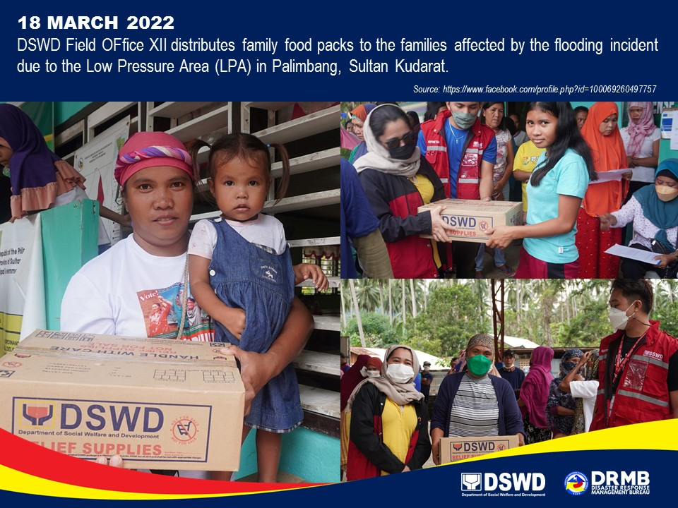

*****
The Disaster Response Operations Monitoring and Information Center (DROMIC) of DSWD-DRMB is closely coordinating with concerned DSWD-Field Offices for significant disaster response updates and assistance provided.

Prepared by:  MARIE JOYCE G. RAFANAN  AARON JOHN B. PASCUA | Released by:  RODEL V. CABADDU

