DSWD DROMIC Report on the Armed Conflict
in Brgy. Mission, Sta. Teresita, Cagayan
31 March 2022, 6PM

- Situation Overview
On February 2, 2022, at around 8:00 in the morning, operating troops of the 501st Infantry Brigade under the 5th Infantry Division (5ID) clashed against CPP-NPA Terrorist (CNT) at the mountainous area of Sitio Sta. Clara, Gonzaga a neighboring part of Sitio Tagcar and Cabungag, Barangay Mission, Sta Teresita, Cagayan.
Source: DSWD-Field Office (FO) II

- Status of Affected Areas and Population
A total of 43 families or 194 persons were affected by the armed conflict in Brgy. Mission, Sta. Teresita, Cagayan (see Table 1).

Table 1. Number of Affected Families / Persons
REGION / PROVINCE / MUNICIPALITY |  | NUMBER OF AFFECTED
 |  | Barangays | Families | Persons
GRAND TOTAL |  | 1 | 43 | 194
REGION II |  | 1 | 43 | 194
Cagayan |  | 1 | 43 | 194
 | Santa Teresita | 1 | 43 | 194
Source: DSWD-FO II

- Status of Displaced Population
- Inside Evacuation Centers
There were 43 families or 194 persons who took temporary shelter at the Brgy. Hall of Mission, Sta. Teresita, Cagayan (see Table 2).

Table 2. Number of Displaced Families / Persons Inside Evacuation Center
REGION / PROVINCE / MUNICIPALITY |  | NUMBER OF EVACUATION CENTERS (ECs) |  | NUMBER OF DISPLACED
 |  |  |  | INSIDE ECs
 |  |  |  | Families |  | Persons (Actual)
 |  | CUM | NOW | CUM | NOW | CUM | NOW
GRAND TOTAL |  | 1 | - | 43 | - | 194 | -
REGION II |  | 1 | - | 43 | - | 194 | -
Cagayan |  | 1 | - | 43 | - | 194 | -
 | Santa Teresita | 1 | - | 43 | - | 194 | -
Source: DSWD-FO II

- Cost of Humanitarian Assistance Provided
A total of ₱123,818.75 worth of assistance was provided by DSWD to the affected families (see Table 3).

Table 3. Cost of Assistance Provided to Affected Families / Persons
REGION / PROVINCE / MUNICIPALITY |  | COST OF ASSISTANCE
 |  | DSWD | LGU | NGOs | OTHERS | GRAND TOTAL
GRAND TOTAL |  | 123,818.75 | - | - | - | 123,818.75
REGION II |  | 123,818.75 | - | - | - | 123,818.75
Cagayan |  | 123,818.75 | - | - | - | 123,818.75
 | Santa Teresita | 123,818.75 | - | - | - | 123,818.75
Source: DSWD-FO II

- Photo Documentation
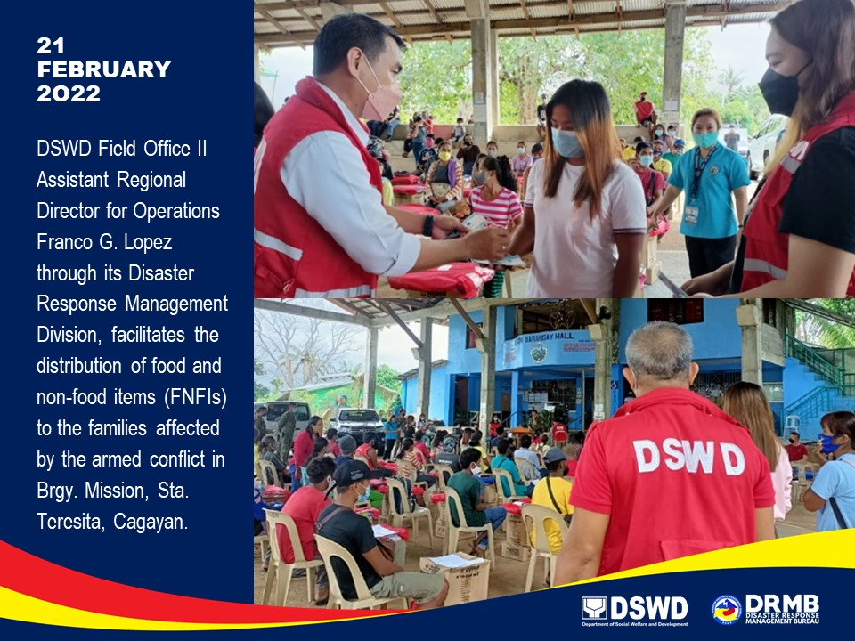

*****
This terminal report is based on the latest report submitted by DSWD-FO II on 21 February 2022. The Disaster Response Operations Monitoring and Information Center (DROMIC) of DSWD-DRMB continues to closely coordinate with DSWD-FO II for any request of Technical Assistance and Resource Augmentation (TARA).

Prepared by:  PHIL JOBERT A. ZALDIVAR | Released by:  LESLIE R. JAWILI

