DSWD DROMIC Terminal Report on the Effects of Shear Line
18 March 2022, 6PM

- Situation Overview

Issued on 11 February 2022 at 7PM, the Shear Line brought Light to moderate to at times heavy rains with possible lightning and strong winds are being experienced over portions of Camiguin, Zamboanga del Sur (Molave and Conception), Zamboanga del Norte (Dipolog, Dapitan, Pinan, Mutia, La Libertad, and Sergio Ozmena), Misamis Occidental, Lanao del Norte, Lanao del Sur, Maguindanao (Matanog, Buldon, Barira, Parang, and Sultan Kudarat), North Cotabato (Alamada, Banisilan, Libungan, and Pigcawayan), Bukidnon (Talakag, Baungon, Manolo Fortich, Malitbog, Impasugong, Kalilangan, and Pangantukan), Misamis Oriental (Lugait, Manticao, Balingasag, and Cagayande Oro City) and may affect nearby areas.

Source: DOST-PAGASA RAINFALL ADVISORY

- Status of Affected Areas and Population

A total of 4,397 families or 17,529 persons are affected in 34 barangays in Regions II and VIII (see Table 1).

Table 1. Number of Affected Families / Persons
REGION / PROVINCE / MUNICIPALITY |  | NUMBER OF AFFECTED
 |  | Barangays | Families | Persons
GRAND TOTAL |  | 34 | 4,397 | 17,529
REGION II |  | 19 | 1,297 | 5,686
Cagayan |  | 19 | 1,297 | 5,686
 | Claveria | 19 | 1,297 | 5,686
REGION VIII |  | 15 | 3,100 | 11,843
Eastern Samar |  | 13 | 2,714 | 9,913
 | Jipapad | 13 | 2,714 | 9,913
Northern Samar |  | 2 | 386 | 1,930
 | San Roque | 2 | 386 | 1,930
Source: DSWD-Field Office (FO) II and VIII

- Status of Displaced Population

- Inside Evacuation Center
A total of 381 families or 1,855 persons sought temporary shelter in nine (9) evacuation centers in Regions II and VIII (see Table 2).

Table 2. Number of Displaced Families / Persons Inside Evacuation Center
REGION / PROVINCE / MUNICIPALITY |  | NUMBER OF EVACUATION CENTERS (ECs) |  | NUMBER OF DISPLACED
 |  |  |  | INSIDE ECs
 |  |  |  | Families |  | Person
 |  | CUM | NOW | CUM | NOW | CUM | NOW
GRAND TOTAL |  | 9 | - | 381 | - | 1,855 | -
REGION II |  | 3 | - | 48 | - | 190 | -
Cagayan |  | 3 | - | 48 | - | 190 | -
 | Claveria | 3 | - | 48 | - | 190 | -
REGION VIII |  | 6 | - | 333 | - | 1,665 | -
Eastern Samar |  | 2 | - | 20 | - | 100 | -
 | Jipapad | 2 | - | 20 | - | 100 | -
Northern Samar |  | 4 | - | 313 | - | 1,565 | -
 | San Roque | 4 | - | 313 | - | 1,565 | -
Source: DSWD-FO II and VIII

- Outside Evacuation Center
A total of 154 families or 722 persons sought temporary shelter with their relatives and/or friends in Regions II and VIII (see Table 3).

Table 3. Number of Displaced Families / Persons Outside Evacuation Centers
REGION / PROVINCE / MUNICIPALITY |  | NUMBER OF DISPLACED
 |  | OUTSIDE ECs
 |  | Families |  | Persons
 |  | CUM | NOW | CUM | NOW
GRAND TOTAL |  | 154 | - | 722 | -
REGION II |  | 81 | - | 357 | -
Cagayan |  | 81 | - | 357 | -
 | Claveria | 81 | - | 357 | -
REGION VIII |  | 73 | - | 365 | -
Northern Samar |  | 73 | - | 365 | -
 | San Roque | 73 | - | 365 | -
Source: DSWD-FO II and VIII

- Total Displaced Population
A total of 535 families or 2,577 persons were displaced in Regions II and VIII due to the effects of Shearline (see Table 4).

Table 4. Total Number of Displaced Families / Persons
REGION / PROVINCE / MUNICIPALITY |  | TOTAL DISPLACED SERVED
 |  | Families |  | Persons
 |  | Total Families |  | Total Persons
 |  | CUM | NOW | CUM | NOW
GRAND TOTAL |  | 535 | - | 2,577 | -
REGION II |  | 129 | - | 547 | -
Cagayan |  | 129 | - | 547 | -
 | Claveria | 129 | - | 547 | -
REGION VIII |  | 406 | - | 2,030 | -
Eastern Samar |  | 20 | - | 100 | -
 | Jipapad | 20 | - | 100 | -
Northern Samar |  | 386 | - | 1,930 | -
 | San Roque | 386 | - | 1,930 | -
Note: Ongoing assessment and validation being conducted.
Source: DSWD-FO II and VIII

- Damaged Houses
A total of one (1) house was totally damaged in Region II (see Table 5).

Table 5. Number of Damaged Houses
REGION / PROVINCE / MUNICIPALITY |  | NO. OF DAMAGED HOUSES
 |  | Total | Totally | Partially
GRAND TOTAL |  | 1 | - | 1
REGION II |  | 1 | - | 1
Cagayan |  | 1 | - | 1
 | Claveria | 1 | - | 1
Source: DSWD-FO II

- Cost of Humanitarian Assistance Provided
A total of ₱697,262.00 worth of assistance was provided by DSWD to the affected families (see Table 6).

Table 6. Cost of Assistance Provided to Affected Families / Persons
REGION / PROVINCE / MUNICIPALITY |  | COST OF ASSISTANCE
 |  | DSWD | LGU | NGOs | OTHERS | GRAND TOTAL
GRAND TOTAL |  | 697,262.00 | - | - | - | 697,262.00
REGION II |  | 697,262.00 | - | - | - | 697,262.00
Cagayan |  | 697,262.00 | - | - | - | 697,262.00
 | Claveria | 697,262.00 | - | - | - | 697,262.00
Source: DSWD-FO II

- Photo Documentation
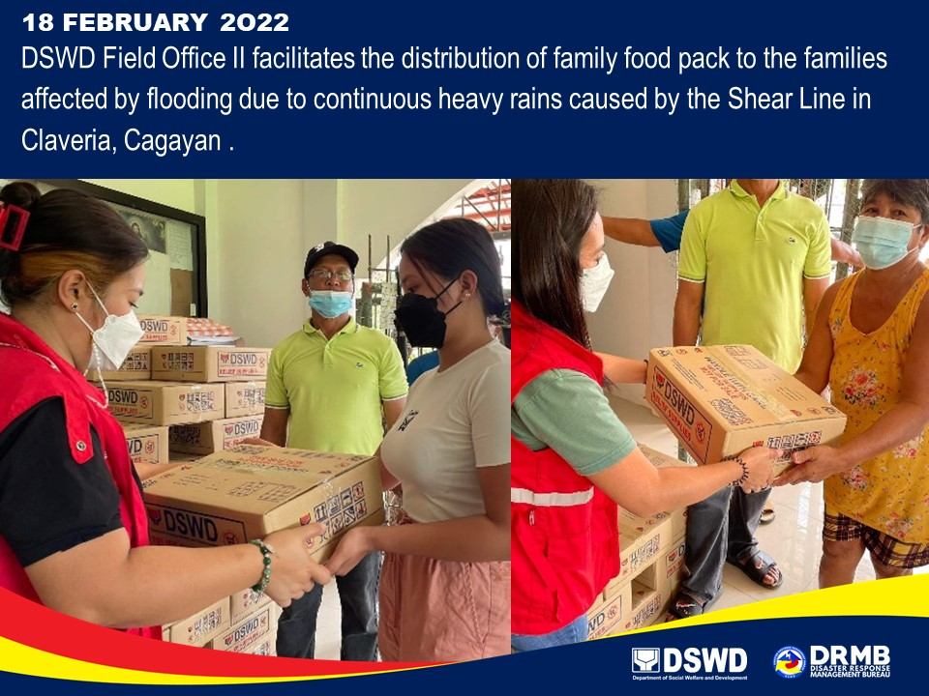

*****
This terminal report is based on the latest report submitted by DSWD-FO II on 21 February 2022 and DSWD-FO VIII on 07 March 2022. The Disaster Response Operations Monitoring and Information Center (DROMIC) of DSWD-DRMB continues to closely coordinate with DSWD-FOs VIII and II for any request of Technical Assistance and Resource Augmentation (TARA).

Prepared by:  AARON JOHN B. PASCUA  MARIE JOYCE G. RAFANAN | Released by:  RODEL V. CABADDU

