DSWD DROMIC Report #1 on the Effects of LPA
as of 07 April 2022, 6PM

- Situation Overview

Issued on 04 April 2022 at 4AM, a Low Pressure Area (LPA) was estimated based on all available data at 970 km East of Guiuan, Eastern Samar (11.0°N, 134.6°E). It is embedded along the Intertropical Convergence Zone (ITCZ) affecting Mindanao. Shear Line affecting Extreme Northern Luzon.

Issued on 07 April 2022 at 4 PM, the Low Pressure Area (LPA) was estimated based on all available data at 180 km East Northeast of Hinatuan, Surigao del Sur (8.9°N, 127.9°E).
Source: DOST-PAGASA Daily Weather Forecast

- Status of Affected Areas and Population

There are 4,981 families or 10,554 persons affected in 22 barangays in Regions XI and Caraga (see Table 1).

Table 1. Number of Affected Families / Persons
REGION / PROVINCE / MUNICIPALITY |  | NUMBER OF AFFECTED
 |  | Barangays | Families | Persons
GRAND TOTAL |  | 22 | 4,981 | 10,554
REGION XI |  | 16 | 4,754 | 9,604
Davao de Oro |  | 11 | 1,432 | 4,278
 | Compostela | 1 | 80 | 400
 | Mawab | 2 | 40 | 126
 | Monkayo | 7 | 1,310 | 3,744
 | New Bataan | 1 | 2 | 8
Davao Oriental |  | 5 | 3,322 | 5,326
 | Cateel | 5 | 3,322 | 5,326
CARAGA |  | 6 | 227 | 950
Agusan del Sur |  | 6 | 227 | 950
 | Bunawan | 6 | 227 | 950
Note: Ongoing assessment and validation are continuously being conducted.
Source: DSWD-Field Offices (FOs)

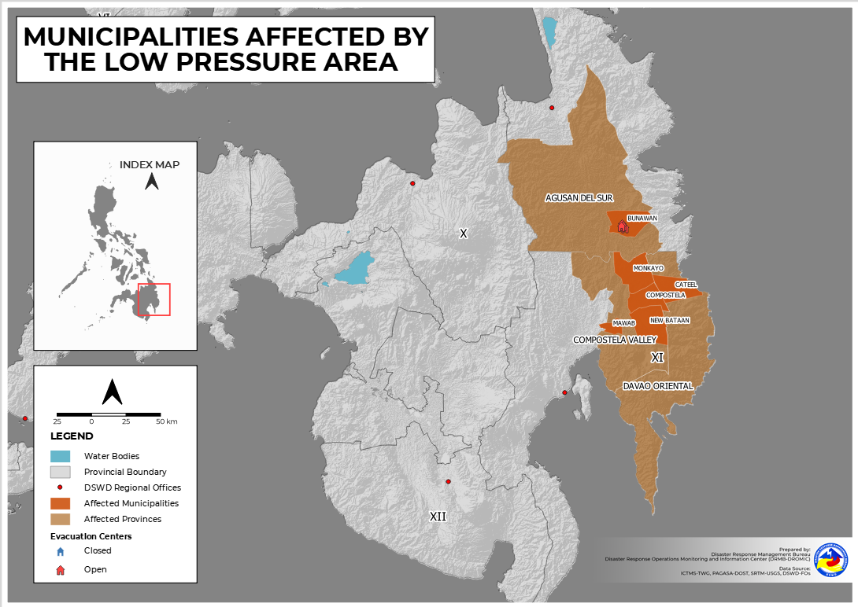

- Status of Displaced Population

    - Inside Evacuation Center
There are 581 families or 2,020 persons currently taking temporary shelter in 11 evacuation centers (see Table 2).

Table 2. Number of Displaced Families / Persons Inside Evacuation Center
REGION / PROVINCE / MUNICIPALITY |  | NUMBER OF EVACUATION CENTERS (ECs) |  | NUMBER OF DISPLACED
 |  |  |  | INSIDE ECs
 |  |  |  | Families |  | Persons
 |  | CUM | NOW | CUM | NOW | CUM | NOW
GRAND TOTAL |  | 11 | 11 | 581 | 581 | 2,020 | 2,020
REGION XI |  | 4 | 4 | 354 | 354 | 1,070 | 1,070
Davao de Oro |  | 4 | 4 | 354 | 354 | 1,070 | 1,070
 | Mawab | 2 | 2 | 35 | 35 | 113 | 113
 | Monkayo | 2 | 2 | 319 | 319 | 957 | 957
CARAGA |  | 7 | 7 | 227 | 227 | 950 | 950
Agusan del Sur |  | 7 | 7 | 227 | 227 | 950 | 950
 | Bunawan | 7 | 7 | 227 | 227 | 950 | 950
Note: Ongoing assessment and validation are continuously being conducted.
Source: DSWD-FOs

- Response Actions and Interventions

- Standby Funds and Prepositioned Relied Stockpile

OFFICE | STANDBY FUNDS | STOCKPILE |  |  | TOTAL STANDBY FUNDS & STOCKPILE
 |  | FAMILY FOOD PACKS |  | OTHER FOOD AND NON-FOOD ITEMS (FNIs)
 |  | QUANTITY | TOTAL COST
TOTAL | 146,042,412.97 | 552,014 | 348,260,982.64 | 733,354,476.14 | 1,227,657,871.75
DSWD-CO | 68,594,777.99 | - | - | - | 68,594,777.99
NRLMB-NROC | - | 77,529 | 48,017,825.00 | 242,880,757.69 | 290,898,582.69
NRLMB-VDRC | - | 3,737 | 2,324,414.00 | 30,824,635.40 | 33,149,049.40
DSWD-FO XI | 5,000,000.00 | 27,331 | 16,225,983.50 | 30,016,022.80 | 51,242,006.30
DSWD-FO Caraga | 5,000,000.00 | 179,949 | 123,419,194.00 | 11,275,962.57 | 139,695,156.57
Other FOs | 67,447,634.98 | 263,468 | 158,273,566.14 | 418,357,097.68 | 644,078,298.80
Note: Inventory Summary is as of 07 April 2022, 4PM.
Source: DSWD-DRMB and DSWD-NRLMB

  - Standby Funds
    - ₱68.59 million Quick Response Fund (QRF) at the DSWD-Central Office.
    - ₱10 million available at DSWD-FOs XI and Caraga.
    - ₱67.45 million in other DSWD-FOs which may support the relief needs of the displaced families due to the effects of LPA through inter-FO augmentation.

  - Prepositioned FFPs and Other Relief Items
    - 81,266 FFPs available in Disaster Response Centers; of which, 77,529 FFPs are at the National Resource Operations Center (NROC), Pasay City and 3,737 FFPs are at the Visayas Disaster Response Center (VDRC), Cebu City.
    - 207,280 FFPs available at DSWD-FOs XI and Caraga.
    - 263,468 FFPs in other DSWD-FOs which may support the relief needs of the displaced families due to Effects of LPA through inter-FO augmentation.
    - ₱733.35 million worth of other FNIs at NROC, VDRC and DSWD-FO warehouses.

- Internally Displaced Person (IDP) Protection

DSWD-FO XI
DATE | SITUATIONS / ACTIONS UNDERTAKEN
06 April 2022 | - The Municipalities of Monkayo and Mawab in Davao de Oro closely coordinated with the affected barangays for the provision of psychosocial services and assessment of needed intervention of the affected families and individuals.

- Camp Coordination and Camp Management (CCCM)

DSWD-FO XI
DATE | SITUATIONS / ACTIONS UNDERTAKEN
06 April 2022 | - DSWD-FO XI through its Disaster Response Management Division (DRMD) closely coordinated with the affected local government units (LGUs) for reports and updates on the situation of the displaced families and individuals inside evacuation centers and to ensure compliance with the provision of emergency relief and protection for the children (Republic Act No. 10821) before, during and after disasters and other emergency situations as well as to monitor the compliance with the safety health protocols set by the Inter-Agency Task Force-Management of Emerging Infectious Diseases (IATF-MEID).

- Other Activities

DSWD-FO V
DATE | SITUATIONS / ACTIONS UNDERTAKEN
06 April 2022 | - DSWD-FO V Quick Response Team (QRT) were alerted.  - The Provincial/Municipal Action Teams of DSWD-FO V in the six (6) provinces were activated and instructed to coordinate with the Local Disaster Risk Reduction and Management Offices (LDRRMOs) and Local Social Welfare and Development Offices (LSWDOs) for significant updates.

DSWD-FO Caraga
DATE | SITUATIONS / ACTIONS UNDERTAKEN
06 April 2022 | - DSWD-FO Caraga coordinated with the Municipal Social Welfare and Development Offices (MSWDOs) and DSWD Social Welfare and Development (SWAD) Team Leaders for the possible provision of augmentation assistance to the affected families.

*****
The Disaster Response Operations Monitoring and Information Center (DROMIC) of DSWD-DRMB is closely coordinating with concerned DSWD Field Offices for significant disaster response updates and assistance provided.

Prepared by:  AARON JOHN B. PASCUA  MARIE JOYCE G. RAFANAN | Released by:  MARC LEO L. BUTAC

