DSWD DROMIC Report #1 on the Fire incident in
Brgy. Bolilao, Mandurriao, Iloilo City
as of 03 April 2022, 6PM

- Situation Overview

On 26 March 2022 at around 7:00 PM, a fire incident transpired in Brgy. Bolilao, Mandurriao, Iloilo City.
Source: DSWD-Field Office (FO) VI

- Status of Affected Areas and Population

A total of one (1) family or six (6) persons are affected in Brgy. Bolilao, Mandurriao, Iloilo City (see Table 1).

Table 1. Number of Affected Families / Persons
REGION / PROVINCE / MUNICIPALITY |  | NUMBER OF AFFECTED
 |  | Barangays | Families | Persons
GRAND TOTAL |  | 1 | 1 | 6
REGION VI |  | 1 | 1 | 6
Iloilo |  | 1 | 1 | 6
 | Iloilo City (capital) | 1 | 1 | 6
Note: Ongoing assessment and validation being conducted.
Source: DSWD-FO VI

- Status of Displaced Population

- Inside Evacuation Center
There is one (1) family or six (6) persons currently taking temporary shelter at Great Vision Church in Mandurriao, Iloilo City (see Table 2).

Table 2. Number of Displaced Families / Persons Outside Evacuation Center
REGION / PROVINCE / MUNICIPALITY |  | NUMBER OF EVACUATION CENTERS (ECs) |  | NUMBER OF DISPLACED
 |  |  |  | INSIDE ECs
 |  |  |  | Families |  | Persons
 |  | CUM | NOW | CUM | NOW | CUM | NOW
GRAND TOTAL |  | 1 | 1 | 1 | 1 | 6 | 6
REGION VI |  | 1 | 1 | 1 | 1 | 6 | 6
Iloilo |  | 1 | 1 | 1 | 1 | 6 | 6
 | Iloilo City (capital) | 1 | 1 | 1 | 1 | 6 | 6
Note: Ongoing assessment and validation being conducted.
Source: DSWD-FO VI

- Damaged Houses

A total of one (1) house is totally damaged in Brgy. Bolilao, Iloilo City (see Table 3).

Table 3. Number of Damaged Houses
REGION / PROVINCE / MUNICIPALITY |  | NO. OF DAMAGED HOUSES
 |  | Total | Totally | Partially
GRAND TOTAL |  | 1 | 1 | -
REGION VI |  | 1 | 1 | -
Iloilo |  | 1 | 1 | -
 | Iloilo City (capital) | 1 | 1 | -
Note: Ongoing assessment and validation being conducted.
Source: DSWD-FO VI

- Cost of Humanitarian Assistance Provided

A total of ₱10,527.65 worth of assistance was provided to the affected families; of which, ₱6,835.00 was provided by DSWD, and ₱3,692.65 was provided by the Local Government Unit to the affected family (see Table 4).

Table 4. Cost of Assistance Provided to Affected Families / Persons
REGION / PROVINCE / MUNICIPALITY |  | COST OF ASSISTANCE
 |  | DSWD | LGU | NGOs | OTHERS | GRAND TOTAL
GRAND TOTAL |  | 6,835.00 | 3,692.65 | - | - | 10,527.65
REGION VI |  | 6,835.00 | 3,692.65 | - | - | 10,527.65
Iloilo |  | 6,835.00 | 3,692.65 | - | - | 10,527.65
 | Iloilo City (capital) | 6,835.00 | 3,692.65 | - | - | 10,527.65
Source: DSWD-FO VI

- Response Actions and Interventions

- Standby Funds and Prepositioned Relief Stockpile
OFFICE | STANDBY FUNDS | STOCKPILE |  |  | TOTAL STANDBY FUNDS & STOCKPILE
 |  | FAMILY FOOD PACKS |  | OTHER FOOD AND NON-FOOD ITEMS (FNIs)
 |  | QUANTITY | TOTAL COST
TOTAL | 73,614,889.41 | 90,191 | 54,120,650.75 | 277,131,542.95 | 404,867,083.11
DSWD-CO | 68,614,227.99 | - | - | - | 68,614,227.99
NRLMB-NROC | - | 73,475 | 45,450,475.00 | 247,179,916.06 | 292,630,391.06
NRLMB-VDRC | - | 3,737 | 2,324,414.00 | 17,274,653.00 | 19,599,067.00
DSWD-FO VI | 5,000,661.42 | 12,979 | 6,345,761.75 | 12,676,973.89 | 24,023,397.06
Note: The Inventory Summary is as of 03 April 2022, 4PM.
Source: DSWD-DRMB and DSWD-NRLMB

  - Standby Funds
    - ₱68.61 million Quick Response Fund (QRF) at the DSWD-Central Office.
    - ₱5 million available at DSWD-FO VI.

  - Prepositioned FFPs and Other Relief Items
    - 77,212 FFPs available in Disaster Response Centers; of which, 73,475 FFPs are at the National Resource Operations Center (NROC), Pasay City and 3,737 FFPs are at the Visayas Disaster Response Center (VDRC), Cebu City.
    - 12,979 FFPs available at DSWD-FO VI.
    - ₱277.13 million worth of other FNIs at NROC, VDRC and DSWD-FO VI warehouses.

- Food and Non-Food Items (FNIs)

DATE | SITUATIONS / ACTIONS UNDERTAKEN
31 March 2022 | - The City Social Welfare and Development Office (CSWDO) of the Iloilo City provided food packs to the affected family. Non-food items including blankets, mosquito nets, and water containers were also provided.

- Other Activities

DATE | SITUATIONS / ACTIONS UNDERTAKEN
31 March 2022 | - DSWD-FO VI monitored the distribution of FNIs to the affected family in Brgy. Bolilao, Mandurriao, Iloilo City.

- Photo Documentation

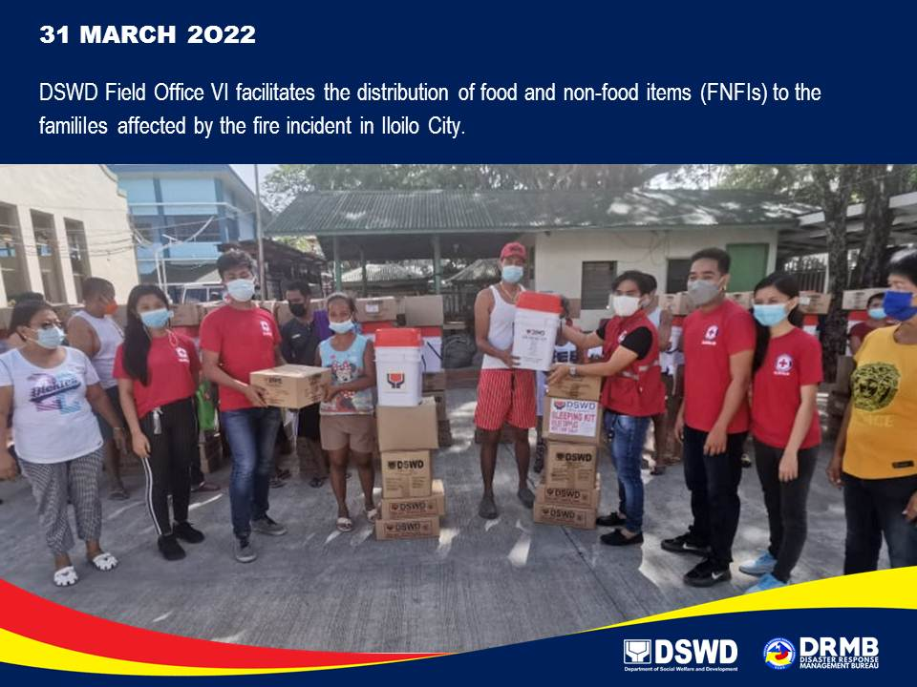

*****
The Disaster Response Operations Monitoring and Information Center (DROMIC) of DSWD-DRMB is closely coordinating with DSWD-FO VI for significant disaster response updates and assistance provided.

Prepared by:  DIANE C. PELEGRINO  MARIE JOYCE G. RAFANAN | Released by:  MARC LEO L. BUTAC

