DSWD DROMIC Report #11 on Tropical Storm AGATON
as of 18 April 2022, 6PM

- Situation Overview

On 04 April 2022, a Low-Pressure Area (LPA) was estimated based on all available data at 970 km East of Guiuan, Eastern Samar (11.0°N, 134.6°E). It was embedded along the Intertropical Convergence Zone (ITCZ) affecting Mindanao. On 09 April 2022 at 4 PM, the LPA which was at the East of Eastern Samar developed into Tropical Depression “Agaton”. On 10 April 2022, “Agaton” intensified into a Tropical Storm as it moved West Northwestward over the coastal waters of Guiuan, Eastern Samar. On 11 April 2022, “Agaton” weakened into a Tropical Depression while over the San Pablo Bay. On 12 April, 2022, the threat of heavy rainfall continued as “Agaton” further weakened into an LPA. On 13 April 2022, the LPA (formerly "Agaton") dissipated.

Source: DOST-PAGASA Severe Weather Bulletin

- Status of Affected Areas and Population

There are 525,781 families or 1,945,975 persons affected in 6,714 barangays in Regions V, VI, VII, VIII, IX, X, XI, XII, Caraga, and BARMM (see Table 1).

Table 1. Number of Affected Families / Persons

REGION / PROVINCE / MUNICIPALITY |  | NUMBER OF AFFECTED
 |  | Barangays | Families | Persons
GRAND TOTAL |  | 6,714 | 525,781 | 1,945,975
REGION V |  | 5 | 70 | 231
Albay |  | 1 | 2 | 13
 | Legazpi City (capital) | 1 | 2 | 13
Masbate |  | 2 | 31 | 100
 | Mobo | 1 | 15 | 35
 | Palanas | 1 | 16 | 65
Sorsogon |  | 2 | 37 | 118
 | Juban | 2 | 37 | 118
REGION VI |  | 5,713 | 309,570 | 1,079,297
Aklan |  | 105 | 12,785 | 43,583
 | Altavas | 13 | 995 | 3,883
 | Balete | 2 | 235 | 656
 | Banga | 20 | 758 | 2,801
 | Kalibo (capital) | 3 | 104 | 497
 | New Washington | 16 | 8,154 | 26,212
 | Buruanga | 8 | 920 | 3,777
 | Lezo | 12 | 162 | 627
 | Makato | 12 | 1,041 | 3,696
 | Malay | 3 | 13 | 43
 | Nabas | 2 | 33 | 163
 | Numancia | 14 | 370 | 1,228
Antique |  | 43 | 1,589 | 6,008
 | San Jose (capital) | 6 | 25 | 77
 | San Remigio | 15 | 185 | 799
 | Sibalom | 1 | 2 | 8
 | Valderrama | 3 | 9 | 21
 | Barbaza | 1 | 3 | 16
 | Bugasong | 8 | 40 | 121
 | Laua-an | 8 | 1,318 | 4,941
 | Tibiao | 1 | 7 | 25
Capiz |  | 364 | 103,082 | 381,727
 | Cuartero | 22 | 7,132 | 28,294
 | Dao | 20 | 6,972 | 34,837
 | Dumalag | 16 | 1,160 | 3,612
 | Dumarao | 28 | 5,107 | 16,848
 | Ivisan | 30 | 4,535 | 17,943
 | Jamindan | 10 | 485 | 1,435
 | Ma-ayon | 32 | 10,250 | 42,213
 | Mambusao | 26 | 12,886 | 43,241
 | Panay | 39 | 11,016 | 45,143
 | Panitan | 13 | 674 | 2,920
 | Pilar | 24 | 13,045 | 39,565
 | Pontevedra | 18 | 2,288 | 8,789
 | President Roxas | 21 | 10,233 | 32,400
 | Roxas City (capital) | 19 | 1,564 | 5,748
 | Sapi-an | 10 | 6,680 | 24,988
 | Sigma | 21 | 8,835 | 32,925
 | Tapaz | 15 | 220 | 826
Guimaras |  | 1 | 5 | 30
 | San Lorenzo | 1 | 5 | 30
Iloilo |  | 5,088 | 170,794 | 561,442
 | Ajuy | 19 | 10,265 | 34,494
 | Anilao | 21 | 8,358 | 33,008
 | Balasan | 23 | 10,884 | 38,380
 | Banate | 18 | 4,636 | 18,070
 | Barotac Nuevo | 26 | 5,171 | 23,257
 | Barotac Viejo | 26 | 9,859 | 35,092
 | Batad | 12 | 2,230 | 7,366
 | Calinog | 6 | 16 | 80
 | Carles | 33 | 20,648 | 78,182
 | Concepcion | 20 | 2,018 | 6,671
 | Dingle | 27 | 2,375 | 11,745
 | Dueñas | 13 | 688 | 3,448
 | Dumangas | 34 | 8,694 | 35,151
 | Estancia | 25 | 5,524 | 22,860
 | Lambunao | 14 | 177 | 740
 | Leganes | 12 | 2,244 | 7,361
 | Lemery | 31 | 9,630 | 32,809
 | Mina | 11 | 156 | 452
 | New Lucena | 4 | 127 | 537
 | Oton | 17 | 4,670 | 17,314
 | City of Passi | 33 | 2,071 | 8,394
 | Pototan | 37 | 3,965 | 15,534
 | San Dionisio | 27 | 9,776 | 33,994
 | San Enrique | 23 | 1,193 | 6,173
 | San Rafael | 9 | 5,207 | 19,004
 | Sara | 42 | 17,329 | 52,191
 | Zarraga | 24 | 5,389 | 19,135
Negros Occidental |  | 112 | 21,315 | 86,507
 | Cadiz City | 13 | 1,857 | 6,200
 | Enrique B. Magalona (Saravia) | 23 | 10,106 | 35,930
 | City of Escalante | 4 | 39 | 146
 | Manapla | 3 | 451 | 1,084
 | Sagay City | 14 | 309 | 1,206
 | San Enrique | 3 | 141 | 705
 | Silay City | 8 | 253 | 836
 | City of Sipalay | 2 | 19 | 54
 | City of Talisay | 12 | 411 | 1,771
 | Toboso | 3 | 44 | 165
 | Valladolid | 7 | 785 | 3,925
 | City of Victorias | 20 | 6,900 | 34,485
REGION VII |  | 157 | 6,258 | 24,220
Cebu |  | 153 | 6,233 | 24,120
 | Asturias | 6 | 258 | 1,055
 | Balamban | 2 | 42 | 192
 | Bantayan | 1 | 288 | 1,080
 | Carmen | 1 | 11 | 51
 | Catmon | 5 | 144 | 603
 | Cebu City (capital) | 7 | 65 | 244
 | Daanbantayan | 4 | 80 | 454
 | Danao City | 2 | 29 | 109
 | Lapu-Lapu City (Opon) | 1 | 12 | 61
 | Madridejos | 2 | 61 | 272
 | Mandaue City | 1 | 100 | 457
 | Medellin | 13 | 504 | 1,797
 | Minglanilla | 2 | 40 | 150
 | Pilar | 6 | 96 | 331
 | Poro | 7 | 196 | 674
 | San Francisco | 6 | 42 | 205
 | San Remigio | 13 | 538 | 1,777
 | Santa Fe | 2 | 45 | 188
 | Sogod | 16 | 607 | 2,224
 | Tabogon | 4 | 34 | 149
 | Tabuelan | 11 | 679 | 2,755
 | City of Talisay | 8 | 490 | 2,279
 | Toledo City | 6 | 310 | 1,289
 | Tuburan | 23 | 1,384 | 5,139
 | Tudela | 4 | 178 | 585
Negros Oriental |  | 4 | 25 | 100
 | La Libertad | 4 | 25 | 100
REGION VIII |  | 588 | 106,658 | 416,620
Biliran |  | 62 | 1,886 | 7,466
 | Almeria | 11 | 125 | 488
 | Kawayan | 8 | 238 | 807
 | Naval (capital) | 19 | 367 | 1,591
 | Cabucgayan | 5 | 102 | 392
 | Caibiran | 9 | 134 | 546
 | Culaba | 10 | 920 | 3,642
Eastern Samar |  | 116 | 37,558 | 154,047
 | Arteche | 10 | 1,193 | 4,900
 | Can-Avid | 1 | 120 | 600
 | Dolores | 31 | 5,918 | 24,699
 | Jipapad | 13 | 2,806 | 9,913
 | Maslog | 1 | 56 | 228
 | Taft | 1 | 816 | 3,008
 | Balangiga | 1 | 4,336 | 21,680
 | Giporlos | 1 | 3,202 | 16,011
 | Guiuan | 1 | 6,458 | 25,894
 | Hernani | 13 | 2,782 | 9,404
 | Lawaan | 1 | 3,019 | 11,976
 | Maydolong | 1 | 340 | 1,700
 | Salcedo | 41 | 6,512 | 24,034
Leyte |  | 352 | 65,424 | 247,864
 | Alangalang | 5 | 1,548 | 6,298
 | Babatngon | 1 | 329 | 1,553
 | San Miguel | 21 | 5,930 | 20,036
 | Santa Fe | 17 | 4,069 | 17,469
 | Tacloban City (capital) | 13 | 1,868 | 9,139
 | Tanauan | 18 | 2,374 | 9,494
 | Tolosa | 1 | 3 | 7
 | Barugo | 9 | 372 | 1,860
 | Carigara | 4 | 10 | 45
 | Dulag | 4 | 404 | 1,616
 | Jaro | 4 | 64 | 256
 | MacArthur | 1 | 161 | 195
 | Villaba | 1 | 7 | 35
 | Albuera | 1 | 203 | 1,008
 | Isabel | 1 | 450 | 1,650
 | Matag-ob | 2 | 6 | 35
 | Ormoc City | 39 | 4,534 | 16,681
 | Abuyog | 64 | 18,926 | 68,182
 | Bato | 18 | 2,331 | 11,655
 | City of Baybay | 44 | 3,672 | 18,357
 | Hilongos | 24 | 1,353 | 4,855
 | Hindang | 20 | 6,075 | 20,681
 | Inopacan | 20 | 6,812 | 22,301
 | Javier (Bugho) | 15 | 2,928 | 10,502
 | Mahaplag | 4 | 667 | 2,669
 | Matalom | 1 | 328 | 1,285
Northern Samar |  | 1 | 4 | 16
 | Lope de Vega | 1 | 4 | 16
Western Samar |  | 1 | 2 | 8
 | City of Catbalogan (capital) | 1 | 2 | 8
Southern Leyte |  | 56 | 1,784 | 7,219
 | Bontoc | 9 | 392 | 1,960
 | Tomas Oppus | 23 | 274 | 998
 | Hinunangan | 1 | 67 | 385
 | Libagon | 4 | 157 | 577
 | Pintuyan | 8 | 73 | 280
 | Saint Bernard | 11 | 821 | 3,019
REGION IX |  | 2 | 107 | 535
Zamboanga del Sur |  | 2 | 107 | 535
 | Zamboanga City | 2 | 107 | 535
REGION X |  | 9 | 533 | 2,211
Bukidnon |  | 6 | 372 | 1,551
 | Cabanglasan | 1 | 73 | 365
 | San Fernando | 1 | 67 | 297
 | Kitaotao | 1 | 30 | 93
 | Quezon | 2 | 20 | 72
 | City of Valencia | 1 | 182 | 724
Misamis Occidental |  | 1 | 6 | 30
 | Calamba | 1 | 6 | 30
Misamis Oriental |  | 2 | 155 | 630
 | Jasaan | 2 | 155 | 630
REGION XI |  | 127 | 46,368 | 160,887
Davao de Oro |  | 59 | 7,207 | 27,227
 | Compostela | 10 | 1,552 | 6,145
 | Mawab | 7 | 377 | 1,179
 | Monkayo | 18 | 3,878 | 15,069
 | Montevista | 1 | 257 | 1,300
 | Nabunturan (capital) | 12 | 572 | 1,571
 | New Bataan | 11 | 571 | 1,963
Davao del Norte |  | 35 | 14,641 | 45,750
 | Asuncion (Saug) | 9 | 9,110 | 21,761
 | Braulio E. Dujali | 1 | 254 | 1,270
 | Carmen | 5 | 1,810 | 9,050
 | Kapalong | 2 | 595 | 1,666
 | New Corella | 12 | 1,834 | 8,218
 | Santo Tomas | 3 | 363 | 1,594
 | City of Tagum (capital) | 3 | 675 | 2,191
Davao del Sur |  | 10 | 7,262 | 15,526
 | Davao City | 10 | 7,262 | 15,526
Davao Oriental |  | 23 | 17,258 | 72,384
 | Baganga | 1 | 27 | 119
 | Caraga | 4 | 675 | 2,089
 | Cateel | 15 | 16,261 | 69,039
 | Governor Generoso | 2 | 25 | 129
 | San Isidro | 1 | 270 | 1,008
REGION XII |  | 43 | 26,565 | 132,698
North Cotabato |  | 37 | 26,383 | 131,788
 | Kabacan | 4 | 1,795 | 8,848
 | Pikit | 33 | 24,588 | 122,940
Sarangani |  | 6 | 182 | 910
 | Alabel (capital) | 4 | 167 | 835
 | Malapatan | 2 | 15 | 75
CARAGA |  | 54 | 18,675 | 74,391
Agusan del Sur |  | 46 | 18,514 | 73,922
 | Bunawan | 10 | 9,018 | 34,203
 | Loreto | 2 | 217 | 879
 | Santa Josefa | 7 | 1,633 | 6,818
 | Trento | 16 | 4,150 | 14,592
 | Veruela | 11 | 3,496 | 17,430
Dinagat Island |  | 8 | 161 | 469
 | San Jose (capital) | 8 | 161 | 469
BARMM |  | 25 | 10,977 | 54,885
Maguindanao |  | 25 | 10,977 | 54,885
 | Sultan Kudarat (Nuling) | 25 | 10,977 | 54,885
Note: This version reflects the actual number of affected families and persons in Regions VI, VII, VIII and Caraga after data validation on 18 April 2022, 2PM. Hence, changes in figures are based on the ongoing assessment and validation that are continuously being conducted.
* Davao Region was affected by the LPA that became a Tropical Cyclone (TS Agaton).
Source: DSWD-Field Offices (FOs)

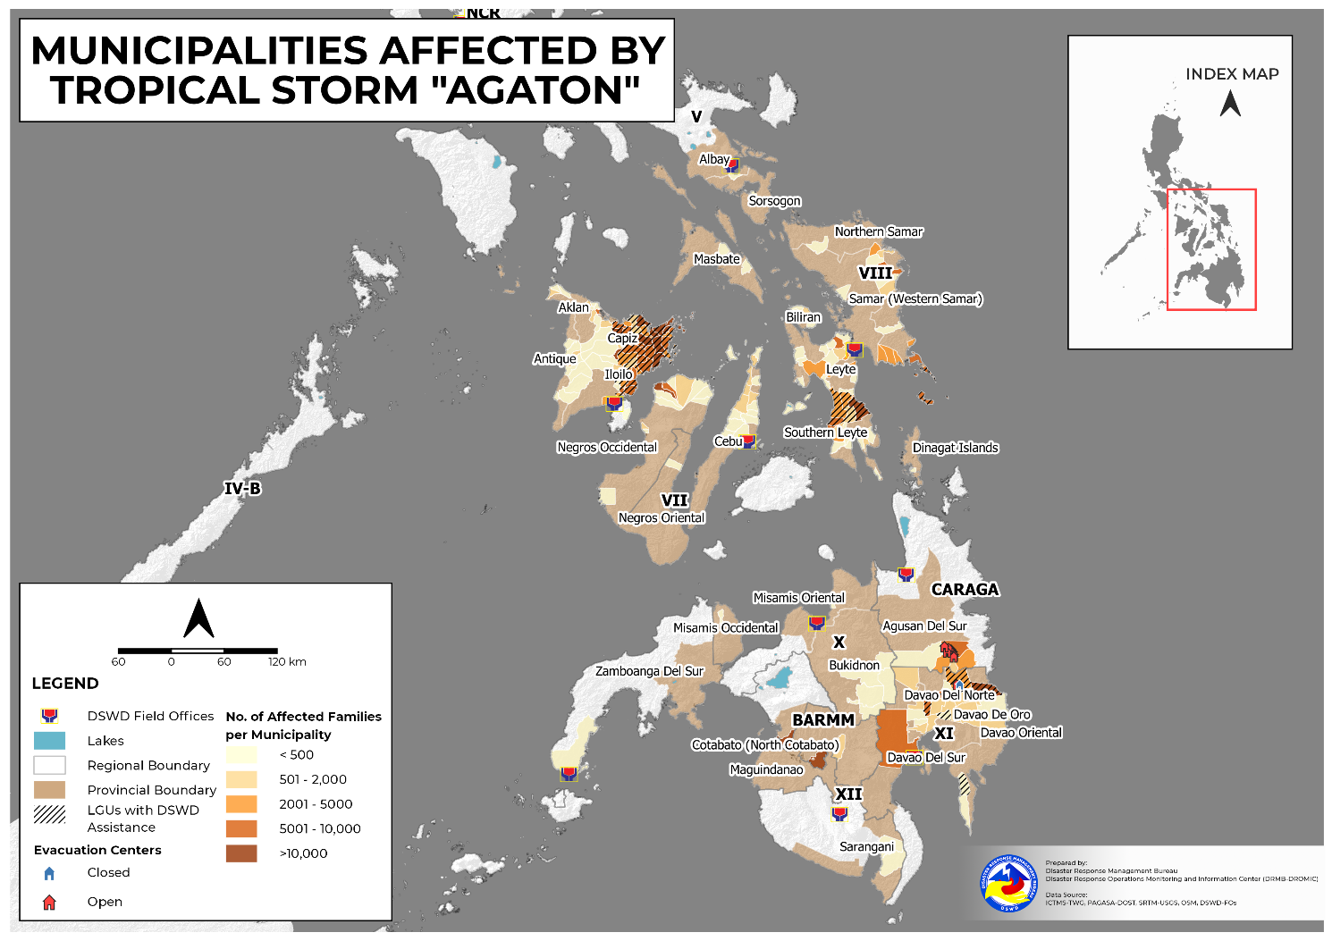

- Status of Displaced Population

    - Inside Evacuation Center
There are 41,590 families or 155,581 persons currently taking temporary shelter in 594 evacuation centers in Regions V, VI, VII, VIII, IX, and X (see Table 2).

Table 2. Number of Displaced Families / Persons Inside Evacuation Center
REGION / PROVINCE / MUNICIPALITY |  | NUMBER OF EVACUATION CENTERS (ECs) |  | NUMBER OF DISPLACED
 |  |  |  | INSIDE ECs
 |  |  |  | Families |  | Persons
 |  | CUM | NOW | CUM | NOW | CUM | NOW
GRAND TOTAL |  | 1,951 | 594 | 100,820 | 41,590 | 368,982 | 155,581
REGION V |  | 3 | 1 | 59 | 6 | 181 | 14
Masbate |  | 2 | 1 | 31 | 6 | 100 | 14
 | Mobo | 1 | 1 | 15 | 6 | 35 | 14
 | Palanas | 1 | - | 16 | - | 65 | -
Sorsogon |  | 1 | - | 28 | - | 81 | -
 | Juban | 1 | - | 28 | - | 81 | -
REGION VI |  | 1,119 | 448 | 36,613 | 17,123 | 140,776 | 62,545
Aklan |  | 43 | 30 | 876 | 772 | 2,757 | 2,334
 | Altavas | 3 | - | 20 | - | 91 | -
 | Balete | 2 | 2 | 182 | 182 | 466 | 466
 | Banga | 4 | - | 51 | - | 207 | -
 | Kalibo (capital) | 2 | 2 | 12 | 12 | 50 | 50
 | New Washington | 12 | 12 | 400 | 400 | 1,233 | 1,233
 | Buruanga | 2 | - | 3 | - | 10 | -
 | Makato | 2 | - | 17 | - | 72 | -
 | Malay | 2 | - | 13 | - | 43 | -
 | Numancia | 14 | 14 | 178 | 178 | 585 | 585
Antique |  | 17 | 11 | 74 | 44 | 218 | 122
 | San Jose (capital) | 5 | - | 23 | - | 70 | -
 | San Remigio | 1 | - | 2 | - | 9 | -
 | Valderrama | 2 | 2 | 7 | 7 | 15 | 15
 | Barbaza | 1 | 1 | 2 | 1 | 10 | 5
 | Bugasong | 5 | 5 | 32 | 28 | 94 | 82
 | Laua-an | 1 | 1 | 1 | 1 | 5 | 5
 | Tibiao | 2 | 2 | 7 | 7 | 15 | 15
Capiz |  | 490 | 94 | 14,480 | 4,694 | 54,873 | 17,508
 | Cuartero | 28 | - | 493 | - | 1,629 | -
 | Dao | 20 | 20 | 458 | 458 | 1,719 | 1,719
 | Dumalag | 28 | - | 371 | - | 1,204 | -
 | Dumarao | 30 | 7 | 1,226 | 152 | 5,004 | 367
 | Ivisan | 4 | - | 20 | - | 72 | -
 | Jamindan | 10 | 1 | 198 | 4 | 707 | 12
 | Ma-ayon | 141 | - | 1,662 | - | 7,754 | -
 | Mambusao | 8 | 8 | 68 | 68 | 246 | 246
 | Panay | 68 | - | 2,397 | - | 7,228 | -
 | Panitan | 15 | - | 376 | - | 1,515 | -
 | Pilar | 29 | - | 957 | - | 3,287 | -
 | Pontevedra | 46 | 23 | 2,425 | 1,143 | 8,877 | 3,880
 | President Roxas | 10 | - | 796 | - | 3,734 | -
 | Roxas City (capital) | 21 | 21 | 387 | 387 | 1,425 | 1,425
 | Sapi-an | 3 | - | 10 | - | 40 | -
 | Sigma | 13 | 13 | 2,480 | 2,480 | 9,854 | 9,854
 | Tapaz | 16 | 1 | 156 | 2 | 578 | 5
Iloilo |  | 471 | 253 | 17,649 | 9,312 | 70,301 | 34,678
 | Ajuy | 34 | 34 | 796 | 796 | 3,164 | 3,164
 | Balasan | 15 | 13 | 450 | 407 | 1,527 | 1,391
 | Banate | 7 | 7 | 322 | 322 | 890 | 890
 | Barotac Nuevo | 19 | 11 | 436 | 296 | 2,180 | 1,480
 | Barotac Viejo | 8 | 8 | 1,533 | 1,533 | 5,308 | 5,308
 | Batad | 10 | 10 | 152 | 152 | 392 | 392
 | Carles | 7 | 7 | 25 | 18 | 113 | 72
 | Concepcion | 4 | - | 252 | - | 655 | -
 | Dingle | 15 | - | 1,181 | - | 5,905 | -
 | Dueñas | 15 | - | 543 | - | 2,715 | -
 | Dumangas | 29 | - | 341 | - | 1,333 | -
 | Estancia | 3 | 3 | 178 | 178 | 729 | 729
 | Leganes | 10 | 2 | 117 | 8 | 523 | 26
 | Lemery | 25 | - | 543 | - | 1,888 | -
 | Mina | 12 | - | 156 | - | 452 | -
 | City of Passi | 75 | 75 | 2,071 | 2,071 | 8,394 | 8,394
 | Pototan | 47 | - | 2,557 | - | 10,191 | -
 | San Dionisio | 36 | - | 1,581 | - | 6,092 | -
 | San Enrique | 11 | 1 | 897 | 37 | 5,074 | 138
 | San Rafael | 5 | - | 16 | - | 54 | -
 | Sara | 80 | 80 | 3,468 | 3,468 | 12,598 | 12,598
 | Zarraga | 4 | 2 | 34 | 26 | 124 | 96
Negros Occidental |  | 98 | 60 | 3,534 | 2,301 | 12,627 | 7,903
 | Cadiz City | 13 | 13 | 1,857 | 1,659 | 6,200 | 5,622
 | Enrique B. Magalona (Saravia) | 15 | 15 | 243 | 243 | 922 | 922
 | City of Escalante | 4 | 4 | 39 | 39 | 146 | 146
 | Manapla | 4 | 4 | 35 | 35 | 135 | 135
 | Sagay City | 14 | - | 294 | - | 1,124 | -
 | Silay City | 8 | 8 | 252 | 252 | 830 | 830
 | City of Sipalay | 5 | 5 | 17 | 17 | 47 | 47
 | City of Talisay | 12 | - | 411 | - | 1,771 | -
 | Toboso | 3 | 3 | 44 | 44 | 165 | 165
 | City of Victorias | 20 | 8 | 342 | 12 | 1,287 | 36
REGION VII |  | 346 | 25 | 5,260 | 424 | 20,526 | 1,632
Cebu |  | 344 | 25 | 5,246 | 424 | 20,473 | 1,632
 | Asturias | 9 | - | 250 | - | 1,025 | -
 | Balamban | 4 | 4 | 42 | 42 | 192 | 192
 | Bantayan | 1 | - | 3 | - | 7 | -
 | Carmen | 1 | 1 | 11 | 11 | 51 | 51
 | Catmon | 9 | - | 131 | - | 543 | -
 | Cebu City (capital) | 6 | 6 | 49 | 48 | 190 | 185
 | Daanbantayan | 6 | - | 80 | - | 454 | -
 | Danao City | 2 | 2 | 29 | 29 | 109 | 109
 | Lapu-Lapu City (Opon) | 2 | 2 | 12 | 12 | 61 | 61
 | Madridejos | 3 | - | 34 | - | 149 | -
 | Mandaue City | 1 | - | 100 | - | 457 | -
 | Medellin | 149 | - | 504 | - | 1,797 | -
 | Minglanilla | 3 | - | 40 | - | 150 | -
 | Pilar | 9 | - | 56 | - | 197 | -
 | Poro | 8 | 2 | 105 | 62 | 332 | 177
 | San Francisco | 7 | - | 37 | - | 185 | -
 | San Remigio | 19 | - | 337 | - | 1,172 | -
 | Santa Fe | 2 | - | 45 | - | 188 | -
 | Sogod | 19 | - | 607 | - | 2,224 | -
 | Tabogon | 7 | 2 | 34 | 16 | 149 | 73
 | Tabuelan | 20 | - | 571 | - | 2,346 | -
 | City of Talisay | 9 | - | 490 | - | 2,279 | -
 | Toledo City | 7 | 3 | 215 | 116 | 855 | 488
 | Tuburan | 33 | - | 1,308 | - | 4,860 | -
 | Tudela | 8 | 3 | 156 | 88 | 501 | 296
Negros Oriental |  | 2 | - | 14 | - | 53 | -
 | La Libertad | 2 | - | 14 | - | 53 | -
REGION VIII |  | 331 | 115 | 43,773 | 23,897 | 158,052 | 90,703
Biliran |  | 52 | 13 | 1,029 | 210 | 4,081 | 802
 | Almeria | 12 | - | 125 | - | 488 | -
 | Kawayan | 6 | - | 174 | - | 576 | -
 | Naval (capital) | 18 | - | 356 | - | 1,547 | -
 | Cabucgayan | 4 | 4 | 76 | 76 | 256 | 256
 | Caibiran | 9 | 9 | 134 | 134 | 546 | 546
 | Culaba | 3 | - | 164 | - | 668 | -
Eastern Samar |  | 9 | 2 | 324 | 39 | 1,401 | 155
 | Giporlos | 6 | - | 90 | - | 450 | -
 | Guiuan | 1 | - | 195 | - | 796 | -
 | Maydolong | 2 | 2 | 39 | 39 | 155 | 155
Leyte |  | 198 | 54 | 41,585 | 23,138 | 149,328 | 87,839
 | Alangalang | 5 | - | 225 | - | 854 | -
 | Babatngon | 3 | 3 | 11 | 11 | 47 | 47
 | San Miguel | 1 | - | 38 | - | 144 | -
 | Santa Fe | 5 | - | 71 | - | 336 | -
 | Tacloban City (capital) | 5 | - | 22 | - | 89 | -
 | Barugo | 1 | 1 | 38 | 38 | 172 | 172
 | Carigara | 1 | 1 | 10 | 10 | 45 | 45
 | Jaro | 4 | - | 64 | - | 256 | -
 | MacArthur | 1 | - | 161 | - | 195 | -
 | Villaba | 1 | 1 | 7 | 7 | 35 | 35
 | Albuera | 1 | - | 203 | - | 1,008 | -
 | Isabel | 1 | - | 450 | - | 1,650 | -
 | Matag-ob | 1 | - | 6 | - | 35 | -
 | Ormoc City | 45 | - | 2,772 | - | 8,610 | -
 | Abuyog | 1 | 1 | 18,926 | 18,926 | 68,182 | 68,182
 | Bato | 1 | - | 2,156 | - | 5,133 | -
 | City of Baybay | 44 | 44 | 3,672 | 3,672 | 17,637 | 17,637
 | Hilongos | 24 | - | 1,267 | - | 4,410 | -
 | Hindang | 18 | - | 850 | - | 4,250 | -
 | Inopacan | 1 | - | 6,812 | - | 22,301 | -
 | Javier (Bugho) | 3 | - | 2,829 | - | 9,985 | -
 | Mahaplag | 30 | 2 | 667 | 146 | 2,669 | 436
 | Matalom | 1 | 1 | 328 | 328 | 1,285 | 1,285
Western Samar |  | 1 | 1 | 2 | 2 | 8 | 8
 | City of Catbalogan (capital) | 1 | 1 | 2 | 2 | 8 | 8
Southern Leyte |  | 71 | 45 | 833 | 508 | 3,234 | 1,899
 | Bontoc | 1 | - | 5 | - | 25 | -
 | Tomas Oppus | 24 | 24 | 124 | 124 | 466 | 466
 | Hinunangan | 1 | - | 65 | - | 385 | -
 | Libagon | 7 | 7 | 152 | 152 | 577 | 577
 | Pintuyan | 7 | 7 | 30 | 30 | 107 | 107
 | Saint Bernard | 31 | 7 | 457 | 202 | 1,674 | 749
REGION IX |  | 2 | 2 | 53 | 53 | 265 | 265
Zamboanga del Sur |  | 2 | 2 | 53 | 53 | 265 | 265
 | Zamboanga City | 2 | 2 | 53 | 53 | 265 | 265
REGION X |  | 4 | 3 | 274 | 87 | 1,156 | 422
Bukidnon |  | 4 | 3 | 274 | 87 | 1,156 | 422
 | Cabanglasan | 2 | 2 | 73 | 73 | 365 | 365
 | Quezon | 1 | - | 19 | - | 67 | -
 | City of Valencia | 1 | 1 | 182 | 14 | 724 | 57
REGION XI |  | 77 | - | 8,205 | - | 24,322 | -
Davao de Oro |  | 37 | - | 2,521 | - | 8,363 | -
 | Compostela | 5 | - | 889 | - | 3,332 | -
 | Mawab | 4 | - | 69 | - | 259 | -
 | Monkayo | 4 | - | 399 | - | 1,275 | -
 | Montevista | 1 | - | 10 | - | 50 | -
 | Nabunturan (capital) | 12 | - | 583 | - | 1,484 | -
 | New Bataan | 11 | - | 571 | - | 1,963 | -
Davao del Norte |  | 11 | - | 436 | - | 1,719 | -
 | Braulio E. Dujali | 1 | - | 8 | - | 19 | -
 | Carmen | 1 | - | 11 | - | 55 | -
 | Kapalong | 2 | - | 35 | - | 117 | -
 | New Corella | 1 | - | 109 | - | 545 | -
 | Santo Tomas | 3 | - | 46 | - | 145 | -
 | City of Tagum (capital) | 3 | - | 227 | - | 838 | -
Davao del Sur |  | 17 | - | 4,302 | - | 11,109 | -
 | Davao City | 17 | - | 4,302 | - | 11,109 | -
Davao Oriental |  | 12 | - | 946 | - | 3,131 | -
 | Caraga | 4 | - | 675 | - | 2,089 | -
 | Cateel | 5 | - | 181 | - | 718 | -
 | Governor Generoso | 2 | - | 25 | - | 129 | -
 | San Isidro | 1 | - | 65 | - | 195 | -
REGION XII |  | 2 | - | 167 | - | 835 | -
Sarangani |  | 2 | - | 167 | - | 835 | -
 | Alabel (capital) | 2 | - | 167 | - | 835 | -
CARAGA |  | 67 | - | 6,416 | - | 22,869 | -
Agusan del Sur |  | 56 | - | 6,265 | - | 22,439 | -
 | Bunawan | 28 | - | 1,539 | - | 5,367 | -
 | Loreto | 1 | - | 54 | - | 134 | -
 | Santa Josefa | 4 | - | 216 | - | 816 | -
 | Trento | 16 | - | 4,150 | - | 14,592 | -
 | Veruela | 7 | - | 306 | - | 1,530 | -
Dinagat Island |  | 11 | - | 151 | - | 430 | -
 | San Jose (capital) | 11 | - | 151 | - | 430 | -
Note: This version reflects the actual number of displaced families and persons in Regions VI, VII, VIII and Caraga after data validation on 18 April 2022, 2PM. Hence, changes in figures are based on the ongoing assessment and validation that are continuously being conducted.
*The LGU of Mobo, Masbate assumes the responsibility in the provision of relief assistance/services to the remaining displaced families staying in the evacuation center.
Source: DSWD-FOs

    - Outside Evacuation Center
There are 31,099 families or 103,254 persons temporarily staying with their relatives and/or friends in Regions VI, VII, VIII, IX, and X (see Table 3).

Table 3. Number of Displaced Families / Persons Outside Evacuation Center

REGION / PROVINCE / MUNICIPALITY |  | NUMBER OF DISPLACED
 |  | OUTSIDE ECs
 |  | Families |  | Persons
 |  | CUM | NOW | CUM | NOW
GRAND TOTAL |  | 82,123 | 31,099 | 283,659 | 103,254
REGION V |  | 11 | - | 50 | -
Albay |  | 2 | - | 13 | -
 | Legazpi City (capital) | 2 | - | 13 | -
Sorsogon |  | 9 | - | 37 | -
 | Juban | 9 | - | 37 | -
REGION VI |  | 77,970 | 28,798 | 265,766 | 92,391
Aklan |  | 1,126 | 386 | 4,294 | 1,415
 | Altavas | 613 | - | 2,396 | -
 | Balete | 53 | 53 | 190 | 190
 | Banga | 2 | 1 | 5 | 1
 | Kalibo (capital) | 6 | 6 | 32 | 32
 | New Washington | 101 | 101 | 385 | 385
 | Buruanga | 2 | - | 9 | -
 | Lezo | 25 | - | 84 | -
 | Makato | 99 | - | 387 | 1
 | Nabas | 33 | 33 | 163 | 163
 | Numancia | 192 | 192 | 643 | 643
Antique |  | 186 | 1 | 806 | 3
 | San Jose (capital) | 1 | - | 7 | -
 | San Remigio | 183 | - | 790 | -
 | Barbaza | 1 | - | 6 | -
 | Bugasong | 1 | 1 | 3 | 3
Capiz |  | 29,666 | 2,657 | 102,203 | 10,401
 | Cuartero | 6,495 | - | 26,364 | -
 | Dao | 413 | 413 | 1,506 | 1,506
 | Dumarao | 3,014 | - | 9,430 | -
 | Ivisan | 12 | - | 30 | -
 | Jamindan | 278 | 8 | 887 | 29
 | Ma-ayon | 961 | - | 4,238 | -
 | Mambusao | 119 | 119 | 526 | 526
 | Panay | 3,860 | - | 13,168 | -
 | Panitan | 298 | - | 1,405 | -
 | Pilar | 12,047 | - | 36,104 | -
 | Pontevedra | 48 | 48 | 235 | 235
 | President Roxas | 348 | 348 | 1,425 | 1,425
 | Roxas City (capital) | 533 | 533 | 2,060 | 2,060
 | Sigma | 1,188 | 1,188 | 4,620 | 4,620
 | Tapaz | 52 | - | 205 | -
Iloilo |  | 46,215 | 25,012 | 155,889 | 78,154
 | Ajuy | 779 | 779 | 3,209 | 3,209
 | Balasan | 747 | 747 | 2,660 | 2,660
 | Barotac Nuevo | 246 | 235 | 1,230 | 1,175
 | Barotac Viejo | 8,326 | 8,326 | 29,759 | 29,759
 | Batad | 216 | 216 | 643 | 643
 | Bingawan | 7 | 7 | 24 | 24
 | Carles | 201 | 176 | 708 | 550
 | Dingle | 1,194 | - | 5,970 | -
 | Dueñas | 145 | - | 723 | -
 | Dumangas | 932 | - | 3,476 | -
 | Lambunao | 177 | - | 740 | -
 | Leganes | 436 | 150 | 187 | 175
 | New Lucena | 106 | 106 | 432 | 432
 | Oton | 4,670 | - | 17,314 | -
 | San Dionisio | 8,014 | - | 27,899 | -
 | San Enrique | 558 | - | 2,438 | -
 | San Rafael | 5,191 | - | 18,950 | -
 | Sara | 13,802 | 13,802 | 39,416 | 39,416
 | Zarraga | 468 | 468 | 111 | 111
Negros Occidental |  | 777 | 742 | 2,574 | 2,418
 | Enrique B. Magalona (Saravia) | 182 | 182 | 751 | 751
 | Manapla | 416 | 416 | 949 | 949
 | Sagay City | 15 | - | 82 | -
 | San Enrique | 141 | 141 | 705 | 705
 | Silay City | 1 | 1 | 6 | 6
 | City of Sipalay | 2 | 2 | 7 | 7
 | City of Victorias | 20 | - | 74 | -
REGION VII |  | 713 | 162 | 2,621 | 635
Cebu |  | 702 | 162 | 2,574 | 635
 | Asturias | 8 | - | 30 | -
 | Catmon | 13 | - | 60 | -
 | Cebu City (capital) | 16 | 16 | 54 | 54
 | Madridejos | 27 | - | 123 | -
 | Pilar | 40 | - | 134 | -
 | Poro | 91 | 50 | 342 | 143
 | San Francisco | 5 | - | 20 | -
 | San Remigio | 201 | - | 605 | -
 | Tabuelan | 108 | - | 409 | -
 | Toledo City | 95 | 95 | 434 | 434
 | Tuburan | 76 | - | 279 | -
 | Tudela | 22 | 1 | 84 | 4
Negros Oriental |  | 11 | - | 47 | -
 | La Libertad | 11 | - | 47 | -
REGION VIII |  | 2,575 | 2,076 | 11,765 | 9,913
Biliran |  | 127 | - | 484 | -
 | Cabucgayan | 26 | - | 136 | -
 | Culaba | 101 | - | 348 | -
Leyte |  | 1,899 | 1,891 | 9,265 | 9,242
 | Babatngon | 45 | 45 | 192 | 192
 | Tacloban City (capital) | 1,846 | 1,846 | 9,050 | 9,050
 | Ormoc City | 8 | - | 23 | -
Northern Samar |  | 4 | 4 | 16 | 16
 | Lope de Vega | 4 | 4 | 16 | 16
Southern Leyte |  | 545 | 181 | 2,000 | 655
 | Tomas Oppus | 150 | 150 | 532 | 532
 | Pintuyan | 31 | 31 | 123 | 123
 | Saint Bernard | 364 | - | 1,345 | -
REGION IX |  | 54 | 54 | 270 | 270
Zamboanga del Sur |  | 54 | 54 | 270 | 270
 | Zamboanga City | 54 | 54 | 270 | 270
REGION X |  | 37 | 9 | 128 | 45
Bukidnon |  | 31 | 3 | 98 | 15
 | Kitaotao | 30 | 2 | 93 | 10
 | Quezon | 1 | 1 | 5 | 5
Misamis Occidental |  | 6 | 6 | 30 | 30
 | Calamba | 6 | 6 | 30 | 30
REGION XI |  | 27 | - | 119 | -
Davao Oriental |  | 27 | - | 119 | -
 | Baganga | 27 | - | 119 | -
CARAGA |  | 736 | - | 2,940 | -
Agusan del Sur |  | 726 | - | 2,901 | -
 | Bunawan | 649 | - | 2,547 | -
 | Santa Josefa | 20 | - | 69 | -
 | Veruela | 57 | - | 285 | -
Dinagat Island |  | 10 | - | 39 | -
 | San Jose (capital) | 10 | - | 39 | -
Note: This version reflects the actual number of displaced families and persons in Regions VI, VII, VIII and Caraga after data validation on 18 April 2022, 2PM. Hence, changes in figures are based on the ongoing assessment and validation that are continuously being conducted.
Source: DSWD-FOs
    - Total Displaced Population
There are 72,689 families or 258,835 persons temporarily staying either in evacuation centers or with their relatives and/or friends in Regions V, VI, VII, VIII, IX, and X (see Table 4).

Table 4. Total Number of Displaced Families / Persons
REGION / PROVINCE / MUNICIPALITY |  | TOTAL DISPLACED SERVED
 |  | Families |  | Persons
 |  | Total Families |  | Total Persons
 |  | CUM | NOW | CUM | NOW
GRAND TOTAL |  | 180,694 | 72,689 | 644,893 | 258,835
REGION V |  | 70 | 6 | 231 | 14
Albay |  | 2 | - | 13 | -
 | Legazpi City (capital) | 2 | - | 13 | -
Masbate |  | 31 | 6 | 100 | 14
 | Mobo | 15 | 6 | 35 | 14
 | Palanas | 16 | - | 65 | -
Sorsogon |  | 37 | - | 118 | -
 | Juban | 37 | - | 118 | -
REGION VI |  | 114,583 | 45,921 | 406,542 | 154,936
Aklan |  | 2,002 | 1,158 | 7,051 | 3,749
 | Altavas | 633 | - | 2,487 | -
 | Balete | 235 | 235 | 656 | 656
 | Banga | 53 | 1 | 212 | 1
 | Kalibo (capital) | 18 | 18 | 82 | 82
 | New Washington | 501 | 501 | 1,618 | 1,618
 | Buruanga | 5 | - | 19 | -
 | Lezo | 25 | - | 84 | -
 | Makato | 116 | - | 459 | 1
 | Malay | 13 | - | 43 | -
 | Nabas | 33 | 33 | 163 | 163
 | Numancia | 370 | 370 | 1,228 | 1,228
Antique |  | 260 | 45 | 1,024 | 125
 | San Jose (capital) | 24 | - | 77 | -
 | San Remigio | 185 | - | 799 | -
 | Valderrama | 7 | 7 | 15 | 15
 | Barbaza | 3 | 1 | 16 | 5
 | Bugasong | 33 | 29 | 97 | 85
 | Laua-an | 1 | 1 | 5 | 5
 | Tibiao | 7 | 7 | 15 | 15
Capiz |  | 44,146 | 7,351 | 157,076 | 27,909
 | Cuartero | 6,988 | - | 27,993 | -
 | Dao | 871 | 871 | 3,225 | 3,225
 | Dumalag | 371 | - | 1,204 | -
 | Dumarao | 4,240 | 152 | 14,434 | 367
 | Ivisan | 32 | - | 102 | -
 | Jamindan | 476 | 12 | 1,594 | 41
 | Ma-ayon | 2,623 | - | 11,992 | -
 | Mambusao | 187 | 187 | 772 | 772
 | Panay | 6,257 | - | 20,396 | -
 | Panitan | 674 | - | 2,920 | -
 | Pilar | 13,004 | - | 39,391 | -
 | Pontevedra | 2,473 | 1,191 | 9,112 | 4,115
 | President Roxas | 1,144 | 348 | 5,159 | 1,425
 | Roxas City (capital) | 920 | 920 | 3,485 | 3,485
 | Sapi-an | 10 | - | 40 | -
 | Sigma | 3,668 | 3,668 | 14,474 | 14,474
 | Tapaz | 208 | 2 | 783 | 5
Iloilo |  | 63,864 | 34,324 | 226,190 | 112,832
 | Ajuy | 1,575 | 1,575 | 6,373 | 6,373
 | Balasan | 1,197 | 1,154 | 4,187 | 4,051
 | Banate | 322 | 322 | 890 | 890
 | Barotac Nuevo | 682 | 531 | 3,410 | 2,655
 | Barotac Viejo | 9,859 | 9,859 | 35,067 | 35,067
 | Batad | 368 | 368 | 1,035 | 1,035
 | Bingawan | 7 | 7 | 24 | 24
 | Carles | 226 | 194 | 821 | 622
 | Concepcion | 252 | - | 655 | -
 | Dingle | 2,375 | - | 11,875 | -
 | Dueñas | 688 | - | 3,438 | -
 | Dumangas | 1,273 | - | 4,809 | -
 | Estancia | 178 | 178 | 729 | 729
 | Lambunao | 177 | - | 740 | -
 | Leganes | 553 | 158 | 710 | 201
 | Lemery | 543 | - | 1,888 | -
 | Mina | 156 | - | 452 | -
 | New Lucena | 106 | 106 | 432 | 432
 | Oton | 4,670 | - | 17,314 | -
 | City of Passi | 2,071 | 2,071 | 8,394 | 8,394
 | Pototan | 2,557 | - | 10,191 | -
 | San Dionisio | 9,595 | - | 33,991 | -
 | San Enrique | 1,455 | 37 | 7,512 | 138
 | San Rafael | 5,207 | - | 19,004 | -
 | Sara | 17,270 | 17,270 | 52,014 | 52,014
 | Zarraga | 502 | 494 | 235 | 207
Negros Occidental |  | 4,311 | 3,043 | 15,201 | 10,321
 | Cadiz City | 1,857 | 1,659 | 6,200 | 5,622
 | Enrique B. Magalona (Saravia) | 425 | 425 | 1,673 | 1,673
 | City of Escalante | 39 | 39 | 146 | 146
 | Manapla | 451 | 451 | 1,084 | 1,084
 | Sagay City | 309 | - | 1,206 | -
 | San Enrique | 141 | 141 | 705 | 705
 | Silay City | 253 | 253 | 836 | 836
 | City of Sipalay | 19 | 19 | 54 | 54
 | City of Talisay | 411 | - | 1,771 | -
 | Toboso | 44 | 44 | 165 | 165
 | City of Victorias | 362 | 12 | 1,361 | 36
REGION VII |  | 5,973 | 586 | 23,147 | 2,267
Cebu |  | 5,948 | 586 | 23,047 | 2,267
 | Asturias | 258 | - | 1,055 | -
 | Balamban | 42 | 42 | 192 | 192
 | Bantayan | 3 | - | 7 | -
 | Carmen | 11 | 11 | 51 | 51
 | Catmon | 144 | - | 603 | -
 | Cebu City (capital) | 65 | 64 | 244 | 239
 | Daanbantayan | 80 | - | 454 | -
 | Danao City | 29 | 29 | 109 | 109
 | Lapu-Lapu City (Opon) | 12 | 12 | 61 | 61
 | Madridejos | 61 | - | 272 | -
 | Mandaue City | 100 | - | 457 | -
 | Medellin | 504 | - | 1,797 | -
 | Minglanilla | 40 | - | 150 | -
 | Pilar | 96 | - | 331 | -
 | Poro | 196 | 112 | 674 | 320
 | San Francisco | 42 | - | 205 | -
 | San Remigio | 538 | - | 1,777 | -
 | Santa Fe | 45 | - | 188 | -
 | Sogod | 607 | - | 2,224 | -
 | Tabogon | 34 | 16 | 149 | 73
 | Tabuelan | 679 | - | 2,755 | -
 | City of Talisay | 490 | - | 2,279 | -
 | Toledo City | 310 | 211 | 1,289 | 922
 | Tuburan | 1,384 | - | 5,139 | -
 | Tudela | 178 | 89 | 585 | 300
Negros Oriental |  | 25 | - | 100 | -
 | La Libertad | 25 | - | 100 | -
REGION VIII |  | 46,348 | 25,973 | 169,817 | 100,616
Biliran |  | 1,156 | 210 | 4,565 | 802
 | Almeria | 125 | - | 488 | -
 | Kawayan | 174 | - | 576 | -
 | Naval (capital) | 356 | - | 1,547 | -
 | Cabucgayan | 102 | 76 | 392 | 256
 | Caibiran | 134 | 134 | 546 | 546
 | Culaba | 265 | - | 1,016 | -
Eastern Samar |  | 324 | 39 | 1,401 | 155
 | Giporlos | 90 | - | 450 | -
 | Guiuan | 195 | - | 796 | -
 | Maydolong | 39 | 39 | 155 | 155
Leyte |  | 43,484 | 25,029 | 158,593 | 97,081
 | Alangalang | 225 | - | 854 | -
 | Babatngon | 56 | 56 | 239 | 239
 | San Miguel | 38 | - | 144 | -
 | Santa Fe | 71 | - | 336 | -
 | Tacloban City (capital) | 1,868 | 1,846 | 9,139 | 9,050
 | Barugo | 38 | 38 | 172 | 172
 | Carigara | 10 | 10 | 45 | 45
 | Jaro | 64 | - | 256 | -
 | MacArthur | 161 | - | 195 | -
 | Villaba | 7 | 7 | 35 | 35
 | Albuera | 203 | - | 1,008 | -
 | Isabel | 450 | - | 1,650 | -
 | Matag-ob | 6 | - | 35 | -
 | Ormoc City | 2,780 | - | 8,633 | -
 | Abuyog | 18,926 | 18,926 | 68,182 | 68,182
 | Bato | 2,156 | - | 5,133 | -
 | City of Baybay | 3,672 | 3,672 | 17,637 | 17,637
 | Hilongos | 1,267 | - | 4,410 | -
 | Hindang | 850 | - | 4,250 | -
 | Inopacan | 6,812 | - | 22,301 | -
 | Javier (Bugho) | 2,829 | - | 9,985 | -
 | Mahaplag | 667 | 146 | 2,669 | 436
 | Matalom | 328 | 328 | 1,285 | 1,285
Northern Samar |  | 4 | 4 | 16 | 16
 | Lope de Vega | 4 | 4 | 16 | 16
Western Samar |  | 2 | 2 | 8 | 8
 | City of Catbalogan (capital) | 2 | 2 | 8 | 8
Southern Leyte |  | 1,378 | 689 | 5,234 | 2,554
 | Bontoc | 5 | - | 25 | -
 | Tomas Oppus | 274 | 274 | 998 | 998
 | Hinunangan | 65 | - | 385 | -
 | Libagon | 152 | 152 | 577 | 577
 | Pintuyan | 61 | 61 | 230 | 230
 | Saint Bernard | 821 | 202 | 3,019 | 749
REGION IX |  | 107 | 107 | 535 | 535
Zamboanga del Sur |  | 107 | 107 | 535 | 535
 | Zamboanga City | 107 | 107 | 535 | 535
REGION X |  | 311 | 96 | 1,284 | 467
Bukidnon |  | 305 | 90 | 1,254 | 437
 | Cabanglasan | 73 | 73 | 365 | 365
 | Kitaotao | 30 | 2 | 93 | 10
 | Quezon | 20 | 1 | 72 | 5
 | City of Valencia | 182 | 14 | 724 | 57
Misamis Occidental |  | 6 | 6 | 30 | 30
 | Calamba | 6 | 6 | 30 | 30
REGION XI |  | 8,232 | - | 24,441 | -
Davao de Oro |  | 2,521 | - | 8,363 | -
 | Compostela | 889 | - | 3,332 | -
 | Mawab | 69 | - | 259 | -
 | Monkayo | 399 | - | 1,275 | -
 | Montevista | 10 | - | 50 | -
 | Nabunturan (capital) | 583 | - | 1,484 | -
 | New Bataan | 571 | - | 1,963 | -
Davao del Norte |  | 436 | - | 1,719 | -
 | Braulio E. Dujali | 8 | - | 19 | -
 | Carmen | 11 | - | 55 | -
 | Kapalong | 35 | - | 117 | -
 | New Corella | 109 | - | 545 | -
 | Santo Tomas | 46 | - | 145 | -
 | City of Tagum (capital) | 227 | - | 838 | -
Davao del Sur |  | 4,302 | - | 11,109 | -
 | Davao City | 4,302 | - | 11,109 | -
Davao Oriental |  | 973 | - | 3,250 | -
 | Baganga | 27 | - | 119 | -
 | Caraga | 675 | - | 2,089 | -
 | Cateel | 181 | - | 718 | -
 | Governor Generoso | 25 | - | 129 | -
 | San Isidro | 65 | - | 195 | -
REGION XII |  | 167 | - | 835 | -
Sarangani |  | 167 | - | 835 | -
 | Alabel (capital) | 167 | - | 835 | -
CARAGA |  | 4,903 | - | 18,061 | -
Agusan del Sur |  | 4,742 | - | 17,592 | -
 | Bunawan | 2,188 | - | 7,914 | -
 | Loreto | 54 | - | 134 | -
 | Santa Josefa | 236 | - | 885 | -
 | Trento | 1,901 | - | 6,844 | -
 | Veruela | 363 | - | 1,815 | -
Dinagat Island |  | 161 | - | 469 | -
 | San Jose (capital) | 161 | - | 469 | -

Note: This version reflects the actual number of displaced families and persons in Regions VI, VII, VIII and Caraga after data validation on 18 April 2022, 2PM. Hence, changes in figures are based on the ongoing assessment and validation that are continuously being conducted.
Source: DSWD-FOs

- Damaged Houses

A total of 11,099 houses were damaged; of which, 1,014 are totally damaged and 10,085 are partially damaged in Regions V, VI, VII, VIII, X, XI and Caraga (see Table 5).

Table 5. Number of Damaged Houses

REGION / PROVINCE / MUNICIPALITY |  | NO. OF DAMAGED HOUSES
 |  | Total | Totally | Partially
GRAND TOTAL |  | 11,099 | 1,014 | 10,085
REGION V |  | 5 | - | 5
Masbate |  | 5 | - | 5
 | Mobo | 5 | - | 5
REGION VI |  | 10,507 | 717 | 9,790
Aklan |  | 76 | 2 | 74
 | Banga | 1 | 1 | -
 | New Washington | 75 | 1 | 74
Antique |  | 183 | 3 | 180
 | San Remigio | 180 | 2 | 178
 | Bugasong | 1 | 1 | -
 | Laua-an | 2 | - | 2
Capiz |  | 638 | 153 | 485
 | Dumalag | 17 | - | 17
 | Dumarao | 309 | 96 | 213
 | Ivisan | 3 | 2 | 1
 | Ma-ayon | 279 | 48 | 231
 | Panay | 1 | 1 | -
 | President Roxas | 29 | 6 | 23
Iloilo |  | 9,604 | 555 | 9,049
 | Barotac Nuevo | 5,171 | 61 | 5,110
 | Barotac Viejo | 189 | 11 | 178
 | Bingawan | 14 | 4 | 10
 | Dumangas | 377 | 60 | 317
 | Lambunao | 177 | - | 177
 | Lemery | 59 | 44 | 15
 | Pototan | 1 | 1 | -
 | San Dionisio | 5 | 4 | 1
 | Sara | 3,611 | 370 | 3,241
Negros Occidental |  | 6 | 4 | 2
 | Manapla | 2 | 2 | -
 | Silay City | 2 | 1 | 1
 | City of Talisay | 2 | 1 | 1
REGION VII |  | 137 | 27 | 110
Cebu |  | 137 | 27 | 110
 | Danao City | 4 | 4 | -
 | Tuburan | 133 | 23 | 110
REGION VIII |  | 340 | 209 | 131
Biliran |  | 106 | 3 | 103
 | Culaba | 106 | 3 | 103
Eastern Samar |  | 1 | - | 1
 | Giporlos | 1 | - | 1
Leyte |  | 224 | 201 | 23
 | Albuera | 5 | 5 | -
 | Bato | 9 | - | 9
 | City of Baybay | 204 | 190 | 14
 | Hindang | 6 | 6 | -
Northern Samar |  | 4 | - | 4
 | Lope de Vega | 4 | - | 4
Southern Leyte |  | 5 | 5 | -
 | Bontoc | 5 | 5 | -
REGION X |  | 46 | 3 | 43
Bukidnon |  | 46 | 3 | 43
 | Kitaotao | 30 | 2 | 28
 | Quezon | 16 | 1 | 15
REGION XI |  | 59 | 55 | 4
Davao de Oro |  | 4 | - | 4
 | Nabunturan (capital) | 4 | - | 4
Davao Oriental |  | 55 | 55 | -
 | Cateel | 55 | 55 | -
CARAGA |  | 5 | 3 | 2
Agusan del Sur |  | 5 | 3 | 2
 | Bunawan | 2 | 2 | -
 | Santa Josefa | 1 | - | 1
 | Trento | 1 | - | 1
 | Veruela | 1 | 1 | -
Note: This version reflects the actual number of damaged houses in Regions VI, VII, VIII and Caraga after data validation on 18 April 2022, 2PM. Hence, changes in figures are based on the ongoing assessment and validation that are continuously being conducted.
Source: DSWD-FOs

- Cost of Humanitarian Assistance Provided

A total of ₱76,737,326.28 worth of assistance was provided to the affected families; of which, ₱57,502,480.82 from the DSWD, ₱17,969,089.46 from the Local Government Units (LGUs), ₱342,900.00 from the Non-Government Organizations (NGOs) and ₱922,856.00 from Other Partners (see Table 6).

Table 6. Cost of Assistance Provided to Affected Families / Persons

REGION / PROVINCE / MUNICIPALITY |  | COST OF ASSISTANCE
 |  | DSWD | LGUs | NGOs | OTHERS | GRAND TOTAL
GRAND TOTAL |  | 57,502,480.82 | 17,969,089.46 | 342,900.00 | 922,856.00 | 76,737,326.28
REGION VI |  | 27,521,022.00 | 12,188,596.00 | - | 922,856.00 | 40,632,474.00
Antique |  | - | 14,251.00 | - | - | 14,251.00
 | San Jose (capital) | - | 725.00 | - | - | 725.00
 | San Remigio | - | 1,496.00 | - | - | 1,496.00
 | Barbaza | - | 150.00 | - | - | 150.00
 | Laua-an | - | 11,880.00 | - | - | 11,880.00
Capiz |  | 11,608,795.00 | 3,662,095.00 | - | - | 15,270,890.00
 | Cuartero | 648,350.00 | - | - | - | 648,350.00
 | Dao | 675,380.00 | - | - | - | 675,380.00
 | Dumarao | 1,365,850.00 | 2,230,100.00 | - | - | 3,595,950.00
 | Ma-ayon | 543,500.00 | 114,600.00 | - | - | 658,100.00
 | Mambusao | 983,565.00 | 300,000.00 | - | - | 1,283,565.00
 | Panay | 1,029,500.00 | 84,960.00 | - | - | 1,114,460.00
 | Panitan | 991,450.00 | - | - | - | 991,450.00
 | Pilar | 648,350.00 | 174,750.00 | - | - | 823,100.00
 | Pontevedra | 2,341,150.00 | 745,185.00 | - | - | 3,086,335.00
 | President Roxas | 528,500.00 | - | - | - | 528,500.00
 | Roxas City (capital) | 676,350.00 | - | - | - | 676,350.00
 | Sapi-an | 648,350.00 | 12,500.00 | - | - | 660,850.00
 | Sigma | 528,500.00 | - | - | - | 528,500.00
Guimaras |  | - | 2,650.00 | - | - | 2,650.00
 | San Lorenzo | - | 2,650.00 | - | - | 2,650.00
Iloilo |  | 15,912,227.00 | 3,219,690.00 | - | 922,856.00 | 20,054,773.00
 | Ajuy | 1,801,850.00 | - | - | 146,840.00 | 1,948,690.00
 | Balasan | 486,000.00 | - | - | - | 486,000.00
 | Banate | 991,582.00 | - | - | 209,100.00 | 1,200,682.00
 | Barotac Nuevo | 486,000.00 | - | - | - | 486,000.00
 | Barotac Viejo | 636,300.00 | - | - | - | 636,300.00
 | Batad | 486,000.00 | - | - | - | 486,000.00
 | Concepcion | 686,400.00 | - | - | 115,536.00 | 801,936.00
 | Dingle | 486,000.00 | - | - | - | 486,000.00
 | Dumangas | 489,000.00 | - | - | - | 489,000.00
 | Estancia | 501,000.00 | - | - | - | 501,000.00
 | Lambunao | - | 118,590.00 | - | - | 118,590.00
 | Leganes | 501,000.00 | - | - | - | 501,000.00
 | Lemery | 1,230,000.00 | - | - | - | 1,230,000.00
 | Mina | 78,156.00 | 6,100.00 | - | - | 84,256.00
 | City of Passi | 1,072,000.00 | - | - | - | 1,072,000.00
 | Pototan | 1,151,115.00 | 1,988,250.00 | - | 153,350.00 | 3,292,715.00
 | San Dionisio | 1,013,500.00 | - | - | - | 1,013,500.00
 | San Enrique | 501,000.00 | - | - | - | 501,000.00
 | San Rafael | 998,085.00 | - | - | - | 998,085.00
 | Sara | 1,162,064.00 | 1,106,750.00 | - | 144,680.00 | 2,413,494.00
 | Zarraga | 1,155,175.00 | - | - | 153,350.00 | 1,308,525.00
Negros Occidental |  | - | 5,289,910.00 | - | - | 5,289,910.00
 | Cadiz City | - | 179,000.00 | - | - | 179,000.00
 | Enrique B. Magalona (Saravia) | - | 4,119,150.00 | - | - | 4,119,150.00
 | City of Talisay | - | 991,760.00 | - | - | 991,760.00
REGION VIII |  | 17,418,325.32 | 2,044,740.00 | - | - | 19,463,065.32
Eastern Samar |  | 2,355,891.00 | 1,998,000.00 | - | - | 4,353,891.00
 | Jipapad | - | 1,800,000.00 | - | - | 1,800,000.00
 | Guiuan | 2,355,891.00 | 198,000.00 | - | - | 2,553,891.00
Leyte |  | 15,062,434.32 | 46,740.00 | - | - | 15,109,174.32
 | Alangalang | - | 46,740.00 | - | - | 46,740.00
 | Abuyog | 8,271,549.32 | - | - | - | 8,271,549.32
 | City of Baybay | 2,113,910.00 | - | - | - | 2,113,910.00
 | Inopacan | 1,125,000.00 | - | - | - | 1,125,000.00
 | Javier (Bugho) | 902,166.00 | - | - | - | 902,166.00
 | Mahaplag | 2,649,809.00 | - | - | - | 2,649,809.00
REGION XI |  | 12,563,133.50 | - | - | - | 12,563,133.50
Davao de Oro |  | 4,420,493.00 | - | - | - | 4,420,493.00
 | Mawab | 1,986,165.00 | - | - | - | 1,986,165.00
 | Monkayo | 2,434,328.00 | - | - | - | 2,434,328.00
Davao del Norte |  | 4,227,099.50 | - | - | - | 4,227,099.50
 | Asuncion (Saug) | 4,227,099.50 | - | - | - | 4,227,099.50
Davao Oriental |  | 3,915,541.00 | - | - | - | 3,915,541.00
 | Cateel | 3,413,091.00 | - | - | - | 3,413,091.00
 | San Isidro | 502,450.00 | - | - | - | 502,450.00
CARAGA |  | - | 3,735,753.46 | 342,900.00 | - | 4,078,653.46
Agusan del Sur |  | - | 3,735,753.46 | 342,900.00 | - | 4,078,653.46
 | Bunawan | - | 1,646,907.00 | 342,900.00 | - | 1,989,807.00
 | Loreto | - | 130,200.00 | - | - | 130,200.00
 | Santa Josefa | - | 668,034.00 | - | - | 668,034.00
 | Trento | - | 1,001,449.46 | - | - | 1,001,449.46
 | Veruela | - | 289,163.00 | - | - | 289,163.00

Note: This version reflects the actual number of assistance provided in Regions VI, VII, VIII and Caraga after data validation on 18 April 2022, 2PM. Hence, changes in figures are based on the ongoing assessment and validation that are continuously being conducted.

Source: DSWD-FO FOs

- Response Actions and Interventions

- Standby Funds and Prepositioned Relied Stockpile
OFFICE | STANDBY FUNDS | STOCKPILE |  |  | TOTAL STANDBY FUNDS & STOCKPILE
 |  | FAMILY FOOD PACKS |  | OTHER FOOD AND NON-FOOD ITEMS (FNIs)
 |  | QUANTITY | TOTAL COST
TOTAL | 136,108,361.70 | 471,499 | 300,853,418.64 | 731,754,677.65 | 1,168,716,457.99
DSWD-CO | 68,594,777.99 | - | - | - | 68,594,777.99
NRLMB-NROC | - | 39,129 | 24,348,225.00 | 242,329,461.34 | 266,677,686.34
NRLMB-VDRC | - | 12 | 8,040.00 | 25,513,622.90 | 25,521,662.90
DSWD-FO V | 5,000,642.50 | 25,998 | 12,919,444.97 | 42,387,136.19 | 60,307,223.66
DSWD-FO VI | - | 7,083 | 3,517,083.00 | 12,847,129.89 | 16,364,212.89
DSWD-FO VII | 5,000,000.00 | 14,089 | 7,467,170.00 | 31,247,181.69 | 43,714,351.69
DSWD-FO VIII | - | 29,411 | 18,338,497.27 | 19,795,652.37 | 38,134,149.64
DSWD-FO IX | 5,000,000.00 | 17,984 | 9,828,076.16 | 13,228,779.23 | 28,056,855.39
DSWD-FO X | 6,193,317.50 | 26,661 | 19,211,952.41 | 53,457,948.56 | 78,863,218.47
DSWD-FO XI | 66,610.00 | 15,846 | 9,703,711.00 | 25,722,912.80 | 35,493,233.80
DSWD-FO XII | 5,000,970.00 | 17,991 | 9,798,300.00 | 35,654,871.93 | 50,454,141.93
DSWD-FO Caraga | 5,000,000.00 | 170,093 | 117,288,042.00 | 10,341,505.61 | 132,629,547.61
Other FOs | 36,252,043.71 | 107,202 | 68,424,876.83 | 219,228,475.14 | 323,905,395.68
Note: Inventory Summary is as of 18 April 2022, 4PM. The replenishment of standby funds for DSWD-FOs VI, VIII and XI are being processed.
Source: DSWD-DRMB and DSWD-NRLMB

  - Standby Funds
    - ₱68.59 million Quick Response Fund (QRF) at the DSWD-Central Office.
    - ₱31.26 million available at DSWD-FOs V, VI, VII, IX, X, XI, XII, and Caraga.
    - ₱36.25 million in other DSWD-FOs which may support the relief needs of the displaced families due to Tropical Storm AGATON through inter-FO augmentation.
  - Prepositioned FFPs and Other Relief Items
    - 39,141 FFPs available in Disaster Response Centers; of which, 39,129 FFPs are at the National Resource Operations Center (NROC), Pasay City and 12 FFPs are at the Visayas Disaster Response Center (VDRC), Cebu City.
    - 325,156 FFPs available at DSWD-FOs V, VI, VII, VIII, IX, X, XI, XII, and Caraga.
    - 107,202 FFPs in other DSWD-FOs which may support the relief needs of the displaced families due to Tropical Storm AGATON through inter-FO augmentation.
    - ₱731.75 million worth of other FNIs at NROC, VDRC and DSWD-FO warehouses.

- Food and Non-Food Items

DSWD-FO I
DATE | SITUATIONS / ACTIONS UNDERTAKEN
11 April 2022 | - Inspection of relief items prepositioned at the satellite warehouses in Pangasinan was conducted to check the quality of the relief items.  - Loading of 2,000 FFPs-equivalent raw materials at the DSWD Regional warehouse in Biday, City of San Fernando, La Union were conducted to be prepositioned at the satellite warehouse in Ayusan Sur, Vigan City.

DSWD-FO V
DATE | SITUATIONS / ACTIONS UNDERTAKEN
13 April 2022 | - DSWD-FO V prepared the delivery of 220 FFPs as resource augmentation to LGU of Pilar, Sorsogon.
12 April 2022 | - DSWD-FO V delivered 1,024 FFPs to LGU of Matnog, Sorsogon as augmentation support.
11 April 2022 | - DSWD-FO V coordinated with Municipal Social Welfare and Development Office (MSWDO) of Matnog, Sorsogon on their request for FFPs as augmentation support for the stranded passengers at Matnog Port.  - The Resource Operation Section of DSWD-FO VI ensured the availability of FFPs and NFIs as need arises.

DSWD-FO VI
DATE | SITUATIONS / ACTIONS UNDERTAKEN
14 April 2022 | - DSWD-FO VI augmented relief items to the following affected LGUs:  - Mambusao, Capiz – 2,000 FFPs  - San Enrique, Iloilo – 800 FFPs  - San Rafael, Iloilo – 2,000 FFPs  - San Dionisio, Iloilo – 500 FFPs and 400 bottled water  - Pres. Roxas, Capiz – 1,000 FFPs  - Lemery, Iloilo – 1,000 FFPs  - Sigma, Capiz – 1,000 FFPs  - Panay, Capiz – 1,000 FFPs  - Estancia, Iloilo – 1,000 FFPs  - Concepcion, Iloilo – 500 FFPs  - Ma-ayon, Capiz – 1,000 FFPs  - DSWD-FO VI Disaster Response Management Division (DRMD) staff conducted an orientation to volunteers from the Armed Forces of the Philippines and Social Work students from Central Philippine University on repacking protocols at the Regional warehouses.
13 April 2022 | - DSWD-FO VI augmented relief items to the following affected LGUs:  - San Dionisio, Iloilo – 1,500 FFPs  - Dumarao, Capiz – 1,000 FFPs, 212 drinking water, 100 hygiene kits, and sleeping kits  - Barotac Viejo, Iloilo – 1,000 FFPs  - Passi City, Iloilo – 1,000 FFPs  - Pototan, Iloilo – 491 FFPs, 491 hygiene kits, and 100 sleeping kits  - Ajuy, Iloilo – 100 sleeping kits and 100 hygiene kits  - Balasan, Iloilo – 1,000 FFPs  - Batad, Iloilo – 1,000 FFPs  - Zarraga, Iloilo – 1,000 FFPs, 50 hygiene kits, and 50 sleeping kits  - Concepcion, Iloilo – 1,000 FFPs  - Dumangas, Iloilo – 800 FFPs  - Lemery, Iloilo – 500 FFPs  - Barotac Nuevo, Iloilo – 1,000 FFPs  - Sara, Iloilo – 100 hygiene kits and 100 sleeping kits
12 April 2022 | - Hauling of FFPs at the Regional warehouse bound for Banate and Ajuy in Iloilo is ongoing. DSWD-FO VI is in coordination with the Armed Forces of the Philippines (AFP) for the hauling of relief goods.  - DSWD-FO VI augmented relief items to the following affected LGUs:  - Ajuy, Iloilo – 1,500 FFPs  - Sara, Iloilo – 1,699 FFPs  - Banate, Iloilo – 1,137 FFPs and 100 family tents  - Dingle, Iloilo – 1,000 FFPs  - FFPs were hauled at the Regional warehouse of DSWD-FO VI for distribution to affected areas in Capiz and Iloilo.
11 April 2022 | - DSWD-FO VI conducted repacking of relief goods at the Regional Warehouse in Mambog, Oton, Iloilo.

DSWD-FO VII
DATE | SITUATIONS / ACTIONS UNDERTAKEN
10 April 2022 | - The Local Disaster Risk Reduction and Management Office (LDRRMO) of Toledo City assisted the Local Social Welfare and Development Office (LSWDO) in the distribution of FNIs to the affected families at Sitio Buswang, Brgy. Cambang-ug, Toledo City.

DSWD-FO VIII
DATE | SITUATIONS / ACTIONS UNDERTAKEN
16 April 2022 | - DSWD-FO VIII delivered 823 FFPs to Mahaplag, Leyte as additional assistance to the affected families.
15 April 2022 | - 2,556 FFPs were distributed to the affected families in Guiuan, Eastern Samar  - 100 Hygiene kits and 100 kitchen kits were delivered to Baybay City, Leyte.
13 April 2022 | - DSWD-FO VIII released the following relief items to the affected LGUs:  - Guiuan, Eastern Samar – 1,800 FFPs  - Abuyog, Leyte – 3,220 FFPs  - Baybay City, Leyte – 2,000 FFPs  - LGUs of Guiuan and Jipapad in Eastern Samar and Alangalang, Leyte distributed relief goods to affected families.
12 April 2022 | - The LGU of Jipapad, Eastern Samar distributed relief goods to its ten (10) Barangays.  - DSWD-FO VIII allocated 1,000 FFPs each for LGUs of Baybay City and Abuyog in Leyte as relief assistance for the families affected by TS Agaton. The said FFPs are already in transit.  - DSWD-FO VIII coordinated with the Philippine National Police (PNP) and Department of Public Works and Highways (DPWH) for temporary warehouses.
11 April 2022 | - The LGU of Hindang, Leyte started serving food packs to the affected families due to Tropical Depression “Agaton”.
10 April 2022 | - DSWD-FO VIII continuously conducted prepositioning of FFPs in the Provinces of Samar, Northern Samar, Eastern Samar, and Biliran, while various LGUs across Eastern Visayas have prepositioned FFPs ready for augmentation if needed.

DSWD-FO XI
DATE | SITUATIONS / ACTIONS UNDERTAKEN
13 April 2022 | - DSWD-FO XI delivered FFPs and NFIs to the Municipality of Cateel, Davao Oriental for distribution on 14 April 2022.
12 April 2022 | - DSWD-FO XI provided FFPs to the LGUs of Monkayo and Mawab in Davao de Oro.
10 April 2022 | - DSWD-FO XI provided FFPs to the LGU of Asuncion, Davao del Norte.

DSWD-FO XII
DATE | SITUATIONS / ACTIONS UNDERTAKEN
12 April 2022 | - The LGU of Alabel, Sarangani provided hot meals, hygiene kits and food packs to the affected families.  - Red Cross SARGEN served hot meals to 350 individuals in different evacuation centers in Alabel, Sarangani.  - The LGU of Malapatan, Sarangani provided food packs, kitchen utensils, hygiene kits, and sleeping materials.  - The LGU of Kabacan, Cotabato extended community kitchen to the affected families and provided laminated sacks to families whose houses were submerged in water.

- Internally Displaced Person (IDP) Protection

DSWD-FO VIII
DATE | SITUATIONS / ACTIONS UNDERTAKEN
- April 2022 | - DSWD-FO VIII Continuous deployment of DSWD Social Workers to the affected LGUs to provide psychosocial support and grief counseling to the affected families
13 April 2022 | - DSWD-FO VIII initiated the establishment of child-friendly space and provided psychosocial support in the evacuation center in Abuyog, Leyte.

DSWD-FO XI
DATE | SITUATIONS / ACTIONS UNDERTAKEN
06 April 2022 | - The Municipalities of Monkayo and Mawab in Davao de Oro closely coordinated with the affected barangays for the provision of psychosocial services and assessment of needed intervention of the affected families and individuals.

DSWD-FO XII
DATE | SITUATIONS / ACTIONS UNDERTAKEN
12 April 2022 | - Red Cross SARGEN conducted Child-Friendly Space – Psychosocial First Aid (CFS-PFA) in evacuation centers in Alabel, Saragani.
- Camp Coordination and Camp Management (CCCM)

DSWD-FO V
DATE | SITUATIONS / ACTIONS UNDERTAKEN
13 April 2022 | - There are a total of 4,972 individuals, 646 delivery trucks, 360 light vehicles, 45 elf trucks, and 145 motorcycles that are stranded at the sea ports of Sorsogon.

DSWD-FO VI
DATE | SITUATIONS / ACTIONS UNDERTAKEN
11 April 2022 | - The Quick Response Team (QRT) in Iloilo and Capiz provided manpower to manage evacuation centers that are open.

DSWD-FO VII
DATE | SITUATIONS / ACTIONS UNDERTAKEN
18 April 2022 | - DSWD-FO VII thru the pantawid staff in coordination with the LGUs are continuously provided and conducted art therapy sessions and other psychosocial interventions for children inside evacuations centers in Poro, Camotes.
10 April 2022 | - The LGU personnel of Cebu City through its Department of Social Welfare Services (DSWS) continue to assist the displaced families and individuals in various evacuation centers. They were provided meals and other food items.  - At least 89 stranded passengers bound for Camotes Island are temporarily taking shelter and are assisted by the LGU of Danao City. They were provided with food, water and other immediate needs.

DSWD-FO VIII
DATE | SITUATIONS / ACTIONS UNDERTAKEN
16 April 2022 | - There are 7,920 families or 33,563 persons who took pre-emptive evacuation and are currently taking temporary shelter in 238 evacuation centers in the Provinces of Eastern Samar, Leyte, Biliran and Southern Leyte. To date, 2,372 families or 8,903 persons in Eastern Samar, Leyte and Southern Samar are still inside evacuations centers.
12 April 2022 | - DSWD-FO VIII deployed social workers for CCCM to Baybay City and Abuyog, Leyte.
DSWD-FO X
DATE | SITUATIONS / ACTIONS UNDERTAKEN
13 April 2022 | - A total of 973 families or 3,699 persons have taken pre-emptive evacuation in 16 evacuation centers in the Provinces of Bukidnon and Misamis Oriental.

DSWD-FO XI
DATE | SITUATIONS / ACTIONS UNDERTAKEN
06 April 2022 | - DSWD-FO XI through its Disaster Response Management Division (DRMD) closely coordinated with the affected local government units (LGUs) for reports and updates on the situation of the displaced families and individuals inside evacuation centers and to ensure compliance with the provision of emergency relief and protection for the children (Republic Act No. 10821) before, during and after disasters and other emergency situations as well as to monitor the compliance with the safety health protocols set by the Inter-Agency Task Force-Management of Emerging Infectious Diseases (IATF-MEID).

- Other Activities

DSWD-FO NCR
DATE | SITUATIONS / ACTIONS UNDERTAKEN
18 April 2022 | - DSWD-FO NCR submitted their terminal report.
10 April 2022 | - The DSWD-FO NCR activated and established its Emergency Operations Center for Tropical Depression Agaton.  - The Quick Response Teams (QRTs) of DSWD-FO NCR composed of organic staff from the Field Office, and Centers and Residential Care Facilities (C/RCFs) were advised to be on standby in response to any eventualities  - The DSWD-FO NCR is continuously coordinating with LGUs through their respective Local Social Welfare and Development Offices (LSWDOs) and with Metro Manila Disaster Risk Reduction and Management Council (MMDRRMC) for reports on incidents requiring augmentation assistance.

DSWD-FO CAR
DATE | SITUATIONS / ACTIONS UNDERTAKEN
12 April 2022 | - DSWD-FO CAR ensured adequate and readily available FNIs for possible augmentation.  - DSWD-FO CAR Quick Response Team (QRT) is on standby and ready for augmentation.  - Staff of the DSWD Provincial Action Team (PAT) under the Disaster Response Management Division (DRMD) were alerted and are on standby for the monitoring of the situation in their respective areas of responsibility.  - DSWD-FO CAR continuously coordinate with LGUs and other partner agencies through PAT staff assigned in the provinces.

DSWD-FO I
DATE | SITUATIONS / ACTIONS UNDERTAKEN
11 April 2022 | - DSWD-FO I initiated the conduct of Response Cluster Meeting on TD Agaton. Updates on the weather condition was discussed and the consolidated resources of the Response Cluster member agencies were presented and updated during the meeting.  - DSWD-FO I Incident Management Team (IMT) Operations Section Chief (OSC) Maricel S. Caleja attended the Weather Updating Session via Zoom. Preparation of the Memorandum for the downgrading of the EPR Protocol from CHARLIE to ALPHA was discussed during the session.
10 April 2022 | - DSWD-FO I closely monitored the movement of Tropical Depression “Agaton” through the Department of Science and Technology – Philippine Atmospheric, Geophysical and Astronomical Services Administration (DOST-PAGASA) and in close coordination with the Regional Disaster Risk Reduction and Management Council (RDRRMC) 1. Likewise, Provincial Operations Offices (POOs) closely coordinated with the different Local Disaster Risk Reduction and Management Councils (LDRRMCs) and Local Social Welfare and Development Offices (LSWDOs) to monitor the adverse effects that might be brought by the weather disturbance.  - Operations Section Chief (OSC) Maricel S. Caleja of DSWD-FO I attended the Pre-Disaster Risk Assessment (PDRA) Analyst Group Meeting via Zoom. The adoption of CHARLIE EPR Protocol and activation of response cluster were recommended during the meeting.  - The DSWD-FO I IMT was activated and on duty while other DSWD staff were on standby for possible augmentation. Likewise, the Field Office ensured availability and readiness of resources.

DSWD-FO III
DATE | SITUATIONS / ACTIONS UNDERTAKEN
13 April 2022 | - The Rapid Deployment Team (RDT) of DSWD-FO III Disaster Response Management Division (DRMD) is currently rendering skeletal and on-call duties to continuously monitor and coordinate with LGUs in the Region for any eventualities that may be brought by TS Agaton and TY Basyang.

DSWD-FO MIMAROPA
DATE | SITUATIONS / ACTIONS UNDERTAKEN
05 April 2022 | - DSWD-FO MIMAROPA alerted the DSWD Social Welfare and Development Offices (SWADOs) to monitor daily local conditions, related eventualities, bulletins, warnings, and other advisories issued by the DOST-PAGASA, DENR-MGB, and other surveillance agencies.  - DSWD-FO MIMAROPA closely coordinated with the Office of Civil Defense (OCD) and Regional Disaster Risk Reduction and Management Council (RDRRMC) MIMAROPA for updates, monitoring and response mechanisms in areas that may be affected.

DSWD-FO V
DATE | SITUATIONS / ACTIONS UNDERTAKEN
15 April 2022 | - DSWD-FO V submitted their terminal report.
11 April 2022 | - DSWD-FO V coordinated with the Social Welfare and Development (SWAD) Teams and LGUs for any request of relief augmentation.
06 April 2022 | - DSWD-FO V Quick Response Team (QRT) were alerted.  - The Provincial/Municipal Action Teams of DSWD-FO V in the six (6) provinces were activated and instructed to coordinate with the Local Disaster Risk Reduction and Management Offices (LDRRMOs) and Local Social Welfare and Development Offices (LSWDOs) for significant updates.

DSWD-FO VI
DATE | SITUATIONS / ACTIONS UNDERTAKEN
13 April 2022 | - DSWD-FO VI led the Response Cluster Meeting and discussed with the member agencies the status of relief augmentation of DSWD. DSWD-FO VI suggested to the body that member agencies should be furnished with the RDRRMC Situational Report and be informed with vital information needed in the relief operation.
12 April 2022 | - Assistant Regional Director for Administration (ARDA) Delia V. Bagolcol of DSWD-FO VI and Disaster Response Management Division (DRMD) staff attended the meeting convened by Iloilo Fifth District Representative Raul Tupas to discuss the effects of TD Agaton.  - ARDA Delia V. Bagolcol together with DRMD Chief Judith T. Barredo convened the Response Cluster member agencies and provided report on disaster response operations for TD Agaton.  - DSWD-FO VI through its DRMD monitored the affected areas in Northern Iloilo and Capiz to provide technical assistance in DROMIC reporting and CCCM.  - DSWD-FO VI Regional Director Ma. Evelyn B. Macapobre convened the Quick Response Team (QRT) to discuss the disaster response operations on TD Agaton.
11 April 2022 | - Division Chief Judith T. Barredo of DSWD-FO VI attended the Emergency Operations Center Situation Updates on TD Agaton.  - Assistant Regional Director for Administration (ARDA) Delia V. Bagolcol together with Division Chief Judith T. Barredo of DSWD-FO VI presided the Response Cluster Meeting on TD Agaton.  - DSWD-FO VI closely coordinated with the LGUs of Banate and Ajuy in Iloilo for the pick-up of requested FFPs and with other LGUs for any possible relief augmentation.  - DSWD-FO VI issued a memorandum activating the Quick Response Team (QRT).  - DSWD-FO VI continuously monitored the situation of IDPs and the status of the evacuation centers in coordination with the Provincial Social Welfare and Development Offices (PSWDOs).  - DSWD-FO VI closely coordinated with the LGUs for any possible relief augmentation.
09 April 2022 | - Division Chief Judith T. Barredo of DSWD-FO VI attended the Pre-Disaster Risk Assessment (PDRA) Meeting convened by the Regional Disaster Risk Reduction and Management Council (RDRRMC).
08 April 2022 | - Staff from the Disaster Response Management Division (DRMD) of the DSWD-FO VI have attended the Pre-Disaster Risk Assessment (PDRA) Analyst Meeting to identify the alert level in Region VI.

DSWD-FO VII
DATE | SITUATIONS / ACTIONS UNDERTAKEN
16 April 2022 | - DSWD-FO VII Ms. Daisy C. Lor together with OCD-VII and MGB-VII visited Camotes Island to initially assess the landslide incidents in LGUs Poro and Tudela if whether or not the areas reported will be declared as a no-build zone and/or not to allow the evacuated families to return to their homes for their safety.
12 April 2022 | - DSWD-FO VII Quick Response Team (QRT) is on standby alert. PCMT and TARA focal persons are also monitoring their respective areas of responsibility (AORs).  - DSWD-FO VII through its Disaster Response Management Division (DRMD) continuously coordinated with the affected LGUs for updates, status of evacuation centers, and any need of interventions especially for families inside evacuation centers.
11 April 2022 | - DSWD-FO VII through its Disaster Response Management Division (DRMD) is continuously coordinating with the affected LGUs for updates and status of affected families and individuals.  - City/Municipal Action Teams (C/MATs) in the Provinces of Bohol, Negros Oriental, Cebu, and Siquijor were directed to be on alert and monitor the situation in coordination with the Local Disaster Risk Reduction and Management Councils (LDRRMCs) to immediately provide assistance and/or support.  - DSWD-FO VII is closely monitoring the situation in coordination with the Response Cluster of the Regional Disaster Risk Reduction and Management Council (RDRRMC) and Office of Civil Defense (OCD)-7.

DSWD-FO VIII
DATE | SITUATIONS / ACTIONS UNDERTAKEN
13 April 2022 | - DSWD Secretary Rolando Joselito Bautista together with DSWD-FO VIII Regional Director Grace Subong visited the severely affected areas in Baybay City, Leyte and provided FFPs to the affected families.
12 April 2022 | - DSWD-FO VIII and other agencies have convened through a Response Cluster Meeting held via Zoom to discuss the disaster response operations to affected municipalities in the Region.  - Clearing operation in areas affected by landslide was continuously conducted by DPWH-SLDEO along with the Municipal Clearing Team of Silago, Southern Leyte.  - DSWD-FO VIII staff conducted Rapid Damage Assessment and Need Analysis (RDANA) in the affected barangays of Abuyog, Leyte, in coordination with the Municipal Social Welfare and Development Office (MSWDO) of the said municipality.
11 April 2022 | - The Quick Response Team (QRT) has been activated.  - DSWD-FO VIII conducted a Quick Response Team (QRT) Committee Chairpersons’ Meeting at the Regional Resource Operations Center (RROC) Building to orient them about their roles and functions, and to discuss the current situation of the Region.
10 April 2022 | - The Regional Disaster Risk Reduction and Management Council (RDRRMC) initiated the Pre-Disaster Risk Assessment (PDRA) Meeting in preparation for the development of LPA to a Tropical Cyclone.
08 April 2022 | - DSWD-FO VIII Sub-Field Offices continuously monitor the situation in different LGUs across Eastern Visayas in coordination with the LSWDOs and LDRRMOs.
07 April 2022 | - DSWD-FO VIII continuously monitored the weather situation through live updates of PAGASA on weather disturbances.  - DSWD-FO VIII continuously produced FFPs for possible augmentation to LGUs that may be affected by the LPA.

DSWD-FO IX
DATE | SITUATIONS / ACTIONS UNDERTAKEN
12 April 2022 | - The Disaster Response Information Management Section (DRIMS) of DSWD-FO IX closely monitored the status of the families in evacuation centers and other significant updates.

DSWD-FO X
DATE | SITUATIONS / ACTIONS UNDERTAKEN
11 April 2022 | - An Emergency Operations Center Regional Briefing was conducted via VTC on 11-12 April 2022 to discuss the latest updates on the affected families of the municipalities in the Region.
08 April 2022 | - DSWD-FO X closely coordinated with the affected LGUs for updates on the status of affected families and individuals.  - The Local Social Welfare and Development Offices (LSWDOs) and Local Disaster Risk Reduction and Management Offices (LDRRMOs) were validating the number of affected families and the extent of damages caused by the LPA.  - The Pre-Disaster Risk Assessment (PDRA) Meeting was conducted and facilitated by the Office of the Civil Defense (OCD) Region 10, convening the Regional Disaster Risk Reduction and Management Council (RDRRMC) and its cluster members. DSWD-FO X as lead agency of the three (3) clusters (FNI, CCCM, and IDP Protection) attended the meeting via video teleconferencing (VTC).  - DSWD-FO X activated its Agency Operations Center (AOC) and provided directives to the Regional and Provincial members of the Quick Response Team (QRT) to be on standby status.

DSWD-FO XI
DATE | SITUATIONS / ACTIONS UNDERTAKEN
09 April 2022 | - DSWD FO XI attended Pre-Disaster Risk Assessment.  - Conducted ocular visit to affected LGUs.

DSWD-FO XII
DATE | SITUATIONS / ACTIONS UNDERTAKEN
12 April 2022 | - The staff of DSWD-FO XII Disaster Response Management Division (DRMD) conducted a simultaneous monitoring and validation in areas affected by flashflood including Maguindanao areas, and closely coordinated with affected LGUs for possible relief augmentation.

DSWD-FO Caraga
DATE | SITUATIONS / ACTIONS UNDERTAKEN
18 April 2022 | - DSWD-FO Caraga submitted their terminal report.
10 April 2022 | - DSWD-FO Caraga attended the PDRA-Emergency Response Preparedness (ERP) Meeting spearheaded by the Office of Civil Defense-Caraga.
06 April 2022 | - DSWD-FO Caraga coordinated with the Local Social Welfare and Development Offices (LSWDOs) and DSWD Social Welfare and Development (SWAD) Team Leaders for the possible provision of augmentation assistance to the affected families.

- Photo Documentation

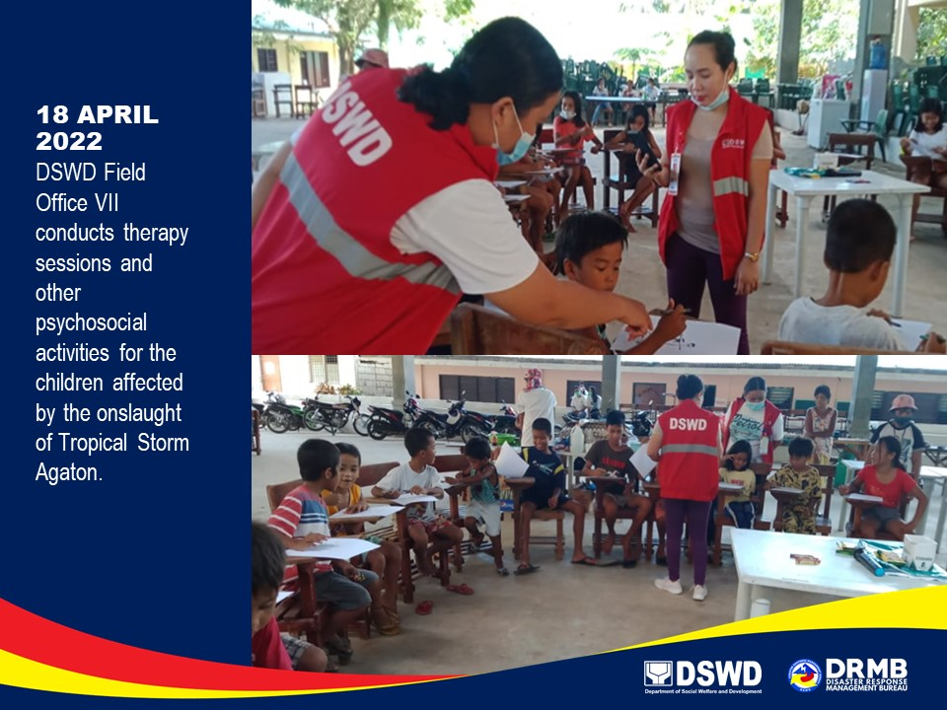

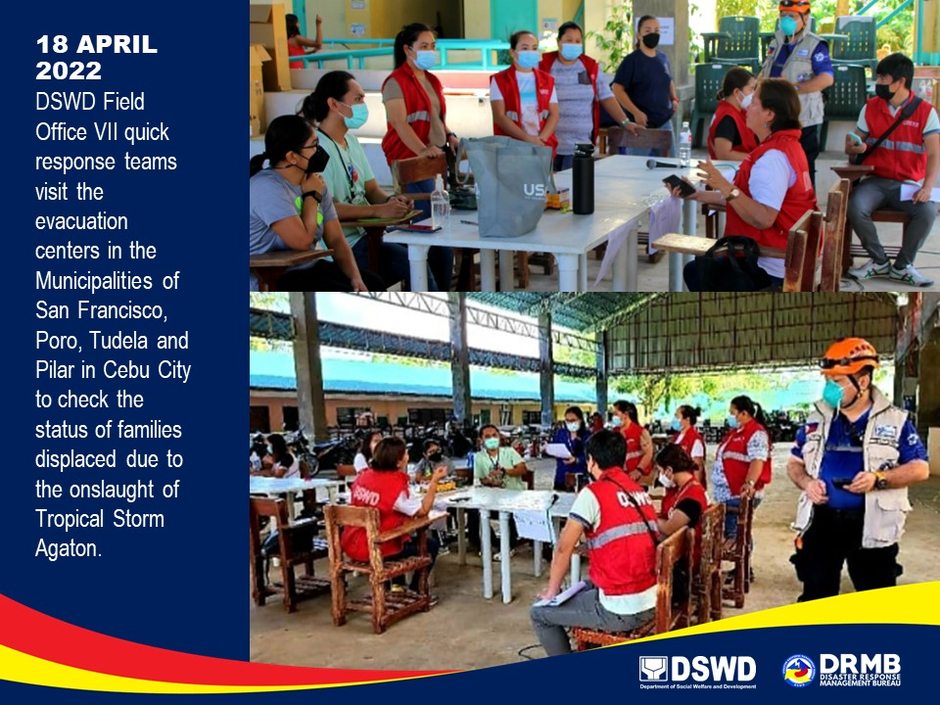

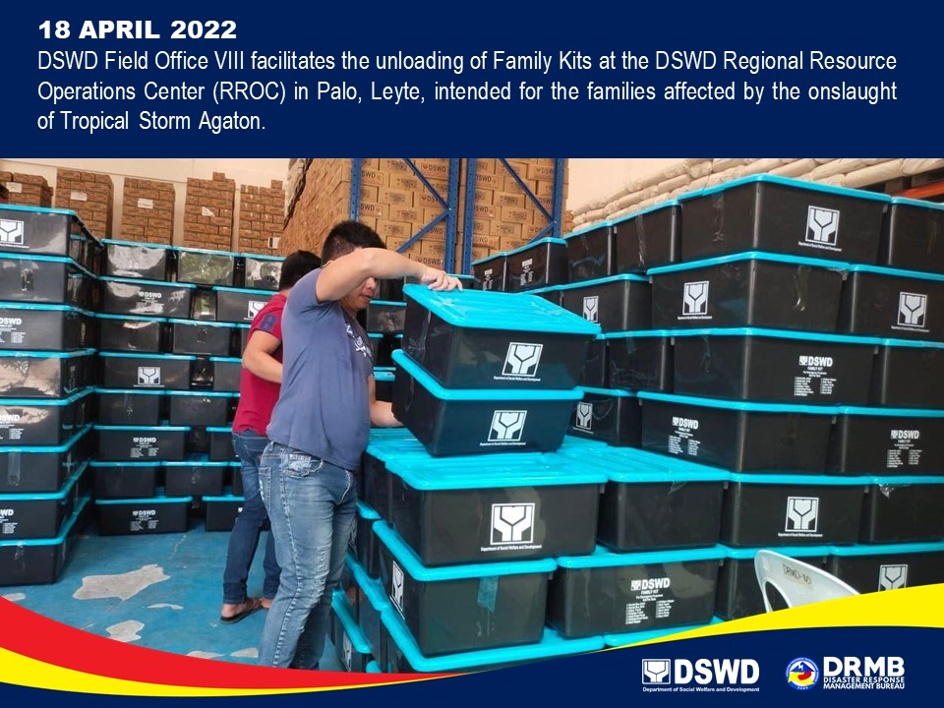

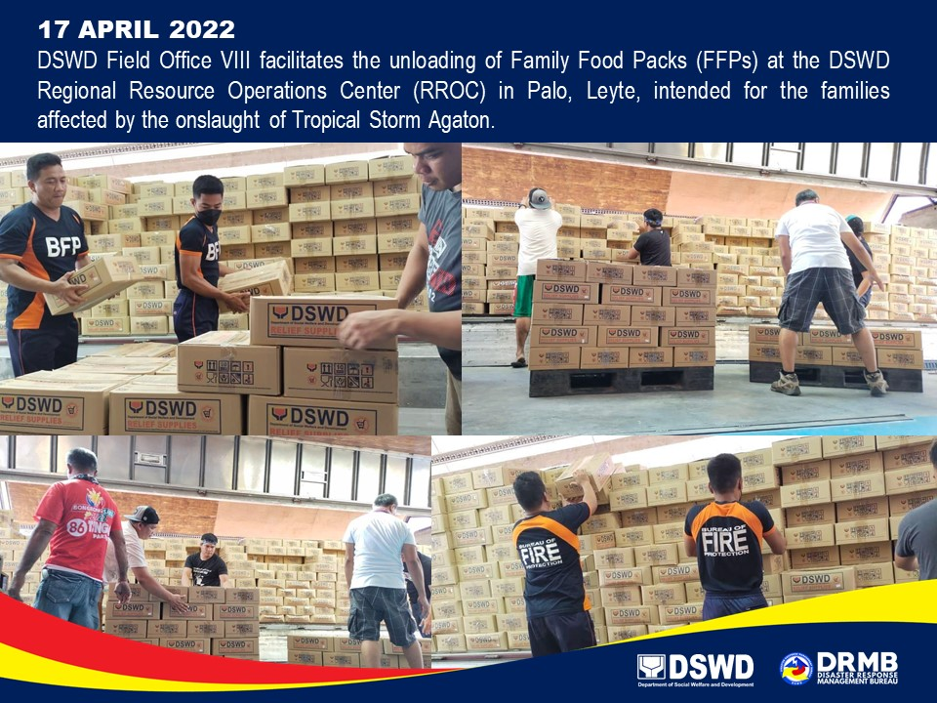

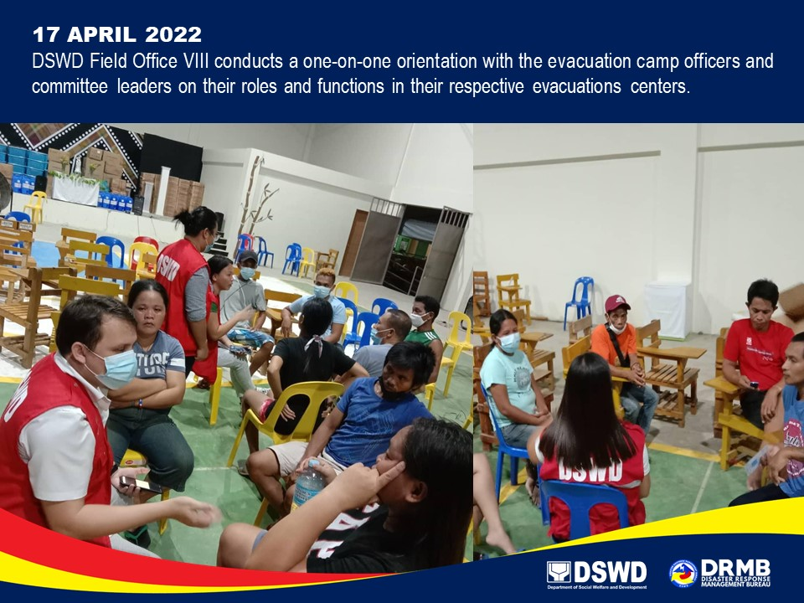

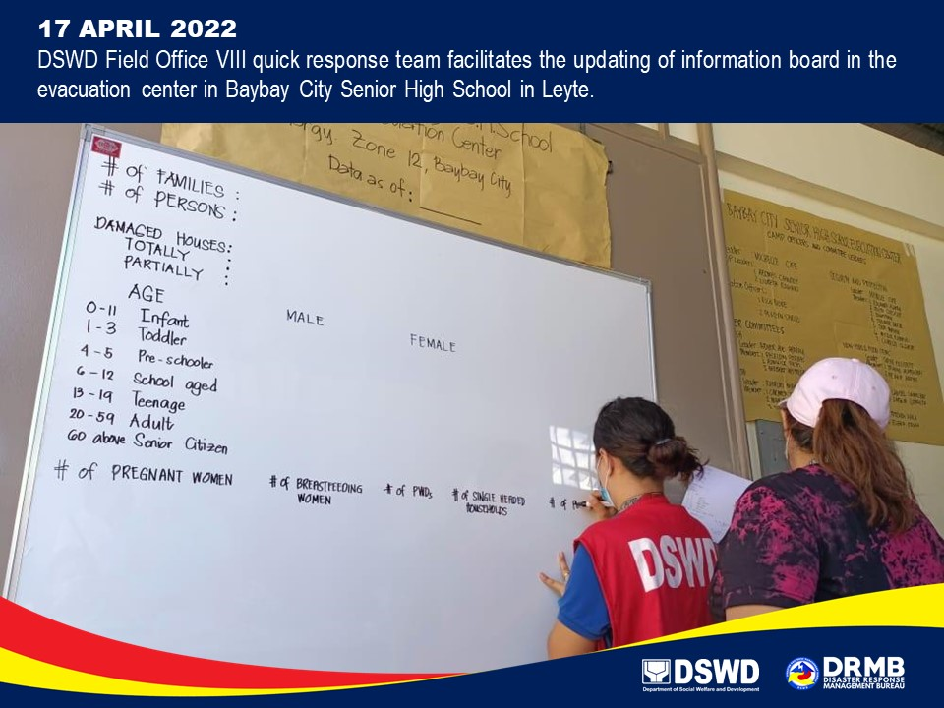

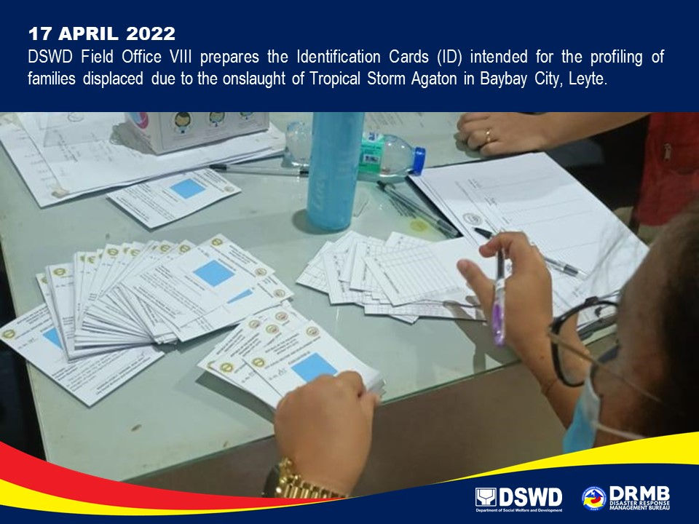

*****
The Disaster Response Operations Monitoring and Information Center (DROMIC) of DSWD-DRMB is closely coordinating with the concerned DSWD Field Offices for significant updates on disaster response operations and assistance provided.

Prepared by:  DIANE C. PELEGRINO  PHIL JOBERT A. ZALDIVAR  MARIE JOYCE G. RAFANAN  JOANNA CAMILLE J. LIZARDO | Released by:  RODEL V. CABADDU

