DSWD DROMIC Report #11 on Taal Volcano Eruption
as of 08 April 2022, 6PM

- Situation Overview

On 26 March 2022 at 8AM, the Philippine Institute of Volcanology and Seismology (PHIVOLCS) has raised Alert Level 3 over Taal Volcano after the phreatomagmatic eruption of the Main Crater at 7:22 AM to 8:59 AM on 26 March 2022, two (2) subsequent phreatomagmatic events at 4:34 AM and 5:04 AM on 27 March 2022 have been recorded by the Taal Volcano Network or TVN based on seismic records and visual cameras. Communities around the Taal Lake shores are advised to remain vigilant, take precautionary measures against possible airborne ash and vog and calmly prepare for possible evacuation should unrest intensify.

Source: Philippine Institute of Volcanology and Seismology (PHIVOLCS)

- Status of Affected Areas and Population

There are 3,325 families or 11,387 persons affected by the Taal Volcano eruption in 22 Barangays in CALABARZON (see Table 1).

Table 1. Number of Affected Families / Persons
REGION / PROVINCE / MUNICIPALITY | NUMBER OF AFFECTED
 | Barangays | Families | Persons
GRAND TOTAL | 22 | 3,325 | 11,387
CALABARZON | 22 | 3,325 | 11,387
Batangas | 22 | 3,325 | 11,387
Agoncillo*** | 6 | 1,697 | 5,396
Balete*** | 3 | 112 | 560
Cuenca* | 2 | 22 | 59
Laurel*** | 5 | 1,477 | 5,314
Talisay*** | 6 | 17 | 58

Note: This version reflects the actual number of affected families and persons after data validation on 08 April 2022, 2PM. Hence, changes in figures are based on the ongoing assessment and validation that are continuously being conducted.
Source: DSWD-FO CALABARZON
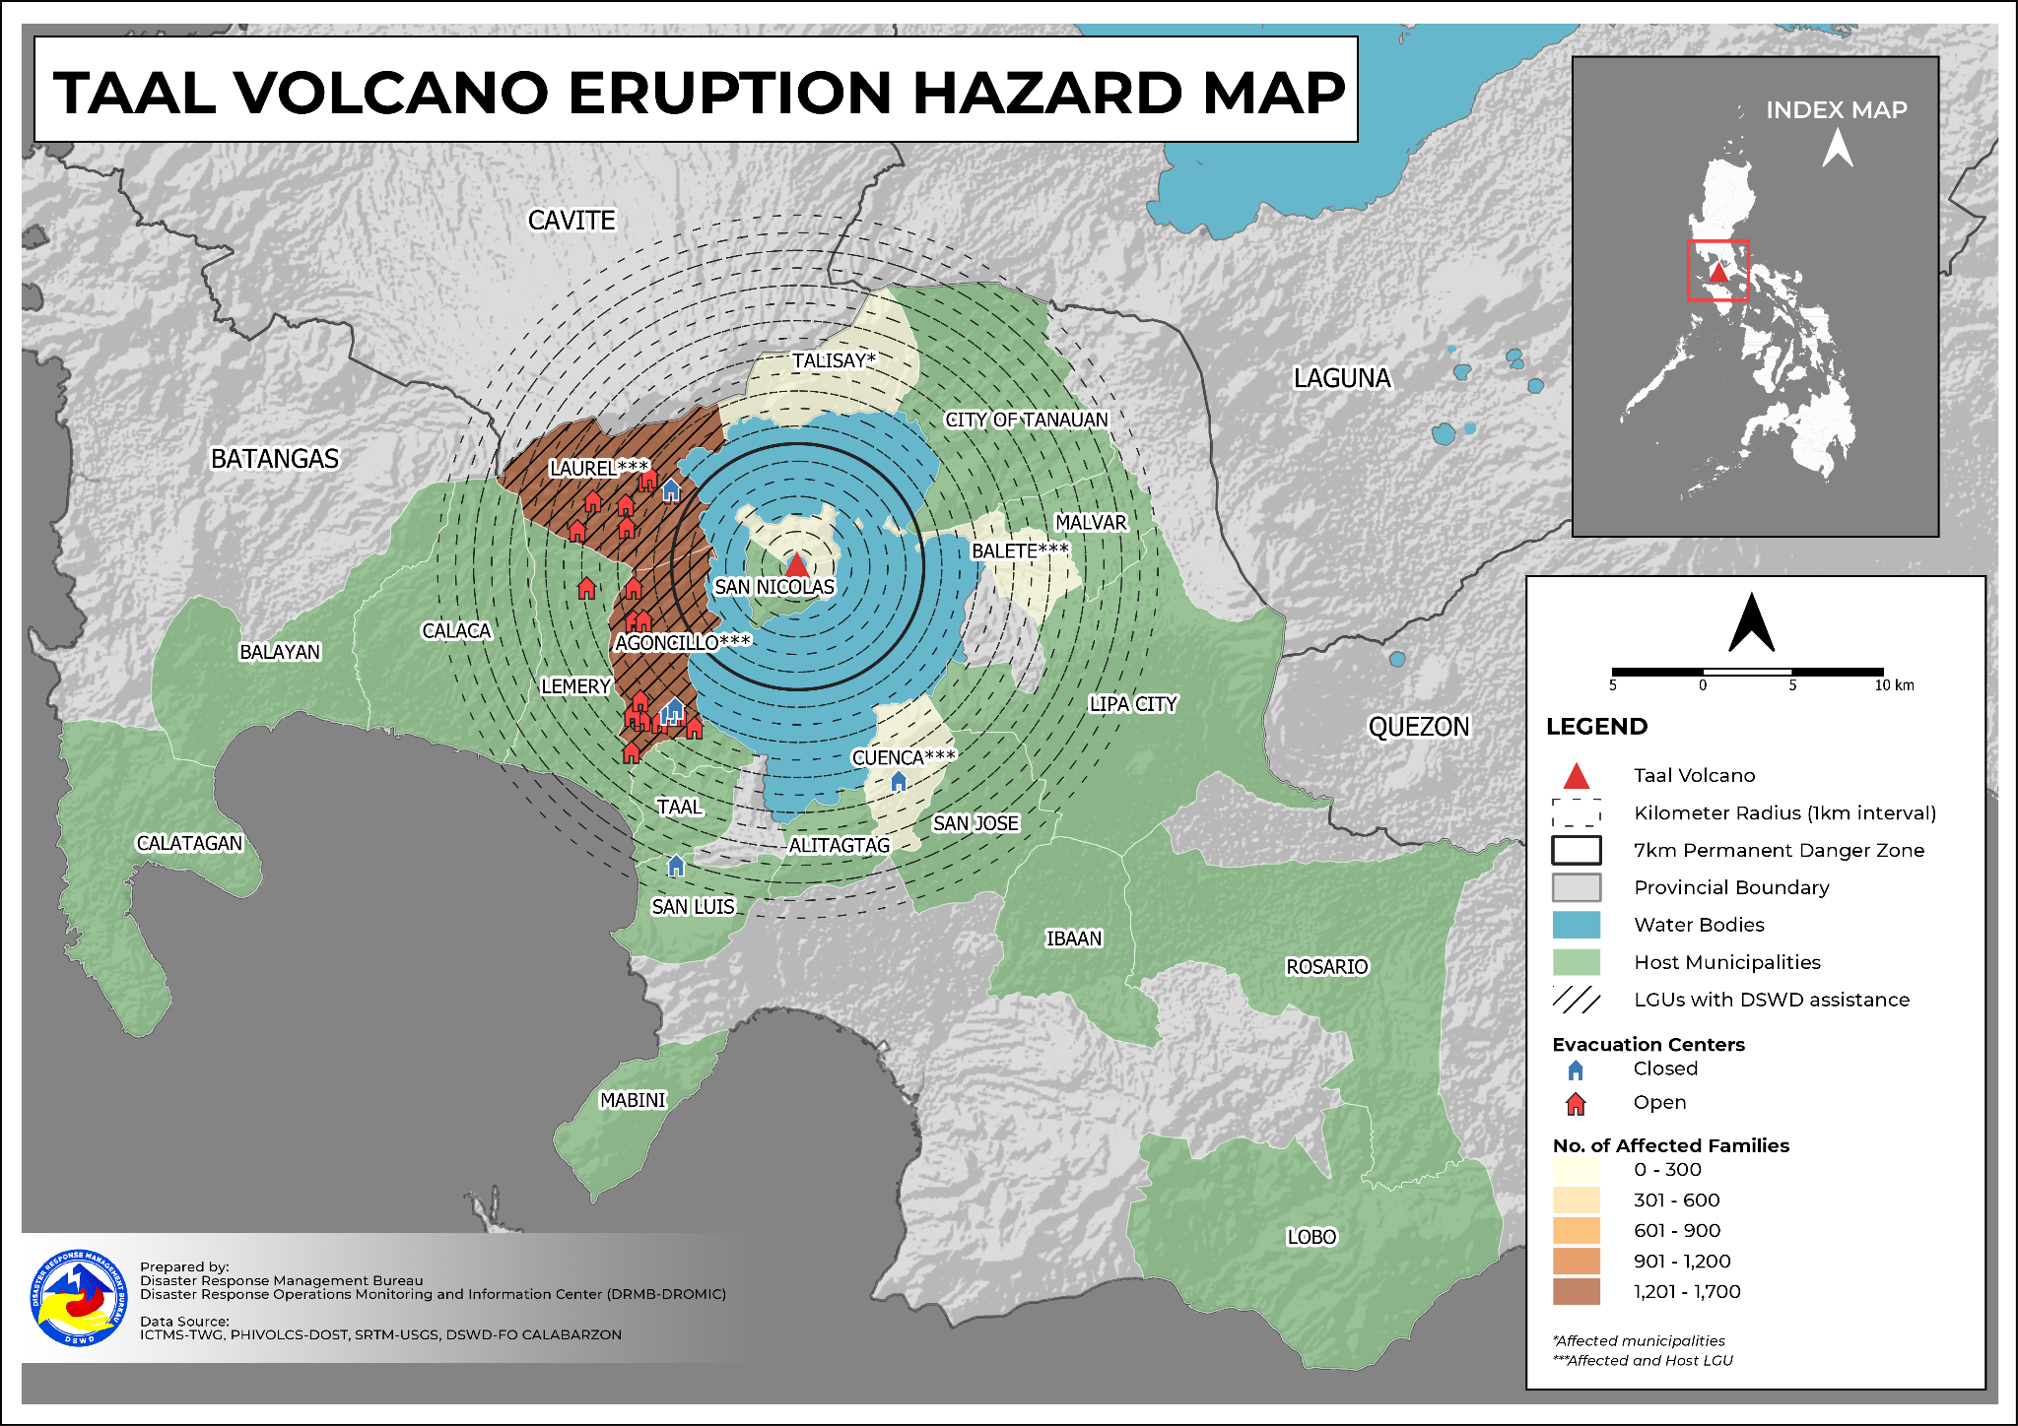

- Status of Displaced Population

        - Inside Evacuation Center
There are 1,197 families or 4,124 persons currently taking temporary shelter in 20 evacuation centers in CALABARZON (see Table 2).

Table 2. Number of Displaced Families / Persons Inside Evacuation Center
REGION / PROVINCE / MUNICIPALITY | NUMBER OF EVACUATION CENTERS (ECs) |  | NUMBER OF DISPLACED
 |  |  | INSIDE ECs
 |  |  | Families |  | Persons
 | CUM | NOW | CUM | NOW | CUM | NOW
GRAND TOTAL | 25 | 20 | 1,540 | 1,197 | 5,267 | 4,124
CALABARZON | 25 | 20 | 1,540 | 1,197 | 5,267 | 4,124
Batangas | 25 | 20 | 1,540 | 1,197 | 5,267 | 4,124
Agoncillo*** | 14 | 12 | 948 | 700 | 3,162 | 2,368
Cuenca* | 1 | - | 9 | - | 27 | -
Laurel*** | 8 | 7 | 565 | 480 | 2,013 | 1,695
Lemery** | 1 | 1 | 17 | 17 | 61 | 61
San Luis** | 1 | - | 1 | - | 4 | -
Note: This version reflects the actual number of displaced families and persons after data validation on 08 April 2022, 2PM. Hence, changes in figures are based on the ongoing assessment and validation that are continuously being conducted.
Source: DSWD-FO CALABARZON

        - Outside Evacuation Center
There are 1,552 families or 5,263 persons temporarily staying with their relatives and/or friends in CALABARZON (see Table 3).

Table 3. Number of Displaced Families / Persons Outside Evacuation Center
REGION / PROVINCE / MUNICIPALITY | NUMBER OF DISPLACED
 | OUTSIDE ECs
 | Families |  | Persons
 | CUM | NOW | CUM | NOW
GRAND TOTAL | 1,788 | 1,552 | 6,130 | 5,263
CALABARZON | 1,788 | 1,552 | 6,130 | 5,263
Batangas | 1,788 | 1,552 | 6,130 | 5,263
Agoncillo*** | 471 | 430 | 1,266 | 1,126
Alitagtag** | 18 | 18 | 99 | 99
Balayan** | 1 | 1 | 4 | 4
Balete*** | 104 | 104 | 530 | 530
Batangas City (capital)** | 3 | 3 | 9 | 9
Calaca** | 68 | 52 | 187 | 165
Calatagan** | 8 | 8 | 33 | 30
Cuenca* | 13 | 3 | 32 | 7
Ibaan** | 15 | 15 | 42 | 42
Laurel*** | 742 | 652 | 2,798 | 2,377
Lemery** | 64 | 60 | 233 | 216
Lipa City** | 45 | 22 | 118 | 59
Lobo** | 1 | 1 | 10 | 10
Mabini** | 3 | 3 | 6 | 6
Malvar** | 4 | 4 | 14 | 13
Mataas Na Kahoy** | 15 | 3 | 22 | 6
Rosario** | 2 | 2 | 9 | 5
San Jose** | 6 | 1 | 18 | 5
San Luis** | 3 | 3 | 14 | 14
San Nicolas** | 98 | 79 | 312 | 261
Santo Tomas** | 16 | 15 | 52 | 47
Taal** | 22 | 19 | 85 | 66
Talisay*** | 6 | 4 | 25 | 6
City of Tanauan** | 58 | 49 | 208 | 158
Taysan** | 2 | 1 | 4 | 2
Note: This version reflects the actual number of displaced families and persons after data validation on 08 April 2022, 2PM. Hence, changes in figures are based on the ongoing assessment and validation that are continuously being conducted.

Source: DSWD-FO CALABARZON

        - Total Displaced Population
A total of 2,749 families or 9,387 persons were displaced in CALABARZON due to the Taal Volcano eruption (see Table 4).

Table 4. Total Number of Displaced Families / Persons
REGION / PROVINCE / MUNICIPALITY | TOTAL DISPLACED SERVED
 | Families |  | Persons
 | Total Families |  | Total Persons
 | CUM | NOW | CUM | NOW
GRAND TOTAL | 3,328 | 2,749 | 11,397 | 9,387
CALABARZON | 3,328 | 2,749 | 11,397 | 9,387
Batangas | 3,328 | 2,749 | 11,397 | 9,387
Agoncillo*** | 1,419 | 1,130 | 4,428 | 3,494
Alitagtag** | 18 | 18 | 99 | 99
Balayan** | 1 | 1 | 4 | 4
Balete*** | 104 | 104 | 530 | 530
Batangas City (capital)** | 3 | 3 | 9 | 9
Calaca** | 68 | 52 | 187 | 165
Calatagan** | 8 | 8 | 33 | 30
Cuenca* | 22 | 3 | 59 | 7
Ibaan** | 15 | 15 | 42 | 42
Laurel*** | 1,307 | 1,132 | 4,811 | 4,072
Lemery** | 81 | 77 | 294 | 277
Lipa City** | 45 | 22 | 118 | 59
Lobo** | 1 | 1 | 10 | 10
Mabini** | 3 | 3 | 6 | 6
Malvar** | 4 | 4 | 14 | 13
Mataas Na Kahoy** | 15 | 3 | 22 | 6
Rosario** | 2 | 2 | 9 | 5
San Jose** | 6 | 1 | 18 | 5
San Luis** | 4 | 3 | 18 | 14
San Nicolas** | 98 | 79 | 312 | 261
Santo Tomas** | 16 | 15 | 52 | 47
Taal** | 22 | 19 | 85 | 66
Talisay*** | 6 | 4 | 25 | 6
City of Tanauan** | 58 | 49 | 208 | 158
Taysan** | 2 | 1 | 4 | 2
Note: This version reflects the actual number of displaced families and persons after data validation on 08 April 2022, 2PM. Hence, changes in figures are based on the ongoing assessment and validation that are continuously being conducted.
*Affected municipalities
**Host LGUs which catered the displaced families or persons from the affected municipalities
***Affected and Host LGU
Source: DSWD-FO CALABARZON

- Cost of Humanitarian Assistance Provided
A total of ₱6,187,146.52 worth of assistance was provided to the affected families; of which, ₱1,645,907.60 from the DSWD, ₱4,541,238.92 was provided by the LGUs (see Table 5).

Table 5. Cost of Assistance Provided to Affected Families / Persons
REGION / PROVINCE / MUNICIPALITY | COST OF ASSISTANCE
 | DSWD | LGU | NGOs | OTHERS | GRAND TOTAL
GRAND TOTAL | 1,645,907.60 | 4,541,238.92 | - | - | 6,187,146.52
CALABARZON | 1,645,907.60 | - | - | - | 4,541,238.92
Batangas | 1,645,907.60 | - | - | - | 4,541,238.92
Agoncillo*** | 1,417,907.60 | - | - | - | 1,653,104.14
Batangas City (capital)** | - | - | - | - | 2,368,362.26
Laurel*** | 228,000.00 | - | - | - | 517,530.00
City of Tanauan** | - | - | - | - | 2,242.52

Source: DSWD-FO CALABARZON

- Response Actions and Interventions

- Standby Funds and Prepositioned Relief Stockpile
REGIONAL / FIELD OFFICE | STANDBY FUNDS | STOCKPILE |  |  | TOTAL STANDBY FUNDS & STOCKPILE
 |  | FAMILY FOOD PACKS |  | OTHER FOOD AND NON-FOOD ITEMS (FNIs)
 |  | QUANTITY | TOTAL COST
TOTAL | 146,109,022.97 | 548,809 | 345,757,021.65 | 733,219,440.03 | 1,225,085,484.65
Central Office | 68,594,777.99 | - | - | - | 68,594,777.99
NRLMB - NROC | - | 82,229 | 50,992,925.00 | 237,690,312.97 | 288,683,237.97
NRLMB - VDRC | - | 3,737 | 2,324,414.00 | 30,824,635.40 | 33,149,049.40
CALABARZON | 5,000,000.47 | 10,308 | 6,785,997.10 | 67,473,436.36 | 79,259,433.93
Other FOs | 72,514,244.51 | 452,535 | 285,653,685.55 | 397,231,055.30 | 755,398,985.36
The Inventory Summary is as of 08 April 2022, 4PM.
Source: DSWD-DRMB and DSWD-NRLMB

  - Standby Funds
- ₱68.59 million Quick Response Fund (QRF) at the DSWD-Central Office.
- ₱5 million available at DSWD-FO CALABARZON.
- ₱72.51 million in other DSWD-FOs which may support the relief needs of the displaced families due to the Taal Volcano eruption through inter-FO augmentation.

  - Prepositioned FFPs and Other Relief Items
    - 85,966 FFPs available in Disaster Response Centers; of which, 82,229 FFPs are at the National Resource Operations Center (NROC), Pasay City and 3,737 FFPs are at the Visayas Disaster Response Center (VDRC), Cebu City.
    - 10,308 FFPs available at DSWD-FO CALABARZON.
    - 452,535 FFPs in other DSWD-FOs which may support the relief needs of the displaced families due to the Taal Volcano eruption through inter-FO augmentation.
    - ₱733.22 million worth of other food and non-food items (FNIs) at NROC, VDRC and DSWD-FO warehouses countrywide.

- Food and Non-Food Items

DSWD-FO CALABARZON
DATE | SITUATIONS / ACTIONS UNDERTAKEN
05 April 2022 | - DSWD-FO CALABARZON together with 10 volunteers, conducted the inspection, sorting and repacking of prepositioned goods in Batangas Provincial Sports Complex.
02 April 2022 | - DSWD-FO CALABARZON produced a total of 500 FFPs through the help of eighteen (18) community volunteers at the regional warehouse in GMA, Cavite. Inspection was also conducted to ensure the quality of the FFPs.
01 April 2022 | - DSWD-FO CALABARZON facilitated the provision of 800 Family Food Packs with 16 volunteers at the FO warehouse in GMA, Cavite. Inspection of the FFP items was also conducted to ensure its quality.
26 March 2022 | - DSWD-FO CALABARZON facilitated the fast tracking of procurement and delivery of raw materials for Food and Non-Food Items (FNIs).  - FNIs augmentation in relation to the election ban shall be considered and coordinated with the proper authorities to avoid problems or delays in case of requests from the affected LGUs.

- Camp Coordination and Camp Management

DSWD-FO CALABARZON
DATE | SITUATIONS / ACTIONS UNDERTAKEN
27 March 2022 | - DSWD-FO CALABARZON has provided technical assistance and guidance in utilizing the CCCM assessment tools to the Batangas PSWDO and PDRRMO as basis for the assessment of the ongoing CCCM including the COVID-19 protocols to ensure protection of all vulnerable sectors and provide necessary and immediate assistance to the affected families.

- Other Activities

DSWD-DRMB
DATE | SITUATIONS / ACTIONS UNDERTAKEN
28 March 2022 | - DRMB is closely coordinating with DSWD-FO CALABARZON for significant reports on the status of affected families, assistance, and relief efforts.
27 March 2022 | - The Disaster Response Management Bureau (DRMB) attended the NDRRMC Emergency Meeting related to the raising of the Alert Level Status of Taal Volcano from Alert Level 2 to Alert Level 3 on 26 March 2022.

DSWD-NRLMB
DATE | SITUATIONS / ACTIONS UNDERTAKEN
28 March 2022 | - DSWD-NRLMB is continuously repacking goods for possible augmentation.

DSWD-FO CALABARZON
DATE | SITUATIONS / ACTIONS UNDERTAKEN
02 April 2022 | - DSWD-FO CALABARZON conducted an emergency meeting through virtual teleconference to discuss preparation for the possible area visitation of President Rodrigo Roa Duterte (PRRD) to LGUs in Batangas affected by the Taal Volcanic Magmatic Unrest.  - DSWD-FO CALABARZON coordinated with the Regional Disaster Risk Reduction and Management Council (RDRRMC) Emergency Operations Center (EOC) regarding the possible augmentation of logistical requirements for the delivery of FFPs to the affected LGUs.
01 April 2022 | - DSWD-FO CALABARZON has provided technical assistance on DROMIC Reporting tools through virtual conference and attended by the Batangas PSWDO, LGUs Laurel and Agoncillo, Batangas PQRT, and DRMD.
27 March 2022 | - DSWD-FO CALABARZON has provided technical assistance to the Batangas Provincial Quick Response Team (QRT) members regarding DROMIC reporting mechanism to establish official and real-time data and information on the ground.  - DSWD-FO CALABARZON has attended the coordination meeting regarding the donations management in view of the COMELEC Resolution No. 10747 dated 16 December 2021.  - DSWD-FO CALABARZON through its Disaster Response Management Division (DRMD) visited the Batangas Provincial Sports Complex together with nine (9) volunteers to conduct inspection of food commodities and segregation of items that are about to expire. This is to ensure the quality of relief items to be distributed as augmentation support to the affected LGUs.  - DSWD-FO CALABARZON issued an advisory to all the Regional/Provincial QRTs and provided guidance as their reference in providing appropriate technical assistance to the LGUs.  - DSWD-FO CALABARZON activated the Regional Operations Center (ROC) through the Regional Incident Management Team (RIMT) for a seamless coordination and appropriate humanitarian response.
26 March 2022 | - DSWD-FO CALABARZON attended the emergency meeting via virtual teleconferencing facilitated by the RDRRMC Chairperson to discuss the Taal Volcano’s current status and courses of actions undertaken by the concerned LDRRMCs and the RDRRMC on 26 March 2022 wherein Batangas PDRRMC activated the Emergency Operations Center and Response Cluster, and Quick Response Teams are ready for deployment as needed.  - DSWD-FO CALABARZON conducted an emergency  - meeting with the Field Office Incident Management Team headed by ARDO Mylah S. Gatchalian as the Incident Commander to discuss needed response activities to be undertaken.  - Regional/Provincial QRTs were informed to stay on alert for possible deployment should the situation escalate.  - DSWD-FO CALABARZON DRMD staff presented the working file with regard to the ongoing crafting of Regional Contingency Plan for the Taal Volcano Eruption (CP-TVE) such as the roles and responsibilities of the Department as lead cluster for Disaster Response.  - DSWD-FO CALABARZON closely coordinated with the Regional/Provincial QRTs and Batangas Provincial Disaster Risk Reduction and Management Office (PDRRMO) and Provincial Social Welfare Development Office (PSWDO) regarding the updates on the status of affected population.  - DSWD-FO CALABARZON DRMD maintained communication with the Local Social Welfare and Development Offices (LSWDOs) in affected areas of Batangas Province for the validation and assessment and request for relief augmentation to the affected population of Taal Volcano Phreatomagmatic Bursts.

*****
The Disaster Response Operations Monitoring and Information Center (DROMIC) of DSWD-DRMB is closely coordinating with the DSWD-FO CALABARZON for significant disaster response updates and assistance provided.

Prepared by:  AARON JOHN B. PASCUA  MARIE JOYCE G. RAFANAN | Released by:  LESLIE R. JAWILI

