DSWD DROMIC Report #2 on the Effects of LPA
as of 08 April 2022, 6PM

- Situation Overview

Issued on 04 April 2022 at 4AM, a Low Pressure Area (LPA) was estimated based on all available data at 970 km East of Guiuan, Eastern Samar (11.0°N, 134.6°E). It is embedded along the Intertropical Convergence Zone (ITCZ) affecting Mindanao. Shear Line affecting Extreme Northern Luzon.

Issued on 07 April 2022 at 4 PM, the Low Pressure Area (LPA) was estimated based on all available data at 180 km East Northeast of Hinatuan, Surigao del Sur (8.9°N, 127.9°E).

Issued on 08 April 2022 at 4 PM, the Low Pressure Area (LPA) was estimated based on all available data at 185 km East Northeast of Surigao City, Surigao del Norte (10.5°N, 127.0°E).
Source: DOST-PAGASA Daily Weather Forecast

- Status of Affected Areas and Population

There are 22,837 families or 67,599 persons affected in 94 barangays in Regions XI and Caraga (see Table 1).

Table 1. Number of Affected Families / Persons
REGION / PROVINCE / MUNICIPALITY |  | NUMBER OF AFFECTED
 |  | Barangays | Families | Persons
GRAND TOTAL |  | 94 | 22,837 | 67,599
REGION XI |  | 75 | 17,929 | 45,387
Davao de Oro |  | 54 | 4,502 | 14,953
 | Compostela | 10 | 1,552 | 6,145
 | Mawab | 7 | 377 | 1,179
 | Monkayo | 14 | 1,430 | 4,095
 | Nabunturan (capital) | 12 | 572 | 1,571
 | New Bataan | 11 | 571 | 1,963
Davao del Norte |  | 9 | 9,110 | 21,761
 | Asuncion (Saug) | 9 | 9,110 | 21,761
Davao Oriental |  | 12 | 4,317 | 8,673
 | Caraga | 4 | 675 | 2,089
 | Cateel | 6 | 3,357 | 5,501
 | Governor Generoso | 1 | 15 | 75
 | San Isidro | 1 | 270 | 1,008
CARAGA |  | 19 | 4,908 | 22,212
Agusan del Sur |  | 19 | 4,908 | 22,212
 | Bunawan | 9 | 1,539 | 5,367
 | Veruela | 10 | 3,369 | 16,845
Note: Ongoing assessment and validation are continuously being conducted.
Source: DSWD-Field Offices (FOs)

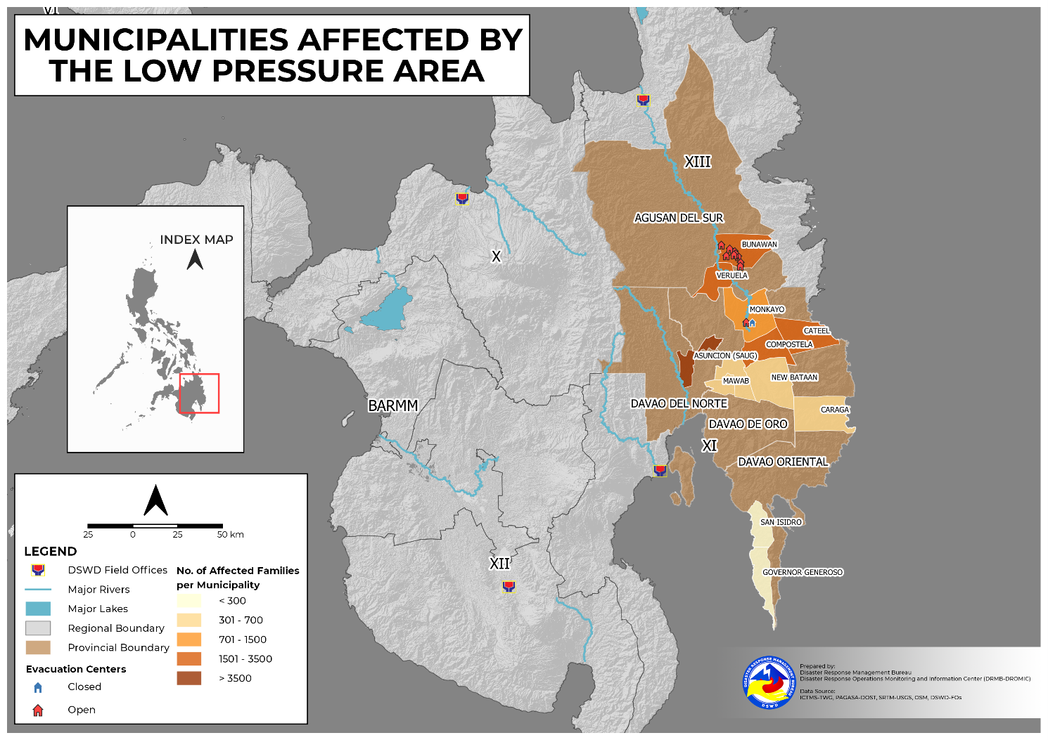

- Status of Displaced Population

    - Inside Evacuation Center
There are 1,868 families or 7,005 persons currently taking temporary shelter in 39 evacuation centers (see Table 2).

Table 2. Number of Displaced Families / Persons Inside Evacuation Center
REGION / PROVINCE / MUNICIPALITY |  | NUMBER OF EVACUATION CENTERS (ECs) |  | NUMBER OF DISPLACED
 |  |  |  | INSIDE ECs
 |  |  |  | Families |  | Persons
 |  | CUM | NOW | CUM | NOW | CUM | NOW
GRAND TOTAL |  | 66 | 39 | 4,563 | 1,868 | 16,160 | 7,005
REGION XI |  | 31 | 4 | 2,718 | 23 | 9,263 | 108
Davao de Oro |  | 24 | 4 | 1,928 | 23 | 6,829 | 108
 | Compostela | 5 | 2 | 889 | 19 | 3,332 | 96
 | Mawab | 4 | - | 69 | - | 259 | -
 | Monkayo | 4 | 2 | 399 | 4 | 1,275 | 12
 | New Bataan | 11 | - | 571 | - | 1,963 | -
Davao Oriental |  | 7 | - | 790 | - | 2,434 | -
 | Caraga | 4 | - | 675 | - | 2,089 | -
 | Cateel | 1 | - | 35 | - | 75 | -
 | Governor Generoso | 1 | - | 15 | - | 75 | -
 | San Isidro | 1 | - | 65 | - | 195 | -
CARAGA |  | 35 | 35 | 1,845 | 1,845 | 6,897 | 6,897
Agusan del Sur |  | 35 | 35 | 1,845 | 1,845 | 6,897 | 6,897
 | Bunawan | 28 | 28 | 1,539 | 1,539 | 5,367 | 5,367
 | Veruela | 7 | 7 | 306 | 306 | 1,530 | 1,530
Note: Ongoing assessment and validation are continuously being conducted.
Source: DSWD-FOs

    - Outside Evacuation Center
There are 57 families or 285 persons currently taking temporary shelter with their relatives and/or friends in Caraga (see Table 3).

Table 3. Number of Displaced Families / Persons Outside Evacuation Center
REGION / PROVINCE / MUNICIPALITY |  | NUMBER OF DISPLACED
 |  | OUTSIDE ECs
 |  | Families |  | Persons
 |  | CUM | NOW | CUM | NOW
GRAND TOTAL |  | 57 | 57 | 285 | 285
CARAGA |  | 57 | 57 | 285 | 285
Agusan del Sur |  | 57 | 57 | 285 | 285
 | Veruela | 57 | 57 | 285 | 285
Note: Ongoing assessment and validation are continuously being conducted.
Source: DSWD-FOs

    - Total Displaced Population
There are 1,925 families or 7,290 persons temporarily staying either in evacuation centers or with their relatives and/or friends in Regions XI and Caraga (see Table 4).

Table 4. Total Number of Displaced Families / Persons
REGION / PROVINCE / MUNICIPALITY |  | TOTAL DISPLACED SERVED
 |  | Families |  | Persons
 |  | Total Families |  | Total Persons
 |  | CUM | NOW | CUM | NOW
GRAND TOTAL |  | 4,620 | 1,925 | 16,445 | 7,290
REGION XI |  | 2,718 | 23 | 9,263 | 108
Davao de Oro |  | 1,928 | 23 | 6,829 | 108
 | Compostela | 889 | 19 | 3,332 | 96
 | Mawab | 69 | - | 259 | -
 | Monkayo | 399 | 4 | 1,275 | 12
 | New Bataan | 571 | - | 1,963 | -
Davao Oriental |  | 790 | - | 2,434 | -
 | Caraga | 675 | - | 2,089 | -
 | Cateel | 35 | - | 75 | -
 | Governor Generoso | 15 | - | 75 | -
 | San Isidro | 65 | - | 195 | -
CARAGA |  | 1,902 | 1,902 | 7,182 | 7,182
Agusan del Sur |  | 1,902 | 1,902 | 7,182 | 7,182
 | Bunawan | 1,539 | 1,539 | 5,367 | 5,367
 | Veruela | 363 | 363 | 1,815 | 1,815
Note: Ongoing assessment and validation are continuously being conducted.
Source: DSWD-FOs

- Damaged Houses

One (1) house was partially damaged in Caraga Region (see Table 5).

Table 5. Number of Damaged Houses
REGION / PROVINCE / MUNICIPALITY |  | NO. OF DAMAGED HOUSES
 |  | Total | Totally | Partially
GRAND TOTAL |  | 1 | - | 1
CARAGA |  | 1 | - | 1
Agusan del Sur |  | 1 | - | 1
 | Bunawan | 1 | - | 1
Note: Ongoing assessment and validation are continuously being conducted.
Source: DSWD-FOs

- Cost of Humanitarian Assistance Provided

A total of ₱932,501.00 worth of assistance was provided by the Local Government Units (LGUs) to the affected families (see Table 6).

Table 6. Cost of Assistance Provided to Affected Families / Persons
REGION / PROVINCE / MUNICIPALITY |  | COST OF ASSISTANCE
 |  | DSWD | LGUs | NGOs | OTHERS | GRAND TOTAL
GRAND TOTAL |  | - | 932,501.00 | - | - | 932,501.00
CARAGA |  | - | 932,501.00 | - | - | 932,501.00
Agusan del Sur |  | - | 932,501.00 | - | - | 932,501.00
 | Bunawan | - | 643,338.00 | - | - | 643,338.00
 | Veruela | - | 289,163.00 | - | - | 289,163.00
Source: DSWD-FO FOs

- Response Actions and Interventions

- Standby Funds and Prepositioned Relied Stockpile
OFFICE | STANDBY FUNDS | STOCKPILE |  |  | TOTAL STANDBY FUNDS & STOCKPILE
 |  | FAMILY FOOD PACKS |  | OTHER FOOD AND NON-FOOD ITEMS (FNIs)
 |  | QUANTITY | TOTAL COST
TOTAL | 146,109,022.97 | 548,809 | 345,757,021.65 | 733,219,440.03 | 1,225,085,484.65
DSWD-CO | 68,594,777.99 | - | - | - | 68,594,777.99
NRLMB-NROC | - | 82,229 | 50,992,925.00 | 237,690,312.97 | 288,683,237.97
NRLMB-VDRC | - | 3,737 | 2,324,414.00 | 30,824,635.40 | 33,149,049.40
DSWD-FO XI | 66,610.00 | 27,331 | 16,225,983.50 | 30,016,022.80 | 46,308,616.30
DSWD-FO Caraga | 5,000,000.00 | 170,093 | 116,590,912.00 | 11,275,962.57 | 132,866,874.57
Other FOs | 72,447,634.98 | 265,419 | 159,622,787.15 | 423,412,506.29 | 655,482,928.42
Note: Inventory Summary is as of 08 April 2022, 4PM. The replenishment of standby funds for DSWD-FO XI is being processed.
Source: DSWD-DRMB and DSWD-NRLMB

  - Standby Funds
    - ₱68.59 million Quick Response Fund (QRF) at the DSWD-Central Office.
    - ₱5.07 million available at DSWD-FOs XI and Caraga.
    - ₱72.45 million in other DSWD-FOs which may support the relief needs of the displaced families due to the effects of LPA through inter-FO augmentation.

  - Prepositioned FFPs and Other Relief Items
    - 85,966 FFPs available in Disaster Response Centers; of which, 82,229 FFPs are at the National Resource Operations Center (NROC), Pasay City and 3,737 FFPs are at the Visayas Disaster Response Center (VDRC), Cebu City.
    - 197,424 FFPs available at DSWD-FOs XI and Caraga.
    - 265,419 FFPs in other DSWD-FOs which may support the relief needs of the displaced families due to Effects of LPA through inter-FO augmentation.
    - ₱733.22 million worth of other FNIs at NROC, VDRC and DSWD-FO warehouses.

- Internally Displaced Person (IDP) Protection

DSWD-FO XI
DATE | SITUATIONS / ACTIONS UNDERTAKEN
06 April 2022 | - The Municipalities of Monkayo and Mawab in Davao de Oro closely coordinated with the affected barangays for the provision of psychosocial services and assessment of needed intervention of the affected families and individuals.

- Camp Coordination and Camp Management (CCCM)

DSWD-FO XI
DATE | SITUATIONS / ACTIONS UNDERTAKEN
06 April 2022 | - DSWD-FO XI through its Disaster Response Management Division (DRMD) closely coordinated with the affected local government units (LGUs) for reports and updates on the situation of the displaced families and individuals inside evacuation centers and to ensure compliance with the provision of emergency relief and protection for the children (Republic Act No. 10821) before, during and after disasters and other emergency situations as well as to monitor the compliance with the safety health protocols set by the Inter-Agency Task Force-Management of Emerging Infectious Diseases (IATF-MEID).

- Other Activities

DSWD-FO MIMAROPA
DATE | SITUATIONS / ACTIONS UNDERTAKEN
05 April 2022 | - DSWD-FO MIMAROPA alerted the DSWD Social Welfare and Development Offices (SWADOs) to monitor daily local conditions, related eventualities, bulletins, warnings, and other advisories issued by the DOST-PAGASA, DENR-MGB, and other surveillance agencies.  - DSWD-FO MIMAROPA closely coordinated with the Office of Civil Defense (OCD) and Regional Disaster Risk Reduction and Management Council (RDRRMC) MIMAROPA for updates, monitoring and response mechanisms in areas that may be affected.

DSWD-FO V
DATE | SITUATIONS / ACTIONS UNDERTAKEN
06 April 2022 | - DSWD-FO V Quick Response Team (QRT) were alerted.  - The Provincial/Municipal Action Teams of DSWD-FO V in the six (6) provinces were activated and instructed to coordinate with the Local Disaster Risk Reduction and Management Offices (LDRRMOs) and Local Social Welfare and Development Offices (LSWDOs) for significant updates.

DSWD-FO VIII
DATE | SITUATIONS / ACTIONS UNDERTAKEN
08 April 2022 | - DSWD-FO VIII Sub-Field Offices continuously monitor the situation in different LGUs across Eastern Visayas in coordination with the LSWDOs and LDRRMOs.
07 April 2022 | - DSWD-FO VIII continuous monitored the weather situation through live updates of PAGASA on weather disturbances.  - DSWD-FO VIII continuously produced FFPs for possible augmentation to LGUs that may be affected by the LPA.

DSWD-FO X
DATE | SITUATIONS / ACTIONS UNDERTAKEN
08 April 2022 | - DSWD-FO X is in close coordination with the affected LGUs for updates on the status of affected families and individuals.  - The Local Social Welfare and Development Offices (LSWDOs) and Local Disaster Risk Reduction and Management Offices (LDRRMOs) are validating the number of affected families and the extent of damages caused by the LPA.

DSWD-FO Caraga
DATE | SITUATIONS / ACTIONS UNDERTAKEN
06 April 2022 | - DSWD-FO Caraga coordinated with the Local Social Welfare and Development Offices (LSWDOs) and DSWD Social Welfare and Development (SWAD) Team Leaders for the possible provision of augmentation assistance to the affected families.

*****
The Disaster Response Operations Monitoring and Information Center (DROMIC) of DSWD-DRMB is closely coordinating with concerned DSWD Field Offices for significant disaster response updates and assistance provided.

Prepared by:  AARON JOHN B. PASCUA  MARIE JOYCE G. RAFANAN | Released by:  MARC LEO L. BUTAC

