DSWD DROMIC Report #4 on Tropical Storm AGATON
as of 11 April 2022, 6PM

- Situation Overview

Issued on 04 April 2022 at 4AM, a Low Pressure Area (LPA) was estimated based on all available data at 970 km East of Guiuan, Eastern Samar (11.0°N, 134.6°E). It is embedded along the Intertropical Convergence Zone (ITCZ) affecting Mindanao. Shear Line affecting Extreme Northern Luzon.

Issued on 07 April 2022 at 4 PM, the Low Pressure Area (LPA) was estimated based on all available data at 180 km East Northeast of Hinatuan, Surigao del Sur (8.9°N, 127.9°E).

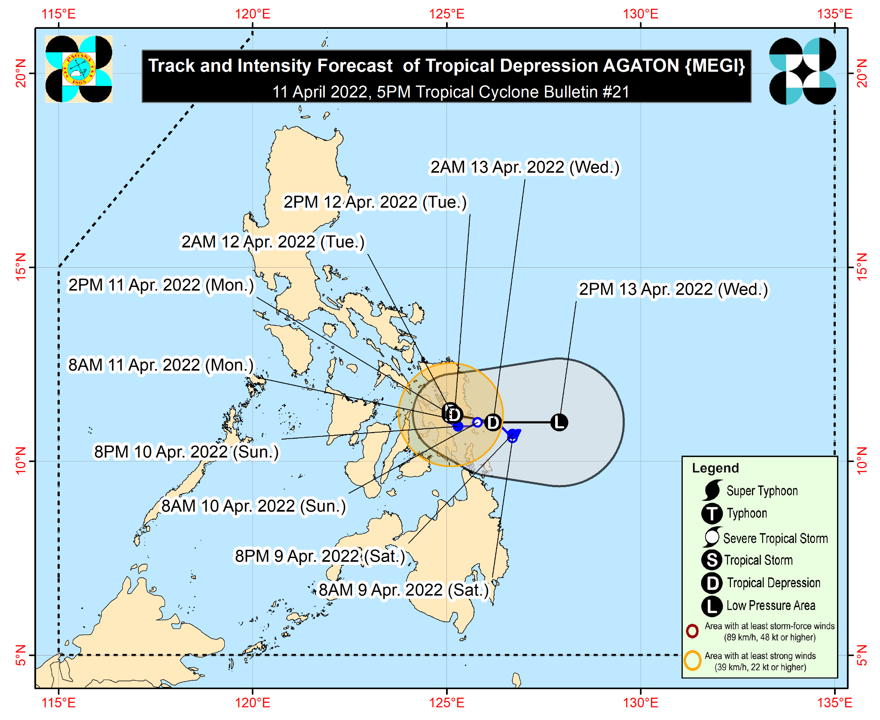
Issued on 08 April 2022 at 4 PM, the Low Pressure Area (LPA) was estimated based on all available data at 185 km East Northeast of Surigao City, Surigao del Norte (10.5°N, 127.0°E).
Issued on 09 April 2022 at 4 PM, the Low Pressure Area (LPA) East of Eastern Samar developed into Tropical Depression “Agaton”.
Issued on 11 April 2022 at 4 PM, TROPICAL DEPRESSION “AGATON” HAS MADE LANDFALL OVER BASEY, SAMAR.

The center of Tropical Depression “AGATON” was estimated based on all available data in the vicinity
of Basey, Samar (11.3°N, 125.1°E).

Intensity
- Maximum sustained winds of 45 km/h near the center, gustiness of up to 60 km/h, and central pressure of 1000 hPa.

Heavy Rainfall
- Today: Moderate to heavy with at times intense rains over Sorsogon, Masbate, Romblon, Biliran, Leyte, Southern Leyte, the northern and central portions of Cebu including Bantayan and Camotes Islands, Aklan, Capiz, Iloilo, Antique, Guimaras, and the northern and central portions of Negros Provinces. Light to moderate with at times heavy rains over Dinagat Islands, Oriental Mindoro, Occidental Mindoro, Marinduque, Quezon, and the rest of Bicol Region and Visayas.
- Tomorrow: Moderate to heavy with at times intense rains over Eastern Visyas, Capiz, Aklan, Iloilo, Antique, the northern portions of Negros Provinces, and the northern portion of Cebu including Batanyan Islands and Camotes Islands. Light to moderate with at times heavy rains over Sorsogon, Masbate, Romblon, and the rest of Visayas.
- Under these conditions and considering significant antecedent rainfall, scattered to widespread flooding (including flooding) and rain-induced landslides are expected especially in areas that are highly or very highly susceptible to these hazard as identified in hazard maps

Severe Winds
- Strong winds (strong breeze to near gale conditions) will be experienced within any of the areas where Wind Signal No. 1 is currently in effect.

HAZARDS AFFECTING COASTAL WATERS
- In the next 24 hours, rough to very rough seas (2.8 to 4.5 m) will prevail over the seaboards of areas where Wind Signal No. 1 is hoisted. These conditions may be risky for most seacrafts. Mariners of small seacrafts are advised to remain in port or take shelter, while those operating larger vessels are advised to take precautionary measures when venturing out to sea and, if possible, avoid navigating in these conditions.
- In the next 24 hours, moderate to rough seas (1.2 to 3.4 m) will also prevail over the remaining seaboards of the country that are not under any wind signal or gale warning. These conditions may be risky for those using small seacrafts. Mariners are advised to take precautionary measures when venturing out to sea and, if possible, avoid navigating in these conditions.

TRACK AND INTENSITY OUTLOOK
- Today through tomorrow afternoon, “AGATON” is forecast to slowly loop in the vicinity of northeastern portion of Leyte and the southern portions of Samar and Eastern Samar before emerging over the Philippine Sea by tomorrow evening as another tropical cyclone with international name “MALAKAS” begins to interact with it.
- “AGATON” is forecast to remain a tropical depression. Any significant intensification will likely be inhibited by the binary interaction of “AGATON” and “MALAKAS”. On the forecast intensity, “AGATON” may further weaken into a remnant low by Wednesday evening as it becomes assimilated within the circulation of “MALAKAS”. However, due to land interaction, further weakening into a remnant low before emerging over the Philippine Sea is possible.

Source: DOST-PAGASA Daily Weather Forecast

- Status of Affected Areas and Population

There are 55,977 families or 218,855 persons affected in 184 barangays in Regions VI, VII, VIII, XI and Caraga (see Table 1).

Table 1. Number of Affected Families / Persons

REGION / PROVINCE / MUNICIPALITY |  | NUMBER OF AFFECTED
 |  | Barangays | Families | Persons
GRAND TOTAL |  | 184 | 55,977 | 218,855
REGION VI |  | 2 | 10 | 38
Negros Occidental |  | 2 | 10 | 38
 | Enrique B. Magalona (Saravia) | 2 | 10 | 38
REGION VII |  | 30 | 329 | 1,245
Cebu |  | 28 | 313 | 1,181
 | Asturias | 1 | 1 | 9
 | Balamban | 1 | 3 | 12
 | Cebu City (capital) | 4 | 38 | 120
 | Medellin | 1 | 1 | 1
 | Minglanilla | 2 | 47 | 188
 | Poro | 3 | 13 | 52
 | San Francisco | 5 | 8 | 38
 | Sogod | 2 | 14 | 62
 | Tabogon | 3 | 16 | 72
 | Toledo City | 1 | 75 | 300
 | Tuburan | 5 | 97 | 327
Negros Oriental |  | 2 | 16 | 64
 | La Libertad | 2 | 16 | 64
REGION VIII |  | 28 | 15,421 | 67,945
Eastern Samar |  | 7 | 14,809 | 64,970
 | Arteche | 1 | 1,193 | 4,900
 | Can-Avid | 1 | 123 | 615
 | Dolores | 1 | 5,918 | 24,699
 | Balangiga | 1 | 4,336 | 21,680
 | Guiuan | 1 | 14 | 70
 | Lawaan | 1 | 3,019 | 11,976
 | Maydolong | 1 | 206 | 1,030
Leyte |  | 13 | 539 | 2,695
 | Tacloban City (capital) | 3 | 251 | 1,274
 | City of Baybay | 6 | 244 | 1,220
 | Mahaplag | 4 | 44 | 201
Southern Leyte |  | 8 | 73 | 280
 | Pintuyan | 8 | 73 | 280
REGION XI |  | 93 | 33,374 | 119,332
Davao de Oro |  | 55 | 4,759 | 16,253
 | Compostela | 10 | 1,552 | 6,145
 | Mawab | 7 | 377 | 1,179
 | Monkayo | 14 | 1,430 | 4,095
 | Montevista | 1 | 257 | 1,300
 | Nabunturan (capital) | 12 | 572 | 1,571
 | New Bataan | 11 | 571 | 1,963
Davao del Norte |  | 15 | 11,357 | 30,695
 | Asuncion (Saug) | 9 | 9,110 | 21,761
 | Carmen | 4 | 1,652 | 7,268
 | Kapalong | 2 | 595 | 1,666
Davao Oriental |  | 23 | 17,258 | 72,384
 | Baganga | 1 | 27 | 119
 | Caraga | 4 | 675 | 2,089
 | Cateel | 15 | 16,261 | 69,039
 | Governor Generoso | 2 | 25 | 129
 | San Isidro | 1 | 270 | 1,008
CARAGA |  | 31 | 6,843 | 30,295
Agusan del Sur |  | 31 | 6,843 | 30,295
 | Bunawan | 9 | 1,539 | 5,367
 | Santa Josefa | 7 | 1,633 | 6,818
 | Trento | 4 | 185 | 680
 | Veruela | 11 | 3,486 | 17,430
Note: Ongoing assessment and validation are continuously being conducted.
Source: DSWD-Field Offices (FOs)

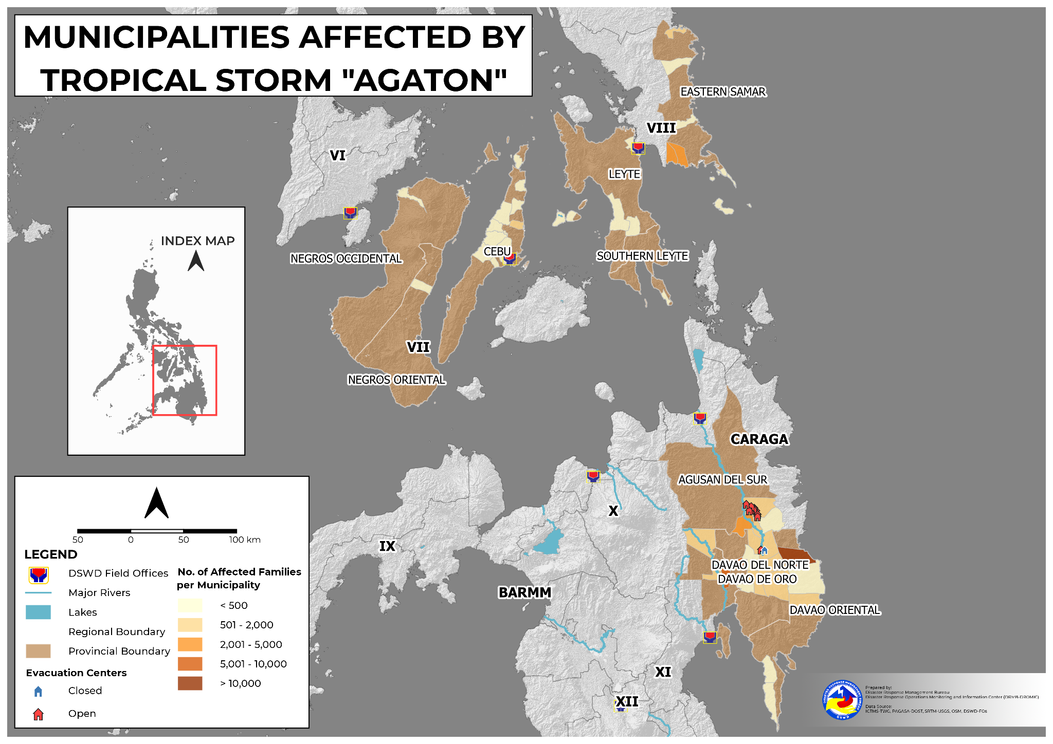

- Status of Displaced Population

    - Inside Evacuation Center
There are 2,890 families or 11,167 persons currently taking temporary shelter in 100 evacuation centers in Regions VI, VII, VIII, XI and Caraga (see Table 2).

Table 2. Number of Displaced Families / Persons Inside Evacuation Center

REGION / PROVINCE / MUNICIPALITY |  | NUMBER OF EVACUATION CENTERS (ECs) |  | NUMBER OF DISPLACED
 |  |  |  | INSIDE ECs
 |  |  |  | Families |  | Persons
 |  | CUM | NOW | CUM | NOW | CUM | NOW
GRAND TOTAL |  | 154 | 100 | 6,421 | 2,890 | 22,883 | 11,167
REGION VI |  | 2 | 2 | 10 | 10 | 38 | 38
Negros Occidental |  | 2 | 2 | 10 | 10 | 38 | 38
 | Enrique B. Magalona (Saravia) | 2 | 2 | 10 | 10 | 38 | 38
REGION VII |  | 38 | 35 | 329 | 300 | 1,245 | 1,140
Cebu |  | 35 | 32 | 313 | 284 | 1,181 | 1,076
 | Asturias | 1 | - | 1 | - | 9 | -
 | Balamban | 1 | 1 | 3 | 3 | 12 | 12
 | Cebu City (capital) | 4 | 4 | 38 | 38 | 120 | 120
 | Medellin | 1 | 1 | 1 | 1 | 1 | 1
 | Minglanilla | 3 | 3 | 47 | 47 | 188 | 188
 | Poro | 3 | 3 | 13 | 8 | 52 | 32
 | San Francisco | 5 | 4 | 8 | 4 | 38 | 22
 | Sogod | 2 | 2 | 14 | 14 | 62 | 62
 | Tabogon | 5 | 5 | 16 | 16 | 72 | 72
 | Toledo City | 3 | 3 | 75 | 75 | 300 | 300
 | Tuburan | 7 | 6 | 97 | 78 | 327 | 267
Negros Oriental |  | 3 | 3 | 16 | 16 | 64 | 64
 | La Libertad | 3 | 3 | 16 | 16 | 64 | 64
REGION VIII |  | 20 | 20 | 334 | 334 | 1,596 | 1,596
Leyte |  | 11 | 11 | 292 | 292 | 1,439 | 1,439
 | Tacloban City (capital) | 1 | 1 | 4 | 4 | 18 | 18
 | City of Baybay | 6 | 6 | 244 | 244 | 1,220 | 1,220
 | Mahaplag | 4 | 4 | 44 | 44 | 201 | 201
Southern Leyte |  | 9 | 9 | 42 | 42 | 157 | 157
 | Pintuyan | 9 | 9 | 42 | 42 | 157 | 157
REGION XI |  | 51 | - | 3,502 | - | 11,611 | -
Davao de Oro |  | 37 | - | 2,521 | - | 8,363 | -
 | Compostela | 5 | - | 889 | - | 3,332 | -
 | Mawab | 4 | - | 69 | - | 259 | -
 | Monkayo | 4 | - | 399 | - | 1,275 | -
 | Montevista | 1 | - | 10 | - | 50 | -
 | Nabunturan (capital) | 12 | - | 583 | - | 1,484 | -
 | New Bataan | 11 | - | 571 | - | 1,963 | -
Davao del Norte |  | 2 | - | 35 | - | 117 | -
 | Kapalong | 2 | - | 35 | - | 117 | -
Davao Oriental |  | 12 | - | 946 | - | 3,131 | -
 | Caraga | 4 | - | 675 | - | 2,089 | -
 | Cateel | 5 | - | 181 | - | 718 | -
 | Governor Generoso | 2 | - | 25 | - | 129 | -
 | San Isidro | 1 | - | 65 | - | 195 | -
CARAGA |  | 43 | 43 | 2,246 | 2,246 | 8,393 | 8,393
Agusan del Sur |  | 43 | 43 | 2,246 | 2,246 | 8,393 | 8,393
 | Bunawan | 28 | 28 | 1,539 | 1,539 | 5,367 | 5,367
 | Santa Josefa | 4 | 4 | 216 | 216 | 816 | 816
 | Trento | 4 | 4 | 185 | 185 | 680 | 680
 | Veruela | 7 | 7 | 306 | 306 | 1,530 | 1,530
Note: Ongoing assessment and validation are continuously being conducted.
Source: DSWD-FOs

    - Outside Evacuation Center
There are 355 families or 1,733 persons temporarily staying with their relatives and/or friends in Regions VIII, XI and Caraga (see Table 3).
Table 3. Number of Displaced Families / Persons Outside Evacuation Center

REGION / PROVINCE / MUNICIPALITY |  | NUMBER OF DISPLACED
 |  | OUTSIDE ECs
 |  | Families |  | Persons
 |  | CUM | NOW | CUM | NOW
GRAND TOTAL |  | 382 | 355 | 1,852 | 1,733
REGION VIII |  | 278 | 278 | 1,379 | 1,379
Leyte |  | 247 | 247 | 1,256 | 1,256
 | Tacloban City (capital) | 247 | 247 | 1,256 | 1,256
Southern Leyte |  | 31 | 31 | 123 | 123
 | Pintuyan | 31 | 31 | 123 | 123
REGION XI |  | 27 | - | 119 | -
Davao Oriental |  | 27 | - | 119 | -
 | Baganga | 27 | - | 119 | -
CARAGA |  | 77 | 77 | 354 | 354
Agusan del Sur |  | 77 | 77 | 354 | 354
 | Santa Josefa | 20 | 20 | 69 | 69
 | Veruela | 57 | 57 | 285 | 285
Note: Ongoing assessment and validation are continuously being conducted.
Source: DSWD-FOs

    - Total Displaced Population
There are 3,245 families or 12,900 persons temporarily staying either in evacuation centers or with their relatives and/or friends in Regions VI, VII, VIII, XI and Caraga (see Table 4).

Table 4. Total Number of Displaced Families / Persons

REGION / PROVINCE / MUNICIPALITY |  | TOTAL DISPLACED SERVED
 |  | Families |  | Persons
 |  | Total Families |  | Total Persons
 |  | CUM | NOW | CUM | NOW
GRAND TOTAL |  | 6,803 | 3,245 | 24,735 | 12,900
REGION VI |  | 10 | 10 | 38 | 38
Negros Occidental |  | 10 | 10 | 38 | 38
 | Enrique B. Magalona (Saravia) | 10 | 10 | 38 | 38
REGION VII |  | 329 | 300 | 1,245 | 1,140
Cebu |  | 313 | 284 | 1,181 | 1,076
 | Asturias | 1 | - | 9 | -
 | Balamban | 3 | 3 | 12 | 12
 | Cebu City (capital) | 38 | 38 | 120 | 120
 | Medellin | 1 | 1 | 1 | 1
 | Minglanilla | 47 | 47 | 188 | 188
 | Poro | 13 | 8 | 52 | 32
 | San Francisco | 8 | 4 | 38 | 22
 | Sogod | 14 | 14 | 62 | 62
 | Tabogon | 16 | 16 | 72 | 72
 | Toledo City | 75 | 75 | 300 | 300
 | Tuburan | 97 | 78 | 327 | 267
Negros Oriental |  | 16 | 16 | 64 | 64
 | La Libertad | 16 | 16 | 64 | 64
REGION VIII |  | 612 | 612 | 2,975 | 2,975
Leyte |  | 539 | 539 | 2,695 | 2,695
 | Tacloban City (capital) | 251 | 251 | 1,274 | 1,274
 | City of Baybay | 244 | 244 | 1,220 | 1,220
 | Mahaplag | 44 | 44 | 201 | 201
Southern Leyte |  | 73 | 73 | 280 | 280
 | Pintuyan | 73 | 73 | 280 | 280
REGION XI |  | 3,529 | - | 11,730 | -
Davao de Oro |  | 2,521 | - | 8,363 | -
 | Compostela | 889 | - | 3,332 | -
 | Mawab | 69 | - | 259 | -
 | Monkayo | 399 | - | 1,275 | -
 | Montevista | 10 | - | 50 | -
 | Nabunturan (capital) | 583 | - | 1,484 | -
 | New Bataan | 571 | - | 1,963 | -
Davao del Norte |  | 35 | - | 117 | -
 | Kapalong | 35 | - | 117 | -
Davao Oriental |  | 973 | - | 3,250 | -
 | Baganga | 27 | - | 119 | -
 | Caraga | 675 | - | 2,089 | -
 | Cateel | 181 | - | 718 | -
 | Governor Generoso | 25 | - | 129 | -
 | San Isidro | 65 | - | 195 | -
CARAGA |  | 2,323 | 2,323 | 8,747 | 8,747
Agusan del Sur |  | 2,323 | 2,323 | 8,747 | 8,747
 | Bunawan | 1,539 | 1,539 | 5,367 | 5,367
 | Santa Josefa | 236 | 236 | 885 | 885
 | Trento | 185 | 185 | 680 | 680
 | Veruela | 363 | 363 | 1,815 | 1,815
Note: Ongoing assessment and validation are continuously being conducted.
Source: DSWD-FOs

- Damaged Houses

A total of seven (7) houses were damaged; of which, one (1) is totally damaged and six (6) are partially damaged in Regions XI and Caraga (see Table 5).

Table 5. Number of Damaged Houses

REGION / PROVINCE / MUNICIPALITY |  | NO. OF DAMAGED HOUSES
 |  | Total | Totally | Partially
GRAND TOTAL |  | 7 | 1 | 6
REGION XI |  | 4 | - | 4
Davao de Oro |  | 4 | - | 4
 | Nabunturan (capital) | 4 | - | 4
CARAGA |  | 3 | 1 | 2
Agusan del Sur |  | 3 | 1 | 2
 | Bunawan | 2 | 1 | 1
 | Santa Josefa | 1 | - | 1
Note: Ongoing assessment and validation are continuously being conducted.
Source: DSWD-FOs

- Cost of Humanitarian Assistance Provided

A total of ₱6,387,043.50 worth of assistance was provided to the affected families; of which, ₱4,227,099.50 from the DSWD and ₱2,159,944.00 from the Local Government Units (LGUs) (see Table 6).

Table 6. Cost of Assistance Provided to Affected Families / Persons
REGION / PROVINCE / MUNICIPALITY |  | COST OF ASSISTANCE
 |  | DSWD | LGUs | NGOs | OTHERS | GRAND TOTAL
GRAND TOTAL |  | 4,227,099.50 | 2,159,944.00 | - | - | 6,387,043.50
REGION XI |  | 4,227,099.50 | - | - | - | 4,227,099.50
Davao del Norte |  | 4,227,099.50 | - | - | - | 4,227,099.50
 | Asuncion (Saug) | 4,227,099.50 | - | - | - | 4,227,099.50
CARAGA |  | - | 2,159,944.00 | - | - | 2,159,944.00
Agusan del Sur |  | - | 2,159,944.00 | - | - | 2,159,944.00
 | Bunawan | - | 1,202,747.00 | - | - | 1,202,747.00
 | Santa Josefa | - | 668,034.00 | - | - | 668,034.00
 | Veruela | - | 289,163.00 | - | - | 289,163.00

Source: DSWD-FO FOs

- Response Actions and Interventions

- Standby Funds and Prepositioned Relied Stockpile
OFFICE | STANDBY FUNDS | STOCKPILE |  |  | TOTAL STANDBY FUNDS & STOCKPILE
 |  | FAMILY FOOD PACKS |  | OTHER FOOD AND NON-FOOD ITEMS (FNIs)
 |  | QUANTITY | TOTAL COST
TOTAL | 146,109,022.97 | 530,368 | 335,315,244.50 | 756,086,128.33 | 1,237,510,395.80
DSWD-CO | 68,594,777.99 | - | - | - | 68,594,777.99
NRLMB-NROC | - | 73,829 | 45,815,725.00 | 257,658,869.52 | 303,474,594.52
NRLMB-VDRC | - | 737 | 458,414.00 | 30,824,635.40 | 31,283,049.40
DSWD-FO VII | 5,000,000.00 | 14,614 | 7,745,420.00 | 31,507,639.19 | 44,253,059.19
DSWD-FO VIII | 5,000,000.00 | 22,736 | 15,102,538.23 | 18,524,659.37 | 38,627,197.60
DSWD-FO XI | 66,610.00 | 20,024 | 11,998,884.00 | 30,016,022.80 | 42,081,516.80
DSWD-FO Caraga | 5,000,000.00 | 170,093 | 117,288,042.00 | 11,258,672.57 | 133,546,714.57
Other FOs | 62,447,634.98 | 228,335 | 136,906,221.27 | 376,295,629.48 | 575,649,485.73
Note: Inventory Summary is as of 11 April 2022, 4PM. The replenishment of standby funds for DSWD-FO XI is being processed.
Source: DSWD-DRMB and DSWD-NRLMB

  - Standby Funds
    - ₱68.59 million Quick Response Fund (QRF) at the DSWD-Central Office.
    - ₱15.07 million available at DSWD-FOs VII, VIII, XI and Caraga.
    - ₱62.45 million in other DSWD-FOs which may support the relief needs of the displaced families due to the effects of LPA through inter-FO augmentation.

  - Prepositioned FFPs and Other Relief Items
    - 74,566 FFPs available in Disaster Response Centers; of which, 73,829 FFPs are at the National Resource Operations Center (NROC), Pasay City and 737 FFPs are at the Visayas Disaster Response Center (VDRC), Cebu City.
    - 227,467 FFPs available at DSWD-FOs VII, VIII, XI and Caraga.
    - 228,335 FFPs in other DSWD-FOs which may support the relief needs of the displaced families due to Effects of LPA through inter-FO augmentation.
    - ₱756.09 million worth of other FNIs at NROC, VDRC and DSWD-FO warehouses.

- Food and Non-Food Items

DSWD-FO VII
DATE | SITUATIONS / ACTIONS UNDERTAKEN
10 April 2022 | - The Local Disaster Risk Reduction and Management Office (LDRRMO) of Toledo City assisted the Local Social Welfare and Development Office (LSWDO) in the distribution of FNIs to the affected families at Sitio Buswang, Brgy. Cambang-ug, Toledo City.

DSWD-FO VIII
DATE | SITUATIONS / ACTIONS UNDERTAKEN
11 April 2022 | - The LGU of Hindang, Leyte started serving food packs to the affected families due to Tropical Depression “Agaton”.
10 April 2022 | - DSWD-FO VIII continuously conducted prepositioning of FFPs in the Provinces of Samar, Northern Samar, Eastern Samar, and Biliran, while various LGUs across Eastern Visayas have prepositioned FFPs ready for augmentation if needed.

DSWD-FO XI
DATE | SITUATIONS / ACTIONS UNDERTAKEN
10 April 2022 | - DSWD-FO XI provided FFPs to the LGU of Asuncion, Davao del Norte.

- Internally Displaced Person (IDP) Protection

DSWD-FO XI
DATE | SITUATIONS / ACTIONS UNDERTAKEN
06 April 2022 | - The Municipalities of Monkayo and Mawab in Davao de Oro closely coordinated with the affected barangays for the provision of psychosocial services and assessment of needed intervention of the affected families and individuals.

- Camp Coordination and Camp Management (CCCM)

DSWD-FO VII
DATE | SITUATIONS / ACTIONS UNDERTAKEN
1 April 2022 | - The LGU personnel of Cebu City through its Department of Social Welfare Services (DSWS) continue to assist the displaced families and individuals in various evacuation centers. They were provided meals and other food items.  - At least 89 stranded passengers bound for Camotes Island are temporarily taking shelter and are assisted by the LGU of Danao City. They were provided with food, water and other immediate needs.

DSWD-FO XI
DATE | SITUATIONS / ACTIONS UNDERTAKEN
06 April 2022 | - DSWD-FO XI through its Disaster Response Management Division (DRMD) closely coordinated with the affected local government units (LGUs) for reports and updates on the situation of the displaced families and individuals inside evacuation centers and to ensure compliance with the provision of emergency relief and protection for the children (Republic Act No. 10821) before, during and after disasters and other emergency situations as well as to monitor the compliance with the safety health protocols set by the Inter-Agency Task Force-Management of Emerging Infectious Diseases (IATF-MEID).

- Other Activities

DSWD-FO NCR
DATE | SITUATIONS / ACTIONS UNDERTAKEN
10 April 2022 | - The DSWD-FO NCR activated and established its Emergency Operations Center for Tropical Depression Agaton.  - The Quick Response Teams (QRTs) of DSWD-FO NCR composed of organic staff from the Field Office, and Centers and Residential Care Facilities (C/RCFs) were advised to be on standby in response to any eventualities  - The DSWD-FO NCR is continuously coordinating with LGUs through their respective Local Social Welfare and Development Offices (LSWDOs) and with Metro Manila Disaster Risk Reduction and Management Council (MMDRRMC) for reports on incidents requiring augmentation assistance.

DSWD-FO I
DATE | SITUATIONS / ACTIONS UNDERTAKEN
10 April 2022 | - DSWD-FO I closely monitored the movement of Tropical Depression “Agaton” through the Department of Science and Technology – Philippine Atmospheric, Geophysical and Astronomical Services Administration (DOST-PAGASA) and in close coordination with the Regional Disaster Risk Reduction and Management Council (RDRRMC) 1. Likewise, Provincial Operations Offices (POOs) closely coordinated with the different Local Disaster Risk Reduction and Management Councils (LDRRMCs) and Local Social Welfare and Development Offices (LSWDOs) to monitor the adverse effects that might be brought by the weather disturbance.  - Operations Section Chief (OSC) Maricel S. Caleja of DSWD-FO I attended the Pre-Disaster Risk Assessment (PDRA) Analyst Group Meeting via Zoom. The adoption of CHARLIE EPR Protocol and activation of response cluster were recommended during the meeting.  - The DSWD-FO 1 Incident Management Team (IMT) was activated and on duty while other DSWD staff were on standby for possible augmentation. Likewise, the Field Office ensured availability and readiness of resources.

DSWD-FO MIMAROPA
DATE | SITUATIONS / ACTIONS UNDERTAKEN
05 April 2022 | - DSWD-FO MIMAROPA alerted the DSWD Social Welfare and Development Offices (SWADOs) to monitor daily local conditions, related eventualities, bulletins, warnings, and other advisories issued by the DOST-PAGASA, DENR-MGB, and other surveillance agencies.  - DSWD-FO MIMAROPA closely coordinated with the Office of Civil Defense (OCD) and Regional Disaster Risk Reduction and Management Council (RDRRMC) MIMAROPA for updates, monitoring and response mechanisms in areas that may be affected.

DSWD-FO V
DATE | SITUATIONS / ACTIONS UNDERTAKEN
06 April 2022 | - DSWD-FO V Quick Response Team (QRT) were alerted.  - The Provincial/Municipal Action Teams of DSWD-FO V in the six (6) provinces were activated and instructed to coordinate with the Local Disaster Risk Reduction and Management Offices (LDRRMOs) and Local Social Welfare and Development Offices (LSWDOs) for significant updates.

DSWD-FO VI
DATE | SITUATIONS / ACTIONS UNDERTAKEN
11 April 2022 | - DSWD-FO VI issued a memorandum activating the Quick Response Team (QRT).  - DSWD-FO VI is continuously monitoring the situation of IDPs and the status of the evacuation centers in coordination with the Provincial Social Welfare and Development Offices (PSWDOs).  - DSWD-FO VI is in close coordination with the LGUs for any possible relief augmentation.
09 April 2022 | - Division Chief, Judith T. Barredo of DSWD-FO VI attended the Pre-Disaster Risk Assessment (PDRA) Meeting convened by the Regional Disaster Risk Reduction and Management Council (RDRRMC).
08 April 2022 | - Staff from the Disaster Response Management Division (DRMD) of the DSWD-FO VI have attended the Pre-Disaster Risk Assessment (PDRA) Analyst Meeting to identify the alert level in Region VI.

DSWD-FO VII
DATE | SITUATIONS / ACTIONS UNDERTAKEN
11 April 2022 | - DSWD-FO VII through its Disaster Response Management Division (DRMD) is continuously coordinating with the affected LGUs for updates and status of affected families and individuals.  - City/Municipal Action Teams in the Provinces of Bohol, Negros Oriental, Cebu, and Siquijor were directed to be on alert and monitor the situation in coordination with the Local Disaster Risk Reduction and Management Councils (LDRRMCs) to immediately provide assistance and/or support.  - DSWD-FO VII is closely monitoring the situation in coordination with the Response Cluster of the Regional Disaster Risk Reduction and Management Council (RDRRMC) and Office of Civil Defense (OCD)-7.

DSWD-FO VIII
DATE | SITUATIONS / ACTIONS UNDERTAKEN
11 April 2022 | - The Quick Response Team (QRT) has been activated.  - DSWD-FO VIII conducted a Quick Response Team (QRT) Committee Chairpersons’ Meeting at the Regional Resource Operations Center (RROC) Building to orient them about their roles and functions, and to discuss the current situation of the Region.
10 April 2022 | - The Regional Disaster Risk Reduction and Management Council (RDRRMC) initiated the Pre-Disaster Risk Assessment (PDRA) Meeting in preparation for the development of LPA to a Tropical Cyclone.
08 April 2022 | - DSWD-FO VIII Sub-Field Offices continuously monitor the situation in different LGUs across Eastern Visayas in coordination with the LSWDOs and LDRRMOs.
07 April 2022 | - DSWD-FO VIII continuously monitored the weather situation through live updates of PAGASA on weather disturbances.  - DSWD-FO VIII continuously produced FFPs for possible augmentation to LGUs that may be affected by the LPA.

DSWD-FO X
DATE | SITUATIONS / ACTIONS UNDERTAKEN
08 April 2022 | - DSWD-FO X is in close coordination with the affected LGUs for updates on the status of affected families and individuals.  - The Local Social Welfare and Development Offices (LSWDOs) and Local Disaster Risk Reduction and Management Offices (LDRRMOs) are validating the number of affected families and the extent of damages caused by the LPA.

DSWD-FO XI
DATE | SITUATIONS / ACTIONS UNDERTAKEN
09 April 2022 | - DSWD FO XI attended Pre-Disaster Risk Assessment.  - Conducted ocular visit to affected LGUs.

DSWD-FO Caraga
DATE | SITUATIONS / ACTIONS UNDERTAKEN
10 April 2022 | - DSWD-FO Caraga attended the PDRA-Emergency Response Preparedness (ERP) Meeting spearheaded by the Office of Civil Defense-Caraga.
06 April 2022 | - DSWD-FO Caraga coordinated with the Local Social Welfare and Development Offices (LSWDOs) and DSWD Social Welfare and Development (SWAD) Team Leaders for the possible provision of augmentation assistance to the affected families.

PHOTO DOCUMENTATION
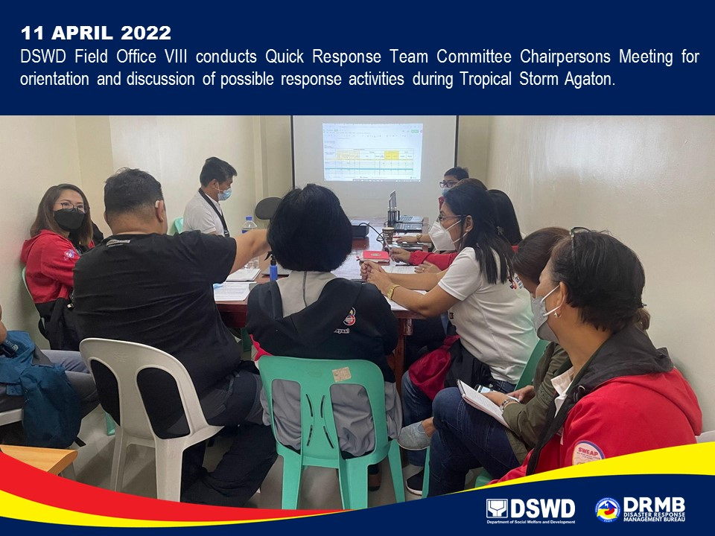

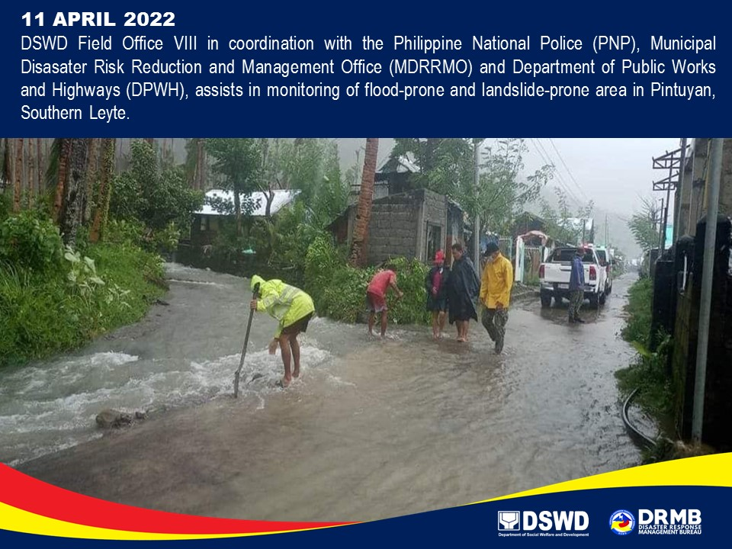
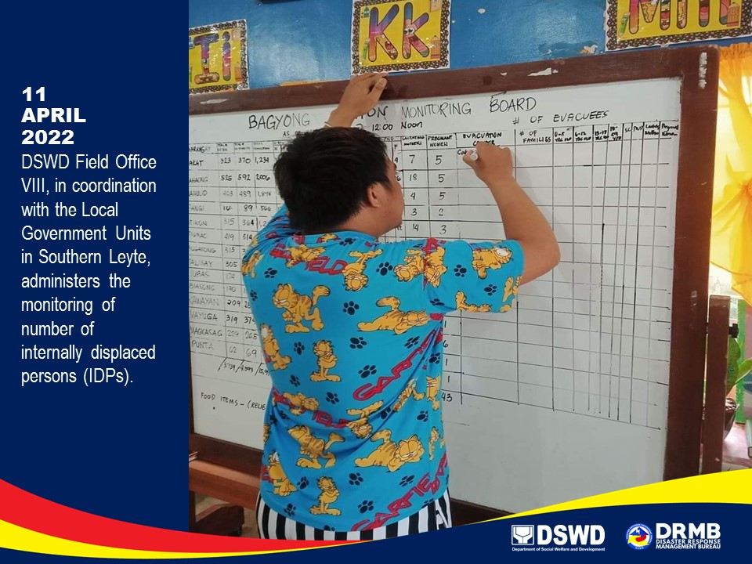

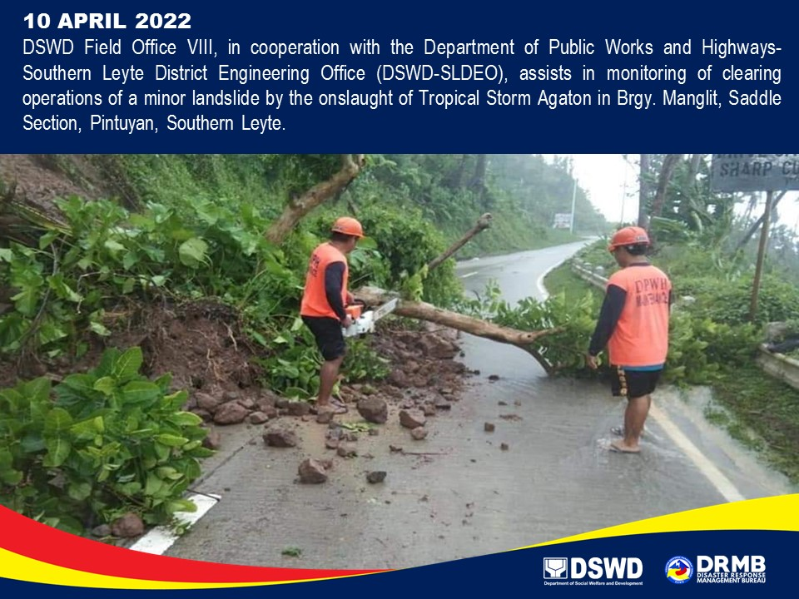
*****
The Disaster Response Operations Monitoring and Information Center (DROMIC) of DSWD-DRMB is closely coordinating with the concerned DSWD Field Offices for significant updates on disaster response operations and assistance provided.

Prepared by:  DIANE C. PELEGRINO  AARON JOHN B. PASCUA  MARIE JOYCE G. RAFANAN | Released by:  MARC LEO L. BUTAC

