DSWD DROMIC Report #5 on Tropical Storm AGATON
as of 12 April 2022, 6PM

- Situation Overview

Issued on 04 April 2022 at 4AM, a Low Pressure Area (LPA) was estimated based on all available data at 970 km East of Guiuan, Eastern Samar (11.0°N, 134.6°E). It is embedded along the Intertropical Convergence Zone (ITCZ) affecting Mindanao. Shear Line affecting Extreme Northern Luzon.

Issued on 07 April 2022 at 4 PM, the Low Pressure Area (LPA) was estimated based on all available data at 180 km East Northeast of Hinatuan, Surigao del Sur (8.9°N, 127.9°E).

Issued on 08 April 2022 at 4 PM, the Low Pressure Area (LPA) was estimated based on all available data at 185 km East Northeast of Surigao City, Surigao del Norte (10.5°N, 127.0°E).
Issued on 09 April 2022 at 4 PM, the Low Pressure Area (LPA) East of Eastern Samar developed into Tropical Depression “Agaton”.
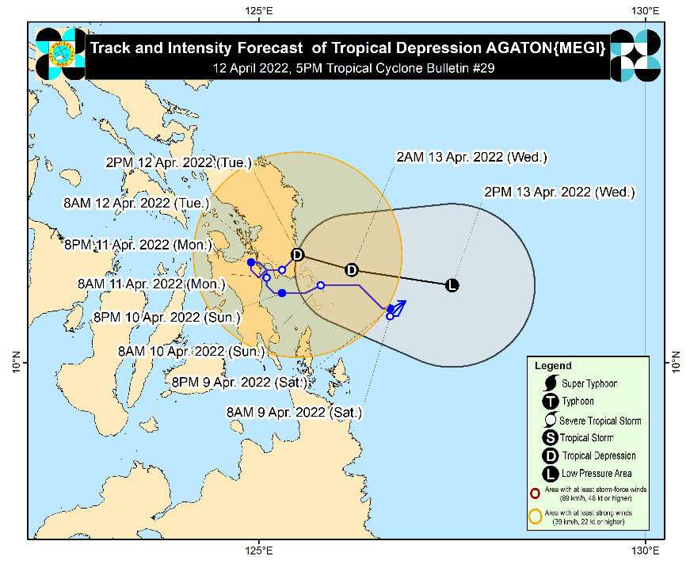
Issued on 12 April 2022 at 5 PM, “AGATON” REMAINS ALMOST STATIONARY OVER LLORENTE, EASTERN SAMAR.

The center of Tropical Depression “AGATON” was estimated based on all available data in the vicinity of Llorente, Eastern Samar (11.3°N, 125.5°E).

Intensity
- Maximum sustained winds of 45 km/h near the center, gustiness of up to 75 km/h, and central pressure of 1002 hPa.

Heavy Rainfall
- Today: Moderate to heavy with at times intense rains over Eastern Visayas, Sorsogon, Masbate, the northern and central portions of Cebu including Bantayan and Camotes Islands, Aklan, Capiz, Iloilo, Antique, Guimaras, and the northern and central portions of Negros Provinces. Light to moderate with at times heavy rains over MIMAROPA, Dinagat Islands, Zamboanga del Norte, Quezon, and the rest of Bicol Region and Visayas.
- Under these conditions and considering significant antecedent rainfall, scattered to widespread flooding (including flooding) and rain-induced landslides are still expected especially in areas that are highly or very highly susceptible to these hazard as identified in hazard maps.

Severe Winds
- Strong winds (strong breeze to near gale conditions) will be experienced within any of the areas where Wind Signal No. 1 is currently in effect.

HAZARDS AFFECTING COASTAL WATERS
- In the next 24 hours, rough seas (2.8 to 4.0 m) will prevail over the seaboards of areas where Wind Signal No. 1 is hoisted. These conditions may be risky for most seacrafts. Mariners of small seacrafts are advised to remain in port or take shelter, while those operating larger vessels are advised to take precautionary measures when venturing out to sea and, if possible, avoid navigating in these conditions.
- In the next 24 hours, moderate to rough seas (1.2 to 3.7 m) will also prevail over the remaining seaboards of the country that are not under any wind signal or gale warning, especially over the northern and eastern seaboards of Luzon and the eastern seaboards of Visayas and Mindanao. These conditions may be risky for those using small seacrafts. Mariners are advised to take precautionary measures when venturing out to sea and, if possible, avoid navigating in these conditions.

TRACK AND INTENSITY OUTLOOK
- “AGATON” is forecast to continue moving slowly eastward within the next 6 to 12 hours before turning more east southeastward towards the Philippine Sea beginning tonight or tomorrow morning. Considering the continuing erratic nature of its movement, the track forecast of “AGATON may likely change in the succeeding bulletins.
- Due to the combined effects of land interaction, increasing vertical wind shear, and the effects of the upper-level outflow of Typhoon “BASYANG”, this tropical depression is forecast to deteriorate into a remnant low within the next 24 hours. The remnant of “AGATON” will then continue tracking generally eastward over the Philippine Sea as it becomes assimilated within the circulation of “BASYANG”.

Source: DOST-PAGASA Daily Weather Forecast

- Status of Affected Areas and Population

There are 98,079 families or 385,126 persons affected in 562 barangays in Regions V, VI, VII, VIII, X, XI and Caraga (see Table 1).

Table 1. Number of Affected Families / Persons

REGION / PROVINCE / MUNICIPALITY |  | NUMBER OF AFFECTED
 |  | Barangays | Families | Persons
GRAND TOTAL |  | 562 | 98,079 | 385,126
REGION V |  | 2 | 24 | 100
Masbate |  | 2 | 24 | 100
 | Mobo | 1 | 8 | 20
 | Palanas | 1 | 16 | 80
REGION VI |  | 212 | 13,025 | 55,069
Aklan |  | 1 | 12 | 58
 | New Washington | 1 | 12 | 58
Capiz |  | 85 | 4,454 | 20,150
 | Cuartero | 4 | 11 | 44
 | Dao | 4 | 53 | 158
 | Dumarao | 22 | 1,362 | 5,063
 | Ma-ayon | 32 | 1,816 | 9,152
 | Panay | 3 | 51 | 208
 | Pilar | 4 | 218 | 852
 | Pontevedra | 7 | 268 | 1,302
 | President Roxas | 8 | 673 | 3,365
 | Sapi-an | 1 | 2 | 6
Iloilo |  | 95 | 6,517 | 26,282
 | Ajuy | 14 | 3,040 | 12,058
 | Balasan | 10 | 248 | 829
 | Banate | 18 | 1,137 | 5,685
 | Batad | 31 | 122 | 382
 | Dingle | 8 | 185 | 813
 | Pototan | 9 | 86 | 285
 | Sara | 5 | 1,699 | 6,230
Negros Occidental |  | 31 | 2,042 | 8,579
 | Enrique B. Magalona (Saravia) | 8 | 1,600 | 6,917
 | Sagay City | 3 | 18 | 68
 | Silay City | 4 | 68 | 260
 | City of Victorias | 16 | 356 | 1,334
REGION VII |  | 30 | 329 | 1,245
Cebu |  | 28 | 313 | 1,181
 | Asturias | 1 | 1 | 9
 | Balamban | 1 | 3 | 12
 | Cebu City (capital) | 4 | 38 | 120
 | Medellin | 1 | 1 | 1
 | Minglanilla | 2 | 47 | 188
 | Poro | 3 | 13 | 52
 | San Francisco | 5 | 8 | 38
 | Sogod | 2 | 14 | 62
 | Tabogon | 3 | 16 | 72
 | Toledo City | 1 | 75 | 300
 | Tuburan | 5 | 97 | 327
Negros Oriental |  | 2 | 16 | 64
 | La Libertad | 2 | 16 | 64
REGION VIII |  | 152 | 30,812 | 134,952
Biliran |  | 9 | 99 | 427
 | Almeria | 2 | 4 | 13
 | Naval (capital) | 2 | 23 | 91
 | Caibiran | 5 | 72 | 323
Eastern Samar |  | 41 | 22,911 | 96,879
 | Arteche | 1 | 1,193 | 4,900
 | Can-Avid | 1 | 120 | 600
 | Dolores | 31 | 5,918 | 24,699
 | Maslog | 1 | 56 | 228
 | Taft | 1 | 816 | 3,008
 | Balangiga | 1 | 4,336 | 21,680
 | Giporlos | 1 | 44 | 220
 | Guiuan | 1 | 6,458 | 25,894
 | Hernani | 1 | 611 | 1,974
 | Lawaan | 1 | 3,019 | 11,976
 | Maydolong | 1 | 340 | 1,700
Leyte |  | 93 | 7,725 | 37,350
 | San Miguel | 1 | 38 | 144
 | Tacloban City (capital) | 3 | 251 | 1,274
 | Tolosa | 1 | 3 | 7
 | Barugo | 1 | 35 | 159
 | Dulag | 4 | 404 | 1,616
 | MacArthur | 1 | 161 | 195
 | Villaba | 1 | 7 | 35
 | Albuera | 1 | 78 | 390
 | Matag-ob | 2 | 6 | 35
 | Ormoc City | 20 | 526 | 2,432
 | Bato | 1 | 1,594 | 7,970
 | City of Baybay | 42 | 4,195 | 20,975
 | Hindang | 10 | 380 | 1,900
 | Mahaplag | 4 | 44 | 201
 | Matalom | 1 | 3 | 17
Northern Samar |  | 1 | 4 | 16
 | Lope de Vega | 1 | 4 | 16
Southern Leyte |  | 8 | 73 | 280
 | Pintuyan | 8 | 73 | 280
REGION X |  | 6 | 507 | 2,109
Bukidnon |  | 4 | 352 | 1,479
 | Cabanglasan | 1 | 73 | 365
 | San Fernando | 1 | 67 | 297
 | Kitaotao | 1 | 30 | 93
 | City of Valencia | 1 | 182 | 724
Misamis Oriental |  | 2 | 155 | 630
 | Jasaan | 2 | 155 | 630
REGION XI |  | 127 | 46,368 | 160,887
Davao de Oro |  | 59 | 7,207 | 27,227
 | Compostela | 10 | 1,552 | 6,145
 | Mawab | 7 | 377 | 1,179
 | Monkayo | 18 | 3,878 | 15,069
 | Montevista | 1 | 257 | 1,300
 | Nabunturan (capital) | 12 | 572 | 1,571
 | New Bataan | 11 | 571 | 1,963
Davao del Norte |  | 35 | 14,641 | 45,750
 | Asuncion (Saug) | 9 | 9,110 | 21,761
 | Braulio E. Dujali | 1 | 254 | 1,270
 | Carmen | 5 | 1,810 | 9,050
 | Kapalong | 2 | 595 | 1,666
 | New Corella | 12 | 1,834 | 8,218
 | Santo Tomas | 3 | 363 | 1,594
 | City of Tagum (capital) | 3 | 675 | 2,191
Davao del Sur |  | 10 | 7,262 | 15,526
 | Davao City | 10 | 7,262 | 15,526
Davao Oriental |  | 23 | 17,258 | 72,384
 | Baganga | 1 | 27 | 119
 | Caraga | 4 | 675 | 2,089
 | Cateel | 15 | 16,261 | 69,039
 | Governor Generoso | 2 | 25 | 129
 | San Isidro | 1 | 270 | 1,008
CARAGA |  | 39 | 7,014 | 30,764
Agusan del Sur |  | 31 | 6,853 | 30,295
 | Bunawan | 9 | 1,539 | 5,367
 | Santa Josefa | 7 | 1,633 | 6,818
 | Trento | 4 | 185 | 680
 | Veruela | 11 | 3,496 | 17,430
Dinagat Island |  | 8 | 161 | 469
 | San Jose (capital) | 8 | 161 | 469
Note: Ongoing assessment and validation are continuously being conducted.
Source: DSWD-Field Offices (FOs)

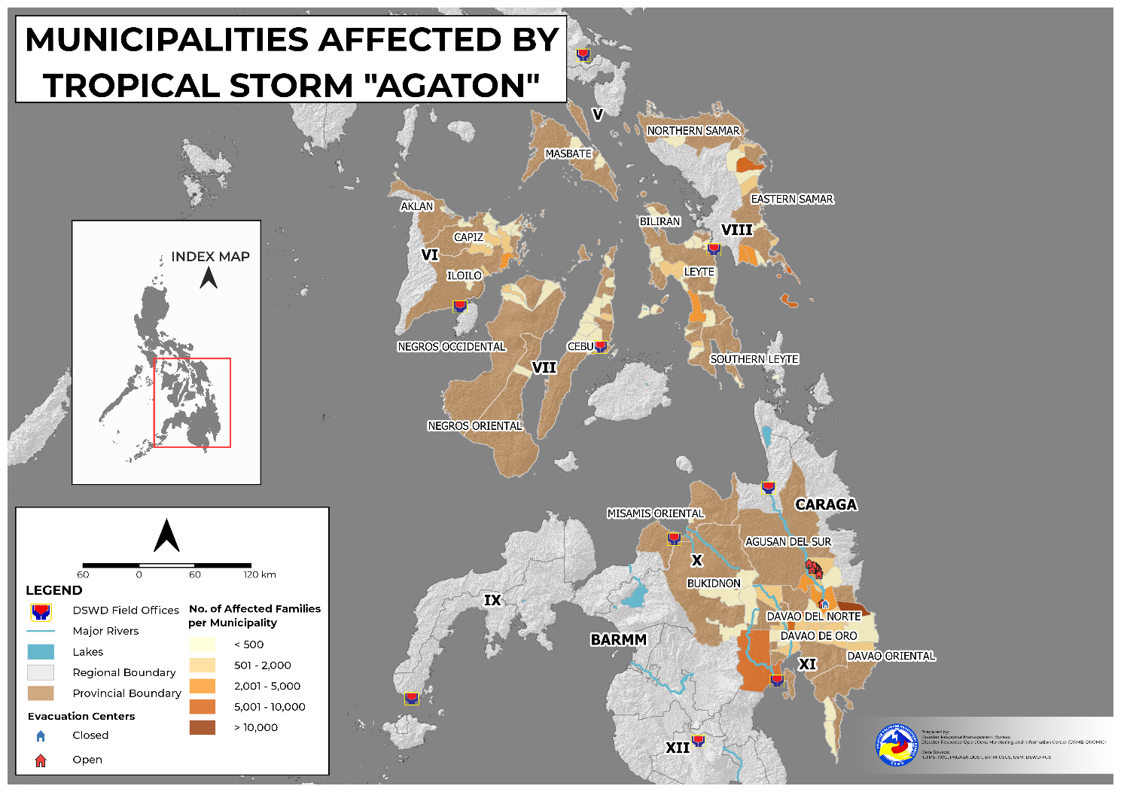

- Status of Displaced Population

    - Inside Evacuation Center
There are 8,303 families or 34,837 persons currently taking temporary shelter in 256 evacuation centers in Regions V, VI, VII, VIII, X, XI and Caraga (see Table 2).

Table 2. Number of Displaced Families / Persons Inside Evacuation Center
REGION / PROVINCE / MUNICIPALITY |  | NUMBER OF EVACUATION CENTERS (ECs) |  | NUMBER OF DISPLACED
 |  |  |  | INSIDE ECs
 |  |  |  | Families |  | Persons
 |  | CUM | NOW | CUM | NOW | CUM | NOW
GRAND TOTAL |  | 360 | 256 | 17,735 | 8,303 | 64,176 | 34,837
REGION V |  | 2 | 2 | 24 | 24 | 100 | 100
Masbate |  | 2 | 2 | 24 | 24 | 100 | 100
 | Mobo | 1 | 1 | 8 | 8 | 20 | 20
 | Palanas | 1 | 1 | 16 | 16 | 80 | 80
REGION VI |  | 144 | 135 | 4,338 | 4,015 | 18,720 | 17,501
Aklan |  | 1 | 1 | 3 | 3 | 17 | 17
 | New Washington | 1 | 1 | 3 | 3 | 17 | 17
Capiz |  | 81 | 81 | 2,237 | 2,237 | 11,064 | 11,064
 | Cuartero | 1 | 1 | 1 | 1 | 3 | 3
 | Dao | 6 | 6 | 47 | 47 | 136 | 136
 | Dumarao | 7 | 7 | 129 | 129 | 837 | 837
 | Ma-ayon | 40 | 40 | 1,170 | 1,170 | 5,955 | 5,955
 | Pilar | 9 | 9 | 216 | 216 | 846 | 846
 | Pontevedra | 12 | 12 | 268 | 268 | 1,302 | 1,302
 | President Roxas | 5 | 5 | 404 | 404 | 1,979 | 1,979
 | Sapi-an | 1 | 1 | 2 | 2 | 6 | 6
Iloilo |  | 41 | 41 | 1,648 | 1,648 | 5,947 | 5,947
 | Ajuy | 10 | 10 | 289 | 289 | 1,223 | 1,223
 | Balasan | 10 | 10 | 248 | 248 | 829 | 829
 | Dingle | 8 | 8 | 185 | 185 | 813 | 813
 | Pototan | 8 | 8 | 85 | 85 | 280 | 280
 | Sara | 5 | 5 | 841 | 841 | 2,802 | 2,802
Negros Occidental |  | 21 | 12 | 450 | 127 | 1,692 | 473
 | Enrique B. Magalona (Saravia) | 2 | 2 | 29 | 29 | 116 | 116
 | Sagay City | 2 | 2 | 17 | 17 | 56 | 56
 | Silay City | 6 | 6 | 68 | 68 | 260 | 260
 | City of Victorias | 11 | 2 | 336 | 13 | 1,260 | 41
REGION VII |  | 38 | 35 | 329 | 300 | 1,245 | 1,140
Cebu |  | 35 | 32 | 313 | 284 | 1,181 | 1,076
 | Asturias | 1 | - | 1 | - | 9 | -
 | Balamban | 1 | 1 | 3 | 3 | 12 | 12
 | Cebu City (capital) | 4 | 4 | 38 | 38 | 120 | 120
 | Medellin | 1 | 1 | 1 | 1 | 1 | 1
 | Minglanilla | 3 | 3 | 47 | 47 | 188 | 188
 | Poro | 3 | 3 | 13 | 8 | 52 | 32
 | San Francisco | 5 | 4 | 8 | 4 | 38 | 22
 | Sogod | 2 | 2 | 14 | 14 | 62 | 62
 | Tabogon | 5 | 5 | 16 | 16 | 72 | 72
 | Toledo City | 3 | 3 | 75 | 75 | 300 | 300
 | Tuburan | 7 | 6 | 97 | 78 | 327 | 267
Negros Oriental |  | 3 | 3 | 16 | 16 | 64 | 64
 | La Libertad | 3 | 3 | 16 | 16 | 64 | 64
REGION VIII |  | 42 | 42 | 2,187 | 2,187 | 9,877 | 9,877
Biliran |  | 11 | 11 | 99 | 99 | 427 | 427
 | Almeria | 2 | 2 | 4 | 4 | 13 | 13
 | Naval (capital) | 2 | 2 | 23 | 23 | 91 | 91
 | Caibiran | 7 | 7 | 72 | 72 | 323 | 323
Eastern Samar |  | 1 | 1 | 195 | 195 | 796 | 796
 | Guiuan | 1 | 1 | 195 | 195 | 796 | 796
Leyte |  | 21 | 21 | 1,851 | 1,851 | 8,497 | 8,497
 | San Miguel | 1 | 1 | 38 | 38 | 144 | 144
 | Tacloban City (capital) | 1 | 1 | 4 | 4 | 18 | 18
 | Barugo | 1 | 1 | 35 | 35 | 159 | 159
 | Villaba | 1 | 1 | 7 | 7 | 35 | 35
 | Albuera | 1 | 1 | 78 | 78 | 390 | 390
 | Matag-ob | 1 | 1 | 6 | 6 | 35 | 35
 | Ormoc City | 1 | 1 | 526 | 526 | 2,432 | 2,432
 | Bato | 1 | 1 | 484 | 484 | 1,936 | 1,936
 | City of Baybay | 7 | 7 | 246 | 246 | 1,230 | 1,230
 | Hindang | 1 | 1 | 380 | 380 | 1,900 | 1,900
 | Mahaplag | 4 | 4 | 44 | 44 | 201 | 201
 | Matalom | 1 | 1 | 3 | 3 | 17 | 17
Southern Leyte |  | 9 | 9 | 42 | 42 | 157 | 157
 | Pintuyan | 9 | 9 | 42 | 42 | 157 | 157
REGION X |  | 3 | 3 | 255 | 87 | 1,089 | 422
Bukidnon |  | 3 | 3 | 255 | 87 | 1,089 | 422
 | Cabanglasan | 2 | 2 | 73 | 73 | 365 | 365
 | City of Valencia | 1 | 1 | 182 | 14 | 724 | 57
REGION XI |  | 77 | - | 8,205 | - | 24,322 | -
Davao de Oro |  | 37 | - | 2,521 | - | 8,363 | -
 | Compostela | 5 | - | 889 | - | 3,332 | -
 | Mawab | 4 | - | 69 | - | 259 | -
 | Monkayo | 4 | - | 399 | - | 1,275 | -
 | Montevista | 1 | - | 10 | - | 50 | -
 | Nabunturan (capital) | 12 | - | 583 | - | 1,484 | -
 | New Bataan | 11 | - | 571 | - | 1,963 | -
Davao del Norte |  | 11 | - | 436 | - | 1,719 | -
 | Braulio E. Dujali | 1 | - | 8 | - | 19 | -
 | Carmen | 1 | - | 11 | - | 55 | -
 | Kapalong | 2 | - | 35 | - | 117 | -
 | New Corella | 1 | - | 109 | - | 545 | -
 | Santo Tomas | 3 | - | 46 | - | 145 | -
 | City of Tagum (capital) | 3 | - | 227 | - | 838 | -
Davao del Sur |  | 17 | - | 4,302 | - | 11,109 | -
 | Davao City | 17 | - | 4,302 | - | 11,109 | -
Davao Oriental |  | 12 | - | 946 | - | 3,131 | -
 | Caraga | 4 | - | 675 | - | 2,089 | -
 | Cateel | 5 | - | 181 | - | 718 | -
 | Governor Generoso | 2 | - | 25 | - | 129 | -
 | San Isidro | 1 | - | 65 | - | 195 | -
CARAGA |  | 54 | 39 | 2,397 | 1,690 | 8,823 | 5,797
Agusan del Sur |  | 43 | 28 | 2,246 | 1,539 | 8,393 | 5,367
 | Bunawan | 28 | 28 | 1,539 | 1,539 | 5,367 | 5,367
 | Santa Josefa | 4 | - | 216 | - | 816 | -
 | Trento | 4 | - | 185 | - | 680 | -
 | Veruela | 7 | - | 306 | - | 1,530 | -
Dinagat Island |  | 11 | 11 | 151 | 151 | 430 | 430
 | San Jose (capital) | 11 | 11 | 151 | 151 | 430 | 430
Note: Ongoing assessment and validation are continuously being conducted.
Source: DSWD-FOs

    - Outside Evacuation Center
There are 2,328 families or 10,363 persons temporarily staying with their relatives and/or friends in Regions VI, VIII, X, XI and Caraga (see Table 3).

Table 3. Number of Displaced Families / Persons Outside Evacuation Center

REGION / PROVINCE / MUNICIPALITY |  | NUMBER OF DISPLACED
 |  | OUTSIDE ECs
 |  | Families |  | Persons
 |  | CUM | NOW | CUM | NOW
GRAND TOTAL |  | 2,452 | 2,328 | 10,910 | 10,363
REGION VI |  | 2,026 | 2,006 | 8,910 | 8,836
Aklan |  | 9 | 9 | 41 | 41
 | New Washington | 9 | 9 | 41 | 41
Capiz |  | 1,115 | 1,115 | 5,271 | 5,271
 | Cuartero | 10 | 10 | 41 | 41
 | Dao | 6 | 6 | 22 | 22
 | Dumarao | 183 | 183 | 665 | 665
 | Ma-ayon | 646 | 646 | 3,197 | 3,197
 | Pilar | 2 | 2 | 6 | 6
 | President Roxas | 268 | 268 | 1,340 | 1,340
Iloilo |  | 881 | 881 | 3,512 | 3,512
 | Ajuy | 22 | 22 | 79 | 79
 | Pototan | 1 | 1 | 5 | 5
 | Sara | 858 | 858 | 3,428 | 3,428
Negros Occidental |  | 21 | 1 | 86 | 12
 | Sagay City | 1 | 1 | 12 | 12
 | City of Victorias | 20 | - | 74 | -
REGION VIII |  | 282 | 282 | 1,395 | 1,395
Leyte |  | 247 | 247 | 1,256 | 1,256
 | Tacloban City (capital) | 247 | 247 | 1,256 | 1,256
Northern Samar |  | 4 | 4 | 16 | 16
 | Lope de Vega | 4 | 4 | 16 | 16
Southern Leyte |  | 31 | 31 | 123 | 123
 | Pintuyan | 31 | 31 | 123 | 123
REGION X |  | 30 | 30 | 93 | 93
Bukidnon |  | 30 | 30 | 93 | 93
 | Kitaotao | 30 | 30 | 93 | 93
REGION XI |  | 27 | - | 119 | -
Davao Oriental |  | 27 | - | 119 | -
 | Baganga | 27 | - | 119 | -
CARAGA |  | 87 | 10 | 393 | 39
Agusan del Sur |  | 77 | - | 354 | -
 | Santa Josefa | 20 | - | 69 | -
 | Veruela | 57 | - | 285 | -
Dinagat Island |  | 10 | 10 | 39 | 39
 | San Jose (capital) | 10 | 10 | 39 | 39
Note: Ongoing assessment and validation re continuously being conducted.
Source: DSWD-FOs

    - Total Displaced Population
There are 10,631 families or 45,200 persons temporarily staying either in evacuation centers or with their relatives and/or friends in Regions V, VI, VII, VIII, X, XI and Caraga (see Table 4).

Table 4. Total Number of Displaced Families / Persons

REGION / PROVINCE / MUNICIPALITY |  | TOTAL DISPLACED SERVED
 |  | Families |  | Persons
 |  | CUM | NOW | CUM | NOW
GRAND TOTAL |  | 20,187 | 10,631 | 75,086 | 45,200
REGION V |  | 24 | 24 | 100 | 100
Masbate |  | 24 | 24 | 100 | 100
 | Mobo | 8 | 8 | 20 | 20
 | Palanas | 16 | 16 | 80 | 80
REGION VI |  | 6,364 | 6,021 | 27,630 | 26,337
Aklan |  | 12 | 12 | 58 | 58
 | New Washington | 12 | 12 | 58 | 58
Capiz |  | 3,352 | 3,352 | 16,335 | 16,335
 | Cuartero | 11 | 11 | 44 | 44
 | Dao | 53 | 53 | 158 | 158
 | Dumarao | 312 | 312 | 1,502 | 1,502
 | Ma-ayon | 1,816 | 1,816 | 9,152 | 9,152
 | Pilar | 218 | 218 | 852 | 852
 | Pontevedra | 268 | 268 | 1,302 | 1,302
 | President Roxas | 672 | 672 | 3,319 | 3,319
 | Sapi-an | 2 | 2 | 6 | 6
Iloilo |  | 2,529 | 2,529 | 9,459 | 9,459
 | Ajuy | 311 | 311 | 1,302 | 1,302
 | Balasan | 248 | 248 | 829 | 829
 | Dingle | 185 | 185 | 813 | 813
 | Pototan | 86 | 86 | 285 | 285
 | Sara | 1,699 | 1,699 | 6,230 | 6,230
Negros Occidental |  | 471 | 128 | 1,778 | 485
 | Enrique B. Magalona (Saravia) | 29 | 29 | 116 | 116
 | Sagay City | 18 | 18 | 68 | 68
 | Silay City | 68 | 68 | 260 | 260
 | City of Victorias | 356 | 13 | 1,334 | 41
REGION VII |  | 329 | 300 | 1,245 | 1,140
Cebu |  | 313 | 284 | 1,181 | 1,076
 | Asturias | 1 | - | 9 | -
 | Balamban | 3 | 3 | 12 | 12
 | Cebu City (capital) | 38 | 38 | 120 | 120
 | Medellin | 1 | 1 | 1 | 1
 | Minglanilla | 47 | 47 | 188 | 188
 | Poro | 13 | 8 | 52 | 32
 | San Francisco | 8 | 4 | 38 | 22
 | Sogod | 14 | 14 | 62 | 62
 | Tabogon | 16 | 16 | 72 | 72
 | Toledo City | 75 | 75 | 300 | 300
 | Tuburan | 97 | 78 | 327 | 267
Negros Oriental |  | 16 | 16 | 64 | 64
 | La Libertad | 16 | 16 | 64 | 64
REGION VIII |  | 2,469 | 2,469 | 11,272 | 11,272
Biliran |  | 99 | 99 | 427 | 427
 | Almeria | 4 | 4 | 13 | 13
 | Naval (capital) | 23 | 23 | 91 | 91
 | Caibiran | 72 | 72 | 323 | 323
Eastern Samar |  | 195 | 195 | 796 | 796
 | Guiuan | 195 | 195 | 796 | 796
Leyte |  | 2,098 | 2,098 | 9,753 | 9,753
 | San Miguel | 38 | 38 | 144 | 144
 | Tacloban City (capital) | 251 | 251 | 1,274 | 1,274
 | Barugo | 35 | 35 | 159 | 159
 | Villaba | 7 | 7 | 35 | 35
 | Albuera | 78 | 78 | 390 | 390
 | Matag-ob | 6 | 6 | 35 | 35
 | Ormoc City | 526 | 526 | 2,432 | 2,432
 | Bato | 484 | 484 | 1,936 | 1,936
 | City of Baybay | 246 | 246 | 1,230 | 1,230
 | Hindang | 380 | 380 | 1,900 | 1,900
 | Mahaplag | 44 | 44 | 201 | 201
 | Matalom | 3 | 3 | 17 | 17
Northern Samar |  | 4 | 4 | 16 | 16
 | Lope de Vega | 4 | 4 | 16 | 16
Southern Leyte |  | 73 | 73 | 280 | 280
 | Pintuyan | 73 | 73 | 280 | 280
REGION X |  | 285 | 117 | 1,182 | 515
Bukidnon |  | 285 | 117 | 1,182 | 515
 | Cabanglasan | 73 | 73 | 365 | 365
 | Kitaotao | 30 | 30 | 93 | 93
 | City of Valencia | 182 | 14 | 724 | 57
REGION XI |  | 8,232 | - | 24,441 | -
Davao de Oro |  | 2,521 | - | 8,363 | -
 | Compostela | 889 | - | 3,332 | -
 | Mawab | 69 | - | 259 | -
 | Monkayo | 399 | - | 1,275 | -
 | Montevista | 10 | - | 50 | -
 | Nabunturan (capital) | 583 | - | 1,484 | -
 | New Bataan | 571 | - | 1,963 | -
Davao del Norte |  | 436 | - | 1,719 | -
 | Braulio E. Dujali | 8 | - | 19 | -
 | Carmen | 11 | - | 55 | -
 | Kapalong | 35 | - | 117 | -
 | New Corella | 109 | - | 545 | -
 | Santo Tomas | 46 | - | 145 | -
 | City of Tagum (capital) | 227 | - | 838 | -
Davao del Sur |  | 4,302 | - | 11,109 | -
 | Davao City | 4,302 | - | 11,109 | -
Davao Oriental |  | 973 | - | 3,250 | -
 | Baganga | 27 | - | 119 | -
 | Caraga | 675 | - | 2,089 | -
 | Cateel | 181 | - | 718 | -
 | Governor Generoso | 25 | - | 129 | -
 | San Isidro | 65 | - | 195 | -
CARAGA |  | 2,484 | 1,700 | 9,216 | 5,836
Agusan del Sur |  | 2,323 | 1,539 | 8,747 | 5,367
 | Bunawan | 1,539 | 1,539 | 5,367 | 5,367
 | Santa Josefa | 236 | - | 885 | -
 | Trento | 185 | - | 680 | -
 | Veruela | 363 | - | 1,815 | -
Dinagat Island |  | 161 | 161 | 469 | 469
 | San Jose (capital) | 161 | 161 | 469 | 469
Note: Ongoing assessment and validation are continuously being conducted.
Source: DSWD-FOs

- Damaged Houses

A total of 54 houses were damaged; of which, 10 is totally damaged and 44 are partially damaged in Regions V, VI, VIII, X, XI and Caraga (see Table 5).

Table 5. Number of Damaged Houses

REGION / PROVINCE / MUNICIPALITY |  | NO. OF DAMAGED HOUSES
 |  | Total | Totally | Partially
GRAND TOTAL |  | 54 | 10 | 44
REGION V |  | 5 | - | 5
Masbate |  | 5 | - | 5
 | Mobo | 5 | - | 5
REGION VI |  | 1 | 1 | -
Iloilo |  | 1 | 1 | -
 | Pototan | 1 | 1 | -
REGION VIII |  | 10 | 5 | 5
Eastern Samar |  | 1 | - | 1
 | Giporlos | 1 | - | 1
Leyte |  | 5 | 5 | -
 | Albuera | 5 | 5 | -
Northern Samar |  | 4 | - | 4
 | Lope de Vega | 4 | - | 4
REGION X |  | 30 | 2 | 28
Bukidnon |  | 30 | 2 | 28
 | Kitaotao | 30 | 2 | 28
REGION XI |  | 4 | - | 4
Davao de Oro |  | 4 | - | 4
 | Nabunturan (capital) | 4 | - | 4
CARAGA |  | 4 | 2 | 2
Agusan del Sur |  | 4 | 2 | 2
 | Bunawan | 2 | 1 | 1
 | Santa Josefa | 1 | - | 1
 | Veruela | 1 | 1 | -
Note: Ongoing assessment and validation are continuously being conducted.
Source: DSWD-FOs

- Cost of Humanitarian Assistance Provided

A total of ₱21,155,538.66 worth of assistance was provided to the affected families; of which, ₱16,908,398.00 from the DSWD and ₱4,247,140.66 from the Local Government Units (LGUs) (see Table 6).

Table 6. Cost of Assistance Provided to Affected Families / Persons

REGION / PROVINCE / MUNICIPALITY |  | COST OF ASSISTANCE
 |  | DSWD | LGU | NGOs | OTHERS | GRAND TOTAL
GRAND TOTAL |  | 16,908,398.00 | 4,247,140.66 | - | - | 21,155,538.66
REGION VI |  | - | 1,335,900.00 | - | - | 1,335,900.00
Capiz |  | - | 43,000.00 | - | - | 43,000.00
 | Pilar | - | 43,000.00 | - | - | 43,000.00
Negros Occidental |  | - | 1,292,900.00 | - | - | 1,292,900.00
 | Enrique B. Magalona (Saravia) | - | 1,292,900.00 | - | - | 1,292,900.00
REGION XI |  | 16,908,398.00 | - | - | - | 16,908,398.00
Davao del Norte |  | 16,908,398.00 | - | - | - | 16,908,398.00
 | Asuncion (Saug) | 16,908,398.00 | - | - | - | 16,908,398.00
CARAGA |  | - | 2,911,240.66 | - | - | 2,911,240.66
Agusan del Sur |  | - | 2,911,240.66 | - | - | 2,911,240.66
 | Bunawan | - | 1,202,747.00 | - | - | 1,202,747.00
 | Santa Josefa | - | 668,034.00 | - | - | 668,034.00
 | Trento | - | 751,296.66 | - | - | 751,296.66
 | Veruela | - | 289,163.00 | - | - | 289,163.00

Source: DSWD-FO FOs

- Response Actions and Interventions

- Standby Funds and Prepositioned Relied Stockpile
OFFICE | STANDBY FUNDS | STOCKPILE |  |  | TOTAL STANDBY FUNDS & STOCKPILE
 |  | FAMILY FOOD PACKS |  | OTHER FOOD AND NON-FOOD ITEMS (FNIs)
 |  | QUANTITY | TOTAL COST
TOTAL | 146,109,022.97 | 517,608 | 327,497,286.80 | 750,785,888.78 | 1,224,392,198.55
DSWD-CO | 68,594,777.99 | - | - | - | 68,594,777.99
NRLMB-NROC | - | 61,729 | 38,461,225.00 | 257,978,906.17 | 296,440,131.17
NRLMB-VDRC | - | 4,987 | 3,337,114.00 | 28,291,860.40 | 31,628,974.40
DSWD-FO V | 5,000,642.50 | 25,742 | 12,780,403.17 | 42,691,633.82 | 60,472,679.49
DSWD-FO VI | 5,000,661.42 | 23,153 | 11,275,443.00 | 13,430,398.29 | 29,706,502.71
DSWD-FO VII | 5,000,000.00 | 14,614 | 7,745,420.00 | 31,507,639.19 | 44,253,059.19
DSWD-FO VIII | 5,000,000.00 | 20,236 | 13,400,338.23 | 18,524,659.37 | 36,924,997.60
DSWD-FO X | 6,193,317.50 | 26,661 | 19,211,952.41 | 53,544,948.56 | 78,950,218.47
DSWD-FO XI | 66,610.00 | 20,820 | 12,459,370.00 | 27,212,412.80 | 39,738,392.80
DSWD-FO Caraga | 5,000,000.00 | 170,093 | 117,288,042.00 | 11,258,672.57 | 133,546,714.57
Other FOs | 46,253,013.56 | 149,573 | 91,537,978.99 | 266,344,757.61 | 404,135,750.16
Note: Inventory Summary is as of 14 April 2022, 4PM. The replenishment of standby funds for DSWD-FO XI is being processed.
Source: DSWD-DRMB and DSWD-NRLMB

  - Standby Funds
    - ₱68.59 million Quick Response Fund (QRF) at the DSWD-Central Office.
    - ₱31.26 million available at DSWD-FOs VII, VIII, XI and Caraga.
    - ₱46.25 million in other DSWD-FOs which may support the relief needs of the displaced families due to Tropical Storm AGATON through inter-FO augmentation.

  - Prepositioned FFPs and Other Relief Items
    - 66,716 FFPs available in Disaster Response Centers; of which, 61,729 FFPs are at the National Resource Operations Center (NROC), Pasay City and 4,987 FFPs are at the Visayas Disaster Response Center (VDRC), Cebu City.
    - 301,319 FFPs available at DSWD-FOs V, VI VII, VIII, X, XI, and Caraga.
    - 149,573 FFPs in other DSWD-FOs which may support the relief needs of the displaced families due to Tropical Storm AGATON through inter-FO augmentation.
    - ₱750.79 million worth of other FNIs at NROC, VDRC and DSWD-FO warehouses.

- Food and Non-Food Items

DSWD-FO I
DATE | SITUATIONS / ACTIONS UNDERTAKEN
11 April 2022 | - Inspection of relief items prepositioned at the satellite warehouses in Pangasinan was conducted to check the quality of the relief items.  - Loading of 2,000 FFPs-equivalent raw materials at the DSWD Regional warehouse in Biday, City of San Fernando, La Union were conducted to be prepositioned at the satellite warehouse in Ayusan Sur, Vigan City.

DSWD-FO V
DATE | SITUATIONS / ACTIONS UNDERTAKEN
12 April 2022 | - DSWD-FO V delivered 1,024 FFPs to LGU of Matnog, Sorsogon as augmentation support.
11 April 2022 | - DSWD-FO V coordinated with Municipal Social Welfare and Development Office (MSWDO) of Matnog, Sorsogon on their request for FFPs as augmentation support for the stranded passengers at Matnog Port.  - The Resource Operation Section of DSWD-FO VI ensured the availability of FFPs and NFIs as need arises.

DSWD-FO VI
DATE | SITUATIONS / ACTIONS UNDERTAKEN
12 April 2022 | - Hauling of FFPs at the Regional warehouse bound for Banate and Ajuy in Iloilo is ongoing. DSWD-FO VI is in coordination with the Armed Forces of the Philippines (AFP) for the hauling of relief goods.
11 April 2022 | - DSWD-FO VI conducted repacking of relief goods at the Regional Warehouse in Mambog, Oton, Iloilo.

DSWD-FO VII
DATE | SITUATIONS / ACTIONS UNDERTAKEN
10 April 2022 | - The Local Disaster Risk Reduction and Management Office (LDRRMO) of Toledo City assisted the Local Social Welfare and Development Office (LSWDO) in the distribution of FNIs to the affected families at Sitio Buswang, Brgy. Cambang-ug, Toledo City.

DSWD-FO VIII
DATE | SITUATIONS / ACTIONS UNDERTAKEN
12 April 2022 | - The LGU of Jipapad, Eastern Samar distributed relief goods to its ten (10) Barangays.  - DSWD-FO VIII allocated 1,000 FFPs each for LGUs of Baybay City and Abuyog in Leyte as relief assistance for the families affected by TS Agaton. The said FFPs are already in transit.  - DSWD-FO VIII coordinated with the Philippine National Police (PNP) and Department of Public Works and Highways (DPWH) for temporary warehouses.
11 April 2022 | - The LGU of Hindang, Leyte started serving food packs to the affected families due to Tropical Depression “Agaton”.
10 April 2022 | - DSWD-FO VIII continuously conducted prepositioning of FFPs in the Provinces of Samar, Northern Samar, Eastern Samar, and Biliran, while various LGUs across Eastern Visayas have prepositioned FFPs ready for augmentation if needed.

DSWD-FO XI
DATE | SITUATIONS / ACTIONS UNDERTAKEN
12 April 2022 | - DSWD-FO XI provided FFPs to the LGUs of Monkayo and Mawab in Davao de Oro.
10 April 2022 | - DSWD-FO XI provided FFPs to the LGU of Asuncion, Davao del Norte.

- Internally Displaced Person (IDP) Protection

DSWD-FO XI
DATE | SITUATIONS / ACTIONS UNDERTAKEN
06 April 2022 | - The Municipalities of Monkayo and Mawab in Davao de Oro closely coordinated with the affected barangays for the provision of psychosocial services and assessment of needed intervention of the affected families and individuals.

- Camp Coordination and Camp Management (CCCM)

DSWD-FO VI
DATE | SITUATIONS / ACTIONS UNDERTAKEN
11 April 2022 | - The Quick Response Team (QRT) in Iloilo and Capiz provided manpower to manage evacuation centers that are open.

DSWD-FO VII
DATE | SITUATIONS / ACTIONS UNDERTAKEN
10 April 2022 | - The LGU personnel of Cebu City through its Department of Social Welfare Services (DSWS) continue to assist the displaced families and individuals in various evacuation centers. They were provided meals and other food items.  - At least 89 stranded passengers bound for Camotes Island are temporarily taking shelter and are assisted by the LGU of Danao City. They were provided with food, water and other immediate needs.

DSWD-FO XI
DATE | SITUATIONS / ACTIONS UNDERTAKEN
06 April 2022 | - DSWD-FO XI through its Disaster Response Management Division (DRMD) closely coordinated with the affected local government units (LGUs) for reports and updates on the situation of the displaced families and individuals inside evacuation centers and to ensure compliance with the provision of emergency relief and protection for the children (Republic Act No. 10821) before, during and after disasters and other emergency situations as well as to monitor the compliance with the safety health protocols set by the Inter-Agency Task Force-Management of Emerging Infectious Diseases (IATF-MEID).

- Other Activities

DSWD-FO NCR
DATE | SITUATIONS / ACTIONS UNDERTAKEN
10 April 2022 | - The DSWD-FO NCR activated and established its Emergency Operations Center for Tropical Depression Agaton.  - The Quick Response Teams (QRTs) of DSWD-FO NCR composed of organic staff from the Field Office, and Centers and Residential Care Facilities (C/RCFs) were advised to be on standby in response to any eventualities  - The DSWD-FO NCR is continuously coordinating with LGUs through their respective Local Social Welfare and Development Offices (LSWDOs) and with Metro Manila Disaster Risk Reduction and Management Council (MMDRRMC) for reports on incidents requiring augmentation assistance.

DSWD-FO CAR
DATE | SITUATIONS / ACTIONS UNDERTAKEN
12 April 2022 | - DSWD-FO CAR ensured adequate and readily available FNIs for possible augmentation.  - DSWD-FO CAR Quick Response Team (QRT) is on standby and ready for augmentation.  - Staff of the DSWD Provincial Action Team (PAT) under the Disaster Response Management Division (DRMD) were alerted and are on standby for the monitoring of the situation in their respective areas of responsibility.  - DSWD-FO CAR continuously coordinate with LGUs and other partner agencies through PAT staff assigned in the provinces.

DSWD-FO I
DATE | SITUATIONS / ACTIONS UNDERTAKEN
11 April 2022 | - DSWD-FO I initiated the conduct of Response Cluster Meeting on TD Agaton. Updates on the weather condition was discussed and the consolidated resources of the Response Cluster member agencies were presented and updated during the meeting.  - DSWD-FO I Incident Management Team (IMT) Operations Section Chief (OSC) Maricel S. Caleja attended the Weather Updating Session via Zoom. Preparation of the Memorandum for the downgrading of the EPR Protocol from CHARLIE to ALPHA was discussed during the session.
10 April 2022 | - DSWD-FO I closely monitored the movement of Tropical Depression “Agaton” through the Department of Science and Technology – Philippine Atmospheric, Geophysical and Astronomical Services Administration (DOST-PAGASA) and in close coordination with the Regional Disaster Risk Reduction and Management Council (RDRRMC) 1. Likewise, Provincial Operations Offices (POOs) closely coordinated with the different Local Disaster Risk Reduction and Management Councils (LDRRMCs) and Local Social Welfare and Development Offices (LSWDOs) to monitor the adverse effects that might be brought by the weather disturbance.  - Operations Section Chief (OSC) Maricel S. Caleja of DSWD-FO I attended the Pre-Disaster Risk Assessment (PDRA) Analyst Group Meeting via Zoom. The adoption of CHARLIE EPR Protocol and activation of response cluster were recommended during the meeting.  - The DSWD-FO I IMT was activated and on duty while other DSWD staff were on standby for possible augmentation. Likewise, the Field Office ensured availability and readiness of resources.

DSWD-FO MIMAROPA
DATE | SITUATIONS / ACTIONS UNDERTAKEN
05 April 2022 | - DSWD-FO MIMAROPA alerted the DSWD Social Welfare and Development Offices (SWADOs) to monitor daily local conditions, related eventualities, bulletins, warnings, and other advisories issued by the DOST-PAGASA, DENR-MGB, and other surveillance agencies.  - DSWD-FO MIMAROPA closely coordinated with the Office of Civil Defense (OCD) and Regional Disaster Risk Reduction and Management Council (RDRRMC) MIMAROPA for updates, monitoring and response mechanisms in areas that may be affected.

DSWD-FO V
DATE | SITUATIONS / ACTIONS UNDERTAKEN
11 April 2022 | - DSWD-FO V coordinated with the Social Welfare and Development (SWAD) Teams and LGUs for any request of relief augmentation.
06 April 2022 | - DSWD-FO V Quick Response Team (QRT) were alerted.  - The Provincial/Municipal Action Teams of DSWD-FO V in the six (6) provinces were activated and instructed to coordinate with the Local Disaster Risk Reduction and Management Offices (LDRRMOs) and Local Social Welfare and Development Offices (LSWDOs) for significant updates.

DSWD-FO VI
DATE | SITUATIONS / ACTIONS UNDERTAKEN
12 April 2022 | - DSWD-FO VI through its Disaster Response Management Division (DRMD) monitored the affected areas in Northern Iloilo and Capiz to provide technical assistance in DROMIC reporting and CCCM.  - DSWD-FO VI Regional Director Ma. Evelyn B. Macapobre convened the Quick Response Team (QRT) to discuss the disaster response operations on TD Agaton.
11 April 2022 | - Division Chief Judith T. Barredo of DSWD-FO VI attended the Emergency Operations Center Situation Updates on TD Agaton.  - Assistant Regional Director for Administration (ARDA) Delia V. Bagolcol together with Division Chief Judith T. Barredo of DSWD-FO VI presided the Response Cluster Meeting on TD Agaton.  - DSWD-FO VI closely coordinated with the LGUs of Banate and Ajuy in Iloilo for the pick-up of requested FFPs and with other LGUs for any possible relief augmentation.  - DSWD-FO VI issued a memorandum activating the Quick Response Team (QRT).  - DSWD-FO VI continuously monitored the situation of IDPs and the status of the evacuation centers in coordination with the Provincial Social Welfare and Development Offices (PSWDOs).  - DSWD-FO VI closely coordinated with the LGUs for any possible relief augmentation.
09 April 2022 | - Division Chief Judith T. Barredo of DSWD-FO VI attended the Pre-Disaster Risk Assessment (PDRA) Meeting convened by the Regional Disaster Risk Reduction and Management Council (RDRRMC).
08 April 2022 | - Staff from the Disaster Response Management Division (DRMD) of the DSWD-FO VI have attended the Pre-Disaster Risk Assessment (PDRA) Analyst Meeting to identify the alert level in Region VI.

DSWD-FO VII
DATE | SITUATIONS / ACTIONS UNDERTAKEN
11 April 2022 | - DSWD-FO VII through its Disaster Response Management Division (DRMD) is continuously coordinating with the affected LGUs for updates and status of affected families and individuals.  - City/Municipal Action Teams in the Provinces of Bohol, Negros Oriental, Cebu, and Siquijor were directed to be on alert and monitor the situation in coordination with the Local Disaster Risk Reduction and Management Councils (LDRRMCs) to immediately provide assistance and/or support.  - DSWD-FO VII is closely monitoring the situation in coordination with the Response Cluster of the Regional Disaster Risk Reduction and Management Council (RDRRMC) and Office of Civil Defense (OCD)-7.

DSWD-FO VIII
DATE | SITUATIONS / ACTIONS UNDERTAKEN
12 April 2022 | - DSWD-FO VIII and other agencies have convened through a Response Cluster Meeting held via Zoom to discuss the disaster response operations to affected municipalities in the Region.  - Clearing operation in areas affected by landslide was continuously conducted by DPWH-SLDEO along with the Municipal Clearing Team of Silago, Southern Leyte.  - DSWD-FO VIII staff conducted Rapid Damage Assessment and Need Analysis (RDANA) in the affected barangays of Abuyog, Leyte, in coordination with the Municipal Social Welfare and Development Office (MSWDO) of the said municipality.
11 April 2022 | - The Quick Response Team (QRT) has been activated.  - DSWD-FO VIII conducted a Quick Response Team (QRT) Committee Chairpersons’ Meeting at the Regional Resource Operations Center (RROC) Building to orient them about their roles and functions, and to discuss the current situation of the Region.
10 April 2022 | - The Regional Disaster Risk Reduction and Management Council (RDRRMC) initiated the Pre-Disaster Risk Assessment (PDRA) Meeting in preparation for the development of LPA to a Tropical Cyclone.
08 April 2022 | - DSWD-FO VIII Sub-Field Offices continuously monitor the situation in different LGUs across Eastern Visayas in coordination with the LSWDOs and LDRRMOs.
07 April 2022 | - DSWD-FO VIII continuously monitored the weather situation through live updates of PAGASA on weather disturbances.  - DSWD-FO VIII continuously produced FFPs for possible augmentation to LGUs that may be affected by the LPA.

DSWD-FO X
DATE | SITUATIONS / ACTIONS UNDERTAKEN
11 April 2022 | - An Emergency Operations Center Regional Briefing was conducted via VTC on 11-12 April 2022 to discuss the latest updates on the affected families of the municipalities in the Region.
08 April 2022 | - DSWD-FO X closely coordinated with the affected LGUs for updates on the status of affected families and individuals.  - The Local Social Welfare and Development Offices (LSWDOs) and Local Disaster Risk Reduction and Management Offices (LDRRMOs) were validating the number of affected families and the extent of damages caused by the LPA.  - The Pre-Disaster Risk Assessment (PDRA) Meeting was conducted and facilitated by the Office of the Civil Defense (OCD) Region 10, convening the Regional Disaster Risk Reduction and Management Council (RDRRMC) and its cluster members. DSWD-FO X as lead agency of the three (3) clusters (FNI, CCCM, and IDP Protection) attended the meeting via video teleconferencing (VTC).  - DSWD-FO X activated its Agency Operations Center (AOC) and provided directives to the Regional and Provincial members of the Quick Response Team (QRT) to be on standby status.

DSWD-FO XI
DATE | SITUATIONS / ACTIONS UNDERTAKEN
09 April 2022 | - DSWD FO XI attended Pre-Disaster Risk Assessment.  - Conducted ocular visit to affected LGUs.

DSWD-FO Caraga
DATE | SITUATIONS / ACTIONS UNDERTAKEN
10 April 2022 | - DSWD-FO Caraga attended the PDRA-Emergency Response Preparedness (ERP) Meeting spearheaded by the Office of Civil Defense-Caraga.
06 April 2022 | - DSWD-FO Caraga coordinated with the Local Social Welfare and Development Offices (LSWDOs) and DSWD Social Welfare and Development (SWAD) Team Leaders for the possible provision of augmentation assistance to the affected families.

- Photo Documentation

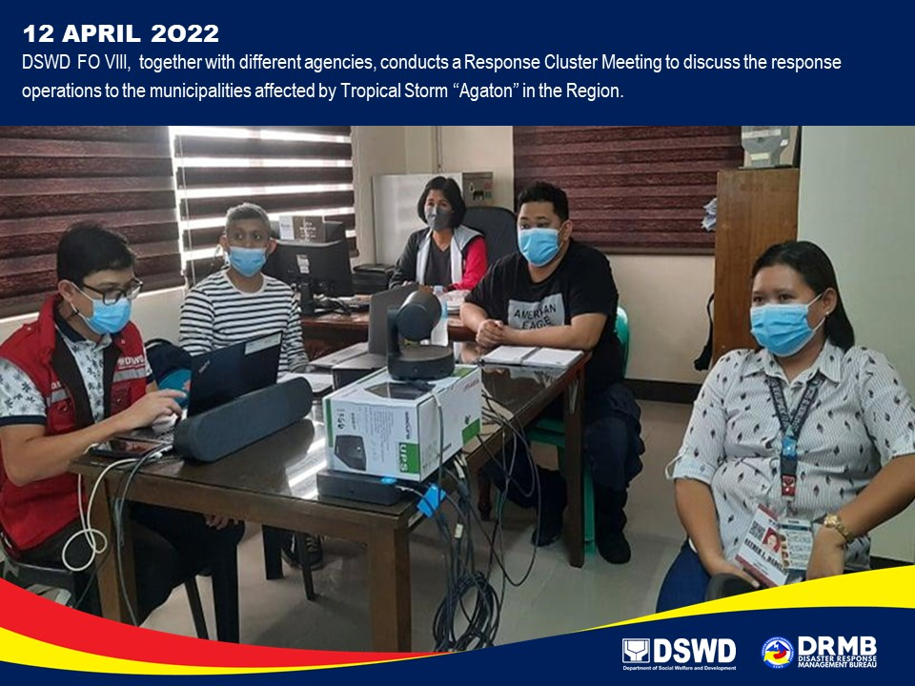

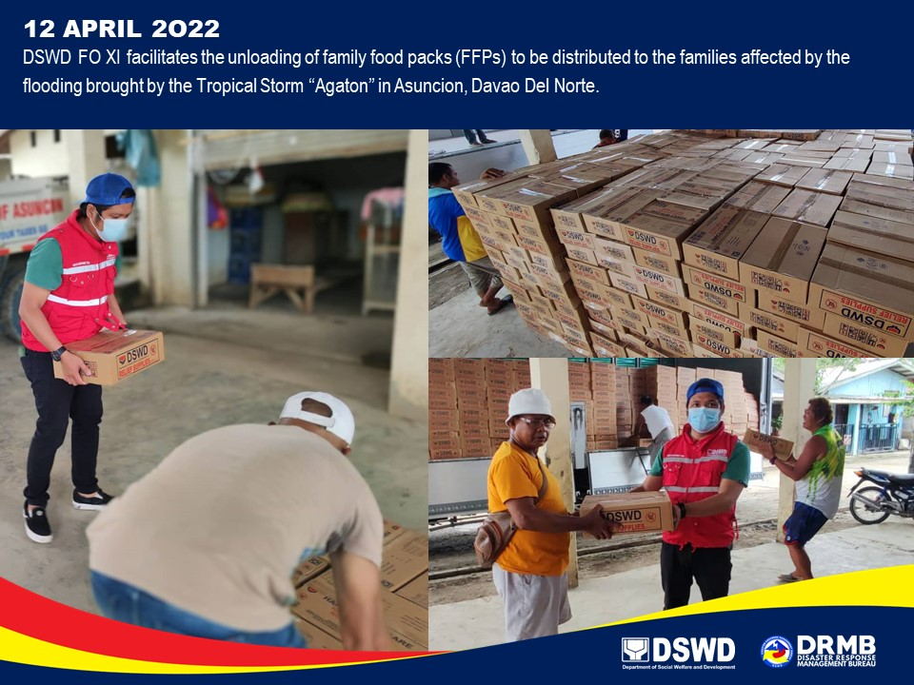
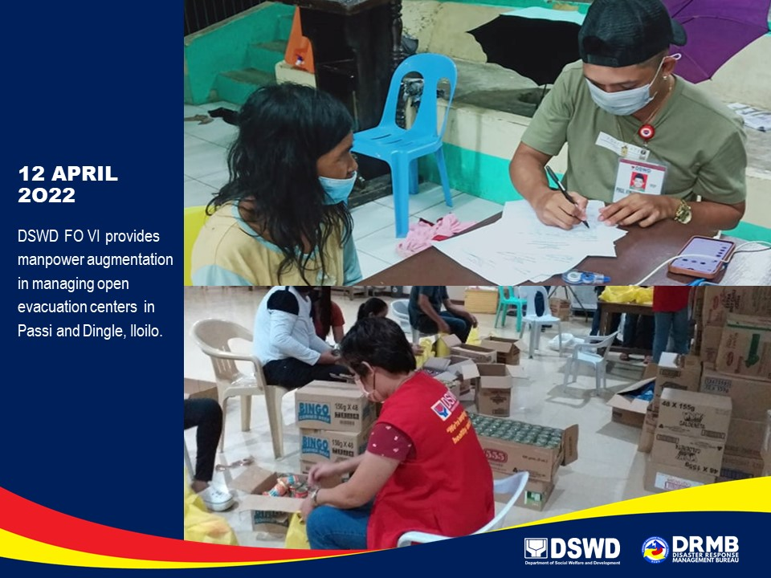

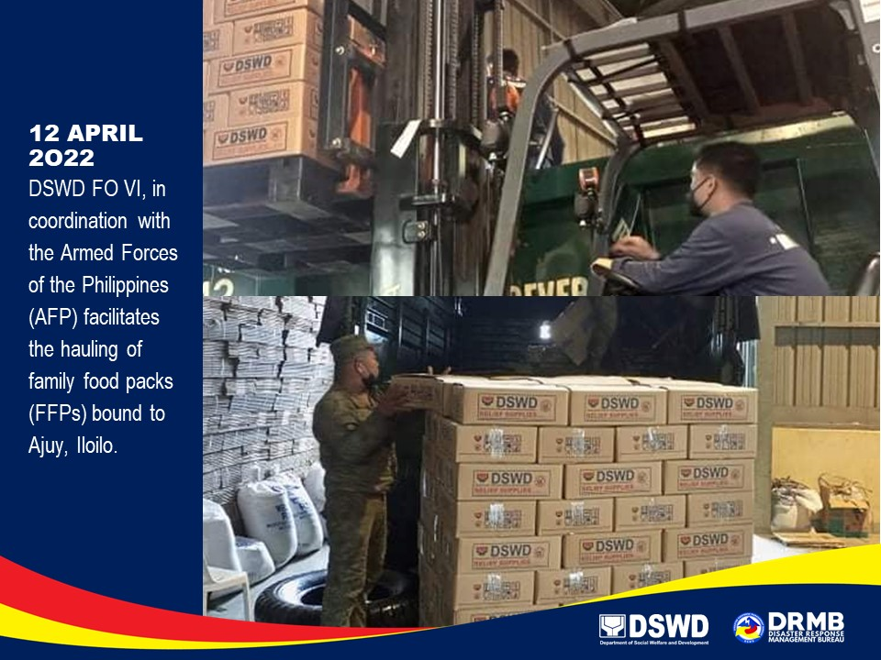
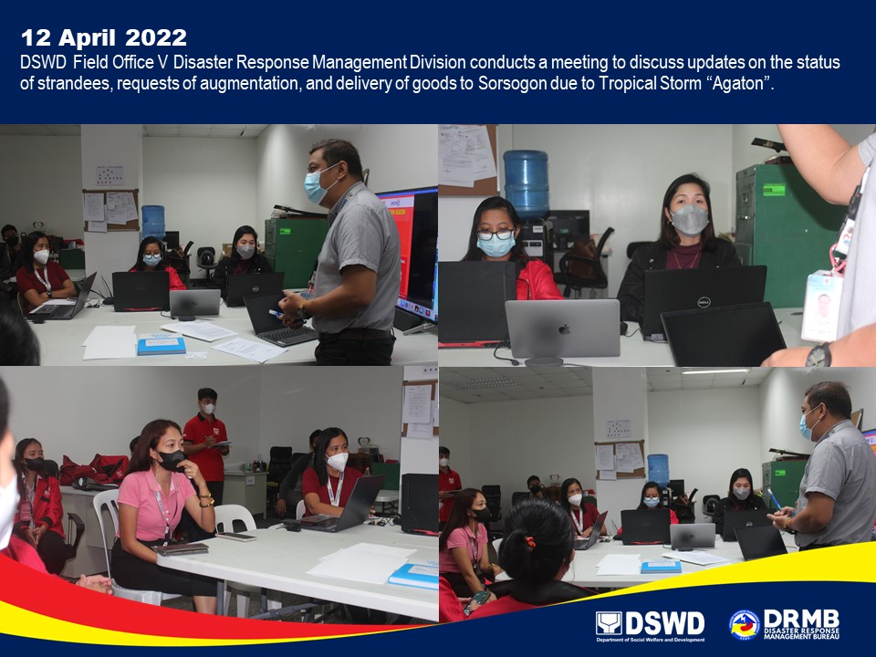

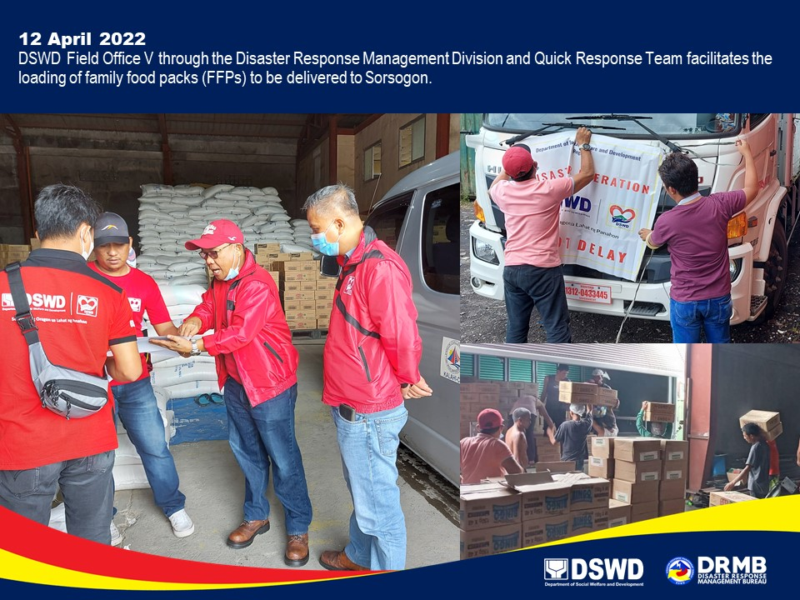
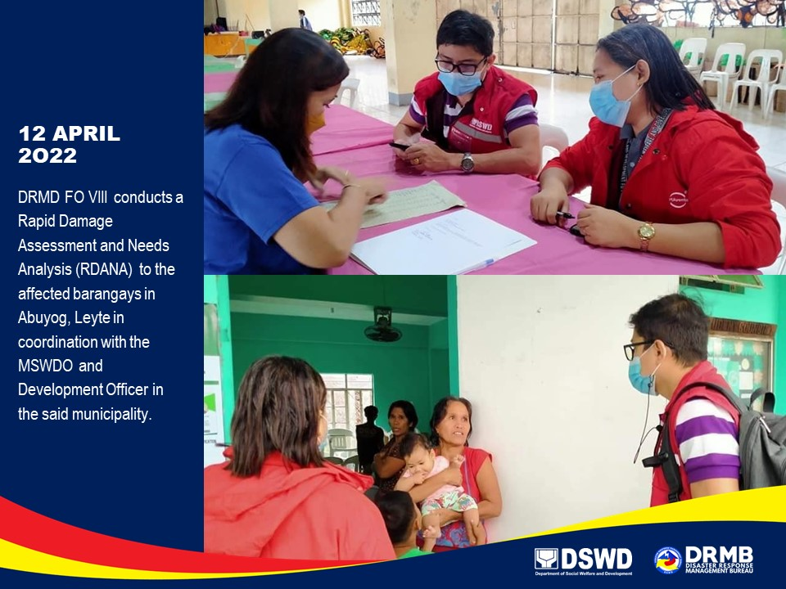

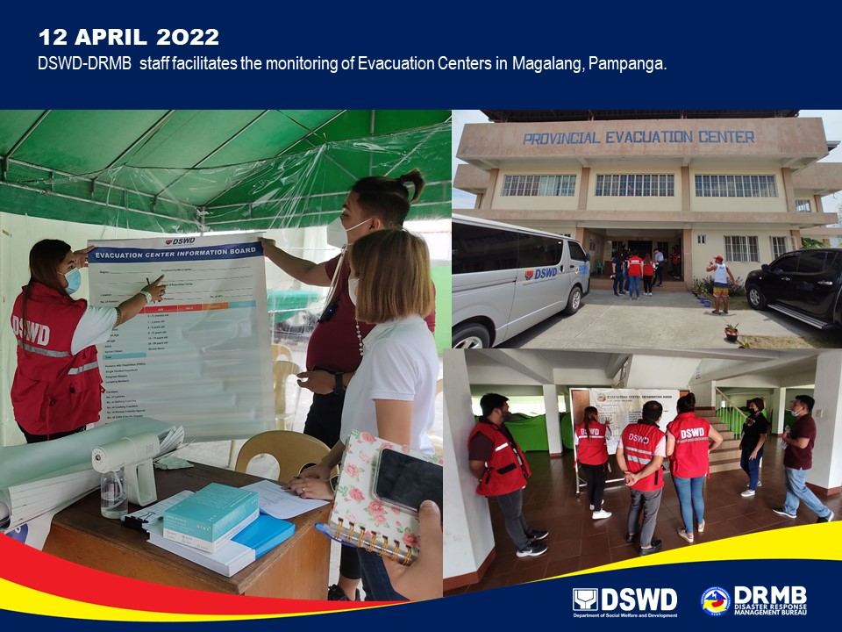
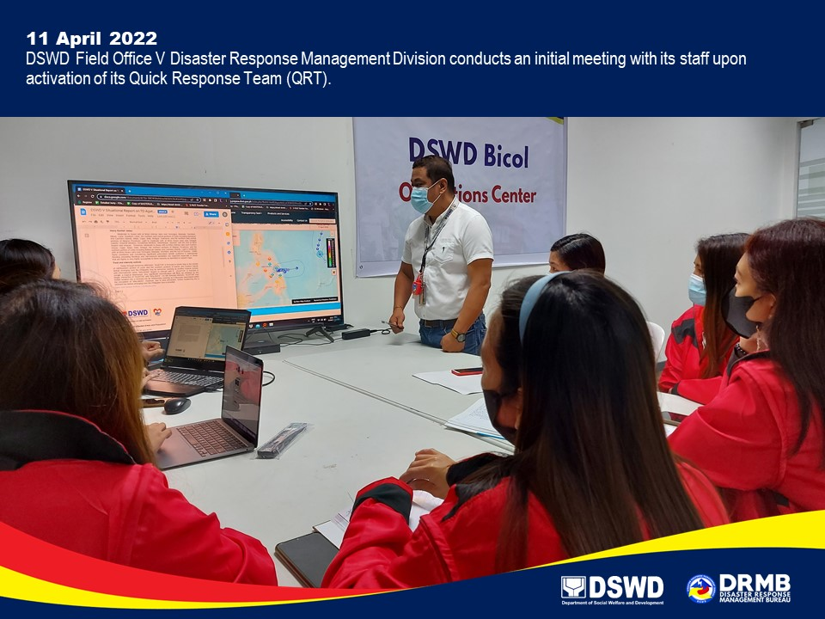

*****
The Disaster Response Operations Monitoring and Information Center (DROMIC) of DSWD-DRMB is closely coordinating with the concerned DSWD Field Offices for significant updates on disaster response operations and assistance provided.

Prepared by:  DIANE C. PELEGRINO  AARON JOHN B. PASCUA  MARIE JOYCE G. RAFANAN | Released by:  MARC LEO L. BUTAC

