DSWD DROMIC Report on the Fire Incident in
Brgy. Kayapa, Bakun, Benguet
05 April 2022, 6PM

- Situation Overview
On 07 February 2022, at around 11:00 in the evening, a residential fire incident transpired in Barangay Kayapa, Bakun, Benguet.
Source: DSWD-Field Office (FO) CAR

- Status of Affected Areas and Population
A total of one (1) family or four (4) persons were affected by the fire incident in Brgy. Kayapa, Bakun, Benguet (see Table 1).

Table 1. Number of Affected Families / Persons
REGION / PROVINCE / MUNICIPALITY | NUMBER OF AFFECTED
 | Barangays | Families | Persons
GRAND TOTAL | 1 | 1 | 4
CAR | 1 | 1 | 4
Benguet | 1 | 1 | 4
Bakun | 1 | 1 | 4
Source: DSWD-FO CAR

- Status of Displaced Population
- Outside Evacuation Centers
There is one (1) family or four (4) persons currently staying with their relatives and/or friends (see Table 2).

Table 2. Number of Displaced Families / Persons Outside Evacuation Centers
REGION / PROVINCE / MUNICIPALITY | NUMBER OF DISPLACED
 | OUTSIDE ECs
 | Families |  | Persons
 | CUM | NOW | CUM | NOW
GRAND TOTAL | 1 | 1 | 4 | 4
CAR | 1 | 1 | 4 | 4
Benguet | 1 | 1 | 4 | 4
Bakun | 1 | 1 | 4 | 4
Source: DSWD-FO CAR

- Damaged Houses
A total of one (1) house was totally damaged by the fire incident (see Table 3).

Table 3. Number of Damaged Houses
REGION / PROVINCE / MUNICIPALITY | NO. OF DAMAGED HOUSES
 | Total | Totally | Partially
GRAND TOTAL | 1 | 1 | -
CAR | 1 | 1 | -
Benguet | 1 | 1 | -
Bakun | 1 | 1 | -
Source: DSWD-FO CAR

- Cost of Humanitarian Assistance Provided
A total of ₱23,807.23 worth of assistance was provided to the affected families; of which ₱8,807.23 was from DSWD and ₱15,000.00 from the Local Government Unit (LGU) (see Table 4).

Table 4. Cost of Assistance Provided to Affected Families / Persons
REGION / PROVINCE / MUNICIPALITY |  | COST OF ASSISTANCE
 |  | DSWD | LGU | NGOs | OTHERS | GRAND TOTAL
GRAND TOTAL |  | 8,807.23 | 15,000.00 | - | - | 23,807.23
CAR |  | 8,807.23 | 15,000.00 | - | - | 23,807.23
Benguet |  | 8,807.23 | 15,000.00 | - | - | 23,807.23
 | Bakun | 8,807.23 | 15,000.00 | - | - | 23,807.23
Source: DSWD-FO CAR

- Photo Documentation

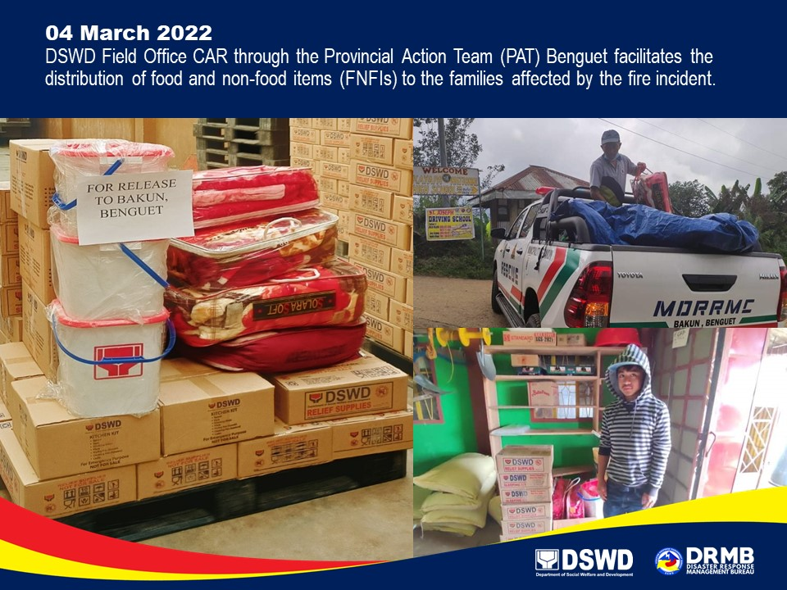

*****
This terminal report is based on the latest report submitted by DSWD-FO CAR on 17 March 2022. The Disaster Response Operations Monitoring and Information Center (DROMIC) of DSWD-DRMB continues to closely coordinate with DSWD-FO CAR for any request of Technical Assistance and Resource Augmentation (TARA).

Prepared by:  PHIL JOBERT A. ZALDIVAR | Released by:  RODEL V. CABADDU

