DSWD DROMIC Report on the Tornado Incident
in Brgy. Palaming, City of San Carlos, Pangasinan
06 April 2022, 6PM

- Situation Overview
In the afternoon of 16 March 2022, a tornado hit Barangay Palaming in City of San Carlos, Pangasinan which left some damaged houses.
Source: DSWD-Field Office (FO) I

- Status of Affected Areas and Population
A total of seven (7) families or 30 persons were affected by the tornado incident in Brgy. Palaming, City of San Carlos, Pangasinan (see Table 1).

Table 1. Number of Affected Families / Persons
REGION / PROVINCE / MUNICIPALITY |  | NUMBER OF AFFECTED
 |  | Barangays | Families | Persons
GRAND TOTAL |  | 1 | 7 | 30
REGION I |  | 1 | 7 | 30
Pangasinan |  | 1 | 7 | 30
 | San Carlos City | 1 | 7 | 30
Source: DSWD-FO I

- Status of Displaced Population
- Outside Evacuation Centers
There is one (1) family or three (3) persons currently staying with their relatives and/or friends (see Table 2).

Table 2. Number of Displaced Families / Persons Outside Evacuation Centers
REGION / PROVINCE / MUNICIPALITY |  | NUMBER OF DISPLACED
 |  | OUTSIDE ECs
 |  | Families |  | Persons
 |  | CUM | NOW | CUM | NOW
GRAND TOTAL |  | 3 | 1 | 5 | 3
REGION I |  | 3 | 1 | 5 | 3
Pangasinan |  | 3 | 1 | 5 | 3
 | San Carlos City | 3 | 1 | 5 | 3
Source: DSWD-FO I

- Damaged Houses
A total of seven (7) houses were damaged by the tornado incident; of which one (1) house was totally damaged and six (6) houses were partially damaged (see Table 3).

Table 3. Number of Damaged Houses
REGION / PROVINCE / MUNICIPALITY |  | NO. OF DAMAGED HOUSES
 |  | Total | Totally | Partially
GRAND TOTAL |  | 7 | 1 | 6
REGION I |  | 7 | 1 | 6
Pangasinan |  | 7 | 1 | 6
 | San Carlos City | 7 | 1 | 6
Source: DSWD-FO I

- Cost of Humanitarian Assistance Provided
A total of ₱57,394.02 worth of assistance was provided to the affected families; of which ₱55,001.00 was from DSWD and ₱2,393.02 from the Local Government Unit (LGU) (see Table 4).

Table 4. Cost of Assistance Provided to Affected Families / Persons
REGION / PROVINCE / MUNICIPALITY |  | COST OF ASSISTANCE
 |  | DSWD | LGU | NGOs | OTHERS | GRAND TOTAL
GRAND TOTAL |  | 55,001.00 | 2,393.02 | - | - | 57,394.02
REGION I |  | 55,001.00 | 2,393.02 | - | - | 57,394.02
Pangasinan |  | 55,001.00 | 2,393.02 | - | - | 57,394.02
 | San Carlos City | 55,001.00 | 2,393.02 | - | - | 57,394.02
Source: DSWD-FO I

- Photo Documentation

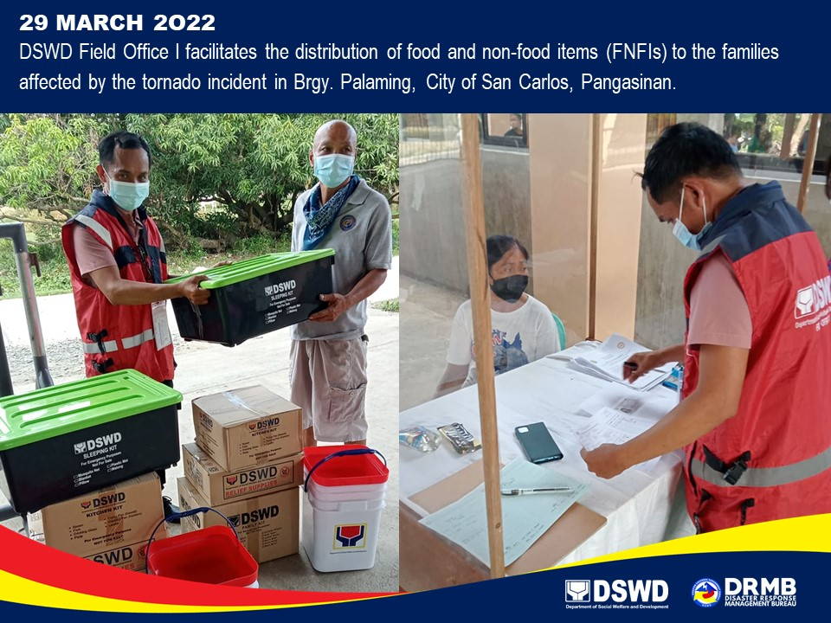

*****
This first and final report is based on the latest report submitted by DSWD-FO I on 30 March 2022. The Disaster Response Operations Monitoring and Information Center (DROMIC) of DSWD-DRMB continues to closely coordinate with DSWD-FO I for any request of Technical Assistance and Resource Augmentation (TARA).

Prepared by:  PHIL JOBERT A. ZALDIVAR | Released by:  RODEL V. CABADDU

