DSWD DROMIC Report on the Vehicular Traffic Accident in Brgy. Upper Maton, Pudtol, Apayao
05 April 2022, 6PM

- Situation Overview
On 23 February 2022, at around 4:00 in the afternoon, a vehicular traffic accident occurred in Upper Maton, Pudtol, Apayao, near the Barangay Health Center, which injured eight (8) individuals and left two (2) casualties.
Source: DSWD-Field Office (FO) CAR

- Status of Affected Areas and Population
A total of 10 families or 10 persons were affected by the vehicular traffic accident in Brgy. Upper Maton, Pudtol, Apayao (see Table 1).

Table 1. Number of Affected Families / Persons
REGION / PROVINCE / MUNICIPALITY | NUMBER OF AFFECTED
 | Barangays | Families | Persons
GRAND TOTAL | 1 | 10 | 10
CAR | 1 | 10 | 10
Apayao | 1 | 10 | 10
Pudtol | 1 | 10 | 10
Source: DSWD-FO CAR

- Damaged Houses
A total of two (2) houses were partially damaged by the vehicular traffic accident (see Table 2).

Table 2. Number of Damaged Houses
REGION / PROVINCE / MUNICIPALITY | NO. OF DAMAGED HOUSES
 | Total | Totally | Partially
GRAND TOTAL | 2 | - | 2
CAR | 2 | - | 2
Apayao | 2 | - | 2
Pudtol | 2 | - | 2
Source: DSWD-FO CAR

- Cost of Humanitarian Assistance Provided
A total of ₱25,814.45 worth of assistance was provided to the affected families; of which ₱23,814.45 was from DSWD and ₱2,000.00 from the Local Government Unit (LGU) (see Table 3).

Table 3. Cost of Assistance Provided to Affected Families / Persons
REGION / PROVINCE / MUNICIPALITY | COST OF ASSISTANCE
 | DSWD | LGU | NGOs | OTHERS | GRAND TOTAL
GRAND TOTAL | 23,814.45 | 2,000.00 | - | - | 25,814.45
CAR | 23,814.45 | 2,000.00 | - | - | 25,814.45
Apayao | 23,814.45 | 2,000.00 | - | - | 25,814.45
Pudtol | 23,814.45 | 2,000.00 | - | - | 25,814.45
Source: DSWD-FO CAR

- Photo Documentation
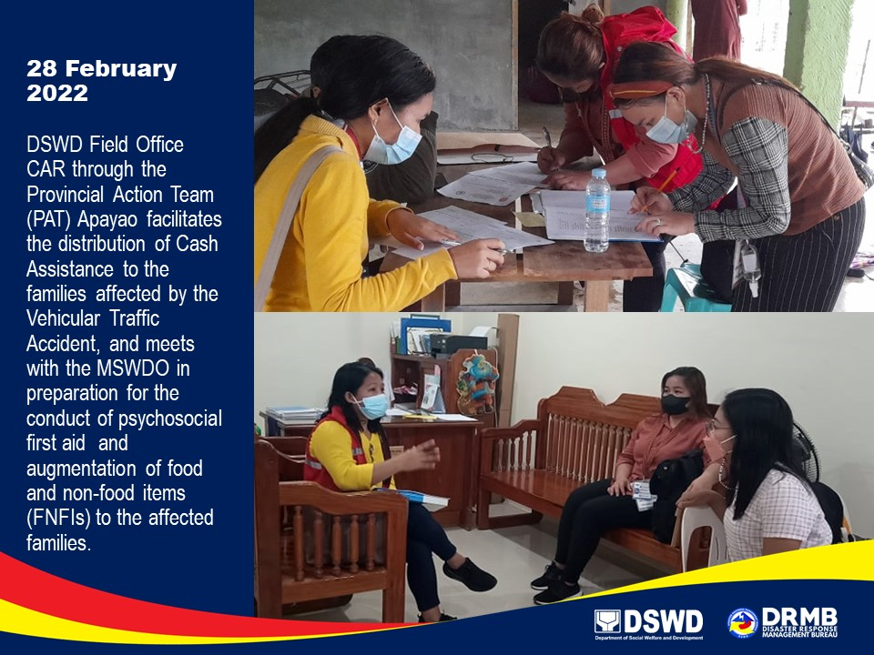

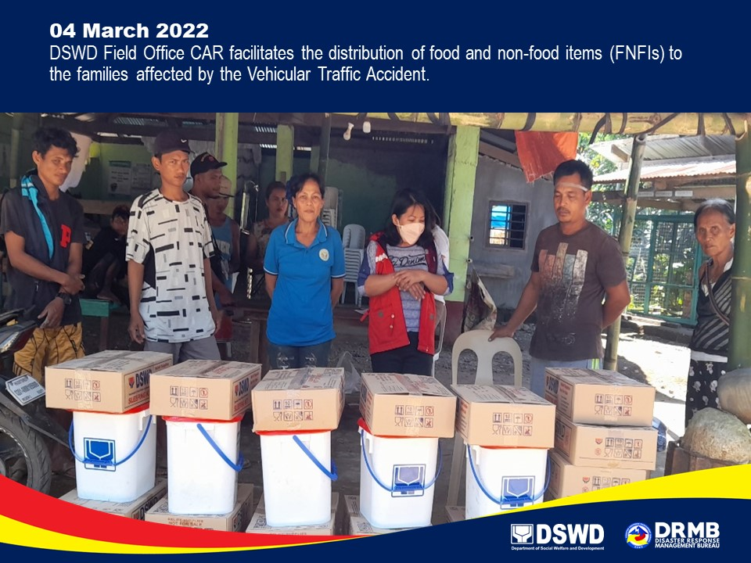

*****
This terminal report is based on the latest report submitted by DSWD-FO CAR on 17 March 2022. The Disaster Response Operations Monitoring and Information Center (DROMIC) of DSWD-DRMB continues to closely coordinate with DSWD-FO CAR for any request of Technical Assistance and Resource Augmentation (TARA).

Prepared by:  PHIL JOBERT A. ZALDIVAR | Released by:  RODEL V. CABADDU

