DSWD DROMIC Report #3 on the Bulusan Volcano Eruption
as of 08 June 2022, 6PM

- Situation Overview

On 05 June 2022, at 10:37 AM, the Philippine Institute of Volcanology and Seismology (PHIVOLCS) has raised the alert status of Bulusan Volcano from Alert Level 0 (Normal) to Alert Level 1 (Low-level Unrest) after a phreatic eruption occurred at the volcano’s summit that lasted approximately 17 minutes which was recorded by seismic and infrasound monitoring by the Bulusan Volcano Network (BVN). The event was poorly visible through cloud cover over the edifice although a steam-rich grey plume at least one kilometer tall was observed from Juban, Sorsogon and was subsequently observed to drift west.

The eruption produced a sluggish gray ash plume that rose more than a kilometer and dispersed wet ash to the west coincident with rainfall over the edifice. Thin fine ashfall fell on the general northwestern sector of the edifice and affected the barangays of Puting Sapa, Añog, Guruyan, Catanusan, Buraburan, Bacolod, and Sangkayon in Juban and Bolos in Irosin, Sorsogon Province. Rumbling sound and sulfurous odor were also observed by residents of Brgys. Añog, Guruyan, and Catanusan. After the eruption, degassing was observed from the crater and, for the first time this year, from the northwest summit vent.

The fine ashfall can cause irritation and breathing problems especially among the vulnerable population – the elderly, children, expecting mothers and those with respiratory disorders – and can be particularly dangerous when inhaled in copious amounts. In addition, ashfall even when thin but having high amounts of sulfur can also cause irritation.
Source: Philippine Institute of Volcanology and Seismology (PHIVOLCS)

- Status of Affected Areas and Population

There are 3,280 families or 16,400 persons affected by the Bulusan Volcano eruption in 11 barangays in Region V (see Table 1).

Table 1. Number of Affected Families / Persons

REGION / PROVINCE / MUNICIPALITY |  | NUMBER OF AFFECTED
 |  | Barangays | Families | Persons
GRAND TOTAL |  | 11 | 3,280 | 16,400
REGION V |  | 11 | 3,280 | 16,400
Sorsogon |  | 11 | 3,280 | 16,400
 | Irosin | 4 | 1,606 | 8,030
 | Juban | 7 | 1,674 | 8,370
Note: Ongoing assessment and validation that are continuously being conducted.
Source: DSWD FO V

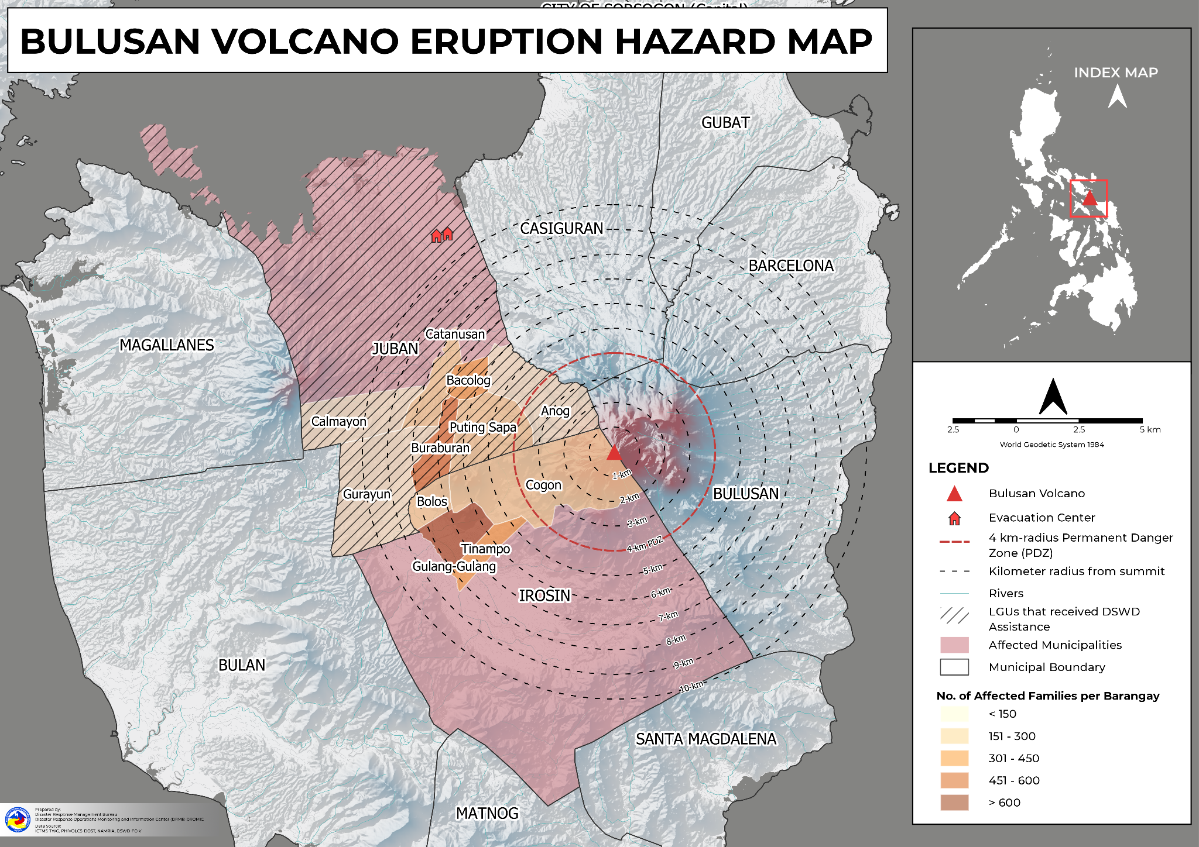

- Status of Displaced Population

        - Inside Evacuation Center
There are 121 families or 418 persons currently taking temporary shelter in two (2) evacuation centers in Region V (see Table 2).

Table 2. Number of Displaced Families / Persons Inside Evacuation Center
REGION / PROVINCE / MUNICIPALITY |  | NUMBER OF EVACUATION CENTERS (ECs) |  | NUMBER OF DISPLACED
 |  |  |  | INSIDE ECs
 |  |  |  | Families |  | Persons
 |  | CUM | NOW | CUM | NOW | CUM | NOW
GRAND TOTAL |  | 2 | 2 | 121 | 121 | 418 | 418
REGION V |  | 2 | 2 | 121 | 121 | 418 | 418
Sorsogon |  | 2 | 2 | 121 | 121 | 418 | 418
 | Juban | 2 | 2 | 121 | 121 | 418 | 418
Note: Ongoing assessment and validation that are continuously being conducted.
Source: DSWD FO V

- Cost of Humanitarian Assistance Provided
A total of ₱310,737.92 worth of assistance was provided to the affected families; of which, ₱288,647.92 from the DSWD and ₱22,090.00 was provided by the LGUs (see Table 3).

Table 3. Cost of Assistance Provided to Affected Families / Persons
REGION / PROVINCE / MUNICIPALITY |  | COST OF ASSISTANCE
 |  | DSWD | LGU | NGOs | OTHERS | GRAND TOTAL
GRAND TOTAL |  | 288,647.92 | 22,090.00 | - | - | 310,737.92
REGION V |  | 288,647.92 | 22,090.00 | - | - | 310,737.92
Sorsogon |  | 288,647.92 | 22,090.00 | - | - | 310,737.92
 | Juban | 288,647.92 | 22,090.00 | - | - | 310,737.92

Source: DSWD FO V

- Response Actions and Interventions

- Standby Funds and Prepositioned Relief Stockpile
OFFICE | STANDBY FUNDS | STOCKPILE |  |  | TOTAL STANDBY FUNDS & STOCKPILE
 |  | FAMILY FOOD PACKS |  | OTHER FOOD AND NON-FOOD ITEMS (FNIs)
 |  | QUANTITY | TOTAL COST
TOTAL | 611,306,819.55 | 531,417 | 334,470,923.26 | 687,943,660.50 | 1,633,721,403.31
DSWD CO | 541,647,400.24 | - | - | - | 541,647,400.24
NRLMB NROC | - | 96,562 | 61,796,364.00 | 134,358,705.97 | 196,155,069.97
NRLMB VDRC | - | 28,629 | 18,139,910.00 | 60,119,155.80 | 78,259,065.80
DSWD FO V | 767,910.00 | 24,585.00 | 11,851,426.65 | 44,197,127.37 | 56,816,464.02
Other FOs | 68,891,509.31 | 381,641.00 | 242,683,222.61 | 449,268,671.36 | 760,843,403.28
Note: The Inventory Summary is as of 08 June 2022, 4PM.
Source: DSWD-DRMB and DSWD-NRLMB

  - Standby Funds
    - ₱541 million Quick Response Fund (QRF) at the DSWD-Central Office.
    - ₱767,910 thousand available at DSWD FO V.
    - ₱68.90 million in other DSWD FOs which may support the relief needs of the displaced families due to the Bulusan Volcano Eruption through inter FO augmentation.

  - Prepositioned FFPs and Other Relief Items
    - 125,191 FFPs available in Disaster Response Centers; of which, 96,562 FFPs are at the National Resource Operations Center (NROC), Pasay City and 28,629 FFPs are at the Visayas Disaster Response Center (VDRC), Cebu City.
    - 24,585 FFPs available at DSWD FO V.
    - 381,641 FFPs in other DSWD FOs which may support the relief needs of the displaced families due to the Bulusan Volcano Eruption through inter FO augmentation.
    - ₱687.94 million worth of other FNIs at NROC, VDRC and DSWD-FO V warehouses.

- Food and Non-Food Items

DSWD FO V
DATE | SITUATIONS / ACTIONS UNDERTAKEN
08 June 2022 | - DSWD FO V provided a total of 242 family food packs and 121 hygiene kits to the affected families.
07 June 2022 | - DSWD FO V delivered 68 family food packs and 34 hygiene kits to the 34 additional IDPs at Juban, Sorsogon.  - DSWD FO V delivered an additional 100 hygiene kits to Juban, Sorsogon of which; 27 were provided to the IDPs and 73 were prepositioned at the LGU of Juban.
06 June 2022 | - DSWD FO V delivered 1,000 family food packs and 58 sets of hygiene kits to Juban, Sorsogon.

- Other Activities

DSWD-DRMB
DATE | SITUATIONS / ACTIONS UNDERTAKEN
07 June 2022 | - DSWD-DRMB is closely coordinating with DSWD FO V for significant reports on the status of affected families, assistance, and relief efforts.

DSWD-NRLMB
DATE | SITUATIONS / ACTIONS UNDERTAKEN
07 June 2022 | - DSWD-NRLMB is continuously repacking goods for possible augmentation.

DSWD FO V
DATE | SITUATIONS / ACTIONS UNDERTAKEN
07 April 2022 | - DSWD FO V thru the Disaster Response Management Division (DRMD) is closely monitoring weather reports and updates relative to the Bulusan Volcano eruption.
06 April 2022 | - SWADT Sorsogon is activated and instructed to coordinate with LGUs for weather reports and updates.
05 June 2022 | - DSWD FO V Quick Response Team (QRT) Alpha was activated.  - SWAD Team members in the six provinces were activated and instructed to coordinate with the P/MDRRMOs, C/MSWDOs for weather reports and updates

- Photo Documentation

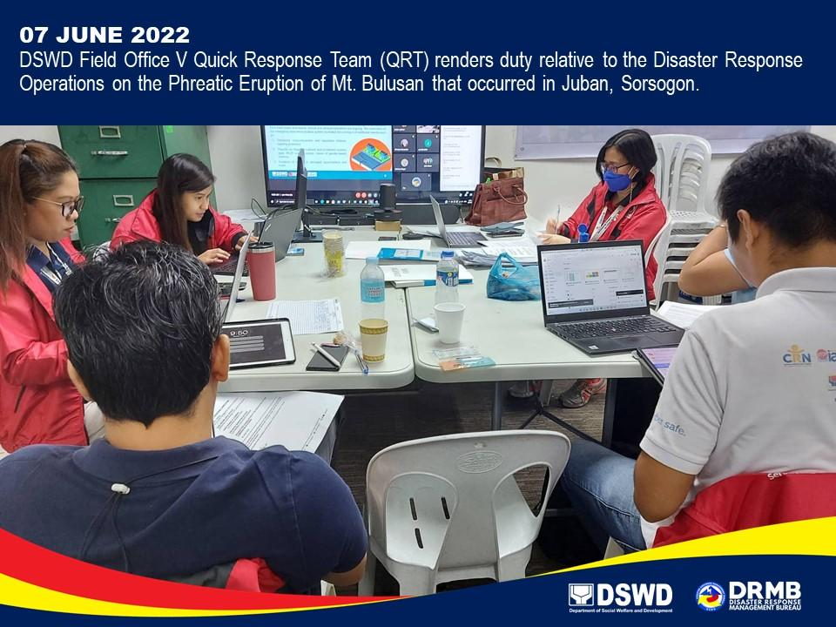

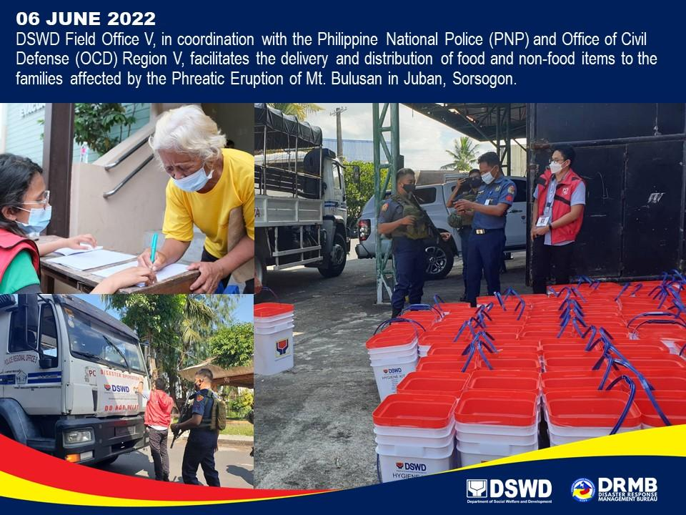

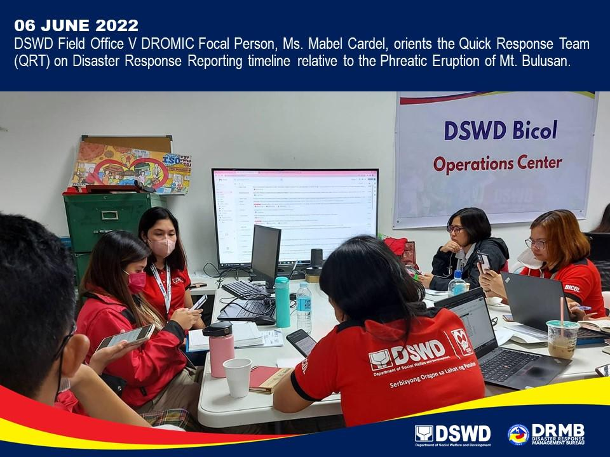

*****
The Disaster Response Operations Monitoring and Information Center (DROMIC) of DSWD-DRMB is closely coordinating with the DSWD FO V for significant disaster response updates and assistance provided.

Prepared by:  JEM ERIC F. FAMORCAN | Released by:  LESLIE R. JAWILI

