DSWD DROMIC Report #1 on the Flooding Incident
due to ITCZ in Region VII
as of 07 July 2022, 6PM
- Situation Overview

Issued on 06 July 2022, Intertropical Convergence Zone (ITCZ) affecting Southern Luzon, Visayas, and Mindanao bringing cloudy skies with scattered rainshowers and thunderstorms caused by the ITCZ that resulted to flooding in some areas in Cebu Province and Negros Oriental in Region VII.

Source: DOST-PAGASA Weather Bulletin and DSWD Field Office (FO) VII

- Status of Affected Areas and Population

A total of 297 families or 1,206 persons are affected in five (5) Barangays in Region VII (see Table 1).

Table 1. Number of Affected Families / Persons
REGION / PROVINCE / MUNICIPALITY |  | NUMBER OF AFFECTED
 |  | Barangays | Families | Persons
GRAND TOTAL |  | 5 | 297 | 1,206
REGION VII |  | 5 | 297 | 1,206
Cebu |  | 4 | 289 | 1,174
 | Cebu City (capital) | 3 | 19 | 94
 | City of Talisay | 1 | 270 | 1,080
Negros Oriental |  | 1 | 8 | 32
 | Vallehermoso | 1 | 8 | 32
Note: Ongoing assessment and validation being conducted.
Source: DSWD FO VII

- Response Actions and Interventions

- Standby Funds and Prepositioned Relief Stockpile
OFFICE | STANDBY FUNDS | STOCKPILE |  |  | TOTAL STANDBY FUNDS & STOCKPILE
 |  | FAMILY FOOD PACKS |  | OTHER FOOD AND NON-FOOD ITEMS (FNIs)
 |  | QUANTITY | TOTAL COST
TOTAL | 553,378,151.49 | 161,168 | 103,061,980.00 | 172,215,921.29 | 828,656,052.78
DSWD CO | 548,378,151.49 | - | - | - | 548,378,151.49
NRLMB NROC | - | 100,764 | 65,387,320.00 | 108,138,933.36 | 173,526,253.36
NRLMB VDRC | - | 51,729 | 32,729,910.00 | 47,584,005.80 | 80,313,915.80
DSWD FO VII | 5,000,000.00 | 8,675 | 4,944,750.00 | 16,492,982.13 | 26,437,732.13
Note: The Inventory Summary is as of 07 July 2022, 4PM.
Source: DSWD-DRMB and DSWD-NRLMB

  - Standby Funds
    - ₱548.38 million Quick Response Fund (QRF) at the DSWD-Central Office.
    - ₱5 million available at DSWD-FO VII.

  - Prepositioned FFPs and Other Relief Items
    - 152,493 FFPs available in Disaster Response Centers; of which, 100,764 FFPs are at the National Resource Operations Center (NROC), Pasay City and 51,729 FFPs are at the Visayas Disaster Response Center (VDRC), Cebu City.
    - 8,6475 FFPs available at DSWD FO VII.
    - ₱172.22 million worth of other FNIs at NROC, VDRC and DSWD-FO VII warehouses.

- Other Activities

DATE | ACTIVITIES
07 July 2022 | - The DSWD FO VII through the Disaster Response Management Division (DRMD) in coordination with the Provincial and City / Municipal Action Teams of the affected local government units (LGUs) for possible request of augmentation support.  - The Cebu City warehouse personnel are on standby for any assistance needed.

- Photo Documentation

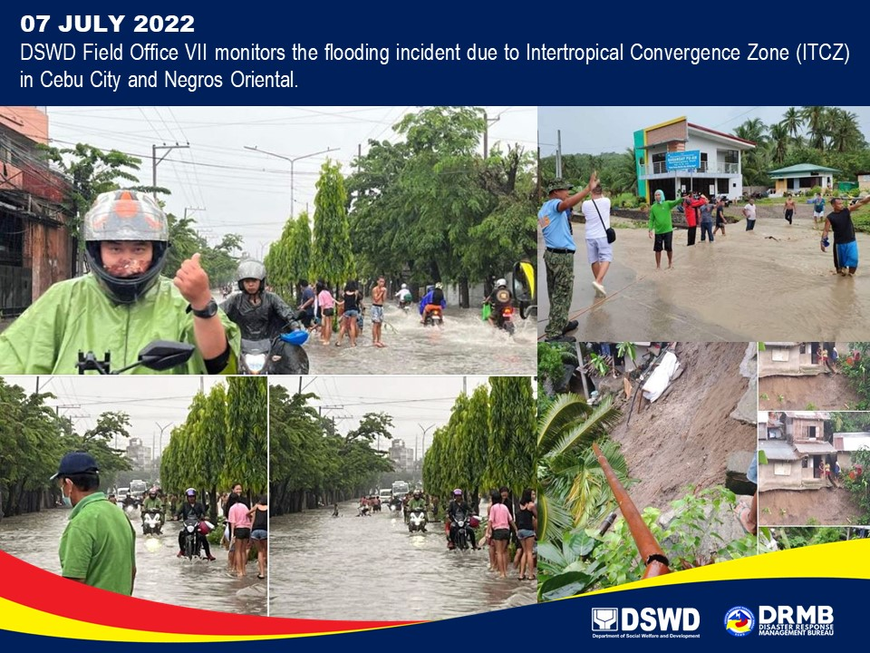

*****
The Disaster Response Operations Monitoring and Information Center (DROMIC) of DSWD-DRMB is closely coordinating with DSWD-FO VII for significant disaster response updates and assistance provided.

Prepared by:  AARON JOHN B. PASCUA | Released by:  RODEL V. CABADDU
MARIE JOYCE G. RAFANAN

