DSWD DROMIC Report #11 on the Bulusan Volcano Eruption
as of 06 July 2022, 6PM

- Situation Overview

As of 06 July 2022 at 5 AM, alert status of Bulusan Volcano remains at Alert Level 1 (low-level unrest).

On 05 June 2022, at 10:37 AM, the Philippine Institute of Volcanology and Seismology (PHIVOLCS) has raised the alert status of Bulusan Volcano from Alert Level 0 (Normal) to Alert Level 1 (Low-level Unrest) after a phreatic eruption occurred at the volcano’s summit that lasted approximately 17 minutes which was recorded by seismic and infrasound monitoring by the Bulusan Volcano Network (BVN). The event was poorly visible through cloud cover over the edifice although a steam-rich grey plume at least one kilometer tall was observed from Juban, Sorsogon and was subsequently observed to drift west.

The eruption produced a sluggish gray ash plume that rose more than a kilometer and dispersed wet ash to the west coincident with rainfall over the edifice. Thin fine ashfall fell on the general northwestern sector of the edifice and affected the barangays of Puting Sapa, Añog, Guruyan, Catanusan, Buraburan, Bacolod, and Sangkayon in Juban and Bolos in Irosin, Sorsogon Province. Rumbling sound and sulfurous odor were also observed by residents of Brgys. Añog, Guruyan, and Catanusan. After the eruption, degassing was observed from the crater and, for the first time this year, from the northwest summit vent.

On 10 June 2022 at 8 PM, residents of ashfall-affected barangays in Juban, Sorsogon were ordered to be evacuated due to the observance of the increased seismic activity of Bulusan Volcano.

On 12 June 2022 at 3:37 PM, an eruption was detected by the BVN. The eruption lasted for approximately 18 minutes and was recorded as an explosion type earthquake by seismic and infrasound instruments, but could not be visually observed in the dark of night. The explosion was felt at Intensity III by residents of Brgy. Añog, Juban and at Intensity II in Brgy. Inlagadian, Casiguran, all within 5-km of the Bulusan summit. Rumbling sounds accompanying the eruption were also reported by witnesses in Sitio Bagong Barrio, Brgy. Santa Lourdes, Barcelona, Brgy. Inlagadian and Brgy. San Juan, Casiguran, Brgy. Bentuco, Gubat, and Brgys. Añog, Calateo, and Puting Sapa, Juban. A brief incandescence at the base of the eruption plume was also reported in Brgy. Inlagadian, Casiguran. By daybreak, multiple active vents at the summit could be observed spewing ash and steam to a height of at least 500 m before being drifted to the northwest. In the morning, six vents – the major crater called Blackbird, three explosion pits on the summit, and the lateral vents on the northwest and north sides of the summit – were actively degassing short plumes which entrained ash until at least 9:00 in the morning. The plumes dispersed into a long veil of ash extending several kilometers to the northwest. This period of “ashing” was accompanied by very weak sporadic volcanic tremor. Degassing of steam-laden plumes continues while the Blackbird Crater generates a thin haze of ash upon the upper northwestern slopes.

The fine ashfall can cause irritation and breathing problems especially among the vulnerable population – the elderly, children, expecting mothers and those with respiratory disorders – and can be particularly dangerous when inhaled in copious amounts. In addition, ashfall even when thin but having high amounts of sulfur can also cause irritation.
Source: PHIVOLCS

- Status of Affected Areas and Population

There are 10,707 families or 44,669 persons affected by the Bulusan Volcano eruption in 30 barangays in Region V (see Table 1).

Table 1. Number of Affected Families / Persons

REGION / PROVINCE / MUNICIPALITY |  | NUMBER OF AFFECTED
 |  | Barangays | Families | Persons
GRAND TOTAL |  | 30 | 10,707 | 44,669
REGION V |  | 30 | 10,707 | 44,669
Sorsogon |  | 30 | 10,707 | 44,669
 | Irosin | 5 | 2,520 | 12,600
 | Juban | 25 | 8,187 | 32,069
Note: Ongoing assessment and validation that are continuously being conducted.
Source: DSWD FO V

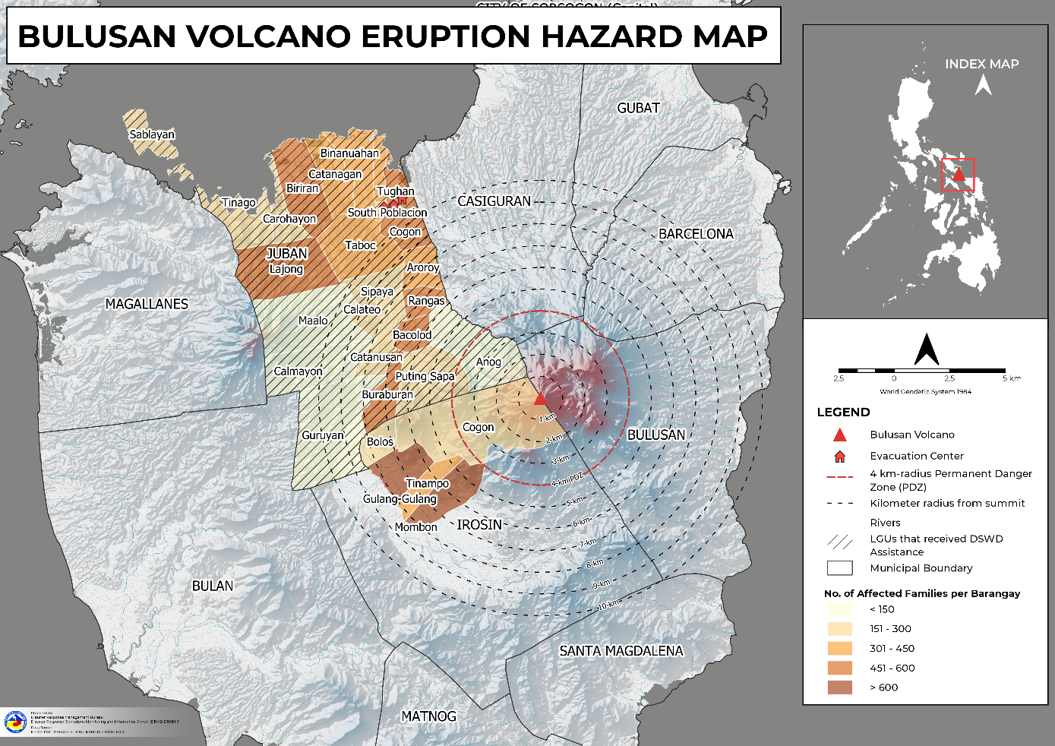

- Status of Displaced Population

        - Inside Evacuation Center
A total of 179 families or 602 persons sought temporary shelter in three (3) evacuation centers in Region V (see Table 2).

Table 2. Number of Displaced Families / Persons Inside Evacuation Center
REGION / PROVINCE / MUNICIPALITY |  | NUMBER OF EVACUATION CENTERS (ECs) |  | NUMBER OF DISPLACED
 |  |  |  | INSIDE ECs
 |  |  |  | Families |  | Persons
 |  | CUM | NOW | CUM | NOW | CUM | NOW
GRAND TOTAL |  | 3 | - | 179 | - | 602 | -
REGION V |  | 3 | - | 179 | - | 602 | -
Sorsogon |  | 3 | - | 179 | - | 602 | -
 | Juban | 3 | - | 179 | - | 602 | -
Note: Ongoing assessment and validation that are continuously being conducted.
Source: DSWD FO V

- Cost of Humanitarian Assistance Provided

A total of ₱1,693,326.94 worth of assistance was provided to the affected families; of which, ₱529,096.94 from the DSWD, ₱22,090.00 from LGUs, and ₱1,142,140.00 from Other Partners (see Table 3).

Table 3. Cost of Assistance Provided to Affected Families / Persons
REGION / PROVINCE / MUNICIPALITY |  | COST OF ASSISTANCE
 |  | DSWD | LGU | NGOs | OTHERS | GRAND TOTAL
GRAND TOTAL |  | 529,096.94 | 22,090.00 | - | 1,142,140.00 | 1,693,326.94
REGION V |  | 529,096.94 | 22,090.00 | - | 1,142,140.00 | 1,693,326.94
Sorsogon |  | 529,096.94 | 22,090.00 | - | 1,142,140.00 | 1,693,326.94
 | Juban | 529,096.94 | 22,090.00 | - | 1,142,140.00 | 1,693,326.94

Source: DSWD FO V

- Response Actions and Interventions

- Standby Funds and Prepositioned Relief Stockpile

OFFICE | STANDBY FUNDS | STOCKPILE |  |  | TOTAL STANDBY FUNDS & STOCKPILE
 |  | FAMILY FOOD PACKS |  | OTHER FOOD AND NON-FOOD ITEMS (FNIs)
 |  | QUANTITY | TOTAL COST
TOTAL | 619,540,300.38 | 537,502 | 334,783,377.59 | 645,476,177.19 | 1,599,799,855.16
DSWD CO | 548,378,151.49 | - | - | - | 548,378,151.49
NRLMB NROC | - | 100,764 | 65,387,320.00 | 108,138,933.36 | 173,526,253.36
NRLMB VDRC | - | 51,729 | 32,729,910.00 | 47,584,005.80 | 80,313,915.80
DSWD FO V | 5,000,000.00 | 29,463 | 14,905,805.20 | 47,437,679.20 | 67,343,484.40
Other FOs | 66,162,148.89 | 355,546 | 221,760,342.39 | 442,315,558.83 | 730,238,050.11
Note: The Inventory Summary is as of 06 July 2022, 4 PM.
Sources: DSWD-DRMB and DSWD-NRLMB

  - Standby Funds

    - ₱548.38 million Quick Response Fund (QRF) at the DSWD Central Office.
    - ₱5 million available at DSWD FO V.
    - ₱66.16 million in other DSWD FOs which may support the relief needs of the displaced families due to the Bulusan Volcano eruption through inter FO augmentation.

  - Prepositioned FFPs and Other Relief Items

    - 152,493 FFPs available in Disaster Response Centers; of which, 100,764 FFPs are at the National Resource Operations Center (NROC), Pasay City and 51,729 FFPs are at the Visayas Disaster Resource Center (VDRC), Mandaue City.
    - 29,463 FFPs available at DSWD FO V.
    - 355,546 FFPs in other DSWD FOs which may support the relief needs of the displaced families due to the Bulusan Volcano Eruption through inter FO augmentation.
    - ₱645.48 million worth of other FNIs at NROC, VDRC and DSWD FO warehouses.

- Food and Non-Food Items

DSWD FO V
DATE | SITUATIONS / ACTIONS UNDERTAKEN
13 June 2022 | - DSWD FO V provided a total of 285 FFPs to affected families.
12 June 2022 | - DSWD FO V provided a total of 232 FFPs to affected families.
08 June 2022 | - DSWD FO V provided a total of 242 FFPs and 121 hygiene kits to the affected families.

- Other Activities

DSWD-DRMB
DATE | SITUATIONS / ACTIONS UNDERTAKEN
06 July 2022 | - DSWD-DRMB is closely coordinating with DSWD FO V for significant reports on the status of affected families, assistance, and relief efforts.

DSWD-NRLMB
DATE | SITUATIONS / ACTIONS UNDERTAKEN
06 July 2022 | - DSWD-NRLMB is continuously repacking goods for possible augmentation.

DSWD FO V
DATE | SITUATIONS / ACTIONS UNDERTAKEN
13 June 2022 | - DSWD FO V Quick Response Team (QRT) Bravo was activated.
12 June 2022 | - DSWD FO V provided 2,000 DAFAC Forms to the LGU of Juban, Sorsogon
07 June 2022 | - DSWD FO V thru the Disaster Response Management Division (DRMD) is closely monitoring weather reports and updates relative to the Bulusan Volcano eruption.
06 June 2022 | - SWADT Sorsogon was activated and instructed to coordinate with LGUs for weather reports and updates.
05 June 2022 | - DSWD FO V QRT Alpha was activated.  - SWAD Team members in the six (6) provinces were activated and instructed to coordinate with the P/MDRRMOs, C/MSWDOs for weather reports and updates

*****
The Disaster Response Operations Monitoring and Information Center (DROMIC) of DSWD-DRMB is closely coordinating with the DSWD FO V for significant disaster response updates and assistance provided.

Prepared by:  AARON JOHN B. PASCUA  MARIE JOYCE G. RAFANAN | Released by:  MARC LEO L. BUTAC

